**Virtual Superstore**

Pawan Mahajan1 Piyush Layge2 Soumya Sathe 3,Prof. Jinal Patel4

Department of Computer Science & Engineering

Thakur Shivkumarsingh Memorial Engineering College, Burhanpur (Affiliated to RGPV Bhopal),India

***Abstract*-** This project will help people to find Groceries online. This contains the websites of different grocery stores where the customer can find what they are looking for.

It also contains the contact numbers of the shopkeeper so that people can contact with them. The Virtual Superstore website allow users to compare the prices of products with multiple stores. This project is aimed to save the time and energy of people by searching the product they need on Virtual Superstore Website’s Shop and also there is no need to go outside to search for the household necessities when you can order them at your doorstep.

***Keywords:*** Groceries at Doorstep

1. INTRODUCTION

***Virtual Superstore***- It is mainly designed for the convenience of people who are suffering from the problem of purchasing groceries shop by shop. Where people can compare the prices of products with different-different stores. And you can purchase the product where the price is cheapest. If the customer could not find something on one shop for what they like or looking for then they can directly move to find that product on another shop without any travelling. Online grocery shopping is a way of buying food and other household necessities using a web-based shopping service. There are two basic methods that people can use to purchase these items online. One is to order them from a local

grocery store that participates in online shopping. A customer can then arrange for a home delivery directly from the store, or he can pick up his order at the store once an employee has assembled it. Another common practice is to order groceries from a large company, such as Amazon or Net grocer, that will ship the items to one’s home.

Online shopping for grocery is an approach to purchasing grocery and other family necessities utilizing an electronic shopping administration. There are two fundamental strategies that individuals can use to buy these things on the web. One is to arrange them from a neighbourhood supermarket that partakes in web-based shopping. A client can then set up for a home conveyance straightforwardly from the store, or he can get his request at the store once a worker has gathered it. Another normal practice is to arrange food from an enormous organization, for example, Amazon or Net grocer, that will send the things to one's home.

1. OBJECTIVE OF PROJECT

The objective of our website i.e. Virtual Superstore.com are as follows:

* Registration of Admin and User
* It contains the information of customer and admin.
* Keep the details of the products

The main objective of this website is to overcome the problem of visiting stores

to purchase groceries rather than spend their precious time with friends and family .Customers can save their precious time with online grocery shopping.

1. APPLICATIONS AND SCOPE
2. APPLICATIONS-
   * Easy user interface.
   * All grocery products availability.
   * Easy search option.
   * On time delivery.
   * Easy to purchase.
   * Easy to pay.
   * Large no of categories.
   * Can compare prices here.
3. Scope-

Virtual Superstore is a web based project through which people can purchace groceries without even going outside of their houses.In future we will try to add the functionality of online order so that people can directly order the products on the site.

* Customer orders can be taken only while the shop is open .
* Both online payment and cash on delivery options are available.

-This project is made up for a particular city only.

1. Flowchart

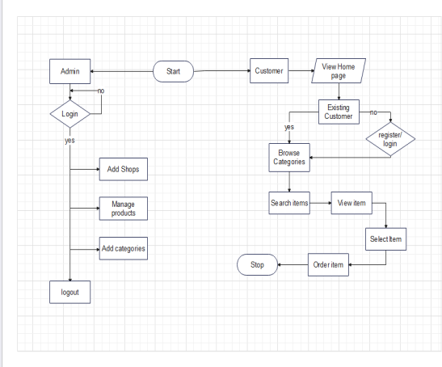

Flow Chart Diagram

A flowchart is a kind of graph that addresses a work process or cycle. A flowchart can likewise be characterized as a diagrammatic portrayal of a calculation, a bit by bit way to deal with tackling an errand. A pictorial portrayal of a calculation builds the comprehensibility of the program.

* + Complex projects can be attracted a basic way utilizing a flowchart.
  + It assists colleagues with getting an understanding into the interaction and utilize this information to gather information, recognize issues, foster programming, and so on.
  + A flowchart is a fundamental stage for planning another interaction or adding additional highlights.
  + Correspondence with others turns out to be simple by drawing flowcharts and sharing them.

1. Advantages:
   * Saves customers time and energy.
   * People can compare prices of products.
   * Delivery at your doorstep.
2. Disadvantages:
   * This website is only for grocery products.
   * This website is designed for a particular city.
   * Return policy is not available.
3. RESULTS

A. Master Page

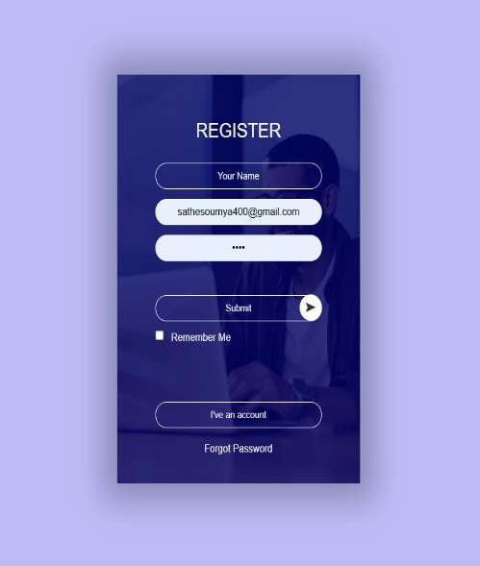

This is the register page .For first when the customer click on the website the home page will be opened then by clicking on the option available below which is not an existing customer new users have to register and finally when they registered successfully then this register page will flip and the login page is on your screen. After the completion of login process you can explore all the shops, categories and items and order your needed product in a very easy way i.e. by making a contact with the shopkeeper through the contact details given.

A. Home Page

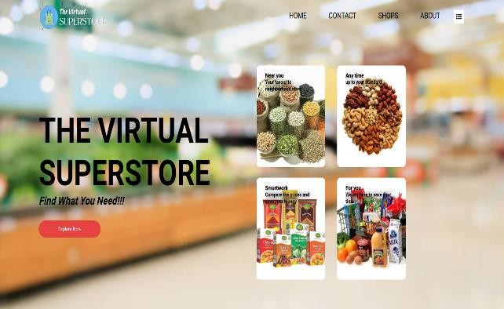

The very First page of our Website is the home page .Below in the home page here two options are given that are if you are an existing customer then you can directly explore the shops on this websites otherwise you have to register/login first Then after from the shops available the user can select shops nearest to them by the address given in the shops description and search the product they want .If the product or items are available then people can order at their doorstep or also can visit the shop.

VII.SHOPS

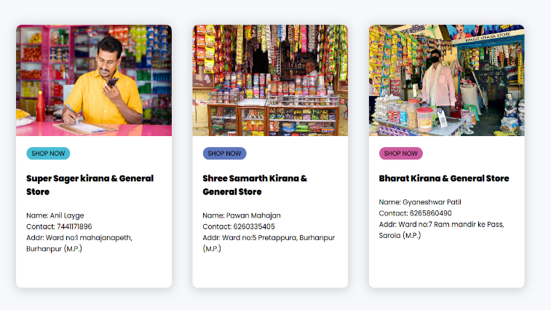

Here are the shops available from where you can pick the shop which is near to you and view the item you want available or not then go to that shop and get your groceries or order them to deliver at your home.

1. MODULES OF THE PROJECT

The framework comprise of the accompanying modules:

Master Maintenance: This module comprises of data about the item and services. This incorporate two sub modules, product expert and cost ace.

Product ace incorporates the data about specific item, for example, item number, item, name, and category, image of items description, features and imperatives of products. All this will be placed to the data set through item ace and thus made accessible in the site .at the end of the day item ace is the administrator region for the merchants/dealers where they can put data about their items which are to be shown in the site.

Cost ace arrangements with the expense of the item, markdown material for the specific result of a merchant/vender.

Detailing: In this module all reports will be created, when the stock is not available on any shop.

IX. CONCLUSION

The Virtual Superstore website saves the time of people as well as their energy as they do not have to visit shop by shop if their needed grocery product is not available on one shop .In this website all the details of customers will be saved so that it will become easier for our customers as they can save their time.

**REFERENCES**

* Software Engineering & Project Management(Technical Publication)
* [www.w3school.com](http://www.w3school.com/)
* [www.scribd.com](http://www.scribd.com/)
* [www.google.com](http://www.google.com/)
* [www.wikipedia.com](http://www.wikipedia.com/)
* JDK API Documentation Online @ <https://docs.oracle.com/en/java/javase/11/> (for JDK 11).
* JDK (Java SE) mother site @ https://www.oracle.com/technetwork/java/javase/overview/index.html