By: Rishikant Upadhyay

E-Commerce Consumer Behaviour Analysis

Title of the Research Paper

# Title of the Research Paper: E-Commerce Consumer Behaviour Analysis

# Abstract

This Research Paper explores the intricacies of consumer behaviour within the realm of E-commerce, shedding light on the factors influencing online purchasing decisions. In an era dominated by digital transactions, understanding consumer preferences and tendencies is paramount for businesses striving to thrive in the competitive E-commerce landscape.

Utilizing a survey-based approach conducted through Google Forms, data was collected from 91 participants, providing valuable insights into the various dimensions of E-commerce consumer behaviour. The survey encompassed aspects such as purchase motivations, preferred payment methods, trust in online transactions, and satisfaction levels with E-commerce platforms.

The findings of this study unveil compelling trends and patterns in E-commerce consumer behaviour, underscoring the significance of factors such as convenience, product quality, pricing, and security in influencing purchasing decisions. Additionally, the research delves into the impact of demographic variables such as age, gender, and income on E-commerce preferences, offering a comprehensive understanding of consumer behaviour dynamics across different segments.

By synthesizing empirical data with theoretical frameworks from marketing and consumer behaviour literature, this thesis provides actionable insights for E-commerce businesses seeking to enhance their strategies and effectively cater to the evolving needs and preferences of online consumers. Furthermore, it contributes to the academic discourse on E-commerce consumer behaviour, offering a foundation for future research endeavors in this domain.

# Objectives of Study

1. To Profile E-commerce Consumers
2. To Analyse E-commerce Shopping Behaviour
3. To Understand Product and Service Preferences
4. To Explore Post-Purchase Behaviour
5. To Identify Factors Influencing Consumer Loyalty
6. To Evaluate General Satisfaction and Recommendation Likelihood
7. To Determine Social Media Engagement with E-commerce Brands

# Introduction

In the realm of electronic commerce (e-commerce), understanding customer behaviour is crucial for businesses aiming to succeed in the digital marketplace. Customer behaviour analysis allows organizations to gain valuable insights into the preferences, needs, and actions of their target audience. By dissecting and interpreting customer behaviour data, businesses can make informed decisions about product offerings, marketing strategies, and user experience optimization.

Consumer behavior in e-commerce is a multifaceted phenomenon influenced by a myriad of factors spanning psychological, social, technological, and economic dimensions. At its core, understanding consumer behavior in the context of online shopping entails unraveling the intricacies of how individuals perceive, evaluate, and ultimately make purchasing decisions in the digital realm. This encompasses a wide spectrum of activities, ranging from browsing product catalogs and comparing prices to navigating through checkout processes and post-purchase interactions. By delving into the underlying motivations, preferences, and behaviors of online shoppers, businesses can gain invaluable insights into how to effectively engage and cater to their target audience in the competitive landscape of e-commerce.

Psychological factors play a pivotal role in shaping consumer behavior in e-commerce. Cognitive processes such as perception, attention, memory, and decision-making mechanisms heavily influence how individuals interact with online platforms and make purchasing choices. For instance, the phenomenon of cognitive biases, including confirmation bias and anchoring bias, can sway consumers' perceptions and judgments, leading to suboptimal decision-making outcomes. Moreover, the perceived risk associated with online transactions, encompassing concerns regarding privacy, security, and product quality, significantly impacts consumers' willingness to engage in e-commerce activities. Building trust and mitigating perceived risk are thus paramount for fostering positive consumer experiences and driving conversion rates in the online marketplace.

## The Importance of Consumer Behavior Analysis in E-commerce

Understanding consumer behavior lies at the heart of successful e-commerce ventures. In the digital marketplace, where competition is fierce and consumer preferences are constantly evolving, a profound comprehension of how individuals navigate online platforms, make purchasing decisions, and interact with brands is paramount. Consumer behavior analysis in e-commerce serves as a guiding light for businesses seeking to tailor their strategies, enhance user experiences, and cultivate lasting relationships with their customers.

At its core, e-commerce consumer behavior analysis provides invaluable insights into the motivations, needs, and desires of online shoppers. By delving into the psychological and sociological factors that influence purchasing decisions, businesses can uncover hidden opportunities and address pain points effectively. For instance, understanding the cognitive biases and decision-making heuristics prevalent among online consumers allows businesses to design intuitive interfaces, streamline the checkout process, and minimize friction points, thereby optimizing the user experience.

Moreover, consumer behavior analysis enables e-commerce businesses to stay attuned to shifting market trends and emerging consumer preferences. In an era where technological innovations and social media dynamics shape consumer behaviors at a rapid pace, staying ahead of the curve is essential for maintaining relevance and competitiveness. By leveraging data-driven insights gleaned from consumer behavior analysis, businesses can adapt their product offerings, marketing strategies, and pricing models to align with evolving consumer expectations, thereby staying agile in a dynamic marketplace.

## Key Factors Influencing Customer Behaviour in Ecommerce

Several factors influence customer behaviour in e-commerce. Understanding these factors allows businesses to pinpoint the drivers behind customer actions and shape their strategies accordingly:

Demographics: Demographic variables such as age, gender, location, and income can significantly impact customer behaviour. Analysing these factors helps businesses identify target markets and tailor marketing messages to specific customer segments.

Psychographics: Psychographics delve into customers' personality traits, values, interests, and lifestyles. By understanding psychographic factors, businesses can create personalized experiences, curate relevant product offerings, and customize marketing content to resonate with specific customer preferences.

Online Channel Preference: Different customers have varying preferences for online channels. Some customers may prefer desktop websites, while others lean towards mobile apps or social media platforms. Businesses need to understand these channel preferences to deliver seamless experiences across all touchpoints.

Purchase Decision-making Process: Analysing the stages of the customer purchase decision-making process (awareness, consideration, evaluation, and purchase) helps businesses optimize their sales funnel and design targeted strategies to guide customers through each stage effectively.

Product Reviews and Ratings: Customer reviews and ratings play a significant role in influencing other potential customers. Analysing and responding to customer feedback helps businesses understand customer sentiment, adapt their products or services, and build trust and loyalty among their customer base.

# Methods and tools for collecting Data

1. Survey Design
2. Google Forms Implementation
3. Data Collection
4. Data Analysis
5. Ethical Considerations

# Research Design

The research design for the master thesis on the topic of E-commerce consumer behaviour analysis, utilizing Google Forms as the data collection method, incorporates a systematic approach to gather comprehensive insights into the intricate dynamics of online consumer behaviour. Employing a quantitative research approach, this study aims to elucidate the multifaceted aspects of E-commerce consumer behaviour and its underlying determinants through the analysis of data collected via Google Forms.

The research approach involves the development of a structured questionnaire tailored to investigate various dimensions of E-commerce consumer behaviour, encompassing demographic information, shopping behaviour patterns, post-purchase behaviour, and general preferences. The questionnaire will be designed meticulously to ensure alignment with the research objectives and theoretical frameworks in consumer behaviour. Utilizing Google Forms as the data collection tool offers several advantages, including ease of administration, accessibility to a wide range of respondents, and streamlined data aggregation and analysis processes.

# Methodology

**Analysis In Quantitative Terms**

Quantitative data gleaned from surveys will be analysed by use of statistical software

In order to provide a concise summary of the most important findings, descriptive statistics such as mean, median, and standard deviation will be computed.

**Analysis of Qualitative Data**

Thematic analysis is going to be used on a variety of different types of qualitative data, including open-ended survey responses and user comments. In order to gain a more in-depth understanding of customer behaviour, themes and patterns in qualitative data will be uncovered and recognized.

**Data Collection Methods:**

1. Google Forms Survey
2. Convenience Sampling Approach

# Data Analysis and Interpretation

**Data Preparation and Processing**

The data planning and processing process for an E-Commerce Consumer Behaviour Analysis includes the following steps:

1. **Data Cleaning**: This includes reviewing the collected data for errors, inconsistencies, missing values. and inconsistencies. Value, all inconsistencies at this stage are resolved or removed.
2. **Data entry**: Coded inputs are entered into computer software such as Microsoft Excel.
3. **Descriptive Statistics**: This step involves calculating the frequency, mean, and standard deviation for each variable in the data.
4. **Interpreting the results:** Interpreting the results of the statistical analysis and draw conclusions based on the research objectives and questions.

# Data Analysis

1. Age Distribution

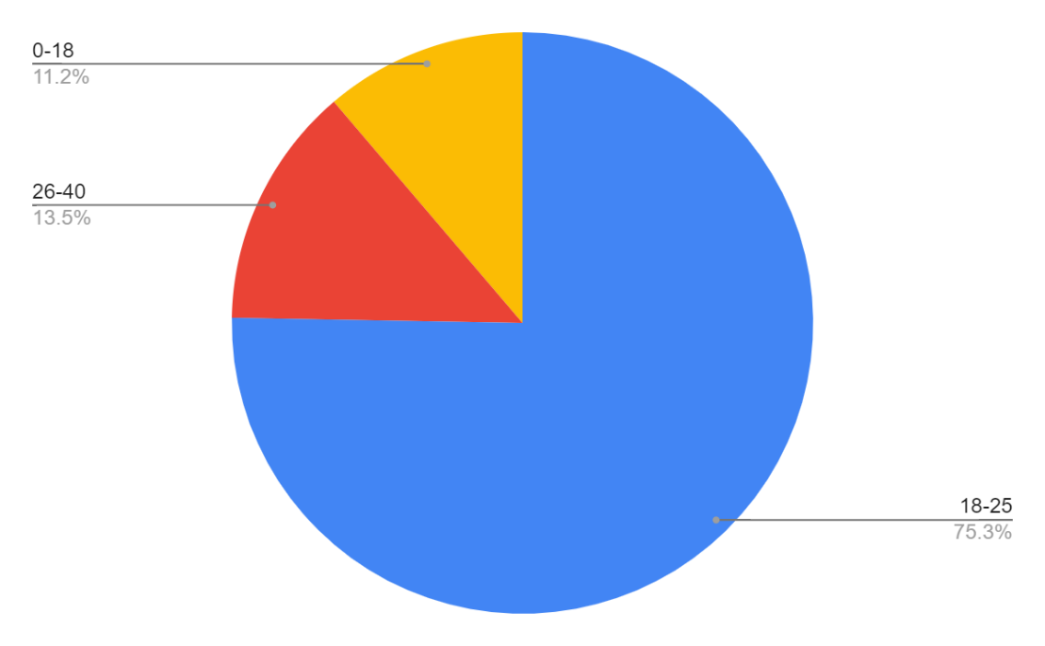

1. **Factors Influencing online shopping decision**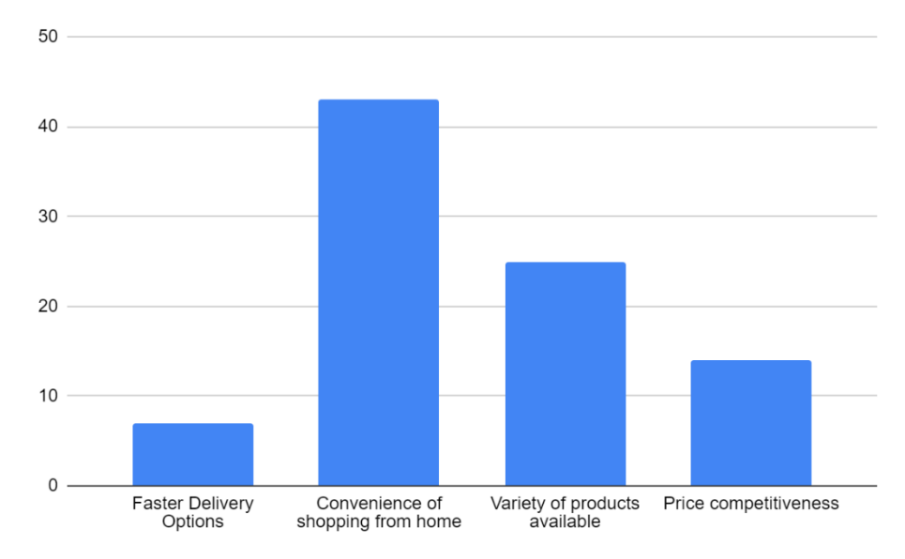
2. **Reading Online Reviews before Purchase**

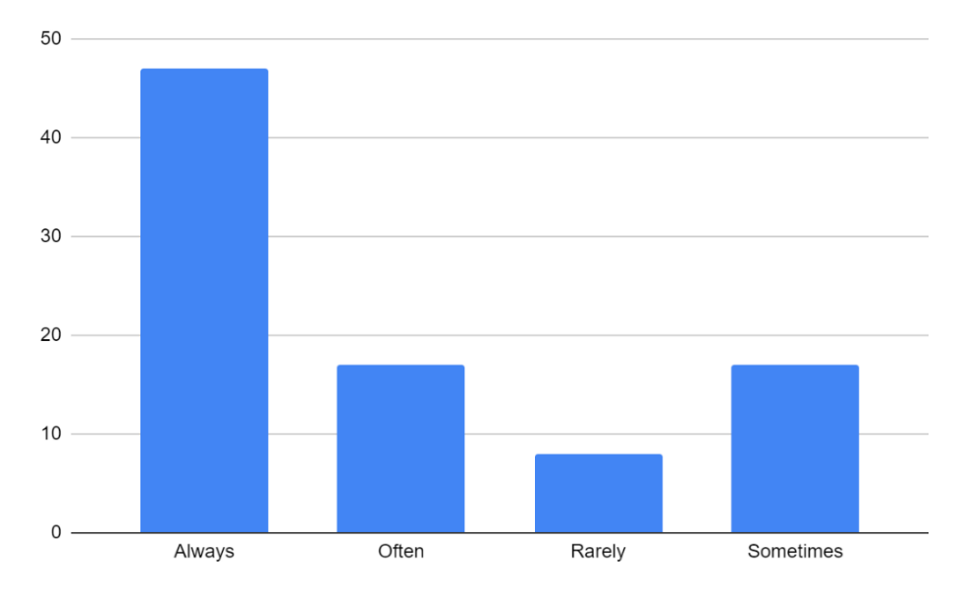

1. **Preferred Payment Method**

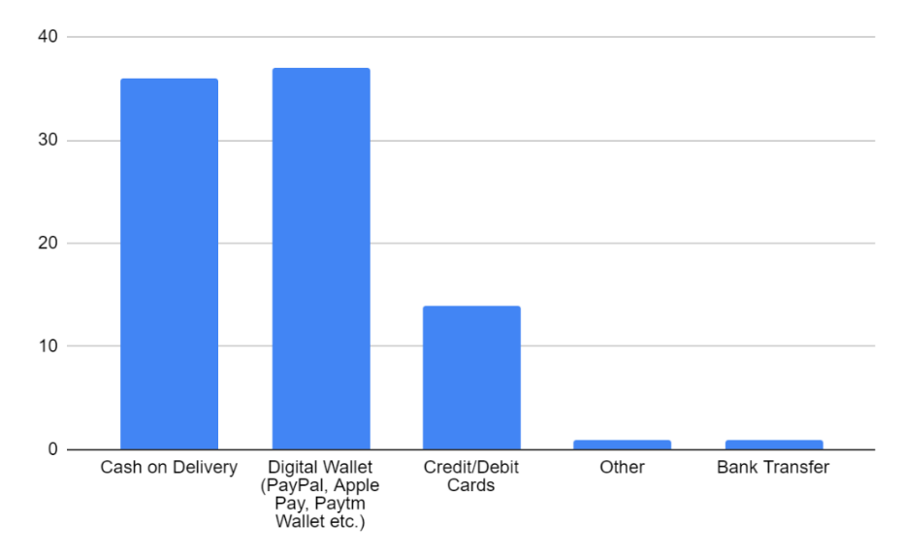

# Limitations

1. **Sample Bias**: The sample might not be representative of the entire population due to potential biases in recruitment methods or participation rates. For example, the questionnaire might attract respondents who are more tech-savvy or have a higher level of education, potentially skewing the results.
2. **Self-Reported Data Reliability**: Responses are based on self-reporting, which can be subject to biases such as social desirability bias or recall bias. Participants might not always provide accurate information about their online shopping behaviour, preferences, or experiences.
3. **Limited Generalizability**: Findings from the study might not be generalizable beyond the specific demographic characteristics of the sample. For instance, if the majority of respondents are from a particular age group or income bracket, the findings may not apply to other demographics.
4. **Temporal Limitations**: The study's findings might be time-bound and may not reflect long-term trends or changes in e-commerce consumer behaviour. As consumer preferences and technology evolve rapidly, the data collected at a specific point in time might become outdated.
5. **Questionnaire Design Constraints**: The questionnaire's design, including the selection of questions and response options, might not capture the full complexity of e-commerce consumer behaviour. Certain factors influencing online shopping decisions or post-purchase behaviours might not be adequately addressed in the questionnaire.
6. **Limited Scope of Analysis**: The questionnaire primarily focuses on individual-level factors influencing e-commerce behaviour, such as demographics and preferences. However, broader contextual factors, such as macroeconomic trends or regulatory environments, are not thoroughly explored, potentially limiting the depth of analysis.
7. **Language and Cultural Considerations**: The questionnaire might not account for cultural or linguistic differences that could affect how respondents interpret and respond to the questions. Translation issues or cultural nuances could impact the validity and reliability of the data collected.

# Conclusion:

The analysis of the questionnaire on "E-Commerce Consumer Behaviour" has provided valuable insights into the preferences, habits, and attitudes of online shoppers across various demographics. Through this study, it has been observed that the majority of respondents fall within the age group of 26-35 years, predominantly male, with a bachelor's degree and employed full-time.

Regarding e-commerce shopping behaviour, convenience and price competitiveness emerge as significant factors influencing online purchase decisions. The smartphone emerges as the primary device for online shopping, highlighting the increasing trend towards mobile commerce. Furthermore, online reviews play a crucial role in the decision-making process for a significant portion of respondents, emphasizing the importance of user-generated content in shaping consumer choices.

Preferences for product categories vary among respondents, with electronics and gadgets being a popular choice followed by clothing and fashion items. Product/service reviews hold substantial weight in influencing purchase decisions, indicating the significance of building trust and credibility through customer feedback. Additionally, expedited shipping options are valued by consumers, suggesting a willingness to pay extra for faster delivery.

Post-purchase behaviour reveals a mixed sentiment towards leaving reviews, with a significant portion of respondents indicating a likelihood to leave a review after making a purchase. Furthermore, factors such as excellent customer service and regular discounts/offers are identified as key drivers for fostering customer loyalty towards e-commerce platforms.

Overall, the satisfaction levels with the online shopping experience are predominantly positive, with a majority of respondents expressing satisfaction and likelihood to recommend their favourite e-commerce platforms to others. Additionally, engagement with e-commerce brands on social media platforms is observed to be moderate, highlighting the importance of maintaining an active presence on social media for brand visibility and customer engagement.

# Recommendations:

Based on the findings of the study, several recommendations can be made to e-commerce platforms and marketers to enhance the online shopping experience and better cater to consumer needs:

1. **Personalized Marketing**: Utilize data-driven insights to personalize marketing efforts and tailor product recommendations based on individual preferences and purchase history.
2. **Mobile Optimization**: Further optimize e-commerce websites and applications for mobile devices to enhance the user experience and facilitate seamless mobile shopping.
3. **Review Management**: Invest in strategies to encourage and manage online reviews effectively, including incentivizing customers to leave feedback and promptly addressing any negative reviews or customer concerns.
4. **Shipping Options**: Offer flexible shipping options, including expedited shipping and same-day delivery, to cater to varying consumer preferences and increase customer satisfaction.
5. **Customer Loyalty Programs**: Implement customer loyalty programs and rewards to incentivize repeat purchases and foster long-term customer relationships.
6. **Social Media Engagement**: Increase engagement with consumers on social media platforms through interactive content, promotions, and customer support to strengthen brand loyalty and drive traffic to e-commerce websites.

# References

* Bellizzi, J., Crowley, A. and Hasty, R. (1983). The effects of colour in store design. Retail, 59(1), 21–45.
* Dawar, N. and Parked, Ph. (1994). Marketing Universals: Consumers use of brand name, price, physical appearance, and retailer reputation as signals of product quality. Market, 58, 23-57.
* Dick, A. (1990). Memory-based inferences during consumer choice. Consumer Research, 17, 82–93.
* Elliot, A., Maier, M., Moller, A., Friedman, R. and Meinhardt, J. (2007). Colour and psychological functioning: the effect of red on performance attainment. Experimental Psychology, 136(1), 154–168.
* Elliot, A. and Niesta, D. (2008). Romantic red: red enhances men’s attraction to women. Personality and Social Psychology. 95(5), 10–17.
* Fred D. Davis, “Perceived Usefulness, Perceived Ease of Use, and User Acceptance of Information Technology”, Journal Storage, vol. 13, no. 3, pp. 319-340, Sep. 1989.