**REAL ESTATE USING BLOCK CHAIN**

**Amey Dalvi*1, Rohit Jadhav*2, Vinit Kareliya*3, Tejas Jaiswal*4, Sayali Karmode*5**

*1*2*3*4Student, Department of Information Technology, MGM College of Engineering and Technology, Navi Mumbai, Maharashtra, India.

*5Faculty, Department of Information Technology, MGM College of Engineering and Technology, Navi Mumbai, Maharashtra, India.

# ABSTRACT

With the introduction of blockchain technology, the real estate sector is changing. Because blockchain technology is decentralized and unchangeable, it was first developed for cryptocurrencies like Bitcoin but has found use in many other industries. Blockchain promises to improve security, facilitate transactions, and promote transparency in the real estate industry. The use of blockchain technology in real estate management and transactions is examined in this article. It looks at how blockchain technology can transform escrow services, smart contracts, title transfers, and other conventional property transaction processes. Real estate transactions can be made more accessible, economical, and efficient by utilizing blockchain technology Blockchain use in real estate is not without its difficulties, though. Scalability, interoperability, and regulatory compliance are a few of the major obstacles that must be overcome before broad use. To further foster confidence among stakeholders, worries about data security and privacy must be properly handled.

The potential advantages of blockchain technology in real estate are enormous, notwithstanding these difficulties. Blockchain has the potential to completely change the way that real estate is purchased, sold, and managed by facilitating quicker transactions, cutting expenses, and enhancing transparency. Blockchain technology is set to play a major role in real estate in the future as regulations change and the technology advances.

# INTRODUCTION

Blockchain maintains data in a network of linked blocks, much like a digital ledger or record-keeping system. A hash is a special identifier that is unique to each block of data. The unique feature of blockchain technology is its decentralized structure, which means that no single organization, such as a government or bank, controls it. Rather, a network of computers known as nodes maintains it, validating and logging transactions. Blockchain technology is safe and impenetrable because it is very impossible to change a block after it has been put to the chain. Although this technology is best known for powering cryptocurrencies like Bitcoin, its uses go much beyond merely facilitating financial transactions; supply chain management and voting systems are only two examples of what it may be used for. In essence, blockchain offers an honest and transparent method of exchanging and storing data without the need for middlemen.

The real estate sector is well-known for its intricate workings, which include several middlemen, protracted procedures, and copious amounts of paperwork. But the rise of blockchain technology has spurred a wave of innovation that could completely change the way properties are handled and real estate transactions are carried out. Blockchain, the decentralized and unchangeable ledger technology that powers digital currencies like Bitcoin, provides an innovative answer to a number of problems the real estate industry is now facing. Blockchain offers a transparent and safe platform for recording transactions, which can improve efficiency, decrease fraud, and streamline procedures.

The context for examining the relationship between blockchain technology and real estate is established by this introduction. It identifies the main problems the sector is experiencing and describes how blockchain technology might help. It also gives a summary of the subjects that will be discussed in more detail in the parts that follow, such as the advantages of blockchain technology in real estate transactions, the possible uses for smart contracts, and the effects of tokenization on property ownership. As we learn more about how blockchain technology is being incorporated into real estate, it's clear that this ground-breaking strategy has the potential to completely change how homes are purchased, sold, and maintained.

This introduction sets the stage for analysing the connection between blockchain technology and real estate. It lists the primary issues facing the industry and explains how blockchain technology could be of assistance.

# LITERATURE REVIEW

**Blockchain Applications in Real Estate Transactions**:

A number of studies have looked into how blockchain might be used to expedite real estate deals. Blockchain can speed up the transfer of property titles, improve transparency, and lower fraud, according to research by Hameed et al. (2019). According to Zheng et al. (2020), smart contracts are essential for automating contracts between buyers and sellers and reducing the need for middlemen.

**Tokenization and Fractional Ownership**:

One potential application of blockchain technology is the tokenization of real estate holdings. Research by Lian et al. (2021) and Lee et al. (2022) explore the advantages of blockchain-enabled fractional ownership, which enables investors to buy and sell fractional shares of real estate. This strategy increases investment opportunities and improves real estate market liquidity.

**Regulatory and Legal Considerations**:

Legal and regulatory issues are important determinants of how blockchain technology is adopted in the real estate industry. Yermack (2019) and Demir et al. (2020) conducted research that examines the difficulties related to property rights, data privacy, and regulatory compliance. Academics stress how crucial it is to create precise legal frameworks to deal with problems like property tokenization and the enforceability of smart contracts.

**Challenges and Limitations:**

The use of blockchain in real estate confronts a number of obstacles despite its potential advantages. According to Xu et al. (2021) and Sharma et al. (2023), the three main technical obstacles are scalability, interoperability, and integration with current systems. Implementation is further hampered by issues with data integrity, cybersecurity, and opposition from conventional stakeholders.

**Future Directions and Opportunities:**

Numerous directions for further study and advancement in blockchain-based real estate applications are offered by the literature. Research by Wang et al. (2023) and Cai et al. (2022) suggests innovative methods for improving the interoperability and scalability of blockchain technology. Furthermore, studies that concentrate on ecosystem growth, market dynamics, and user acceptability can offer important new perspectives on how blockchain technology will affect real estate in the long run.

# METHODOLOGY

1. **Research and Analysis**: Conduct a comprehensive analysis of the current challenges and inefficiencies in the real estate industry. Identify specific pain points such as lengthy transaction times, high costs, lack of transparency, and fraud susceptibility.

1. **Understanding Blockchain Technology**: Educate stakeholders about blockchain technology, its principles, and its potential applications in real estate. Explore various blockchain platforms and consensus mechanisms to determine the most suitable solution for the intended use cases.

1. **Use Case Identification**: Identify and prioritize use cases where blockchain can add the most value in real estate, such as property transactions, title management, lease agreements, or property data management.

1. **Stakeholder Engagement**: Engage key stakeholders including real estate agents, property developers, legal experts, government agencies, and financial institutions. Gather feedback and insights to ensure alignment with industry requirements and regulatory compliance.

1. **Development of Proof of Concept (PoC):** Develop a proof of concept (PoC) to demonstrate the feasibility and functionality of blockchain-based solutions for real estate.

Test the PoC in a controlled environment to validate its effectiveness in addressing the identified use cases.

1. **Prototype Development**: Develop a prototype of the blockchain-based real estate solution incorporating feedback from the PoC phase. Design the architecture, user interface, and smart contract logic to ensure seamless integration with existing real estate workflows.

1. **Pilot Implementation**: Select a limited number of properties or transactions for the initial pilot implementation of the blockchain solution. Collaborate with participating stakeholders to execute realworld transactions and evaluate the performance of the system.

1. **Monitoring and Evaluation**: Monitor the pilot implementation to assess the efficiency, security, and user experience of the blockchain solution Gather feedback from stakeholders and iterate on the prototype to address any identified issues or areas for improvement.

1. **Scalability and Integration**: Evaluate the scalability of the blockchain solution to accommodate a larger volume of transactions and properties. Explore opportunities for integrating the blockchain solution with existing real estate platforms, databases, and regulatory frameworks.

1. **Regulatory Compliance:** Work closely with regulatory authorities to ensure compliance with relevant laws and regulations governing real estate transactions.Implement necessary safeguards to protect sensitive data and ensure data privacy for all parties involved.

1. **Deployment and Rollout:** Deploy the finalized blockchain solution for real estate on a larger scale, ensuring proper training and support for users. Monitor the ongoing performance of the system and provide continuous updates and maintenance as needed.

# MODELING AND ANALYSIS

The integration of blockchain technology into the real estate sector has garnered significant attention due to its potential to revolutionize traditional practices. This paper presents a comprehensive modeling and analysis of the implications of blockchain in real estate transactions, focusing on its impact on efficiency, transparency, and security.

The study begins by elucidating the foundational principles of blockchain technology, emphasizing its decentralized nature, cryptographic security, and immutable ledger functionality. It then examines how these characteristics can address key challenges in real estate transactions, such as fraud prevention, data integrity, and cumbersome intermediaries.

A modeling framework is proposed to conceptualize the integration of blockchain at various stages of the real estate transaction lifecycle, including property listing, offer negotiation, contract execution, and title transfer. Each stage is analyzed to identify potential bottlenecks, inefficiencies, and opportunities for optimization through blockchain implementation.

Furthermore, the paper conducts a comparative analysis of traditional real estate processes versus blockchainenabled workflows. By quantifying parameters such as transaction speed, cost reduction, and risk mitigation, the analysis demonstrates the tangible benefits of adopting blockchain in real estate transactions.

Moreover, the study evaluates the impact of blockchain on market dynamics, including liquidity, accessibility, and asset tokenization. Through simulation modeling and scenario analysis, the paper explores the potential effects of widespread blockchain adoption on real estate markets, investor behavior, and regulatory frameworks.

The analysis also considers potential challenges and barriers to adoption, including regulatory compliance, interoperability, and scalability. By incorporating these factors into the modeling framework, the paper provides a holistic assessment of the opportunities and challenges associated with blockchain integration in real estate.

Finally, the study concludes with recommendations for stakeholders, including policymakers, real estate professionals, and technology developers, to facilitate the adoption and implementation of blockchain in the real estate sector. By leveraging the insights from this modeling and analysis, stakeholders can navigate the complexities of blockchain integration and harness its transformative potential to reshape the future of real estate transactions.

# PROPOSED SYSTEM

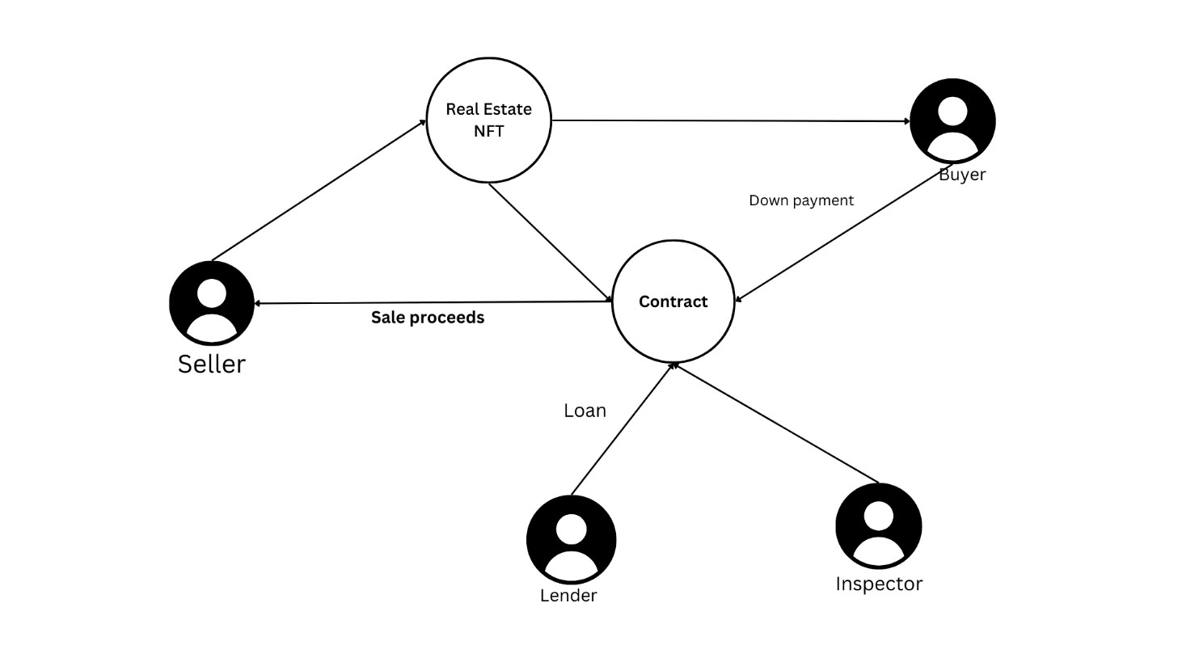

**Figure5.1:** System architecture

The Diagram depicts the relation between the client and the Smart Contract, basically the client passes the data to get stored on Smart Contract

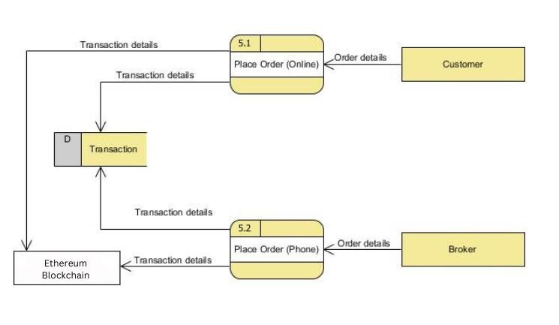**Figure5.2:** Data Flow Diagram

The above Diagram shows the overall flow of the project of smart contract by which Client can store Ethers,Buy token on Metamask and connect with Dapps. Nodes and Blockchain Solidity performs to carry out Smart Contract project successfully.

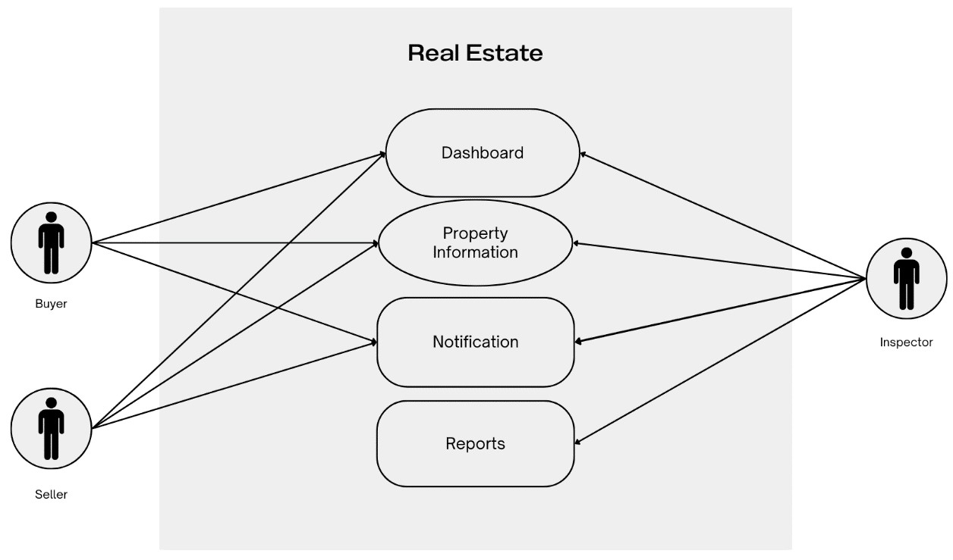

**Figure5.3:**ER Diagram

The Entity-Relationship Diagram shows the features about the user can perform with the application.

# RESULTS AND DISCUSSION

The integration of blockchain technology in the real estate industry has yielded significant results and sparked discussions around its potential to transform traditional processes. Below are key findings and discussions regarding the impact of blockchain on various aspects of real estate:

1. **Efficiency and Transparency**:

Blockchain has streamlined real estate transactions by providing a decentralized, transparent, and tamper-proof ledger of property ownership and transaction history. This transparency reduces the need for intermediaries, such as title companies and escrow agents, resulting in faster and more cost-effective transactions. Moreover, the immutable nature of blockchain records minimizes the risk of fraud and ensures the integrity of property titles.

1. **Smart Contracts:**

Smart contracts, enabled by blockchain technology, have automated and enforced agreements between buyers and sellers in real estate transactions. These self-executing contracts execute predefined terms automatically once conditions are met, eliminating the need for manual intervention and reducing the potential for disputes. Smart contracts can facilitate various aspects of real estate transactions, including property transfers, rental agreements, and lease payments.

1. **Fractional Ownership and Tokenization:**

Blockchain has enabled fractional ownership and tokenization of real estate assets, allowing investors to purchase and trade fractional shares of properties. This innovation increases liquidity in real estate markets by lowering the barriers to entry for individual investors and providing opportunities for diversification. Tokenization also simplifies the process of raising capital for real estate projects through crowdfunding and peer-to-peer lending platforms.

1. **Challenges and Considerations:**

Despite its potential benefits, the adoption of blockchain in real estate faces several challenges. Regulatory compliance, interoperability between different blockchain platforms, and scalability issues need to be addressed to ensure widespread implementation. Moreover, concerns regarding data privacy, security, and the risk of smart contract vulnerabilities require careful consideration. Overcoming these challenges will require collaboration between industry stakeholders, policymakers, and technology developers.

1. **Future Outlook:**

The future of blockchain in real estate holds promise for further innovation and disruption. As the technology matures and regulatory frameworks evolve, blockchain is expected to become increasingly integrated into various aspects of property transactions and management. Continued research and development in areas such as decentralized finance (DeFi), non-fungible tokens (NFTs), and digital identity verification are likely to drive further advancements in the use of blockchain in real estate.

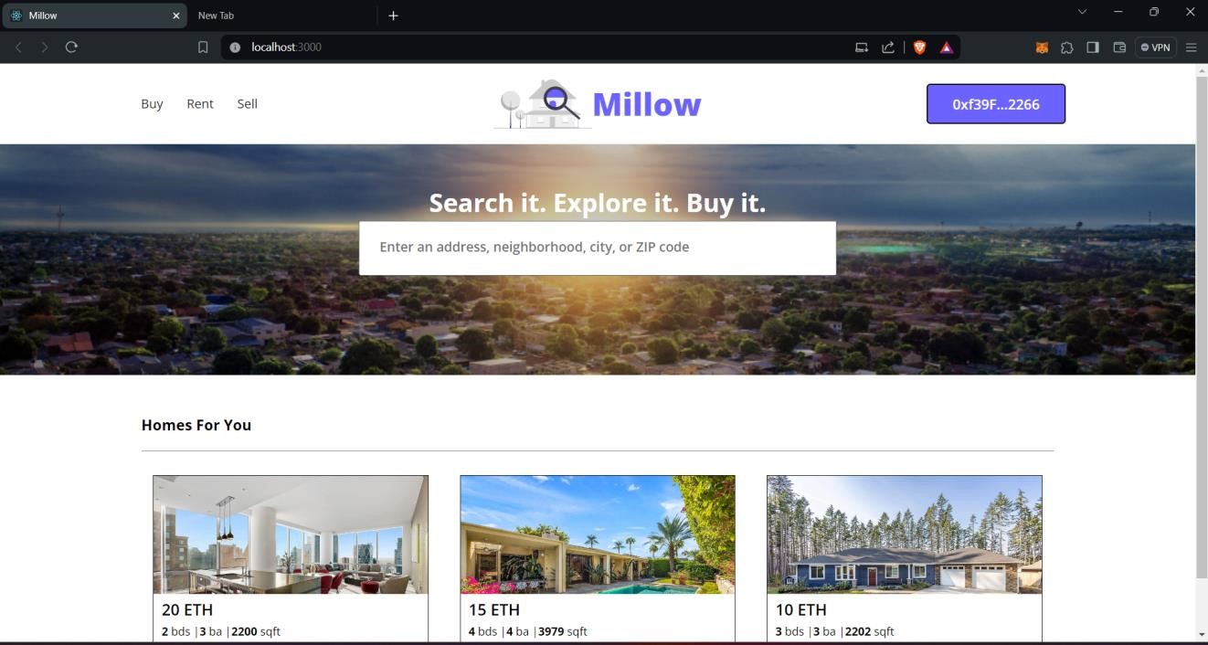

**Figure 1:** Home Page.

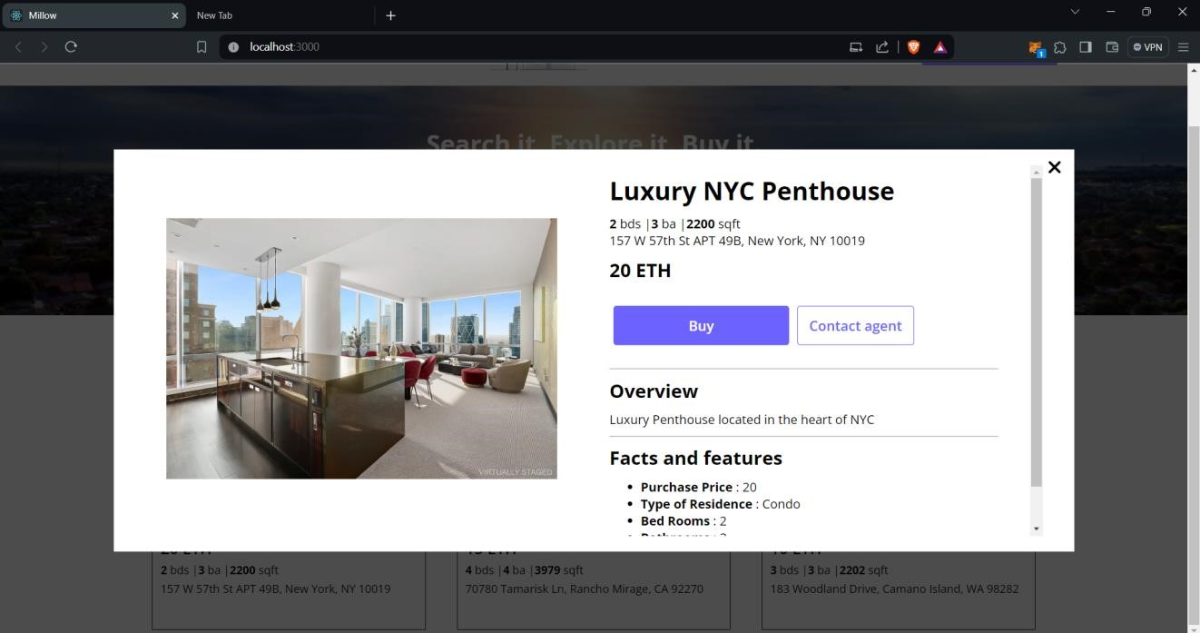

**Figure 2:** Buyer Page.

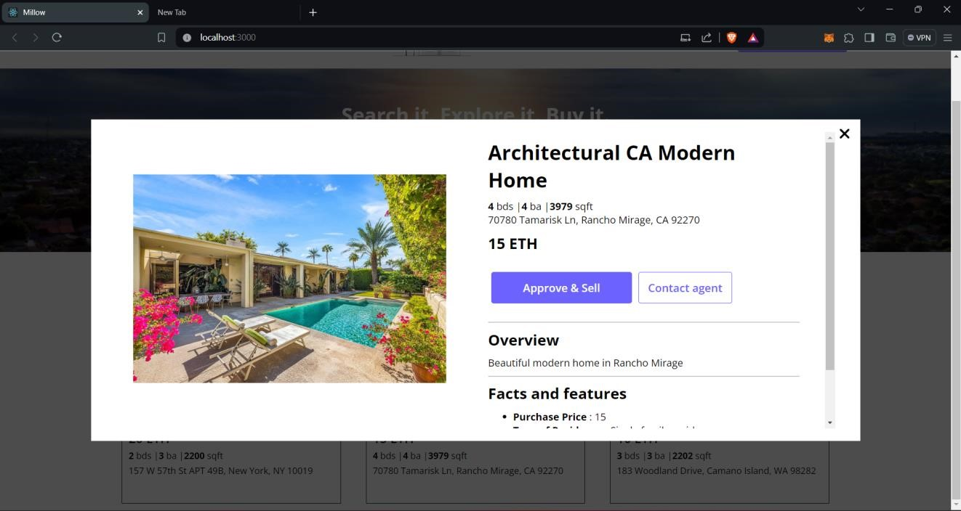

**Figure 3:** Seller Page.

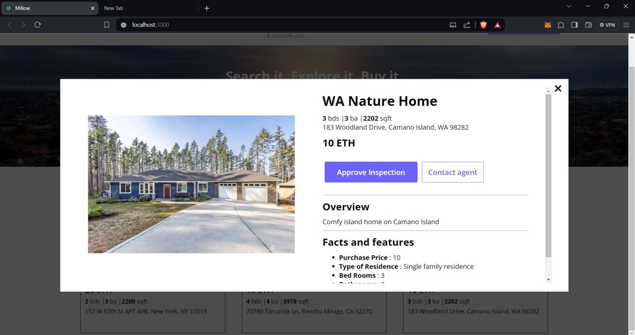

**Figure 4:** Inspector Page.

# CONCLUSION

In conclusion, the integration of blockchain technology into the real estate industry represents a significant step towards modernizing and revolutionizing traditional processes. By leveraging blockchain's decentralized ledger, smart contracts, and tokenization capabilities, real estate transactions can become more efficient, secure, and accessible to a wider range of participants. Blockchain's ability to provide transparent and tamper-proof records of property ownership and transaction history addresses long-standing issues of fraud and opacity in the real estate market. Smart contracts automate and enforce agreements, reducing the need for intermediaries and minimizing the potential for disputes. Furthermore, blockchain enables fractional ownership and tokenization of properties, enhancing liquidity and opening up new investment opportunities for individuals. Crowdfunding and peer-to-peer lending platforms powered by blockchain offer investors greater flexibility and diversification in real estate investment. However, challenges such as regulatory compliance, interoperability, and scalability remain obstacles to widespread adoption. Addressing these challenges will require collaboration between industry stakeholders, policymakers, and technologists to develop robust frameworks and standards. Despite these hurdles, the potential benefits of blockchain in real estate are undeniable. As the technology continues to mature and regulatory frameworks evolve, blockchain is poised to transform the way properties are bought, sold, and managed. By embracing blockchain, the real estate industry can unlock new levels of efficiency, transparency, and innovation, ushering in a new era of growth and opportunity.

# REFERENCES

[1] S. Gore, S. Hamsa, S. Roychowdhury, G. Patil, S. Gore and S. Karmode, "Augmented Intelligence in Machine Learning for Cybersecurity: Enhancing Threat Detection and Human-Machine Collaboration," 2023 Second International Conference on Augmented Intelligence and Sustainable Systems (ICAISS), Trichy, India, 2023,

pp. 638-644, DOI: 10.1109/ICAISS58487.2023.10250514.

[2] Layth Almahadeen, Renzon Daniel Cosme Pecho, Murugananth Gopal Raj, Nichenametla Rajesh, Zainab

Mohammed Imneef, Sayali Karmode Yelpale, “Digital Investigation Forensic Model with P2P Timestamp

Blockchain for Monitoring and Analysis” , Journal of Electrical System, Vol. 1, No 1, (2024): 09-17 (DOI :

https://doi.org/10.52783/jes.656)

[3] Sayali Karmode, Security Challenges for IoT Based Applications & Solutions Using Fog Computing: A Survey, Journal of Journal of Cybersecurity and Information Management, Vol. 3 , No. 1 , (2020) : 21-28 (DOI :https://doi.org/10.54216/JCIM.030103)

[4] M. S. K. Yelpale, “Security and privacy challenges in cloud computing: a review,” Journal of Cybersecurity and Information Management, vol. 4, no. 1, pp. 36–45, 2020. View at: Google Scholar.

[5] Sayali Karmode Yelpale, “IOT Technology for Pandemic Situation,” NJITM, vol. 4, no. 2, pp. 25–27, Jan. 2022 https://mbajournals.in/index.php/JoITM/article/view/806.

[6] Karmode, S. S., & Bhagat, V. B. (2017). DETECTION AND BLOCKING SOCIAL MEDIA MALICIOUS

POSTS. International journal of modern trends in engineering and research, 4(5).

[7] Kermode, S. S., & Bhagat, V. B. (2016). A Review: Detection and Blocking Social Media Malicious Posts. Int.J. Mod. Trends Eng. Res, 3(11), 130-136. doi: 10.21884/IJMTER.2016.3133.Q4M8O .

[8] Prof. Bhushan B. Thakare, Prof. Sayali Karmode Yelpale, “Smart Home with Edge Computing,” InternationalJournal of Interdisciplinary Innovative Research & Development (IJIIRD), Vol 6, 2021 https://ijiird.com/wp-content/uploads/CSE016-1.pdf

[9] Sayali Karmode, “Blockchain Technology Security Issues and Concerns : A Review,” International ResearchJournal of Modernization in Engineering Technology and Science, Vol 6, Issue 03, March 2024

DOI : https://www.doi.org/10.56726/IRJMETS50249

[10] Pranav Chavan, Harshraj Deshmukh, Aakash Dhotre, Aditya Gharat, Sayali Karmode, “Blockchain Democracy Evaluating a Secure Voting System”, International Research Journal of Modernization in Engineering Technology and Science, Vol 6, Issue 03, March 2024 DOI : https://www.doi.org/10.56726/IRJMETS50478

[11] B. J. Dange, Kaustubh Manikrao Gaikwad, H. E. Khodke, Santosh Gore, S. N. Gunjal, Kalyani Kadam, Sayali Karmode, “Machine Learning for Quantum Computing Bridging the Gap between AI and Quantum Algorithms”, Int J Intell Syst Appl Eng, vol. 12, no. 21s, pp. 600–605, Mar. 2024.

[12] N Kumar, E Howard, S Karmode, Reinforcement Learning for Optimal Treatment Planning in Radiation

Therapy”, NATURALISTA CAMPANO, Vol 28, Issue 1, 2024

https://museonaturalistico.it/index.php/journal/article/view/355

[13] M. Shah, M. Shaikh, V. Mishra and G. Tuscano, "Decentralized Cloud Storage Using Blockchain," 2020 4th International Conference on Trends in Electronics and Informatics (ICOEI)(48184), Tirunelveli, India, 2020,pp. 384-389, doi: 10.1109/ICOEI48184.2020.9143004. keywords: {Contracts; Peer-to-peer computing; Cloudcomputing; Encryption; Blockchain; Data Security; IPFS; Encryption; Smart Contract; Cloud Storage},

[14] G. Richa Shalom, Ganesh Rohit Nirogi,Dec, "Decentralized Cloud Storage Using Blockchain," DOI

Link: https://doi.org/10.22214/ijraset.2022.46810

[15] Crosby.M, P. Pattanayak, S. Verma, and V. Kalyanaraman, “Blockchain technology: Beyond bitcoin,” Applied

Innovation, vol. 2, pp. 6–10, 2016.

[16] David Vorick et al. Sia: Simple Decentralized Storage. 2014.

[17] Eli Ben-Sasson et al. Zerocash: Decentralized Anonymous Payments from Bitcoin.2014.

[18] Jin Sun et al. Blockchain-Based Secure Storage and Access Scheme for Electronic Medical Records in

IPFS.IEEE.2014.