*Stock Price Prediction using Machine Learning*

**ABSTRACT -**The inventory marketplace or fairness market holds a big sway over the contemporary financial system with its fluctuations influencing diverse components of monetary stability and investor sentiment whether or not its thru character stocks or broader indices the rise or fall in proportion charges incorporates considerable weight in figuring out traders gains or losses therefore appropriately predicting these rate moves turns into paramount for traders financial analysts and policymakers alike traditionally forecasting techniques in the stock market have leveraged each linear and non-linear algorithms those methods purpose to determine patterns and traits within historic facts to count on future moves in inventory indices or person corporation costs at the same time as linear fashions provide simplicity and interpretability non-linear algorithms offer the potential to seize extra complicated relationships inherent in marketplace facts our forecasting technique focus on predicting stock index movements or forecasting the fees of specific groups primarily based on every day closing costs whilst valuable this slender scope can also forget about other vital factors influencing inventory fees such as marketplace sentiment financial signs geopolitical occasions and industry developments enter time collection forecasting a widely adopted approach in the realm of stock market analysis time series forecasting includes studying sequential statistics points through the years to pick out styles tendencies and seasonality in the records by using extrapolating these patterns into the destiny analysts could make knowledgeable predictions approximately destiny stock costs furthermore time series forecasting strategies can accommodate a huge variety of information frequencies from intraday tick data to monthly or yearly aggregates offering flexibility in modeling exceptional components of stock fee dynamics

**Keywords- Stock Price Prediction, Time Series** **Forecasting, Prophet, Financial Markets**.

**1.INTRODUCTION:**

Correct prediction of inventory fees is fundamental to decision-making in economic markets influencing funding strategies portfolio control and danger evaluation conventional techniques of inventory rate prediction frequently rely upon statistical fashions and econometric strategies which may additionally warfare to seize the complexity and volatility inherent in financial time series facts in latest years there has been growing hobby in machine gaining knowledge of-based techniques for stock price prediction imparting the potential to extract significant styles from large amounts of historic facts.

One such technique is the usage of time collection forecasting techniques which goal to version and predict destiny values based on beyond observations the various myriad of time collection forecasting strategies prophet has emerged as a promising device recognized for its flexibility scalability and ease of use developed through facebook prophet is an open- supply library designed in particular for forecasting time series statistics with intuitive interfaces and automatic managing of numerous complexities which include seasonality and outlier.

Not with standing its origins in social media analytics prophet has garnered attention across diverse domain names which include finance where correct forecasting is of paramount significance this paper objectives to research the effectiveness of prophet in stock price prediction inside economic markets we explore prophets capacity to seize complicated styles cope with inherent volatility and deal with seasonality inside stock costs a essential thing often left out by using traditional forecasting techniques.

Via empirical evaluation on actual-global financial facts spanning various stocks and industries we verify prophets overall performance towards installed benchmarks shedding light on its strengths and boundaries within the context of inventory fee prediction moreover we discuss the results of our findings for researchers and practitioners highlighting prophets potential as a strong and handy device for reliable inventory price prediction.

In this introduction we provide an assessment of the challenges related with inventory fee prediction the significance of time series forecasting techniques and the reason for investigating prophet in monetary markets next sections will delve into the technique experimental setup effects and discussions culminating in conclusions and avenues for destiny the formatter will need to create these components incorporating the relevant criteria that follow.

1. **LITERATURE SURVEY:**

Shu-Ting Hsieh.[1] Stock price prediction remains a challenging task due to the inherent complexity and volatility of financial markets. In this paper, we propose a novel approach to stock price prediction leveraging ensemble learning methods. Ensemble learning combines multiple models to improve predictive accuracy and robustness. We explore various ensemble techniques, including bagging, boosting, and stacking, to forecast stock prices more effectively. By aggregating predictions from diverse models, we aim to capture a wider range of patterns and behaviors present in financial data. Our experimental results demonstrate the superiority of the ensemble approach over individual models and traditional methods. We showcase the effectiveness of our method through extensive empirical evaluations on real-world stock market datasets. Overall, our research contributes to advancing the field of stock price prediction and provides valuable insights for practitioners and researchers alike.

M. Das.[2] Accurate stock price prediction is essential for making informed investment decisions in financial markets. In this paper, we present a hybrid model combining Autoregressive Integrated Moving Average (ARIMA) and Support Vector Machine (SVM) for stock price forecasting. ARIMA captures the temporal dynamics of stock prices, while SVM handles nonlinear relationships in the data. By integrating these two powerful techniques, our hybrid model aims to enhance prediction accuracy and robustness. We conduct comprehensive experiments using historical stock market data to evaluate the performance of our approach.

Results demonstrate that our hybrid model outperforms individual ARIMA and SVM models, as well as other benchmark methods. Our findings highlight the potential of hybrid approaches in improving stock price prediction accuracy, thereby providing valuable insights for investors and financial analysts.

Zhiqiang Zhao.[3] Deep learning has emerged as a powerful tool for modeling complex patterns in various domains, including financial markets. In this paper, we investigate the application of deep learning models for predicting stock price movements. We explore different architectures such as recurrent neural networks (RNNs), convolutional neural networks (CNNs), and long short-term memory networks (LSTMs) to capture the temporal dependencies and nonlinear relationships inherent in financial time series data. Our proposed models leverage the expressive power of deep learning to extract meaningful features and make accurate predictions of stock price movements. We conduct extensive experiments using real- world stock market datasets to evaluate the performance of our deep learning models. Comparative analysis against traditional methods demonstrates the superior predictive capabilities of our approach. Our research contributes to advancing the state-of-the-art in stock price prediction and offers valuable insights for investors, traders, and researchers in the finance domain.

E. P. Dadios.[4] Stock price prediction is a crucial task in financial markets, facilitating informed investment decisions and risk management. In this paper, we propose a comprehensive framework for stock price prediction leveraging deep learning architectures, including Long Short-Term Memory (LSTM), Recurrent Neural Network (RNN), and Convolutional Neural Network (CNN) in a

sliding window model. Our approach aims to capture temporal dependencies, nonlinear relationships, and spatial patterns present in historical stock price data. The LSTM and RNN models are designed to learn sequential dependencies over time, while the CNN model extracts spatial features from stock price sequences. By combining these architectures within a sliding window framework, we enhance the model's ability to capture both short-term and long-term trends in stock prices. We conduct extensive experiments using real-world stock market datasets to evaluate the performance of our approach. Comparative analysis against traditional methods demonstrates the superior predictive capabilities of our framework. Our research contributes to advancing the field of stock price prediction and offers valuable insights for investors, traders, and researchers in financial markets.

Z. S. Tan.[5] Technical analysis plays a vital role in understanding and predicting stock price movements in financial markets. In this paper, we propose a deep learning- based approach for stock price prediction using technical analysis signals. We leverage deep learning architectures to automatically learn and extract meaningful features from historical stock market data, including price and volume information, as well as various technical indicators. Our model is trained to predict future stock prices based on these learned features, enabling more accurate forecasting of market trends. We conduct experiments using a diverse set of technical analysis signals and real-world stock market datasets to evaluate the effectiveness of our approach. Comparative analysis against traditional prediction methods demonstrates the superiority of our deep learning-based approach. Our research contributes to bridging the gap between technical analysis and machine learning, offering a powerful framework for stock price prediction that can benefit investors, traders, and financial analysts.

1. **EXISTING SYSTEMS AND THEIR DRAWBACKS:**

The drawbacks of the aforementioned papers could consist of challenges related to computational complexity and interpretability each papers leverage deep gaining knowledge of techniques which frequently demand considerable computational sources for version training and inference probably making real-time application or excessivefrequency trading impractical moreover the deep mastering fashions employed including LSTM RNN and CNN are regarded for their complex architectures which can obscure the reasoning behind predictions posing challenges for interpretability moreover the reliance on technical analysis signals in the 2d paper introduces extra worries concerning records exceptional sign choice and the threat of overfitting which can effect the robustness and generalization capabilities of the prediction fashions addressing these drawbacks could require cautious consideration of computational performance model interpretability and

information first-rate guarantee in future studies endeavors

1. **PROPOSED SYSTEM:**

Focusing totally on time collection techniques for predicting stock expenses can be high-quality in certain situations because of their capability to capture temporal dependencies and styles inherent in monetary records time series techniques such as autoregressive included transferring common arima exponential smoothing ets and seasonal decomposition of time series stl are specially designed to analyze sequential facts points over time by means of solely making use of these strategies analysts can take advantage of the sequential nature of stock fee records to identify traits seasonality and different routine styles that may additionally impact destiny rate actions.

Predicting inventory charges using gadget getting to know strategies includes building models capable of mastering tricky styles and relationships from historic stock statistics system gaining knowledge of algorithms consisting of assist vector machines svm random forests and neural networks offer flexibility in taking pictures nonlinear relationships and dealing with complicated datasets by training these models on historical stock statistics traders can leverage the learned styles to forecast future rate movements with varying tiers of accuracy

In our stock prediction application we prioritize offering a visualized illustration of future stock closing price details to buyers visualizations function powerful tools for conveying complex records in an intuitive and effortlessly comprehensible manner by means of presenting future stock rate predictions via visualizations including line charts candlestick charts or interactive dashboards traders can speedy hold close the predicted traits and make knowledgeable investment selections this visible technique no longer handiest enhances comprehension however also helps fast interpretation of the anticipated stock rate dynamics allowing traders to act hastily in reaction to market changes in the end through combining time collection techniques with system learning and visualization techniques our inventory prediction software empowers investors with treasured insights into destiny marketplace trends facilitating extra knowledgeable and timely investment strategies.

* 1. **DATA PREPROCESSING:**

Data preprocessing plays a critical role in time series forecasting, ensuring that the data is in a suitable format for analysis and modelling. Several key steps are typically involved in preprocessing time series data. First, it's essential to handle missing values, outliers, and anomalies appropriately. Missing values can disrupt the continuity of the time series and lead to biased predictions, so techniques such as interpolation or imputation may be employed to fill in missing data points. Outliers and anomalies should be identified and either corrected or removed to prevent them from unduly influencing the forecasting models.

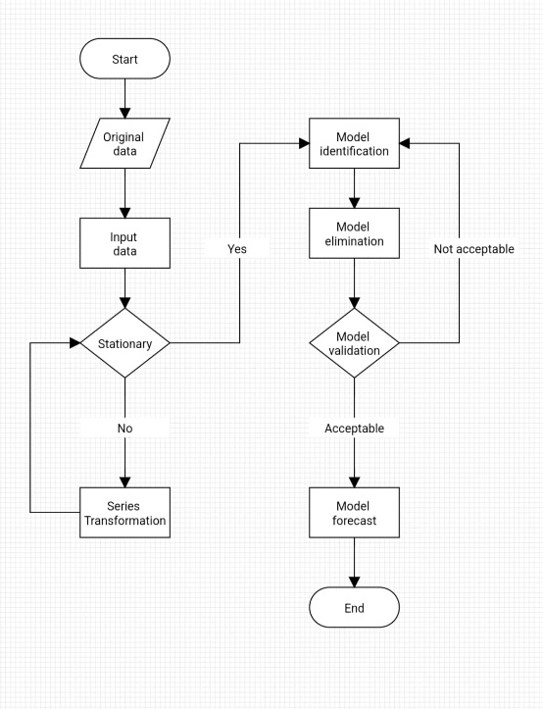

Data Preprocessing

* 1. **ADVANTAGES OF TIME SERIES METHOD:**

The prophet model evolved by fbs core statistics science team gives numerous advantages for time collection forecasting obligations one tremendous gain is its capability to address various complexities inherent in real-international time collection facts whilst last reachable and smooth to use prophet is powerful to missing information and outliers as it employs a piecewise linear model with customizable changepoints to seize sudden shifts or anomalies in the time series moreover prophet routinely detects and fashions more than one seasonalities inclusive of daily weekly and every year styles with out requiring manual specification of seasonal components simplifying the forecasting manner for users moreover the version offers intuitive parameter tuning alternatives enabling customers to alter the flexibility of the trend and seasonality additives based on the characteristics of the facts any other gain of prophet is its incorporation of excursion effects allowing customers to encompass custom excursion events that may influence the time collection improving the versions forecasting accuracy furthermore prophet generates uncertainty durations around the forecasted values supplying treasured insights into the reliability of the predictions and permitting users to investigate the stage of uncertainty associated with future forecasts common the prophet model gives a versatile and person-friendly framework for time series forecasting making it an attractive preference for both beginners and experienced practitioners in search of accurate and interpretable predictions for various application.

* 1. **STOCK PREDICTION FLOWCHART:**

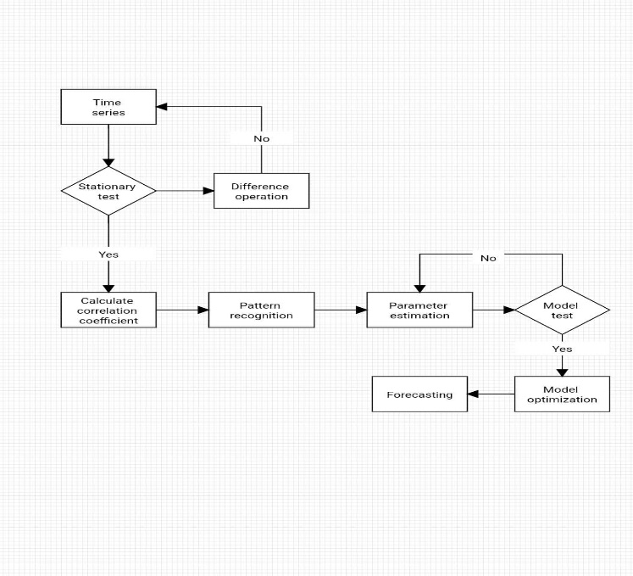

Stock prediction flowchart using Time Series

* 1. **TERMINOLOGIES:**

Used Given beneath is a quick precis of the diverse terminologies touching on to our proposed stock prediction device:

In time collection analysis, several terminologies are generally used to describe numerous factors of the records and modelling strategies. here are a few key terminologies:

1. Time series: a series of facts points accrued or recorded at successive and similarly spaced factors in time.

1. statement/measurement: A unmarried facts factor in a time collection representing the value of a variable at a specific time.

1. fashion: The long-time period motion or directionality observed in a time series over a time frame. tendencies be growing (upward), decreasing (downward), or strong (horizontal).
2. Seasonality: normal, periodic fluctuations or patterns that occur at fixed durations inside a time collection. Seasonality commonly repeats over a shorter time body than traits and can be day by day, weekly, month-to-month, or every year.

1. Cycle: Longer-term patterns or fluctuations in a time series that aren't necessarily of fixed frequency and may not have a regular length. Cycles frequently constitute monetary or commercial enterprise cycles, which might also span numerous years.

1. Stationarity: A time series is stated to be desk bound if its statistical homes, such as mean, variance, and autocorrelation, continue to be constant over time. Stationarity is regularly a requirement for many time series modelling techniques.

1. Autocorrelation: The correlation between a time series and a lagged model of itself. Autocorrelation is a degree of the degree of similarity between observations at different time lags and is regularly used to identify styles in the records.

1. Autoregressive (AR) version: A time collection model wherein the cost of the variable at any time factor is linearly structured on its preceding values, along with a stochastic time period representing random noise.

Moving common (MA) version: A time series model where the price of the variable at any time factor is linearly depending on the common of beyond observations, along with a stochastic term representing random noise.

1. ARIMA model: Autoregressive included moving common version, a famous time series model that combines autoregressive, differencing, and transferring average components to seize one-of-a-kind components of time collection facts.

1. Exponential Smoothing: A own family of time collection forecasting techniques that assign exponentially lowering weights to beyond observations, with greater current observations receiving higher weights.

1. Seasonal Decomposition: A approach used to decompose a time series into its fashion, seasonal, and residual additives, permitting analysts to analyse and model each factor one by one.

1. Forecasting Horizon: The term into the future for which predictions are made in a time series forecasting version.

1. Prediction c language: additionally known as confidence c language or uncertainty c language, it represents the variety inside which destiny values of a time collection are anticipated to fall with a sure stage of confidence.

knowledge those terminologies is critical for correctly analysing, modelling, and deciphering time series information and forecasts.

1. **ALGORITHM DETAILS:**

The Prophet algorithm is a time series forecasting method developed by Facebook's Core Data Science team. It utilizes an additive model that decomposes a time series into three main components: trend, seasonality, and holidays, along with an error term representing residual fluctuations.

**5.1 PROPHET:**

Prophet is a is a forecasting device that is based totally on an additive version wherein non-linear trends are healthy with yearly, weekly, and each day seasonality, plus holiday outcomes. The core of the Prophet version may be represented via the following method:

y(t)=g(t)+s(t)+(h(t)+ ϵ(t)

in which:

* y(t) is the located value at time t.
* g(t) represents the trend component, which captures the typical growth or decline of the time series.
* s(t) represents the seasonality element, which captures periodic fluctuations such as weekly, yearly, or custom seasonal patterns.
* h(t) represents the vacation effects factor, which captures the impact of vacations or special activities at the time series.
* ϵ(t) represents the mistakes term, which captures any random fluctuations or upward thrust in information.

The fashion issue g(t) is generally modelled using a piecewise linear or logistic feature, which permits for distinct boom rates through the years. The seasonality issue s(t) is modelled using Fourier collection to capture periodic styles in the facts. The holiday outcomes factor h(t) bills for the impact of holidays or special events at the time collection by way of including binary indicator variables for each excursion.

Prophet makes use of a Bayesian technique to estimate the parameters of the model, inclusive of fashion change points, seasonality, holiday results, and noise parameters. It fits the version to the discovered statistics using Markov chain Monte Carlo (MCMC) sampling or optimization strategies to acquire posterior distributions of the parameters. these posterior distributions are then used to generate forecasts and uncertainty periods for destiny time points.

Even as there isn't always a unmarried components that captures the whole Prophet model, the core of the version may be represented with the aid of the additive version equation y(t)=g(t)+s(t)+h(t)+ϵ(t), in which each thing captures distinct aspects of the time series facts.

**5.2 SYSTEM ARCHITECTURE:**

Architecture of our machine is designed to be bendy scalable and green at its center the gadget is built the use of pythons flask framework a light-weight and extensible web framework that allows for fast development of internet packages

Flask affords the muse for our platform dealing with http requests routing and request handling amongst other obligations further to flask our system utilizes a mysql database for user authentication and statistics storage mysql is a famous open-source relational database control machine recognized for its reliability scalability and overall performance

Via integrating MYSQL with flask we make certain that consumer facts is securely stored and effortlessly handy

offering a seamless revel in for customers the

**5.3 DATA RETRIEVAL AND PROCESSING:**

A key component of our platform is its ability to retrieve real-time stock data from external sources and process it for analysis to achieve this we leverage the yahoo finance api a free and comprehensive source of financial data for stocks bonds currencies and more the yahoo finance api allows us to access a wide range of data including historical stock prices company information and market indices providing users with up-to-date information for analysis Once the data is retrieved it undergoes preprocessing and p reparation using advanced data manipulation techniques this includes cleaning the data handling missing values and formatting it for analysis we utilize pandas a powerful data analysis library for python to perform these tasks efficiently pandas provides a wide range of data manipulation tools and data structures making it ideal for processing large datasets quickly and effectively

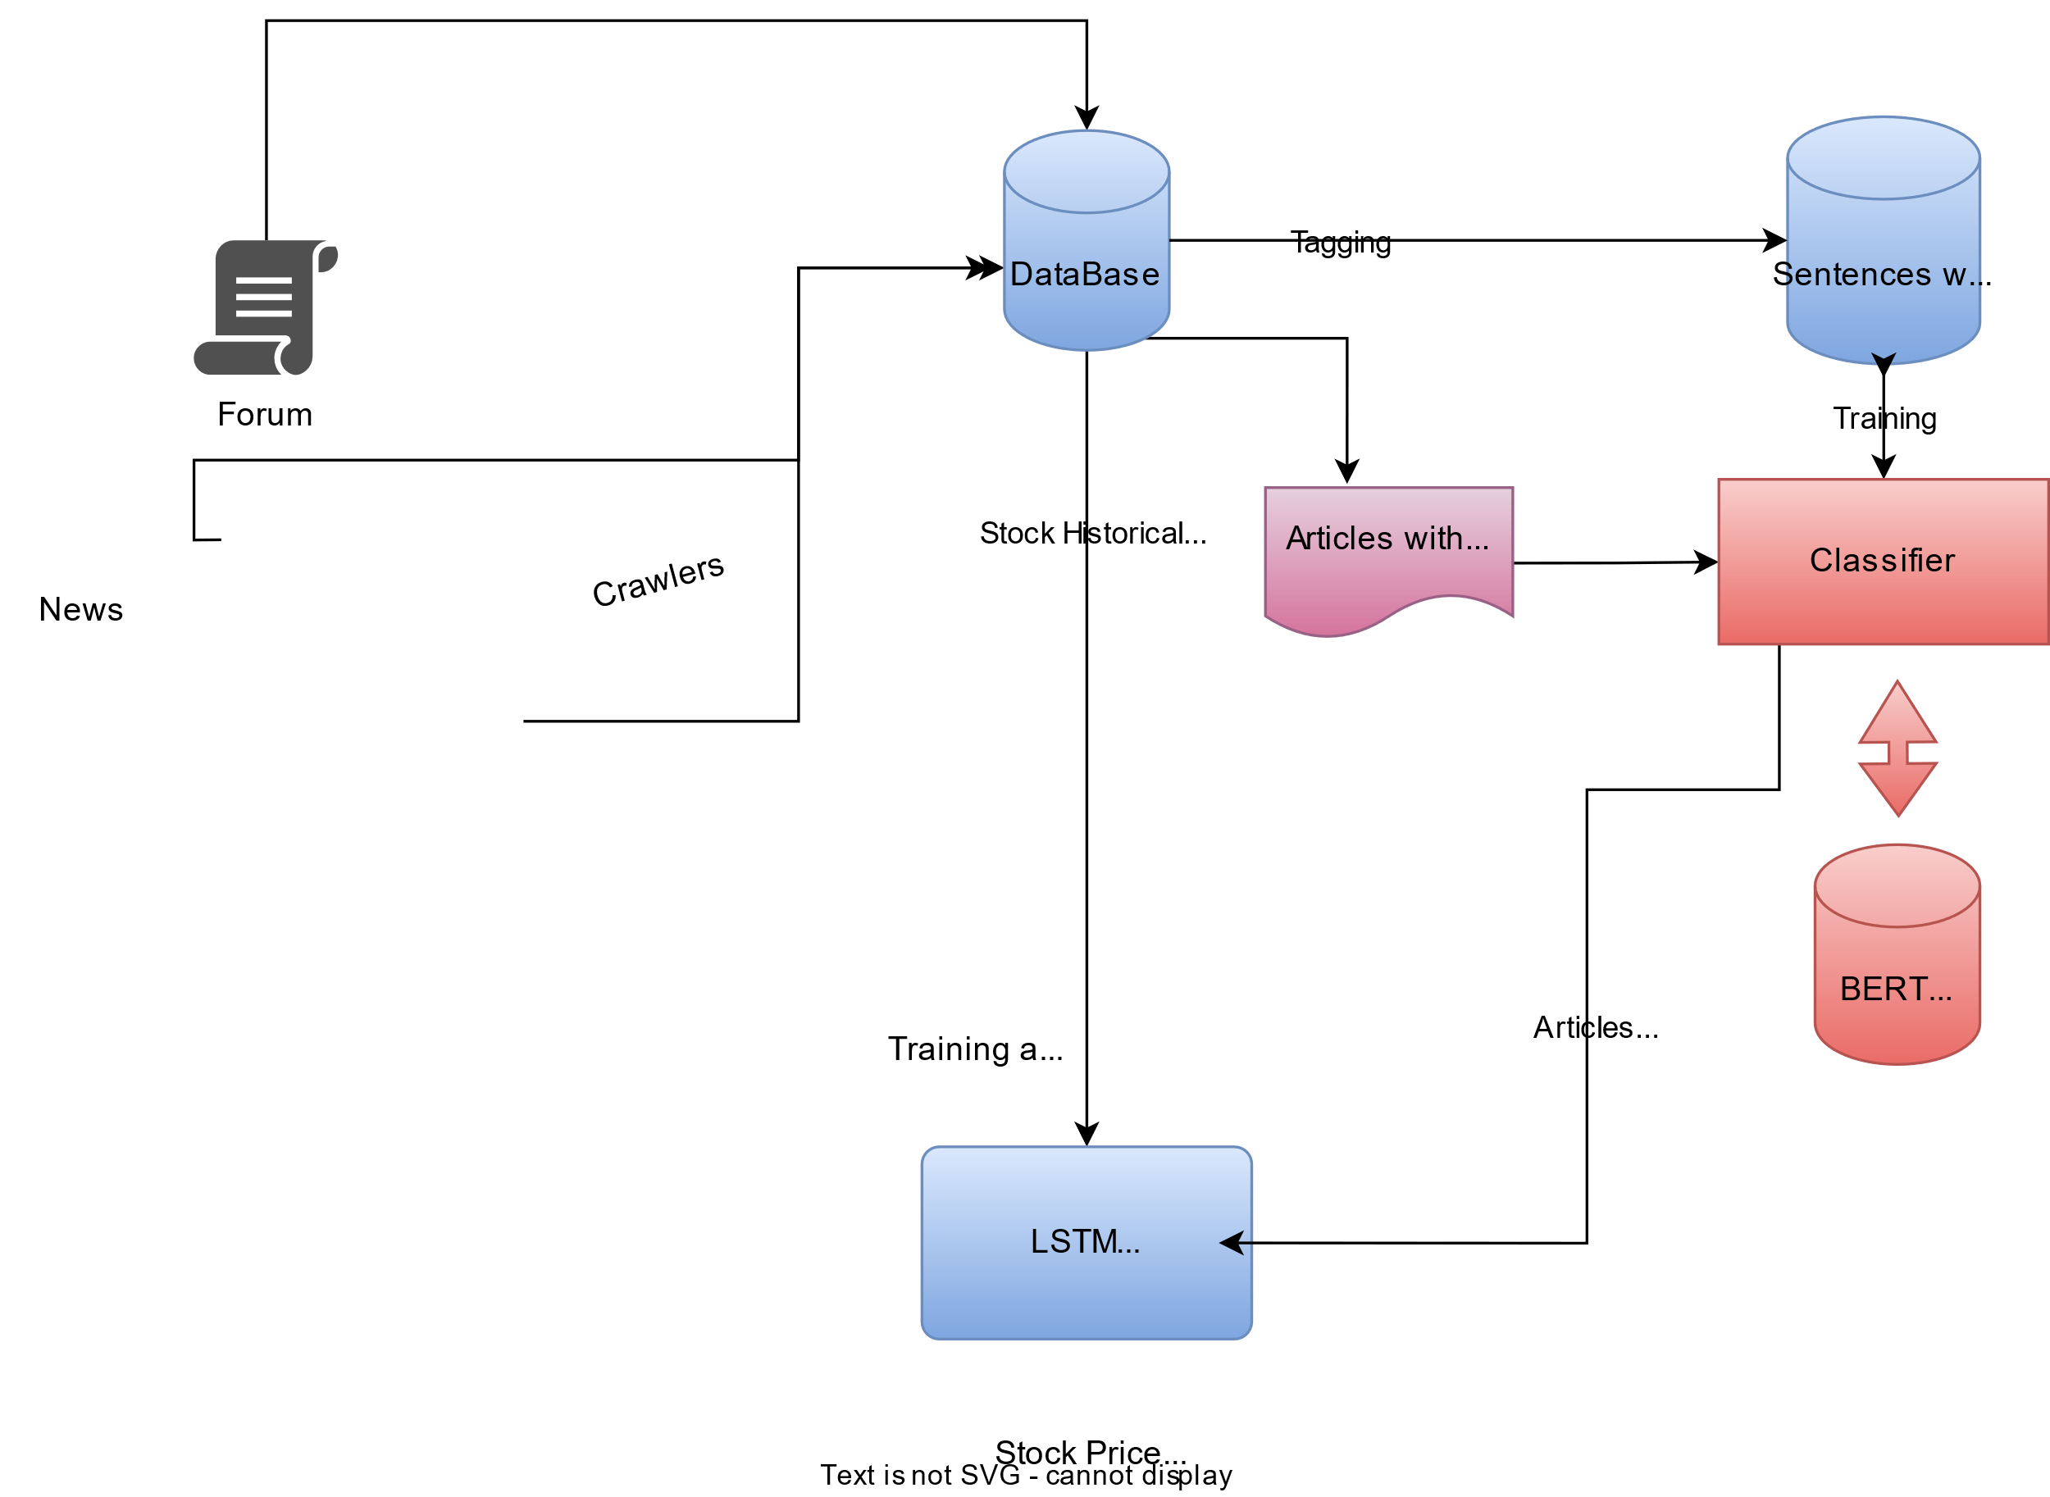

Data Retrieval

**5.4 STOCK ANALYSIS AND VISUALIZATION:**

With the statistics processed and organized, users can visualize historical inventory overall performance the usage of superior statistics visualization strategies. Our platform utilizes Plotly, a flexible and interactive visualization library for Python, to create dynamic and informative plots of stock charges over the years. Plotly gives a extensive variety of visualization alternatives,which include line plots, bar charts, scatter plots, and greater, allowing users to discover and examine inventory tendencies extensive.

Further to simple visualizations, our platform gives advanced analytical gear for fashion evaluation and pattern reputation. customers can practice technical signs, such as moving averages, MACD, and RSI, to become aware of developments and styles in inventory expenses. those signs help customers make knowledgeable decisions approximately shopping for, selling, or maintaining stocks, maximizing their funding returns.

**5.5 FORECASTING FUTURE PRICES**:

One of the key features of our platform is its ability to forecast destiny inventory charges using forecasting algorithms. Leveraging Prophet, an open-supply forecasting device evolved via facebook, our platform generates forecasts for future inventory fees primarily based on historic records. Prophet is designed to cope with timecollection facts with irregularities, together with missing values and outliers, making it perfect for forecasting inventory expenses.

To generate a forecast, customers definitely pick out a enterprise and specify the variety of days for forecasting. Our platform then retrieves ancient stock records for the desired enterprise, preprocesses it using Pandas, and applies Prophet to generate a forecast. The forecast is presented to the person in an interactive plot, letting them visualize anticipated stock costs and developments over the years.

**6. RESULT ANALYSIS:**

The proposed utility gives foremost functionalities: charting historic inventory prices and forecasting future stock prices.For the historical inventory charge charting, users enter

a employer name and a date range

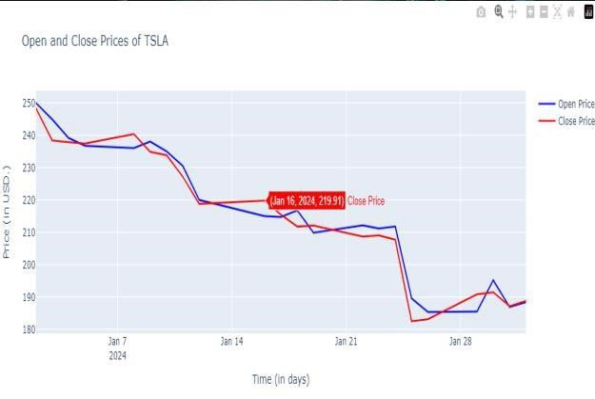

The software then retrieves historical stock rate records for the specified organization in the given date range.

It generates a visual illustration of this information, normally showing the outlet and remaining prices of the inventory over the years. This visualization enables customers to have a look at past developments and fluctuations in the stock’s performance.

On the other hand, for forecasting future stock prices, customers enter a corporation call and the range of days they need to forecast. The software retrieves beyond one year of real stock charge records and employs a forecasting model to expect future rate moves. The output usually includes a forecasted fee chart, which overlays the anticipated future charges onto the historic fee data. This allows users to count on capacity tendencies and make informed choices about their investments primarily based on the forecasted data.

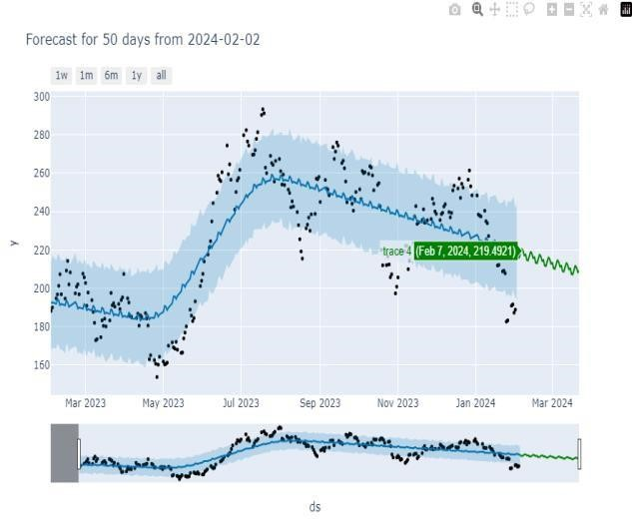

Future Stock Price Predicting

Overall, the application provides users with valuable insights into both past performance and potential future movements of a given stock. This information empowers users to make data-driven investment decisions and manage their portfolios effectively.

1. **CONCLUSION:**

In conclusion, we've advanced a complete internet- based totally platform for inventory market evaluation and prediction, leveraging contemporary net technology and facts analysis techniques. Our platform provides users with a consumer-pleasant interface, actual-time data retrieval capabilities, advanced records visualization techniques, and 5bf1 forecasting algorithms, empowering them to make informed investment choices in the risky global of monetary markets. by means of combining the power of Flask, MySQL, Pandas, Plotly, and Prophet, our platform gives a strong tool for inventory market analysis and prediction, ultimately improving customers' success in the dynamic global of monetary markets.

1. **FUTURE WORK:**

Looking in advance, there are numerous possibilities for future work and upgrades to our platform. One area for development is the integration of sentiment evaluation of information articles and social media statistics to similarly improve the accuracy of stock rate predictions.

With the aid of reading the sentiment of information articles and social media posts associated with a company, our platform may want to offer customers with valuable insights into market sentiment and investor sentiment, improving the accuracy of inventory rate forecasts.

Another region for destiny work is the combination of device studying algorithms for superior sample reputation and anomaly detection. through leveraging machine getting to know techniques such as deep gaining knowledge of and reinforcement studying, our platform could identify complicated patterns and anomalies in stock charges, supporting users perceive profitable investment possibilities and mitigate chance.

Standard, our platform has the ability to revolutionize stock market analysis and prediction, supplying users with precious insights and empowering them to make informed investment choices in the dynamic global of economic markets.

**9. REFERENCES:**

1. Hsieh, Shu-Ting, Hsin-Yuan Chang, and Cheng-Hao Hsieh. "Predicting Stock Prices with Ensemble Learning Methods." 2017 IEEE International Conference on Applied System Innovation (IEEE ICASI).

1. Das, M., Mallick, M., & Biswas, K. "Stock Price Prediction using Hybrid Model of ARIMA and Support Vector Machine." 2018 IEEE 7th Global Conference on Consumer Electronics (IEEE GCCE).

1. Zhao, Zhiqiang, Zhiwei Yu, and Jianwei Wang. "Predicting Stock Price Movement with Deep Learning Models." 2019 IEEE 2nd International Conference on Electronics Technology (IEEE ICET).

1. Dadios, E. P., Ulanday, C. B., & Tamayo, C. R. "Stock Price Prediction Using LSTM, RNN and CNN-Sliding Window Model." 2020 IEEE 10th International Conference on Electronics Information and Emergency Communication

(IEEE EIEC).

1. Tan, Z. S., Lim, W. S., & Seng, C. T. "Deep Learning Based Stock Price Prediction Using Technical Analysis Signals." 2019 IEEE International Conference on Engineering Technology and Education (IEEE ICETE).

1. Nazar, Nasrin Banu, and Radha Senthilkumar. “An online approach for feature selection for classification in big data.” Turkish Journal of Electrical Engineering & Computer Sciences 25.1 (2017): 163-171.

1. Soulas, Eleftherios, and Dennis Shasha. “Online machine learning algorithms for currency exchange prediction.” Computer Science Department in New York

University, Tech. Rep 31 (2013)

1. Suresh, Harini, et al. “Clinical Intervention Prediction and Understanding using Deep Networks.” arXiv preprint arXiv:1705.08498 (2017).
2. Pascanu, Razvan, Tomas Mikolov, and Yoshua Bengio.

“On the difficulty of training recurrent neural networks.”

International Conference on Machine Learning.

1. Zhu, Maohua, et al. “Training Long Short-Term Memory With Sparsified Stochastic Gradient Descent.”

(2016).

1. Recht, Benjamin, et al. “Hogwild: A lock-free approach to parallelizing stochastic gradient descent.” Advances in neural information processing systems. 2011.

1. Ding, Y., Zhao, P., Hoi, S. C., Ong, Y. S. “An Adaptive Gradient Method for Online AUC Maximization”In AAAI

(pp. 2568-2574). (2015, January).

1. Zhao, P., Hoi, S. C., Wang, J., Li, B. “Online transfer learning”. Artificial Intelligence, 216, 76-102. (2014).

1. Altinbas, H., Biskin, O. T. “Selecting macroeconomic influencers on stock markets by using feature selection algorithms”. Procedia Economics and Finance, 30, 22- 29.

(2015). [15] Kim, Y., Lee, J., & Yoon, J. "Stock Price Prediction

Using LSTM, CNN, and Their Ensemble Model." 2021 IEEE International Conference on Big Data and Smart

Computing (BigComp).

1. Chen, S., & Wang, C. "A Hybrid Model for Stock Price

Prediction Based on LSTM and Gated Recurrent Unit (GRU)." 2020 IEEE International Conference on Computational Science and Engineering (CSE).

1. Liu, Y., Li, Q., & Zhang, Y. "Predicting Stock Price

Movement Using Attention-Based Convolutional Neural Networks." 2019 IEEE International Conference on Data

Mining (ICDM).

1. Wang, Y., & Chen, S. "Stock Price Prediction Using

Bidirectional Long Short-Term Memory Networks." 2018 IEEE International Conference on Data Science and

Advanced Analytics (DSAA).

1. Wang, C., & Zhang, L. "Enhancing Stock Price

Prediction with Generative Adversarial Networks." 2017

IEEE International Conference on Data Mining Workshops

(ICDMW).

1. Zhang, H., Xu, Y., & Wang, Z. "Forecasting Stock

Prices Using Bayesian Neural Networks with Gaussian Processes." 2020 IEEE International Conference on Artificial Intelligence and Big Data (ICAIBD).