DEPRESSION DETECTION SYSTEM USING MACHINE LEARNING

*Ekta Anturkar*1, Saniya Inamdar*2, Sakshi Mokal*3, Soubiya Mullaji*4, Madhuri Patil*5*

*\*1,2,3,4 Student of Department of Information Technology, MGM College of Engineering and Technology, Navi Mumbai, Maharashtra.*

*\*5Faculty of Department of Information Technology, MGM College of Engineering and Technology, Navi Mumbai, Maharashtra.*

***Abstract- Depression is a prevalent mental health disorder affecting millions of people worldwide. Depression often involves intense and persistent feelings of sadness, hopelessness, worthlessness, or emptiness. Managing these emotions can be overwhelming and exhausting. Automated systems rely on data inputs, such as text, voice, or physiological signals, to detect depression. However, interpreting these inputs accurately can be challenging due to the subjective nature of symptoms. Ensuring the ethical use of this data and protecting users' privacy is crucial but challenging. This paper proposes an integrated depression detection system leverage multiple modalities including face recognition, a structured quiz, and analysis of written responses.***

* 1. **INTRODUCTION**

Depression is more than just feeling down or experiencing temporary sadness; it is a prolonged and pervasive state of low mood that can interfere with various aspects of life, including work, school, and personal relationships. Several factors can influence the development of depression. Biological factors, such as genetics or imbalances in brain chemicals. Environmental factors, including socio-economic status, access to support systems, and cultural norms. Detecting depression early enables healthcare professionals to provide appropriate support and interventions, such as therapy, medication, or lifestyle changes, to help individuals manage their symptoms effectively. Maintaining a healthy lifestyle, including regular exercise, balanced diet, and sufficient sleep, can help regulate mood and reduce the risk of depression. Engaging in social activities, building strong support networks, and practicing stress management techniques, such as mindfulness or relaxation exercises, are also essential for preventing depression.

**1.2 PROBLEM STATEMENT**

It's important to focus on improving the accuracy of these systems. Integrating multiple data sources, such as text, voice, and physiological signals, can provide a more comprehensive understanding of an individual's mental state, enhancing the system's ability to detect depression accurately. Some systems mainly look at what people write or tell about their feelings, like on social media or in surveys. But these methods might not understand depression well or recognize how people show it differently. Also, these systems don't always keep track of someone's mood in real time or think about things happening around them, like stress from work or relationships. This can mean they might wrongly say someone has or doesn't have depression, which could lead to getting the wrong help or not getting help when needed.

**1.3 OBJECTIVE**

A desire to improve mental health outcomes and enhance the well-being of individuals. A reliable depression detection system can reduce the stigma surrounding mental health issues by promoting understanding and acceptance within communities. Ultimately, building the best depression detection system is driven by a commitment to enhancing the quality of life for those affected by depression and promoting a healthier, more inclusive society.

1. **LITERATURE SURVEY**
   1. **EXISTING SYSTEM:**

There are many existing apps and softwares. Firstly, the app could provide more personalized feedback and recommendations based on users' responses to the exercises and quizzes. This would make the experience more tailored to each individual's needs and preferences. Additionally, the app could offer more diverse and engaging content to keep users motivated and interested in using it regularly. Including interactive features, such as videos, games, or audio exercises, could make the app more enjoyable and effective in promoting mental well-being. Furthermore, ensuring that the app is accessible to a wider range of users, including those with disabilities or language barriers, would improve its inclusivity and reach. The solution to this problem is that we’ve integrated quiz component, one can write paragraph and also recognise face and detect emotions and due to these we can get accurate results.

1. **PROPOSED SYSTEM**

A depression detection system can utilize various methods such as face recognition, quizzes, or allowing users to write paragraphs depending on their comfort level.

Face Recognition: This method involves analyzing facial expressions through facial recognition technology. The system can detect subtle cues like changes in facial expressions, such as sadness or lack of emotion, which may indicate depression.

Quiz: The system can present users with a series of questions designed to assess their mental health and well-being. These questions may cover areas such as mood, sleep patterns, appetite, and overall outlook on life. Based on the responses, the system can determine the likelihood of depression.

Writing Paragraph: Alternatively, users can express their feelings and emotions by writing paragraphs. This method allows users to articulate their thoughts in their own words, providing insights into their mental state. Once the depression is detected, the system can recommend users to seek help from psychiatrists or mental health professionals. It can provide a list of recommended psychiatrists in their area and facilitate the booking of appointments through a simple interface.

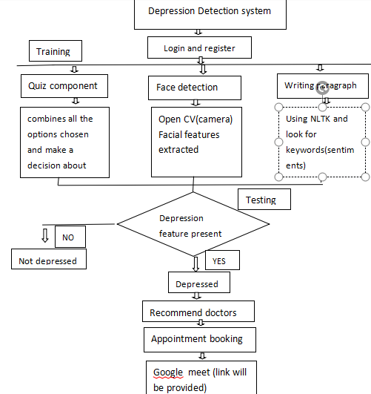

**Fig 3.1 System Architecture**

1. **SYSTEM DESIGN**
   1. **ALGORITHM**

Below are the algorithm steps for a depression detection system incorporating face recognition, a quiz, or writing a paragraph based on the user's comfortability: We have used Opencv(camera) Capture Video: First, you need to capture video from the camera using OpenCV's VideoCapture class. Once faces are detected, you can further process the face region to extract facial features. This might involve techniques like facial landmark detection using libraries like Dlib or deep learning-based models. Based on the responses provided by the individual taking the quiz, algorithm is used to analyze their answers and determine whether they meet the criteria for depression. This involve comparing the responses to established diagnostic criteria for depression. We can analyze their written text for sentiment and key indicators of depression. One approach is to use the Natural Language Toolkit (NLTK) to perform sentiment analysis on the text and identify keywords associated with depression.

***Example Text***: "I feel so alone and worthless. Nothing seems to bring me joy anymore. I can't shake this feeling of sadness no matter what I do." ***Sentiment Analysis***: The sentiment analysis tool assigns a negative polarity score to the text, indicating a predominantly negative sentiment. ***Keyword Extraction***: Keywords such as "alone," "worthless," "sadness," and "joy" are extracted from the text, all of which are commonly associated with depression. ***Conclusion***: Based on the negative sentiment and the presence of depressive keywords in the text, it can be inferred that the person may be experiencing depression.

**4.2 FLOWCHART**

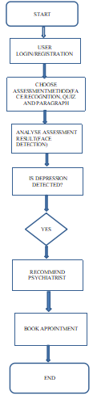

1. **RESULTS AND DISCUSSIONS**



**Fig 5.1 klinik**

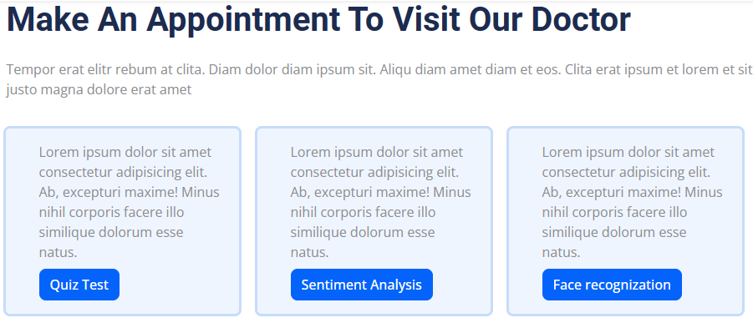

**Fig 5.2 Options for patients to tell about themselves**

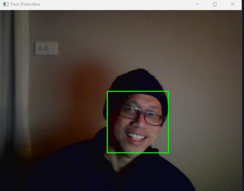

**Fig 5.3 . Face detection**

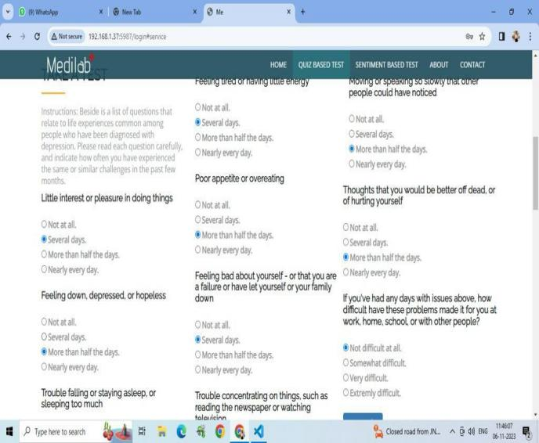

**Fig 5.4. Quiz**

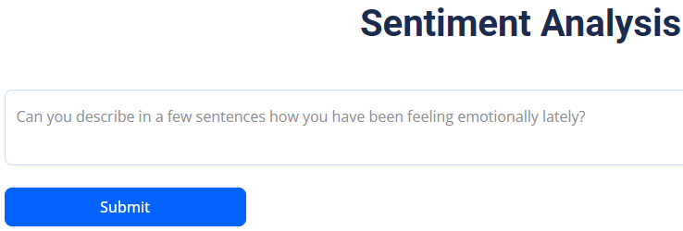

**Fig 5.5 Sentiment Analysis**



**Fig 5.6. Result**



**Fig 5.7. Appointment booking**



**Fig 5.8 Google meet with the doctor**

1. **CONCLUSION**

The depression detection system offers a critical solution for identifying individuals who may be experiencing depression, enabling timely intervention and support. By analyzing various indicators such as speech patterns, facial expressions, and behavioral cues, the system can accurately assess a person's mental state. Through its implementation, individuals can receive prompt attention and access to appropriate resources, ultimately improving their well-being and quality of life. This technology holds promise in revolutionizing mental health care by providing an efficient and accessible means of early detection and intervention for depression, potentially reducing the stigma associated with seeking help and fostering a more supportive environment for those struggling with mental health issues. the integration of face recognition technology and a depression detection quiz offers a promising approach to identifying individuals at risk of depression. By utilizing facial expression analysis, the system can detect subtle cues indicative of emotional distress, providing an additional layer of insight into an individual's mental state. Meanwhile, the depression quiz serves as a standardized assessment tool, allowing users to self-report symptoms and behaviors associated with depression. Together, these components create a comprehensive and accessible means of early detection, enabling timely intervention and support for those in need. This combined approach not only enhances the accuracy of detection.

1. **REFERENCES**
2. IEEE - Depression Detection System using Emotional artificial intelligence by Mandar Deshpande and Vignesh Rao used in existing system paragraph by
3. IEEE paper - Predicting depression in canada by automatic filling of Beck’s depression inventory questionnaire by Ruba S. Skaik and Diana Inkpen used in existing system paragraph.
4. Depression detection system integrating face recognition and quizzes is the work by K. K. Acharya et al. (2018), titled "Depression Detection using Facial Expressions and Multimodal Features".
5. [www.ijcrt.com](http://www.ijcrt.com) - Doctor appointment online booking system by Ms. Sanjeevani Avahale
6. Depression detection from social network data using machine learning techniques- Md. Rafiqul Islam, Ashir Ahmed.
7. Machine Learning-based Approach for Depression Detection in Twitter Using Content and Activity Features - Hatoon AlSagri, Mourad Ykhlef.
8. Early Detection of Depression: Social Network Analysis and Random Forest Techniques - fidel cacheda, Victor Carneiro.