**A STUDY ON WORKLIFE BALANCE FOR WOMEN EMPLOYEES**

**IN ASHOK LEYLAND**

## **BHARATH.R1, SHAMITHA DHARSHINI R2**

1Assistantprofessor, Department of MBA, Paavai Engineering College,

Namakkal, Tamil Nadu, India

2PG Student, Department of MBA, Paavai Engineering College,

Namakkal, Tamil Nadu, India

**ABSTRACT:** Work-life balance is a crucial factor for every female employee to achieve success. Each Industry has diverse plans, policies, procedures, practices, and programs to help their employees to succeed in the balance between their work engagements and family engagements. Some policies are legal while others are involuntarily implemented. The main motto of this study is to insight out about the technology change, increased work Pressure with constant deadlines, co-existing virtual workplace and changing demographic profile such as gender, experiences, an increase of disposable income inflation, improving living standard have encouraged the importance of the provision of work-life balance in the industrial sector. In the modern era, it is essential especially for females as they play a dual role. The Research Paper depicts the direction of work-life arrangement for the female employee in the Indian industry.

**Keywords:** work life balance, women empowerment, gender equality, female employees, Ashok Leyland

**1. INTRODUCTION:**

Ashok Leyland is an Indian multinational automotive manufacturer, headquartered in Chennai. It is owned by the Hinduja Group. It was founded in 1948 as Ashok Motors which became Ashok Leyland in the year 1955.Ashok Leyland is the second-most successful manufacturer of commercial vehicles in India (with a market share of 32.1% in 2016), the third-most successful manufacturer of buses in the world, and the tenth-most successful manufacturer of trucks. With the corporate office located in Chennai, its manufacturing facilities are in Ennore, Bhandari, two in Hosur, Alwar and Pant Nagar.

**1.1. Objectives of the study:**

* + Improving employee well-being
  + Enhancing employee engagement and productivity
  + Promoting gender equality
  + Attracting and retaining top talent
  + Meeting the needs of a diverse workforce

**1.2. Need of the study:**

* + Flexible work arrangements
  + Parental leave policies
  + Childcare and eldercare support
  + Wellness programs
  + Time management training
  + Supportive workplace culture

**2. Work Life Balance:**

* Work-life balance is the state where a person chooses to equally prioritize the demands of work and career and the demands of their personal life. An individual who lacks this balance has more work and home obligations, works longer hours, and lacks personal time.
* With a satisfactory work-life balance, employers can reap a range of benefits. Productivity is higher, absenteeism is lower, and physical and mental health improves with a higher commitment and motivation to work. Personal relationships can also benefit from achieving this balance.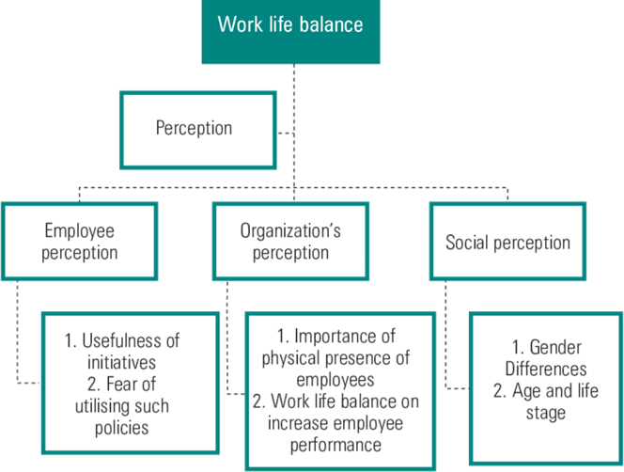

# **Gender Differences in Work Life Balance:**

# 

* Gender inequality in the workplace takes many forms - unequal pay, disparity in promotions, incidents of sexual harassment, and racism. Often, it presents itself in more nuanced ways, like fewer opportunities for women who are mothers and a higher incidence of burnout in women.
* What is gender equality in the workplace? Gender equality in the workplace means employees of all genders have access to the same rewards, opportunities and resources at a company, including: Equal pay and benefits for comparable roles with similar responsibilities.
* These influences may stem from psychological factors, such as upbringing, or physical factors, such as an employee's capability to perform job duties. Differences may also stem from gender stereotypes related to men and women.

**2.2. Women Empowerment in India:**



1. The Labor Force Participation Rate for males has gone up to 57.5% in 2020-21, as compared to 55.6% in 2018-19. Female Labor Force Participation Rate has gone up to 25.1% in 2020-21 from 18.6% in 2018-19.
2. According to the Union Budget 2022, the overall workforce participation rate in India is 20.3%, of which 18.2% is in Urban India presently. In 2022, Women's employability is at 51.44 per cent for 2022, compared to 41.25 per cent in 2021.

**3. RESEARCH METHODOLOGY**

Research Methodology describes the research procedure, which includes the overall research design and the data collection method.

# **3.1. Research Design**

A research design is the specialization of measure and procedure for the information needed to solve problems in the overall operational pattern of Framework of the project that stipulates what information is to be collected from which sources by what procedure. There are 3 types of research design.

1. Explorative Research Design
2. Descriptive Research Design
3. Experimental Research Design

The research Design that is used by the investigator is descriptive Research design.

# **3.1.1. Descriptive Research Design**

The Descriptive Design is marked by the prior formulation of specific research problem. The investigator already knew a substantial amount of the research problem. The investigator should be able to define clearly what is that he/she wants to measure and to setup appropriate and specific means for measuring it.

# **3.2. Sample Design**

A sample design may be defined as a plan for obtaining a sample from a given population. It therefore refers to the technique or procedure the researcher would adopt in selecting item.

# **3.3. Sampling Techniques**

The researcher had made use of stratified sampling technique to collect data.

# **3.4. Convenient Randon Sampling**

In many surveys the population is heterogeneous. Stratified random sampling refers to a sampling design where the entire universe is divided into group or strata (1)there is a greater homogeneity as possible with in each stratum (2)as marked difference as possible between the strata.

# **3.5. Sample Size**

The research has drawn 100 respondents as sample for these collections of data.

# **3.6. Sampling Techniques**

The sampling techniques was used for the survey was convenience sampling.

# **3.7. Methods Od Data Collection Data Sources**

Data in the study are of two types:

* Primary data
* Secondary data

**3.7.1. Primary Data**

Primary goal is original and collected by the researcher freshly. In this study primary data was collected through questionnaire. A questionnaire is a popular means of collecting primary data. A questionnaire is a list of question for the own.

# **3.7.2. Secondary Data**

Secondary data is the data, which is already available. It can be obtained through company records, internet and some data collected from the observation method by the researcher.

# **3.8. Statistical Tools Used**

The commonly used statistical tools for analysis of collected data are:

➢ Percentage analysis

# **3.8.1. Simple Percentage Analysis**

This method is used to compare two or more series of data, to describe the relationship or the distribution of two or more series of data. Percentage analysis test is done to find out the percentage of the response of the response of the respondent.

**4. ANALYSIS:**

**Table No: 4.1**

## **Respondents Based on Age Group**

|  |  |  |
| --- | --- | --- |
| **Particulars** | **Frequency** | **Percentage** |
| 20 – 30 | 45 | 45 |
| 30 – 40 | 30 | 30 |
| 40 – 50 | 10 | 10 |
| Above 50 | 15 | 15 |

**Chart No: 4.1**

**Respondents Based on Age Group**

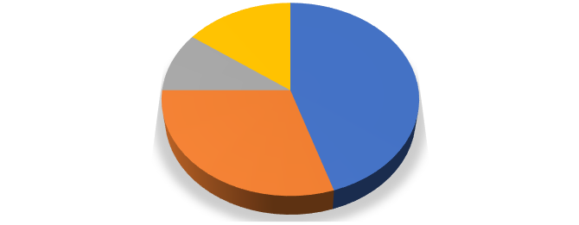

**Age**

**Above 50**

**15%**

**40 - 50**

**10%**

**30 - 40**

**30%**

**20 - 30**

**45%**

20 - 30

30 - 40

40 - 50

Above 50

## **Table No: 4.2**

## **Respondents Based on Marital Status**

|  |  |  |
| --- | --- | --- |
| **Particulars** | **Frequency** | **Percentage** |
| Married | 55 | 55 |
| Unmarried | 45 | 45 |

**Chart No: 4.2**

**Respondents Based on Marital Status**

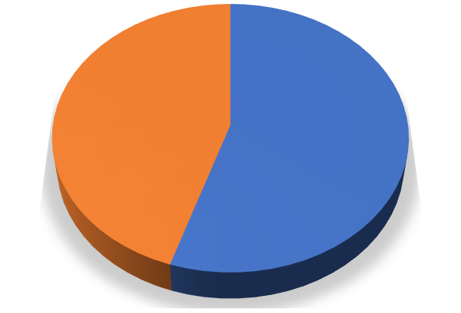

**MARITAL STATUS**

**Unmarried**

**45%**

**Married**

**55%**

Married

Unmarried

**Table No: 4.3**

## **Respondents Based on Wake Up**

|  |  |  |
| --- | --- | --- |
| **Particulars** | **Frequency** | **Percentage** |
| Before 5am | 78 | 78 |
| After 5 am | 22 | 22 |

**Chart No: 4.3**

**Respondents Based on Wake Up**

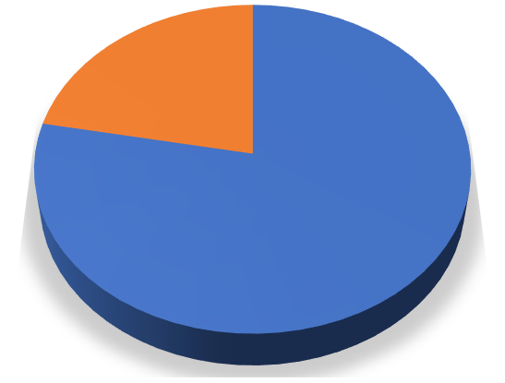

**wake up**

**After 5 am**

**22%**

**Before 5 am**

**78%**

Before 5 am

After 5 am

## **Table No: 4.4**

## **Respondents Based on Basic Need**

|  |  |  |
| --- | --- | --- |
| **Particular** | **Frequency** | **Percentage** |
| Yes | 98 | 98 |
| No | 2 | 2 |

**5. FINDINGS, SUGGESTIONS**

**5.1. Findings:**

* The study found that the majority, 98 percent of the respondents, were very satisfied with their basic needs.
* The study found that the majority, 56 percent of the respondents, faced a friendly approach from their co-workers.
* The study found that the majority, 62 percent of the respondents, were satisfied with their overall job satisfaction and work-life balance.
* The study found that the majority, 87 percent of the respondents, have personal feelings about the safety measures in the organization.
* The study found that the majority, 87 percent of the respondents, are satisfied with the safety measures and protocols in the workplace.
* The study found that the majority, 90 percent of the respondents, have never experienced sexual harassment in the workplace.

**5.2. Suggestions:**

1. **Flexible Work Arrangements:**

Develop and implement policies and programs that provide women with flexible work arrangements such as job sharing, telecommuting, compressed work weeks, or part- time work options. This can help women balance their work and personal responsibilities, reducing stress and increasing job satisfaction.

# **Child Care Services:**

# Offer child care services or subsidies to help women employees balance their work and family responsibilities. This can include onsite or offsite child care facilities, afterschool programs, or referrals to trusted child care providers.

# **Health and Wellness Programs:**

# Develop health and wellness programs that encourage women to take care of their physical and mental health. This can include yoga classes, meditation sessions, fitness challenges, and counseling services.

# **Mentorship Programs:**

# Establish mentorship programs to help women employees navigate their career paths within the organization. This can help women feel supported and empowered to achieve their career goals while balancing their personal responsibilities

**6. CONCLUSION:**

In conclusion, promoting work-life balance for women employees in Ashok Leyland in a positive way is essential for creating a supportive and inclusive workplace culture that empowers women to succeed both personally and professionally. By implementing policies and programs that prioritize employee well-being, Ashok Leyland can demonstrate its commitment to supporting women's work-life balance and creating a positive work environment.

Positive initiatives such as flexible work arrangements, child care services, health and wellness programs, mentorship programs, employee assistance programs, workshops and training, and recognition and rewards can have a significant impact on women employees' work-life balance, job satisfaction, and overall well-being.

In conclusion, promoting work-life balance for women employees in Ashok Leyland in a positive way is a win-win for both the company and its employees. By prioritizing employee well-being and creating a positive work environment, Ashok Leyland can foster a culture of inclusion, diversity, and empowerment that benefits everyone.

**7. REFERENCE**

1. Anderson, E.W., Sullivan, M.W.,―The Antecedents and Consequences of Customer Satisfaction for Firms, Marketing Science,12(2), 125-43
2. Argyris C, Schon D.A, Organizational Learning: A Theory of Action Perspective, Addison-Wesley, and Menlo Park, CA.
3. Arthur J, ‗Effects of human resource systems on manufacturing performance and turnover. ‘In Academy of Management Journal, v37, pp.670 -87.
4. Antrea D―Customer Satisfaction Cues to Support Market Segmentation and Explain Switching Behavior Journal of Business Research, 47(3), 191-207.
5. Beck, S. ‗Why Associates Leave, and Strategies To Keep Them.‘ In American Lawyer Media L.P., v5, i2, pp. 23-27.
6. Clarke, K.F. ‗What businesses are doing to attract and retain employee becoming an employer of choice.‘ In Employee Benefits Journal, March, pp. 34 -37.
7. Coff, R.W., ―Human Assets and Management Di lemmas: Coping with Hazards on the Road to Resource- Based Theory, Academy of Management Journal, Vol. 22, pp.374- 402.
8. Cronin, J.J., Taylor, S.A "Measuring service quality: reexamination and extension", Journal of Marketing, Vol. 56 No.3, pp.55-68.
9. Davidow, W.H., Uttal, Total Customer Service: The Ultimate Weapon, Harper and Row, New York.
10. Dr. Dug ani Yuva raju (PDF-Scholar), Prof. S. Durga Rao,” Customer Satisfaction towards Honda Two Wheelers: A Case Study in Tirupati” IOSR Journal of Business and Management (IOSR-JBM) e-ISSN: 2278-487X, p-ISSN: 2319-7668. Volume 16, Issue 5. (May. 2014).
11. Dr. K. Mallikarjuna Reddy “Consumers Behaviour Towards Two-Wheeler Motor Bikes” Osmania Journal of Management.
12. Philip Kotler.,(1999) “Marketing Management” Ashok K .Ghosh., New Delhi.
13. Kothari C.R., Research Methodology, New Delhi; New Age International publication, second edition.