**StayEase**

Tejal Mahajan, Tejal Mahajan, Urmila. Sawaldekar, prof. Kiran Tayadeya

Department Of Computer Science & Engineering

Thakur Shivkumarsingh Memorial Engineering Collage, Burhanpur, (Affiliated to RGPV Bhopal),

India

**ABSTRACT**

“StayEase is a user-friendly web application designed for the buying and selling of properties. It empowers users to easily manage their property listings, leads, and market prospects. With features for searching residential and commercial properties, users can efficiently view property details. Both administrators and users can access property listings, with users having the capability to upload and manage their property information. StayEase streamlines the process by allowing users to fill out their requirements, enabling administrators to match properties accordingly. It serves as a convenient platform for contacting property sellers and receiving instant responses from real estate professionals.

**Keywords:** Real Estate ,Online Real Estate Platform, Multiple Listing Service System.

**1. INTRODUCTION**

StayEase is a user-friendly real estate system, designed to connect property sellers directly with interested buyers, eliminating the need for real estate professionals. Our platform streamlines the process, saving time and empowering users to efficiently track leads, manage listings, and market to potential buyers. With a focus on user convenience, our system allows easy searching for desired properties, enabling supervisors to match properties to users’ requirements seamlessly. Recognizing the importance of location in property decisions, our application enables users to select specific areas and access relevant information. Our project aims to develop a prototype real estate listing service using innovative technology. This basic website enables users to register, log in, and manage their properties, simplifying the process and reducing paperwork. With this user-friendly platform, users can post, buy, rent, or sell their properties and obtain information about property rates in different zones.

**2. OBJECTIVE OF THE PROJECT**

The objective of our website i.e StayEase.com are as follows :

- Admin Registration: We offer easy registration

for administrators to efficiently manage the real

estate platform.

- Customer Registration: Customers can register and

create accounts to access personalized property

listings and services.

- Information Management: StayEase stores crucial

details of both customers and administrators to

streamline property transactions and

communication.

- Property Listings: We provide comprehensive

information about properties, enabling customers to

make well-informed decisions.

- Convenient Property Search: StayEase offers a

user-friendly interface for browsing and searching

properties, making it easy to find the perfect home

or investment opportunity.

With StayEase, finding your ideal property is simpler and more convenient than ever before. Explore our listings and embark on your real estate journey with confidence.

**3. APPLICATIONS AND SCOPE**

***A. Applications***

- StayEase is a real estate listings service that

helps people to find properties that are for sale

and rent in their area

- This system solve the Reachability problem.

Easy to search Property

- Customer usually find the property that are for

sale or rent on Website, and they can get all

the details available there.

***B. Scope***

StayEase is a cutting-edge online platform designed to simplify the process of buying, selling, and renting properties. In today’s rapidly advancing technological landscape, we believe in providing our customers with the convenience of conducting real estate transactions from the comfort of their own homes.

Our vision for StayEase is to create a seamless and beneficial experience for our customers. At StayEase, we prioritize convenience and accessibility. Our goal is to provide a user-friendly platform that caters to all your real estate needs, whether you’re looking to buy, sell, or rent a property.

- The main function of this system or company is

to convert the manual trading services.

- Properties and flats in the better quality service

that customers want.

- Allows the customers to view or get details of

various properties/flats available.

- Add the properties/flats to the stock.

**4. USECASE DIAGRAM**

A use case diagram is a dynamic or behavior diagram in UML. Use case diagrams model the functionality of a system using actors and use cases. Use cases are a set of actions, services, and functions that the system needs to perform. In this context, a "system" is something being developed or operated, such as a web site. The "actors" are peopleor entities operating under defined roles within the system.

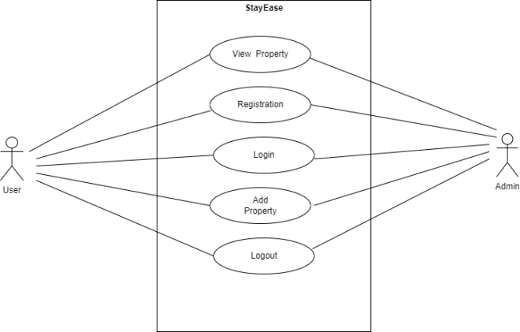

Usecase Diagram

**5. ADVANTAGES**

- StayEase is a online platform for service seeker

and service provider.

- It Reduces the human effort and consumes less

time compared to the manual system.

- This can be useful tools for people who are

interested in investing in property.

- StayEase is listing service which helps people

find properties that are for sale and rent in their

area.

-The customers always have an option to choose

the best one from the available properties.

**6. DISADVANTAGES**

- GUI is only in English.

- Application and formart is not responsible for

entries may be wrong.

- The system can be complex and time-

consuming to use, particularly for a complex

properties.

- The functions on these sites may be limited.

- The system relies on accurate and up-to-date

information on land and property ownership

which can be difficult to obtain in some cases

**7. RESULT**

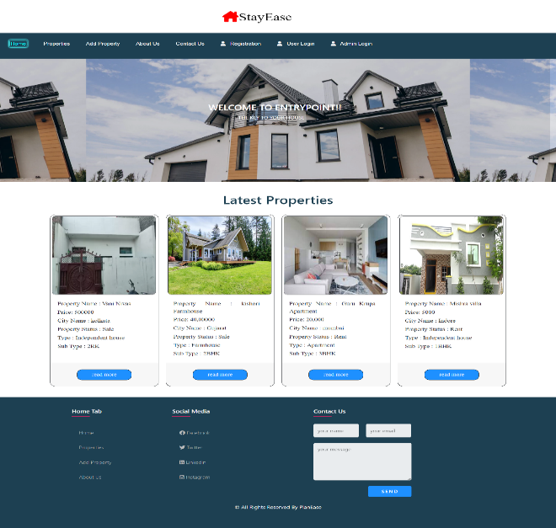A. Homepage

This is the home page of our website. The very first page of our website. In this page you can view the latest properties that was add recentily i.e which properties you want to buy according to choice, after clicking on the desired section you will jump on to our new page. After that you have a large verities of a

Properties. And if customer want to sell or rent the property he can first have to do registration and after the registration he can login in the website.

B. Master page

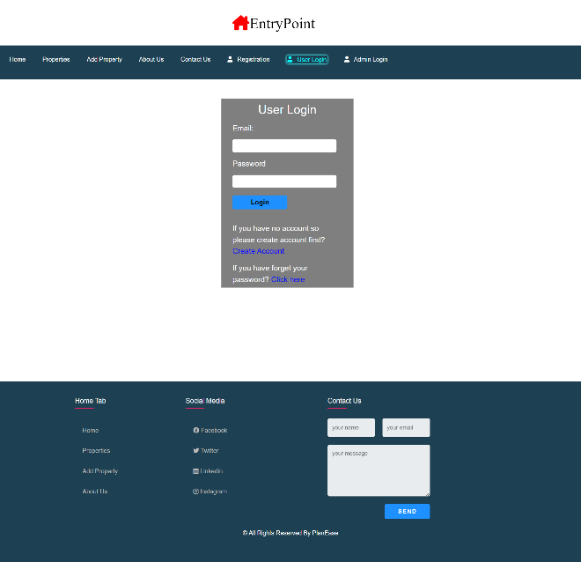

This is the login page of our website that can be access by

the user. In this page customers have to fill their details only once. After submitting all the details needed the

User data will be saved in our database so that whenever the same customer have to list any Property again his/ her details will be shown by just entering his username and password. After login user can add there property. User can contact us through the contact form he can reach us through these form.

C. Add property

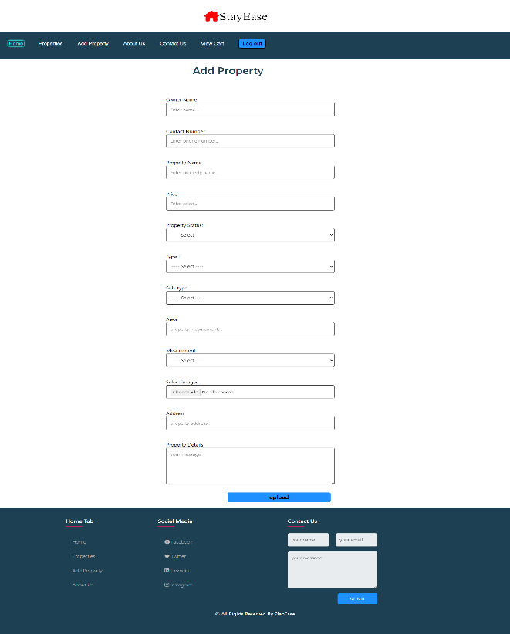

In this page user can add there property that is it if he want to sell or rent the property and after fill up the details such as owner name, contact number, property name, price property status, type and sub-type , area measurement and image, address and property details customer can list there property.

First admin has to login on the website after that only after that he access admin services. And for Admin there is admin page which consist of admin dashboard which can be access by admin were admin can manage the properties and users.

This is the Database table for all the properties.

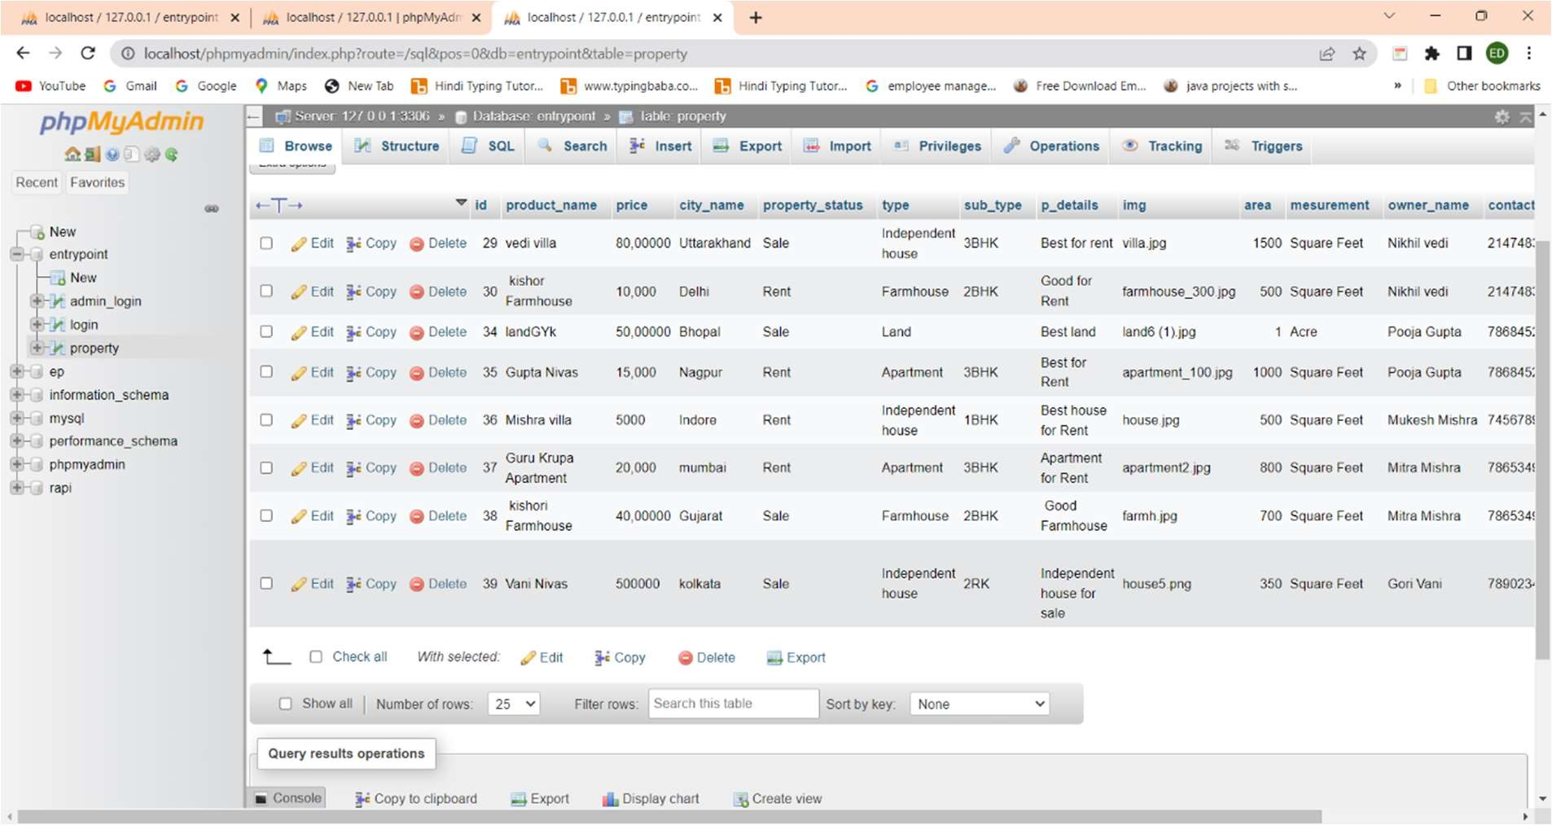

**8.** **MODULES OF THE PROJECT**

The system consists of the following modules:-

- User Module: Handles user registration, login,

profiles, and preferences.

- User Authentication Module:-This module will

allow users to log in and authenticate their identity

before accessing the project report system.

- Listing Module: Allows users to create, edit, and

manage property listings with details like

descriptions, images.

- Search and Filtering: Provides functionality for

users to search for properties based on criteria such

as location, price range, property type and status.

- Admin Panel: Provides administrators with tools to

manage users, listings, and site content, as well as

monitor user activity and analytics.

**9. CONCLUSION**

Our project “StayEase” will be efficient and less time consuming. The purpose of this project was to develop a web application. A application for purchasing and selling properties online. . The entire system is secured. This website can make it easy to keep track of the all properties in one place . It will manage the details of properties, sell and buy. It will maintain or increase the customer satisfaction. According to requirement gathered and technologies used to realize those requirements are best utilized to achieve that functionality. The StayEase web portal gives a platform through which clients can communicate and use the services provided by this portal.

**REFERENCES**

[1]. computer code Testing Techniques (Second Edition) by Boris Beizer.

[2] www.onestoptesting.com Referred topics associated with Testing sorts.

[3] www.en.wikipedia.org/wiki/Software the testing Referred the topics associated with begin and stop the computer code testing method and connected ones.

[4] B. Beizer. Software Testing Techniques (2nd ed.). Van

[5] N. Juristo, A. M. Moreno, and S. Vegas. Reviewing 25 years of testing technique experiments. Empirical Softw. Eng., 9(1-2);7-44, 2004

[6] W. Howden. Reliability of the path analysis testing strategy. IEEE Trans. Softw. Eng., SE-2(3):208- 215, 1976.