SMART POLE FOR SMART CITIES

A.Vinoth Kumar^{#1}, Sampath Kumar.P^{#2},Elango.S^{#3},
Mathankumar.K ^{#4}, Thenarasan.S^{#5}

^{#1} Assistant Professor,
^{#2} ^{#3} ^{#4} ^{#5} Final Year Students Department of EEE,

P. A. College of Engineering and Technology, Pollachi, Coimbatore, Tamilnadu, India
represent a holistic approach to urban development, promoting efficiency, sustainability, and connectivity to create cities that are not only intelligent but also more livable and resilient for the future.

- INTRODUCTION
- LITERATURE SURVEY
[1]. Castro P S, Zhang D, Li S. Urban traffic modelling and prediction using large scale taxi GPS traces. In: Proceedings of 10th International Conference, Pervasive 2012, Newcastle, 2012. 57–72.The study addresses the pressing need for effective urban traffic management by leveraging the wealth of data generated by taxi services. The authors commence their exploration by collecting and analyzing large-scale GPS traces from taxis, acknowledging the ubiquitous nature of these vehicles and their potential to serve as real-time data sources. The research methodology involves the development of a robust urban traffic model based on the collected taxi GPS traces. By harnessing the spatial and temporal patterns inherent in the taxi data, the authors aim to create a predictive model capable of forecasting traffic conditions in urban environments. The paper likely details the intricacies of the employed modelling techniques, considering the challenges associated with the dynamic and complex nature of urban traffic.
Abstract- With the rapid urbanization globally, the concept of smart cities has emerged as a solution to address various urban challenges, ranging from traffic congestion to energy efficiency. One of the pivotal components in transforming traditional urban infrastructure into smart cities is the deployment of smart poles. Smart poles integrate advanced technologies such as sensors, cameras, communication networks, and renewable energy sources to enhance urban services and citizen experiences. This paper presents an overview of the design, functionalities, and potential benefits of smart poles in smart cities. It examines how smart poles serve as multifunctional urban assets, offering features such as intelligent lighting, environmental monitoring, traffic management, public Wi-Fi access, and emergency response systems. Furthermore, the paper discusses the role of data analytics in leveraging the vast amounts of data collected by smart poles to optimize urban operations, improve decision- making, and enhance overall urban sustainability. Additionally, it explores the challenges and considerations associated with the deployment of smart poles, including privacy concerns, cybersecurity risks, and infrastructure compatibility. By leveraging the capabilities of smart poles, cities can foster innovation, efficiency, and resilience, ultimately creating more livable and sustainable urban environments for their residents
[2]. Pacifici F, Chini M, Emery W J. A neural network approach using multi-scale textural metrics from very high- resolution panchromatic imagery for urban land-use classification. Remote Sens Environ, 2009, 113: 1276– 1292.The research article by Pacifici, Chini, and Emery, titled "A neural network approach using multi-scale textural metrics from very high-resolution panchromatic imagery for urban land-use classification," published in Remote Sensing of Environment in 2009, addresses the challenge of urban land- use classification by proposing an innovative neural network methodology.
Smart poles are pivotal elements in the transformation of cities into intelligent, connected, and sustainable urban landscapes. These innovative structures serve as multifunctional hubs, integrating cutting-edge technologies to enhance urban living. At their core, smart poles are equipped with a suite of sensors, cameras, and communication devices, forming an interconnected network that gathers real-time data on various aspects of city life. This data encompasses traffic flow, air quality, noise levels, and environmental conditions, enabling municipalities to make informed decisions for optimizing city operations. Moreover, smart poles often incorporate energy- efficient LED lighting, contributing to sustainable practices by reducing energy consumption and carbon emissions. As charging stations for electric vehicles can also be integrated, smart poles promote the adoption of cleaner transportation methods. The integration of 5G connectivity further propels smart poles into the forefront of technological innovation, fostering the development of smart cities by facilitating seamless communication between devices and enabling the deployment of advanced applications such as autonomous vehicles and augmented reality. In essence, smart poles
[3]. Nam T, Pardo T A. Smart city as urban innovation: Focusing on management, policy, and context. In: Proceedings of 5th International Conference on Theory and Practice of Electronic Governance. New York: ACM, 2011.185–194 .Nam T and Pardo T. A. in their paper titled "Smart city as urban innovation: Focusing on management, policy, and context," presented at the 5th International Conference on Theory and Practice of Electronic Governance in 2011, delve into the concept of smart cities, emphasizing the crucial factors of management, policy, and context in their development and implementation. The authors argue that the emergence of smart cities represents a significant urban innovation driven by

advancements in information and communication technologies (ICTs). They highlight that the successful realization of smart cities requires effective management strategies, coherent policies.
[4]. Chourabi H, Nam T, Walker S, et al. Understanding smart cities: an integrative framework. In: Proceedings of 45th Hawaii International Conference on System Science, Maui, 2012. 2289–2297.Chourabi, Nam, Walker, and their collaborators present an integrative framework for comprehending smart cities in their paper titled "Understanding smart cities: an integrative framework," presented at the 45th Hawaii International Conference on System Science in 2012. The authors aim to provide a structured approach to conceptualizing smart cities, facilitating deeper insights into their multifaceted nature.Their framework encompasses various dimensions crucial for understanding smart cities, including technology, economy, environment, governance, people, and living. By synthesizing these dimensions, the authors offer a holistic perspective that goes beyond the technological aspect typically associated with smart cities.
[5].Tiwari A. Urban sciences, big data and India’s smart initiative. Global J Multidiscip Stud, 2014.In his paper "Urban sciences, big data, and India’s smart initiative," published in the Global Journal of Multidisciplinary Studies in 2014, Tiwari delves into the intersection of urban sciences, big data, and India's smart city initiative. Tiwari explores how leveraging big data and adopting principles from urban sciences can contribute to the success of India's smart city endeavors. The paper begins by contextualizing the rapid urbanization occurring in India and the associated challenges such as congestion, pollution, and inadequate infrastructure. Tiwari argues that traditional approaches to urban planning and management are insufficient to address these challenges effectively. Instead, he advocates for the integration of big data analytics and insights from urban sciences to inform evidence-based decision-making in urban governance.
[6].Cimmino A, Pecorella T, Fantacci R, et al. The role of small cell technology in future smart city applications. Trans Emerg Telecommun Technol, 2015, 25:Cimmino, Pecorella, Fantacci, and their collaborators explore the significance of small cell technology in future smart city applications in their article published in the Transactions on Emerging Telecommunications Technologies in 2015. The authors delve into the potential of small cell technology to address the growing demand for connectivity and support the diverse range of services expected in smart cities. Small cell technology refers to low-powered radio access nodes that enhance wireless network coverage and capacity, particularly in dense urban areas where traditional macro cellular networks may face challenges.

- PROPOSED METHODOLOGY

Economic growth, and inclusive development, ultimately paving the way Smart poles represent a critical component of the infrastructure for building smart cities, offering a versatile platform for integrating various technologies to enhance urban services, connectivity, and sustainability. Our proposed system for smart poles aims to leverage cutting-edge advancements in sensor technology, communication networks, and data analytic to create a robust and scalable framework for addressing the diverse needs of modern urban environments.
At the core of our system are multifunctional smart poles equipped with a range of sensors capable of capturing real-time data on environmental conditions, traffic patterns, air quality, noise levels, and other relevant parameters. These sensors are
strategically deployed throughout the city to provide comprehensive coverage and enable data-driven decision- making by city authorities and service providers.
In addition to sensor capabilities, our smart poles are equipped with advanced communication technologies, including 5G wireless networks and Wi-Fi hotspots, to ensure seamless connectivity for residents, businesses, and IoT devices. By serving as nodes in a connected urban network, these poles facilitate high-speed internet access, support smart transportation systems, and enable the proliferation of IoT applications, such as smart lighting, waste management, and public safety initiatives.
Furthermore, our proposed system integrates intelligent data analytics algorithms to process the vast amounts of data collected by the sensors deployed on smart poles. These analytics algorithms employ machine learning and artificial intelligence techniques to extract actionable insights, detect patterns, and predict future trends in urban dynamics.
By harnessing the power of data analytics, city stakeholders can optimize resource allocation, improve service delivery, and enhance the overall quality of life for residents.
Moreover, our smart pole system is designed to be modular and adaptable, allowing for seamless integration with existing urban infrastructure and accommodating future technological advancements. This scalability ensures that cities can continuously evolve and upgrade their smart pole networks to meet evolving demands and emerging challenges.
In conclusion, our proposed system for smart poles offers a comprehensive and future-proof solution for building smart cities. By leveraging sensor technology, communication networks, and data analytics, smart poles serve as essential conduits for transforming urban environments into efficient, connected, and sustainable communities. With the implementation of our system, cities can unlock new opportunities for innovation towards a brighter and more resilient urban future.
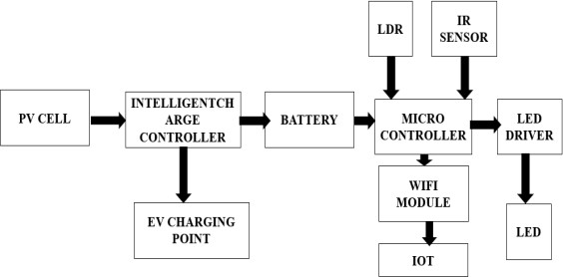
Fig 1: Block Diagram of Proposed System

The block diagram of smart poles for smart cities outlines a comprehensive frame work integrating various components to support the development of intelligent urban infrastructure.
At its core are multifunctional smart poles equipped with a range of sensors, including environmental, traffic, and security sensors, enabling real-time data collection.
These sensors interface with a central control unit or gateway installed within the smart pole, responsible for processing and transmitting collected data to a cloud-based platform for further analysis.
The communication infrastructure forms another crucial aspect of the block diagram, encompassing high-speed wireless networks such as 5G and Wi-Fi, enabling seamless connectivity for residents, businesses, and IoT devices. This connectivity facilitates the transmission of data between smart poles, city authorities, and end-users, enabling a wide range of smart city applications.

- CIRCUIT DIAGRAM

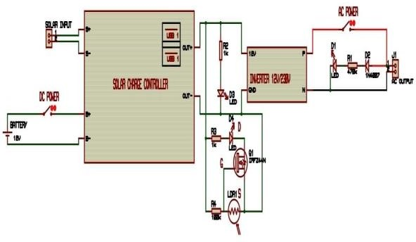

Fig 2:Circuit Diagram of Proposed System

- HARDWARE

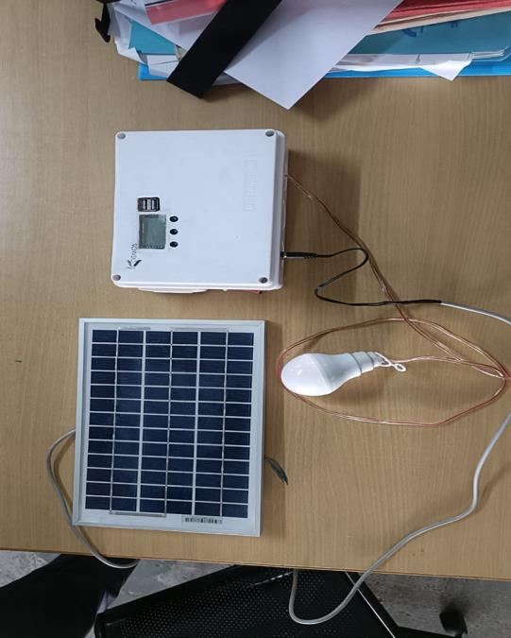

CONCULSION
Smart poles represent a pivotal advancement in urban infrastructure, heralding the dawn of truly interconnected and efficient smart cities. These multifunctional structures, equipped with a plethora of sensors, communication devices, and energy-efficient lighting, serve as the cornerstone for modern urban development. In conclusion, the integration of smart poles into urban landscapes offers a multitude of benefits, ranging from enhanced safety and security to improved energy management and sustainability.
First and foremost, smart poles play a critical role in bolstering public safety and security. Equipped with
surveillance cameras, motion sensors, and environmental monitoring systems, they provide real-time data on traffic flow, pedestrian movement, and environmental conditions. This information enables authorities to respond swiftly to emergencies, mitigate potential risks, and enhance overall public safety.Moreover, smart poles contribute to the optimization of energy usage and environmental sustainability. By incorporating energy-efficient LED lighting systems and renewable energy sources such as solar panels and wind turbines, they reduce energy consumption and carbon emissions, paving the way for greener and more eco-friendly urban environments. Additionally, the integration of smart grids and energy management systems allows for better monitoring and control of energy distribution, further enhancing efficiency and reducing wastage.
Furthermore, smart poles serve as essential infrastructure for the deployment of advanced communication networks and the Internet of Things (IoT). Equipped with wireless communication technologies such as 5G, Wi-Fi, and Bluetooth, they enable seamless connectivity and data exchange between various smart devices and urban infrastructure elements. This connectivity fosters innovation and the development of smart applications and services that enhance quality of life, promote economic growth, and drive sustainable development.
In addition to their functional benefits, smart poles also contribute to the aesthetic enhancement of urban landscapes. Designed with sleek and modern aesthetics, they blend seamlessly into their surroundings, complementing the architectural style of the city while enhancing its visual appeal. Furthermore, the integration of customize LED lighting systems allows for dynamic lighting designs, creating vibrant and engaging urban environments.
In conclusion, smart poles represent a transformotive solution for building smarter, safer, and more sustainable cities. Their multifunctional capabilities, coupled with their aesthetic appeal and connectivity features, make them indispensable elements of modern urban infrastructure. As cities continue to evolve and embrace the principles of smart urbanism, smart poles will play an increasingly vital role in shaping the cities of the future, where efficiency, sustainability, and connectivity converge to create vibrant and livable urban environments for generations to come.

REFERENCE

- Mr.N.Sivaiah, Ch.Lakshmi Prasanna, Ch.Tejaswini, Ch.Manisha, D.Yasaswini, “Automated Street Light Controlling System”, e-ISSN: 2395-0056, (2018).
- T.Santhi Sri, Rajesh Varma, V VS. Hari Krishna, K. Varun Chowdary “Automated Street Lighting System”,ISSN : 2278-3075(2019).
- Ngabo, C. I., & El Beqqali, O. (2016, November). Real- time Lighting Poles Monitoring by using Wireless Sensor Networks Applied to the Smart Cities. In Proceedings of the International Conference on Big Data and Advanced Wireless Technologies (pp. 1-8).
- Shaikh, A., Thapar, M., Koli, D., &Rambade, H. (2018, March). IOT Based Smart Electric Pole. In 2018 Second International Conference on Electronics, Communication and Aerospace Technology (ICECA) (pp. 594-597). IEEE.
- Mammeri, A., Zhou, D., Boukerche, A., &Almulla, M. (2014, June). An efficient animal detection system for smart cars using cascaded classifiers. In 2014 IEEE International Conference on Communications (ICC) (pp. 1854-1859). IEEE

