**SMART SHOPPING SYSTEM USING ROBOTIC TECHNOLOGY**

**G. Sowmya1,J. Geetha Gayathri 1, T. Pavani 1 B. Prasanna Lahari 1, V. Sugeetha 1**

**1.Department of Electronics and Communication Engineering**

**Santhiram Engineering College (Autonomous), Nandyal.**

**Email:** [sowmya.ece@srecnandyal.edu.in](mailto:sowmya.ece@srecnandyal.edu.in)

**ABSTRACT**

Shopping at huge shopping malls is getting to be every day activity. There is huge rush at the shopping malls on occasions and ends of the week. People buy different things and put them in trolley. After completion of buys, one needs to go to billing counter for payments. At billing counter, the buyer plans to utilizing bar code per user which is exceptionally time-consuming and comes about in long line at billing counter. Consequently, to make a framework that can be utilized to solve the challenges of client and save the important time of users is the primary point of this extend. This paper gives a see of a smart shopping trolley which will offer assistance the client to filter the item by and send the bill directly to the billing counter.

**INTRODUCTION**

Shopping means going to a store, inspecting the things, obtaining them, going through the billing counter, standing in a long line, filtering the things, calculating the total cost, and paying the bill using cash, credit or debit card. In any case, it is not continuously pleasant for everybody. According to finding the things, people battle a lot while shopping, which suffers them most. In this system, there are three components. The first component comprises the real trolley. The trolley consists of the essential storage unit, two servo engines, a weight sensor, and one Nodemcu microcontroller with Wi-Fi. The Nodemcu runs an HTTP server that takes the smart phone’s input.

The smart phone has a custom android app which performs communication with the trolley and the web server and has a QR code scanner for item checking. The mobile app also keeps track of the whole shopping list. The Apache web server is planned for storing data on the accessible items and making changes to them. The mobile phone interacts with the web server to recover the item data. At that point it consists of all these components working together. The android app interacts with the web server and the shopping trolley and sends appropriate instructions to it. This is how the entire system works.

**Related work**

**Smart Cart with Automatic Billing, Product Information**

A. Yewatkar [1] in the paper smart Cart with Automatic Billing, Product Data, Item Suggestion Using RFID & Zigbee with Anti-Theft created a smart shopping cart system that will keep a track of purchased items and moreover online transaction for billing using RFID and Zigbee. The system will too provide proposals for items to purchase based on client buy history from a centralized system.

**A framework for attribute choice in marketing using harsh computing and formal** D.P. Acharjya and T. K. Das [2] in the paper A framework for quality choice in promoting using unpleasant computing and formal concept investigation their approach is pointed at taking care of an data system that contains numerical quality values that are “almost similar” instep of “exact similar”. To handle such an data system they using two processes—pre-process and post-process. In pre-process, they utilized harsh set on intuitionistic fuzzy guess space with requesting rules to discover information and affiliations, while in post-process formal concept examination to distinguish the chief properties influencing choices is used.

**Developing a human less comfort store with AI system created a system that comprises of two key parts**

H. H. Chiang et al. [4] in the paper creating a human less convenience store with AI system created a system that comprises of two key parts, specifically the Customer’s Application and the smart shelf. The Customer’s Application gives a stage for the clients to perform self-checkout through online transactions. The smart shelf helps the retail store owners in overseeing stock and giving a smooth flow in the business. Inside the smart self, the face recognition makes a difference to give extra security highlights and offer assistance retail store owners keep track of the number of clients who have effectively registered.

**Methodology**

The smart shopping trolley system implants a shopping cart (trolley) with a RFID reader. It makes possible for the client to self scan the RFID tags of the purchased items which aspires to buy. A wireless transmission smart-device makes note of all the scanned things in the specific trolley (with allotment number) and is connected with the Supermarket’s backend database which contains features of the items such as cost price.

The scrutinized items are automatically billed in the wireless smart device for their purchases, thereby significantly reducing total waiting time and transmitted to the shop’s central Billing program. A RFID tag is used to encode data in a visual design readable by the machine. Customers will have a RFID reader on their trolley. At whatever point RFID tag gets closer to the RFID reader, it will check the tag display on the items and sends the information to Arduino UNO which will translate the tag and store in the memory. Each tag has a unique identity and gives add up to data approximately the item related information. RFID labels are more secure and dependable than barcodes. So, it is way better to work with RFID labels when we have a number of items in grocery store or supermarket.

The smart shopping trolley is semi-automated it implies when there is rush in supermarket the client has to push the trolley but when there is no rush in odd hours at that point the trolley will take after the client. Semiautomatic or smart trolley system which requires a minute manual work but can carry any sum of weight based on the battery backup, motor’s torque and speed. Smart trolley system works with offer assistance of Arduino and sensors like ultrasonic sensor which are used to recognize the presence of a client. Arduino is the fundamental programmable part and draw wire sensor is the primary sensor that would detect the user’s position with regard to trolley. Other sensors like ultrasonic is used to detect the user’s position without any contact between the client and the trolley.

In this project we make use of RFID labels connected to the items in which the detail about the item is encoded. RFID tags are simply called as advanced barcode. It is a little transponder which transmits a serial number to a reader. RFID is the special type wireless card which has inbuilt inserted chip along with loop antenna. The inbuilt embedded chip represents the 12-digit card number. RFID reader is the circuit which creates 125KHZ magnetic signal. This magnetic signal is transmitted by the loop antenna connected along with this circuit which is used to examined the RFID card number. In this project RFID card is utilized as security access card. So, each item has the individual RFID card.

**Block Diagram**

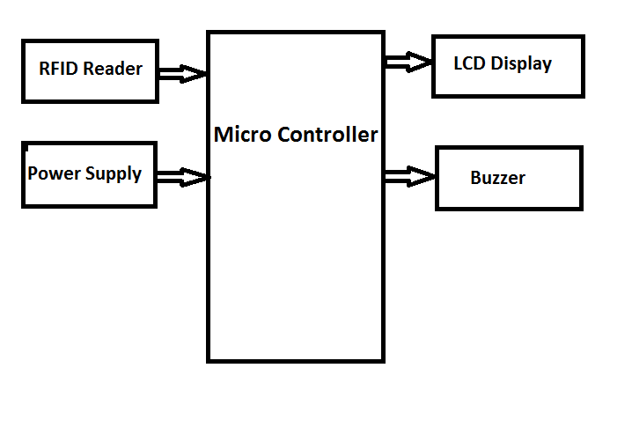

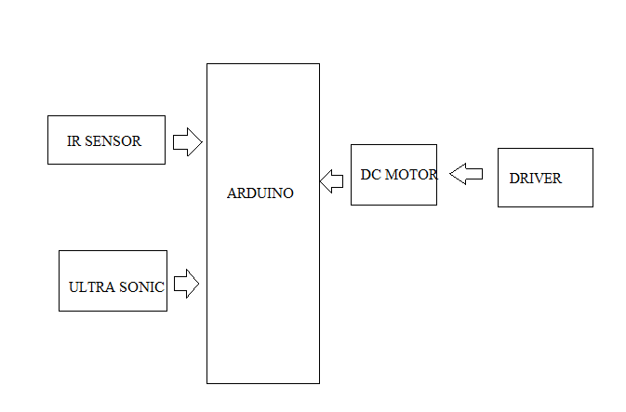

Shopping mall and showcase is a big corner for client to purchasing the everyday requirement like branded food item, snacks, cloth materials, electric and electronic gadgets etc. Nowadays, a greater numbers of shopping mall are available large as well as small in the world. In occasions and end of the week time we can see a huge rush at shopping mall. The public was demand & investing more time in shopping mall. After purchasing a long time, the clients waste of unnecessary time at the billing counter for billing the purchased item. Continuously improvement was compulsion in the common billing system to increment the quality of shopping experience to the clients.

To overcome these issues and to change and improve the existing system, we have designed a smart trolley for smart shopping using RFID. This can be done by simply attaching using RFID labels to the items and a RFID reader with a LCD display on the shopping trolley. In this system, client will have to know the cost of each and each thing that is checked in with offer assistance RFID and LCD, add up to cost of the thing will be shown in LCD and also brief about the item. In this system will save time of clients and manpower required in shopping mall. It is too utilized to reduce the employee work in the shopping mall.

**IR Sensor**

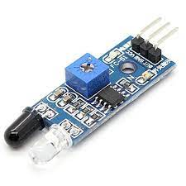

An Infrared Sensor (IR Sensor) is a radiation sensitive optoelectronic component with a spectral sensitivity in the infrared wavelength extend 780 nm … 50 µm. IR sensors are now broadly used in movement detectors, which are utilized in building services to switch on lights or in alarm systems to detect unwelcome guests.

**Hardware**

The Orange OG555 12V 50 RPM DC motor is a lightweight, compact measured high-performance DC motor with a rated torque of 346.8N-cm and a gear reduction of 180K having a 27mm long D shaped shaft with a distance across of 6mm and a hole. The input Voltage extend is from 6V to 15V and has a full load current of 3.38A.

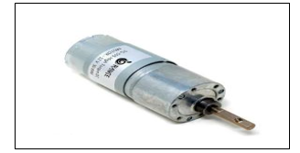

A motor driver takes the low-current signal from the controller circuit and amps it up into a high-current signal, to accurately drive the engine. Smarties smart motor driver 15D is a double channel motor driver capable of providing 15amps continuous with top currents upto 30amps (10sec) per channel. The driver can be worked on radio control, analog, TTL serial and PWM modes.

Switching between any of 4 modes can be done with onboard 4 position DPDT mode switch. Onboard MOSFETs are switched at 16KHz to guarantee calm operation. It has a microcontroller unit to give smart features such as multiple input modes and current limit and thermal protection. It has a microcontroller unit it give smart features such as multiple input modes and current limit and thermal protection. The driver is equipped with a temperature control include where if the temperature of the board comes to 80 degrees, at that point motor engine speed gets to be half and speed will be normal once the temperature comes to below 70 degrees. The motor driver will closed down at 100 degrees.

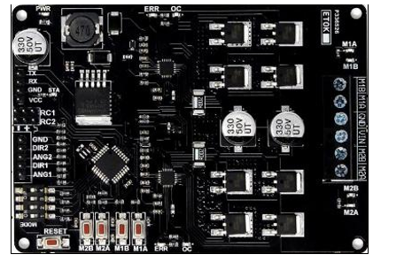

**Servo motor**

A servo motor (or simply servo) is a rotary or linear actuator that permits for exact control of angular or linear position, velocity, and acceleration in a mechanical system. [1][2] It constitutes part of a servo mechanism, and consists of a suitable motor coupled to a sensor for position feedback. It also requires a relatively sophisticated controller, regularly a dedicated module designed particularly for use with servomotors.

Servo motors are not a particular class of motor, in spite of the fact that the term servo motor is frequently utilized to refer to a motor suitable for utilize in a closed-loop control system. Servo motors are utilized in applications such as robotics, CNC machinery, and automated manufacturing.

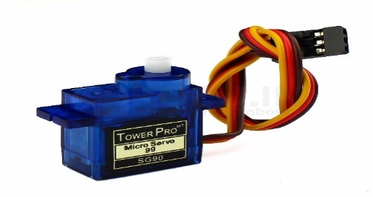

**LCD**

Typically has a standard HD44780 controller and can show a variety of characters and symbols, including uppercase and lowercase letters, numbers, and special characters. The display is frequently illuminated, making it simple to read in low light conditions. LCD shows are commonly used in a variety of applications, including industrial control systems, buyer gadgets, and embedded systems. They are generally low-cost, low-power, and simple to interface with microcontrollers, making them as well known choice for showing data in electronic projects.

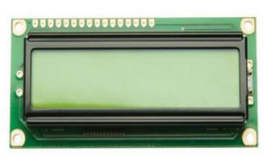

Once the display is properly connected and arranged, you can send content and other data to the display using a variety of commands, such as “clear display”, “move cursor”, and “write character”. The display can also be arranged to showcase the characters or graphics, permitting for more advanced visualizations.

**Buzzer**

A buzzer or beeper is an audio signaling gadget, which may be mechanical, electromechanical, or piezoelectric (piezo for short). Typical uses of buzzers and beepers include alarm gadgets, timers, train and confirmation of client input such as mouse click or keystroke.

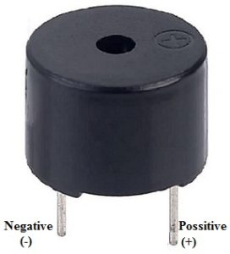

**EM18**

EM18 is a RFID reader which **is utilized to examined RFID tags of frequency 125KHz**. After reading tags, it transmits unique ID serially to the PC or microcontroller using UART communication or Wiegand format on particular pins. Em18 RFID reader reads the information from RFID tags which contains stored ID which is of 12 bytes.

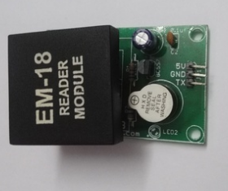

**RFID card reader**

An RFID reader is a radio frequency device that emits a signal through an antenna. This signal through an antenna. This signal is received by RFID tags that react to interrogation by the reader. Responses are studied by the reader, and through a variety of protocols the reader can communicate with all the RFID tags in its field.

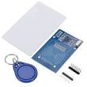

**CONCLUSION**

Taking into account the changing trend in shopping. We come to a conclusion that the smart shopping basket is most certainly a clear need for the retail show casing industry for quick billing. It can follow a human at whatever point he moves in a straight line. The project aims to create an automatic human guided shopping trolley can lead a client to the items areas in shopping mall and he or she is able to know the items areas through a shopping outline. It will take after client accuracy-advance IR systems improve accuracy by moving forward. With the help of automatic line taking after and human leading functions portable robot, shopping mall owners require as it were to buy the convenient robot and can easily install it under shopping trolleys. Clients can at the point appreciate shopping without pushing the shopping trolleys on their own.

**References**

1. Mr. S. Balamurugan and Mr. S. Balaji “Smart Shopping Cart”, 2017.
2. Mr. Manikandan and Mr. Mohan “RFID Based Shopping Trolley for Supermarket”, 2017.
3. Mr. Kumar and Mr. Gupta. A “Smart Trolley using Arduino”, 2017.
4. Mr. Raj and Mr. Inamdar “Smart Cart with Automatic billing”, 2016.
5. R.O’ Neil (21 June 2005, 21 June 2017) “Smart trolley for shopping malls”.
6. Mr. Inamdar, Mr. Singh “Smart cart using automatic billing, product information, product recommendation using RFID, 2015.
7. Mr. P. Chandrasekar and Ms. T. Sangeetha “Smart shopping cart with automatic billing system through RFID and transmitter and receiver”, IEEE, 2014.
8. S. K. Nataraj, F. Al-Turjman, A. H. Adom, R. Sitharthan, M. Rajesh and R. Kumar, "Intelligent Robotic Chair with Thought Control and Communication Aid Using Higher Order Spectra Band Features," in IEEE Sensors Journal, doi: 10.1109/JSEN.2020.3020971.
9. B. Natarajan, M. S. Obaidat, B. Sadoun, R. Manoharan, S. Ramachandran and N. Velusamy, "New Clustering-Based Semantic Service Selection and User Preferential Model," in IEEE Systems Journal, doi: 10.1109/JSYST.2020.3025407.
10. Ganesh Babu, R.; Obaidat, Mohammad S.; Amudha, V.; Manoharan, Rajesh; Sitharthan, R.: 'Comparative analysis of distributive linear and non-linear optimized spectrum sensing clustering techniques in cognitive radio network systems', IET Networks, 2020, DOI: 10.1049/iet-net.2020.0122
11. Raja lingam, B., Al-Turjman, F., Santhosh kumar, R. et al. Intelligent multimodal medical image fusion with deep guided filtering. Multimedia Systems (2020).
12. **Sowmya et.al *“*VLSI IMPLEMENTATION OF TERNARY ADDER AND MULTIPLIER USING TANNER TOOL”,** JOURNAL OF PHARMACEUTICAL NEGATIVE RESULTS , VOLUME 13 ,SPECIAL ISSUE 5 ,2022
13. **Sowmya et.al“ENHANCED FIXED WIDTH BOOTH MULTIPLIER FOR IMPROVED ACCURACY”** JOURNAL OF PHARMACEUTICAL NEGATIVE RESULTS , VOLUME 13 ,SPECIAL ISSUE 5 ,2022
14. **Sowmya et.al“TEMPERATURE AND HUMIDITY SENSOR BASED AIR BLOWER CONTROLLER FOR FOOD DRYING”,** JOURNAL OF ALGEBRAIC STATISTICS, VOLUME 13, NO. 1, 2022, P. 869 – 876, ISSN: 1309-3452.
15. **Sowmya et.al *“*PACKET LOSS AWARE TRUST MANAGEMENT (PLATM) FOR IOT NETWORK** “,INTERNATIONAL JOURNAL OF ADVANCED SCIENCE AND TECHNOLOGY,VOL. 29, NO. 7S, (2020), PP. 5544-5550
16. **Sowmya et.al“TRUST AWARE ROUTING FOR WIRELESS SENSOR NETWORKS”,** ALOCHANA CHAKRA JOURNAL, PP-4283 TO 4289 JUNE 2020, 2231-3990
17. **Sowmya et.al“LABVIEW BASED TEXT DETECTION AND OBJECT RECOGNITION PROTOTYPE FOR THE BLIND AND THE DUMB PEOPLE**” JOURNAL OF EMERGING TECHNOLOGIES AND INNOVATIVE RESEARCH, VOL 6,ISSUE 5, PP-2255 TO 2258,(UGC)
18. **Sowmya et.al**“**MULTI-CONTEXT CLUSTER BASED TRUST AWARE ROUTING FOR INTERNET OF THINGS**”, JOURNAL OF MECHANICS OF CONTINUA AND MATHEMATICAL SCIENCES, VOL.-14, NO.-5, SEP - OCTOBER (2019), PP.396-418. DOI: [HTTP://DOI.ORG/10.26782/JMCMS.2019.10.00029](http://doi.org/10.26782/jmcms.2019.10.00029).
19. **Sowmya et.al“GRAPHICAL APPROACH FOR THE OPTIMIZATION OF MULTI-STANDARD SOFTWARE DEFINED RADIO (SDR) SYSTEMS USING VLSI**” JOURNAL OF EMERGING TECHNOLOGIES AND INNOVATIVE RESEARCH, VOL 6,ISSUE 2, PP-1148 TO 1152 ,FEB 2019(UGC)
20. **Sowmya et.al“PATIENT HEALTH MONITORING SYSTEM USING IOT**” JOURNAL OF EMERGING TECHNOLOGIES AND INNOVATIVE RESEARCH, VOL 6,ISSUE 1, PP-91-95, JAN 2019(UGC)
21. **Sowmya et.al“ PRIVACY AND SECURITY INVESTIGATION OF RFID AUTHENTICATION BASED ON ECC FOR IOT”**IN INTERNATIONAL JOURNAL OF PURE AND APPLIED MATHAMATICS SPECIAL ISSUE VOLUME 117NO 1091-952017**(SCOPUS INDEXED)**
22. **Sowmya et.al“INTEGRATED OPTICAL RECEIVER IMPLEMENTATION USING CMOS TECHNOLOGY**” JOURNAL OF EMERGING TECHNOLOGIES AND INNOVATIVE RESEARCH, VOL 5,ISSUE 10, PP-953-957,OCT 2018