E-Subway

Adarsh Mahajan, Gaurav Harne, Karan Choudhary, Prof. Raj Kumar Verma

Department of Computer Science & Engineering.

Thakur ShivKumar Singh Memorial Engineering College, Burhanpur,

(Affiliated to RGPV Bhopal), India

ABSTRACT

Delivery System is an online food ordering system that makes things easier for customers. It overcomes the disadvantages of traditional classification systems. Our system provides a way to order food online without dealing with restaurants and poor service. The system improves customers' decision-making process. The online food ordering system brings the food online and customers can easily order according to their preferences. The food menu allows customers to easily follow items. The system also provides feedback where the user can rate the dish. Additionally, the proposed system can recommend hotels and meals based on the user's score. Hotel staff is informed about improvement and quality. Payment can be made online or through the payment system. To make ordering more secure, separate accounts containing an ID and password are maintained for each user. The rapid development in the use of the Internet and related technologies provides the Internet with many opportunities. Many companies and businesses are now determined to do their business better thanks to the internet. One of the businesses started by the internet is online food ordering. In today's lifestyle, many restaurants focus on fast preparation and delivery rather than providing a fine dining experience. Most of the deliveries planned recently have been loaded onto the phone, but there are still many problems in the system.

INTRODUCTION

Online food ordering system places the food online and customers can easily order as per their preferences. Food tracking allows online customers to easily track products. Management maintains the customer base and improves the food delivery service. The

e-Metro system inspires us to improve the system. Various tools are available to help system users get the best service. The system also includes both restaurant and dining room equipment for customers. Once again, the idea that those who use the dining room are mostly people who move to new cities for various reasons emerges. So they are interconnected. The reuse of smartphones is also considered as a reason for the users of this system to access all services with a single click. Another engine can be considered as how the system will be set up to prevent users from making fatal mistakes, users will be able to change their profiles, users will be able to track their food via GPS, users will be able to make comments and suggestions and give points. Results suitable for restaurants/service providers. In the absence of a complete program that can meet customer needs in restaurant and catering services, a system is needed. It is said that the proposed system will be used by people who continue to leave cities. For example, it will be useful for students studying in different cities. The proposed system provides customers/users with the flexibility to place orders from Restaurants or Mess. It also offers recommendations sent daily for restaurant patrons/gig hosts. In a given system, there will be no limit to the number of orders the customer wants. The same app can also be used as a business launch for developers. Provides real-time customer feedback and feedback on restaurant/owner concerns. The proposed system is designed to prevent users from making fatal mistakes and inappropriate actions. The scale of the proposed system is reasonable because of the people move to different cities so that more people can use the proposed system. The system/interface will require user input. The main elements that make up the views of the dataset are: name, address, email address, mobile phone number, other values ​​​​related to the person, etc. The output includes the user/customer order, invoice, results, and payment method. .

The reason you chose this project is the idea of ​​a project that aims to solve the problem people face when they move to another city. The system is used not only by million thousand users but also by food service providers. The system and effective communication between consumers and food producers will ensure the creation of a more efficient and effective system.

MOTIVATION

Motivations for this project are as follows:

* + - Whenever there is a need of food for a new person in a city but he can't find any food on the city because he is unknown to the city so our website will deliver the food to the needy person.
    - Usually in the small cities there were no such kind of fast food ordering system so this makes us motivation for our E-subway and we have started the project in our town.
    - Basically our website will try to order the food as soon as possible within the 30 minutes so as no such time waste will occur to the person.
    - The person is just a click away from the tasty and delicious food as our website is very easy to handle And UI is so user friendly so that anyone can order food.

OBJECTIVE OF PROJECT

Objectives of the project are:

* + - The purpose of the project is to remove the traditional queuing system for the restaurants and mess.
    - Our purpose also to save a person's times as we are so quick and swift to delivery of food.
    - Our E-subway is a revolutionary website for consuming food across the town.
    - To provide a system from where one can manage the food at any time, he/she should not have any problem in managing the food.

APPLICATION

* + - * The E-Subway System is accessible anytime, anywhere on any device which can access internet.
      * The facility to provide service of ordering food.
      * Peoples from all over the town are able to access website in single click.
      * E-Subway systems are very helpful in food ordering easily and on affordable price.

LIMITATION

* + - Our services is only at limited region.
    - There is no facility of Return.
    - There is need for internet connection to access the store.
    - Since it is a startup so this project does not have all categories of Food Dishes.

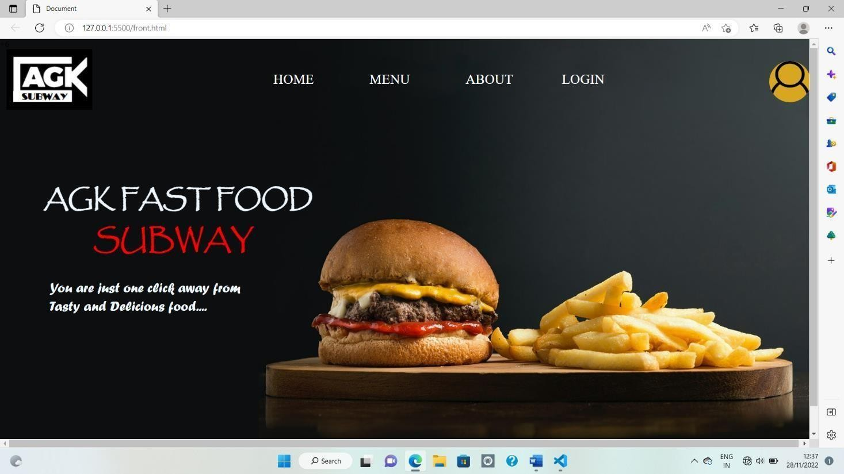RESULT

Home Page

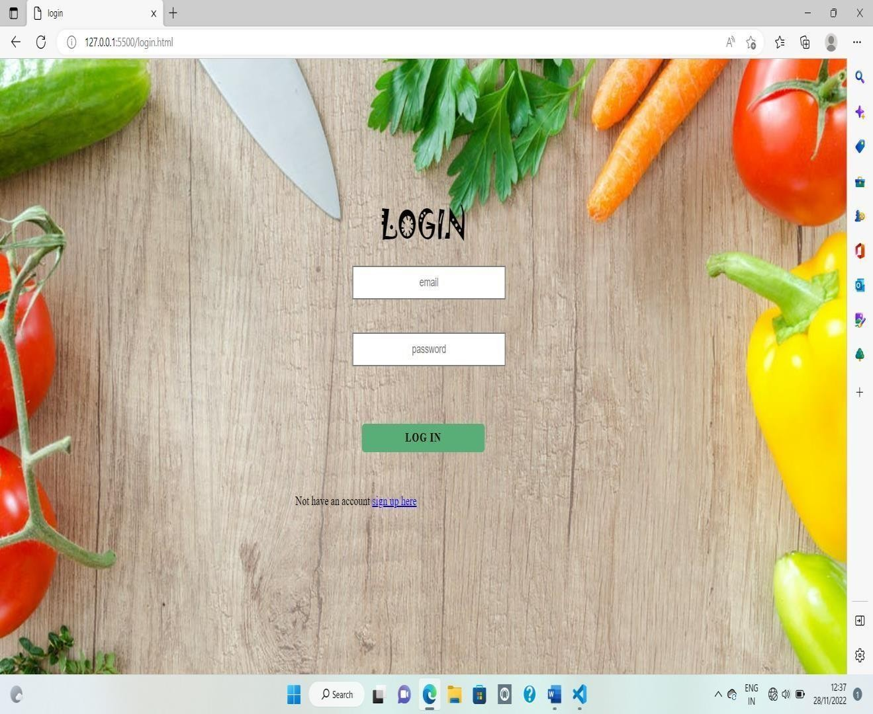

SUMMARY

Therefore, conclusion of the proposed system is based on user’s need and is user centered. The system is developed in considering all issues related to all user which are included in this system. Wide range of people can use this if they know how to operate android smart phone. Various issues related to Mess/Tiffin Service will be solved by providing them full fleged system. Thus, implementation of Online Food Ordering system is done to help and solve one of the important problems of people. Based on the result of this research, it can be concluded: It helps customer in making order easily; It gives information needed in making order to customer. The Food website application made for restaurant and mess can help restaurant and mess in receiving orders and modifying its data and it is also made for admin so that it helps admin in controlling all the Food system.

CONCLUSION

* + - It provide the fast and fresh service to the needy one’s.
    - This project provide easier way to access our website because of user friendly UI.
    - The user can categories food and add the food to cart and save it for future reference.

FUTURE SCOPE

* This project aimed at developing an online food ordering system which can be used in small places, and medium cities firstly and then on a large scale.
* We can add coupons system so that the users can avail the discount offer.
* We can include more food items
* according to the response we get from customer.
* We will further add more location services which makes our website to reach to more peoples.

REFERENCE

* [www.google.com](http://www.google.com/)
* [www.wikipedia.com](http://www.wikipedia.com/)
* [www.youtube.com](http://www.youtube.com/)
* [www.w3schools.com](http://www.w3schools.com/)
* Varsha Chavan, Priya Jadhav, Snehal Korade, Priyanka Teli, ”Implementing Customizable Online Food Ordering System Using Web Based Application”, International Journal of Innovative Science, Engineering Technology(IJISET) 2015.
* Resham Shinde, Priyanka Thakare, Neha Dhomne, Sushmita Sarkar, ”Design and Implementation of Digital dining in Restaurants using Android”, International Journal of Advance Research in Computer Science and Management Studies 2014.
* Khairunnisa K., Ayob J., Mohd. Helmy A. Wahab, M. Erdi Ayob, M. Izwan Ayob, M. Afif Ayob, ”The Application of Wireless Food Ordering System” MASAUM Journal of Computing 2009