**ART GALLERY**

**Chaitali Mahajan, Priyanka Choudhary, Somesh Nerkar**

Department of Computer Science & Engineering.

Thakur ShivKumar Singh Memorial Engineering College, Burhanpur,

(Affiliated to RGPV Bhopal), India

# Abstract:

This project delves into the inner workings of art galleries, those captivating spaces where artwork comes to life. We explore the various tasks involved in managing these galleries, from selecting which pieces to exhibit to ensuring a delightful experience for visitors.

Throughout our journey, we uncover the strategies galleries use to curate engaging exhibitions, care for their precious collections, and connect with audiences. By gaining insights into these processes, we aim to assist galleries in enhancing their operations and enriching the art-viewing experience.

# Introduction:

Art galleries are like treasure troves filled with paintings, sculptures, and other amazing creations. But running them smoothly involves a lot of work. From deciding which artworks to display to attracting visitors and making sure everything runs smoothly, managing an art gallery is no easy task. In this project, we'll dive into the exciting world of art gallery management. We'll learn how galleries plan exhibitions, take care of their collections, engage with visitors, and manage their finances. By understanding these aspects better, we can help galleries become even better at what they do. So, get ready to explore the fascinating world of art gallery management with us! We'll uncover the secrets behind these cultural hubs and discover how they contribute to our enjoyment and appreciation of art. Let's dive in and see what we can uncover together.

# Literature Review:

Art gallery management is a fascinating field that has captured the attention of researchers and practitioners alike. In our exploration of the literature, we find several key themes that shed light on the complexities and challenges of managing art galleries.

Firstly, scholars emphasize the importance of curatorial decision-making in shaping the identity and success of art exhibitions.

Researchers have examined various approaches to curating, from thematic and chronological displays to experimental and interdisciplinary formats. Understanding these methods helps galleries create engaging and thought-provoking exhibitions that resonate with diverse audiences.

Secondly, the literature underscores the significance of collection management practices in preserving and showcasing artworks. Studies highlight the importance of proper documentation, conservation efforts, and ethical acquisition policies to safeguard the integrity of gallery collections. By implementing best practices

in collection management, galleries can ensure the longevity and accessibility of their holdings.

Thirdly, scholars emphasize the role of audience engagement strategies in fostering connections between galleries and their communities. Research explores the effectiveness of educational programs, outreach initiatives, and digital platforms in attracting visitors and cultivating meaningful experiences. By embracing innovative approaches to audience engagement, galleries can broaden their reach and inspire greater participation in the arts.

Finally, scholars discuss the financial challenges facing art galleries and propose strategies for achieving sustainability. Studies examine revenue generation models, fundraising tactics, and budget management techniques to support gallery operations. By adopting sound financial practices, galleries can navigate economic uncertainties and pursue their mission of

promoting artistic excellence.

# Methodology:

To develop an effective art gallery management system, we're following a step-by-step approach:

* Understanding Needs: We start by talking to gallery managers and staff to understand their challenges and requirements. This helps us identify what features the system should have to meet their needs.
* Research: We then research existing art gallery management systems to see what works well and what could be improved. This helps us learn from others' experiences and avoid reinventing the wheel.
* Designing: Based on our understanding and research, we design the system, outlining its structure, features, and user interface. We make sure it's user-

friendly and meets the needs of gallery staff.

In our project we used SDLC’s different models as follows:

Incremental modeling is a software development process that breaks down requirements into more specific parts of the software's functionality. In this model, each module goes through requirements, design, implementation, and testing phases. Each subsequent version of the module adds functionality to the previous version. The process continues until a complete system is obtained. The different categories of incremental models are as follows:

**1. Requirements Analysis:** In the first stage of the incremental model, product analysis skills determine the requirements. The system enables the analysis team to understand the requirements. This stage plays an important role in software development under the incremental model.

**2. Design & Development:** In this growth phase of the SDLC model, the functional design and development process of the system is successfully completed. When the software develops new features, it uses incremental model building and development phase.

**3. Testing:** In an incremental process, the testing phase checks the performance of each existing feature and other incremental features. During the testing phase, different methods are used to measure the behavior of each activity.

**4. Implementation:** The implementation phase supports the coding phase of system development. Contains final code designed during the design development phase of the and tested for functionality during the testing phase. After this stage is completed, the number of active products is increased and upgraded to the final system product.

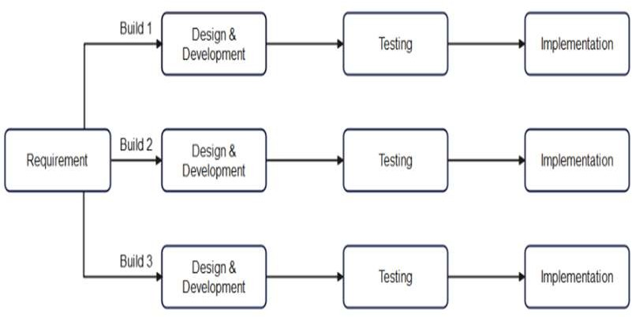

Fig.1.1: Incremental Model

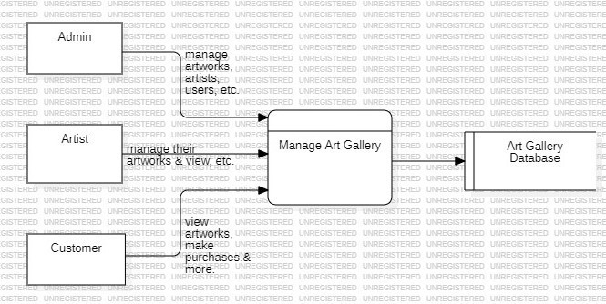

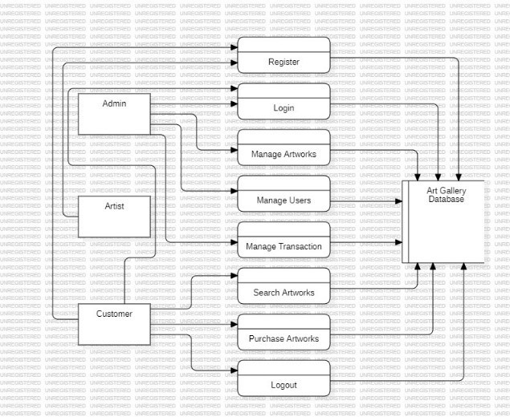 Fig.1.2: DFD

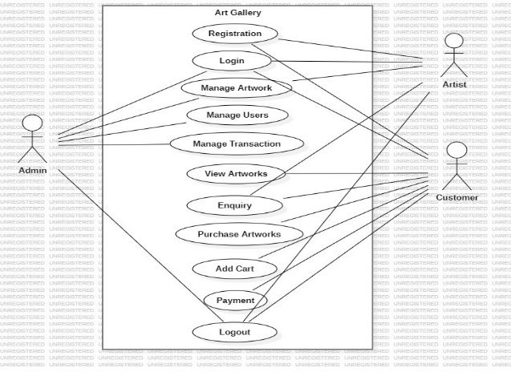

Fig.1.3: Use Case Diagram

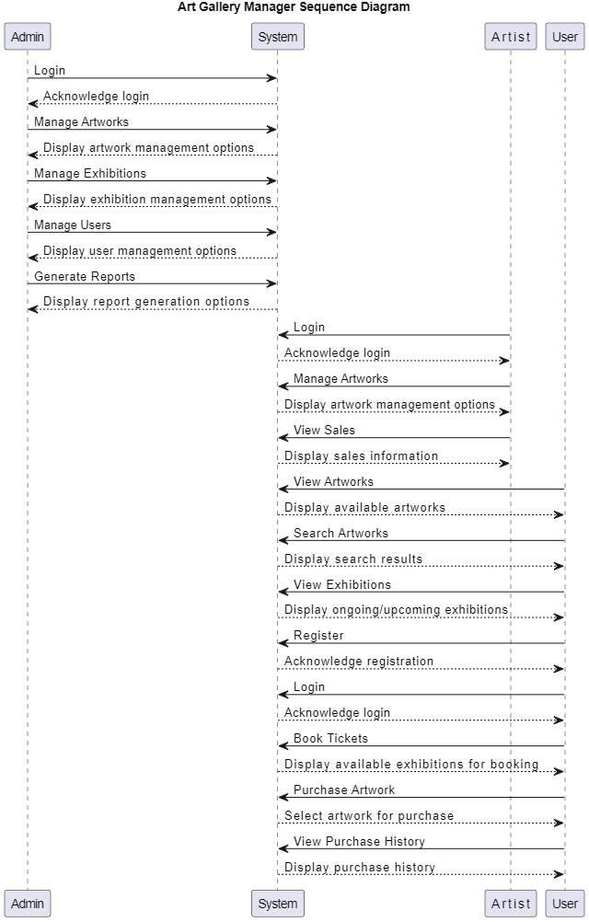

Fig.1.4: Sequence Diagram

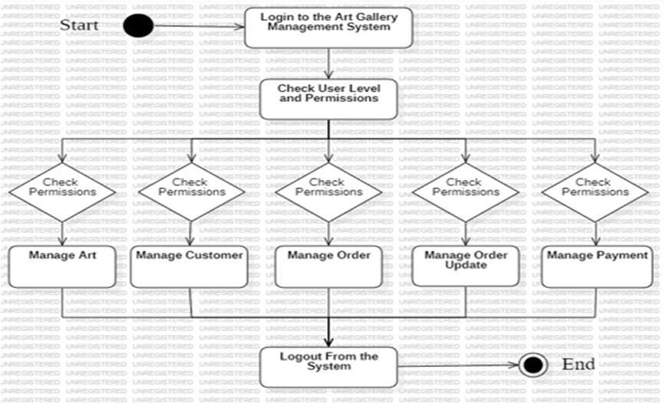

Fig.1.5: Activity Diagram

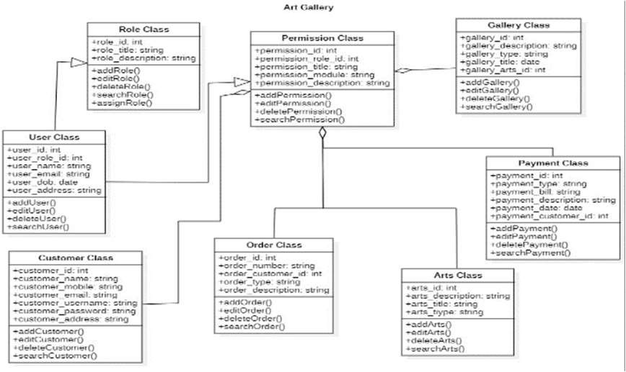

Fig.1.6: Class Diagram

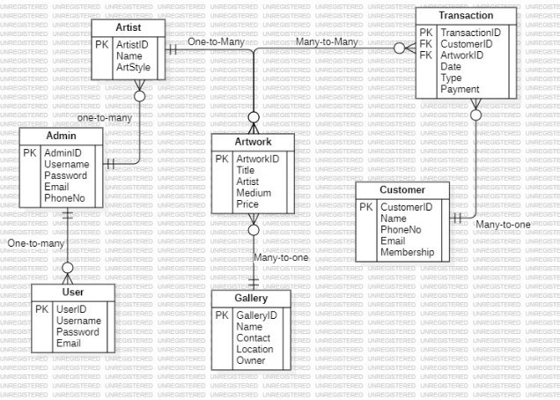Fig.1.7: ER Diagram

# Results:

After implementing the art gallery management system, we observed several positive outcomes:

* Improved Efficiency: Gallery staff reported that the system helped streamline various tasks, such as artwork cataloguing, inventory management, and scheduling exhibitions. This increased efficiency allowed them to focus more on curating engaging experiences for visitors.
* Enhanced Organization: The system's centralized database made it easier to store and access information about artworks, artists, and exhibitions. This improved organization reduced the time spent searching for information and minimized the risk of errors.
* Better Visitor Experience: With the system's integrated ticketing and visitor management features, galleries were able to provide a smoother and more personalized experience for visitors. This included faster check-ins, tailored recommendations, and easier access to information about the artworks on display.
* Increased Revenue: By automating processes such as ticket sales, merchandise purchases, and membership renewals, the system helped galleries generate more revenue. This additional income contributed to the financial sustainability of the galleries and supported their ongoing operations.

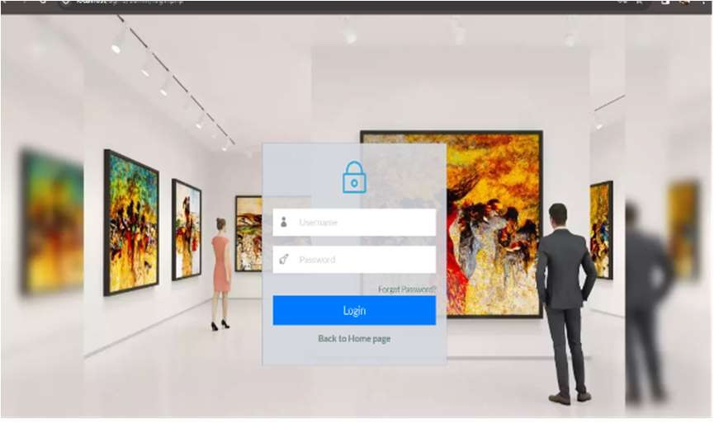

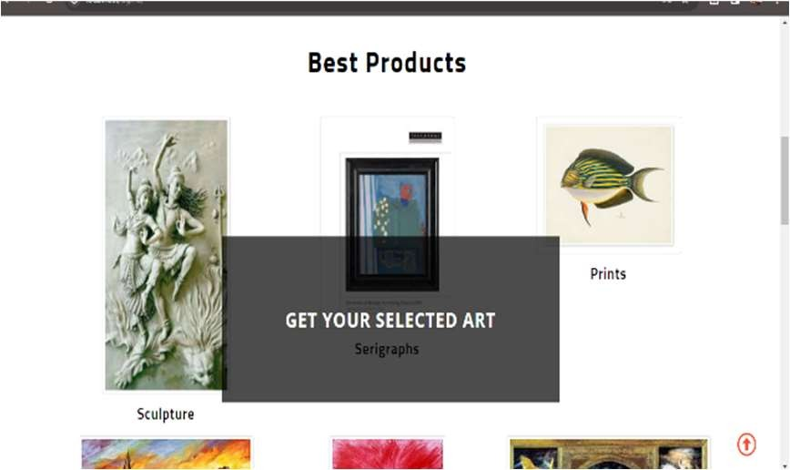 Fig. Login Page

Fig. Home Page

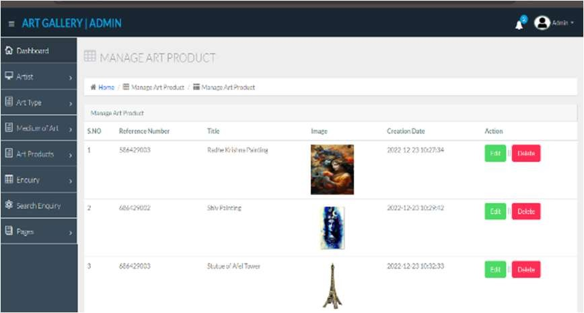

Fig. Admin Dashboard

# Conclusion:

In conclusion, the implementation of the art gallery management system has yielded positive results, enhancing efficiency, organization, and visitor experience. The system's streamlined processes have empowered gallery staff to focus more on curatorial tasks and community engagement. Additionally, the system has facilitated revenue generation, contributing to the financial sustainability of galleries.

Moving forward, continual refinement and adaptation of the system will ensure its continued effectiveness in supporting galleries' missions to promote and preserve the arts, ultimately enriching the cultural landscape for both staff and visitors alike.

# Future Scope:

* Expansion: Consider expanding physical gallery space or establishing satellite galleries in different locations.
* Online Presence: Strengthen the virtual gallery presence with interactive online exhibitions and e- commerce.
* Art-Tech Integration: Embrace emerging technologies like augmented reality (AR) and virtual reality (VR) for immersive art experiences.
* Global Outreach: Forge international partnerships to host cross-border exhibitions and cultural exchanges.
* Art Innovation Hub: Develop a platform for artists to experiment with cutting-edge techniques and foster innovation.
* Art Investment: Collaborate with art investors and venture capitalists to support emerging artists and projects.
* Art Therapy Expansion: Expand art therapy programs for mental health and wellness initiatives.
* Sustainability Initiatives: Lead the way in sustainable art practices and eco-friendly gallery operations.

# References:

* **Books:** Look for books on art gallery management, curation, and art history that can provide valuable insights into the subject.
* **Art Magazines:** Publications like Artform, ART news, and Art Review often feature articles on gallery trends, exhibitions, and artists.
* **Online Art Resources:** Websites like Artsy, Arnette, and Hyperallergic offer news, features, and insights into the art world.
* **Museum and Gallery Association Websites:** Check websites of museum and gallery associations for resources and best practices in gallery management.
* **Interviews and Case Studies:** Look for interviews with gallery owners, curators, and artists to learn from their experiences. Case studies of successful gallery projects can also be informative.
* **Art Market Reports:** Reports from organizations like The Art Market Monitor and Art Basel can provide insights into art market trends.
* **Art Education Institutions:** Universities and art schools often have research papers, theses, and publications related to gallery management and the art world.