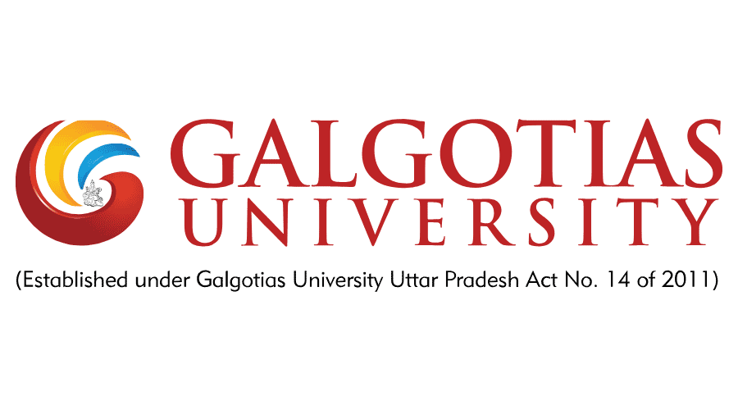**More Then Masala:Decoding The Emotional Connection In Haldiram’s Brand Loyalty**



*PROJECT REPORT SUBMITTED IN PARTIAL FULFILLMENT FOR THE AWARD OF THE DEGREE OF:*

Master of Business Administration

*By :Sarika Yadav(22GSOB2010561)*

*IN BRANCH OF STUDY:*SCHOOL OF BUSINESS

*UNDER THE SUPERVISION OF:*

*Prof. Dr. Md.Chand Rashid*

*Title of the research paper :* **More Then Masala:Decoding The Emotional Connection In Haldiram’s Brand Loyalty**

**Abstract:**

Haldiram’s started out as a small sweet store in a remote area and has grown into a major Indian snack and convenience (Ready to Eat) food manufacturer. A highlight of Haldiram marketing mix, it has made the company a leading manufacturer and retailer of Namkeen and confectionery.

Haldiram's customizes its products to suit the taste and preferences of customers from all over India. It launched products, as per the taste of people belonging to particular regions. For example it launched 'Murukkus' a south Indian Snack and Chennai Mixture' for the customers who lives in south region of India. Similarly Haldiram's launched 'bhelpuri' keeping in mind the customers of western India. The Haldiram’s offers certain products ('Nazarana', 'Panchratan' and 'Premium') only during the festival season as gift packs.

Haldiram's competes on the basis of numerous factors including brand recognitior due to distinct packaging. Product quality. Traditional taste and authentic Indian flavor. The Haldiram’s timely introduce the new products and line extension has played a major part on consumer’s buying behavior.

**Introduction:**

More than Masala: Decoding the Emotional Connection in Haldiram's Brand Loyalty" is a study or exploration into the deeper emotional bonds that consumers form with the Haldiram's brand beyond just the appeal of its products. It aims to unravel the psychological and sociological factors contributing to the strong loyalty that customers exhibit towards Haldiram's, delving into aspects such as nostalgia, cultural identity, and trust. This investigation sheds light on how brands can go beyond merely selling products to creating meaningful connections with their audience.

|  |  |
| --- | --- |
| Type | Private |
| Industry | Food |
| Founded | Bikaner, Rajasthan |
| Founder | Ganga Bishan Agarwal (haldiram ji) |
| CEO | Manish Agarwal |
| Executive director | Ashok Kumar tyagi |
| Headquarters | Nagpur, Maharashtra, India |
| Products | Snacks, sweets, beverages, frozen foods, potato chips |
| Revenue | ₹7,130 crore (us$940 million) (2019) |
| Website | [www.haldiram.online](http://www.haldiram.online), [haldiram.online](https://haldiram.online/) |
| **Offices** | |
| Head Office - Nagpur | |
| Address: | Plot No. 145/146, Haldiram House, Bhandara Road Chowk, Old Pardi Naka, Surya Nagar, Nagpur, Maharashtra 440035. |
| Telephone: | [+91 9764449796](tel:+91%209764449796), [+91 9607778600](tel:+91%209607778600), [+91 9607678600](tel:+91%209607678600) |
| Fax: | 0712 – 2680218 |
| Email ID: | support@haldirams.com |
| Regional Office - Mumbai | |
| Address: | Haldiram Foods International Pvt Ltd, A-204/207 Shyam Kamal West Wing, Agrawal Market, Mumbai – 400057 |
| Telephone: | [022 – 26130771](tel:022%20%E2%80%93%2026130771), [022 – 26170762](tel:022%20%E2%80%93%2026170762) |
| Fax: | 022 – 20145116 |
| Email ID: | support@haldirams.com |

**About The Haldiram’s:**

Haldiram’s is an Indian International sweets, snacks and Restaurant Company. It’s headquarter is in Nagpur, Maharashtra. The manufacturing plants of Haldiram’s is available in various locations such as Nagpur, Delhi, Gurgaon, Rudrapur and Noida. Haldiram’s has its own retail stores and various restaurants in Pune, Nagpur, Kolkata, Noida and Delhi.

**Haldiram’s: Brand:**

Users – Customer loves to eat Indian meals with quality

* Country of origin – Bikaner
* Organization associations – innovational & high quality products
* Brand personality – “Maharaj”, Its known for lip-smacking dishes
* Symbol – For richness & purity its written in golden
* Brand customer relationship – Every time they provide quality products
* Emotional benefits – Customer likes to purchase of hygienic & quality products

**Strengths as Brand:**

* First mover
* quality & hygienic product
* Value for money products
* Used as exchange of gifts
* Strong distribution network
* Hoardings for promotion
* For all age groups

Various awards of recognition

# **Literature Review:**

Haldiram has been a dominant player in fastfood category in the Indian market in spite of the presence of McDonald's, KFC and Domino's.

Over a period spanning six and a half decades, the Haldiram's Group (Haldiram's) had emerged as a household name for ready-to-eat snack foods in India. It had come a long way since its relatively humble beginning in 1937 as a small tine sweet shop m Bikaner, m the Rajasthan state of India.

The group had presence not only m India but in several countries all over the world. Ill the early 1990s, Haldiram's comprised of three units, one each in Kolkata, Nagpur and New Delhi. The Agarwals family that owned Haldiram's were always conscious of the need to satisfy customers order to grow their business. The company offered a wide variety of traditional Indian sweets and snacks at competitive prices that appealed to people belonging to different age groups. Haldiram's had many 'firsts' to its credit.

It was the first company in India to brand 'namkeens3. The group also pioneered new ways of packaging namkeens.

# **Research Objectives:**

* To explore the frequency of consumption of Haldiram's products among consumers.
* To identify the main reasons for choosing Haldiram's over other snack brands.
* To analyze the emotional responses evoked by Haldiram's products in stores or advertisements.
* To examine the role of recommendation behavior in building brand loyalty.
* To investigate the association of specific emotions or feelings with the Haldiram's brand.
* To understand the factors that contribute to Haldiram's emotional connection compared to other snack brands.
* To assess the importance of brand trust and reputation in snack product selection and its relation to Haldiram's.
* To gather suggestions for Haldiram's to enhance its emotional connection with consumers.
* Investigate the factors contributing to brand loyalty in the context of Haldiram's products.
* Analyze the role of emotional connections in fostering brand loyalty among consumers of Haldiram's.
* Explore the significance of cultural influences on consumer perceptions and emotional attachment to Haldiram's brand.
* Examine the impact of brand experience and satisfaction on the emotional connection and subsequent loyalty to Haldiram's.
* Identify strategies employed by Haldiram's to strengthen emotional connections with consumers and enhance brand loyalty.
* Evaluate the effectiveness of Haldiram's marketing campaigns and brand communication in nurturing emotional bonds with consumers.

Propose recommendations for Haldiram's and similar brands to further enhance emotional engagement and foster long-term brand loyalty among consumers.

# **History of Haldirams:**

Haldiram’s was founded in 1941 by Ganga Bishan Agrawal, fondly known as Haldiam ji in his household; as a retail sweets and Namkeen shop in Bikaner, Rajasthan.

Haldiram began as a small sweet shop in Bikaner, a land famous for its savouries flavours, as was it for its leather-faced pipe players and fierce warriors. By 1982, Haldiram's had set up shop in Delhi, the capital of India that had begun to pick up and take off. Pay attention to the traditional taste of savouries and sweet. It was word of mouth that grew the business manifold over the next decade till Haldiram's came to stand for a good quality food company that was synonymous with traditional taste, hygiene and innovation.

In the international we have started from USA to export our products, thanks to the large Indian population there. We began with about 15-20 products, all savouries, and Namkeens because they are a favourite with Indians.

What started as a small town enterprise in India is today a global phenomenon. Haldiram is a way of life for Indians, regardless of the country they live in. And the countries they live in are also rapidly developing for these products.

**Certification and Accolades:**

* BRC
* FSSAI
* Products of india
* Halal food certified
* Kosher certified
* FSSC 22000

# **Quality Assurance:**

Consumers around the globe needed to be sure that the products they want buy are of unique quality. Our focus is on delivering quality goods with the highest excellence to the consumer, while being committed to using resources responsibly.

We pay utmost attention to the selection of finest raw material, this is achieved through proper quality management system with the help of our suppliers through internal review process.

Haldiram certified that all our products are BRC ‘A’ certified and are regularly checked under the guidelines provided by BRC by our professional quality management team. We invest in the newer and better, we are working to make our products of superior quality.

Haldiram’s have its own management team and procedures to support us in maintaining our degree of excellence –

* Daily gathering and monitoring of customer feedback.
* Performance monitoring of supplier against criteria set by haldiram’s.
* They provide time to time Training and development of skills of our employees.
* Regular Inspection of our internal process.
* Management reviews of Inspection result, customer’s feedback and complaints.

# **Research Design and Methodology**

## **Research Design:**

This study aims to decode the emotional connection in Haldiram's brand loyalty among consumers. To achieve this objective, a quantitative research approach utilizing a cross-sectional survey design will be employed. The data collection method will involve the distribution of a structured questionnaire via Google Forms to gather responses from a sample of Haldiram's consumers.

### **Sampling Technique:**

A non-probability convenience sampling technique will be utilized to select respondents for the study. Participants will be recruited from various demographics and geographical locations to ensure diversity in the sample.

### **Questionnaire Design:**

The questionnaire will consist of nine closed-ended questions designed to explore consumers' consumption patterns, preferences, emotional associations, and perceptions regarding Haldiram's brand. Each question will offer multiple-choice response options to facilitate easy data collection and analysis.

### Variables:

**Independent Variable:** Emotional connection with Haldiram's brand.

**Dependent Variables:** Consumption frequency, reasons for choosing Haldiram's, emotional responses to Haldiram's products, recommendation behavior, association of emotions with the brand, perceptions of brand differentiation, sense of nostalgia or comfort, importance of brand trust and reputation, and suggestions for strengthening emotional connection.

### **Data Collection Procedure:**

The Google Form questionnaire will be distributed via social media platforms, email, and online forums frequented by Haldiram's consumers. Participants will be informed about the purpose of the study and assured of the confidentiality of their responses. Data collection will continue until a sufficient sample size is achieved to ensure statistical reliability and validity.

### **Data Analysis:**

Quantitative data obtained from the survey will be analyzed using descriptive and inferential statistical techniques. Descriptive statistics such as frequencies, percentages, means, and standard deviations will be computed to summarize the demographic characteristics of the sample and the responses to each questionnaire item. Inferential statistics, including correlation analysis and regression analysis, will be conducted to examine the relationships between variables and identify factors influencing emotional connection and brand loyalty.

## **Methodology:**

The methodology for the master thesis on the topic "More Than Masala: Decoding The Emotional Connection In Haldiram’s Brand Loyalty" involves a systematic approach to understanding consumer perceptions and behaviors towards Haldiram’s products. The data for this study was collected through a Google Form questionnaire designed to gather insights into various aspects of consumer attitudes, emotions, and preferences regarding Haldiram’s brand.

The questionnaire consisted of nine open-ended and close-ended questions aimed at eliciting responses pertaining to different dimensions of brand loyalty and emotional connection. The questions included:

* Frequency of consuming Haldiram's products.
* Reasons for choosing Haldiram's over other snack brands.
* Emotional responses triggered by encountering Haldiram's products in stores or advertisements.
* Instances of recommending Haldiram's products to friends or family and reasons behind those recommendations.
* Association of specific emotions or feelings with the Haldiram's brand.
* Perceptions of what sets Haldiram's apart from other snack brands in terms of emotional connection.
* Experiences of nostalgia or comfort associated with consuming Haldiram's products.
* Importance of brand trust and reputation in choosing snack products, and evaluation of Haldiram's performance in this aspect.
* Suggestions for Haldiram's to enhance its emotional connection with consumers.

The data collection process involved distributing the questionnaire link through various online platforms and social media channels to reach a diverse pool of respondents. The respondents were encouraged to provide honest and detailed responses to each question, ensuring the richness and depth of the data collected.

Once the respo:nses were collected, they were analyzed using qualitative and quantitative research methods. Qualitative analysis involved thematic coding and categorization of open-ended responses to identify recurring themes and patterns in consumer perceptions and behaviors. Quantitative analysis involved statistical analysis of closed-ended responses to quantify the prevalence of different attitudes and opinions among respondents.

Overall, the methodology employed in this study aims to provide a comprehensive understanding of the emotional connection underlying Haldiram’s brand loyalty, shedding light on the factors driving consumer preferences and behaviors in the snack industry.

# **Findings**

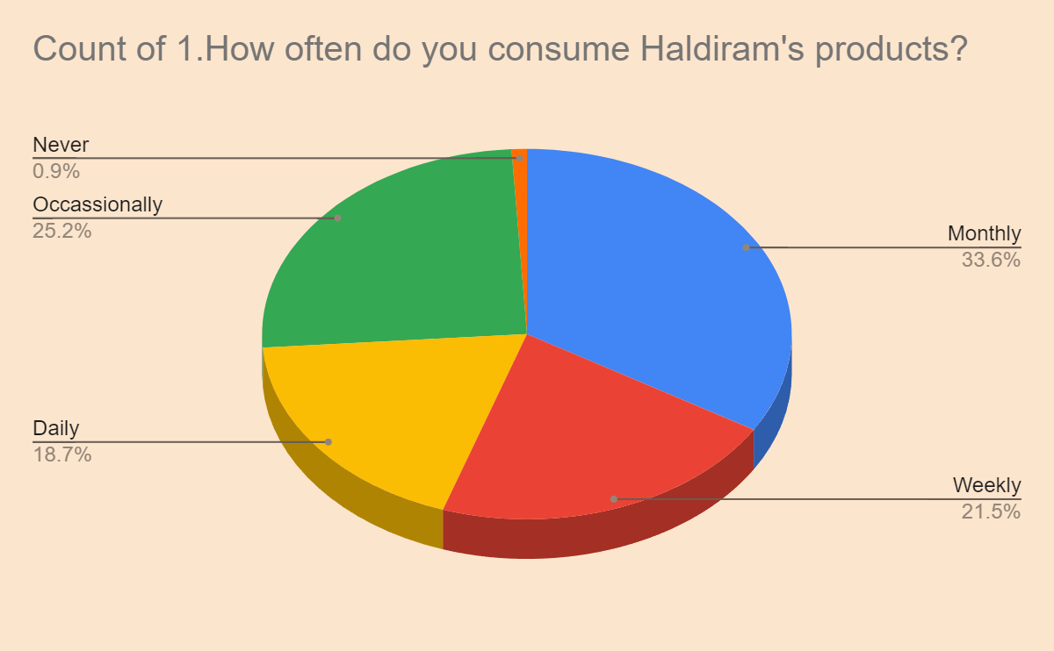

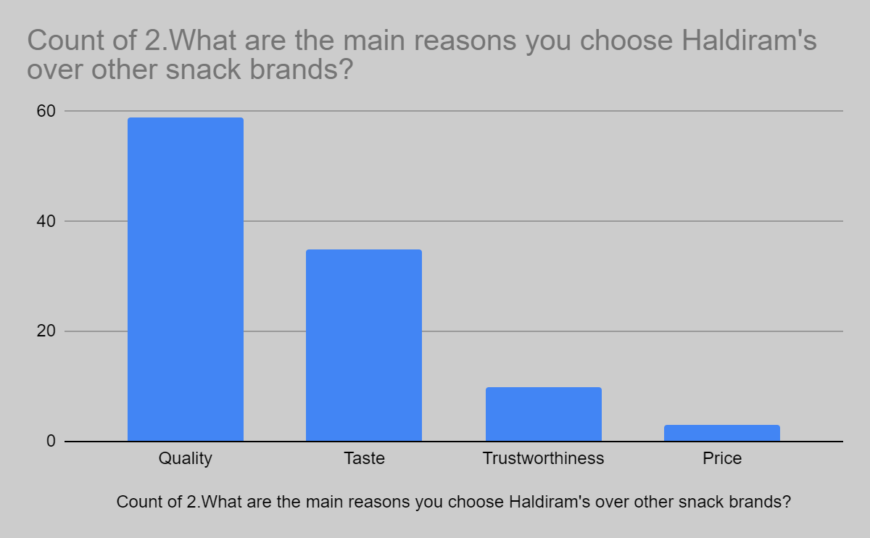

# **Limitations:**

* Sample Size: Limited sample size may restrict the generalizability of findings to a broader consumer population.
* Geographical Scope: Focusing solely on a specific geographic area or market segment may limit the applicability of findings to other regions or demographics.
* Time Constraints: Constraints on time may limit the depth of data collection and analysis, potentially overlooking nuances in consumer behavior and emotional connections.
* Data Availability: Availability of secondary data or access to proprietary information from Haldiram's could be limited, impacting the comprehensiveness of the analysis.
* Subjectivity: Interpretation of emotional connections and brand loyalty may be subjective, leading to potential biases in the analysis and conclusions.
* External Factors: External factors such as economic conditions, competitive landscape, or unforeseen events may influence consumer behavior and brand loyalty, which may not be fully accounted for in the study.
* Research Methodology: Limitations inherent in the chosen research methodology, such as survey design, interview techniques, or data analysis methods, could affect the validity and reliability of the findings.

# **CONCLUSION:**

The market is flooded with major players like Frito-Lay India, PepsiCo's snack food arm, which has pioneered the snack-chip revolution in the country, Haldiram's and Delhi-based snack-food-retailer Bikanerwala Foods Pvt Ltd, etc. Even dairy major Mother Dairy has a presence in this category. With the entry of companies like IC and HLL into this industry, it is becoming increasingly difficult for companies like Haldiram's who have not given serious attention to its branding activities till now.

Increased media exposure, increasing purchasing power of the target audience as well as their willingness to spend more on eating out due to lifestyle changes will fuel the demand for snack foods and only companies that have voice and space in the market. Enough part. Will be able to survive. Haldiram has the ability to meet these demands and being able to do it successfully requires only a certain modification in its strategies, which it has already started considering.