**An Analysis of Restaurant Table Reservation Systems**

**Koyana Mahajan1, Mahima Patil2, Prof. Jinal Patel3**

Department of Computer Science & Engineering

Thakur Shivkumar Singh Memorial Engineering Collage, Burhanpur (Affiliated to RGPV Bhopal),India

**Abstract:-**In this research paper, we present the design and implementation of a restaurant table reservation system with the increasing demand for online services. Efficient table reservation system have become essential for both customer and restaurant owners our system aims to streamline the reservation process, enhance customer experience, and optimize restaurant operations. The system incorporates various features, including a user-friendly interface for customer to browse available tables, select preferred dining times and make reservation the system utilizes database management to store and retrieve reservation information securely to develop the system, we employed python programming language along with relevant libraries such as web development.

**Keywords:** Restaurant table reservation, Online services.

**I. INTRODUCTION**

The dining industry is witnessing a transformative shift with the advent of technology driven solutions aimed at optimizing operational efficiency and enhancing customer experience. Among these innovations, automated table reservations system stand out as a pivotal tool for restaurant to streamline their booking processes, manage seating arrangements, and ultimately, improve moreover, this research investigate the impact of digital reservation system on various stakeholders, including restaurant owners, managers, staff, and overall service quality. This research paper explores the significance of automated table reservation system in the contemporary restaurant landscape. Through a comprehensive examination of existing literature, industry reports, and case studies, this study aims to shed light on the benefits, challenges, and implications of adopting such system. Customers. In summary this research paper offer a challenges associated with implementing a digital solution for restaurant table reservations.

**II. OBJECTIVE OF PROJECT**

The objective of our website are as follows-

* Registration of Admin.
* Registration of customer.
* It contains the information of customer and admin.
* Keeps the detail of tables.

The reservation system influences the overall dining experiences for customer, including case of booking, customization options, and communication with the restaurant considering factors such as increased table utilization it may include features such as managing multiple reservation, handling cancellations. This project may involve developing a user-friendly interface for customers to view availability select a desired time and date, provide contact information, and receive confirmation.

**III. APPLICATION AND SCOPE**

1. **Applications**

* The main advantage of booking tables at a restaurant is that they do not have to wait for a table after they reach the restaurant.
* Explore how reservation system contribute to a better dining experience by allowing customers to book tables in advance.
* In this table reservation system customers also book their food.
* Customer book their food also.

1. **Scope**

The scope of a restaurant table reservation project could include features like user registration, table availability management, reservation booking, cancellation.

* User Registration- Allow user to create account with their personal information, such as name, contact details and preferences.
* Table Availability Management- Implement a system to manage table availability in real-time. This include tracking table status, such as occupied, reserved or available.

**IV. FLOW CHART**

Flow chart is a type of diagram that represents a work flow or process. A flow chart can also be defined as a diagrammatic representation of an algorithm. Flow charts are used in analyzing, designing, documenting or managing a process.

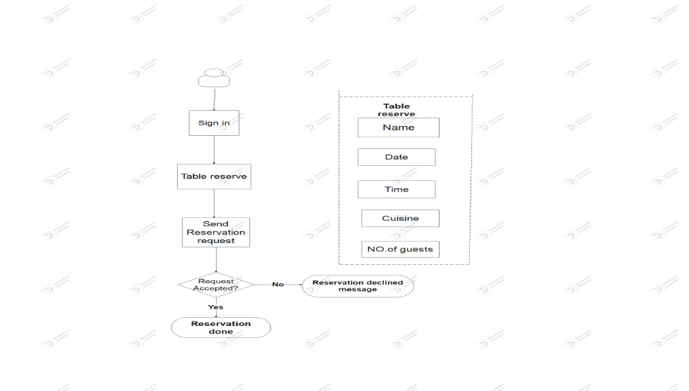

**V. RESULTS**

**A. Login Page**

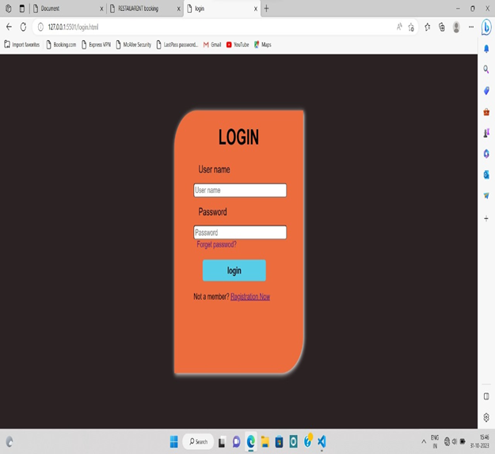

This is a login page of our website. The login page allows a user to gain access to a website by entering their username and password. Benefit of the login page is user can see their profile and information of their order. In this page users have fill their details only once. After submitting all the details needed the user data will be saved in our database.

**B. Home Page**

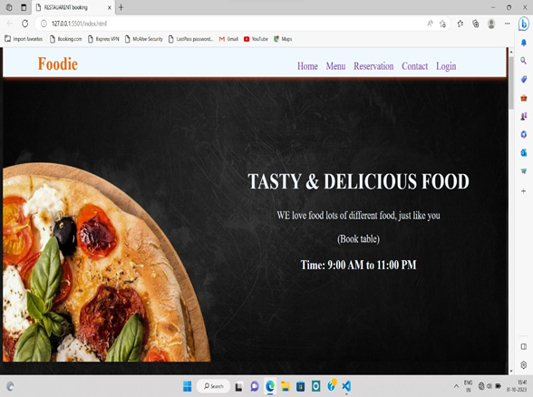

A home page is the default or front page of a site. It is the first page that visitors see when they sign-up for registration page. This is a home page of RESTAURANT TABLE BOOKING as the starting point of the website.

This home page is the main page of a website where visitors first land. On this page you need to provide the most important information about the restaurant table reservation project. You should include basic details about the restaurant, a reservation form, contact details. The purpose of this page is to attract visitors and provide them with accurate information about the reservation process.

The goal of the home page is to attract visitors, provide essential information and make the reservation process as smooth as possible.

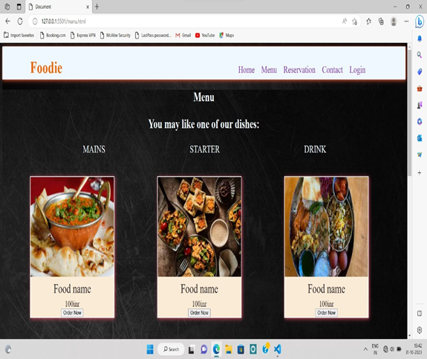

Different types of menus are available.

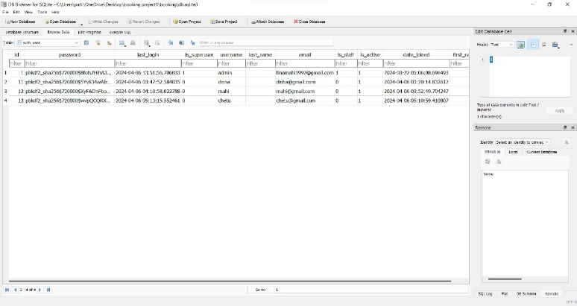

This is the database table of the users.

**VI. Reservation Form**

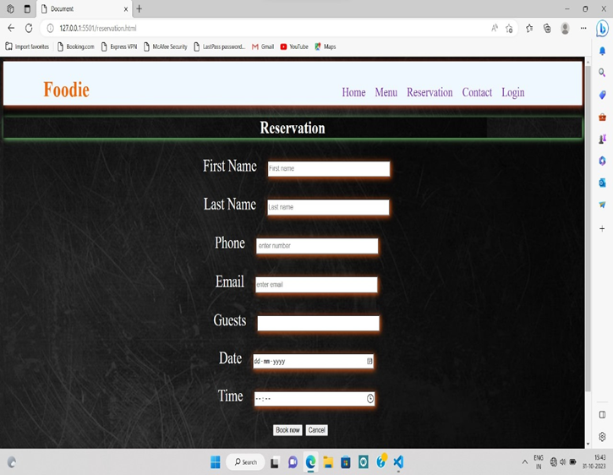

This form collects the user's name and email, phone number for contacting the customer regarding the reservation. Allow customer to choose the date and time for their reservation. Checkbox or agreement box to confirm that the customer understand the restaurant reservation policies, such as cancellation fees or time limits.

**VII. MODULES OF THE PROJECT**

The "Restaurant table booking" project, various modules can be developed to support its functionality and objectives. Here are some potential modules that could be included in the project:

1. **User Management Module: This module manages user authentication (login, registration) to access different functionalities within the system.**
2. **Table Management Module: This module manages the inventory of tables in the restaurant including their availability, capacity and status (occupied, reserved, available).**
3. **Payment Processing Module:** If the system include online payment for reservation this module handles payment transactions securely.
4. **Admin Dashboard Module:** This module provide administrators with tools to manage reservation, view analytics, update restaurant information and manage user account.
5. **Database Management Module:** Designing and implementing the database schema to store information such as customer details, reservation times, table availability and restaurant settings.

**VIII. CONCLUSION**

In conclusion the restaurant table reservation project presents a viable solution to streamline the booking process, enhance customer experience and optimize table utilization. Through the implementation of an online reservation system, restaurant can efficiently manage their seating capacity, reduce wait times and improve overall operational efficiency.

The restaurant table reservation project has successfully addressed the need for efficient reservation management. By implementing an online booking system, we have provided customers with a convenient way to reserve tables, reducing the workload on staff and minimizing errors. The project has enhanced the overall dining experience for customers while improving operational efficiency for the restaurant. Moving forward, continuous monitoring and updates to the system will be necessary to ensure it remains effective and meets evolving customer needs.

The restaurant table reservation project offers significant benefits to both customers and owners. Through the implementation of an efficient reservation system, customers can enjoy convenience , reduced waiting times, and enhanced dining experiences. Meanwhile, restaurant owners can optimize table turnover, improve resource allocation, and ultimately increase profitability.

**XI. REFERENCES**

[1] Fundamentals of Software Engineering Paperback -January 2014 by Mall B (Author)

[2] Software Engineering, Tenth Edition, By Pearson Paperback –May 2017 by Ian Sommerville (Author)

[3] [www.google.com](http://www.google.com) Most visited website in the world that help to gain knowledge about every field

[4] [www.youtube.com](http://www.youtube.com) It’s an American online video sharing and social media platform that provide content related to the user need.

[5] The official Django documentation provides comprehensive guides, tutorials, and references for developing Django web applications [Django Documentation](https://docs.djangoproject.com/en/stable/)