Comparative study of coefficient of performance (COP) of earth tube heat exchanger

**Ankur Sharma1, Manish Dixit2**

*1MTech Student, Mechanical Engineering Department , Dr. A.P.J. Abdul Kalam Technical University Lucknow*

*2Professor, Mechanical Engineering Department , Dr. A.P.J. Abdul Kalam Technical University Lucknow*

*Corresponding Author: Ankur Sharma ,ankursharma.me20@gmail.com, Mob:9839076427*

**Abstract:**

Application of ground coupled heat exchanger (GCHE) systems has been increasing worldwide. They are being utilized in various applications such as space conditioning, water heating, agricultural etc. These systems have the ability to reduce cooling load during the summer and heating load in the winter, providing energy savings and environmental benefits through reduced emissions. Additionally, GCHE systems have the potential to convert a primary energy, making them an attractive solution for sustainable heating and cooling. Experimental and modelling studies play a crucial role in understanding and optimizing the performance of ground coupled heat exchanger systems. These studies provide valuable insights into the performance, efficiency, and limitations of GCHE systems, helping researchers and engineers make informed decisions in system design and operation. Some of the studies reviewed focus on earth-air heat exchanger systems, which involve the exchange of heat between the air in contact with the ground and the surrounding environment. Other studies focus on ground source heat pump systems, where heat is extracted from or injected into the ground for heating and cooling purposes.

In this paper we compare the operating parameters effects, i.e. air velocity and temperature, on the thermal performance of a horizontal geothermal heat exchanger (GI tube and copper tube) were investigated. For the tube with a length of 9 m and a diameter of 0.05 m, for the outlet velocity of 11 m/s, a temperature drop was observed for GI tubes from 3.930 C - 12.60C in hot weather and a temperature rise for GI tubes from 6oC - 10oC in cold weather, as well as a temperature drop for copper tubes from 3.930C - 12.60C in hot weather and a temperature rise for copper tubes from 60C – 100C in cold weather. The system is most efficient to use at higher outlet velocity and maximum temperature difference.

**Key wards:** ETHE,GI Pipe, Copper Pipe, Heating, Cooling

**1. Introduction:**

Energy systems based on renewable energy sources (RES) have recently undergone massive development due to the global focus on sustainability and green systems,[1, 2, 3]. This has been accompanied by a significant reduction in the use of fossil fuels in order to reduce the impact of energy systems on the environment [1]. In this context, heat recovery and energy storage systems have shown great potential to save energy and reduce the negative effects of most renewable energies such as power fluctuations and interruptions. Another attractive approach is the increased use of geothermal energy (GE), as it is the most stable renewable energy source[1, 4]. It is also available in all seasons and can be used for various applications such as heating, cooling and power generation [5, 6]. GE is mainly divided into two types: deep and shallow. The former is based on the extraction of hot geothermal fluid from deep underground layers, which is used for direct heating or electricity generation. Near-surface geothermal energy, on the other hand, is generally used for heating and cooling via a ground-coupled heat exchanger [7–9]. At a certain depth, the average ground temperature is higher than the ambient air in winter and lower in summer, making shallow GE a good source for heating and cooling [10]. This depth can vary depending on the region, soil properties and ambient air conditions.

**1.1 Ground Coupled Heat Exchanger:**

GCHE systems have several main objectives. These are to achieve the best operating efficiency, the lowest possible operating costs and environmentally friendly operation, the lowest possible acquisition costs and surface area, to increase indoor comfort and the long-term durability of the system, to enable easy maintenance and servicing and to generate revenue from certified emission reduction (CER). The sequestration of one ton of carbon dioxide equivalent (CO2-e) is represented by one CER unit.

#### **2. Experimental Setup:**

#### **2.1 Description of Set-Up:**

We conducted the experiment by using a 5 cm diameter MS pipe that was buried 3 meters underground. To circulate the air through the pipe, we utilized a blower. Velocity of the air was measured using a vane type anemometer, while the temperature was measured using a thermocouple attached to the Temp. Sensor (Figure 2.1).

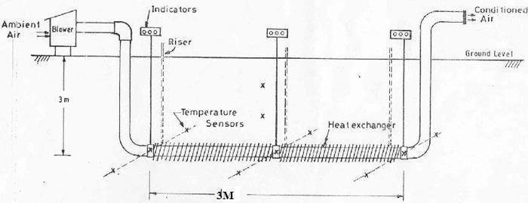

Figure 2.1: Schematic Representation of Experimental Set up

The arrangement shown in figure 5.1 features a MS pipe with a diameter of 5 cm. This pipe is buried beneath the ground at a depth of 3 m. At this depth, the pipe extends horizontally for a distance of 3 m. The entire length of the experimental arrangement measures 9 m.

The image 2.2 is presented prior to the installation. A protective sheet is placed over the outlet pipe to act as insulation, effectively avoiding any changes in the air entering through the outlet pipe. In the experimental arrangement, L bends have been utilized.

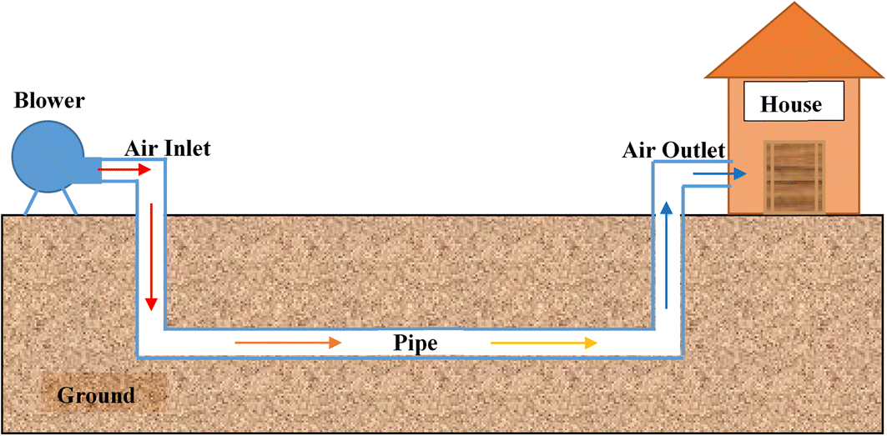

Figure 2.2: Experimental set up

The initial setup, shown in figure 2.2, displays the outlet pipe covered by an insulating sheet. This sheet serves the purpose of maintaining a consistent airflow through the pipe, while also incorporating L bends in the experimental arrangement.

**3.2 Procedure for Experimentation:**

In order to begin the experimentation, we initiated the blower and allowed air to flow through the pipe until a steady state was achieved. Using a vane type anemometer, we determined the velocity at both the inlet and outlet of the pipe. To measure the temperature, we attached a thermocouple wire at the middle of the inlet, middle of the pipe, and middle of the outlet. The thermocouple wire was connected to a temperature auto scanner, which continuously displayed the thermocouple readings. We repeated this process under different ambient conditions, conducting the experiment over a span of three days in the summer season (May 24th, 25th, and 26th, 2019) and three days in the winter season (January 2nd, 3rd, and 4th, 2019). All the data collected was compiled into a single table. From the observations obtained in the experiment, we created graphs to visualize the results. Finally, we calculated the total cooling and heating for flow velocities of 11m/s using the given equation.

**For Summer Climate**

For winter climate

Qc = mCp (Tinlet – Toutlet)

For Summer Climate

Qc = mCp (Toutlet –Tinlet)

Where m= mass flow rate of air through the pipe

Cp= specific heat capacity of air

Tinlet= inlet temperature of air

Toutlet= outlet temperature of air.

**Coefficient of performance (COP) of the system has been calculated from the following Expression:**

**For Summer Climate**

COP= mCp (Tinlet – Toutlet)/ Power Input …………………………..(1)

**For winter climate**

COP= mCp (Toutlet –Tinlet)/ Power Input……………………………. (2)

**3. EXPERIMENTAL RESULT FOR SUMMER AND WINTER SEASON**

This study was conducted by compressing material GI and Copper for an earth tube heat exchanger. Experimental data for GI pipe was sourced from the research paper by Arvind Sen et al. Data for copper pipe was gathered through experimentation. The results for both materials were then combined into a single summary.

**3.1(a) Cooling Model Test (GI PIPE):**

Arvind at al. [14] worked already in this earth tube heat exchanger. The air speed was 11 m/s. The speed was measured with a portable, digital vane anemometer. The vane wheel measures 66 x 132 x 29.2 mm and the velocity range is 0.3 to 45 m/s. The anemometer measures the average air velocity. The air flow rate was 0.0863 m3/s and the mass flow rate was 0.0269 kg/s. The ETHE system was operated for seven hours on 3 days ( 24, 25 & 26 MAY-2019) in the month of May. The temperature of the tube air at the inlet, centre and outlet was measured at one hour intervals. The system was switched on at 10.00 am and switched off again at 5.00 pm. The tests in May were carried out on 24, 25 and 26 May 2019). The ambient temperature on these three days was very similar.

|  |  |  |  |  |
| --- | --- | --- | --- | --- |
| **Table 3.1 (a). Average Inlet Temp, Middle And Outlet Temp. Of ETHE(MAY -2019)** | | | | |
| **Time** | **Ta=Ti** | **Tmid** | **To** | **COP** |
| 10:00AM | 30.73 | 29.06 | 26.8 | 0.851 |
| 11:00AM | 34.33 | 29.16 | 26.76 | 1.640 |
| 12:00AM | 36.56 | 29.43 | 27.13 | 2.043 |
| 01:00PM | 37.63 | 29.46 | 27.10 | 2.281 |
| 02:00PM | 40.13 | 29.66 | 27.13 | 2.817 |
| 03:00PM | 40.00 | 29.63 | 27.13 | 2.788 |
| 04:00PM | 39.8 | 29.76 | 27.2 | 2.730 |
| 05:00PM | 39.6 | 29.9 | 27.13 | 2.702 |

The results of the three days were therefore averaged. Table 3.1(a) shows the average of the measured values from three days. The ambient temperature started at 30.50oC at 10.00 am and rose to a maximum of 40.13oC at 2.00 pm. The outlet air temperature was 26.8oC when the system started at 10am.The table also shows the COP values. The maximum COP was reached at 2 p.m., i.e. 2.817. Graphical representation of findings shown in fig.3.1

**Graphical Representation:**

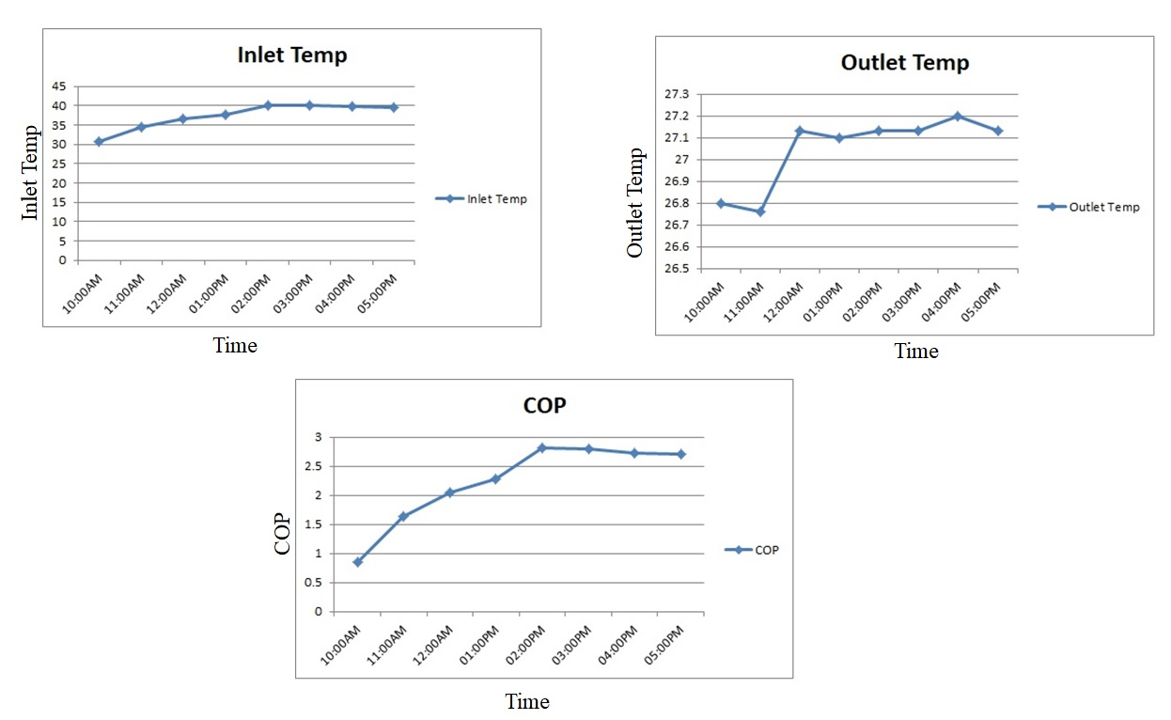

Fig.3.1. Graphical representation of Input, output and COP with respect to time

**3.1(b) Cooling Model Test (COPPER PIPE**):

A velocity of air measuring 11m/s was achieved. The instrument used to find out the velocity is a portable digital vane type anemometer. The size of the vane is given as 66 x 132 x29.2 mm and with a range of velocities from 0.3 to 45 m/s. The mean air velocity was calculated using this anemometer. In this case, volume flow rate (0.0863 m3/s) is reduced while mass flow rate (0.0269 kg/s) increased. System operated for seven hours on three days in June month (4th,5th,&6 June-2023). Inlet tube air temperature, middle tube air temperature and outlet tube air temperatures were obtained hourly throughout the experiment period. The system was switched on at ten o’clock in the morning up to five o’clock in the evening.

|  |  |  |  |  |
| --- | --- | --- | --- | --- |
| **Table-3.1(b) Average Inlet Temp, Middle And Outlet Temp. Of ETHE(June- 2023)** | | | | |
| **Time** | **Ta=Ti** | **Tmid** | **To** | **COP** |
| 10:00AM | 30.33 | 27.10 | 22.70 | 1.65 |
| 11:00AM | 32.70 | 27.20 | 22.76 | 2.15 |
| 12:00AM | 35.50 | 27.36 | 22.23 | 2.87 |
| 01:00PM | 36.73 | 27.43 | 22.13 | 3.16 |
| 02:00PM | 39.73 | 27.60 | 22.16 | 3.80 |
| 03:00PM | 39.36 | 27.56 | 22.23 | 3.65 |
| 04:00PM | 38.63 | 27.70 | 21.10 | 3.71 |
| 05:00PM | 38.4 | 27.86667 | 22.26 | 3.49 |

Technical tests were carried out in June on three days i.e.,4th ,5th, and 6th June 2023). Ambient temperatures were almost same for these three days. So we averaged results for these three days. Table-3.1(b) gives means of the readings on those same days. When the system started working at 10am today, the outgoing air was cooling down; it had a terminal temperature reading at inlet 30.330c and oultlet temp 22.700c. The COP values have also been indicated in this table. Maximum COP Achieved at 2pm i.e 3.80 more as compare to GI based earth tube heat exchanger. Graphical representation of findings shown in fig 3.2

**Graphical Representation:**

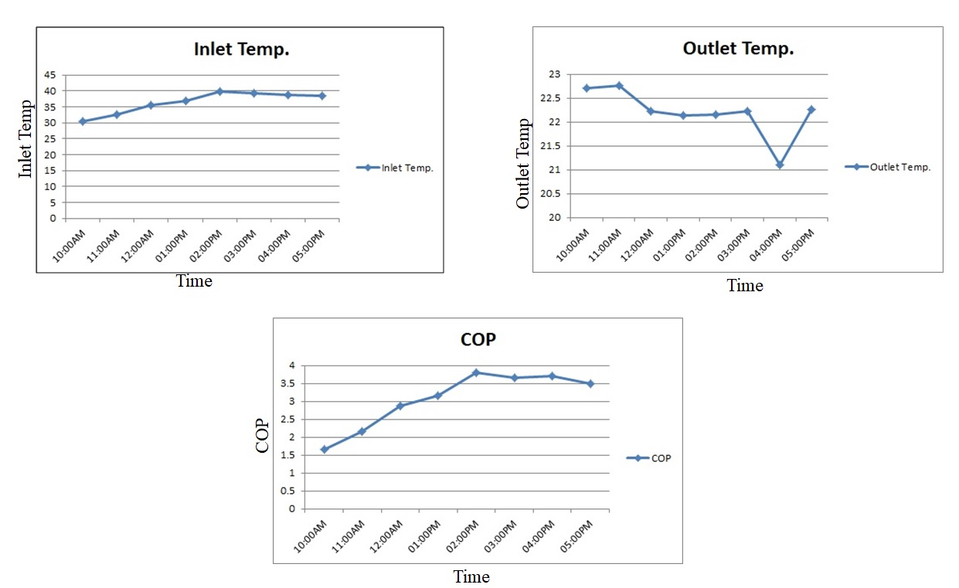

Fig.3.2. Graphical representation of Input, output and COP with respect to time

**3.2(a) HEATING MODEL TEST(GI PIPE):**

Arvind at al. [14] worked already in this earth tube heat exchanger. The tests for the heating mode were carried out on three days in January 2019 (02, 03 & 4). The system was switched on at 10am and ran continuously for 8 hours that day until 5pm. The temperature values were recorded at hourly intervals. Again, the conditions were similar on the three consecutive days and therefore the results were summarised. Table 3.2(a), which is the average of the three test runs. The ambient temperature started at 21oC (10am) and rose to the highest value of 30.10oC at 5 pM. Temperature of the air at the outlet varying from 27.53oC to 40.36oC. ETHE was able to raise the ambient air temperature at 5 PM from 21.00oC to 30.10oC.The table also shows the COP values. The maximum COP Achieved at 5pm i.e 2.25. Graphical representation of findings shown in fig 3.3

|  |  |  |  |  |
| --- | --- | --- | --- | --- |
| **Table:3.2 (a) Average Inlet Temp, Middle And Outlet Temp. of ETHE(Jan2019)** | | | | |
| **Time** | **Ta=Ti** | **Tmid** | **To** | **COP** |
| 10:00AM | 21.00 | 25.42 | 27.53 | 1.41 |
| 11:00AM | 22.13 | 25.54 | 28.63 | 1.40 |
| 12:00AM | 24.33 | 25.62 | 31.43 | 1.53 |
| 01:00PM | 26.53 | 27.78 | 34.56 | 1.74 |
| 02:00PM | 27.3 | 28.46 | 36.5 | 1.99 |
| 03:00PM | 27.27 | 28.92 | 36.66 | 2.03 |
| 04:00PM | 29.1 | 29.38 | 39.5 | 2.22 |
| 05:00PM | 30.10 | 32.41 | 40.36 | 2.25 |

**Graphical Representation:**

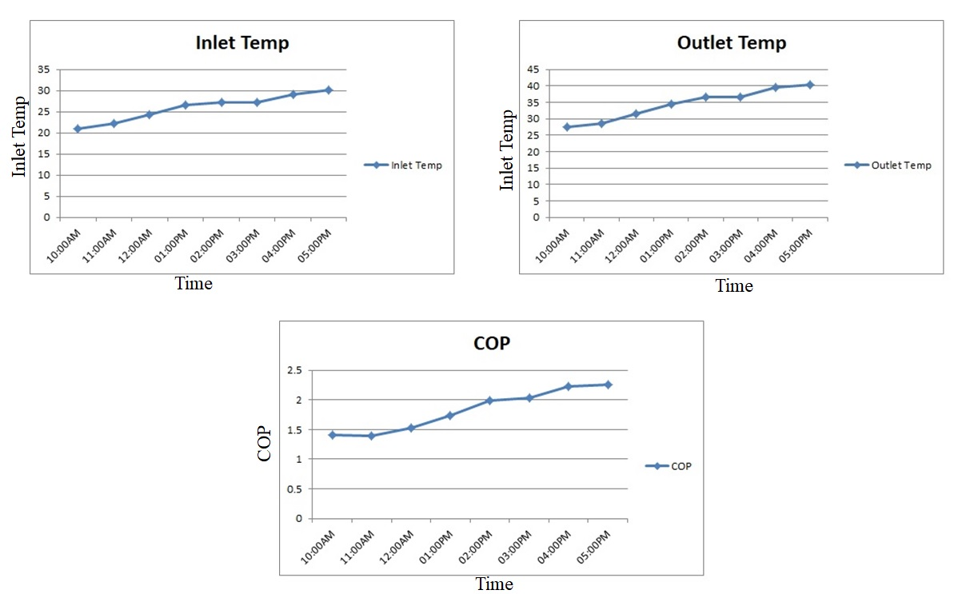Fig.3.3. Graphical representation of Input, output and COP with respect to time

**3.2(b) HEATING MODEL TEST(COPPER PIPE):**

The tests for the heating mode were carried out on three days in January 2024 (12, 13 & 14). The system was switched on at 10am and ran continuously for 8 hours that day until 5pm. The temperature values were recorded at hourly intervals. Again, the conditions were similar on the three consecutive days and therefore the results were summarised. Table 3.2(b), which is the average of the three test runs. The ambient temperature started at 21.34oC (10am) and rose to the highest value of 30.12oC at 5 pM. In Copper Pipe Temperature of the air at the outlet varying from 27.56oC to 39.53oC. ETHE was able to raise the ambient air temperature at 10AM To 5 PM from 21.34oC to 30.12oC.The table also shows the COP values. The maximum COP Achieved at 3pm i.e2.22 as compared to GI based earth tube heat exchanger. Graphical representation of findings shown in fig 3.4

|  |  |  |  |  |
| --- | --- | --- | --- | --- |
| **4.2 (b)Average Inlet Temp, Middle And Outlet Temp. of ETHE(Jan-2024)** | | | | |
| **Time** | **Ta=Ti** | **Tmid** | **To** | **COP** |
| 10:00AM | 21.34 | 25.34 | 27.56 | 1.34 |
| 11:00AM | 22.17 | 25.55 | 28.46 | 1.30 |
| 12:00AM | 24.37 | 25.54 | 31.33 | 1.50 |
| 01:00PM | 26.47 | 27.71 | 34.23 | 1.68 |
| 02:00PM | 27.40 | 28.42 | 36.36 | 1.94 |
| 03:00PM | 27.35 | 28.88 | 37.60 | 2.22 |
| 04:00PM | 29.20 | 29.34 | 39.20 | 2.16 |
| 05:00PM | 30.12 | 32.21 | 39.53 | 2.039 |

**Graphical Representation:**

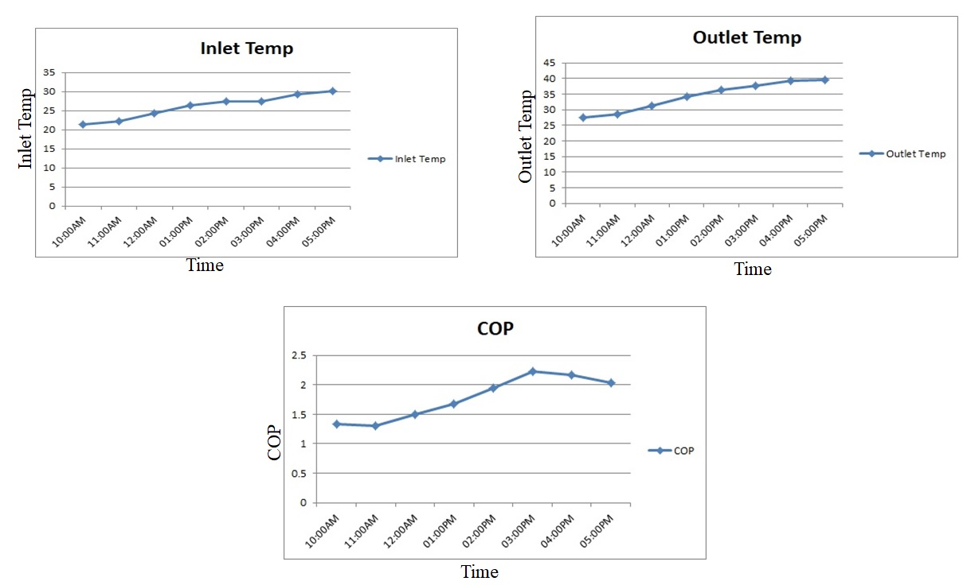

Fig.3.4. Graphical representation of Input, output and COP with respect to time

**5. Conclusion:**

**Explanation of the Results:**

Having done the calculation in the previous chapter, we can see that the results are quite encouraging. The results are summarized under the following points:

* IN GI pipe For the pipe with a length of 9m and a diameter of 0.05m, a temperature drop of 3.930C-130C was found at an exit velocity of 11m/s in Summer session and temperature rise 6.530C – 10.40C in winter session.
* IN COPPER Pipe For the pipe with a length of 9 m and a diameter of 0.05 m, a temperature Drop of 7.630C - 17.570C at a flow velocity of 11m/s was recorded in winter session and temperature rise from 6.260C – 10.250C in winter session.
* IN GI pipe The maximum COP in the summer season is 2.817 at 14:00 and the maximum COP in the winter season is 2.817 at 02:00PM
* IN COPPER pipe The maximum COP achieved in the summer season is 3.68 at 14:00 and the maximum COP achieved in the winter season is 3.80 at 02:00PM m/s. Discharge velocity 11m/s
* IN GI pipe The COP of the system varies between 0.851 – 2.817 in the summer season and 1.41-2.22 in the winter season at an outlet velocity of 11m/s.
* IN COPPER The COP of the system varies between 1.53 – 3.68 in the summer season and 1.34-2.22 in the winter season at exit velocity 11
* The results also show that heat conduction plays a very important role in cooling the air. This is shown by the fact that the temperature remains constant where the insulation is applied.
* If the fan speed is high and the length of the pipes is short, the temperature difference between inlet and outlet is very small.
* Overall Copper based earth tube heat exchanger better then the GI based Earth tube heat exchanger.
* This work can be used as a design tool for designing such systems depending on the requirements and environmental variables. The work can help in the design of such systems with the flexibility to choose different pipe types, different pipe dimensions, different materials and different environmental conditions. So you have the opportunity to analyze a variety of combinations before deciding on the best alternative in terms of the dimension of the pipe, the material of the pipe and the type of fluid to be used.

**6. Future Scope:**

1. Use the fan with variable speed.
2. A theoretical model should be developed to predict the soil temperature per meter of soil depth and the influence of the moisture content in the soil.
3. This system will be tested for different pipe lengths and diameters.
4. For further studies, a mechanism to control the humidity for the winter and summer season should be integrated.
5. The fluid dynamic studies should be conducted to minimize the flow losses in the pipe and the effects of moisture should be investigated.

**References:**

[1] S. Dey, A. Sreenivasulu, G. Veerendra, K.V. Rao, P.A. Babu, Renewable energy present status and future potentials in India: An overview, Innovation and Green Development, 1 (2022) 100006.

[2] D. Gielen, F. Boshell, D. Saygin, M.D. Bazilian, N. Wagner, R. Gorini, The role of renewable energy in the global energy transformation, Energy strategy reviews, 24 (2019) 38-50.

[3] W. Strielkowski, L. Civín, E. Tarkhanova, M. Tvaronavičienė, Y. Petrenko, Renewable energy in the sustainable development of electrical power sector: A review, Energies, 14 (2021) 8240.

[4] A. Sahay, V. Sethi, A. Tiwari, M. Pandey, A review of solar photovoltaic panel cooling systems with special reference to Ground coupled central panel cooling system (GC-CPCS), Renewable and Sustainable Energy Reviews, 42 (2015) 306-312.

[5] A.K.S. Al-Sayyab, A. Mota-Babiloni, J. Navarro-Esbrí, Renewable and waste heat applications for heating, cooling, and power generation based on advanced configurations, Energy Conversion and Management, 291 (2023) 117253.

[6] K. Du, J. Calautit, Z. Wang, Y. Wu, H. Liu, A review of the applications of phase change materials in cooling, heating and power generation in different temperature ranges, Applied energy, 220 (2018) 242-273.

[7] A.K. Chaturvedi, V. Bartaria, Performance of earth tube heat exchanger cooling of air—a review, Int J Mech Eng Robotics Res, 4 (2015) 378-382.

[8] L. Chen, Y. Hu, R. Wang, X. Li, Z. Chen, J. Hua, A.I. Osman, M. Farghali, L. Huang, J. Li, Green building practices to integrate renewable energy in the construction sector: a review, Environmental Chemistry Letters, (2023) 1-34.

[9] N.M. Chinenye, S. Manuwa, O. Olukunle, I. Oluwalana, Development of an active evaporative cooling system for short-term storage of fruits and vegetable in a tropical climate, Agricultural Engineering International: CIGR Journal, 15 (2013) 307-313.

[10] S. Dey, A. Sreenivasulu, G. Veerendra, K.V. Rao, P.A. Babu, Renewable energy present status and future potentials in India: An overview, Innovation and Green Development, 1 (2022) 100006.

[11] A. Martzopoulou, V. Firfiris, T. Kotsopoulos, Application of urban passive cooling systems and design techniques in livestock buildings, in: IOP Conference Series: Earth and Environmental Science, IOP Publishing, 2020, pp. 012029.

[12] M. Ghosal, G. Tiwari, D. Das, K. Pandey, Modeling and comparative thermal performance of ground air collector and earth air heat exchanger for heating of greenhouse, Energy and buildings, 37 (2005) 613-621.

[13] D. Gielen, F. Boshell, D. Saygin, M.D. Bazilian, N. Wagner, R. Gorini, The role of renewable energy in the global energy transformation, Energy strategy reviews, 24 (2019) 38-50.

[14] Sen A, Performance Analysis of The Shell and Tube Type Heat Exchanger. International Journal of Innovative Trends in Engineering. 2018,Vol 37,Page11-16.