**Design, simulation and operational analysis of cutting and bending machine**

**Omkar Chavan1, Niranjan Chougule2, Omkar Desai 3, Ritesh Jadhav4, Alpesh Jamdar 5,Prof. Pradip Patil6**

**DEPARTMENT OF MECHANICAL ENGINEERING**

**ANNASAHEB DANGE COLLEGE OF ENGINEERING & TECHNOLOGY, ASHTA, DIST: SANGLI,**

**MAHARASHTRA, INDIA.**

**ABSTRACT**

This research aims to develop an innovative cutting and bending machine that can handle diverse materials and geometries while optimizing performance and minimizing waste. The design phase involves integrating advanced engineering principles like finite element analysis and computer-aided design to ensure reliability and durability. The machine’s cutting mechanism accommodates various materials, while its bending component handles various profiles and angles. Advanced control systems enable programmable and automated operations. The analysis phase uses computational simulations to assess the machine’s performance under various operating conditions. Finite element analysis helps identify potential weak points and optimize the design for strength and rigidity, while kinematic simulations ensure accurate and efficient tool movement, reducing cycle times and enhancing productivity.

1. **INTRODUCTION**

In today’s modern manufacturing landscape, cutting and bending machines have become indispensable tools for a wide range of industries. From metalworking and construction to automotive and aerospace, these machines play a critical role in shaping raw materials into precise and intricate components used in various products. The design and development of cutting and bending machines are rooted in engineering excellence, innovative technologies, and a deep understanding of industrial processes. The concept of cutting and bending materials can be traced back to ancient times when simple hand tools were used to shape materials like wood and metal. However, the real revolution in cutting and bending technology came with the advent of the Industrial Revolution in the late 18th and early 19th centuries. During this period, mechanization and automation rapidly advanced, leading to the development of early versions of cutting and bending machines. Over the years, these machines evolved, incorporating better precision, power, and safety features.

1. **METHODOLOGY**

Phase I: Force calculations

In this stage, calculations of the forces acting on the base plate, SS cladding component, fasteners, dies, and structure. For calculations of forces like shearing and bending, the material and thickness of the component will be considered.

Phase II: Design of the setup

The setup of the cutting and bending machine will be designed at this stage. The setup consists of the base layout, vertical support beams, and a tool-holding column. The below-mentioned figure provides a brief overview of the machine.

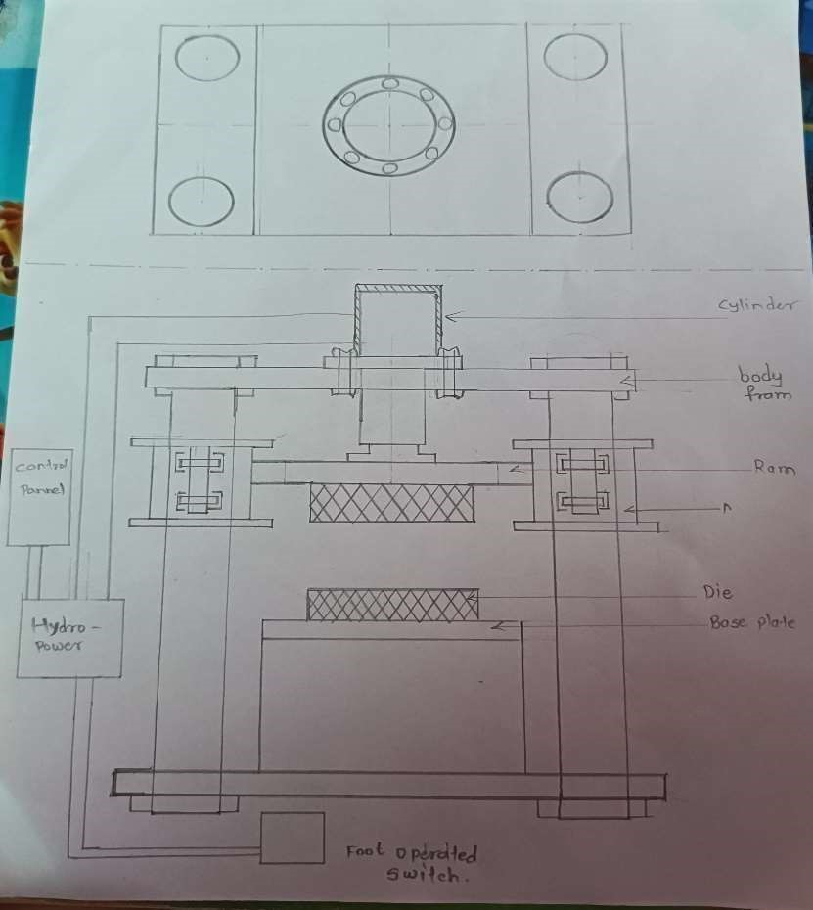

Conceptual design of machine

Phase III: Selection of power pack and motor

In this step, the cylinder design will be completed. Using the operating pressure, total power, and reservoir capacity, we will choose the power pack in this step. The motor will be chosen in accordance with industry-standard power ratings.

Phase IV: Selection of standard components

The selection of standard components such as bolts, screws, bearings, valves, etc. will be done in this phase.

Phase V: Drawing of components and setup

In this phase the drawings of components and setup will be done using CAD software’s.

Phase VI: Simulation of cutting and bending operation

In this phase the simulation of cutting operation will be performed using the CAD/CAE software’s.

1. **FORCE CALCULATIONS**
2. Cutting Force

The force required for shear cutting can be calculated using the formula:

Force = yield stress ×Area of the Material Being Cut

Where:

Yield stress is point where the material changes its shape.

Area of the Material Being Cut is the cross-sectional area of the material being cut.

Therefore,

Yield stress = 275N/mm2.

Thickness of plate = 2mm, Length = 1m (1000mm)

Force = 2*1000*275

Force = 550 KN = 550/9.81 = 56.06 Ton

**3.2 Bending force**

The force required for shear cutting can be calculated using the formula:

Force = yield stress ×Area of the Material Being Cut

Where:

Yield stress is point where the material changes its shape.

Area of the Material Being Cut is the cross-sectional area of the material being cut.

Therefore,

Yield stress = 275N/mm2.

Thickness of plate = 2mm

Length = 1m (1000mm) Force = 2*1000*275

Force = 550 KN = 550/9.81 = 56.06 Ton

Force=Material Factor ×Bending Length ×Material Thickness

Here, material factor is ultimate tensile strength of metal (i.e.,257.2N/mm^2)

Thickness of plate = 2mm,

Length = 1m (1000mm),

Tensile strength = 515 N/mm^2

Y = 1mm

We know flexure formula,

M/I = σ / Y

M = 4* F

I = l*b3 /12

= 1000*23 /12

I = 666.6 mm4

4*F / 666.6 = 515/1

F = 515* 666.6/4

Force = 85833.33N = 85.83KN = 8.74 Ton

1. **CAD DESIGN AND MANUFACTURING DRAWING THE MACHINE**

Designing a machine in 3D with CATIA involves a systematic process aimed at realizing a functional and efficient product. Beginning with conceptualization, the machine's purpose and layout are outlined, guiding subsequent stages. Leveraging CATIA's robust tools, components are meticulously modelled in the Part Design workspace, ensuring precision and manufacturability. These components are then assembled in the Assembly Design environment, with constraints applied to achieve proper alignment and movement.

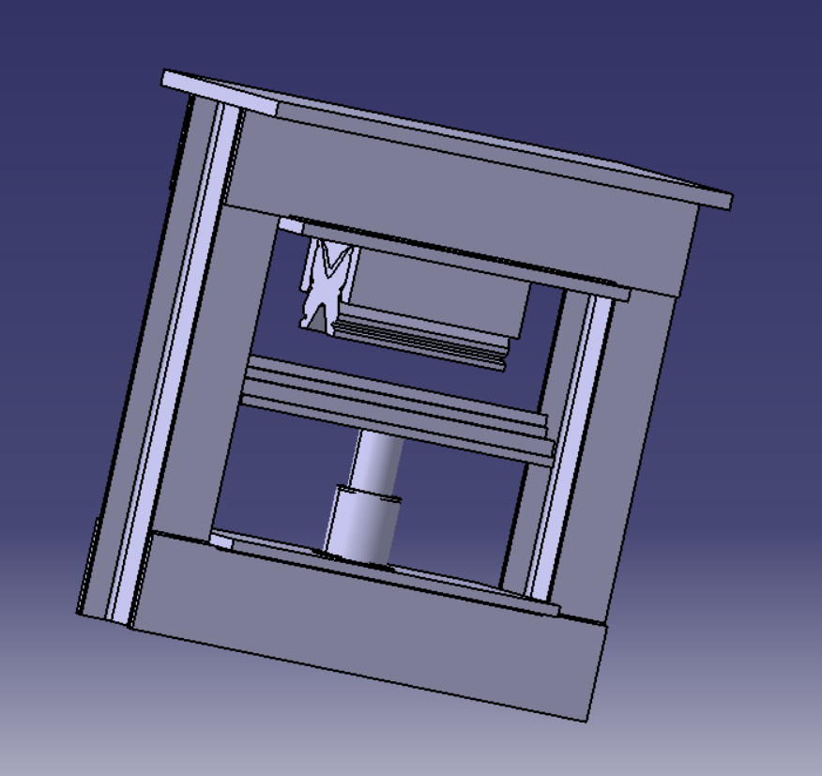  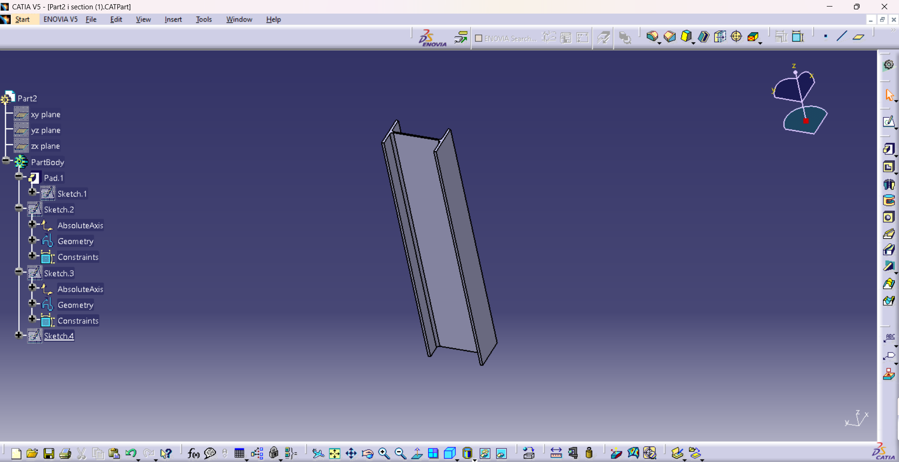

Cad design of machine CAD design of column

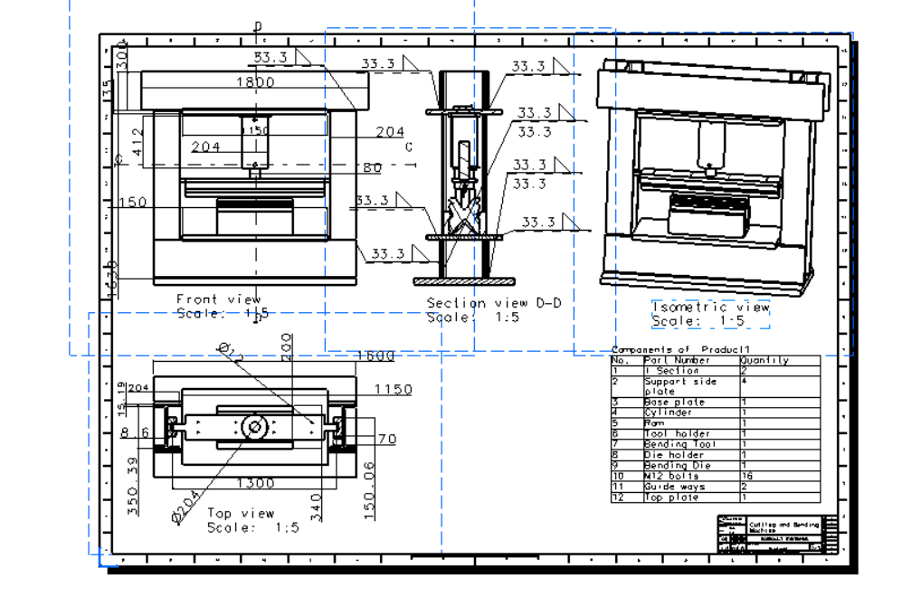

Manufacturing Drawing of Machine

* + - 1. **ANALYSIS OF THE COMPONENTS**

To assess the structural integrity of the bending machines and ensure that they are capable of withstanding the forces and stresses involved in operations, we use ANSYS analysis as a tool. It helps to design parts for bending machines that will decrease weight, cost, and material consumption while maximizing strength and longevity.

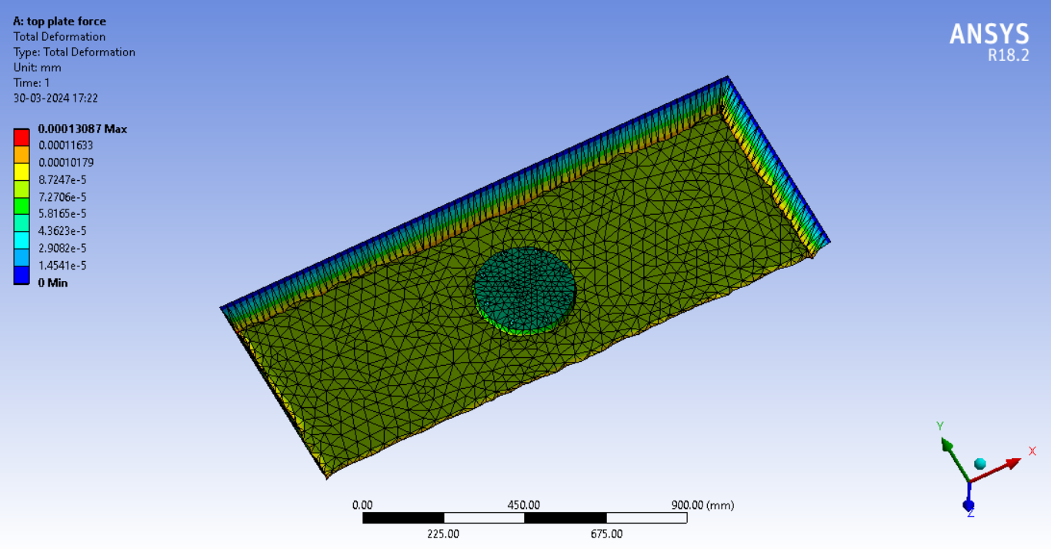 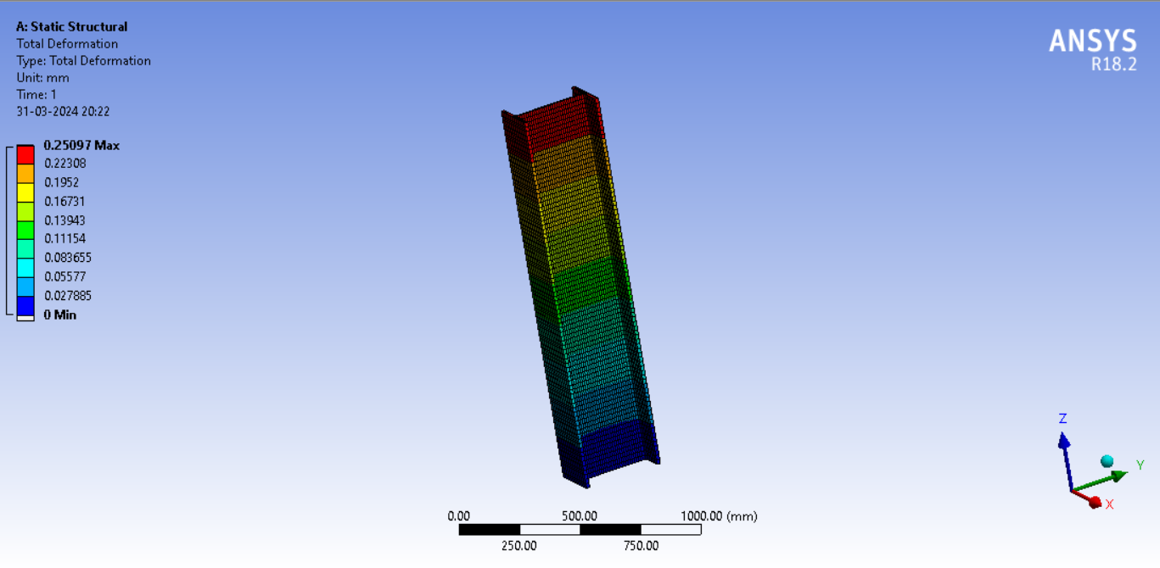

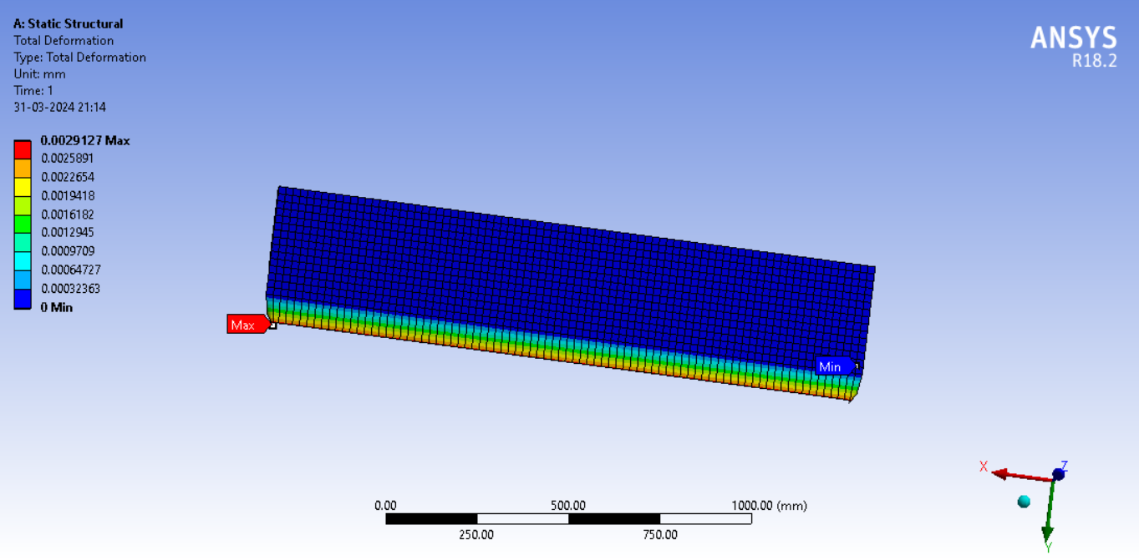

**6. CONCLUSIONS**

As compare to the different sheet bending machine and cutting machine the combined machine is better. The productivity of sheet bending and cutting machine is higher. The part of machine is able to handle the heavy load on machine. The time required to complete bending operation is less and the requirement of extra workers reduced. It is easier to manufacture, requires a less complicated procedure to fabricate, and is more cost-effective. The machine can cut and bend steel plates up to 2mm thickness and 1000mm length.

**7. REFERENCES**

1. Sai Krupanandan N B, Pavan Kumar S P, Nishchith Rai S, “Design and Fabrication of Hydraulic Cutting Machine” International Journal of Engineering Research & Technology (IJERT), Vol. 12 Issue 05, May-2023, pp 303-310.
2. Aniruddha Kulkarni, MangeshPawar & Pravin Yadav, “Sheet metal bending machine” International Journal of Innovations in Engineering Research and Technology [IJIERT], Vol. 2, ISSUE 3, March, 2015, pp 1-23.
3. LarsPetruschke,MaxBurkhardt &PhilippSchraml, “Method to identify energy efficiency potentials of metal cutting machine tools in industry” Elsevier B.V. Vol. 2, 2020, pp 522-527.
4. Ye Li, Ragha Rapthadu, “Bending-additive-machining hybrid manufacturing of sheet metal structures” International Manufacturing Science and Engineering [ASME], June 4, 2017, pp 1- 10.
5. Yogita Bagul, Arif Mansuri, “A review on sheet metal cutting/shearing machine” International Research Journal of Modernization in Engineering Technology and Science, Vol. 04, Issue1, January,2022.
6. Prajwal V. Charde, Shubham Musle, Yogesh Nandanwar, “Design and Development of Sheet Metal Cutting Machine for Circular Profiles” Journal of Emerging Technologies and Innovative Research (JETIR), Vol. 6, May, 2019, pp 295-299.

***Reference Books:***

1. V. B. Bhandari, *“Design of Machine Elements”*, Tata McGraw Hill Education Pvt. Ltd., pp. 749-751, Edition-3, 2010
2. S. R. Mujumdar, “Oil Hydraulic System: Principal and Maintenance”, Tata McGraw Hill Education Pvt. Ltd., pp 121-139 2002.
3. R. S. Khurmi, J. K. Gupta, “A Textbook of Machine Design”, Eurasia publishing house Pvt. Ltd., pp. 128-134, Edition-14, 2005