**PLANT DISEASE DETECTION SYSTEM USING CNN**

Anjali Panchal, Swamini zinje, shrawani wadhwane, Prof. Sayali Karmode

UG Students, IT Dept, MGM’s College of Engineering Kamothe, Navi Mumbai, India

Assistant Professor, IT Dept, MGM’s College of Engineering Kamothe, Navi Mumbai, India

[Swaminizinje@gmail.com](mailto:Swaminizinje@gmail.com) , [shrawaniwadhwane@gmail.com](mailto:shrawaniwadhwane@gmail.com) , [anjalipanchal782@gmail.com](mailto:anjalipanchal782@gmail.com) , sayalis.karmode@gmail.com

**Abstract---Plant diseases pose a continuous danger to smallholder farmers' livelihoods and food security. Images I agriculture may now be classified using computer vision models thanks to the recent revolution in smartphone penetration. In terms of image recognition, convolutional neural networks (CNNs) are thought to be state-of-the-art because they can quickly and definitively diagnose a condition. This paper examines the efficacy of a pre-trained ResNet34 model in identifying agricultural diseases. The created model can identify seven plant illnesses from healthy leaf tissue and is available as a web application. A dataset including photographs of leaves, taken under controlled conditions, is created for the purpose of training and verifying the model. The suggested approach can attain an accuracy of 97.2% and an F1 score of more than 96.5%, according to validation results. This shows that CNNs can classify plant illnesses technically and offers a way forward for small-holder farmers to use AI solutions.**

**Keywords—deep learning, transfer learning, classification, CNN, plant disease detection,**

1. **INTRODUCTION**

One of the major sources of yield in India is the production of crops. It is of enhancing the technological advancement in the fields relate to crop productivity. Here farmers domesticate a most variety of vegetation and crops. More studies are built with the important domain of qualitative and efficient farming is concentrated on enhancing the yield and food crop productivity at a minimum time with a greater outcome. The detection of plant ailment with the aid of using human visualization is a greater hard assignment and on the identical time, much less efficient, and it’s achieved with a constrained set of leaf images and takes more time. Whereas the automated identity approach will take much less time and effort and a extra correct program. Here we use photograph processing to come across the diseases. We can position the photograph right into a machine and a laptop can carry out diverse levels for identity and come across the associated training to which that photograph belongs. These paintings pursuits to make a leaf popularity method primarily based totally at the unique traits derived from images. We classify the images into four categories depending on the code name of plant diseases. For training, phase loads the variety of images and it resizes with a resolution. Then pics and corresponding labels are appended to the list. The above steps are used for checking out the data. For classification here, we use the CNN algorithm.

It consists of several layers for efficient implementation. In every step, convolutional layer construct and pooling are added. Finally, the regression layer is delivered to get the output. Another important parameter is learning rate (LR) which consists of how the speed at which learning the model. Here 1.e-3 set as LR. After the version building, load the statistics withinside the version. Here we use the variable consisting of a model name that represents healthy or diseased. Then save the model on the folder to this variable name and put the data to this model and detect it. Common diseases like viral, bacterial, fungal infections can be difficult to distinguish, and these symptoms can be represented in the difference in colour, function, and shape in which plant responds to the pathogen. Smaller datasets are much less green and have an effect on the version performance. Training a large set of data can not only reduce over fitting but can enhance a model’s overall performance. The high-satisfactory and form of education dataset vastly effect the version capabilities. The training data contains noise the classifier’s accuracy becomes dependent on this composition. This topic of early detection is explored due to a limited number of datasets, and it consists of less accuracy and detection. This device avoids the collection of greater leaf inputs for analysing them withinside the laboratory due to the fact preexisting snap shots and datasets are taken and become aware of the plant diseases.it imparts a possible functioning technique that may use now no longer be highly-priced and complex. It works via way of means of the use of CNN to detecting the leaf is healthful or diseased and if it's miles a disease, it identifies the illnesses like fungi, viruses, bacteria, black spots, powdery mildew, downy mildew, blight, canker, etc. And additionally gives treatments for recoverability of those diseases.

1. **PROBLEM STATEMENT**

The Indian economy is based primarily on agriculture. Our environment is being harmed by the widespread commercialization of agriculture. Chemical accumulation in our environment, including soil, water, air, animals, and even human bodies, has increased due to the usage of chemical pesticides. Artificial fertilizers can increase yield temporarily, but they have negative long-term effects on the ecosystem, as they linger for years after they contaminate groundwater. The fortunes of farming communities worldwide have been adversely affected by this tendency in yet another way. Farmers' fortunes have declined in almost every nation on earth, in spite of this purported increase in output. Plant disease detection with the unaided eye. the process of observing symptoms on plant leaves becomes very complex very quickly. Owing to this challenge, the sheer number of farmed crops and the psychopathological issues that accompany them, even seasoned plant specialists and agricultural farmers may frequently be unable to accurately diagnose certain illnesses, leading to incorrect conclusions and treatments. Numerous bacterial and fungal infections affect a large number of plants. Plant diseases are also caused by the massive population growth and contaminated soil, water, and air.

1. **LITERATURE REVIEW**

K. Muthu Kannan and co-workers located spot infections in leaves and classified them in line with the diseased leaf classes the usage of numerous devices studying algorithms. LVQ - Learning Vector Quantization, FFNN - Feed Forward Neural Network, and RBFN - Radial Basis Function Networks were utilized to diagnose diseased plant leaves by analysing the collection Of shape and texture statistics from the troubled leaf picture. The simulation confirmed that the proposed machine is effective. With the support of this work, a machine learning-based system for improving crop quality in the Indian economy can be developed. [1]

The study of plant leaf disease detection by Malvika Ranjan and colleagues starts with image capturing. Colour data, such as HSV features, are retrieved from the segmentation results, and an artificial neural network (ANN) is then trained by selecting feature values that can effectively discriminate between healthy and sick samples. Using a aggregate of picture information processing techniques and an, the modern-day look at indicates a way for figuring out cotton leaf ailments early and reliably.[2]

The goal of Syafiqah Ishakais and colleague’s study of Leaf Disease Classification using Artificial Neural Network is to acquire and analyse data from leaf photos in order to determine healthy Or diseased leaves of scientific plant life the use of photo processing methods. To extract photos and get data, an set of rules of adjusted contrast, segmentation, and functions extraction is hired from the photo processing approach. The Artificial Neural Network was used to analyse the findings of the experiment. The structure of the community used to categorise wholesome or dangerous leaves is multilayer feed-ahead Neural Networks, that are multilayer perceptron and radial foundation characteristic RBF. The end outcome of the experiment demonstrates that the RBF network outperforms the MLP network. [3]

Srdjan Spasojevic and colleagues present Deep Convolutional Neural Network Supported Identification of Crop Diseases by Plant Image Classification, a new method for the construction of a crop diseases recognition model primarily based totally on plant picture category and deep convolutional networks. With the ability to identify crops from their surroundings, the built model can recognize thirteen types of plant illnesses from healthy leaves. All of the important strategies for making use of this sicknesses reputation version are unique for the duration of the study, starting with the gathering of images a good way to set up a database that is evaluated by agricultural experts. Caffe, a deep mastering framework advanced with the aid of using Berkley Vision and Learning Centre, changed into used to carry out the deep CNN training. The experimental effects at the advanced version completed precision among 91% and 98%, for separate elegance tests, on common 96.3%.[4]

CNN and Modelling Adversarial Networks have been used to categorise plant diseases. Others, like Emanuel Cortes A deep neural community and semi-supervised algorithms had been skilled to differentiate crop species and sickness fame of fifty-seven exceptional lessons the use of a publicly to be had dataset of 86,147 photos of ill and healthy plants. Rs-net was the unlabelled data experiment that functioned successfully. With a detection rate of 1e-5, it was able to score more than 80% in the training phase in less than 5 epochs.[5]

Sharath D. M. and colleagues created a Bacterial Blight detection method for Pomegranate plants in 2019 utilizing variables including colour, mean, homogeneity, SD, variance, correlation, entropy, and edges. Grab cut segmentation was used by the authors to segment the image's region of interest. The edges of the photos were extracted using the Canny edge detector. The authors have succeeded in developing a system that can forecast the degree of infection in the fruit.[6]

1. **METHODOLOGY**

**4.1. Convolutional-Neural-Network Models**

Recently, there has been a significant increase in interest in CNNs, with DL being the most often used architecture. This is because DL models are able to learn key characteristics from input images at multiple convolutional levels, which is comparable to how the human brain functions. DL has the ability to efficiently and rapidly handle complicated problems with a low error rate, high classification accuracy, and both. The convolutional, pooling, fully connected, and activation functions layers make up the various parts of the DL model.

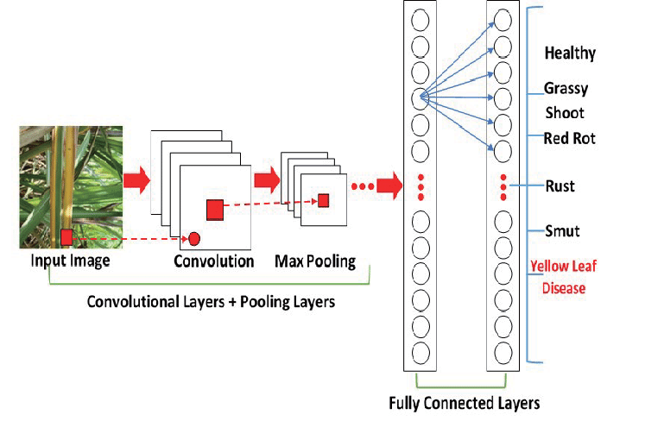

Fig1: Convolutional-Neural-Network architecture

**Input layer**

It contains data in the form of image. The parameters include height, width, depth and color information of the image (RGB). Input length is constant to 224 X 224 RGB image.

**Convo layer**

Convolutional layer is likewise known as characteristic extraction layer. This layer extracts the prominent features from the given collection of images using dot products of the image dimensions.

**Pooling Layer**

The pooling layer helps to reduce the computational power in order to process the data by decreasing (or) reducing the dimensions of the featured matrix obtained by using the dot products. Fully related layer: It incorporates of loads, neurons and biases. It connects neurons from one convolutional layer to another.

**SoftMax Layer/ Logistic Layer**

SoftMax executes multi-classification. Logistic layer executes the binary classification. It determines the chance of the presence of a given item withinside the image. If the object is present in the image, then the probability is ‘1’otherwise it is ‘0’.

**Activation Function- ReLU**:

It transforms the overall weighted enter via the node and places it into the operation, turns on the node. Rectified Linear Unit (ReLU) is an activation function used in the neural networks for convolutional operations.

**4.2. Transfer-Learning Approach**

Transfer learning in deep learning refers to using a pretrained network for a new task. Because it trains the network with less input and great accuracy, transfer learning is highly popular in deep learning. In transfer learning, a computer makes better generalizations about one task by using experience from a prior one. The final few levels of the trained network are replaced with new layers during transfer learning. Examples of these additional layers include a completely connected layer and a SoftMax classification layer, both of which include 38 classes in our paper. We removed the layer's freezing and stacked one activation layer, one batch-normalization layer, and one dropout layer in each model. Different learning rates, batch sizes, and dropout levels.

**4.3. Dataset**

We utilized the public Plant Village dataset, which comprises 54,305 leaves of both healthy and diseased plants, for training and testing purposes. Tables 5 and 6 display detailed database information, the number of classes and images in each class, their common and scientific names, and the viruses that cause sickness. Images of both healthy and diseased leaves from 14 distinct plant species are available in 38 different classes within the database. Every picture was taken in a lab setting. Sample leaf images from the Plant Village datasets that were examined with various batch sizes, learning rates, and dropout values are displayed

In our experiment, we used three different formats of Plant Village datasets. We conducted the experiment using segmented leaf photos from the same dataset after running it with coloured leaf images first. The background of the segmented photos was smoothed to make it easier to analyse and deliver more useful information. Finally, we assessed the effectiveness of the adopted strategies using grayscale pictures from the same dataset. Two sets of all the leaf photos were created: a training set and a testing set. We divided the leaf images into three sets: 80–20 (80% training and 20% testing), 70–30 (70% training and 30% testing), and 60–40 (60% training and 40% testing) in order to assess performance.

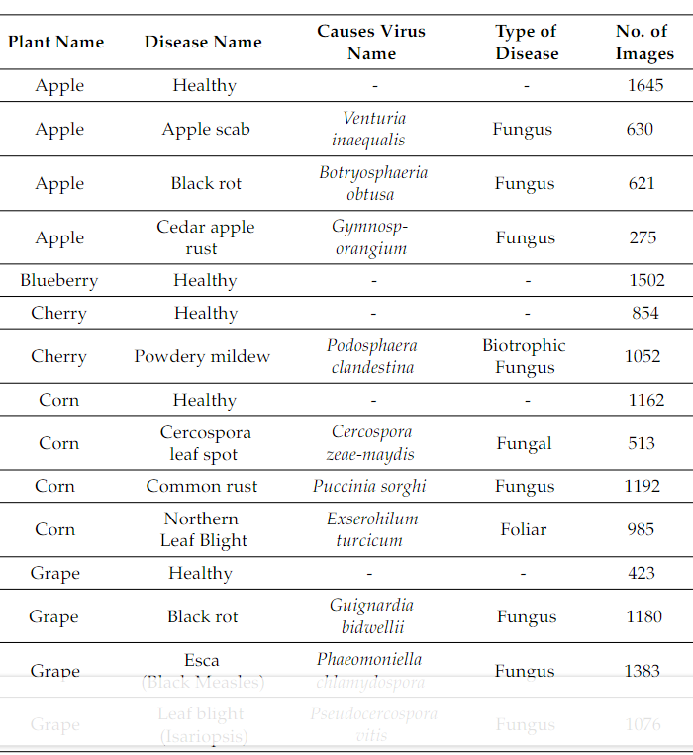

Fig 2. Detailed description of Plant Village dataset with relative information

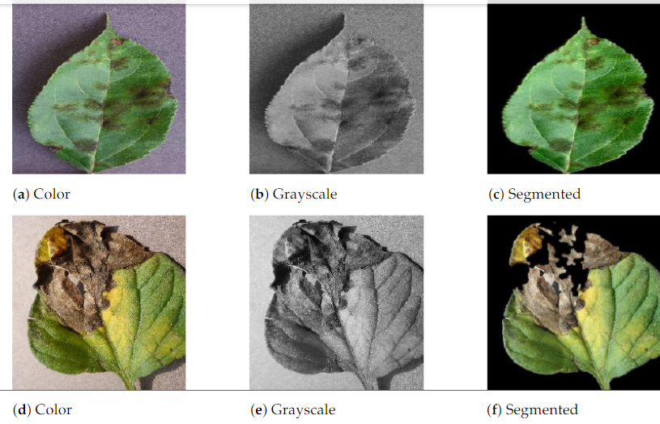

Fig.3.sample images of colour, grayscale and segmented version of Plant Village image dataset.

1. **RESULT AND DISCUSSION**

**5.1. RESULT**

1)Phase One – Trialling of Image Size

Phase One results demonstrate that for image sizes ranging from 155 x 155 to 255 x 255, an accuracy and F1 score of more than 90% may be attained. As anticipated, larger images result in better feature extraction but also longer running times (Table IV.). The first analysis yielded very good results. As said earlier, if the model achieved an accuracy of 80% or higher, it would be approved. The outcomes easily surpass the approval requirements, even at this early level.

To achieve this result, each model was passed a range of learning rates from 1e-05 to 1e-04 and run for 4 epochs. Overall, the best outcomes, with the highest accuracy and F1score, were obtained with an image size of 244. Despite the fact that research indicates that images with a resolution of 224 x 224 are ideal for plant disease classification tasks (10a), this model seems to only slightly benefit from a larger picture size. These factors led to the selection of picture size 244 for the remaining investigation.

2)Phase Two – Model Optimisation

The model achieved an accuracy of 0.9465 and an F1 score of 0.9359 before it was fine-tuned. A plot showing learning rate (logarithmic scale) vs loss was examined to help with fine-tuning (Fig. 4). This indicates that there is not much of a reduction in learning rates between 1e-06 and 1e-04. However, there is a noticeable increase in loss as the learning rate rises above 1e-04. Taking these facts into account, many trials measuring learning rate were conducted.

3)Phase Three– Visualisations

An analysis of heat maps reveals the inner workings of the CNN. When attempting to extract plant disease traits, colour, shape, and texture seem to be crucial considerations . Colour seems to be particularly important, providing an additional layer of characterization that makes it easier to distinguish between disorders that are similar to one another. This clarifies why RGB data is crucial for disease classification tasks, as was previously mentioned [10, 20]. The CNN demonstrates good feature recognition for all three species. This also applies to rice disease groups, where symptoms are more subtle and challenging to differentiate.

**5.2. DISCUSSION**

The early detection and identification of plant diseases using deep-learning techniques has recently made tremendous progress. Identification largely reliant on conventional methods. Electronics 2021,10, 1388 16 of 19 relies on a few variables, including feature extraction, illness region segmentation, and picture improvement.

Our method is predicated on the deep learning-based transfer learning strategy for disease identification. We utilized depth wise separable convolution in the inception block rather than normal convolution, which resulted in a significant parameter reduction. The residual network connection layer as well as the inception layer are both used. Because there are a lot less parameters in the model than in the original design, it is more accurate and requires less training time. We deployed the assess the performance toward a lightweight model that may be implemented on a smartphone to help with plant disease diagnostics. Additionally, we implemented which takes resolution, depth, and width into account when convolution Ing.

Despite achieving excellent success rates in plant disease diagnosis, the convolutional neural network-based deep learning architecture has several limits and room for improvement. The deep-learning model misclassified the sample images due to a little amount of noise. Future research will assess and enhance performance on noisy photos. We used a dataset of 38 distinct illnesses and healthy leaves to assess performance. Nonetheless, the collection needs to be expanded to include more different types of illness photos and larger land areas. Drones can also take aerial images, which can enhance the dataset. The fact that all of the test photos come from the same image dataset is another significant problem. One significant and difficult problem is testing the network using real-time field photos. The images that we used for testing our model are part of the same dataset, the training dataset.

1. **CONCLUSION**

Small-holder farmers rely on prompt and precise crop disease diagnosis to avoid losses. A Convolutional Neural Network that has already been trained was optimized and put online in this study. An app for detecting plant diseases was the end product. All you need to use this free, simple-to-use service is an internet connection and a smartphone. Consequently, the requirements of the user as stated in this document have been met. In this instance, the model benefited from augmentation and transfer learning, which enabled the CNN to generalize with more reliability. When the model was exposed to "in field" imagery, this helped the model extract features better, but it was insufficient. The classifier's accuracy in this instance was only 44%. Above importantly, this emphasizes how crucial it is to diversify the training dataset by adding different background data, more plant anatomy, and different disease stages.

All things considered; this study provides compelling evidence about how CNNs can be used to support small-holder farmers in their battle against plant disease. Future research should concentrate on expanding the variety of training datasets and evaluating comparable web apps in authentic scenarios. In the absence of such advancements, plant disease control efforts will persist. There are still certain difficulties in identifying leaf diseases despite the efforts of numerous ML and DL models. Pre-trained models like Google Net, Alex Net, Vignette, and Reset, as well as the training data from ImageNet [410], [411] (Image Database), have been used in numerous published research projects. These models have yielded higher accuracy than other models that are currently in use. Some researchers have utilized fewer than 1,000 Plant Village datasets, even though the most popular one is sufficient to train the CNN model.

1. **FUTURE WORK**

The project's primary objective is to create a fully functional system that includes a trained model on the server and a mobile application that uses photos taken with the phone's camera to identify diseases in fruits, vegetables, and other plants. By making it easier to identify and cure plant illnesses quickly, this application will benefit farmers and enable them to use chemical pesticides with knowledge and discretion. Future research will also involve extending the model's application to a larger geographic area by training it to identify plant diseases on drone-captured aerial photographs of vineyards and orchards, in addition to convolution neural networks for object detection. In large-scale open-field cultivations, drones and other autonomous vehicles, like smartphones, will be utilized for dynamic disease identification and real-time monitoring. The creation of an automated pesticide prescription system, which would need the approval of an automated disease detection system in order to permit farmers to buy the necessary pesticides, is a potential future option for agronomists working in remote areas. As a result, there could be significant restrictions on the unregulated procurement of pesticides, which could lead to their excessive and improper usage and their possibly disastrous impact on environment.

**REFERENCES**

1. Robert G. de Luna, Elmer P. Dadios, Argel A. Bandala, “Automated Image Capturing System for Deep Learning-based Tomato Plant Leaf Disease Detection and Recognition,” International Conference on Advances in Big Data, Computing and Data Communication Systems (icABCD) 2019.
2. Suma VR Amog Shetty, Rishab F Tated, Sunku Rohan, Triveni S Pujar, “CNN based Leaf Disease Identification and Remedy Recommendation System,” IEEE conference paper 2019.
3. Peng Jiang, Yuehan Chen, Bin Liu, Dongjian He, Chunquan Liang, “Real-Time Detection of Apple Leaf Diseases Using Deep Learning Approach Based on Improved Convolution Neural Networks,” IEEE ACCESS 2019.
4. Geetharamani, Arun Pandian, “Identification of plant leaf diseases using a nine- layer deep convolution neural network,” Computers and Electrical Engineering 76 (2019).
5. Robert G. de Luna, Elmer P. Dadios, Argel A. Bandala, “Automated Image Capturing System for Deep Learning-based Tomato Plant Leaf Disease Detection and Recognition,” Proceedings of TENCON 2018 - 2018 IEEE Region 10 Conference
6. Arsenovic Marko, Karanovic Mirjana, Sladojevic S. “Solving Current Limitations of Deep Learning Based Approaches for Plant Disease Detection.” Symmetry. 2019; 11(7):939.
7. Sethy, P.K.; Barpanda, N.K.; Rath, A.K.; Behera, S.K. Deep feature-based rice leaf disease identiﬁcation using support vector machine. Comput. Electron. Agric. 2020,175, 105527.
8. Chen, J.; Chen, J.; Zhang, D.; Sun, Y.; Nanehkaran, Y.A. Using deep transfer learning for image-based plant disease identiﬁcation. Comput. Electron. Agric. 2020,173, 105393.
9. 9Bai, X.; Cao, Z.; Zhao, L.; Zhang, J.; Lv, C.; Li, C.; Xie, J. Rice heading stage automatic observation by multi-classiﬁer cascade-based rice spike detection method. Agric. For. Meteorol. 2018,259, 260–270, doi: 10.1016/j.agrformet.2018.05.001.
10. Ramcharan, A.; Baranowski, K.; McCloskey, P.; Ahmed, B.; Legg, J.; Hughes, D.P. Deep Learning for Image-Based Cassava Disease Detection. Front. Plant Sci. 2017,8, 1852, doi:10.3389/fpls.2017.01852
11. Y. Oo and N. Htun, "Plant Leaf Disease Detection and Classification using Image Processing", International Journal of Research and Engineering, vol. 5, no. 9, pp. 516-523, 2018. Available: 10.21276/ijre.2018.5.9.4
12. Camargo, A.; Smith, J. Image pattern classiﬁcation for the identiﬁcation of disease-causing agents in plants. Compute. Electron. Agric. 2009,66, 121–125
13. R Prakash, G P Saraswathy, G Ramalakshmi Detection of leaf diseases and classification using digital image processing IEEE International Conference on Innovations in Information, Embedded and Communication Systems (2017), pp. 1-4
14. B Mishra, S Nema, M Lambert, S Nema Recent technologies of leaf disease detection using image processing approach-review IEEE International Conference on Innovations in Information, Embedded and Communication Systems (2017), pp. 1-5
15. Sanjay B. Dhaygude, Nitin P. Kumbhar Agricultural plant leaf disease detection using image processing Int J Adv Res Electr Electron Instrum Eng, 2 (1) (2013)
16. S. Arivazhagan, R. Newlin Shebiah, S. Ananthi, S. Vishnu Varthini Detection of unhealthy region of plant leaves and classification of plant leaf diseases using texture features Agric Eng Int CIGR, 15 (1) (2013), pp. 211-217
17. Smita Naikwadi, Niket Amoda Advances in image processing for detection of plant diseases Int J Appl Innov Eng Manage, 2 (11) (2013)