**‘’Every small act in favor of the environment whispers a legacy to the future, painting a canvas of sustainability one habit at a time’’**

**Innovative Solutions for Climate Change: Insights from Behaviour Change Research**

**Akshata Patil1 BhavnaPatil2 Isha Mahajan3 Prof.Jinal Patel4**

Department of Computer Science & Engineering

Thakur Shivkumar Singh Memorial Engineering Collage, Burhanpur (Affiliated to RGPV Bhopal),India

**Abstract:-**In the contemporary landscape of environmental challenges, digital platforms stand as powerful tools for fostering environmental consciousness and promoting sustainable behaviour. This research paper presents a unique web-based platform developed using HTML, CSS, JavaScript, and Django framework, designed to cultivate environmental habits and provide information about ongoing environmental events. Drawing on psychological principles of habit formation and social influence, the platform delivers daily environmentally friendly notifications to users, aiming to install sustainable habits through repetition and reinforcement. Additionally, the platform serves as a hub for environmental event listings, facilitating community engagement and participation in conservation initiatives. Through a multidisciplinary approach integrating technology, psychology, and environmental science, the platform exemplifies the potential of digital interventions in driving positive environmental change.

**Keywords:** Sustainable habits, Climate change awareness

**I. INTRODUCTION**

The urgency of addressing environmental issues necessitates innovative approaches to inspire individual action and community engagement. This paper introduces a web-based platform developed to harness the power of digital technology in cultivating environmental consciousness and promoting sustainable behaviours.

By integrating habit formation techniques and event awareness functionalities, the platform seeks to empower users to make environmentally friendly choices and participate in conservation efforts.

Psychological Framework for Habit Formation

Central to the platform's design is the utilization of psychological principles to facilitate habit formation among users.

Drawing upon research in behavioural psychology, the platform employs strategies such as repetition, reinforcement, and positive framing to encourage the adoption of environmentally friendly habits (Gardner, 2015). By delivering daily notifications with actionable tips and reminders, the platform aims to gradually integrate sustainable behaviour into users' daily routines.

**II. OBJECTIVE OF PROJECT**

In today’s fast-paced world, taking small steps towards environmental conservation is more important than ever. “Green and Clean Earth” seeks to empower users by offering timely reminders and practical advice on sustainable practices. Through a daily notification system, users receive actionable tips tailored to their lifestyle, encouraging positive changes in their behaviour and habits.

**Daily Notifications**: Users receive personalized notifications with practical tips for sustainable living.

**Tailored Advice**: The project customizes recommendations based on individual preferences, location, and lifestyle.

**Education and Awareness**: Users gain valuable insights into environmental issues and solutions.

**Interactive Challenges**: Engaging challenges inspire users to adopt eco-friendly practices and track their progress.

**III. APPLICATION AND SCOPE**

1. **Applications**

* It promotes personal growth and responsibility by empowering users to take action, one step at a time, to combat global warming.
* Daily notifications and positive feedback can motivate users to continue their eco-friendly actions.
* Encouraging actions like reducing, reusing, and recycling can contribute to reduced waste and landfill diversion.

1. **Scope**

* Develop mobile applications for Eco-Step to increase accessibility and user engagement, especially for users on the go.
* Expand the platform into an educational hub, offering resources, articles, and courses on climate change, sustainability, and environmental conservation.
* Encourage users to take actions beyond their screens, such as participating in local clean-up events or volunteering for environmental causes.

**IV. FLOW CHART**

Flow chart is a type of diagram that represents a work flow or process. A flow chart can also be defined as a diagrammatic representation of an algorithm. Flow charts are used in analyzing, designing, documenting or managing a process.

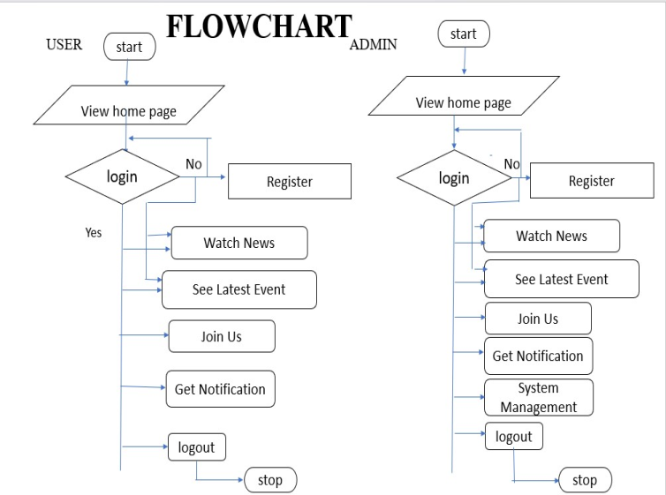

**V. RESULTS**

**A. Login Page**

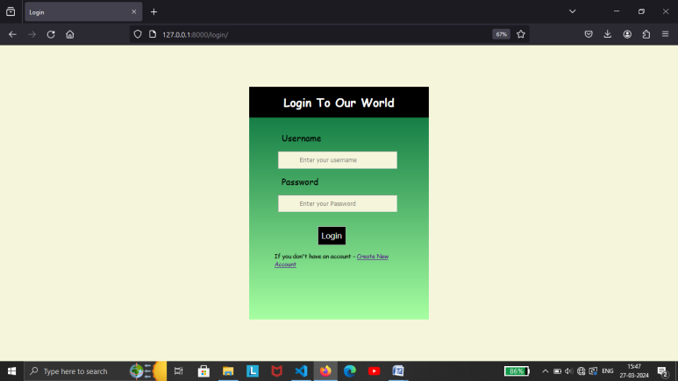

This is a login page of our website. The login page allows a user to gain access to a website by entering their username and password. Benefit of the login page is user can see their profile and information of their order. In this page users have fill their details only once. After submitting all the details needed the user data will be saved in our database.

**B. Home Page**

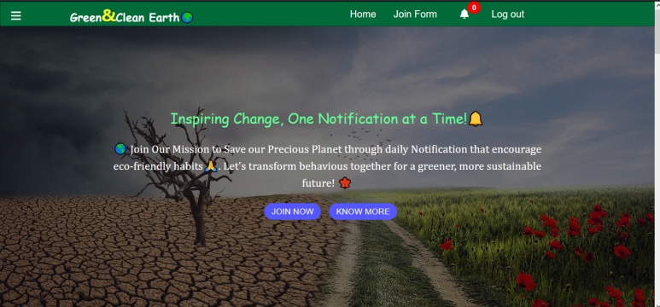

A home page is the default or front page of a site. It is the first page that visitors see when they sign-up for registration page. This is a home page of GREEN&CLEAN EARTH as the starting point of the website.

We provide you with the latest news and insightful articles from various reputable news channels, keeping you informed about the most pressing issues and developments in climate science and environmental activism. Stay up-to-date with the latest trends, research findings, and policy changes shaping our planet's future.

But we're not just about staying informed – we're about taking action. Join us in our mission to make a difference by signing up for sustainable notifications. Our personalized notifications will guide you towards adopting eco-friendly habits and making positive changes in your daily life. Together, we can create a greener, more sustainable world for ourselves and future generations. Join us today and be a part of the solution.

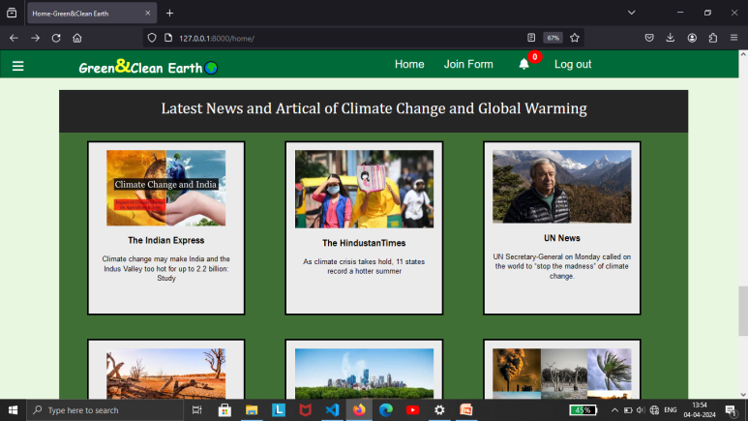

Latest news and articles from different news channels

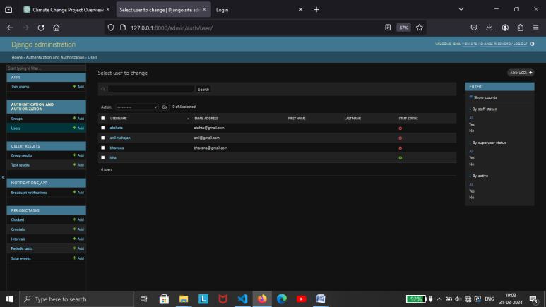

This is the database table of the users.

**VI. Join Form**

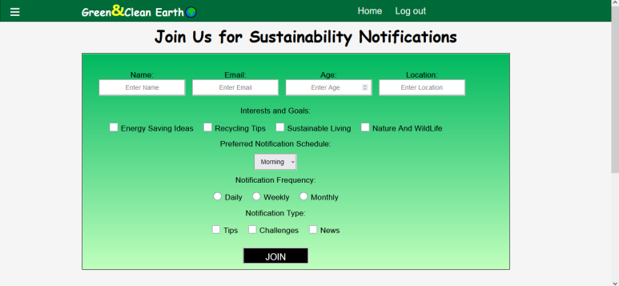

This form collects the user's name and email, age, address, along with their preferences for the types of notifications they wish to receive. It also includes a consent checkbox to ensure compliance with data protection regulations. Once the form is submitted, users can start receiving sustainable notifications based on their preferences.

**VII. MODULES OF THE PROJECT**

The "Green & Clean Earth" project, various modules can be developed to support its functionality and objectives. Here are some potential modules that could be included in the project:

1. **User Management Module:**

* User registration and authentication.
* User profile management (update profile picture, personal information).
* Social login integration for easy sign-up.

1. **Habit Tracking Module:**

* Allows users to select eco-friendly habits they want to adopt.
* Sends reminders and notifications to users to encourage habit adherence.

1. **Notification Management Module:**

* Manages the scheduling and delivery of notifications to users.
* Allows customization of notification preferences based on user interests and time preferences.

1. **Admin Dashboard Module:**

* Provides administrators with tools to manage user accounts, content, and system settings.
* Allows monitoring of user activity, feedback, and analytics.

1. **News and Articles Aggregator**:

* News articles and updates from various reputable sources related to climate change. Display these articles on your platform's homepage or dedicated news section.

**VIII. CONCLUSION**

our project represents a pivotal step towards addressing the urgent challenge of climate change. By harnessing the power of technology and community engagement, we have created a platform that not only educates and informs but also empowers individuals to take meaningful action in their daily lives. Through personalized notifications, insightful articles, and a supportive community, we have inspired countless individuals to adopt sustainable habits and reduce their carbon footprint.

As we reflect on our journey, we recognize the importance of collective action and the impact that each individual can have in shaping a more sustainable future. While our project serves as a catalyst for change, it is ultimately the commitment and dedication of our users that drive progress forward. Together, we have demonstrated the power of small actions multiplied by millions, showing that every effort, no matter how small, contributes to the greater good.

Looking ahead, we remain committed to advancing our mission and expanding our reach to even more individuals around the world. We will continue to innovate, collaborate, and advocate for policies and practices that prioritize environmental sustainability. With determination and perseverance, we believe that we can overcome the challenges of climate change and build a brighter, more resilient planet for generations to come. Thank you to all who have been a part of this journey. Together, we can make a difference.

**XI. REFERENCES**

[1] Fundamentals of Software Engineering Paperback -January 2014 by Mall B (Author)

[2] Software Engineering, Tenth Edition, By Pearson Paperback –May 2017 by Ian Sommerville (Author)

[3] [www.google.com](http://www.google.com) Most visited website in the world that help to gain knowledge about every field

[4] [www.youtube.com](http://www.youtube.com) It’s an American online video sharing and social media platform that provide content related to the user need.

[5] The official Django documentation provides comprehensive guides, tutorials, and references for developing Django web applications [Django Documentation](https://docs.djangoproject.com/en/stable/)