**Computer Aided First Aid Kit**

**Lincy K**1**, Neeraj Zacharia James**2**, Neethu Jaisan**3**,Dr. GodwinRaj D**4 **,Ranjitha Rajan**5

1,2,3Students, Electronics & Communication Engineering, Amal Jyothi College of Engineering, Kanjirapally, Kottayam, Kerala, India

4Associate Professor, Electronics & Communication Engineering, Amal Jyothi College of Engineering,

Kanjirapally, Kottayam, Kerala, India

5Assistant Professor,Electronics & Communication Engineering, Amal Jyothi College of Engineering, Kanjirapally, Kottayam, Kerala, India

**ABSTRACT**

This project introduces a user-friendly first-aid kit designed to improve accessibility and understanding of basic first-aid procedures. Leveraging sensors and image capture, the kit collects data and connects to a web application. It provides educational resources and visual guides tailored to specific injuries or situations. Real-time data assists users in following appropriate procedures while emphasizing the importance of seeking professional medical attention when needed. Ethical considerations and responsible development are prioritized throughout, ensuring user safety and data privacy. This project introduces a user-friendly first-aid kit designed to improve accessibility and understanding of basic first-aid procedures. Leveraging sensors and image capture, the kit collects data and connects to a web application. It provides educational resources and visual guides tailored to specific injuries or situations. Real-time data assists users in following appropriate procedures while emphasizing the importance of seeking professional medical attention when needed. Ethical considerations and responsible development are prioritized throughout, ensuring user safety and data privacy

# 1. INTRODUCTION

In the face of emergencies, basic first-aid knowledge can be life-saving. Traditional training methods, however, can be expensive, time-consuming, or lack interactivity. This knowledge gap leaves individuals feeling unprepared. This project proposes a user-friendly web application to empower individuals with readily accessible first-aid information. Two core principles guide its development:

1. Unmatched User-Friendliness: A clean interface, clear navigation, and simple language ensure everyone can find critical information in emergencies. Interactive elements like visuals, step-by-step animations, and even audio guides further enhance comprehension and retention.
2. Responsible Development: Collaboration with qualified medical professionals ensures the accuracy and comprehensiveness of the information, adhering to established protocols and ethical guidelines.

The application goes beyond a static information repository. It dynamically tailors educational materials based on user input. For example, if a user selects "burns," the application presents information and visuals on different burn types, severity, and appropriate first-aid steps tailored to the specific situation. This personalized approach equips users with the most relevant information for effective action.

Future development can explore incorporating interactive quizzes and self-assessment tools to help users track their knowledge retention. Gamified learning with points and badges can further enhance engagement.

While the application empowers users, it acknowledges the need for professional medical assistance in many situations. It promotes responsible decision-making by emphasizing the importance of seeking professional help when necessary. Built-in emergency contact information and links to local medical resources guide users towards appropriate care.

This web application has the potential to significantly improve first-aid awareness and preparedness within a community. By providing readily accessible, user-friendly information, individuals gain confidence to administer basic first-aid while knowing when to seek professional help. This empowers them to take control in emergencies, potentially saving lives.

Future development can focus on expanding the application's functionalities and reach. Integrating multilingual support empowers individuals from diverse backgrounds. Mobile device optimization allows users to access critical first-aid information on the go.

This user-friendly web application prioritizes accessibility, clarity, and responsible development. Its goal is to bridge the gap in first-aid education, creating a more informed and prepared community. By empowering individuals with readily accessible, situation-specific first-aid knowledge, the application has the potential to enhance emergency preparedness, promote responsible decision-making, and ultimately, save lives. This project represents a significant step towards building a safer and

more knowledgeable community, one where individuals feel confident taking action in emergencies

# 2. LITERATURE SURVEY

In the paper [1] that has been referred, “Computer-aided diagnosis in medical imaging: Historical review, current status and future potential”, By:Kunio Doi “This article does a good job of examining the development, state, and prospects of computer-aided diagnosis (CAD) in medical imaging. The historical review recounts the evolution of CAD back to the 1980s, while the introduction highlights the growing incorporation of CAD into clinical procedures. The article explains the difference between computer-aided diagnosis (CAD) and automated diagnosis, and it predicts that CAD will become a crucial component of picture archiving and communication systems (PACS). While statistical data on CAD-related articles gives context, more information on particular findings would improve comprehension. The essay is a useful resource for readers with different degrees of familiarity since the conclusion recognizes the existing significance of CAD in breast cancer screening and anticipates broader uses.” In the paper[2]that has been referred “Machine learning and phone data can improve targeting of humanitarian aid” By:Emily Aiken, Suzanne Bellue, Dean Karlan, Chris Udry & Joshua E. Blumenstock. “This study proposes a novel approach to enhance the targeting of humanitarian assistance during the COVID-19 pandemic in low- and middle-income countries. By utilizing mobile phone data and machine-learning algorithms trained on traditional survey data, the researchers demonstrate a significant reduction in exclusion errors (4–21%) compared to traditional geographic targeting methods. While acknowledging limitations compared to a comprehensive social registry, the study underscores the potential of leveraging mobile phone data in crisis settings where traditional data sources are lacking or outdated, offering a more efficient means of identifying and aiding vulnerable populations”. In the paper [3] that has been referred, “Life supporting first aid training of the public—review and recommendations”. By:Philip Eisenburger ,Peter Safar “The history and difficulties of teaching laypeople life-saving first aid (LSFA) techniques—particularly cardiopulmonary resuscitation (CPR) and basic life support (BLS)—are examined in this article. It highlights the need for the general public to acquire better LSFA skills and explores cutting-edge strategies, such as self-training techniques that make use of machine learning algorithms and data from mobile phones. The review emphasizes the value of psychomotor skills, the influence of psychological and motivational elements, and the creation of LSFA self-learning labs in educational environments. All things considered, it offers insightful information for enhancing LSFA instruction and enabling laypeople in emergency situations”. In the paper [4] that has been referred to, “Mixed Reality Medical First Aid Training System Based on Body Identification.” By: Jiayu Wang, Ruoxiu Xiao, Lijing Jia & Xianmei Wang. “This proposal introduces a novel approach to medical first aid training based on body identification, addressing the need for improved awareness and skills in emergency situations. The system involves collecting medical body model images, utilizing the Darknet framework with the lightweight YOLO_v2 network for body part identification, and employing SLAM technology to superimpose virtual emergency instructions on real environments seen through HoloLens glasses. The system aims to enhance the learning of cardiopulmonary resuscitation and artificial respiration through high observability and real touch experiences. In the paper[5]that has been referred to, “First Aid App” By: Muhammad Hakim Sharin Bin Mohd Tauhid the plan for developing a First Aid Mobile App involves two phases:

Planning and Implementation/Maintenance. “In the Planning Phase, analysis and design are conducted, while the Implementation/Maintenance Phase involves coding, testing, deployment, and ongoing maintenance. The objective is to create an app with visual aids for easier first aid learning, targeting primarily younger users but aiming for relevance across all age groups. Market research reveals a need for more interactive first aid apps. Future work recommendations include localization for broader accessibility and integration with online doctor services. Overall, the project aims to address gaps in existing first aid apps and encourage users to acquire life-saving skills through an engaging platform”. In the paper [6] that has been referred to, “Significant improvement of the quality of bystander first aid using an expert system with a mobile multimedia device” By:Lorenz Ertl , Frank Christ. “the authors tested an algorithm based computer programme on a small mobile device for the improvement of the quality of care provided by lay people in common emergency situations. The use of the computer significantly improved the performance of basic life support of lay people. The emergency care was performed in a similar time frame, however, it was more purposeful, missing less crucial steps and close to optimum care.” In the paper [7] that has been referred, “Wound Healing Dressings and Drug Delivery Systems: A Review” By:Joshua S. Boateng , Kerr H. Matthews , Howard N.E. Stevens , Gillian M. Eccleston “This review has considered many classes of wound dressings including topical pharmaceutical agents, traditional wound dressings and modern dressings such as hydrocolloids, alginates, hydrogels, polyurethane film and foam and novel biomaterials such as collagen, chitosan and hyaluronic acid used directly or as tissue engineered matrices for skin replacement” In the paper [8] that has been referred to, “.Healthcare informatics and analytics in big data.” By:Md. Ileas Pramanik , Raymond Y.K. Lau , Md. Abul Kalam Azad , Md. Sakir Hossain , Md. Kamal Hossain Chowdhury , B.K. Karmaker “The evolution of Healthcare Informatics and Analytics (HCI&A) spans three generations: HCI&A 1.0 utilizes traditional relational database technologies, HCI&A 2.0 emerged with Web 2.0 facilitating collaborative healthcare via social networks, and HCI&A 3.0 addresses big healthcare data challenges with large-scale management and analytical tools. This critical analysis encompasses various data analytics tools and techniques within realworld healthcare applications, aiming to contribute to understanding state-of-the-art technologies and providing a roadmap

for future research in the field.” In the paper [9] that has been referred, “Blood Pressure Monitoring System using Wireless technologies” By:Bharat Singh, Shabana Uroojb, Sakshi Mishrac, Surojeet Halda “ The paper presents a highly economical and user-friendly blood pressure monitoring system that costs less than a thousand Rupees. The system requires only a single command to initiate, activated by pressing a button, ensuring easy operation. Its wireless design eliminates the need for bulky components, making it compact, flexible, and travel-friendly. By connecting to a network, healthcare professionals can remotely access patient data, enabling efficient monitoring and management. Additionally, incorporating a memory component allows for automatic electronic data logging, enhancing convenience and accuracy. Integration with modern health apps enables comprehensive monitoring and personalized medical advice. Furthermore, the system's prediction algorithm can be utilized by medical devices to administer appropriate medication doses rapidly during emergencies, potentially saving lives. In cases of extreme blood pressure readings, the system promptly notifies emergency contacts, ensuring timely intervention and support”. In the paper [10] that has been referred to, “An overview on state-of-the-art electrocardiogram signal processing methods: Traditional to AI-based approaches” By:Venkata Anuhya Ardeti , Venkata Ratnam Kolluru , George Tom Varghese , Rajesh Kumar Patjoshi. “The comprehensive review of the research paper underscores the critical importance of early prediction and diagnosis of cardiovascular diseases (CVDs) through the analysis of electrocardiogram (ECG) signals. By leveraging signal processing techniques, including traditional and advanced machine learning methods, researchers aim to mitigate the risks associated with CVDs and arrhythmias. The integration of novel body sensors, wearable devices, and IoT technologies enables the development of low-cost, real-time ECG monitoring systems for both home and ambulatory settings, facilitating remote patient monitoring and diagnosis. Despite significant advancements, challenges such as signal noise and data interpretation persist, highlighting the need for continued research and innovation in this field. Overall, this review provides a comprehensive overview of ECG analysis methodologies, hardware implementations, and challenges, paving the way for future advancements in cardiovascular disease monitoring and prevention”.

# 3. GRAPHICAL ABSTRACT

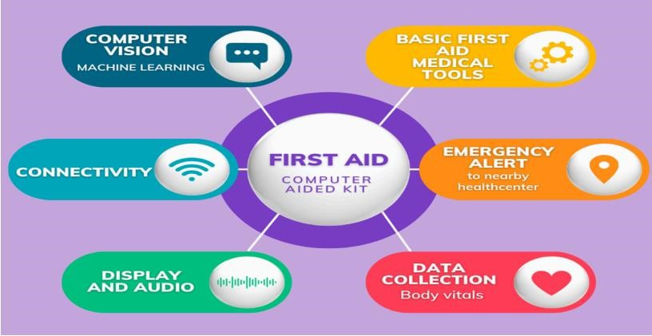

## 3.1 PROBLEM STATEMENT

Despite the widespread availability of basic first-aid information, many individuals lack the confidence and practical understanding to effectively apply these skills in emergency situations. Traditional first-aid resources often present information in a static and passive manner, hindering knowledge retention and application. This gap can lead to delayed or incorrect first-aid interventions, potentially worsening the situation for the injured individual until professional help arrives. Therefore, there is a need for an engaging and interactive first-aid guide that addresses the limitations of traditional resources by: Enhancing user engagement: utilizing interactive elements like quizzes, simulations, and animations to cater to different learning styles and improve information retention. Promoting practical application: providing opportunities to practice learned skills through simulated scenarios, fostering confidence in applying first-aid procedures. Emphasizing seeking professional help: clearly communicating the importance of seeking professional medical assistance in any critical situation, ensuring the guide compliments, not replaces, professional guidance. By addressing these challenges and promoting active learning, this project aims to equip individuals with the knowledge, confidence, and practical skills crucial for effective firstaid application in emergencies, potentially leading to improved outcomes for those requiring assistance until professional help arrives.

## 3.2 CIRCUIT DIAGRAM

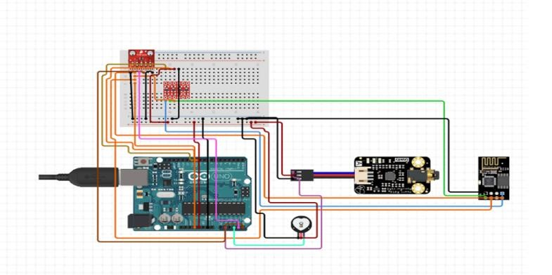

**FIG. .1 - graphical circuit-using arduino uno**

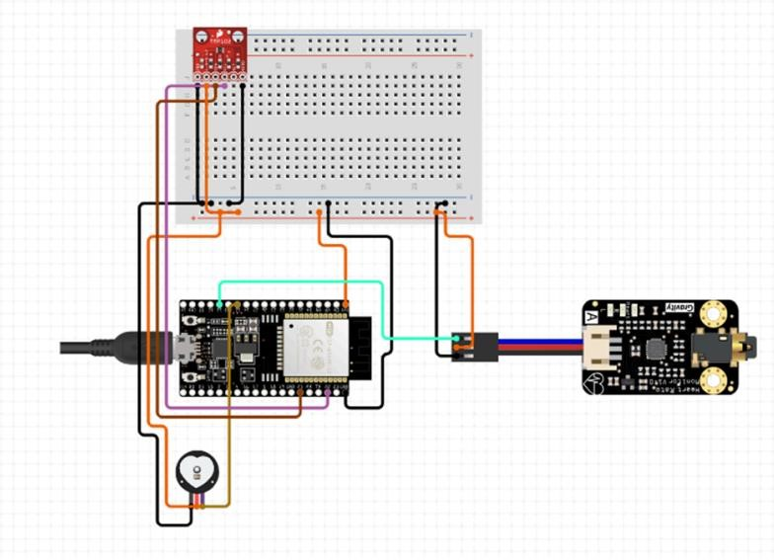

**FIG. - graphical circuit-using esp32**

**Components required:**

**pulse sensor, ecg sensor, thermal sensor**

## 3.3 SCHEMATIC DIAGRAM

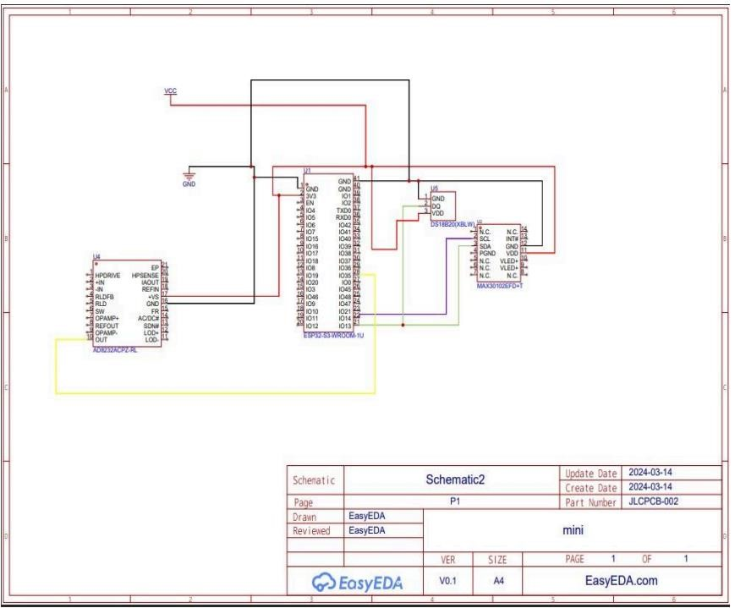

## 4. PROPOSED SYSTEM

The novelty of a computer-aided first aid kit lies in its potential to provide real-time guidance and assistance during emergencies. With sensors, AI algorithms, and connectivity, it can assess situations, offer tailored instructions, and even communicate with emergency services. This innovation aims to enhance the effectiveness of first aid by incorporating technology for faster, more accurate responses **.**

## 5. CONCLUSION

In conclusion, this project explored the development of a first-aid kit integrated with sensors, image capture, and a web application to provide initial first-aid guidance and educational resources. By leveraging technology and focusing on userfriendliness, the project aimed to improve accessibility and understanding of basic first-aid procedures.

This prototype demonstrated potential benefits in providing users with readily available information and visual guides tailored to specific situations. However, it is crucial to acknowledge that this system does not replace professional medical attention. Seeking professional help for emergencies and complex injuries remains paramount.

Future development will prioritize responsible practices and continued validation. Collaboration with medical professionals will ensure accuracy and adherence to ethical guidelines. User testing will refine the interface and educational materials for optimal effectiveness. Moreover, exploring regulatory compliance and obtaining necessary approvals will be crucial before wider implementation.

While further development and responsible implementation are vital, this project holds promise for enhancing first-aid awareness and potentially empowering individuals to take initial action in critical situations. Continued research and collaboration with experts will guide the project towards responsible innovation and contribute to improved public health through accessible first-aid knowledge.

## 6. REFERENCES

1. “Computer-aided diagnosis in medical imaging: Historical review, current status and future potential”, By:Kunio Doi
2. “Machine learning and phone data can improve targeting of humanitarian aid” By:Emily Aiken, Suzanne Bellue, Dean Karlan, Chris Udry & Joshua E. Blumenstock
3. “Life supporting first aid training of the public—review and recommendations.” By:Philip Eisenburger ,Peter Safar
4. “Mixed Reality Medical First Aid Training System Based on Body Identification” By: Jiayu Wang, Ruoxiu Xiao, Lijing Jia & Xianmei Wang
5. “First Aid App” By: Muhammad Hakim Sharin Bin Mohd Tauhid
6. “Significant improvement of the quality of bystander first aid using an expert system with a mobile multimedia device.” By:Lorenz Ertl , Frank Christ
7. “Wound Healing Dressings and Drug Delivery Systems”: A Review. By:Joshua S. Boateng , Kerr

H. Matthews , Howard N.E. Stevens , Gillian M. Eccleston

[8] “Healthcare informatics and analytics in big data.” By:Md. Ileas Pramanik , Raymond Y.K. Lau , Md. Abul Kalam Azad , Md. Sakir Hossain , Md. Kamal Hossain Chowdhury , B.K. Karmaker [9] “Blood Pressure Monitoring System using Wireless technologies.” By:Bharat Singh, Shabana Uroojb, Sakshi Mishrac, Surojeet Haldar

[10] “An overview on state-of-the-art electrocardiogram signal processing methods: Traditional to AIbased approaches.” By:Venkata Anuhya Ardeti , Venkata Ratnam Kolluru , George Tom Varghese , Rajesh Kumar Patjosh