ENVIRONMENTAL IMPACT ASSESSMENT FOR DEVELOPMENTAL PROJECTS

***Misal Shubham Ravsaheb1, Pansare Shivani Bhausaheb 2, Pomnar Dhanshri Ramesh3, Shaikh Mustakim Alam 4, Prof. Shinde P.B 5***

1,2,3,4 Student, Department of Civil Engineering, Vidya Niketan College of engineering, Bota.

5 Lecturer, Department of Civil Engineering, Vidya Niketan College of engineering, Bota.

# ABSTRACT

Environmental Impact Assessment (EIA) stands as a pivotal tool in contemporary developmental projects, striving to reconcile human progress with ecological sustainability. This abstract delves into the essence of EIA within the context of developmental endeavors. It elucidates the significance of comprehensive assessments in preempting and mitigating adverse environmental effects arising from such projects. By analyzing potential impacts on various environmental components, including air, water, soil, and biodiversity, EIA aims to inform decision-makers and stakeholders about the project's consequences. Moreover, it underscores the imperative of stakeholder engagement and interdisciplinary collaboration in fostering transparent, inclusive, and informed decision-making processes. This emphasizes the role of EIA as a proactive measure in fostering sustainable development, balancing economic growth with environmental conservation, and ensuring the well-being of both present and future generations. This highlights the evolving nature of EIA frameworks, adapting to the complexities of modern development challenges and incorporating principles of resilience and adaptive management. It acknowledges the inherent uncertainties and limitations in predicting environmental impacts, advocating for a precautionary approach and ongoing monitoring and evaluation throughout project lifecycles. it underscores the importance of integrating EIA into broader sustainability frameworks, aligning development goals with global environmental priorities such as climate change mitigation and biodiversity conservation.

**keywords:** Environmental Impact Assessment (EIA), Developmental Projects, Sustainability, Biodiversity

# INTRODUCTION

Environmental Impact Assessment (EIA) stands as a pivotal tool in the realm of developmental projects, serving as a comprehensive evaluation mechanism to gauge the potential consequences on the environment before undertaking any significant endeavor. In the wake of burgeoning industrialization and urbanization, the necessity of such assessments has become increasingly apparent, with the recognition that human activities can exert profound and often irreversible effects on the delicate balance of ecosystems. The essence of EIA lies in its capacity to foresee, mitigate, and manage adverse environmental impacts, thereby fostering sustainable development practices. By scrutinizing the foreseeable repercussions of proposed projects on various environmental components such as air, water, soil, and biodiversity, EIA endeavors to strike a harmonious equilibrium between development aspirations and ecological preservation. This introductory exploration delves into the fundamental principles, methodologies, and significance of Environmental Impact Assessment in navigating the complex interplay between human progress and environmental conservation. The important topic of Environmental Impact Assessment (EIA) in relation to development initiatives is examined in this paper. Its goal is to evaluate and lessen the negative effects that different development projects have on the environment. The study looks at methods for evaluating any harm to the environment, loss of biodiversity, and disturbances to ecosystems brought on by infrastructure developments. The research, which places a strong emphasis on sustainable practices, aims to provide thorough insights into striking a balance between environmental protection and developmental objectives. The results are intended to provide guidance to stakeholders, project planners, and policymakers on how to include efficient EIA procedures to guarantee ethical and environmentally acceptable development practices in a range of project situations. In-depth examination of the fundamental ideas of EIA, a critical assessment of its contribution to sustainable development, and an analysis of its main features are the objectives of this research. Understanding

the intricate and interwoven link between human activity and the environment is crucial to appreciating the importance of environmental impact assessments (EIAs). Numerous development initiatives, including those involving land use changes, mining operations, industrial development, and infrastructural expansion, may have significant ecological effects. In order to help decision-makers make wise decisions and minimise negative consequences, EIAs are used as a preventative strategy to evaluate the possible environmental repercussions of these projects. The essential elements of an EIA policy will be investigated in this research, together with the legal and regulatory frameworks that control its application. It will examine the main goals and tenets of the EIA process, including the inclusion of scientific knowledge, stakeholder engagement, and alternative consideration. Globally, there is growing evidence of the link between sustainable development and environmental well-being. Understanding the complex link between economic development and its possible environmental effects, the Environmental Impact Assessment (EIA) concept has become an essential instrument. The primary goal of an environmental impact assessment (EIA) is to methodically identify and assess how development projects, plans, programmes, and policies will affect the environment. By giving options that strike a balance between ecological concerns and developmental objectives, this technique helps decision-makers make well-informed choices. Traditionally used for particular projects, the scope of environmental impact assessments (EIAs) is growing to include sectoral and land-use planning.

# 1.1 Importance of environmental preservation in modern developmental initiatives.

EIA plays a crucial role in protecting the environment and promoting sustainable development. By identifying potential impacts and proposing mitigation measures, it ensures that projects are designed and implemented in an environmentally responsible manner. The process helps identify potential environmental impacts at an early stage, allowing for appropriate measures to be taken to prevent or minimize adverse effects. It enables the integration of environmental considerations into project planning and decision-making. EIA promotes public participation, allowing affected communities and stakeholders to voice their concerns and contribute to the decision-making process. This transparency enhances public trust and accountability. Lastly, EIA ensures that environmental considerations are integrated into the planning and design of projects from the early stages. Doing so helps avoid costly and environmentally damaging modifications later in the project lifecycle.

# 1.3 Role of Environmental Impact Assessment (EIA) in project sustainability.

.

# PROBLEM STATEMENT

The increasing prevalence of developmental projects across various sectors necessitates a comprehensive examination of their environmental implications. As these initiatives expand, they pose a considerable threat to ecological balance and biodiversity, calling for urgent action to mitigate their adverse effects. The problem lies in the insufficient evaluation and mitigation of the ecological footprint associated with these projects, leading to habitat destruction, species depletion, and ecosystem degradation. Additionally, the lack of public involvement and awareness exacerbates this issue, hindering effective decision-making and sustainable planning. Therefore, there is an imperative need to address these challenges by enhancing the environmental impact assessment process for developmental projects, ensuring thorough evaluation, and minimizing ecological harm while fostering public engagement and awareness to promote sustainable development.

# LITRATURE REVIEW

**Chukwuma, Chrysanthus (1996).** The relation between the environment and successful economic development is gaining global recognition. The realization of the significance of predicting environmental impacts of development gave birth to environmental impact assessment (EIA), which is basically concerned with the identification and assessment of the environmental effects of development projects, plans, programmes and policies in order that an appropriate choice selection from presenting alternatives is made. EIAs have been mostly concerned with development projects, while a significant few have undergone implementation for land-use and sectoral plans and; in particular, the domestic policies from which these development activities generated. Identification and assessment of environmental development impacts are intricate because of the variants of impacts which may be caused by anthropogenic activities on environmental and social systems. To identify and assess these impacts necessitates collation of extensive data, and, most significantly, presenting, communicating or articulating the findings to decision makers and the public, most of whom lack the knowledge of the technicalities entailed. In order to surmount certain problems related to EIAs, attention is given to the development of structured aids or approaches to assessment, oftentimes referred to as EIA methodologies or methods. **Attaullah Shah (2010)** conducted research on “environmental impact assessment (eia) of infrastructure development projects in developing countries”: Environmental Impact

Assessment (EIA) is a tool used to identify the environmental, social and economic impacts of a project prior to decisionmaking. The process leads to the selection of the projects on the principle of sustainable development, so that the adverse effects of the new developments are mitigated through proactive and rational decisions making. Over the years, EIA has not been practiced holistically in the developing countries and particularly in South Asian Nations. However, in the last few years Governments, environmentalists, researchers, media and communities of these countries have formulated sufficient legislative and institutional frame work for the EIA. In this paper, an overview of the EIA practices in developing countries and particularly South Asia, have been given, with special reference to the developments in Pakistan. The creation of awareness and formulating legislation has thus forced the countries to abandon many developmental projects, which were detrimental to the environment Some of the basic flaws in the EIA of a mega project (Zero Point Interchange ProjectZPIP0 have been highlighted. **Luis E. Sánchez (2008)** conducted research on “Tiering strategic environmental assessment and project environmental impact assessment in highway planning in São Paulo, Brazil” Constructing highways in dense urban areas is always a challenge. In São Paulo Metropolitan Region, heavy truck traffic contributes to clog streets and expressways alike. As part of the traffic neither originates nor head to the region, a peripheral highway has been proposed to reduce traffic problems. This project, called Rodoanel, is an expressway approximately 175 km long. The fact that the projected south and north sections would cross catchments that supply most of the metropolis water demand was strongly disputed and made the environmental permitting process particularly difficult. The agency in charge commissioned a strategic environmental assessment (SEA) of a revamped project, and called it the Rodoanel Programme. However, the SEA report failed to satisfactorily take account of significant strategic issues. Among these, the highway potential effect of inducing urban sprawl over water protection zones is the most critical issue, as it emerged later as a hurdle to project licensing. Conclusion is that, particularly where no agreed-upon framework for SEA exists, when vertical tiering with downstream project EIA is sought, then a careful scoping of strategic issues is more than necessary. If an agreement on ‘what is strategic’ is not reached and not recognized by influential stakeholders, then the unsettled conflicts will be transferred to project EIA. In such a context, SEA will have added another loop to the usually long road to project approval.

**Christopher Wood (2003)** conducted research on “Environmental Impact Assessment In Developing Countries: An Overview” Developing Country Environmental Impact Assessment (Eia) Dates Back To The Mid-1970s And, Although It Varies significantly from country to country, its performance generally falls far behind that of EIA in developed countries. It is crucial that this performance be improved in order to help to protect the environment of three quarters of the world’s land area. This paper reviews developing country EIA against a set of robust evaluation criteria to determine its strengths and weaknesses. These relate to: legal basis; coverage; consideration of alternatives; screening; scoping; EIA report preparation; EIA report review; decision-making; impact monitoring; mitigation; consultation and participation; system monitoring; costs and benefits; and strategic environmental assessment. Because developing country EIA meets so few of the 14 evaluation criteria, several urgent generic issues need to be addressed if EIA is to fulfil its potential. These include legislation, organisational capacity, training, environmental information, participation, diffusion of experience, donor policy and political will. **Bao Cun-kuan (2004)** conducted research on “Framework and operational procedure for implementing Strategic Environmental Assessment in China” Over the last 20 years, Environmental Impact Assessment (EIA) has been implemented and become an important instrument for decision-making in development projects in China. The Environmental Impact Assessment Law of the P.R. China was promulgated on 28 October 2002 and will be put into effect on 1 September of 2003. The law provides that Strategic Environmental Assessment (SEA) is required in regional and sector plans and programs. This paper introduces the research achievements and practice of SEA in China, discusses the relationship of SEA and ‘‘integrating of environment and development in decision-making (IEDD)’’, and relevant political and legal basis of SEA. The framework and operational procedures of SEA administration and enforcement are presented. Nine cases are analyzed and some proposals are given. **Wenfeng Mao (2002)** conducted research on “Impacts of the economic-political reform on environmental impact assessment implementation in China” Economic, political and institutional reform has significant implications for environmental regulation; however, the linkages between them have received little attention in the research literature or in governmental studies until very recently. This paper analyzes the impacts of economic– political reform on environmental regulation in China by examining the implementation of its environmental impact assessment (EIA) system. Local governments can design and enforce their own environmental policies, while local leaders have both incentive and means to impede the implementation of environmental regulations when deemed unfavorable for local economic growth. The paper argues that the impacts of China’s economic– political reform on its environmental regulation in general, and EIA implementation in particular, are mixed and less than beneficial. The economic–political reforms in China have brought about mixed impacts on its environmental regulation. On the one hand, they allow local governments to design and enforce their own environ- mental policies according to their particular circumstances. On the other hand, they enable local leaders to have both incentives and means to impede the implementation of environmental regulations when

deemed as unfavorable for local economic growth; this leads to lax, selective or inconsistent environmental implementation at local levels. **Leonard Ortolano (1995)** conducted research on “Environmental Impact Assessment: Challenges and Opportunities” Environmental impact assessment (EIA) is required, in one form or another, in more than half the nations of the world. This paper examines how EIA requirements have influenced projects, programs, and organizations. EIAs have had far less influence than their original supporters had hoped. This paper provides organizational and methodological reasons for this disparity and indicates ways in which EIA might be used more productively in the future. Environmental impact assessment programs have changed the way project proponents and government agencies charged with approving projects do business. These changes have occurred in both projects and organizations. The most evident change is the inclusion of measures in project proposals to mitigate adverse environmental effects. A less common, but significant project-level change is where ElAs have affected project type, size and location. What is arguably more significant but less widely studied is the influence of EIA on project proponents. While many project proponents have been inarginally affected, others have changed fundamentally. **Ben F Harris-Roxas (2011)** conducted research on “A rapid equity focused health impact assessment of a policy implementation plan: An Australian case study and impact evaluation” Equity focused health impact assessments (EFHIAs), or health equity impact assessments, are being increasingly promoted internationally as a mechanism for enhancing the consideration of health equity in the development of policies, programs and projects. Despite this there are relatively few examples of examples of completed EFHIAs available. This paper presents a case study of a rapid EFHIA that was conducted in Australia on a health promotion policy implementation plan. It briefly describes the process and findings of the EFHIA and evaluates the impact on decision-making and implementation. The rapid EFHIA was undertaken in four days, drawing on an expert panel and limited review of the literature. A process evaluation was undertaken by email one month after the EFHIA was completed. An impact evaluation was undertaken two years later based on five semi-structured interviews with members of the EFHIA working group and policy officers and managers responsible for implementing the plan. A cost estimation was conducted by the EFHIA working group. This EFHIA was conducted in a short timeframe using relatively few resources. It had some reported impacts on the development of the implementation plan and enhanced overall consideration of health equity. This case highlights some of the factors and preconditions that may maximize the impact of future EFHIAs on decision-making and implementation.

**Jing Wu (2011)** conducted research on “Strategic environmental assessment implementation in China Five- year review and prospects” Through literature review and questionnaire survey, the purpose of this study is to understand current status and major fields of SEA implementation in China, and then to provide advice for future improvement of SEA system, according to objective evaluation of the effectiveness of SEA implementation. Major types and fields of SEA implementation were firstly studied to conclude that the attitude of decision-makers and competent authority of SEA implementation does generate direct impacts on SEA implementation. Current status of SEA implementation was then studied, in terms of timing, techniques and methodologies, public participation, information disclosure, alternative, and review organization, to conclude that SEA implementation in China is “impact-based SEA” and the major problems of SEA implementation are resulted from deficient and defective management of SEA system, such as laws, regulations, and means of management. In order to have objective evaluation on the effectiveness of SEA implementation, to understand good practice of SEA implementation, and to provide advice for future improvement of SEA system, it is necessary to establish reasonable and feasible evaluation criteria for the effectiveness of SEA implementation, based upon foreign experience and political, legislative, administrative and cultural characteristics of China. Various types and stages of SEA should be carefully considered to be included into the evaluation criteria for the effectiveness of SEA implementation. **Françoise Jabot 1, (2020)** conducted research on “A Comparative Analysis of Health Impact Assessment Implementation Models in the Regions of Montérégie (Québec, Canada) and Nouvelle-Aquitaine (France) Françoise” Many countries have introduced health impact assessment (HIA) at the national, regional, or local levels. In France and in Québec, there is increasing interest in using HIA to inform decision-makers and influence policies, programs, and projects. This paper aims to compare HIA implementation models in two regions: Nouvelle-Aquitaine (France) and Montérégie (Québec, Canada) using a case study methodology. The objective is to gain a better understanding of the similarities and differences in the approaches used to achieve the operationalization of HIA. The methodological approach involves four steps: (1) design of an analytical framework based on the literature; (2) exchanges within the research team and review of documents concerning the two implementation strategies under study; (3) development of the case studies based on the proposed framework; and (4) cross- comparison analysis of the case studies. The findings show that the two regions share certain similarities, including the strong commitment and political will of the public health organizations involved and a well- established culture of engaging in Intersectoral action with municipal partners. Differences mainly concern their different approaches to implementing HIAs in accordance with the regional policies and the organizational and administrative contexts in place. This study identifies potential avenues for supporting the practice of HIA at the municipal level

**Matthew Cashmore (2004)** conducted research on “The interminable issue of effectiveness: substantive purposes, outcomes and research challenges in the advancement of environmental impact assessment theory” An analysis of studies of the outcomes of environ- mental impact assessment (EIA) indicates that its role in consent and design decisions is limited, due primarily to passive integration with the decision processes it is intended to inform. How much EIA helps sustainable development is largely unknown, but it is hypothesized that it is more than is typically assumed, through a plethora of causes, including emancipation of stakeholders and incremental change in the bureaucracy, companies and scientific institutions. To enhance the effectiveness of EIA, research should focus more on theory about the nature and operation of diverse causal pro- cases, even though the concepts, methods and analytical challenges would be substantial. The issue of effectiveness has been an overarching theme of EIA research ever since this decision tool was first enacted (Sadler, 1996). Nonetheless, re- search has focused overwhelmingly on procedural definitions of effectiveness, and remarkably little is known about the degree to which EIA is achieving its substantive purposes. It is, furthermore, evident that the precise purposes of this decision tool have been interpreted in different ways, in part due to the diversity of scientific disciplines EIA encompasses and the changing nature of the human– environment relationship. **I. M. GRAY (1998)** conducted research on “A review of the quality of environmental impact assessments in the Scottish forest sector” The Environmental Assessment (Afforestation) Regulations 1988 became effective on 12 July 1988. In Scotland, between 1988 and 1996 a total of 160 applications for grant assistance for afforestation proposals received by the Forestry Commission have been subject to Environmental Impact Assessment (EIA). Of these, 81 had been completed by 1996 and the assessment process concluded. Although there were instances of good practice in the assessment process, the review highlighted the overall poor quality of EIA and ES production. The recurring elemental failure, which subsequently led to additional difficulties, was the absence of a full scoping phase. Assessments were therefore unfocused, did not adequately investigate the key issues and wasted effort on irrelevancies. This in turn led to the col- lection of inadequate baseline data, which later made the task of assessing the magnitude and significance of impact extremely difficult. The review also noted that only one Woodland Grant Scheme (WGS) application was rejected following EIA, and that none of the ESs reviewed found any significant impacts. In light of the poor coverage of mitigation methods this suggests that both project screening and EIA practice require strengthening. The authors wish to thank the Forestry Authority for the assistance given while carrying out the background research for this paper. **Simon Tarabon (2019)** Environmental impact assessment (EIA) is performed to limit potential impacts of development projects on species and ecosystem functions. However, the methods related to EIA actually pay little attention to the landscape-scale effects of development projects on biodiversity. In this study we proposed a methodological framework to more properly address the landscape-scale impacts of a new stadium project in Lyon (France) on two representative mammal species exemplary for the endemic fauna, the red squirrel and the Eurasian badger. Our approach combined species distribution model using Maxent and landscape functional connectivity model using Graphab at two spatial scales to assess habitat connectivity before and after development project implementation. The development project had a negative impact on landscape connectivity: overall habitat connectivity (PC index) decreased by

–6.8% and –1.8% and the number of graph components increased by +60.0% and +17.6% for the red squirrel and the European badger respectively, because some links that formerly connected habitat patches were cut by the development project. Changes affecting landscape structure and composition emphasized the need to implement appropriate avoidance and reduction measures. Our methodology provides a useful tool both for EIA studies at each step of the way to support decision-making in landscape conservation planning. The method could be also developed in the design phase to compare the effectiveness of different avoidance or mitigation measures and resize them if necessary to maximize habitat connectivity. **Peter N. Duinker (2007)** conducted research on “Scenario analysis in environmental impact assessment: Improving explorations of the future Peter” Scenarios and scenario analysis have become popular approaches in organizational planning and participatory exercises in pursuit of sustainable development. However, they are little used, at least in any formal way, in environmental impact assessment (EIA). This is puzzling because EIA is a process specifically dedicated to exploring options for more-sustainable (i.e., less environmentally damaging) futures. In this paper, we review the state of the art associated with scenarios and scenario analysis, and describe two areas where scenario analysis could be particularly helpful in EIA: (a) in defining future developments for cumulative effects assessment; and (b) in considering the influence of contextual change – e.g. climate change – on impact forecasts for specific projects. We conclude by encouraging EIA practitioners to learn about the promise of scenario-based analysis and implement scenario-based methods so that EIA can become more effective in fostering sustainable development.

1. **PROPOSED METHODOLOGY AND OPERATING PRINCIPLE**

* Give a succinct synopsis of the subject, emphasising the need to research the Environmental Impact Assessment (EIA) policy and its execution plan.
* Identify the research goals and questions to lead the investigation.

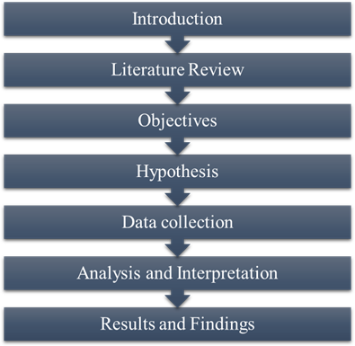

# Data collection

In terms of technique, this study will employ both primary and secondary data Primary data will be obtained using techniques including surveys, interviews, and focus groups. Secondary data, on the other hand, is collected from sources such as reports, articles, and statistics, and it may give a broader picture.

# Primary Data:

* + - Surveys: Conduct structured interviews and questionnaires among individuals and communities residing near project sites, focusing on their experiences, perceptions, and concerns regarding environmental impact assessments (EIAs).
    - Field Observations: Directly observe public hearings, site visits, and environmental mitigation measures in action, documenting processes and interactions to gain insights into the practical implementation of EIAs.
    - Case Studies: Select specific developmental projects that have undergone EIAs and conduct in-depth analyses, examining the environmental impacts, effectiveness of mitigation measures, and overall outcomes of the EIA process.

# Secondary Data:

* + - Government Reports: Gather official reports and publications from relevant government agencies responsible for overseeing EIA policies, focusing on policy guidelines, implementation strategies, monitoring mechanisms, and statistical data on EIA outcomes.
    - Academic Research: Review peer-reviewed research articles, academic papers, and studies related to EIA policies and implementation strategies, emphasizing their effectiveness, challenges, and best practices.
    - EIA Reports: Analyze comprehensive EIA reports submitted by project developers as part of the assessment process, examining baseline data, predicted impacts, proposed mitigation measures, and monitoring plans outlined in these documents.

# Data Analysis

* Describe the process of data analysis, including the software or analytical techniques to be used.
* Specify the types of data analysis techniques appropriate for the research questions.
* Present a plan for organizing, coding, and interpreting the collected data.
* Outline how the research findings will be validated and any measures taken to ensure data accuracy and reliability.

# Sample Size-

To calculate the sample size for a population of 150 using Cronbach alpha, you will need to provide additional information such as the expected Cronbach alpha, the expected population correlation coefficient, the desired level of statistical power, and the desired level of significance.

Assuming that you want to estimate the sample size needed to achieve a 95% confidence level, 80% power, and a Cronbach alpha of 0.8, with an expected population correlation coefficient of 0.5, and a margin of error of 5%, you can use the following formula:

The Cochran formula is as follows:



i.e.,

Z = 95 percent confidence level yields Z values of 1.96. p = 50% of population Size. (0.5)

q = 1-p (1-0.5) = 0.5

e = Margin of error (0.05)

((1.96)2 (0.5) (0.5)) / (0.05)2 = 385.

Cochran's formulae for Smaller Size population

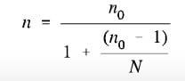

Here n0 is Cochran’s sample size recommendation, N is the population size, and n is the new, adjusted sample size. In our example, there were just 305 employees from manufacturing industry so we get sample size as,

385 / (1 + (384 / 305)) = 180.

# Study Area- Undri

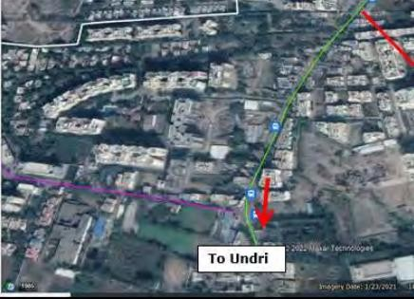

**Figure 1. Geographical structure**

# Tool used Spss software

SPSS (Statistical Package for the Social Sciences) is a software tool renowned for statistical analysis, data management, and documentation. Developed by IBM, it enjoys widespread adoption across various disciplines like social sciences and business for its robust capabilities in analyzing and interpreting data. Key functionalities encompass data manipulation, descriptive statistics, graphical visualization, and advanced statistical analysis. SPSS facilitates researchers and analysts in efficiently handling data tasks, from organizing and cleaning datasets to conducting sophisticated statistical analyses, thereby empowering informed decision-making processes across diverse fields.

# Here are some general aspects of SPSS software:

* SPSS offers robust data management capabilities, empowering users to seamlessly import, clean, and organize data from diverse sources like spreadsheets, databases, and text files. Its intuitive interface simplifies the process of data manipulation, allowing for efficient transformation and recoding of variables to suit analytical needs. Moreover, SPSS provides specialized tools for handling missing data, ensuring data integrity and accuracy throughout the analysis process. This comprehensive suite of features makes SPSS a preferred choice for researchers and analysts seeking to streamline their data management tasks and maximize the quality of their analyses.
* SPSS provides a robust suite of descriptive statistical procedures, empowering users to gain comprehensive insights into their data. These procedures include calculating frequencies to determine the occurrence of values within a dataset and descriptive ratios to understand proportions or percentages. Measures of central tendency such as mean, median, and mode offer a clear understanding of the typical or central value in a dataset, while measures of variability like standard deviation and variance provide insights into the spread or dispersion of data points. Additionally, SPSS facilitates cross-tabulations, allowing users to analyze relationships between categorical variables by generating contingency tables and calculating association measures such as chi-square statistics. These features collectively enable users to effectively summarize and interpret their data, facilitating informed decision-making processes.
* SPSS empowers users with a diverse array of options for visualizing data, including histograms, scatterplots, bar charts, line charts, and pie charts. These visual representations serve as powerful tools for elucidating patterns and relationships inherent within the data. Histograms provide a clear depiction of data distributions, while scatterplots unveil correlations between variables. Bar charts and line charts offer insights into trends and comparisons among different categories or over time.
* SPSS excels in generating comprehensive output reports, encompassing tables, charts, and statistical results. These reports are highly customizable, allowing users to tailor them to their specific needs and preferences. One of SPSS's notable strengths is its versatility in exporting reports to various formats, including Microsoft

Word, Excel, and PDF. This feature streamlines the sharing and presentation of findings, as users can seamlessly integrate SPSS-generated content into their preferred document or presentation format.

**WORKING PRINCIPLE**

The working principle behind environmental impact assessment (EIA) for developmental projects revolves around a holistic approach aimed at evaluating and mitigating the ecological footprint of such endeavors. At its core, this process involves comprehensive analyses to understand the potential effects on the environment, encompassing factors like biodiversity and ecosystem health. By thoroughly assessing these impacts, stakeholders can identify potential risks and opportunities to promote sustainable project planning. Moreover, the principle underscores the importance of fostering public participation and awareness throughout the EIA process. Engaging stakeholders ensures that diverse perspectives are considered, leading to more informed decisions that prioritize environmental conservation and community well-being.

**RESULT AND DISCUSSION**

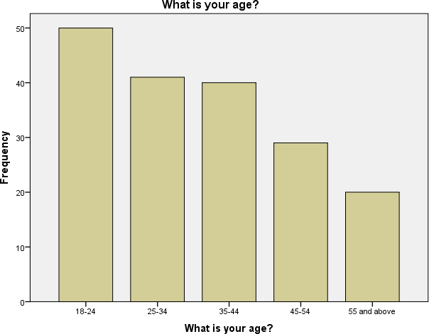

**Figure No.1 What is your age?**

According to the table, the majority of the respondents fall within the 18-24 age range, with a frequency of 50, representing 27.8% of the total sample. The next largest group is the 25-34 age range, with a frequency of 41, accounting for 22.8% of the sample. The 35-44 age range follows closely behind with a frequency of 40, representing 22.2% of the respondents. The 45- 54 age range has a lower frequency of 29, accounting for 16.1% of the sample. Finally, the 55 and above age range has the smallest frequency of 20, making up 11.1% of the total respondents. The cumulative percentage column shows the accumulation of the valid percentages as we move down the table. For example, the cumulative percentage at the end of the 18-24 age range is 27.8%, which indicates that 27.8% of the respondents are 24 years old or younger. This value increases as we move down the table and reaches 100% at the end, indicating the total coverage of all age ranges.

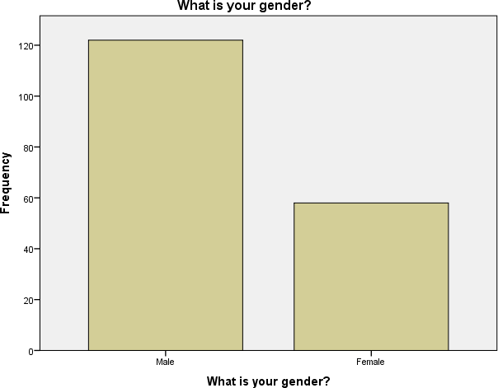

**Figure No.2 What is your gender?**

Based on the given data, there were 180 respondents in total who were asked about their gender. Out of these respondents, 122 (67.8%) identified as male, while 58 (32.2%) identified as female. This distribution indicates that the majority of respondents were male, accounting for nearly two-thirds of the sample, while females comprised around one-third. It's important to note that these numbers are specific to the survey data provided and may not reflect the gender distribution in the general population.

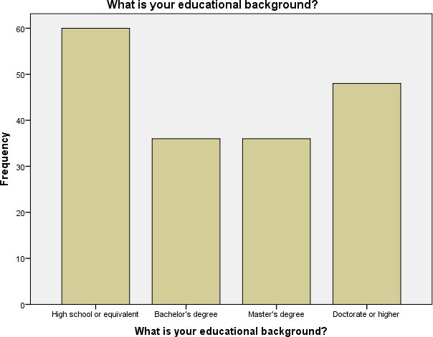

**Figure No. 3 What is your educational background?**

Based on the provided data, the educational background of the respondents is as follows. Out of the total 180 respondents, 60 (33.3%) reported having a high school diploma or an equivalent qualification. 36 (20.0%) respondents held a bachelor's degree, while another 36 (20.0%) had a master's degree. The highest level of education, a doctorate or higher, was reported by 48 (26.7%) respondents. These figures indicate a diverse range of educational backgrounds among the respondents, with a significant number holding advanced degrees. It's important to note that this data is specific to the sample surveyed and may not represent the educational distribution in the general population.

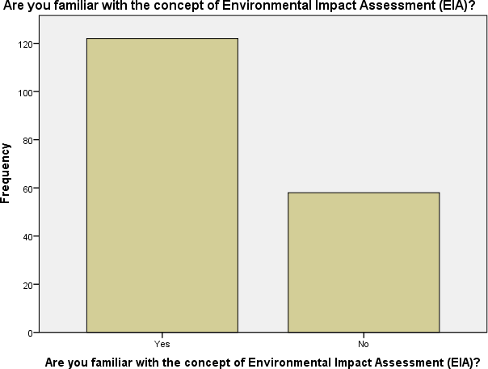

**Figure No. 4 Are you familiar with the concept of Environmental Impact Assessment (EIA)?**

Based on the provided data, it appears that 67.8% of the respondents, which is 122 individuals, indicated their familiarity with the concept of Environmental Impact Assessment (EIA). On the other hand, 32.2% of the respondents, equivalent to 58 individuals, stated that they were not familiar with EIA. This suggests that the majority of the surveyed individuals have some level of knowledge or awareness about Environmental Impact Assessment. It is important to note that this data is specific to the respondents in the survey and may not reflect the overall familiarity with EIA among the general population.

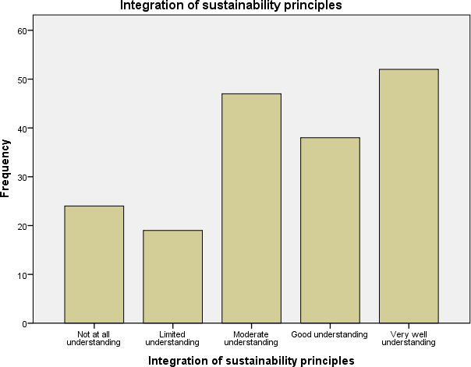

**Figure No.5 Integration of sustainability principles**

The data provided suggests that the respondents' understanding of the integration of sustainability principles can be categorized into five levels. Thirteen point three percent of the respondents reported having no understanding, while 10.6% had a limited understanding. On the other hand, 26.1% expressed a moderate understanding, and 21.1% reported a good understanding. The highest proportion, 28.9%, claimed to have a very well understanding of sustainability principles. These findings demonstrate a varied level of comprehension among the surveyed individuals, with a significant portion having a moderate to high understanding. However, it's important to remember that these results are specific to the survey participants and may not reflect

the overall understanding of sustainability principles in the wider population.

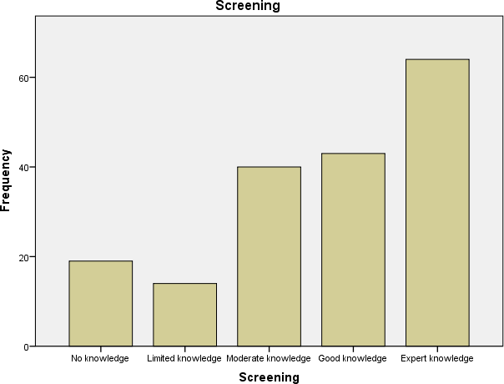

**Figure No.6 Screening**

The provided data indicates the level of knowledge among respondents regarding screening. The results can be categorized into five levels. Approximately 10.6% of respondents reported having no knowledge of screening, while 7.8% had limited knowledge. A larger portion, 22.2%, possessed a moderate level of knowledge. Additionally, 23.9% of respondents demonstrated good knowledge, and the highest proportion, 35.6%, claimed to have expert knowledge in screening. These findings show a range of knowledge levels among the surveyed individuals, with a significant percentage having at least a moderate understanding or higher. It's important to note that these results are specific to the respondents in the survey and may not represent the overall knowledge level regarding screening in the wider population.

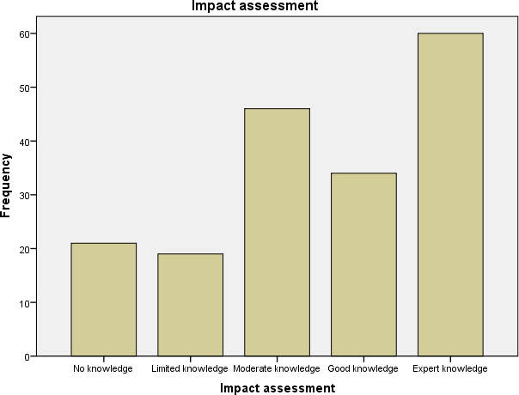

**Figure No.7 Impact assessment**

The data provided shows the level of knowledge among respondents regarding impact assessment. The results can be categorized into five levels. Approximately 11.7% of respondents reported having no knowledge of impact assessment, while

10.6% had limited knowledge. A larger portion, 25.6%, possessed a moderate level of knowledge. Furthermore, 18.9% of respondents demonstrated good knowledge, and the highest proportion, 33.3%, claimed to have expert knowledge in impact assessment. These findings indicate a range of knowledge levels among the surveyed individuals, with a notable percentage having at least a moderate understanding or higher. It's important to note that these results are specific to the respondents in the survey and may not represent the overall knowledge level regarding impact assessment in the wider population.

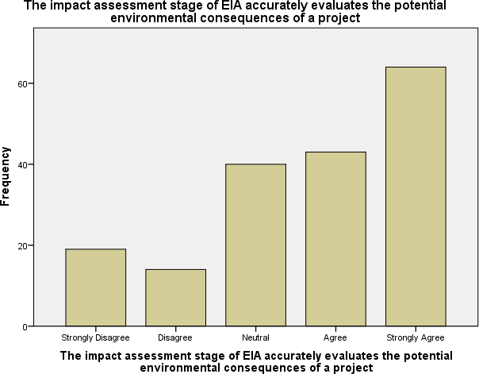

**Figure No.8 The impact assessment stage of EIA accurately evaluates the potential environmental consequences of a project**

Based on the provided data, opinions regarding the accuracy of the impact assessment stage of Environmental Impact Assessment (EIA) can be categorized into five levels. Approximately 10.6% of respondents strongly disagreed with the statement, while 7.8% disagreed. On the other hand, 22.2% expressed a neutral stance. Meanwhile, 23.9% agreed with the statement, and the highest proportion, 35.6%, strongly agreed. These findings demonstrate a range of opinions among the surveyed individuals regarding the accuracy of the impact assessment stage in evaluating the potential environmental consequences of a project. It's important to note that these results reflect the perceptions of the respondents and may vary based on their individual experiences and understanding of EIA processes.

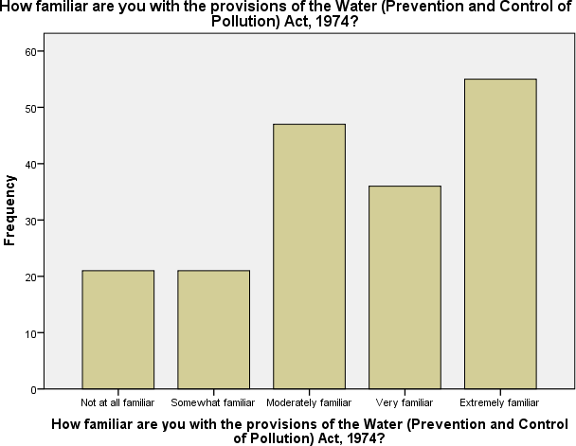

**Figure No.9 How familiar are you with the provisions of the Water (Prevention and Control of Pollution) Act, 1974?**

Based on the provided data, the familiarity levels of the respondents regarding the provisions of the Water (Prevention and Control of Pollution) Act, 1974, can be categorized into five levels. Approximately 11.7% of respondents reported being not at all familiar with the act, while another 11.7% considered themselves somewhat familiar. A larger portion, 26.1%, claimed to be moderately familiar with the act. Furthermore, 20.0% of respondents expressed being very familiar, and the highest proportion, 30.6%, stated being extremely familiar with the provisions of the act. These findings indicate a range of familiarity levels among the surveyed individuals regarding the Water (Prevention and Control of Pollution) Act, 1974. It's important to note that these results reflect the self-reported familiarity of the respondents and may vary based on their specific knowledge and experiences related to the act.

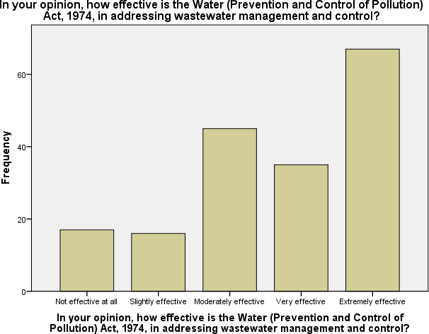

**Figure No.10 In your opinion, how effective is the Water (Prevention and Control of Pollution) Act, 1974, in addressing wastewater management and control?**

Based on the provided data, opinions regarding the effectiveness of the Water (Prevention and Control of Pollution) Act, 1974, in addressing wastewater management and control can be categorized into five levels. Approximately 9.4% of respondents considered the act not effective at all in this regard, while 8.9% believed it to be slightly effective. A larger portion, 25.0%, perceived the act to be moderately effective. Additionally, 19.4% of respondents regarded it as very effective, and the highest proportion, 37.2%, deemed it extremely effective in addressing wastewater management and control. These findings reflect the opinions of the respondents regarding the effectiveness of the Water (Prevention and Control of Pollution) Act, 1974, in relation to managing and controlling wastewater. It's important to note that these opinions are subjective and may vary based on the individual perspectives and experiences of the respondents.

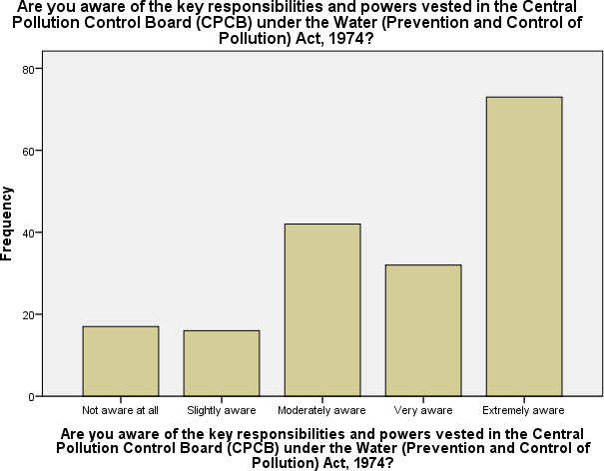

**Figure No.11 Are you aware of the key responsibilities and powers vested in the Central Pollution Control Board (CPCB) under the Water (Prevention and Control of Pollution) Act, 1974?**

Based on the provided data, the awareness levels of the respondents regarding the key responsibilities and powers vested in the Central Pollution Control Board (CPCB) under the Water (Prevention and Control of Pollution) Act, 1974, can be categorized into five levels. Approximately 9.4% of respondents reported being not aware at all, while 8.9% considered themselves slightly aware. A larger portion, 23.3%, claimed to be moderately aware of the responsibilities and powers of the CPCB. Furthermore, 17.8% of respondents expressed being very aware, and the highest proportion, 40.6%, stated being extremely aware of the CPCB's key responsibilities and powers under the act. These findings indicate a range of awareness levels among the surveyed individuals regarding the role and authority of the CPCB as defined in the Water (Prevention and Control of Pollution) Act, 1974. It's important to note that these results reflect the self-reported awareness of the respondents and may vary based on their specific knowledge and understanding of the act and the CPCB's functions.

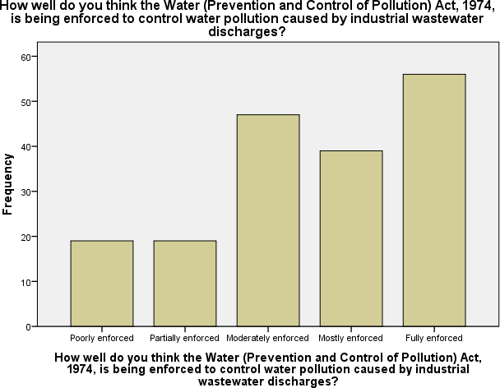

**Figure No.12 How well do you think the Water (Prevention and Control of Pollution) Act, 1974, is being enforced to control water pollution caused by industrial wastewater discharges?**

Based on the provided data, opinions regarding the enforcement of the Water (Prevention and Control of Pollution) Act, 1974, to control water pollution caused by industrial wastewater discharges can be categorized into five levels. Approximately 10.6% of respondents believed that the act is poorly enforced, while another 10.6% considered it partially enforced. A larger portion, 26.1%, perceived the act to be moderately enforced. Furthermore, 21.7% of respondents believed it is mostly enforced, and the highest proportion, 31.1%, regarded it as fully enforced in controlling water pollution caused by industrial wastewater discharges. These findings reflect the opinions of the respondents regarding the enforcement of the Water (Prevention and Control of Pollution) Act, 1974. It's important to note that these opinions are subjective and may vary based on the individual perspectives and experiences of the respondents.

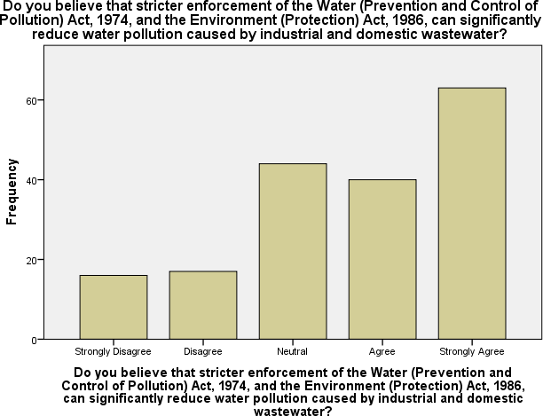

**Figure No.13 Do you believe that stricter enforcement of the Water (Prevention and Control of Pollution) Act, 1974,**

**and the Environment (Protection) Act, 1986, can significantly reduce water pollution caused by industrial and domestic wastewater?**

Based on the provided data, opinions regarding the belief that stricter enforcement of the Water (Prevention and Control of Pollution) Act, 1974, and the Environment (Protection) Act, 1986, can significantly reduce water pollution caused by industrial and domestic wastewater can be categorized into five levels. Approximately 8.9% of respondents strongly disagreed with the statement, while 9.4% disagreed. On the other hand, 24.4% expressed a neutral stance. Meanwhile, 22.2% of respondents agreed with the statement, and the highest proportion, 35.0%, strongly agreed. These findings reflect the range of opinions among the surveyed individuals regarding the potential impact of stricter enforcement of the mentioned acts in reducing water pollution caused by industrial and domestic wastewater. It's important to note that these opinions are subjective and may vary based on the individual perspectives and experiences of the respondents.

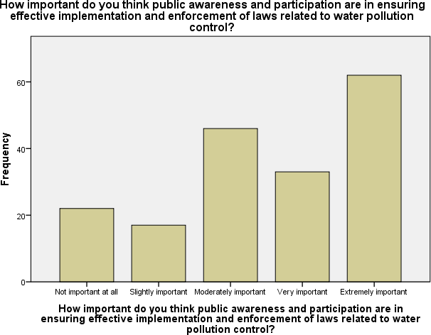

**Figure No.14 How important do you think public awareness and participation are in ensuring effective implementation and enforcement of laws related to water pollution control?**

Based on the provided data, opinions regarding the importance of public awareness and participation in ensuring effective implementation and enforcement of laws related to water pollution control can be categorized into five levels. Approximately 12.2% of respondents considered public awareness and participation not important at all in this context, while 9.4% believed it to be slightly important. A larger portion, 25.6%, regarded public awareness and participation as moderately important. Additionally, 18.3% of respondents perceived it to be very important, and the highest proportion, 34.4%, deemed it extremely important in ensuring the effective implementation and enforcement of laws related to water pollution control. These findings reflect the opinions of the respondents regarding the significance of public awareness and participation in addressing water pollution. It's important to note that these opinions are subjective and may vary based on the individual perspectives and experiences of the respondents.

**Table No.1 ANOVA**

|  |  |  |  |  |  |  |
| --- | --- | --- | --- | --- | --- | --- |
|  | | Sum of  Squares | df | Mean  Square | F | Sig. |
| The EIA policy in India is up- to-date with recent  developments and future directions | Between Groups | 236.653 | 4 | 59.163 | 139.270 | .000 |
| Within Groups | 74.342 | 175 | .425 |  |  |
| Total | 310.994 | 179 |  |  |  |
| The scoping phase of EIA effectively identifies and  addresses key environmental concerns | Between Groups | 202.735 | 4 | 50.684 | 79.324 | .000 |
| Within Groups | 111.815 | 175 | .639 |  |  |
| Total | 314.550 | 179 |  |  |  |
| The impact assessment stage of EIA accurately evaluates the  potential environmental consequences of a project | Between Groups | 176.657 | 4 | 44.164 | 57.819 | .000 |
| Within Groups | 133.671 | 175 | .764 |  |  |
| Total | 310.328 | 179 |  |  |  |
| How familiar are you with the provisions of the Water (Prevention and Control of  Pollution) Act, 1974? | Between Groups | 5.098 | 4 | 1.274 | .702 | .591 |
| Within Groups | 317.630 | 175 | 1.815 |  |  |
| Total | 322.728 | 179 |  |  |  |
| In your opinion, how effective  is the Water (Prevention and | Between Groups | 5.162 | 4 | 1.290 | .745 | .563 |
| Within Groups | 303.166 | 175 | 1.732 |  |  |

|  |  |  |  |  |  |  |
| --- | --- | --- | --- | --- | --- | --- |
| Control of Pollution) Act, 1974, in addressing wastewater  management and control? | Total | 308.328 | 179 |  |  |  |
| Are you aware of the key responsibilities and powers vested in the Central Pollution Control Board (CPCB) under the Water (Prevention and Control of Pollution) Act,  1974? | Between Groups | 176.932 | 4 | 44.233 | 55.273 | .000 |
| Within Groups | 140.046 | 175 | .800 |  |  |
| Total | 316.978 | 179 |  |  |  |
| How well do you think the Water (Prevention and Control of Pollution) Act, 1974, is being enforced to control water pollution caused by industrial wastewater discharges? | Between Groups | 8.128 | 4 | 2.032 | 1.182 | .320 |
| Within Groups | 300.783 | 175 | 1.719 |  |  |
| Total | 308.911 | 179 |  |  |  |
| How well do you think the Environment (Protection) Act, 1986, has been implemented to  regulate activities that contribute to water pollution? | Between Groups | 202.735 | 4 | 50.684 | 79.324 | .000 |
| Within Groups | 111.815 | 175 | .639 |  |  |
| Total | 314.550 | 179 |  |  |  |
| Do you believe that stricter enforcement of the Water (Prevention and Control of Pollution) Act, 1974, and the Environment (Protection) Act, 1986, can significantly reduce water pollution caused by industrial and domestic  wastewater? | Between Groups | 8.121 | 4 | 2.030 | 1.230 | .300 |
| Within Groups | 288.829 | 175 | 1.650 |  |  |
| Total | 296.950 | 179 |  |  |  |
| How important do you think public awareness and participation are in ensuring effective implementation and  enforcement of laws related to water pollution control? | Between Groups | 28.828 | 4 | 7.207 | 4.122 | .003 |
| Within Groups | 305.972 | 175 | 1.748 |  |  |
| Total | 334.800 | 179 |  |  |  |

The provided table presents the results of the analysis of variance (ANOVA) conducted for several statements related to environmental policies and acts. The ANOVA compares the variation between groups with the variation within groups to determine if there are significant differences between the responses.

For the statement regarding the up-to-dateness of the EIA policy in India, there is a significant difference between the groups, indicating that the perception of the policy varies significantly among the respondents.

Similarly, for the effectiveness of the scoping phase of EIA and the accuracy of the impact assessment stage of EIA, there are significant differences between the groups, suggesting that respondents have diverse opinions on these aspects.

In contrast, for the familiarity with the provisions of the Water (Prevention and Control of Pollution) Act, 1974, the effectiveness of the act in addressing wastewater management, the awareness of the key responsibilities of the CPCB, the enforcement of the act to control water pollution caused by industrial wastewater discharges, and the implementation of the Environment (Protection) Act, 1986, there are no significant differences between the groups.

However, for the importance of public awareness and participation in ensuring effective implementation and enforcement of laws related to water pollution control, there are significant differences between the groups, indicating that respondents hold varying levels of importance regarding this matter.

Overall, the ANOVA results provide insights into the variability of opinions among the respondents concerning different aspects of environmental policies and acts, highlighting areas where there are significant differences in perception.

**CONCLUSION**

Effective environmental impact assessment (EIA) for developmental projects is paramount for mitigating ecological footprints, preserving biodiversity, and fostering sustainable development. Through comprehensive assessments, we can identify potential risks to ecosystems and biodiversity, allowing for informed decision- making and proactive measures to minimize adverse effects. Moreover, integrating public participation and awareness into the EIA process not only ensures transparency but also facilitates community engagement and

support for environmentally responsible development. By prioritizing environmental considerations in project planning and implementation, we can achieve a harmonious balance between development and conservation, safeguarding our planet for current and future generations.

The Environmental Impact Assessment (EIA) remains an indispensable tool for evaluating the potential environmental consequences of developmental projects. Through comprehensive analysis and consideration of various factors including ecological, social, and economic aspects, the EIA process facilitates informed decision- making aimed at minimizing adverse impacts and promoting sustainable development. It underscores the importance of proactive measures such as mitigation strategies and alternative assessments to safeguard environmental integrity and enhance overall project sustainability. However, challenges persist in ensuring effective implementation and enforcement of EIA recommendations, highlighting the need for continued collaboration among stakeholders, stringent regulatory frameworks, and ongoing monitoring and evaluation mechanisms. Ultimately, integrating environmental considerations into developmental planning processes not only fosters responsible stewardship of natural resources but also contributes to the well-being of present and future generations.

**FUTURE SCOPE**

In the foreseeable future, the scope of Environmental Impact Assessment (EIA) for developmental projects is poised to expand significantly, driven by increasing global awareness of environmental sustainability and the imperative for responsible development. With mounting concerns over climate change, biodiversity loss, and resource depletion, EIAs will likely evolve to incorporate more comprehensive and rigorous methodologies to assess the potential ecological, social, and economic impacts of proposed projects. Moreover, advancements in technology, such as remote sensing, geographic information systems (GIS), and artificial intelligence, will enhance the precision and efficiency of impact assessments. Additionally, there will likely be a growing emphasis on stakeholder engagement and public participation throughout the EIA process, fostering transparency and accountability. Furthermore, as regulatory frameworks evolve to address emerging environmental challenges, EIAs may encompass broader criteria, including considerations of cumulative impacts, ecosystem services, and climate resilience. Ultimately, the future scope of EIAs for developmental projects will be characterized by a holistic approach that seeks to balance development needs with environmental protection and sustainability goals, ensuring that projects contribute positively to both human well-being and the health of the planet.

# REFERANCE

1. Munyazikwiye, F. (2011). An assessment of environmental impact assessment (eia) procedures and challenges faced by environmental officers in eia implementation in rwanda. Phys. Rev. E. <http://www.ainfo.inia.uy/digital/bitstream/item/7130/1/LUZARDO-BUIATRIA-2017.pdf>
2. Shah, A. (2010). Environmental Impact Assessment ( Eia ) Of Infrastructure Development Projects In.
3. Tarabon, S., Bergès, L., Dutoit, T., & Isselin-nondedeu, F. (2019). Environmental impact assessment of development projects improved by merging species distribution and habitat connectivity modelling. 0–28.
4. Chukwuma, C. (2007). Environmental impact assessment of development projects and natural resources—a viewpoint. February 2015, 37–41. [Https://doi.org/10.1080/00207239608711056](https://doi.org/10.1080/00207239608711056)
5. Ortolano, L., & Shepherd, A. (1995). Environmental impact assessment: Challenges and opportunities. Impact Assessment, 13(1), 3–30. https://doi.org/10.1080/07349165.1995.9726076
6. Gray, I. M. (1999). A review of the quality of environmental impact assessments in the Scottish forest sector. Advances, 72(18), 20001–20001.
7. Wu, J., Chang, I. S., Bina, O., Lam, K. C., & Xu, H. (2011). Strategic environmental assessment implementation in China - Five-year review and prospects. Environmental Impact Assessment Review, 31(1), 77–84. <https://doi.org/10.1016/j.eiar.2010.04.010>
8. Cashmore, M., Gwilliam, R., Morgan, R., Cobb, D., & Bond, A. (2004). The interminable issue of effectiveness: Substantive purposes, outcomes and research challenges in the advancement of environmental impact assessment theory. Impact Assessment and Project Appraisal, 22(4), 295–310. <https://doi.org/10.3152/147154604781765860>
9. Harris-Roxas, B. F., Harris, P. J., Harris, E., & Kemp, L. A. (2011). A rapid equity focused health impact assessment of a policy implementation plan: An Australian case study and impact evaluation. International Journal for Equity in Health, 10, 1–12. <https://doi.org/10.1186/1475-9276-10-6>
10. Jabot, F., Tremblay, E., Rivadeneyra, A., Diallo, T. A., & Lapointe, G. (2020). A comparative analysis of health impact assessment implementation models in the regions of Montérégie (Québec, canada) and nouvelle-aquitaine (france). International Journal of Environmental Research and Public Health, 17(18), 1–18. <https://doi.org/10.3390/ijerph17186558>
11. Collins, A., Jones, C., & Munday, M. (2009). Assessing the environmental impacts of mega sporting events: Two options? Tourism Management, 30(6), 828–837. <https://doi.org/10.1016/j.tourman.2008.12.006>
12. Daniel R, M. (2016). The National Environmental Policy Act. Decision Making in Environmental Law, 271–282. <https://doi.org/10.4337/9781783478408.ii.20>
13. Duinker, P. N., & Greig, L. A. (2007). Scenario analysis in environmental impact assessment: Improving explorations of the future. Environmental Impact Assessment Review, 27(3), 206–219. <https://doi.org/10.1016/j.eiar.2006.11.001>
14. Bao, C. K., Lu, Y. Sen, & Shang, J. C. (2004). Framework and operational procedure for implementing Strategic Environmental Assessment in China. Environmental Impact Assessment Review, 24(1), 27–46. <https://doi.org/10.1016/S0195-9255(03)00137-9>
15. Mao, W., & Hills, P. (2002). Impacts of the economic-political reform on environmental impact assessment implementation in China. Impact Assessment and Project Appraisal, 20(2), 101–111. <https://doi.org/10.3152/147154602781766744>
16. Chukwuma Sr., C. (1996). Environmental impact assessment of development projects and natural resources—a viewpoint. *International Journal of Environmental Studies*, *50*(3–4), 187–200. https://doi.org/10.1080/00207239608711056
17. Attaullah Shaha, Salimullah.Kb andM.H.Shaha, Razaulkah.Kc, I. U. J. (2010). Environmental Impact Assessment ( Eia ) of Infrastructure Development Projects in. *International Journal Sustainable Development*, *1*(4), 47–54. <http://www.ssrn.com/link/OIDA-Intl-Journal-Sustainable-Dev.htm>
18. Sánchez, L. E., & Silva-Sánchez, S. S. (2008). Tiering strategic environmental assessment and project environmental impact assessment in highway planning in São Paulo, Brazil. *Environmental Impact Assessment Review*, *28*(7), 515–522. https://doi.org/10.1016/j.eiar.2008.02.001
19. Tarabon, S., Bergès, L., Dutoit, T., & Isselin-Nondedeu, F. (2019). Environmental impact assessment of development projects improved by merging species distribution and habitat connectivity modelling. *Journal of Environmental Management*, *241*, 439–449. https://doi.org/10.1016/j.jenvman.2019.02.031
20. Chukwuma, C. (1996). Environmental impact assessment of development projects and natural resources - A viewpoint. *International Journal of Environmental Studies*, *50*(3–4), 187–200. https://doi.org/10.1080/00207239608711056
21. Wood, C. (2003). *ENVIRONMENTAL IMPACT ASSESSMENT IN DEVELOPING COUNTRIES: AN OVERVIEW Conference on New Directions in Impact Assessment for Development: Methods and Practice*. *November*, 1–28.