**AUTOMATIC SWITCHING OF POWER SUPPLY FROM THREE DIFFERENT SOURCES**

**Rane Pratik1, Muthal Shubham2, Amrutkar Om3, Jagtap Sarika4**

1,2,3Student, Department of E&TC, MVP’s KBT College of Engineering, Nashik, Maharashtra, India

4Assistant Professor, Department of E&TC, MVP’s KBT College of Engineering, Nashik, Maharashtra, India

**ABSTRACT**

**The need for electricity is growing day by day and frequent power outages are causing a lot of issues in different sectors such as industry, hospital, office and home. Therefore, it is necessary to have an alternative arrangement for the power source. In such a situation, this project offers the automatic operation of the electrical power distribution system, which is the rapid and dependable transfer of power from one source to another in the event of specific events like power outage, power interruptions, routine maintenance of the power line, etc. To achieve the dependability of such system, this project offers a practical solution, which is to provide an alternate power supply or an uninterrupted power supply to the load in automated mode during frequent power cut or in situations where power cut or power outage cannot be avoided.**

**Keywords:** Uninterrupted Power Supply, LCD, atmega328p, Relay Driver IC

1. **INTRODUCTION**

In a world where electricity demand is high and power interruptions are commonplace due to limited capacity at generating stations, there is a pressing need for innovative solutions to ensure continuous and reliable power supply. This project introduces an "Automatic Power Supply from Four Different Sources" system designed to address this issue. By seamlessly switching between solar, mains, inverter, and generator, the system aims to overcome the challenges associated with power outages. A microcontroller serves as the central control unit, orchestrating the operation and providing an automated and efficient solution to manage diverse power sources. The integration of this system holds potential benefits for various sectors, ensuring uninterrupted power for critical applications and improving overall power reliability.

**Need of Project –**

*Reliable Power:* We need a system that ensures electricity is always available, even if one power source fails. It's like having multiple backup plans to keep the lights on.

*Using Different Energies Wisely:* With solar and other energy sources, we can save money and help the planet. A smart system can decide when to use each one, kind of like picking the best battery for your toy.

*Keeping Costs Low:* By using cheaper energy when it's available and switching to other sources when needed, we can save money on electricity bills, just like using coupons for shopping.

*Helping the Environment*: Using clean energy like solar or wind power is good for the planet. A system that automatically switches to these sources can help reduce pollution.

*Making Homes and Businesses Safer:* Having a backup plan for power means businesses can keep running smoothly and families won't be in the dark during an outage.

1. **LITERATURE SURVEY**

In [1], the researchers are made the project which is designed to check the availability of any live phase, and the load will be connected to the live phase only using AT89C52 MCU. This microcontroller continuously checks for the live condition of all the phases connected to it, and the controller connects the load to the active phase Relay & this relay is driven with a transistor. If two or three phases are live, the phase will be connected to the phase that is ON only and automatically transferred to the phase that is ON if the main fails or changes from generator to mains when mains is available. An LCD displays the status of phase condition. And the also given the Contrast control preset for LCD contrast control.

In [2], Francis E. Idachaba, Joseph O. Olowoleni, Augustus E. Ibhaze propose a system that provides an opportunity for the development of standalone power supply systems in rural areas without public utility. It also provides an opportunity for minimal reliance on public utility by users

In [3], the author uses four different power supply that are solar, Invertor, Mains, & Generator. They use Arm 7 (LPC2148) as a Microcontroller & LED as a indication for which supply is providing supply to a load. They use of GSM technology, which helps in operating the system from the different places.

In [4], Solar , wind , thermal And mains are used as a four different power supply. The author uses more renewable sources to keep energy cost very low. They use four switches as a four different supplies & give it to microcontroller as a input. They use 8051 as a Microcontroller which gives command to relay driver which supply is available and switch that relay.

In [5], this paper they connected three different power supplies to the three relays and that three relays are connected to relay driver and that relay driver is connected to a microcontroller. Whenever any supply is unavailable the microcontroller gives indication to relay driver and then relay driver switch off that relay and shift to another. They uses three different power supply that are Mains, Solar & Generator. They use 8051 as a Microcontroller & ULN 2003 as a Relay driver & LCD to display which power supply is available.

In [6], the proposed system they uses GSM technology, which helps in operating the system from different places. This GSM technology is the latest technology, which is used to collect information about the different sources whether the switch is ON or OFF. In this system, they use of AT89S52 Microcontroller which has many advanced features than the 8051 microcontroller.

1. **METHODOLOGY**

This project uses an arrangement where three different sources of supply are channelized to a load to have an uninterrupted operation of the load. As it is not practicable to get three sources of supply such as solar supply, mains supply and invertor supply, we use relays only. The project has taken one source of 230v mains supply and assumed as if being fed from three different sources by connecting all the three incoming sources in parallel. The ac source to the lamp is connected to relay 1 to relay 2 and to relay 3 by making the entire ‘NO’ (normally open) contacts parallel and all the common contacts in parallel. Three switches representing a failure of corresponding supply such as solar, mains and invertor.

* 1. **LOGIC DESIGN:**

The project basically supplies continuous power to a load in automated mode through one of the three sources of supply that are: solar, mains and invertor when any one of them is unavailable. Three switches are used for three respective sources. These are connected to a microcontroller(atmega328p) that provides input signals to it. Whenever a switch is pressed, it represents the failure of that particular source. A relay driver receives a microcontroller generated output signal and then the relay driver switches that particular relay to provide continuous power supply. A lamp was used as a load for demonstration purpose which draws power from the mains. When solar fails to supply power, automatically the next available source is used, say mains. If the mains fails, then the next one is used and so on. An LCD(16x2) is also used to display which source is currently being used for power supply.

* 1. 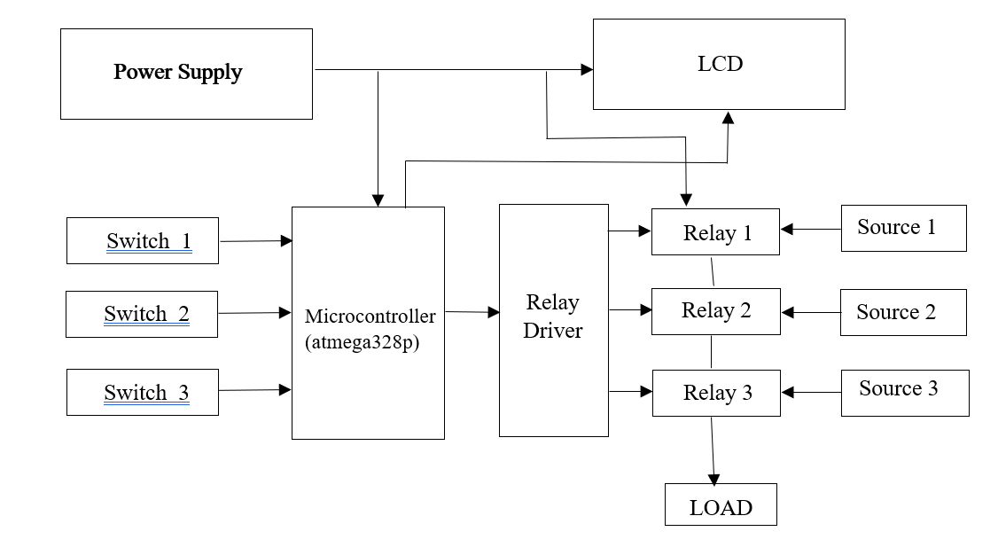**BLOCK DIAGRAM:**

**Figure 1:** Block Diagram

*Power Supply* - Regulated power supply is an electronic circuit that is designed to provide a constant dc voltage of predetermined value across load terminals irrespective of ac mains fluctuations or load variations So, a regulated power supply system takes the unregulated alternating or AC power and provides a regulated DC power supply. So, this involves voltage step down, rectification, filtration, and regulation. In this it provides 5v to microcontroller, LCD & 12v to relays.

*Switches –* These switches are represents the absence of that power supply. If we press the switch it shows that this power supply is not available. It gives Output to Microcontroller.

*Microcontroller -* The microcontroller acts as the central control unit. In this project we used Atmega328p microcontroller. It continuously monitors the status of three different power sources. Based on programmed logic, it decides which power source to use for the load. The microcontroller communicates with a relay driver to activate or deactivate relays, physically connecting or disconnecting power sources accordingly. It takes the input from a three switches. The microcontroller also interfaces with an LCD to display real-time information about the selected power source.

*Relay Driver -* The relay driver serves as an intermediary between the microcontroller(atmega328p) and the relays. It amplifies the low-voltage control signals from the microcontroller, providing the necessary power to activate the relays. The relay driver ensures that the microcontroller can effectively control the relays, allowing them to switch between different power sources. By translating the microcontroller's signals into a form suitable for relay activation, the relay driver plays a crucial role in the automated management of power sources in the system.

*Relays -* In this project, relays serve as switches controlled by the microcontroller. Each relay corresponds to one of the three power sources. The microcontroller, based on its programming and sensor inputs, activates or deactivates relays to physically connect or disconnect the power sources from the load. This relay-controlled switching mechanism enables the system to seamlessly transfer the load to a different power source as needed, ensuring a continuous and reliable power supply.

*LCD –* The LCD (Liquid Crystal Display) serves as the user interface. We use 16x2 LCD in project. The microcontroller communicates with the LCD to display real-time information about the status of the power sources and the overall system. The LCD provides a visual representation of the selected power source. Users can easily monitor the operation of the automatic power supply system through the displayed information.

* 1. 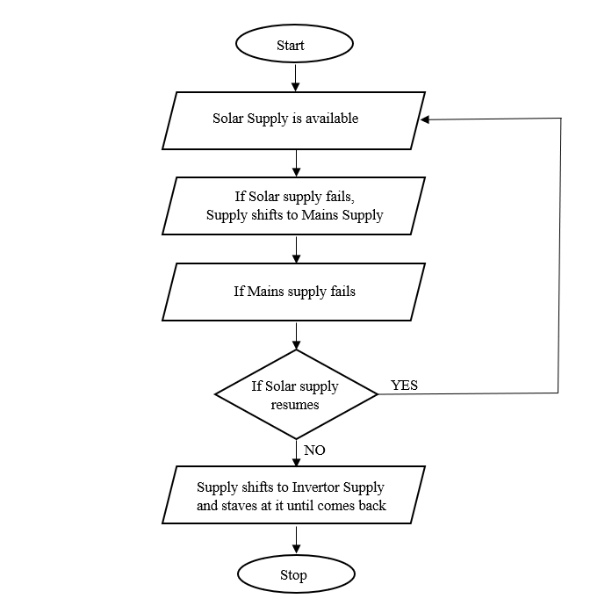**FLOW CHART:**

**Figure 2:** Flow Chart

1. 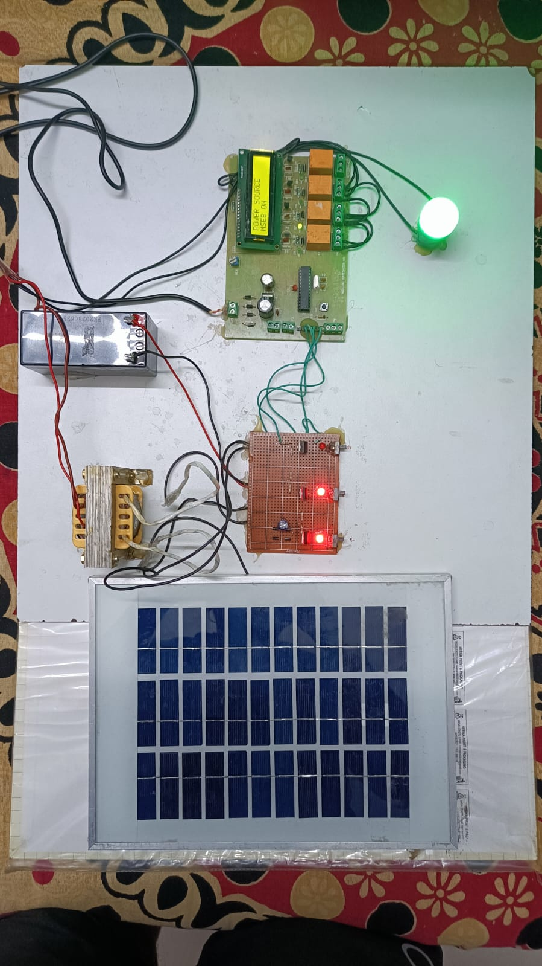**RESULT**

**Figure 3:** Result

1. **CONCLUSION**

This Project is used to handle power supply from Solar, Mains & Invertor most effectively. The outline of the project is the selection of supply from mains, solar & invertor automatically using microcontroller concept. The significance of this project lies in the various and wide places of applications such as; schools, offices, hospitals, and most especially manufacturing industries and mining industries where a continuous supply of power is vital.

1. **REFERENCES**
2. L S Ezema, B U Peter, O O Haris (2003). “Design Of Automatic Change Over Switch With Generator Control Mechanism”, 3(3), ISSN: 2223- 9944
3. Mbaocha Christian (2012). Smart Phase Change-Over System With AT89C52 Microcontroller. IOSR Journal Of Electrical And Electronics Engineering (IOSRJEEE), ISSN: 2278-1676
4. Mr.Shahaji Dudhate, Mr.Amol Attargekar, Mr.Dhanaji Desai, Prof. Mrs.Aditi Patil(2016). “Power Supply Control From Different Sources” International Journal Of Scientific & Engineering Research (IJSER ), 7(1), ISSN 2229-5518
5. Francis E. Idachaba, Joseph O. Olowoleni, Augustus E. Ibhaze (2017). “Design Of An Automatic Renewable Energy Supply And Switching System” Proceedings Of The World Congress On Engineering And Computer Science, San Francisco, USA
6. G. Mahesh1 , A.Vinod Kumar2 , K. Anitha Reddy3 And Y.Sudha4 (2019). “Auto Power Supply Control From Four Different Sources” Journal Of Research In Science, Technology, Engineering And Management (JORSTEM)
7. Jenyfal Sampson, G. Arunsai Kumar, C. Balaji Dileep, G. Vinay Kumar, B. Venkata Kiran (2021). “AUTO POWER SUPPLY CONTROL FROM THREE DIFFERENT SOURCES”, (IJCRT)
8. Abdurrahman Shuaibu Hassan, Ibrahim Adabara, Amanyire Ronald, Kaumba Muteba(Year not provided) “Design And Implementation Of An Automatic Power Supply From Four Different Source Using Microcontroller”