

Research Report: **Comparison of life insurance SBI and ICICI**

**Kunal Kishor**

**(21GSOB1110017)**

**BBA BFSI (09)**

**Professor- Dr Pradeep Chaudhary**

**(School of Business)**

**1. ABSTRACT-**

This comparative analysis of SBI and ICICI Bank reveals significant differences in various aspects such as Deposits, Advances, Investments, Insurances, Net profit, and Total assets. It is evident that SBI operates on a larger scale compared to ICICI Bank, indicating a broader scope of operations and influence in the financial sector.

The banking system plays a crucial role in a country's economic functioning, boasting a large network of branches and offering a diverse range of financial services. India's banking industry is substantial, with State Bank of India (SBI) and ICICI Bank standing out as the two largest banks in the public and private sectors, respectively. Assessing the financial outcomes of these banks is essential for understanding their performance and efficiency, which are integral to the country's financial system.

**2. INTRODUCTION-**

A robust banking system is a fundamental requirement for the economic development of any nation, as it effectively mobilizes people's savings. India's banking system is characterized by a vast network of branches that cater to various financial needs of the population.

**2.1. SBI**

A major player in India's banking sector, operates over 16,000 branches, offering a wide range of banking services not only in India but also internationally, including services tailored for non-resident Indians. Headquartered in Mumbai, SBI has 14 local head offices, 57 zonal offices in key cities across India, and approximately 130 branches outside India. It commands a significant market share among Indian commercial banks, holding about 20% in deposits and loans.

**Keywords**: banking system, economic development, savings mobilization, State Bank of India, branch network, international presence.

**2.2. ICICI**

ICICI Bank is the second-largest private sector bank in India, with 2,552 branches and 7,440 ATMs nationwide. Headquartered in Mumbai, India, it is one of the leading commercial banks in the country, offering a wide range of banking services through various channels. Apart from providing advanced banking facilities such as internet banking, telebanking, and mobile banking, ICICI also plays a significant role in investment banking, venture capital and asset management, and life and non-life insurance. The bank has a global presence in 18 countries, including the United Kingdom, Canada, and Russia.

**Keywords:** branch network, investment banking, insurances, international branches.

**3. Objectives of the study**

* + To compare the economic performance overall of SBI and ICICI.
  + To recognize and compare the profitability of these leading banks.
  + To compare and evaluate the managerial efficiency.
  + To evaluate the difference between types of services.
  + Comparing between life insurances of SBI and ICICI
  + Bring awareness in people for buying various insurances.

**4. Research Methodologies**

**4.1. Primary data (online survey)**

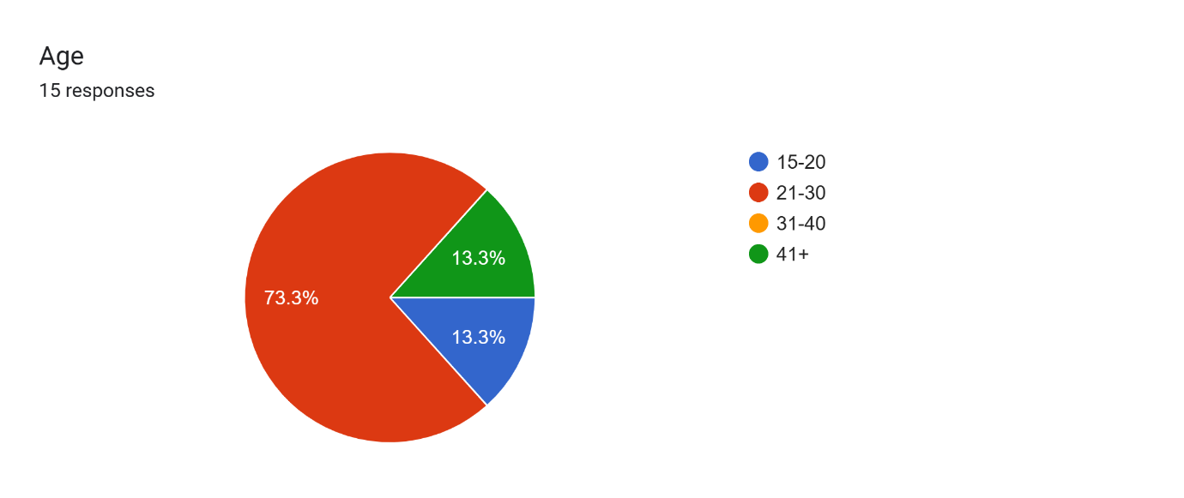

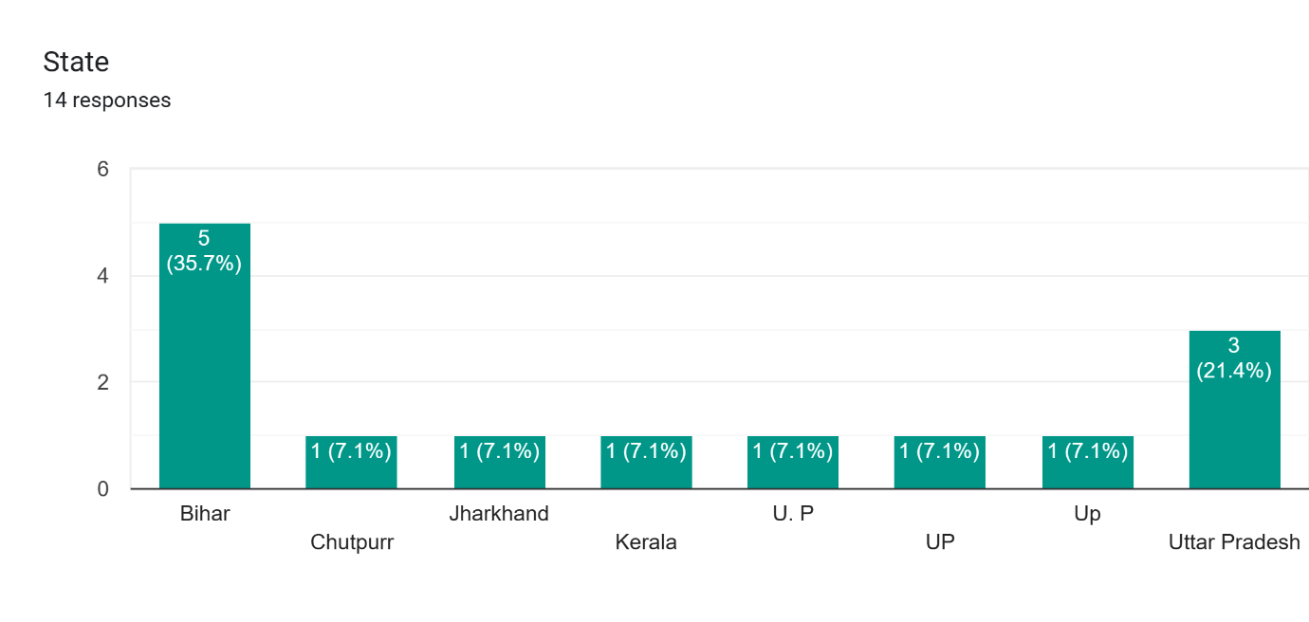

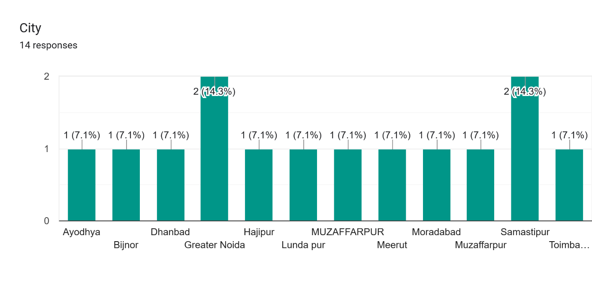

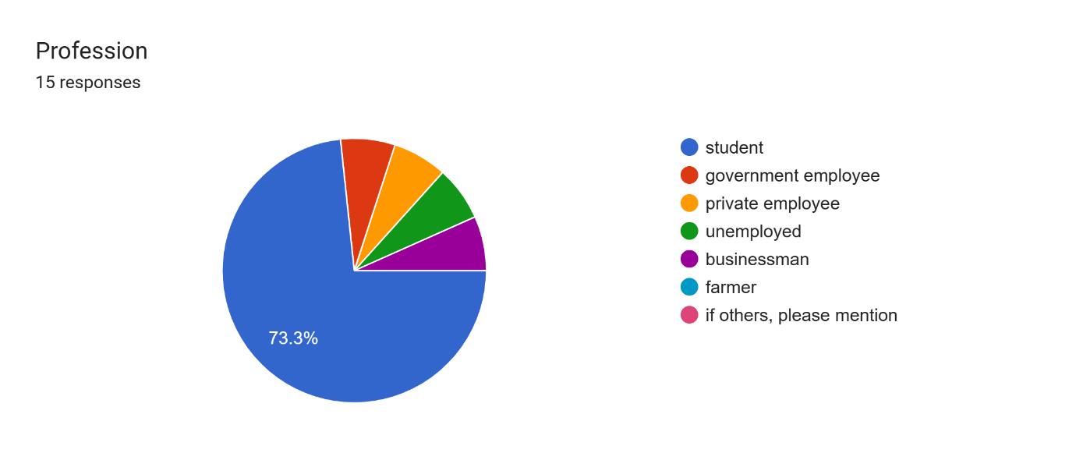

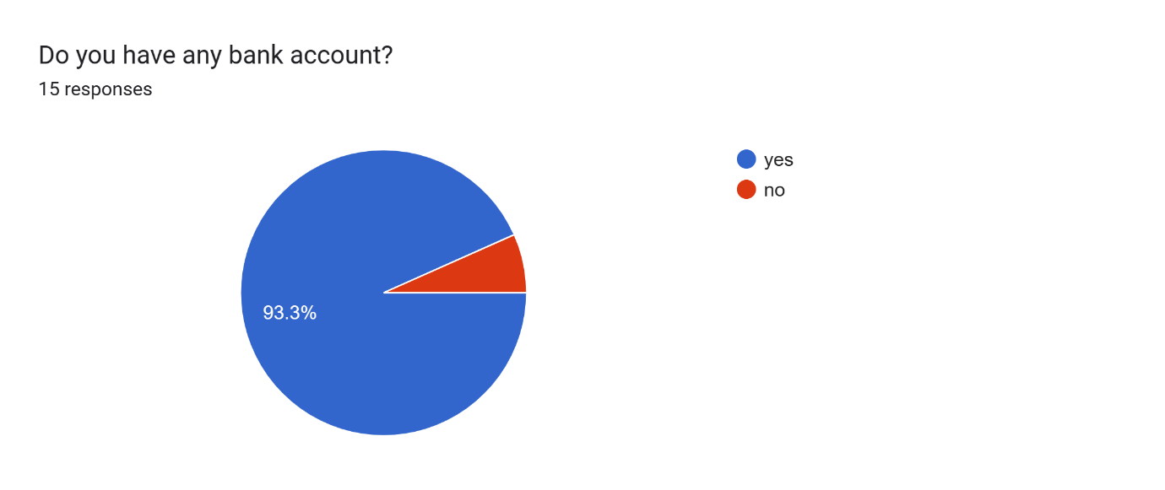

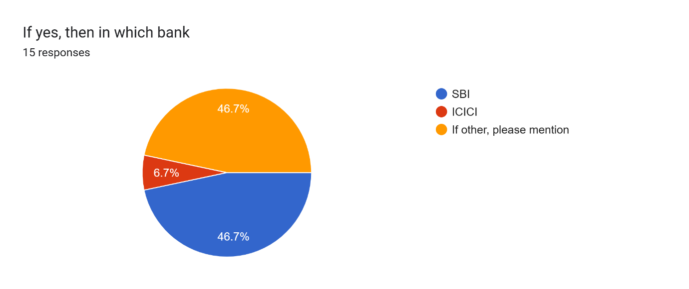

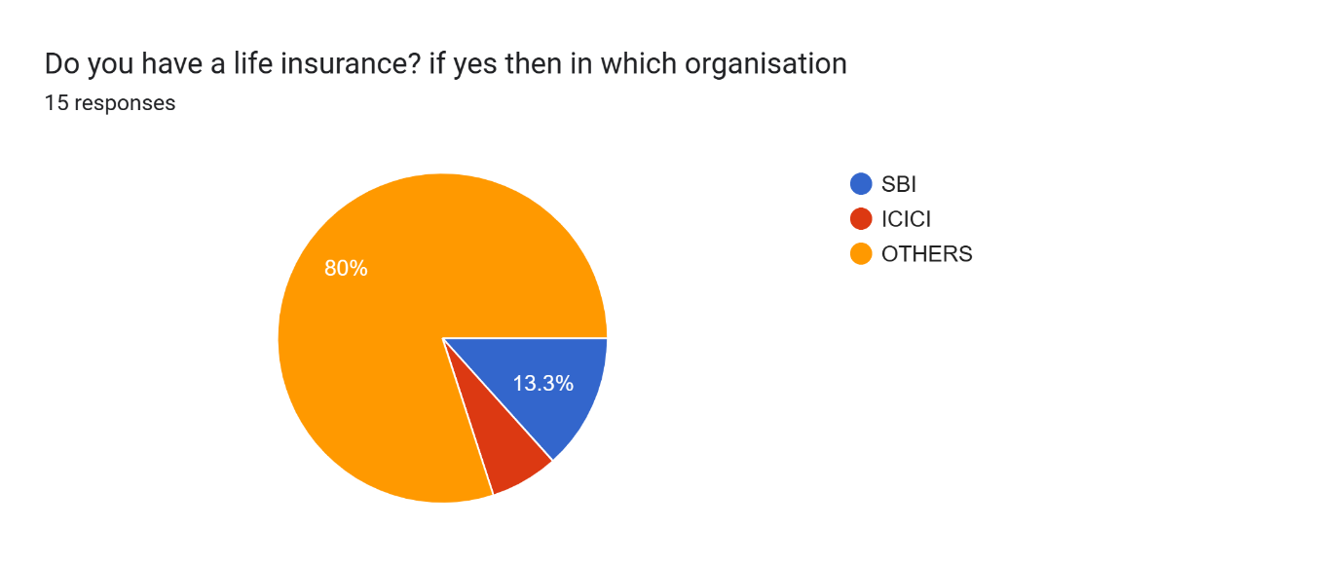

**Taking loan**

**Opening a new bank account**

**4.2. Secondary data**

|  |  |  |  |  |  |  |  |  |
| --- | --- | --- | --- | --- | --- | --- | --- | --- |
| **YEAR** | |  | | --- | | **SBI** | |   (Rs. in CRORE) | | | |  | | --- | | **ICICI**  (Rs in CRORE) | | | | |
|  |
| **NET PROFIT** | **NET SALES** | **NET PROFIT RATIO** | **NET**  **PROFIT** | **NET**  **SALES** | **NET PROFIT**  **RATIO** |  |
|  |
| **2006-07** | 4541.31 | 4637.53 | 9.67 | 3110.22 | 29957.24 | 10.38 |  |
| **2007-08** | 6729.12 | 58348.74 | 11.53 | 4157.73 | 39667.19 | 10.48 |  |
| **2008-09** | 9121.23 | 76479.78 | 11.93 | 3757.55 | 39210.31 | 9.58 |  |
| **2009-10** | 9166.05 | 85962.07 | 10.66 | 4024.98 | 32999.36 | 12.2 |  |
| **2010-11** | 7370.35 | 96329.45 | 7.65 | 5149.21 | 33082.96 | 15.56 |  |
|  | **AVERAGE** | | **10.29** | **AVERAGE** | | **11.64** |  |

This is evident that the Net Profit Ratio of both SBI and ICICI Bank fluctuated during the study period. The highest Net Profit Ratio for SBI was 11.93% in 2008-09, while ICICI Bank reached 15.56% in 2010-11.

TABLE 1.

**Table 2** reveals that during the specified period of analysis, the Operating Profit Ratio of both SBI and ICICI Bank exhibited fluctuations. SBI's highest Operating Profit Ratio occurred in 2008-09 at 19.10%, while ICICI Bank's highest was 22.31% in 2010-11.

|  |  |  |  |  |  |  |  |  |
| --- | --- | --- | --- | --- | --- | --- | --- | --- |
| **YEAR** | |  | | --- | | **SBI**  (Rs. in CRORE) | | | | | |  | | --- | | **ICICI**  Rs in CRORE | | | | |
|  |
| **OPERATING**  **PROFIT** | **NET SALES** | **OPERATING**  **PROFIT RATIO** | **OPERATING**  **PROFIT** | **NET SALES** | **OPERATING**  **PROFIT RATIO** |  |
|  |
| **2006-07** | 7774.36 | 46937.79 | 16.56 | 3793.56 | 29957.24 | 12.66 |  |
| **2007-08** | 10962.9 | 58348.74 | 18.79 | 5706.85 | 39667.19 | 14.39 |  |
| **2008-09** | 14604.94 | 76479.78 | 19.1 | 5407.91 | 39210.31 | 13.79 |  |
| **2009-10** | 14578.54 | 85962.07 | 16.96 | 5552.3 | 32999.36 | 16.82 |  |
| **2010-11** | 16217.24 | 96329.45 | 16.83 | 7380.82 | 33082.96 | 22.31 |  |
|  | **AVERAGE** | | **17.65** | **AVERAGE** | | **15.99** |  |

**5. Conclusion**

The study aimed to assess the financial performance of two Indian life insurance companies, SBI Life Insurance and ICICI Prudential Life Insurance, by analyzing factors influencing their profitability. Given the impact of company performance on the broader economy, empirical analysis is crucial for evaluation. Financial ratios such as Liquidity Ratio, Profitability Ratio, Persistency Ratio, and Solvency Ratio were calculated for this purpose. Additionally, a T-Test was conducted to determine if there was a significant difference in the Current Ratio between SBI Life Insurance and ICICI Prudential Life Insurance.

The findings indicated that SBI Life Insurance possesses a sound liquidity position, while ICICI Prudential Life Insurance faces challenges in financial health. SBI Life Insurance demonstrated better profitability compared to ICICI Prudential Life Insurance. However, there was a decline in Profitability Ratio over the study period, indicating operational efficiency deterioration in both firms. Therefore, immediate corrective actions are necessary to halt this decline.

The Test results revealed a significant difference in the Current Ratio between SBI Life Insurance and ICICI Prudential Life Insurance. Based on these findings, it can be concluded that **SBI Life Insurance is performing better than ICICI Prudential Life Insurance.**

**6. References**

* <https://www.onlinesbi.sbi/>
* <https://www.iciciprulife.com/>
* <https://www.researchgate.net/publication/356555195_A_Comparative_Study_-Financial_Performance_of_State_Bank_Of_India_and_ICICI_Bank_Of_India>