PLEKSUS: INSPECT THE SUSPECT

**Aniket Elinje1, Tejashree Mestry2, Ankush Dubey3, Prof. Janhavi Sangoi4**

**1,2,3**Student, Viva Institute of Technology, Mumbai University, Maharashtra, India.

**4**Professor, Viva Institute of Technology, Mumbai University, Maharashtra, India.

**ABSTRACT**

The PLEKSUS: INSPECT THE SUSPECT is a revolutionary tool in law enforcement, embodying cutting-edge innovation with its advanced image deblurring technology. This state-of-the-art solution enhances the clarity of surveillance footage, significantly improving facial recognition accuracy and expediting image matching with extensive databases. Operating seamlessly in real-time, Smart Eyes on the Horizon is crucial for proactive crime prevention, enabling law enforcement to anticipate and respond swiftly to emerging threats, staying ahead in the evolving criminal landscape. Its user-friendly interface, scalability, and customizable features make it widely adopted among law enforcement agencies. In addition to enhancing image quality, it excels in accurately identifying suspects, particularly in detecting violent incidents. This versatile tool is not just a technological asset but also a strategic ally that strengthens law enforcement capabilities in protecting communities. Moreover, Pleksus represents a significant advancement in law enforcement technology, meeting the escalating demand for enhanced capabilities while prioritizing privacy and cost-effectiveness. By providing officers with exceptional image deblurring capabilities, it enables more effective incident response, contributing to the goal of creating safer communities. Ultimately, Pleksus symbolizes the ongoing evolution of law enforcement technology, combining precision and efficiency for societal benefit. It not only demonstrates technological prowess but also underscores a commitment to a safer and more secure future.

**Keywords:** Advanced image deblurring, Cutting-edge innovation, Databases, Facial recognition, Law enforcement, Privacy, Proactive crime prevention, Rapid responses, Real-time, Safer communities, Scalability, Surveillance footage, Suspect identification, User-friendly interface, Violence detection.

1. **INTRODUCTION**

In an age where ensuring public safety is of utmost importance, technological progress plays a crucial role in aiding law enforcement agencies in preventing and addressing violent acts. One significant advancement is the creation of a violence detection system that incorporates image enhancement and database matching features. This report delves into the multifaceted nature of this innovative system, which not only helps identify violent incidents but also improves suspect identification through advanced image processing and database integration. Acts of violence, ranging from physical altercations to terrorist activities, pose a continual threat to society. Surveillance cameras are widely used in public areas to monitor and record potential security risks. However, the effectiveness of these systems is often hindered by poor image quality. Law enforcement agencies face challenges in identifying and responding to violent incidents due to various factors such as motion blur, inadequate lighting, and camera instability, which can make footage unclear and unusable. These obstacles delay the accurate identification of individuals involved and hinder prompt responses to mitigate threats. To address these issues, the system described in this report incorporates cutting-edge image enhancement technology. By reducing motion blur and improving image clarity, this system enables law enforcement agencies to extract crucial information from surveillance footage, facilitating a more accurate assessment of violent incidents and enabling targeted responses. Furthermore, the system goes beyond image enhancement by seamlessly integrating with law enforcement databases, allowing for quick and accurate matching of captured images with existing records. This integrated approach transforms the process of suspect identification, increasing the chances of apprehending individuals involved in violent incidents. By combining image enhancement and database matching, this system offers a comprehensive solution to the complex challenges faced by law enforcement in investigating acts of violence..

1. **REVIEW OF LITERATURE SURVEY**

**2.1 Literature Survey**

The following chapter is a literature survey of the previous research papers and research which gives detailed information about the previous system along with its advantages and disadvantages.

Deisy Chaves, Eduardo Fidalgo, Enrique Alegre, Rocío Alaiz-Rodríguez, Francisco Jáñez- Martino, George Azzopardi (Deisy Chaves, Eduardo Fidalgo, Enrique Alegre, Rocío Alaiz-Rodríguez, Francisco Jáñez- Martino, George Azzopardi 2020)**.** The study delves into the intricate relationship between speed and accuracy in three leading facial recognition systems driven by deep learning. It examines their performance using real-world image datasets like WIDER Face and UFDD, considering various CPUs and GPUs for computation. Additionally, a regression model is developed to predict performance metrics, aiding forensic laboratories in evaluating face detection methods. Experimental findings suggest that resizing images to 25% and 50% of their original sizes on CPUs and GPUs respectively strikes an optimal balance between speed and accuracy. Furthermore, the development of multiple linear regression models facilitates performance assessment with a Mean Absolute Error (MAE) of 0.113, indicating promising prospects for adoption in the forensic industry.

Sujy Han, Tae Bok Lee, Yong Seok Heo (Sujy Han, Tae Bok Lee, Yong Seok Heo 2023). The majority of existing techniques for face deblurring utilize the distribution modeling abilities of generative adversarial networks (GANs) to ensure that the deblurred image follows the distribution of sharp, high-quality images. Within the field of GANs, efforts persist to generate clear and realistic facial images from initially obscured or blurry representations. To address this challenge, attention is directed towards intricately modeling the joint distribution of clear facial images and segmentation label maps. This innovative approach within the GAN framework aims to excel in facial image deblurring, promising exceptional clarity and realism in the final result. The researchers propose a novel approach called the Semantic-Aware Pixel-wise Projection discriminator, designed to capture pixel-label correlations by integrating semantic label map information. This discriminator assesses image authenticity on a per-image basis and produces a detailed map of pixel-wise probabilities, accurately reflecting the realism of individual pixels in the input image. Additionally, they introduce a new concept called prediction-weighted (PW) loss, which fine-tunes the decoder's performance by emphasizing misclassified pixels. This method utilizes pixel-level authenticity assessment maps to dynamically adjust the contribution of each pixel, improving the overall fidelity and coherence of the generated output. Extensive experimental results demonstrate that these techniques outperform other methods in terms of both numerical and qualitative perceptual image quality.

Dilnoza Mamieva, Akmalbek Bobomirzaevich Abdusalomov, Mukhriddin Mukhiddinov, Taeg Keun Whangbo (Dilnoza Mamieva, Akmalbek Bobomirzaevich Abdusalomov, Mukhriddin Mukhiddinov, Taeg Keun Whangbo 2023).The study focuses on enhancing facial detection in challenging environments using deep learning methods. Traditional approaches that rely on manually crafted features struggle with photos taken in uncontrolled conditions. To address these challenges, the study introduces the RetinaNet baseline, a single-stage framework for facial identification. This framework enhances both speed and accuracy through network advancements. Experiments conducted on datasets like WIDER FACE and FDDB demonstrate outstanding results, achieving an average precision (AP) of 41.0 at 11.8 frames per second (FPS) for single-scale inference and 44.2 for multi-scale inference on the WIDER FACE benchmark. The model, developed using PyTorch, achieves a high accuracy rate of 95% in detecting faces. The research also discusses future directions, including handling blurry photos in low-light conditions and enhancing real-time facial emotion recognition using deep learning techniques like 3D CNN, 3D U-Net, and YOLOv. Overall, the proposed approach significantly improves both the accuracy and efficiency of face detection, offering a promising solution for challenging real-world scenarios.

Viktor Denes Huszar, Vamsi Kiram Adhikarla, (Member, IEEE), Imre Negyesi, Csaba Krasznay (Viktor Denes Huszar, Vamsi Kiram Adhikarla, (Member, IEEE), Imre Negyesi, Csaba Krasznay 2023). The study focuses on employing deep learning techniques to enhance the detection of harmful behavior in surveillance videos. By utilizing 3D convolutions and pretrained action recognition models, the method achieves a 2% increase in accuracy while using fewer parameters, and it remains resilient to common compression artifacts. The importance of having comprehensive and diverse datasets for violence detection, as well as ensuring consistent quality across datasets, is emphasized. Analyses across different datasets reveal variations in model performance, leading to efforts aimed at constructing large-scale datasets that include real-world surveillance footage. Additionally, the research introduces a lightweight computational architecture suitable for practical surveillance applications, with aspirations to better handle scenarios involving events spanning multiple video segments in the future. Overall, this study contributes to the advancement of violence detection technologies for real-world surveillance applications.

Shivalila Hangaragi, Tripty Singh, Neelima N (Shivalila Hangaragi, Tripty Singh, Neelima N 2023). The research delves into the areas of face detection and recognition, key domains in computer vision and deep learning with extensive applications including security, access control, and database identification. A model incorporating Face Mesh is proposed, facilitating strong performance in various scenarios characterized by differing lighting conditions, backgrounds, and accommodating non-frontal facial images across different demographics. Training the model involves utilizing a blend of images sourced from the Labeled Wild Face (LWF) dataset and real-time captures. During testing, the model matches facial landmarks to training images for recognition, assigning unrecognized faces as "unknown." Impressively, the model achieves a notable accuracy rate of 94.23% in facial recognition tasks. Additionally, the report includes experiments evaluating face reconstruction accuracy using the BU3DFE dataset, demonstrating the model's proficiency in recognizing non-frontal faces across diverse populations. Comparative analyses against existing methods underscore its effectiveness, showcasing a strong accuracy of 94.23% in varied testing scenarios.

Raghda Awad Shaban Naseri, Ayça Kurnaz, Hameed Mutlag Farhan (Raghda Awad Shaban Naseri, Ayça Kurnaz, Hameed Mutlag Farhan 2022). The authors present an efficient and precise deep learning-powered face mask identification system tailored for IoT applications in their paper. The primary objective is to facilitate real-time recognition of face masks on IoT devices by leveraging a resource-efficient and optimized face detection model. This model, designed for real-time performance, demonstrates encouraging accuracy and undergoes evaluation based on standard criteria. The study addresses potential challenges and constraints while highlighting the practical significance of their IoT-compatible face mask detection technology in scenarios like public safety and health compliance monitoring, emphasizing its relevance in contemporary contexts.

Nadia Mumtaz, Naveed Ejaz, Shabana Habib, Syed Muhammad Mohsin, Prayag Tiwari, Shahab S. Band, Neeraj Kumar (Nadia Mumtaz, Naveed Ejaz, Shabana Habib, Syed Muhammad Mohsin, Prayag Tiwari, Shahab S. Band, Neeraj Kumar 2022). The study delves into the challenges posed by the extensive volume of Big Video Data generated in smart cities, particularly through surveillance cameras, highlighting the complexity of automating its interpretation effectively. It specifically focuses on Violence Detection (VD) within the broader scope of Movement Recognition, emphasizing the transition from manually crafted features to real-time deep learning-based models. Through an extensive survey, it elucidates various approaches in deep sequence learning and VD localization strategies, as well as earlier image processing techniques and VD literature based on machine learning. The study explores the advantages of simpler methods over complex models in terms of efficiency. It underscores both the achievements and challenges in computer vision related to VD, suggesting a shift from traditional features to robust representations using 2D CNNs and eventually 3D CNNs. While testing results demonstrate the excellent accuracy and precision of VD datasets, the article raises concerns about the suitability of current models for real-world surveillance scenarios characterized by sudden changes. It emphasizes the importance of adapting deep models to dynamic environments and extracting relevant information post-localization to achieve successful VD.

[Tao Wang,](https://arxiv.org/search/cs?searchtype=author&query=Wang%2C%2BT) [Kaihao Zhang](https://arxiv.org/search/cs?searchtype=author&query=Zhang%2C%2BK), [Xuanxi Chen](https://arxiv.org/search/cs?searchtype=author&query=Chen%2C%2BX), [Wenhan Luo](https://arxiv.org/search/cs?searchtype=author&query=Luo%2C%2BW), [Jiankang Deng](https://arxiv.org/search/cs?searchtype=author&query=Deng%2C%2BJ), [Tong Lu](https://arxiv.org/search/cs?searchtype=author&query=Lu%2C%2BT), [Xiaochun](https://arxiv.org/search/cs?searchtype=author&query=Cao%2C%2BX) [Cao](https://arxiv.org/search/cs?searchtype=author&query=Cao%2C%2BX), [Wei Liu,](https://arxiv.org/search/cs?searchtype=author&query=Liu%2C%2BW) [Hongdong Li](https://arxiv.org/search/cs?searchtype=author&query=Li%2C%2BH), [Stefanos Zafeiriou](https://arxiv.org/search/cs?searchtype=author&query=Zafeiriou%2C%2BS) (Tao Wang, Kaihao Zhang, Xuanxi Chen, Wenhan Luo, Jiankang Deng, Tong Lu, Xiaochun Cao, Wei Liu, Hongdong Li, Stefanos Zafeiriou 2022). The work provides an in-depth examination of the evolution of Face Restoration (FR) techniques, from early methods based on probabilistic assumptions and models to modern deep learning-based approaches in the area of low-level computer vision. The study begins by presenting alternative problem formulations and the distinguishing features of face photos. It discusses the issues of face restoration before providing a full evaluation of FR methods that include both prior-based and deep learning-based methodologies. Deep learning approaches are evaluated in terms of network designs, loss functions, and benchmark datasets. In addition, the research performs a comprehensive benchmark evaluation of representative FR approaches. Finally, the research not only covers the subject of face restoration systematically, but it also identifies future approaches, such as network architecture, metrics, benchmark datasets, and potential applications in this domain.

Zhengwei Zhu, Yushi Lei, Yilin Qin, Chenyang Zhu, Yangping Zhu (Zhengwei Zhu, Yushi Lei, Yilin Qin, Chenyang Zhu, Yangping Zhu 2023). The study introduces an enhanced deep learning-based model for Super-Resolution (SR), aiming to improve low-resolution (LR) images. The model, building upon Real-ESRGAN, addresses issues like excessive smoothness and lack of texture. By transitioning from High-Dimensional Modeling (HDM) to second-order degenerate modeling and using the SmoothL1 loss function, it achieves faster convergence and better texture preservation. Comparative experiments against five models show superior performance in generating high-quality images with enhanced texture detail and lower distortion metrics.

Tae Bok Lee, Sujy Han, Yong Seok Heo (TAE BOK LEE, SUJY HAN, YONG SEOK HEO 2022). Facial motion deblurring for individual images is a crucial yet specialized area in image deblurring, focusing on restoring sharpness in motion-blurred facial images. Deep neural networks have become pivotal tools in image restoration, particularly in single-image face deblurring, showing remarkable effectiveness. However, many existing methods aim to recover only a single sharp image from a motion-blurred facial image, neglecting the broader context of capturing aggregated sharp moments during exposure. Our goal is to restore output images conditioned on continuous control factors, addressing this temporal ambiguity. We introduce the facial motion-based reordering (FMR) process to mitigate temporal ambiguity by utilizing human facial information. We propose CFMD-GAN, a novel framework for persistent facial motion deblurring achieved through a unified network and training process. By incorporating FMR, we ensure a stable learning process by integrating domain-specific facial knowledge. We describe the key components of CFMD-GAN, designed to recover the continuous moment latent in a blurry facial image via a moment control factor. The dataset comprises high-quality facial videos captured in real-world scenarios, and blurry images are synthesized by averaging various consecutive sharp frames, similar to recent motion deblurring studies. Performance evaluation involves metrics such as PSNR, SSIM, and facial identity distance measured via ArcFace. This research introduces a new frontier in image restoration, offering opportunities for further refinement and innovation in integrating diverse facial priors.

Archana Tomar, Harish Patidar (Archana Tomar and Harish Patidar 2023). In today's diverse landscape, there is a growing demand for high-quality imagery in various fields such as medical imaging, satellite observation, and multimedia. Image super-resolution plays a vital role in reconstructing high-resolution images from low-resolution ones. Deep Convolutional Neural Networks (DCNNs) have shown great promise in this task, as they are capable of learning intricate patterns and relationships within images. Our research is focused on developing a specialized DCNN architecture specifically for image super-resolution. Through supervised learning, the network is trained to generate high-resolution outputs from low-resolution inputs. Experimental results demonstrate the superior performance of our DCNN compared to existing methods, consistently improving metrics such as PSNR and SSIM. In conclusion, our DCNN represents a significant advancement in image super-resolution, effectively enhancing image quality and preserving details.

Tong Han, Li Zhao, Chuang Wang (Tong Han, Li Zhao, Chuang Wang 2023). The need for high-quality imagery is evident in medical diagnostics, satellite surveillance, and multimedia applications. Super resolution technology, utilizing Deep Convolutional Neural Networks (DCNNs), aims to improve image resolution by overcoming traditional limitations. Our research focuses on developing a specialized DCNN architecture for image super-resolution, addressing challenges like blurred and low-quality images. Various approaches, such as SRGAN and PULSE, offer different benefits in enhancing image resolution. Future advancements may involve the integration of advanced loss functions and the development of lightweight models. Furthermore, optimizing video enhancement algorithms shows promise in improving video quality across multiple platforms. In conclusion, researchers aim to advance image enhancement through deep learning techniques, striving to provide users with exceptional visual experiences across a wide range of applications and platforms.

Zhiwei Yang, Yunyan Wang (Zhiwei Yang and Yunyan Wang 2021). Deep learning has transformed image reconstruction, with generative adversarial networks (GANs) leading the way in image resolution enhancement. Hierarchical feature learning algorithms, which combine recurrent neural networks (RNNs), GANs, and dense convolutional networks, excel in reconstructing high-resolution images. The proposed modified SRGAN network leverages stacked convolutions and activation functions to improve remote sensing imagery. By refining object judgment criteria and integrating characteristic values, it surpasses the original structure, resulting in enhanced resolution and clarity. Training on the AID dataset and refining adversarial loss through discriminant network comparison further improves the results. This paper introduces a modified SRGAN network for reconstructing high-resolution remote sensing data, demonstrating improvements over the original structure. The replacement of normalization layers with residual error, refinement of object judgment criteria, and incorporation of characteristic values to enhance sensory loss all contribute to the enhanced outcomes.

Leese, Matthias (Leese, Matthias 2022). This paper investigates the methods of data collection and analysis employed by police departments, focusing on the intersection of technology, data-driven strategies, and crime prevention tactics. The research, conducted over several years, explores how police departments gather, process, and utilize data to inform their operational decisions. Key findings include the rise of data-driven managerialism within police departments, characterized by a shift towards using large volumes of data for crime analysis and prevention. The paper stresses the importance of understanding the socio-technical aspects of data practices, emphasizing that data are not impartial representations of reality but are shaped by social factors. The analysis demonstrates that predictive policing aims to anticipate future criminal activity and implement targeted prevention measures. A notable tool in this field is PRECOBS, which utilizes advanced algorithms and historical crime data to predict "near-repeat" crimes. This acronym, derived from "Pre Crime Observation System," marks a significant advancement in law enforcement technology, providing proactive insights into potential criminal activity based on past patterns. For example, the PRECOBS algorithm identifies patterns in crime data to estimate spatio-temporal risk factors for burglary. The paper underscores the importance of data quality control, as crime data are regularly updated and corrected to ensure accuracy and completeness. It explores how digital interfaces streamline data collection processes and ensure completeness, which is vital for effective predictive policing. Moreover, the paper emphasizes a practice-oriented perspective, highlighting how social reality is shaped through data practices. It argues against dystopian views of technology-driven policing, advocating for a nuanced understanding of the interaction between data, algorithms, and human agency. Overall, the paper contributes valuable insights to the broader discussion on crime, data, and policing by shedding light on the complexities of contemporary data-driven approaches and their implications for law enforcement strategies.

Arjun Menon, Kumari Shivani Singh, Raushan Kumar, Ritvik Sethi, Abha Kiran Rajpoot (Arjun Menon, Kumari Shivani Singh, Raushan Kumar, Ritvik Sethi, Abha Kiran 2023). This article discusses the limitations of traditional methods in criminal detection and proposes facial recognition technology as a viable solution. It outlines the drawbacks of relying on physical evidence and highlights the potential of facial recognition to automate and enhance the identification process. Facial recognition technology employs automated techniques to extract and analyze facial features, enabling swift and precise identification of individuals. Unlike conventional methods dependent on physical traces, facial recognition can promptly issue alerts even if individuals attempt to conceal their identities. Fueled by artificial intelligence and deep learning algorithms, facial recognition technology can overcome challenges like disguises or obscured faces, providing law enforcement with an effective tool for crime detection. Its efficiency and speed make it increasingly attractive to police departments worldwide. The article emphasizes the importance of data integrity, security, and traceability in criminal identification systems, with facial recognition offering advancements in these areas. By automating the process and leveraging AI capabilities, facial recognition technology offers a promising solution to the persistent challenge of criminal detection. Overall, the article advocates for the adoption of facial recognition technology as a transformative tool in law enforcement, promising improved efficiency, accuracy, and adaptability in identifying and apprehending criminals.

1. **ANALYSIS TABLE**

|  |  |  |  |
| --- | --- | --- | --- |
| **Title** | **Summary** | **Advantages** | **TechStack** |
| Assessment and Estimation of Face Detection Performance Based on Deep Learning for Forensic Applications [1] | This study explores the use of face recognition in criminal investigations, focusing on challenges and benefits. It evaluates three deep-learning- based face detection models for speed and accuracy on various hardware setups. Also introduces a regression model to estimate performance with a low Mean Absolute Error (MAE) of 0.113. | By addressing the challenges of working with low- quality images from real-world scenarios, the research contributes to the development of more robust face recognition systems capable of handling difficult conditions. | MTCNN,  PyramidBox, DSFD |
| Semantic-Aware Face Deblurring With Pixel-Wise Projection Discriminator [2] | The face deblurring advancements use GANs to enhance sharpness. A new approach combines sharp face images and segmentation labels in GANs. A semantic-aware SAPP discriminator for pixel-label matching and a prediction-weighted loss for pixel importance. Training starts coarse and goes fine for global and local focus. This method outperforms existing  techniques | The method yields enhanced perceptual image quality, surpassing existing techniques. This means that the deblurred face images are more visually appealing and faithful to the original  sharp images. | Generative adversarial networks (GANs) , Semantic-aware pixel-wise projection (SAPP) |
| Improved Face Detection Method via Learning Small Faces on Hard Images Based on a Deep Learning Approach [3] | The evolution of facial recognition from manual techniques to deep learning-based face detection. A single-stage face detector called RetinaNet baseline, which enhances detection speed and accuracy. The method achieves competitive results on benchmark datasets, particularly with multi- scale inference. Implemented in PyTorch, achieves a high accuracy of 95.6% in successfully detected faces, outperforming existing methods in both detection  and recognition tasks. | The method leverages deep learning to achieve significantly improved accuracy in face detection, which is crucial for various applications, including facial recognition and analysis. | Retina net baseline, a single- stage face detector |
| Toward Fast and Accurate Violence Detection for Automated Video Surveillance Applications [4] | The challenge of automated violence detection in CCTV videos, driven by the difficulty of analyzing the vast amount of video data in real-time Utilizing intelligent networks enhanced by 3D convolutions, the system adeptly assimilates spatial intricacies and temporal dynamics within the video footage. Utilized to enhance efficiency and accuracy. The approach is evaluated on diverse public datasets, outperforming existing methods by approximately 2% in accuracy with fewer model parameters. It also shows robustness in handling common compression artifacts. | Despite its improved accuracy, the approach requires fewer model parameters, making  it more efficient in terms of computational resources and memory usage. | Anomaly detection, Anomaly localization, Automated video surveillance |
| Face Detection and Recognition Using Face Mesh and Deep Neural Network [5] | This survey paper presents a novel approach to detecting and recognizing faces by leveraging Face Mesh technology.. It has various practical applications, including identifying people in specific locations, checking against police databases, and controlling access to restricted areas. The model is robust, working well in different conditions and with various demographics. It's trained on diverse datasets and achieves an impressive 94.23% accuracy in face recognition. | The model demonstrates robust performance, functioning effectively under varying conditions, including changes in illumination and background. It can also handle non- frontal images of individuals of different genders, ages, and races. | Neural Network;  Face mesh landmarks. |
| Optimized face detector-based intelligent face  mask detection model in IoT using deep learning approach [6] | This study introduces an advanced model using IoT for automated mask  identification. It optimizes key parameters through a novel algorithm called ASMFO and achieves remarkable accuracy improvements in face detection and mask classification. Compared to conventional methods, it significantly outperforms with high effect for accurate mask detection, particularly in public health contexts. | By using SSD and a hybrid deep  Learning approach, the model employs state-of-the-art technology for face detection and mask classification, ensuring accuracy and efficiency. | Single Shot Multi- box Detector (SSD). |
| An Overview of  Violence Detection Techniques: Current Challenges and Future Directions [7] | The proliferation of surveillance cameras in smart cities led to a massive volume of video data, making automated analysis a challenging task. Violence Detection is essential for identifying unusual human actions in this data. Traditional VD relies on manual features, but deep learning-based models are gaining prominence. This paper provides an overview of deep sequence learning and localization strategies in VD, as well as earlier image processing and machine learning approaches | Deep learning- based models mentioned in the overview can facilitate real-time VD analysis, allowing swift detection of violent incidents, which is crucial for ensuring public safety. | Big Video data, Deep Learning for VD. |
| A Survey of Deep Face  Restoration: Denoise, Super- Resolution, Deblur, Artifact Removal [8] | Face Restoration (FR), which enhances low- quality face images to high-quality ones. Traditional methods had limitations, but recent advances in deep learning have improved FR significantly. The paper provides a comprehensive survey of deep learning techniques for FR, covering problem formulations, challenges, methods, network architectures, loss functions, and benchmark evaluations. It also discusses future directions and offers an open-source repository for the discussed methods. | The shift from traditional methods to deep- learning based approaches addresses the limitations of FR for real-world applications, where the quality of input images can vary significantly | Face restoration,  Deep learning,  Face deblurring,  Face denoising. |
| IRE: Improved Image Super-Resolution Based on Real-ESRGAN [9] | It introduces an enhanced model of Real-ESRGAN, a deep learning technique for Image Super-Resolution, aiming to address issues of smoothness and texture lack in reconstructed images. It employs High-Dimensional Modeling initially but transitions to second-order degenerate modeling, utilizing SmoothL1 loss function and PatchGAN discriminator. The model, trained on 256x256-pixel input images with kernel size of 3, outperforms traditional metrics across five test datasets, demonstrating superior texture detail and lower distortion. The proposed method surpasses benchmarks like BSRGAN in both qualitative and quantitative assessments, showcasing its advancements in image quality. | Enhanced texture detail and reduced distortion in reconstructed images. | Deep Learning , Real-ESRGAN, High-Dimensional Modeling (HDM),SmoothL1 Loss Function, ZatchGAN Discriminator. |
| Continuous Facial Motion Deblurring [10] | The CFMD-GAN framework heralds a pioneering approach to address the challenge of continuous facial motion deblurring. Its primary objective is the revitalization of clarity within facial images marred by motion blur through the adept utilization of deep neural networks.. By introducing the facial motion-based reordering (FMR) process, the model addresses temporal ambiguity and ensures stable learning through domain-specific facial knowledge. CFMD-GAN stands as the pioneering endeavor in single-to-video face deblurring, offering significant advancements in image restoration and paving the way for future research in continuous facial motion deblurring. | 1. Restoration of continuous sharp moments from single motion-blurred facial images.  2. Mitigation of temporal ambiguity through facial motion-based reordering. | Deep Learning, Generative Adversarial Networks (GANs), Facial Motion-Based Reordering (FMR), Image Restoration Techniques, Python Programming Language,  TensorFlow or PyTorch Frameworks. |
| Enhancing image super-resolution with deep convolutional neural networks [11] | This research introduces a specialized Deep Convolutional Neural Network (DCNN) architecture for image super-resolution, leveraging its ability to learn complex mappings between low and high-resolution image spaces. Through supervised learning on paired datasets, the DCNN consistently outperforms existing methods like SRCNN, ESRGAN, and SRGAN, showcasing significant improvements in metrics like PSNR and SSI. The proposed DCNN architecture demonstrates proficiency in preserving image fidelity and reducing reconstruction errors, marking substantial advancements in image super-resolution. | 1. Specialized DCNN architecture tailored explicitly for image super-resolution.  2. Comprehensive evaluation across multiple datasets and evaluation metrics affirm the method's robustness and versatility. | Deep Convolutional Neural Networks (DCNN), Supervised Learning. |
| Research on Super-resolution Image Based on Deep Learning [12] | Exploring the domain of image super-resolution, utilizing Deep Convolutional Neural Networks (DCNNs) to enhance image resolution across various applications. By leveraging DCNNs' ability to learn intricate patterns, specialized architectures are developed to overcome challenges like blurred images and low quality. Different approaches, such as SRCNN, SRGAN, and PULSE, offer distinct advantages in enhancing image resolution, with future advancements focusing on sophisticated loss functions and lightweight models. | 1. Utilizes Deep Convolutional Neural Networks (DCNNs) for image super-resolution, enabling the enhancement of image resolution across diverse domains.  2. Specialized DCNN architectures tailored explicitly for image super-resolution address challenges like blurred images and low quality. | Deep Convolutional Neural Networks (DCNNs), Convolutional Neural Network (CNN) Models, Generative Adversarial Networks (GANs), Supervised and Self-supervised Learning. |
| Image Enhancement and Improvement Algorithm Based on Esrgan Singal Frame Remote Sensing Image [13] | Presenting advancements in high-resolution remote sensing image reconstruction using a modified SRGAN network. Leveraging generative adversarial networks (GANs) and hierarchical feature learning algorithms, the proposed model enhances resolution and clarity compared to the original structure. Key modifications include replacing normalization layers with residual error, refining object judgment criteria, and incorporating characteristic values to enhance sensory loss. Training on the AID dataset and calibrating adversarial loss through discriminant network comparison further refine the results, promising significant advancements in remote sensing image super-resolution. | 1. Utilizes a modified SRGAN network for reconstructing high-resolution remote sensing data, showcasing enhancements over the original structure.  2. Incorporates generative adversarial networks (GANs) and hierarchical feature learning algorithms to improve resolution and clarity. | Generative Adversarial Networks (GANs),  Recurrent Neural Networks (RNNs),  Dense Convolutional Neural Networks. |
| Enacting criminal futures: data practices and crime prevention[14] | This paper investigates data practices in police departments, highlighting the shift towards data-driven managerialism and the emergence of predictive policing. Key findings include the socio-technical nature of data practices, emphasizing their social construction and importance in crime prevention. The study underscores the significance of data quality control and the role of digital interfaces in streamlining data collection for predictive policing. It advocates for a nuanced understanding of technology-driven policing and human agency. | 1. Offers insights into data-driven approaches in law enforcement, enhancing crime analysis and prevention strategies.  2. Emphasizes the socio-technical aspects of data practices, highlighting their social construction and implications for policing. | Predictive policing software like PRECOBS (Pre Crime Observation System), Algorithms for crime data analysis,  Digital interfaces for data collection and quality control. |
| Leveraging Facial Recognition Technology in Criminal Identification [15] | This article promotes facial recognition technology as a solution to the challenges faced by traditional criminal detection methods. It highlights the speed, accuracy, and automation capabilities of facial recognition, enabled by artificial intelligence and deep learning algorithms. Advantages include rapid identification of individuals, even when disguises are used, and advancements in data integrity, security, and traceability. | 1. Speed and accuracy: Facial recognition technology offers rapid and accurate identification of individuals, enhancing law enforcement efficiency.  2. Automation: Automated techniques extract and analyze facial characteristics, reducing reliance on physical evidence and manual processes. | Artificial intelligence,  Deep learning algorithms, Facial recognition software and systems. |

**2.1 RESEARCH METHODOLOGY**

The methodology for implementing the PLEKSUS:INSPECT THE SUSPECT integrates both frontend and backend processes to create a robust solution addressing identified challenges and objectives. Leveraging CNN, LSTM, image enhancement and HaarCascade classifiers, the system utilizes advanced computer vision techniques for real-time violent motion detection, image deblurring and face detection for database matching.

**Frontend Implementation:** User Interface Design: Design an intuitive interface allowing seamless interaction with the system, incorporating features such as real-time motion detection display, screenshot capture confirmation, andnotification settings.

**Live Video Feed Integration:** Integrate functionality to capture live video feeds from surveillance cameras directly into the UI, ensuring smooth streaming and real-time display of motion events.

**Motion Detection Confirmation:** Implement frontend processes to confirm and capture screenshots upon detecting motion in the live video feed, providing visual feedback to users.

**Image Deblurring:** Integrate pre-processing techniques in the frontend to deblur captured screenshots, enhancing image clarity and quality for further analysis.

**Email Notification:** Develop frontend functionalities to send deblurred screenshots via email to designated recipients, such as law enforcement authorities, upon motion detection events.

**Backend Implementation:** System Initialization: Develop backend processes to initialize the system, establishing connections with surveillance cameras for live video feed capture and email services for notification.

**Motion Detection:** Utilize libraries and difference neural network technologies to implement backend algorithms for motion detection in captured video frames, processing the feed in real-time and triggering screenshot capture events.

**Image Deblurring:** Implement backend algorithms to deblur captured screenshots using image processing techniques, enhancing image quality for database matching.

**Face Detection:** Integrate HaarCascade classifiers in the backend for face and person detection, utilizing trained models to identify faces and individuals within frames.

**Database Management:** Develop backend functionalities to manage the database, including user registration, image storage, and matching processes.

**New User Registration:** Create backend processes for registering new users, collecting their personal information, and storing their images in the database.

**Image Matching:** Integrate database matching algorithms to compare mailed images with existing database entries, identifying any matches or new entries.

**Result Display:** Develop backend functionalities to display the details of detected individuals, including name and other relevant information, on the frontend interface.

**3.1 Block Diagram**

A block diagram is a diagram of a system in which the principal parts or functions are represented by blocks connected by lines that show the relationships of the blocks.

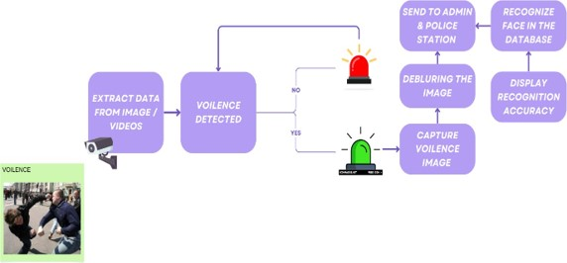

Fig 3.1 Block Diagram

Figure 1: Represents how the system will work. The videos and images captured by the surveillance cameras will be checked and if violence is detected the image will be captured. This image will be deblurred and will be sent to the admin and the police station. The officers will use the deblurred image and check the faces in the database.

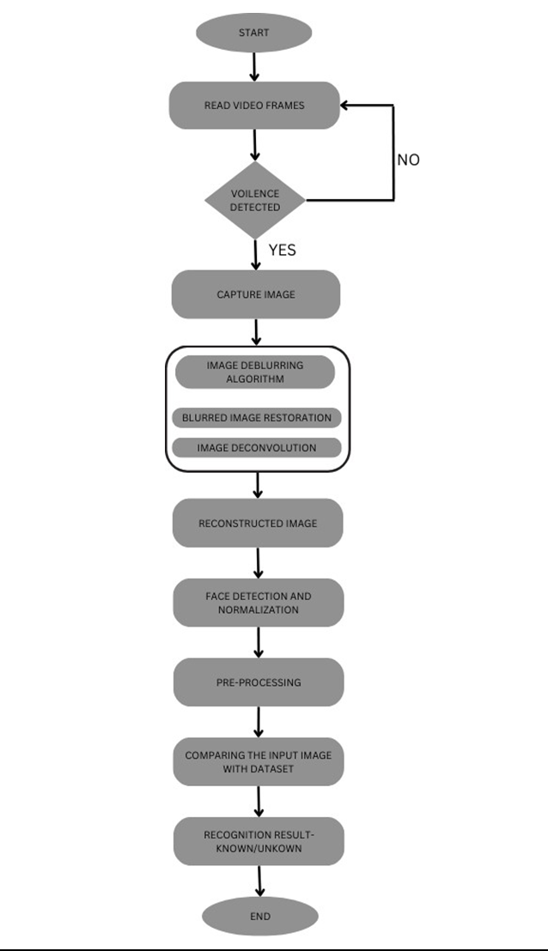

Figure 3.2 System Flow Diagram

Figure 3.2 represents the flowchart of our system. It shows how the data will flow in the system and how the system will work.

1. **RESULTS AND DISCUSSION**

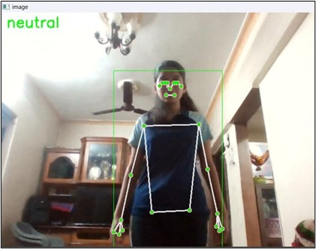

Fig. 4.1: Neutral Image(No violence Detected)

The figure 4.1 Represents a neutral image. The depicted image exhibits no signs of violent activity, and the neutral function operates efficiently when no such activity is detected.

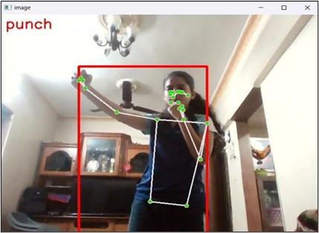

Fig. 4.2: Punch Image(Violence Detected)

The figure 4.2, Represents a punch image. The depicted scene displays indications of violent activity, and the punch function effectively triggers when a punch is detected.



Fig. 4.3: Screenshot of punch

The figure 4.3, displays the screenshots that are taken when the punch motion is detected by the surveillance systems.

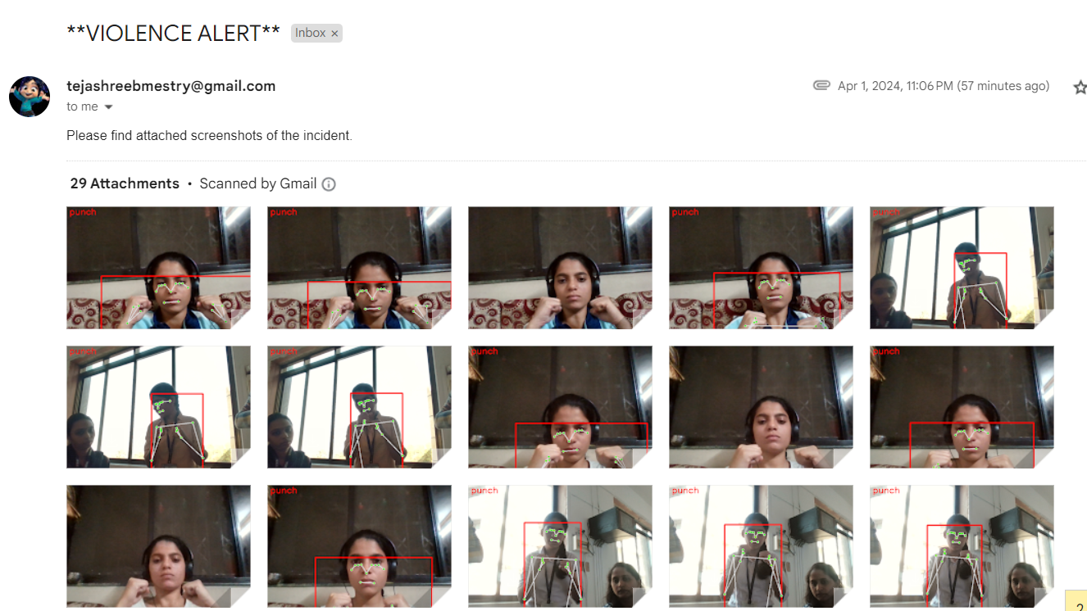

Fig. 4.4: Mail sent when Violence detected

The figure 4.4, it illustrates the process when the mail is sent to the desired receivers as soon as the punch motion or violence is detected.

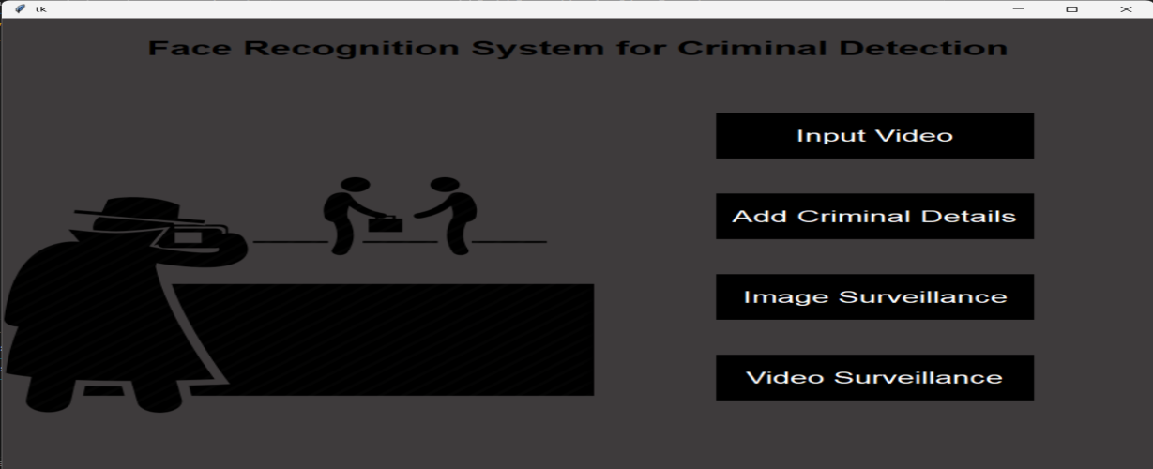

Fig. 4.5: GUI for Face Recognition System

The figure 4.5, illustrates the Facial Recognition System for Criminal Detection, showcasing its interface and functionality for adding criminal details, input videos, image surveillance and video surveillance.

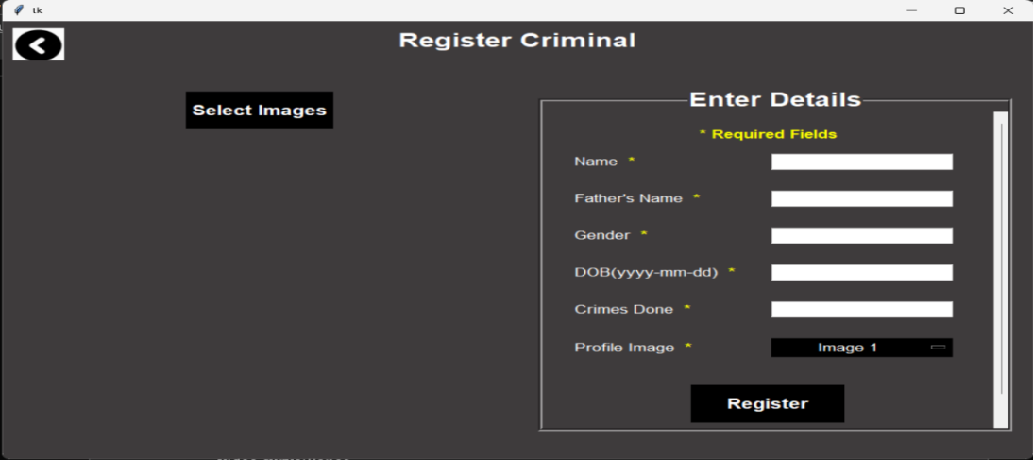

Fig. 4.6: Register Criminal Page

The figure 4.6, depicts the interface for Registering Criminals and the details after clicking on add criminal details from fig 4.5 this page will appear. Enter the details, select at least 5 images and then click on register.

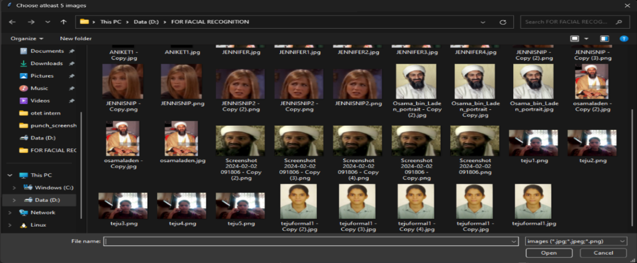

Fig 4.7: Images Folder and Video Folder

The figure 4.7, depicts the image and video folder where the mailed images are stored, from where 5 images has to be selected of the person that has to be registered.



Fig 4.8: Registration Successful

The figure 4.8, depicts the pop-up that appears when the registration is successfully done.

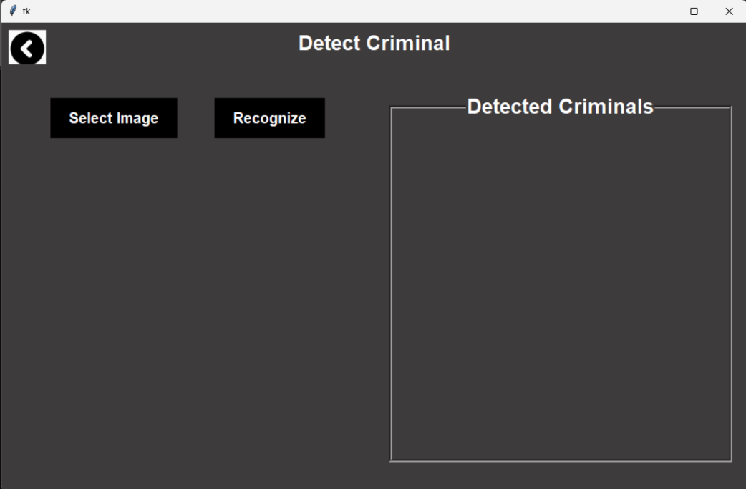

Fig 4.9: Detect Criminal

The figure 4.9, depicts the page that appears when the image surveillance button is clicked, this page shows the detected criminals names when we insert the image of the person using the select image button.

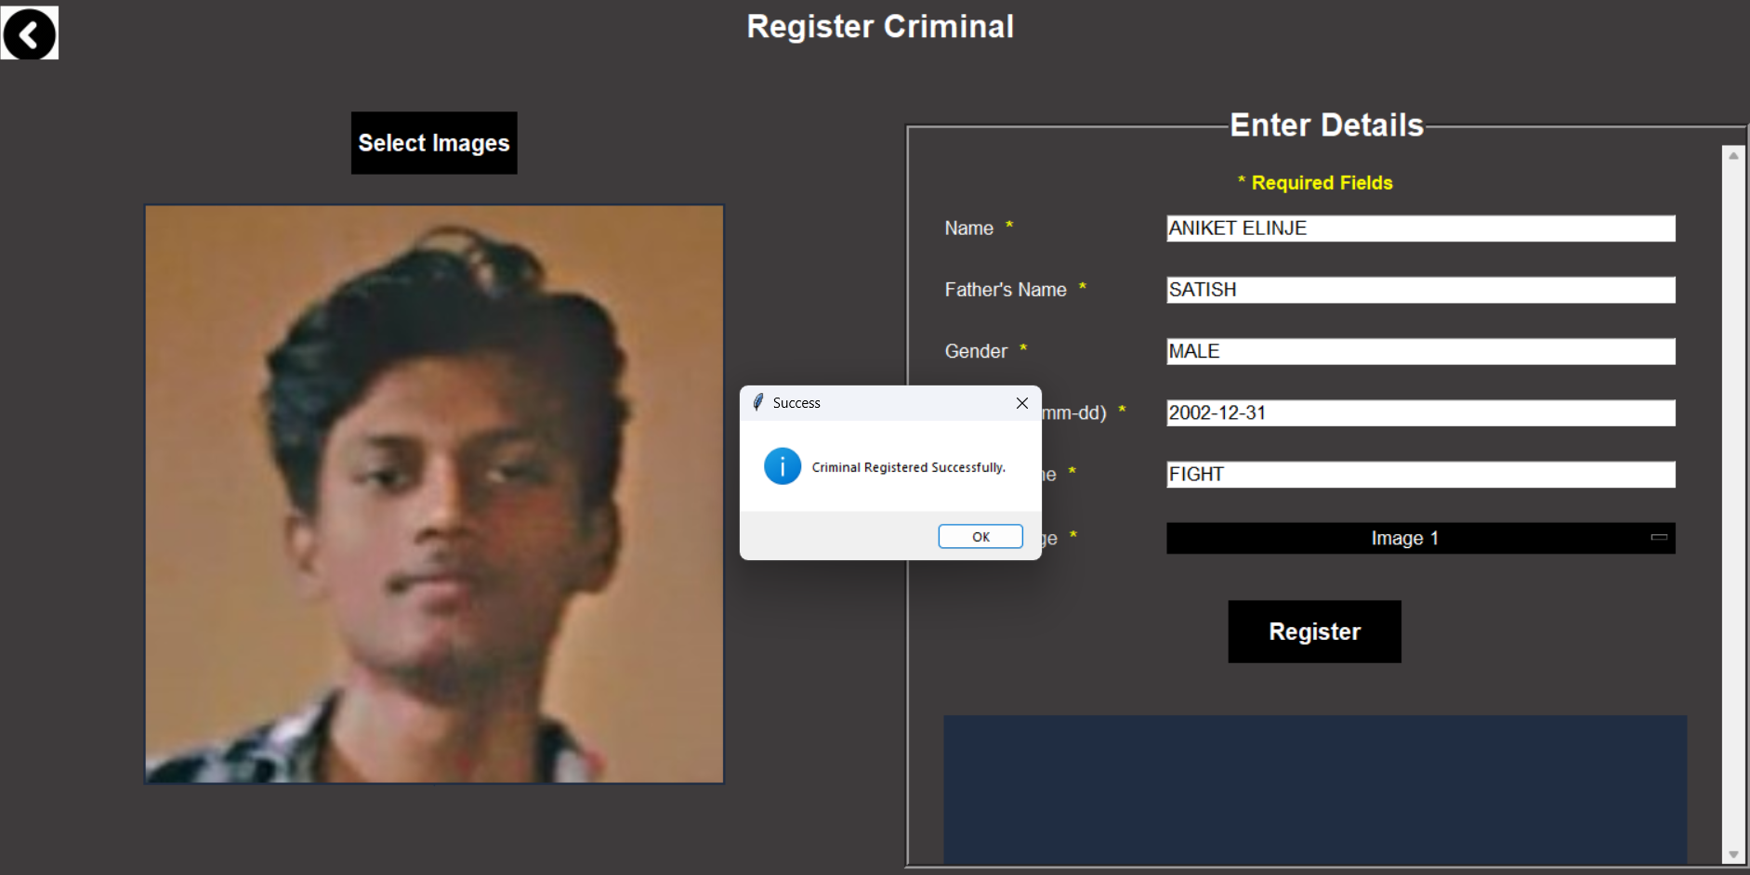

Fig 4.10: Detect Criminal

The figure 4.10 depicts the page that appears when the image surveillance button is clicked, this page has correctly recognized the image and the detail, the name has appeared in the detected criminals box.

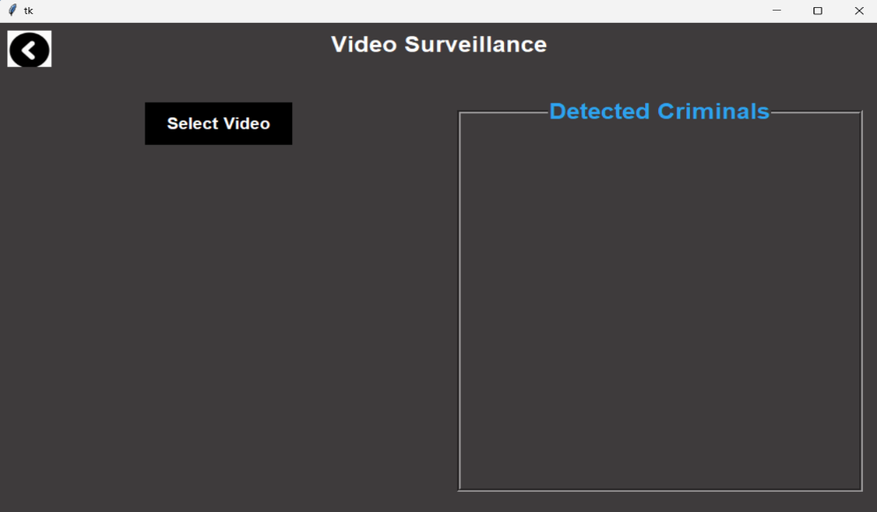

Fig 4.11: Video Surveillance

The figure 4.11 depicts the page that appears when the video surveillance button is clicked, this page shows the detected criminals names when we insert the video involving the person or criminal using the select video button.

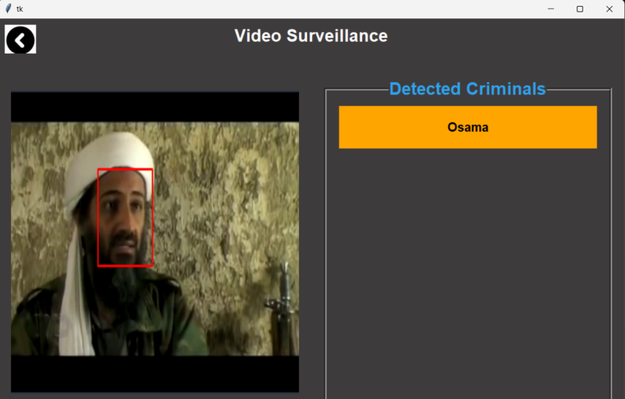

Fig 4.12: Video Surveillance

The figure 4.12 depicts the page that appears when the video surveillance button is clicked, this page has correctly recognized the person in the video and the detail, the name has appeared in the detected criminals box

1. **CONCLUSION**

In conclusion, PLEKSUS the violence detection system integrated with deblurring and database matching capabilities represents a significant advancement in the field of video surveillance and security. By addressing the challenges associated with blurred images and the need for efficient database matching, this system enhances the accuracy and reliability of violence detection in real-world scenarios. The deblurring component ensures that even in situations where image quality is compromised, the system can still effectively identify violent activities. Simultaneously, the database matching feature allows for the quick and precise identification of individuals involved in violent incidents. This holistic approach not only improves the overall performance of violence detection but also has the potential to significantly enhance public safety and security in various applications, from public spaces to law enforcement. As technology continues to advance, the integration of deblurring and database matching into violence detection systems is a promising avenue for further research and development.

1. **REFERENCES**

|  |  |
| --- | --- |
| [1] | Deisy Chaves, Eduardo Fidalgo, Enrique Alegre, Rocío Alaiz-Rodríguez, Francisco Jáñez- Martino, George Azzopardi, "Assessment and Estimation of Face Detection Performance Based on Deep Learning for Forensic Applications," *Free PMC Article,* 11 August 2020. |
| [2] | Sujy Han, Tae Bok Lee, Yong Seok Heo, "Semantic-Aware Face Deblurring With Pixel-Wise Projection Discriminator," *IEEE ACCESS,* vol. 11, pp. 11587-11600, 3 February 2023. |
| [3] | Dilnoza Mamieva, Akmalbek Bobomirzaevich Abdusalomov, Mukhriddin Mukhiddinov, Taeg Keun Whangbo, "Imroved Face Detection Method via Learning Small Faces on Hard Images Based on a Deep Learning Approach," *Sensors,* 2 January 2023. |
| [4] | Viktor Denes Huszar, Vamsi Kiram Adhikarla, (Member, IEEE), Imre Negyesi, Csaba Krasznay, "Toward Fast and Accurate Violence Detection for Automated Video Surveillance Applications," *IEEE ACCESS,* vol. 11, 14 February 2023. |
| [5] | Shivalila Hangaragi, Tripty Singh, Neelima N, "Face Detection and Recognition Using Face Mesh and Deep Neural Network," *ScienceDirect,* vol. 218, 31 January 2023. |
| [6] | Raghda Awad Shaban Naseri, Ayça Kurnaz, Hameed Mutlag Farhan, "Optimized face detector-based intelligent face mask detection model in IoT using deep learning approach," *ScienceDirect,* vol. 134, 20 December 2022. |
| [7] | Nadia Mumtaz, Naveed Ejaz, Shabana Habib, Syed Muhammad Mohsin, Prayag Tiwari, Shahab S. Band, Neeraj Kumar, "An Overview of Violence Detection Techniques: Current Challenges and Future Directions," *ResearchGate,* 8 October 2022. |
| [8] | Tao Wang, Kaihao Zhang, Xuanxi Chen, Wenhan Luo, Jiankang Deng, Tong Lu, Xiaochun Cao, Wei Liu, Hongdong Li, Stefanos Zafeiriou, "A Survey of Deep Face Restoration: Denoise, Super-Resolution, Deblur, Artifact Removal," *Cornell University,* p. 21, 5 November 2022. |
| [9] | Zhengwei Zhu, Yushi Lei, Yilin Qin, Chenyang Zhu, Yangping Zhu, "IRE: Improved Image Super-Resolution," *IEEE Access,* vol. 11, pp. {45334-45348}, 12 May 2023. |
| [10] | TAE BOK LEE, SUJY HAN, YONG SEOK HEO , "Continuous Facial Motion Deblurring," *IEEE Access,* vol. 10, pp. 76079-76094, 25 July 2022. |
| [11] | Archana Tomar and Harish Patidar, "ENHANCING IMAGE SUPER-RESOLUTION WITH DEEP CONVOLUTIONAL NEURAL NETWORKS," *ICTACT Journal on Image \& Video Processing,* vol. 14, 2023. |
| [12] | Tong Han, Li Zhao, Chuang Wang, "Research on Super-resolution Image Based on Deep Learning," *International Journal of Advanced Network, Monitoring and Controls,* vol. 8, pp. 58 - 65, 31 May 2023. |
| [13] | Zhiwei Yang and Yunyan Wang, "Image Enhancement and Improvement Algorithm Based on Esrgan Singal Frame Remote Sensing Image," *Journal of Physics: Conference Series,* vol. 1952, 2021. |
| [14] | Leese, Matthias, "Enacting criminal futures: data practices and crime prevention," *Policing and Society,* vol. 33, pp. 333 -- 347, 24 August 2022. |
| [15] | Arjun Menon, Kumari Shivani Singh, Raushan Kumar, Ritvik Sethi, Abha Kiran, "Leveraging Facial Recognition Technology in Criminal Identification," *Researchgate,* p. 10, 2023. |