­­

Research Driven Critique : Importance of Insurance

Rishabh Singh

Galgotias University

Professor – Dr. Jaideep Sharma

# Abstract

This research paper sculp into the fundamental concept of insurance, its significance, various types, who needs life insurance most, how insurance works, why do you need of insurance, how much life insurance coverage one need, how can you choose one of the best insurance plan, when to get insurance plan, what are the factors that shape the insurance plan and the transformative role of ICICI **(prudential life insurance)** in the banking sector. It discusses ICICI's current brand image, what sets it apart from competitors, and its contributions to reshaping banking culture**.**

# Introduction

Insurance is a financial tool crafted to shield individuals, businesses, and organizations from potential risks and uncertainties. Through the transfer of risk to an insurer in exchange for premium payments, individuals and entities can mitigate the impact of financial losses. In the contemporary landscape characterized by volatility, insurance assumes a pivotal role in furnishing stability and security to both individuals and businesses.

Insurance is a contractual agreement between two parties: the insured and the insurer. The fundamental concept underlying insurance is risk pooling, wherein a large number of policyholders collectively contribute premiums to form a pool of funds. These funds are then utilized to reimburse those who experience covered losses. The essential elements of insurance comprise the policy itself, the premium payments, the extent of coverage offered, and any deductible amounts applicable.

# Importance of Insurance

Insurance plans offer essential financial protection for various situations, including medical emergencies, hospitalization, illnesses, and future medical needs.

In the unfortunate event of the sole breadwinner's demise, insurance coverage can alleviate the financial burden on the family. It can facilitate the repayment of outstanding debts such as mortgages, ensuring the family's stability.

By securing insurance, your family's standard of living can be maintained even in your absence. The lump sum payout can cover household expenses, providing much-needed financial relief during difficult times like accidents or medical emergencies.

Furthermore, insurance plans contribute to securing your child's future, particularly concerning their education. Financial provisions ensure that your children can pursue their aspirations without financial constraints, regardless of unforeseen circumstances.

Additionally, many insurance plans offer savings and investment options alongside coverage. These avenues enable the accumulation of wealth for future needs through regular contributions. Premium payments are allocated towards life coverage and either a savings or investment plan, tailored to your long-term objectives and financial requirements.

ICICI v/s SBI

|  |  |  |
| --- | --- | --- |
| **Parameter** | **ICICI Prudential Life Insurance** | **SBI Life** |
| **Claim Settlement Ratio** | **9**7.90% | 93.09% |
| **Solvency Ratio** | **2**.07 | 2.15 |
| **Availability** | **O**nline/offline | Online/Offline |
| **Life Cover** | **U**p to 99 years | Up to 99 years |
| **Riders** | **A**vailable | **Available** |
| **Number of Branches Available** | **9**47 | **514** |
| **Premium Payment Term** | **R**egular pay , single pay and limited pay | Regular Pay, Single Pay, Limited Pay |
| **Premium Payment Mode** | **Y**early/Half-yearly /Quarterly/Monthly | Yearly/Half-yearly/ Quarterly/ Monthly |
| **Entry Age** | **18 to 65 years** | 18 to 65 years |
| **Death Benefit** | **yes** | Yes |
| **Maturity Benefit** | **yes** | Yes |
| **E-services** | Buying policy, renewal, update information, premium payments and claim settlement | Buying policy, renewal, update information, and claim settlement |
| **Plans Available** | Term, ULIP, Savings, Retirement, Group, Health, Rural Plans | Protection, ULIP, Savings, Retirement, Group, Wealth Creation, Money Back Plans |

**SWOT Analysis of ICICI Prudential Life Insurance**

**Strength:** ICICI Prudential is one of the leading financial institutions in India.

Financial stability that may lead to oversight of gestation periods.

Incentives and motivational schemes offered by the company.

Emphasis on service quality as a core mission.

Extensive database comprising corporate clients, retail customers, and bank clients affiliated with ICICI.

Largest paid-up capital deposited with IRDA among competitors.

Comprehensive training programs for all ICICI Prudential associates.

**Weakness:** High goals are set for financial advisors and sales departments within the industry. Numerous competitors in the market provide similar products, albeit with variations in premiums and offerings. The premiums for policies are significantly high, posing challenges for advisors. Moreover, there are concerns about the sustainability of risk associated with investments in the money market.

**Opportunities**:

Health insurance and pension schemes represent a sizable market potential, estimated at around $15 billion. There is a strategic initiative to expand partnerships with corporate agents across India, including broker agents. Leveraging the strong brand presence of the company contributes significantly to enhancing sales in the market. Moreover, there is a focus on attracting more customers by offering products that prioritize their needs and preferences.

**Threats:** "Bajaj and Birla Sun Life offer competitive plans with low premiums. However, many individuals lack awareness regarding various distribution channels within the insurance sector. Existing insurance companies pose a significant threat, alongside potential challenges from new market entrants. Additionally, shifts in IRDA policies could impact the industry landscape.

**Financial performance of ICICI PRUDENTIAL Life Insurance**

Profit after Tax (PAT) increased by 17.9% to ₹ 6.79 billion.

Value of New Business (VNB) reached ₹ 14.51 billion, boasting a VNB margin of 26.7%.

The retail protection segment experienced robust year-on-year growth of 55.9%.

Total Annualised Premium Equivalent (APE) amounted to ₹ 54.30 billion.

Retail New Business Sum Assured (NBSA) saw a significant year-on-year growth of 43.7%, reaching ₹ 1.6 trillion in the first nine months of FY2024.

Total in-force sum assured expanded by 17.3% to ₹ 32.3 trillion as of December 31, 2023.

13th-month persistency stood at 87.4% as of December 31, 2023.

Assets Under Management (AUM) grew by 13.8% year-on-year to ₹ 2.9 trillion as of December 31, 2023.

|  |  |  |  |
| --- | --- | --- | --- |
| Rs. billion | 9M-FY2023 | 9M-FY2024 | Growth Y-O-Y |
| Profit After Tax | 5.76 | 6.79 | 17.9% |
| Value of New business | 17.10 | 14.51 | (15.1)% |
| Value of New Business Margin | 32.0% | 26.7% | - |
| New Business Sum Assured | 6,921 | 7,228.49 | 4.4% |
| New Business Received premium | 112.87 | 115.27 | 2.1% |
| Annualised premium Equivalent | 53.41 | 54.30 | 1.7% |
| savings | 39.54 | 40.00 | 1.2% |
| protection | 10.50 | 10.92 | 4.0% |
| annuity | 3.37 | 3.39 | 0.6% |
| 13th month persistency | 86.1% | 87.4% | 130 bps |
| 49th month persistency | 63.9% | 67.1 | 320 bps |
| Savings cost ratio | 13.9% | 16.3% | - |
| Overall Cost Ratio | 20.8% | 25.3% |  |
| Solvency | 212.2% | 196.5% |  |
| Assets Under Management | 2,518.94 | 2,866.76 | 13.8% |

**Result from the survey**

Let me start with that the most of the people really showed interest and I would like to extend my thanks to them to support me during survey. Here, I have represented the information through charts. Here I have concluded some questions and represented through graphs.

According to services

Almost most of the people prefer ICICI over SBI in terms of services, they believe that ICICI services if faster than SBI, server of ICICI rarely unreachable, that is the reason for the large no. of branches of ICICI in country

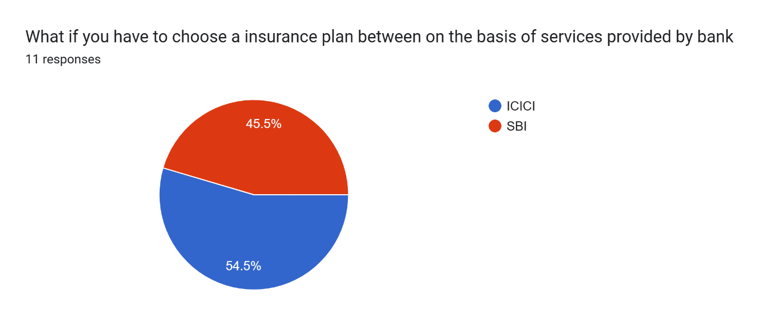

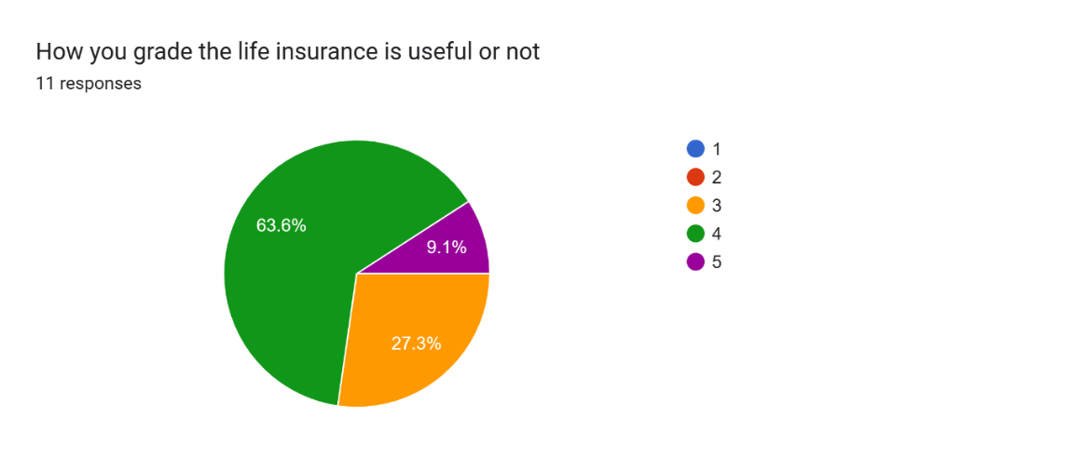

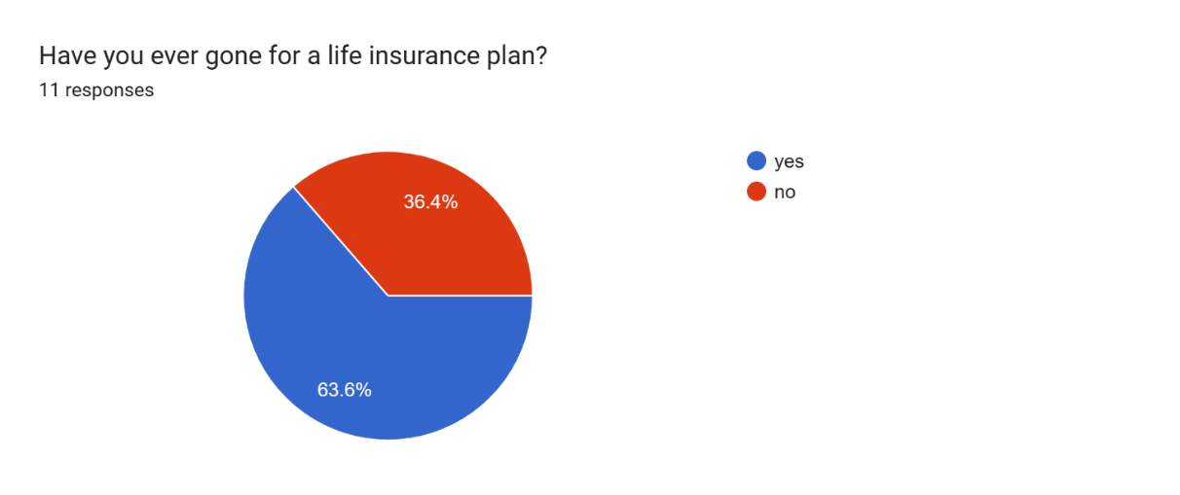

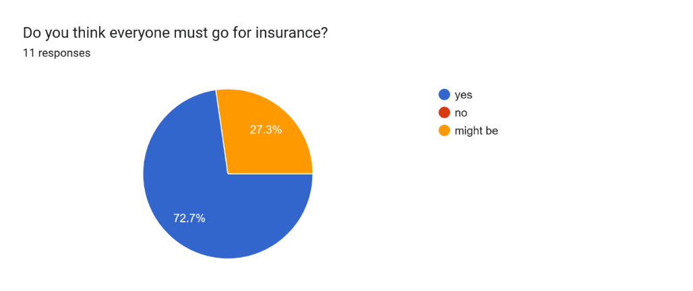

**Conclusion :** ICICI, a prominent financial institution in India, has built a robust brand identity through years of dedicated service. Renowned for its pioneering products, customer-centric ethos, and technological prowess, ICICI has garnered the trust and loyalty of millions of clients. Its unwavering commitment to excellence, integrity, and transparency has been instrumental in cementing its esteemed reputation within the banking and financial services landscape.

The unique services offered by ICICI set it apart from its competitors, making it the preferred choice for a vast number of customers.

In summary, insurance plays a crucial role in risk management and financial security amidst today's uncertainties. ICICI, with its solid brand reputation, innovative strategies, and transformative influence on the banking sector, exemplifies the significance of prioritizing customers, embracing technology, and upholding ethical standards to drive positive change and promote financial inclusivity. As the banking and insurance industries continue to evolve, ICICI's tradition of excellence and innovation is poised to continue shaping the future of financial services.

References:

[Life Insurance - ICICI Prudential Life Insurance India 2024 (iciciprulife.com)](https://www.iciciprulife.com/)

[Investopedia](https://www.investopedia.com/)

**https://www.policybachat.com/articles/sbi-life-vs-icici-prudential-life-insurance-comparison**