**A REVIEW: NANOCAPSULE: A INNOVATIVE MEDICINE DELIVERY TECHNIQUE**

**Shaikh Rauf A1, Damal Rahul R.2, Kale Akash3, Garje Sanjay Y4, Sayyed Gaffar A5 1,2,3,4,5 SAJVPM COP and RC Kada, India.**

# Abstract

**N**ano capsules are vesicular systems in which the medicine is contained in a hollow with an inn er liquid core and a polymeric membrane surrounding it. Nano capsules come with a number of benefits and drawbacks**.** Two types of polymers can be employed in the manufacture of Nano ca psules. 1) Polymers found in nature 2) Polymers that have been synthesised.a) Solvent evaporat ion b) Nano precipitation c) emulsification / Solvent diffusion d) Salting out e) Dialysis f) Super c ritical fluid technology are some of the methods used to create nano capsules.

Nano capsules are subjected to a variety of characterization and evaluation procedures. To achi eve controlled release and efficient drug targeting, dispersed polymer nanocapsules can be empl oyed as nano-sized drug carriers. Drug-

loaded polymeric nanocapsules have been shown to have potential applications in drug delivery systems To develop current nano-

particulate drug delivery methods, enormous research efforts have been made.

Newly discovered therapeutic compounds with a modest biopharmaceutical profile, on the other g (NC), have the potential to provide therapeutic benefits in the field of drug delivery

*Key words:nanocapsules,nanoparticles,drug delivery system*

# Introduction

Nanocapsules range in size from 10 nm to 1000 nm and are available in a variety of sizes.

They have a liquid/solid core in which the medicine is deposited in a cavity surrounding by a pol ymer membrane consisting of natural or manmade polymers. The protective layer, which is ofte n pyrophoric and rapidly oxidised, has piqued interest because it delays the release of active co mpounds.

Nanocapsules are a type of nanoparticle that consists of one or more active components (core) a nd a protective matrix (shell)[1]into which the therapeutic substance can be encased.

Nanocapsules have been created as drug delivery methods for a variety of medications via a vari ety of routes, including oral and parental administration. Drug toxicity should be reduced.

Nanocapsules

are polymeric nanoparticles with a polymeric wall made up of nonionic surfactants, macromolec ules, phospholipids and an oil core .

# Nanocapsule structure

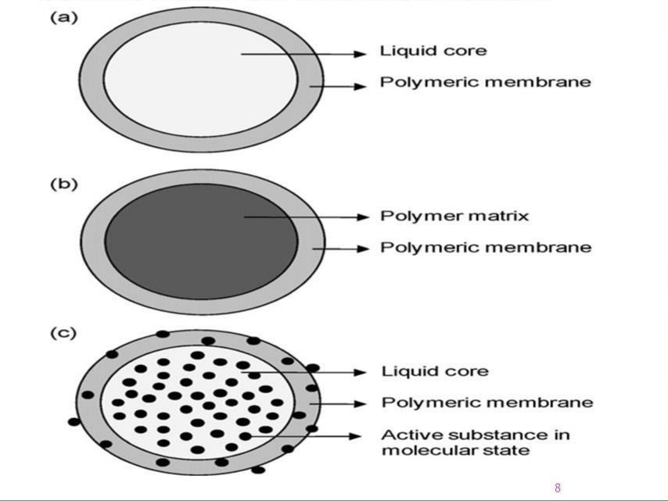

## Advantages:

1. *Sustained release, increasing drug selectivity and effectivenes2. improved drug bioavailability, and reduced drug toxicity are some of their key advantages.*
2. *When injected intravenously, nanocapsules, which are submicron in size, reach the target and release the encapsulated medicine.*
3. *When injected intravenously, nanocapsules, which are submicron in size, reach the target and release the encapsulated medicine.*

## Nanocapsule Drawbacks:

1.a high-cost formulation with a high yield Productivity is more harder to achieve.

1. *As a result,technology, industrial application.The transition to commercial production is quite difficult.*
2. *difficult Reduced dose-adjustment ability Technology that is extremely advanced To produce, you'll need certain skills.*
3. *The stability of the dose form is a major concern.because of its micro size Recycling is highly costly.*

## Nanocapsule preparation methodologies:

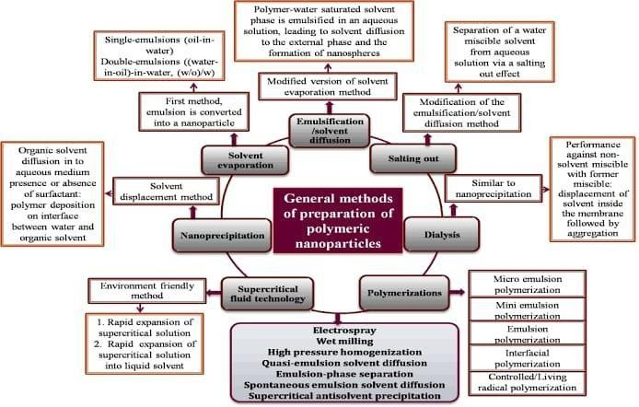

#### Method of nanoprecipitation:

The method of nanoprecipitation is also known as Interfacial deposition or solvent displacement

The Biodegradable polymers are extensively utilised. Polyesters, particularly poly-caprolactone, are a type of polymer (PCL),Polylactide (PLA) and polylactide-co-glicolide (PLGA) are two types of polylactide.

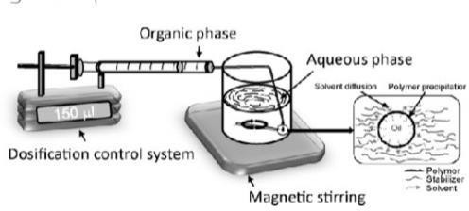

Preparation of nanocapsule by precipitation method

#### Method of emulsion–diffusion:

The water miscible solvent, as well as a little amount of water, are used in this approach.As an oil, an immiscible organic solvent is utilised. phase. The most widely used polymers are PCL, PLA, and other biodegradable polyesters as well as eudragit. Poly (hydroxybutyrate-co- hydroxybutyrate-co-hydroxybutyrate-co-hydroxybut hydroxyvalerate) (PHBHV) is another option

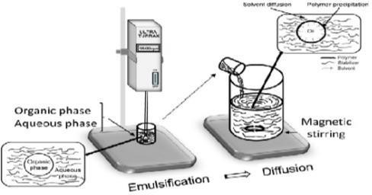

Preparation of nanocapsule by emulsion-diffusion method

#### Method of double emulsification:

Double emulsions are heterodisperse heterogeneous complex emulsions."Emulsions of emulsions" systems

It can be divided into two categories:

w/o/w oil-water emulsion and oil-water-oil emulsion (o/w/o) emulsion

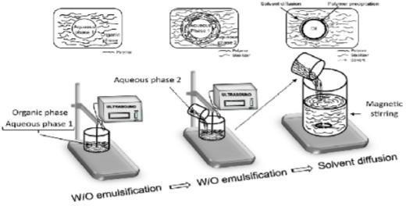

Preparation of nanocapsule by double emulsification method

#### Method of emulsion-coacervation:

A combination of two methods is used in this strategy .One of the aqueous phases is the polymer. chitosan, an ethylene oxide di-block co-polymer, or

One is a propylene oxide (PEO-PPO) and the other is a propylene oxide (PEO-PPO) sodium tri polyphosphate polyanion In this case,

positively charged amino group, technique

Negatively charged tripeptides interact with chitosan. coacervates with a size of in polyphosphate Nanometers are the smallest units of measurement.

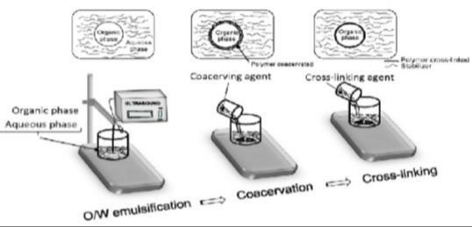

Preparation of nanocapsule by the emulsion –coacervation method

#### Application of a polymer coating:

They use poly (methyl methacrylate) as a layer-formed polymer (PMMA) Nanocapsules are made of poly(methacrylate) (PMA) and poly(carbonate) (PCL). The mechanism of formation is based on In three-phase system engulfment occurs.

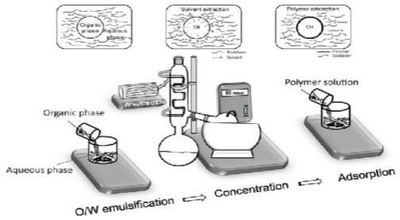

Preparation of nanocapsule by polymer- coating method

#### The layer-by-layer approach :

The layer-by-layer approach utilises Polycations such as polylysine, chitosan, and gelatin are examples of polycations.

B, poly (allylamine) (PAA) poly(allylamine) poly(allylamine) poly(allylamine) poly(ally (ethyleneimine)

(PEI), aminidextran, and protamine sulphate are all examples of protamine sulphate. The Polyanions like this are used:

(styrene) polymer sodium alginate, poly (acrylic) sulfonate) (PSS), sodium alginate carboxymethyl cellulose, dextran sulphate,

gelatin A, chondroitin, and hyaluronic acid, heparin.

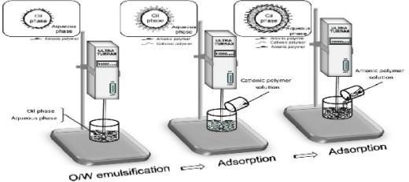

Preparation of nanocapsule by layer by layer method

### NANOCAPSULES: CHARACTERIZATION

1. ***THE SIZE OF THE PARTICLE***

Because smaller particles have more surface area, most therapeutic chemicals attached to or ne ar the surface of the particle cause immediate drug release, whereas bigger particles with vast c ore surfaces diffuse out gradually .

### PH OF NANOCAPSULE DETERMINATION

Formulation of Nanocapsules At room temperature, pH was determined using a digital pH mete

r. The pH of nano capsule dispersion is 3.0-7.5.

|  |  |  |  |  |
| --- | --- | --- | --- | --- |
| ***3. DRUG CONTENT DETERMINATION:***  *Drug content was determined by dissolving 1 mL of prepared nanocapsules in 20 mL acetonitril*  *e. The UV Spectrophotometer at 232nm was then used to examine a suitable amount of sample. Each sample's absorbance was measured and compared to a reference point.*   1. ***CHARACTERIZATION OF THE STRUCTURE:***   *To determine various features such as shape, size, and surface morphology, structural characteri sation can be done using field emission scanning electron microscopy (FE-*  *SEM) and transmission electron microscopy (TEM).*  *The nano capsules were micrographed with a Phillips Cm 200 operating at 20- 200 kv, and the Fe-SEM was performed with a Hitachi S-4800 FE-*  *SEM equipped with an energy dispersion spectrometer (EDS)*   1. ***DRUG RELEASE IN VITRO:***   *The USP type 11 dissolving apparatus was used to conduct in vitro dissolution tests. The experiment was conducted in 100 mL of buffer (PH 3.0).*  *The suspension of nano capsules was placed in a dialysis membrane and dipped in a dissolving media that was kept inert at 370.50C.*  *The stirring speed was kept constant at 100 rpm.*  *5ml of sample was taken at specified intervals and spectrophotometrically evaluated for drug rel ease. 5 mL of fresh dissolving medium was added to the dissolution jar after each withdrawal.*  ***Application of nanocapsule*** | | | |  |
|  | *Application* | *Drug* | *Mode of preparation* |  |
| *Agrochemical* | *Abomectin nanocapsule cypermethrin capsules pyrethrum nanocapsule* | *Emulsion polymerization Microemulsion polymerization Microemulsion polymerization* |  |
|  | | | |  |

|  |  |  |  |  |
| --- | --- | --- | --- | --- |
|  | | | |  |
|  | *Anti-inflammatory drugs* | *Diclofenac sodium* | *Sol-gel method* |  |
| *Antiseptics* | *Indomethacin loaded nanocapsule* | *Interfacial polymerization* |  |
| *Cosmetics* | *Epsilon caprolactone nanocapsule* | *Emulsion-Diffusion method* |  |
| *Diabetes* | *Insulin-loaded Biodegradable (isobutylcyanoacrylate)* | *Interfacial polymerization* |  |
| ***Conclusion:***  *The better distribution of bioactive compounds via targeted delivery via nanocapsules presents various problems and potential for future study and development of novel improved therapeutics.*  *They can be used in the delivery of active pharmaceutical ingredients (APIs). They provide the novel effective drug delivery systems in the up coming future.*  ***Reference:*** | | | |  |

1. *Gauri Nilewar,P.B.Mute,P.P Talhan,Shruti Takhare,Dr.R.G.Bhoyar college of pharmacy,wardha Maharashtra,India Nanocapsules:Nano novel drug delivery system Pharma Tutor (June 2017).*
2. *Nazli Erdogar,Safiye Akkin,EremBilensoy.Recent patents on drug delivery and formulation 12(4),252-266,2018.Nanocapsule for drug delivery:an updated review of the last decade*
3. *Pavankumar Kothamasu ,Hemanth Kanumur,and Sivakumar Thangavel 2012.Nanocapsule*

:The weapons for novel drug delivery system.

1. *Pierre P.D.Kondiah…viness Pillay in Advanced 3D-printed systems and nanosystems for drug delivery and tissue engineering ,2020*
2. *Karthikeyan Subramani,Manjula menta, in Emrging Nanotechnologies in Dentistry (Second Edition), 2018.*
3. *Bantu Karnakar ,Swarupa Arvapalli, Syeda Jabeen,A. Vaishnavi,ps.Rishika,J.V.C Sharma .A systematic review on nanocapsule:A novel drug delivery system.Journal of Biomedical and Pharmaceutical Research 10 (1) :68-75.*
4. *Chen Y, Lin X, Park H, Greever .R, study of artemisinin nanocapsul a anticancer drug delivery systems, International journal of Pharmaceutical. 2008;365(12):1012.*
5. *Mora-Huertas,C.E;Fessi,H;Elaissari,A polymer-based nanocapsules for drug delivery.Int.J.Pharm.2010,385,113-145.[Cross Ref] [Pub Med]*
6. *Kothamasu,P,Kanukumar,H.Ravur,N.Maddac;Parasuramrajam,R; Thangavel,S. Naannocapsules:The weapons for novel drug delivery systems Bioimpacts:BI2012,2,71- 81[Cross Ref] [PubMed]*
7. *Quintanar-Guerrero,D;Allemann,E.Doelkar,E.fessi,H.Preparation polymers by a new process based on emulsification-diffusion technique.Pharm.Res 1998,15,1056-1062.[Cross Ref] [Pub med]*
8. *P.R.Radhika,sasikanth and T.Sivakumar page no:1426-1429.2011 International journal of pharmaceutical sciences and Research.Nanocapsules: A new approach in drug delivery.*
9. *Jager A,Stefani v,Guterres ss and Pohlmann AR.2007 physico-chemical characterization of nanocapsule.Polymeric wall using fluorescent benzazole probes.Int J Pharm,338(1-2),297-305.*
10. *Patrick Couverur,Gillian Barratt,Elias Fattal,Christine Vauthier-Critical Review in Therapeutic drug carries system 19(2),2002.Nanocapsule technology:a review*
11. *Ngoc Trinh Huynh,C passirani,Patrick Saulnier.Jean-pierre Benoit.International journal of pharmaceutics 379(2),201-209,2009.Lipid nanocapsules:a new platform for nanomedicine.*
12. *Siyuan Deng ,Maria Rosa,Gigli obianco,Reberta Censi,Piera Di Martino nanomaterials 10(5),847,2020 polymeric nanocapsule as nonotechnological alternative for drug delivery system:current status,challenges and opportunities.*
13. *D.Quintanar-Guerrero,H.Fessi,E.Allemann,and E.Doelkar.procede preparation de nanocapsules de type vesiculaire,ulilisables notament Comme vecteures colloidaux de principles actifs pharmaceutiques autres French pat.Appl.97 09 672*
14. *F.Chouinard.S.Buczkowski,and V.Lenaerts –poly(alkylcynocrylate) nanocapsules: physicochemical characterization and mechanism of formation .pharm.Res.11:869-874(1994).*
15. *Praveen Solanki,Kitawat,Ashok Dashora.Nanocapsules used in drug delivery system,international journal of pharmaceutical Erudition 2017.*
16. *Azonano Nanocapsules and dendrimers properties and future applications Institute of nanotechnology.2006;25(9):5.*
17. *Srivastava A.Yadava .T.Sharma.S.Nayak .A.Kumari.A.Mishra.N polymersin drug delivery*

;journal of Biosciences and medicines .2016;24(3):1-16.

1. *Zhang 2D .2004,Nanocapsules,Encyclopedia of nanoscience and Nanotechnology,H.S.Nalwa[Ed].American scientific publishers,6,77-160.*
2. *Sneha Anand P.S.Rajinikanth,in Biopolymer-Based Nnomaterials in drug delivery and Biomedical application 2021.*