Evault in Blockchain to store and manage legal records
Sagar Anil Yeshwantrao1
Assistant Professor
Department of Computer Engineering
PHCET, Rasayani,
Maharashtra, India
sagaryeshwantrao@mes.ac.in

Krishna Changdev Satpute2
Department of Computer Engineering
PHCET, Rasayani
Maharashtra, India
krishnacs20comp@student.mes.ac.in

Tejas Hemant Patil3
Department of Computer Engineering
PHCET, Rasayani
Maharashtra, India
tejashp21hcompe@student.mes.ac.in

Soham Baban Shinde4
Department of Computer Engineering
PHCET, Rasayani,
Maharashtra, India
Sohambscs20comp@student.mes.ac.in

Abstract - The eVault project introduces a revolutionary approach to the storage and management of legal records by harnessing the potential of blockchain technology. In an era marked by increasing digitization and the need for secure, transparent, and easily accessible legal documents, eVault emerges as a transformative solution. Traditional methods of legal record storage often suffer from issues like data tampering, lack of transparency, and fragmented access. eVault addresses these challenges via making use of blockchain's inherent characteristics: unchangeability, transparency, additionally decentralized architecture. eVault offers a safe and tamper-proof a platform for legal professionals, additionally individuals to store, manage, and retrieve legal records. These records encompass contracts, deeds, court documents, and a wide range of legal paperwork. All data stored in eVault is encrypted, ensuring the utmost confidentiality. The eVault project redefines the landscape of legal record management, offering a comprehensive, secure, and convenient platform for legal professionals and individuals alike. By combining the transparency and immutability of blockchain with user-friendly interfaces and robust privacy controls, eVault empowers users to take control of their legal records, making them accessible when needed while preserving their integrity and confidentiality. In a time where trust additionally security are crucial, eVault are crucial innovation in the legal industry.

Keywords - Digitization, Secure, Transparent, Legal Documents, Immutability, Decentralized Architecture, Tamper-Proof Platform.

Introduction
In today's digital era, the management and security
of legal ledgers have become critical for ensuring transparency, authenticity, and accessibility. Long established methods of storing legal documents often lack the necessary security and efficiency required to safeguard sensitive information. Consequently, there is an increasing need for a reliable and secure system that can manage and store legal records in a tamper-proof and easily accessible manner. This innovative project seeks to create a robust and transparent platform that ensures the integrity and confidentiality of legal records, thereby enhancing trust and efficiency in the legal industry. E-Vault based policy will make use of blockchain's distributed ledger technology to create an immutable record of all legal documents, thereby preventing unauthorized access, tampering, or forgery. This secure and transparent system will enable legal professionals, clients, and relevant stakeholders to access and manage their records seamlessly while ensuring compliance with data protection regulations and legal standards. Besides, the project intends to streamline legal record-keeping processes, reduce the risk of data breaches, and enhance the overall security and trustworthiness of legal documentation. Via integration of blockchain technology, the "E-Vault in Blockchain to Store and Manage Legal Records" project aspires to set a new standard for secure and transparent legal ledger authority, fostering trust and confidence through the legal industry and beyond.

- Blockchain technology
Block chain technology is revolutionizing the way ledger is preserved, safeguarded, and managed across many industries. Fundamentally, block chain is a distributed ledger that keeps track of transactions or data in an unchangeable and safe way. Unlike traditional centralized databases, block chain functions using nodes, a decentralized network of computers, where everyone transaction is authorized by multiple participants rather than a single authority. Block chain technology has applications across crypto-currency, ranging from supply chain authority and digital identity authorization to legal recordkeeping. Its decentralized nature eliminates the potential for one point of failure and reduces dependency on third-party intermediaries, leading to increased efficiency, security, and costs.

- Working of blockchain
Blockchain technology is a revolutionary innovation. system for decentralized ledgers that guarantees safe and transparent storing records on a computer network. Operating on the principles of decentralization, immutability, transparency, and consensus, blockchain eliminates the need for a central authority by distributing data control among multiple nodes. Its unique structure, chaining blocks through cryptographic hashes, makes it virtually impossible to tamper with historical records, fostering trust and reliability. Participants in the blockchain network maintain synchronized, transparent records by means of consensus techniques like Proof of Stake or Proof of Work. Additionally, blockchain supports smart contracts, programmable self-fulfilling contracts that enhance automation as well efficiency. Cryptographic techniques, including public and private keys, ensure the security and integrity of transactions. Beyond cryptocurrencies, blockchain finds applications in various sectors where trust, security, and transparency are paramount, such as supply chain management and healthcare.

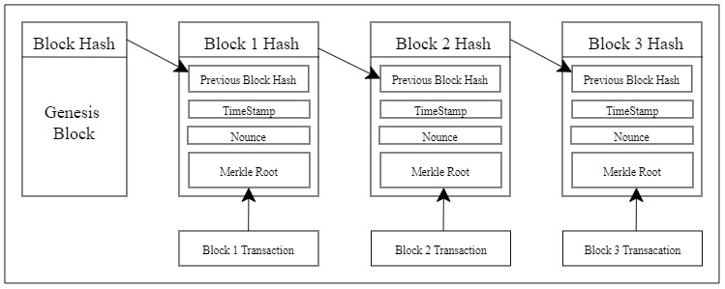
Figure 1. Blockchain Proposal By Nakamoto
Satoshi Nakamoto, the pseudonymous creator of Bitcoin, presented a groundbreaking proposal in 2008 through the Bitcoin whitepaper, envisioning a decentralized digital currency system. Nakamoto's concept involved a peer-to-peer network, eliminating the need for central authorities in financial transactions. The proposed Proof of Work consensus mechanism ensured network security by employing miners to solve complex mathematical problems, preventing double-spending and maintaining an immutable transaction history. The blockchain, a public ledger with linked blocks secured through cryptographic hashes, played a pivotal role in transparently recording transactions. Nakamoto's emphasis on cryptographic security, utilizing public and private key pairs, aimed at facilitating secure ownership and transfer of digital assets. The proposal laid the foundation for the development of cryptocurrencies, marking a transformative shift in how value is transferred and perceived in the online realm.

LITERATURE REVIEWS
1). As per Michal Munk, Petr Hajek, and Farhana Akter Sunny [1], This research carried out a systematic review of the literature to explore that field blockchain technology comprehensively. While not solely focused on legal record systems, It offers insightful information about the broader applications and also implications blockchain technology.

2). According to Daniel Diaz-Fuentes, Judith Clifton, and Diego Cagigas [2], This research specifically investigates blockchain application in public services through a methodical literature evaluate. By creating a database of records and conducting analyses, the study sheds light regarding the possible advantages and challenges that of implementing blockchain in the public domain applications.

3). As per study by Ashwin and Aditya Vijaykumar Singh Ompraksha Tiwari, Vivian Brian Lobo, and Shreyash Sanjay Singh [3], The article focuses on a specific application of blockchain technology in maintaining criminal records. By leveraging blockchain, this system seeks to improve the security, openness, and integrity that of criminal record-keeping processes.

4). In accordance to Fran Casino, Constantinos Patsakis, and Thomas K. Dasaklis [4], This work provides a comprehensive evaluation of applications based on blockchain across various domain names, offering insights into The state of blockchain technology as of right now adoption and its impact on different sectors.

5). As per Shujun Li, Yang Lu, Enes Altuncu, and Rahime Belen-Saglam [5], Addressing concerns related to legal compliance, this review explores the tension between Regulation on the General Data Protection (GDPR) requirements additionally blockchain systems. It highlights the ongoing debates among investigators, users, practitioners, and legislators regarding the lawful implications blockchain technology.

METHODOLOGY
Blockchain technology has revolutionized legal record storing systems through innovative methodologies that enhance security, transparency, and efficiency in managing legal documents. Smart contracts are essential by Process automation for transactions based on predefined terms, ensuring secure and transparent agreements between parties. Additionally, blockchain-powered arbitration systems enable the creation of automated agreements that apply arbitration awards automatically, offering a cost-effective and efficient dispute resolution mechanism.
Furthermore, blockchain technology ensures data integrity and transparency in the legal industry by storing legal information on a decentralized ledger. This approach increases data integrity and makes evidence tampering evident through changes in hash values, providing a robust system for maintaining the integrity of legal records. By leveraging blockchain technology, legal entities can streamline processes, reduce costs, and accelerate legal proceedings through automation. Tasks such as drafting legal documents and managing transactions are automated using smart contracts, leading to increased efficiency and cost savings that can be passed on to clients.
Moreover, blockchain technology offers enhanced security features such as anonymity for parties engaging in trusted exchanges without revealing identities. The distributed ledger system tracks asset changes securely, while consensus mechanisms provide protection against fraud or manipulation. By utilizing cryptographic hashes to certify data integrity against records, workflows, and signatures, blockchain ensures the validity of legal documents and processes without the risk of corruption or tampering. Overall, these methodologies showcase how blockchain is transforming legal record storing systems by providing a secure, transparent, and efficient framework for managing legal documents and processes.

PROPOSED SYSTEM
The proposed system for a blockchain-based legal record system utilizing Ganache Ethereum network and Posegrace SQL integrates cutting-edge technologies to enhance the security, transparency, and efficiency of managing legal records. By leveraging the Ganache Ethereum network, which provides a local blockchain environment for testing and development, the system ensures a secure and reliable platform for storing legal records. Additionally, integrating Posegrace SQL, a powerful relational database management system, enhances data management capabilities, allowing for efficient storage and retrieval of legal documents with structured query capabilities.
The use of smart contracts within the proposed system automates and secures transaction processes, ensuring that predefined terms are met before executing legal agreements. This automation streamlines legal proceedings and reduces the risk of human error in document processing. Furthermore, the integration of blockchain technology offers benefits such as enhanced data integrity and transparency in legal record-keeping. By storing legal information on a decentralized ledger, the system increases data integrity and provides a tamper-evident mechanism through hash values, ensuring the authenticity and security of legal documents.

A. Modules Description
The modules included into the suggested system are:

- Setup wallet for using the Ethereum blockchain network's smart contracts.
- Sign-up / login into the website by creating an account or using an existing account to access the documents.
- Upload or view the assigned files to the user and create blocks using smart.

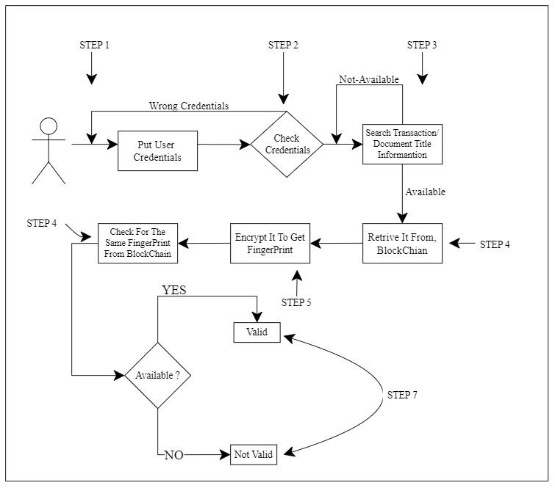
Figure 2: Flow diagram for the suggested setup
1. Organizing a wallet for execution the Ethereum blockchain network.
To set up an Ethereum wallet for carrying out smart contracts on the Ethereum distributed ledger, start by connecting to the Ethereum network using a tool like MetaMask and selecting a test network for initial contract testing. Ensure your wallet is funded with Ether to cover transaction costs, then write and compile your smart contract code in Solidity using tools like Remix IDE and the Solidity compiler. Thoroughly test your smart contracts before deploying them on the blockchain network, and once ready, deploy them by broadcasting a deployment transaction. By following these steps and utilizing essential tools, you can effectively set up an Ethereum wallet and execute smart contracts on the Ethereum blockchain network.
2. Gathering information from users via the web application
As the information for the user was required to legal document system are gathered using online application forms. It's created Using JS, CSS, and HTML for front-end also chakra JS UI is used for creating the user interface.
3. Using smart contracts to create blocks
To create blocks using smart contracts, developers can utilize tools like the Blocks Editor for customizing smart contract creation workflows. Smart Contract Blocks simplify contract creation by offering predefined variables for transactions, promoting standardization and reliability. Platforms like Stellar provide building blocks for developing full-fledged products and services with safe and efficient smart contract execution. These tools enhance functionality, ensuring compatibility and interoperability across applications in blockchain networks.
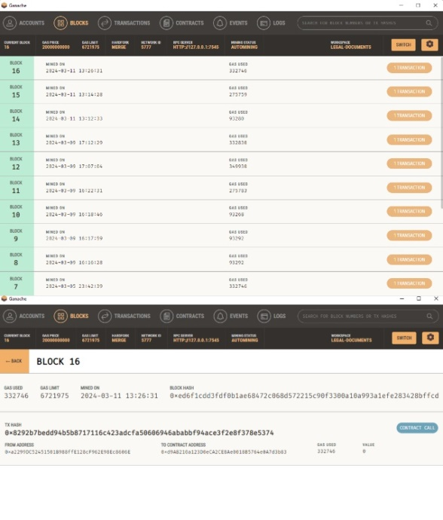
Figure 3: Block Creation & Gas Used

IMPLEMENTATION
The blockchain-based legal record system built using Ganache is like a super secure digital filing cabinet specifically designed to store important legal documents. Imagine it as a high-tech vault where clients, lawyers, and judges can safely keep and access legal records without worrying about them being tampered with or lost. This system uses special tools like MetaMask and Ganache to create private keys that act as digital locks, ensuring only authorized users can access the stored documents. It's like having your own virtual safe deposit box that keeps all your legal papers safe and sound.
With this system, each document stored in the digital vault is protected by advanced encryption technology, making sure that only the right people can view or modify them. It also keeps a detailed log of any changes made to the records, creating a tamper-proof trail that guarantees the integrity and authenticity of the documents.
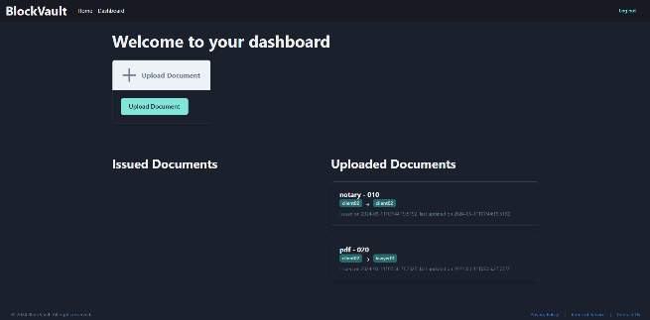
Figure 4: Dashboard Of Website
Moreover, the implementation of a blockchain-based legal record system enhances data integrity and transparency in the legal industry. Legal documents stored on a decentralized ledger are protected from unauthorized access or tampering through advanced encryption and append-only feeds. Using smart contracts automates managerial tasks and transactional work for lawyers, reducing manual labour hours and associated costs. By offering a safe and efficient platform for overseeing legal documents, this system revolutionizes how legal documents are handled, ensuring accessibility, cost savings, automation, data integrity, and transparency within the legal sector.
Blockchain technology revolutionizes legal document management by offering enhanced security, transparency, and efficiency. The inherent security features of blockchain ensure that legal documents are protected through strong access restrictions and encryption, protecting private data from unwanted access or tampering. By creating a decentralized and immutable ledger, blockchain instils trust and transparency in document transactions, allowing for verification and validation of each document's integrity and authenticity. This transparency not only enhances accountability but also builds confidence among stakeholders in the legal system, ensuring the reliability of document management processes.
One of the key advantages of using blockchain in legal document management is the instant verification and tracking capabilities it provides. Organizations can easily track the creation, modification, and access history of documents in real-time, creating a comprehensive audit trail for compliance and regulatory purposes. Additionally, blockchain-based certificates offer irrefutable proof of authenticity, enabling efficient notarization, verification of academic degrees, or validation of legal contracts. This streamlined verification process enhances operational efficiency and reduces the risk of fraudulent activities within document management workflows.
Furthermore, blockchain technology eliminates the need for third-party intermediaries in legal document management, reducing costs and enhancing operational efficiency. The decentralized nature of blockchain ensures equal access to information for all participants while maintaining data integrity and security. By implementing granular access controls, organizations can securely share documents with authorized individuals, mitigating the risk of unauthorized access or data breaches. The tracking and auditability features provided by blockchain enable organizations to maintain a transparent record of document-related activities, ensuring compliance with regulatory requirements and internal policies while streamlining document management processes effectively.
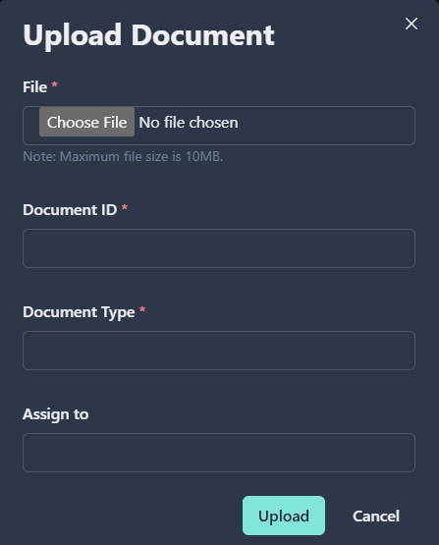
Figure 5: Document Details
The process of uploading documents to a blockchain network involves several steps. First, the user selects the files they want to upload through a file input dialog. The selected files are then processed, and their metadata is extracted. This metadata, along with the actual files, is hashed and stored on the blockchain. The hash serves as a unique identifier for the document, proving its existence and authenticity without exposing the actual content.
To ensure security, the user signs the document with their digital signature, which is known only to them. This signature allows anyone to verify that the document was indeed provided by the right person. The An audit log, which is stored on the blockchain, documents the path from sender to recipient creating a secure and verifiable transfer system.
In addition to document storage, blockchain technology can be used to prevent duplication and flag redundant documents It also allows for the creation of an archive, enabling users to view the document's entire editing history. This ensures that any changes made to the document are transparent and traceable, enhancing the overall safety as well as integrity among the document system of management.

FUTURESCOPE
The use of blockchain technology in the legal sector is poised as to revolutionize traditional practices by offering numerous advantages. From automating transactional work to digitally signing and archiving legal contracts, blockchain streamlines processes while reducing costs and enhancing efficiency. The introduction of smart contracts, e-signatures, and document storage on blockchain platforms promises to automate and simplify legal procedures, ultimately benefiting both legal professionals and clients. Moreover, the transparency embedded in blockchain-based contracts ensures compliance and eliminates doubts, fostering trust among stakeholders in the legal ecosystem.
Looking ahead, the future of blockchain evidence in courts holds significant promise for enhancing security, transparency, and efficiency within the legal system. As legislative frameworks evolve to recognize blockchain evidence and smart contracts in court proceedings, jurisdictions worldwide are paving the path to a more accessible and trustworthy judicial framework. By embracing blockchain technology for document management, legal professionals can expect streamlined workflows, reduced costs, improved data integrity, and enhanced transparency in their operations.

CONCLUSION
In conclusion, the implementation of E-Vault in Blockchain for the storage and management of legal records represents a noteworthy development in the area of data security additionally with legal documentation. Through the utilization of blockchain technology, a decentralized and immutable ledger system, the E-Vault platform ensures unparalleled transparency, integrity, and security in the storage and management of legal records. This innovation has not only revolutionized the traditional methods of record-keeping but has also addressed the pressing concerns related to data tampering, unauthorized access, and data loss prevalent in conventional storage systems. Furthermore, the E-Vault in Blockchain has significantly enhanced data accessibility and sharing, facilitating collaboration among legal entities, clients, and relevant stakeholders. With the elimination of intermediaries and the adoption of a decentralized network, the platform has fostered a more collaborative and transparent environment, promoting effective communication and decision-making within the legal domain. The incorporation of robust encryption protocols has fortified data privacy and confidentiality, ensuring that sensitive legal information remains safeguarded from unauthorized parties, thereby upholding the principles of confidentiality and privacy in legal operations. In essence, the E-Vault in Blockchain has emerged as a pivotal tool in modernizing the legal sector, streamlining processes, enhancing security, and fostering trust and transparency. Its implementation has not only elevated the standards of data management but has also set a new precedent for the integration of cutting-edge technology in the legal industry. As the world continues to embrace digital transformation, the E-Vault in Blockchain stands as a testament to the power of innovation in revolutionizing the way legal records are stored, managed, and accessed, ultimately shaping a more secure and efficient legal landscape for the future.
ACKNOWLEDGMENT
We express our profound gratitude to all contributors who have been instrumental in the success of our research project, their dedication, insights, and collaborative efforts have significantly shaped our work. Special thanks to Prof. Sagar Yeshwantrao for his invaluable guidance and support throughout the project, and to Prof. Rohini Bhosale and the Computer Engineering department for their unwavering backing and provision of resources that enabled the completion of this research. Our peers and mentors deserve recognition for their diverse ideas, feedback, and insights that have enriched our project, fostering a collaborative environment conducive to innovation and growth. Together, their collective contributions have not only enhanced the quality of our work but also exemplified a culture of excellence and collaboration within our academic community, leading to the successful culmination of this research endeavour.
REFERENCES
[1]. Farhana Akter Sunny,Petr Hajek, Michal Munk, Mohammad Zoynul Abedin, Md. Shahriare Satu, Md. Iftekharul Alam Efat, Md. Jahidul Islam "A Systematic Review of Blockchain Applications", "Blockchain, applications, business and industry, internet of things, privacy and security", Vol 10, 2022, DOI: 10.1109/ACCESS.2022.3179690
[2]. Diego Cagigas, Judith Clifton, Daniel Diaz-Fuentes,Marcos Fernández-Gutiérrez "Blockchain for Public Services: A Systematic Literature Review", "Blockchain, public services, government, civil servants, eGovernment, public sector innovation, systematic literature review.", Vol 09, 2021, DOI: 10.1109/ACCESS.2021.3052019
[3]. Aditya Vijaykumar Singh, Ashwin Omprakash Tiwari, Shreyash Sanjay Singh, Vivian Brian Lobo, "A Criminal Record Keeper System using Blockchain", 2018 Ivannikov Ispras Open Conference (ISPRAS), DOI:10.1109/ICOEI53556.2022.9776725
[4]. Fran Casino, Thomas K. Dasaklis, Constantinos Patsakis, "A systematic literature review of blockchain-based applications: Current status, classification and open issues", Vol 36, 2018, DOI: 10.1016/j.tele.2018.11.006
[5]. Rahime Belen-Saglam, Enes Altuncu, Yang Lu, Shujun Li, "A systematic literature review of the tension between the GDPR and public blockchain systems", Vol 4, 2023, DOI: 10.1016/j.bcra.2023.100129
[6]. Julian Solarte-Rivera, Andrés Vidal-Zemanate, Carlos Cobos, José Alejandro Chamorro-Lopez, Tomas Velasco"Document Management System Based on a Private Blockchain for the Support of the Judicial Embargoes Process in Colombia", 2018, DOI: 10.1007/978-3-319-92898-2_10
[7]. Meng Han, Zhigang Li, Jing He, Dalei Wu, Ying Xie, Asif Iqbal Baba, "A Novel Blockchain-based Education Records Verification Solution", "Conference: the 19th Annual SIG Conference", October 3–6, 2018, DOI: 10.1145/3241815.3241870
[8]. Maisha Afrida Tasnim, Abdullah Al Omar, Shahriar Rahman, Md. Zakirul Alam Bhuiyan, "CRAB: Blockchain Based Criminal Record Management System", "Conference: The 11th International Conference on Security, Privacy and Anonymity in Computation, Communication and Storage", 2018, pp. 294–303
[9]. Dezhi Han, Hongzhi Li, "EduRSS: A Blockchain-Based Educational Records Secure Storage and Sharing Scheme", "Educational records, Blockchain, Smart contract, Secure storage and sharing", Vol 7, 2019, DOI: 10.1109/ACCESS.2019.2956157
[10]. Eman-Yasser Daraghmi, Yousef-Awwad Daraghmi, Shyan-Ming Yuan, "MedChain: A Design of Blockchain-Based System for Medical Records Access and Permissions Management", 2019, DOI: 10.1109/ACCESS.2019.2952942
[11]. Shovon Niverd Pereira, Noshin Tasnim, Rabius Sunny Rizon, Muhammad Nazrul Islam "Blockchain-Based Digital Record-Keeping in Land Administration System", "Proceedings of International Joint Conference on Advances in Computational Intelligence", 2021, pp.431-443
[12]. R.C. Suganthe, N. Shanthi, R.S. Latha, K. Gowtham, S. Deepakkumar, R. Elango, "Blockchain enabled Digitization of Land Registration", " 2021 International Conference on Computer Communication and Informatics (ICCCI)", 2021, DOI: 10.1109/ICCCI50826.2021.9402469
[13]. Heng Xu, Nan Zhang, "Privacy implications ofblockchain systems: a datamanagement perspective", "Published in Organizational Cybersecurity Journal: Practice, Process and People", Vol 03, 2023, DOI:10.1108/OCJ-01-2023-0003
[14]. Alhaj Hossen, Md. Mahedi Hasan, Tahmid Ahmed, Md. Anwar Hussen Wadud, "A Blockchain-Based Secured Land Record System Using Hyperledger Fabric", "The Fourth Industrial Revolution and Beyond", 2023, DOI: 10.1007/978-981-19-8032-9_13

