Baswant Housing Real Estate

|  |  |  |
| --- | --- | --- |
| Snehal R Pande Information Technology  Met’s Institute of Technology Polytechnic, Bhujbal Knowledge City, Adgaon, Nashik, Maharashtra, India [email:pandesnehal332@gmail.com](mailto:pandesnehal332@gmail.com) | Tejas N Vadanere Information Technology  Met’s Institute of Technology Polytechnic, Bhujbal Knowledge City, Adgaon, Nashik,  Maharashtra, India [email:tejasvadnere555@gmail.com](mailto:tejasvadnere555@gmail.com) | Jeevan Jadhav Information Technology  Met’s Institute of Technology Polytechnic, Bhujbal Knowledge City, Adgaon, Nashik,  Maharashtra, India [email:sonujadhav@gmail.com](mailto:sonujadhav@gmail.com) |
|  | Navtesh A. Deore Information Technology  Met’s Institute of Technology Polytechnic, Bhujbal Knowledge City, Adgaon, Nashik, Maharashtra, India  [email:navteshdeore2005@gmail.com](mailto:navteshdeore2005@gmail.com) |  |

|  |  |
| --- | --- |
| Pallavi.M.Takate Project Guide Information Technology  Met’s Institute of Technology Polytechnic,  Bhujbal Knowledge City, Adgaon, Nashik, Maharashtra, India [email:pallavit_iot@bkc.met.edu](mailto:pallavit_iot@bkc.met.edu) | Sanjeev.B.Patil  HOD, Dept. of Information Technology Met’s Institute of Technology Polytechnic,  Bhujbal Knowledge City, Adgaon, Nashik, Maharashtra, India [email:sanjeevp_iot@bkc.met.edu](mailto:sanjeevp_iot@bkc.met.edu) |

***Abstract- The data of different properties in different areas can be available at one put. This site is outlined to look accessible property in our locality. Form buying property. selling property or reanting of property in our range This framework offer assistance us to keep up the database of different properties with their rates and oweners, buyers, renters, agents information. Here you found the way better administrations resources property or houses. Due to this System. there is no require to visit different places in look of desirproperty.***

***Keyword: Residential Projects, Quality Construction, Sustainability Initiatives, Quality Construction.***

# INTRODUCTION

Baswant Housing Real Estate stands as a beacon of excellence and innovation in the realm of real estate development. Established with a vision to redefine urban living and working spaces, Baswant Housing has emerged as a trusted name synonymous with quality, reliability, and customer satisfaction.

Since its inception, Baswant Housing Real Estate has been at the forefront of creating iconic residential, commercial, and mixed-use projects that not only elevate skylines but also enrich lives. With a meticulous focus on design, construction, and sustainability, the company has carved a niche for itself in the competitive real estate landscape.

Driven by a passion for excellence and a commitment to surpassing expectations, Baswant Housing Real Estate continues to push boundaries, embracing new technologies, architectural trends, and sustainable practices to deliver projects that inspire and endure.

# Literature Review

The real estate industry is a dynamic and multifaceted sector that plays a vital role in shaping urban environments and meeting the evolving needs of communities. Baswant Housing Real Estate, as a prominent player in this field, has garnered attention from researchers and scholars alike. This literature review aims to provide insights into existing research and scholarly works related to Baswant Housing Real Estate, focusing on key themes such as sustainability, innovation, customer satisfaction, and urban development.

Research in sustainable real estate development emphasizes the importance of incorporating environmentally friendly practices into construction projects. Baswant Housing Real Estate has been commended for its commitment to sustainability, with studies highlighting the company's

adoption of green building technologies, energy-efficient designs, and eco-friendly materials. Scholars argue that integrating sustainability into real estate projects not only reduces environmental impact but also enhances long-term value and marketability.

# Methodology

1. **Research Objectives Definition:**

Clearly define the objectives of the study. These may include understanding Baswant Housing Real Estate's business model, analyzing its market positioning, assessing customer satisfaction levels, evaluating sustainability practices, or exploring innovation in its projects.

# Ethical Considerations:

Ensure ethical principles are upheld throughout the research process, including informed consent, confidentiality, anonymity, and respect for participants' rights. Obtain necessary approvals from relevant authorities or ethics committees if required.

# Reporting and Dissemination:

Present the research findings in a comprehensive report, highlighting key insights, analysis, and recommendations. Consider the audience and purpose of the research when determining the format and style of the report. Disseminate the findings through presentations, publications, or other appropriate channels to share knowledge and contribute to the body of research on Baswant Housing Real Estate.

# Sampling Strategy:

* + **Population Definition:** Define the population under study, which may include all stakeholders associated with Baswant Housing Real Estate, such as employees, customers, investors, and partners.
  + **Sampling Method:** Determine the sampling method based on the research objectives. For instance, purposive sampling may be used to select key informants for interviews, while random sampling may be employed for customer surveys.

# Triangulation:

Use triangulation to enhance the credibility and validity of the findings by comparing and corroborating information obtained from multiple sources.

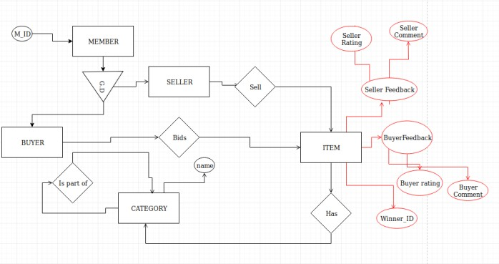

# Results

Project Portfolio: Visitors to the Baswant Housing Real Estate website can expect to find a comprehensive portfolio showcasing their various residential, commercial, and mixed- use projects. Each project listing would likely include detailed information such as location, amenities, floor plans, and virtual tours where available.

Company Profile: The website would feature an overview of Baswant Housing Real Estate, highlighting their history, mission, values, and key milestones. This section may also include information about the company's leadership team, corporate social responsibility initiatives, and awards or recognitions received.

Customer Testimonials: Potential homebuyers or investors may find testimonials from satisfied customers who have previously purchased properties from Baswant Housing Real Estate. These testimonials could provide insights into the quality of construction, customer service, and overall satisfaction experienced by past clients.

Latest News and Updates: The website may feature a section dedicated to news and updates, where visitors can find information about new project launches, construction milestones, industry partnerships, and other company announcements.

# Future Scope

Baswant Housing Real Estate stands at the forefront of innovation and excellence in the real estate sector, poised for continued growth and success in the future. With a strong foundation built on quality construction, customer satisfaction, and sustainability, the company is well- positioned to capitalize on emerging trends and opportunities in the evolving real estate landscape.

**Expansion into New Markets:** Baswant Housing Real Estate has the potential to expand its footprint beyond existing markets, tapping into burgeoning urban centers and emerging suburban areas. By diversifying its geographical presence, the company can access new customer segments and capitalize on growing demand for housing and commercial properties in rapidly developing regions.

**Innovation in Design and Technology:** Embracing innovative design concepts and cutting-edge technologies will remain a key focus for Baswant Housing Real Estate. By incorporating smart home features, energy-efficient systems, and sustainable building materials, the company can enhance the attractiveness and functionality of its projects while reducing environmental impact and operational costs.

**Focus on Sustainable Development:** As sustainability continues to gain prominence in the real estate industry, Baswant Housing Real Estate can further strengthen its commitment to eco-friendly practices. Investing in green building certifications, renewable energy solutions, and carbon-neutral initiatives will not only align with regulatory requirements but also appeal to environmentally conscious

consumers and investors.

**Mixed-Use and Transit-Oriented Developments:** The trend towards mixed-use and transit-oriented developments presents an opportunity for Baswant Housing Real Estate to create vibrant, integrated communities that offer a blend of residential, commercial, and recreational amenities. By leveraging strategic partnerships and urban planning principles, the company can develop innovative projects that promote connectivity, walkability, and livability.

# Output

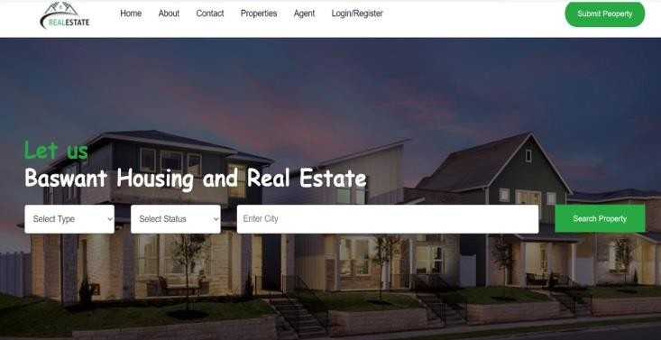

1. **CONCLUSION**

As visitors conclude their exploration of the Baswant Housing Real Estate website, they are left with a profound understanding of the company's ethos, values, and vision for the future. Through an intuitive and engaging interface, the website effectively communicates Baswant Housing's commitment to excellence, innovation, sustainability, and customer satisfaction in the real estate sector.

With its user-friendly navigation, informative content, and visually captivating design, the website serves as a gateway to a world of unparalleled residential, commercial, and mixed-use developments. Whether seeking a dream home, a prime office space, or an investment opportunity, visitors are empowered to explore Baswant Housing's diverse portfolio of projects with confidence and clarity.

# REFERENCES

1. [1] A. Adair, J. Berry, W. McGreal, Hedonic modeling, housing submarkets and residential valuation, Journal of Property Research, 13 (1996) 67-83.
2. O. Bin, A prediction comparison of housing sales prices by parametric versus semi-parametric regressions, Journal of Housing Economics, 13 (2004) 68-84.
3. T. M. Oshiro, P. S. Perez, and J. A. Baranauskas, “How many trees in a random forest?” In Lecture Notes in Computer Science (including subseries Lecture Notes in Artificial Intelligence and Lecture Notes in Bioinformatics), vol. 7376 LNAI, 2012, pp. 154–168, ISBN: 9783642315367. DOI: 10 . 1007 / 978 - 3 - 642 - 31537-4\ 13
4. J. Schmidhuber, “Multi-column deep neural networks for image classification,” in Proceedings of the 201 IEEE Conference on Computer Vision and Pattern Recognition (CVPR), ser. CVPR ’12, Washington, DC, USA: IEEE Computer Society, 2012, pp. 3642–3649, ISBN: 978-1- 4673-1226-4. [Online].
5. T. Kauko, P. Hooimeijer, J. Hakfoort, Capturing housing market segmentation: An alternative approach

based on neural network modeling, Housing Studies, 17 (2002)875-894.

1. LI Bo-sheng. Financial Crisis Management. Beijing: Social Sciences Academic Press, 2008
2. SONG Min-gang. The Cause and Characteristic Index Analysis of Real Estate Enterprise Financial Risk. China Securities and Futures, 2009(11):44-46
3. LU Wen-dai. Statistical Analysis of SPSS for Windows. Beijing: Electronics Industry Press, 2006
4. CHEN Li-wen, MENG Ling-ge. A Study on the Model of Warning System Against Listed Corporate of Real Estate. Value Engineering, 2010(08):34-36
5. WANG Cheng, WANG Ji-shun. Comprehensive Evaluation on the Marks of Statistical Practices Graduates Based on Factor Analysis and Cluster Analysis. Journal of Gansu Lianhe University (Natural Sciences),2011(01):26-30