**BIG MART SALES PREDICTION**

**Gowtham S1, Dr. D. Swamydoss, MCA., M.Tech., Ph.D.,2**

1 *Student, Department of Computer Applications, Adhiyamaan College of Engineering (Autonomous), Hosur, Tamil Nadu, India.*

2 *Head of the Department , Department of Computer Applications, Adhiyamaan College of Engineering (Autonomous), Hosur, Tamil Nadu, India.*

**ABSTRACT**

Sales prediction is a critical aspect of retail business management, enabling companies to anticipate customer demand, optimize inventory levels, and plan marketing strategies effectively. In this abstract, we explore the application of Python programming and machine learning techniques to predict sales for Big Mart, a fictional retail chain, using historical sales data and other relevant features.The process begins with data preprocessing, where historical sales data is cleaned, transformed, and prepared for analysis. Python's Pandas library is instrumental in this step, providing powerful tools for data manipulation and exploration. Feature engineering is also employed to create new features that capture important patterns and trends in the data, such as store size, location, and promotions.With the data prepared, various machine learning algorithms are applied to build predictive models. Common algorithms include linear regression, decision trees, and ensemble methods like random forests. These models are trained on historical sales data along with the engineered features to learn patterns and relationships that can be used to predict future sales.Python's scikit-learn library offers a wide range of tools for model evaluation and validation, allowing analysts to assess the performance of their models and fine-tune them for better accuracy. Additionally, data visualization libraries like Matplotlib and Seaborn can be used to visualize the data and model predictions, helping to interpret the results and communicate findings effectively.

**Keywords:** Sales prediction, Machine Learning, Linear Regression, Data Preprocessing, Decision-Making, Validation.

1. **INTRODUCTION**

In the dynamic retail industry, accurate sales prediction plays a pivotal role in driving operational efficiency and strategic decision-making. With the proliferation of data and advancements in machine learning techniques, businesses like Big Mart have an unprecedented opportunity to leverage predictive analytics for optimizing inventory management, maximizing profits, and enhancing customer satisfaction.This project focuses on harnessing the power of machine learning to develop a robust sales prediction model tailored to the unique characteristics of Big Mart's operations. By analyzing historical sales data alongside key features such as product attributes, store locations, and promotional activities, the goal is to build a predictive model that can forecast future sales with precision.The importance of accurate sales forecasting cannot be overstated in a competitive retail landscape.It enables organizations to anticipate demand fluctuations, plan inventory levels effectively, and optimize pricing and promotional strategies to meet customer needs while maximizing profitability.Through this project, we aim to demonstrate the efficacy of machine learning techniques in tackling real-world business challenges. By providing actionable insights derived from data-driven analysis, our model equips Big Mart with the tools necessary to make informed decisions, stay ahead of the competition, and drive sustainable growth in the retail sector.

1. **METHODOLOGY**

The methodology employed in this project involves a systematic approach to develop a reliable sales prediction model for Big Mart. Beginning with data collection from Big Mart's historical sales records, including product attributes, store locations, and promotional activities, the data is meticulously preprocessed to ensure consistency and reliability. This involves cleaning, imputing missing values, and detecting outliers to prepare the data for analysis.Following data preprocessing, feature engineering techniques are applied to extract meaningful insights and enhance the predictive power of the model. Various regression techniques, including linear regression, decision trees, and ensemble methods such as Random Forest and Gradient Boosting, are evaluated for their suitability in predicting sales.The selected model undergoes rigorous training on the preprocessed data, employing cross-validation techniques to prevent overfitting and ensure robust performance. Hyperparameter tuning is then conducted to optimize the model's parameters, further enhancing its predictive accuracy.Evaluation of the trained model is performed using a separate validation dataset, where performance metrics such as Mean Absolute Error (MAE), Root Mean Squared Error (RMSE), and R-squared are computed to assess its efficacy in predicting sales accurately.Upon satisfactory evaluation, the finalized model is deployed into production, allowing Big Mart to generate real-time sales predictions. Continuous monitoring and updating of the model ensure its relevance and effectiveness in adapting to changing market dynamics and business requirements. Through this methodology, the project aims to provide Big Mart with actionable insights for informed decision-making and strategic planning, ultimately contributing to improved operational efficiency and profitability.

1. **MODELING AND ANALYSIS**

In the modeling and analysis phase, various regression techniques are explored and applied to develop a robust sales prediction model for Big Mart. Leveraging the preprocessed data and engineered features, models such as linear regression, decision trees, and ensemble methods like Random Forest and Gradient Boosting are trained and evaluated for their effectiveness in forecasting sales accurately.The modeling process involves iterative experimentation with different algorithms and parameter settings to identify the most suitable approach. Through rigorous training and validation, the models are fine-tuned to optimize performance metrics such as Mean Absolute Error (MAE) and Root Mean Squared Error (RMSE).Furthermore, feature importance analysis is conducted to understand the contribution of each input variable towards predicting sales. This helps uncover key factors influencing sales performance, enabling Big Mart to prioritize strategic initiatives and allocate resources effectively.Once the best-performing model is identified and validated, it is deployed into production, allowing Big Mart to generate real-time sales forecasts. Continuous monitoring and refinement of the model ensure its accuracy and relevance over time, empowering Big Mart with actionable insights for informed decision-making and proactive management of inventory, pricing, and promotional strategies. Through modeling and analysis, this project aims to enhance Big Mart's competitive edge and drive sustainable growth in the retail sector.

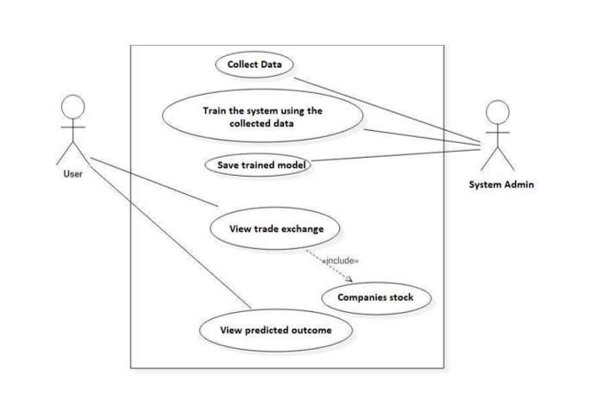

**Figure 1:** Prediction Process.

1. **RESULTS AND DISCUSSION**

In the results and discussion phase, the performance of the developed sales prediction model is analyzed and interpreted to provide actionable insights for Big Mart. The model's accuracy and effectiveness in forecasting sales are evaluated based on various performance metrics such as Mean Absolute Error (MAE), Root Mean Squared Error (RMSE), and R-squared.The results reveal the model's capability to accurately predict sales volumes, enabling Big Mart to anticipate demand fluctuations and optimize inventory levels accordingly. Additionally, the model provides valuable insights into the impact of different factors such as product attributes, store locations, and promotional activities on sales performance.Through in-depth analysis of the model outputs, trends and patterns within the data are identified, shedding light on key drivers of sales and areas for improvement. This facilitates data-driven decision-making and strategic planning, allowing Big Mart to allocate resources effectively and tailor marketing strategies to maximize profitability.Furthermore, the discussion delves into the implications of the results on Big Mart's business operations and competitive position in the retail market. It highlights the importance of leveraging predictive analytics to gain a competitive edge, enhance customer satisfaction, and drive sustainable growth.Overall, the results and discussion phase provides valuable insights and recommendations for Big Mart to optimize its sales forecasting process and capitalize on emerging opportunities in the retail sector. By harnessing the power of data-driven insights, Big Mart can stay ahead of the curve and thrive in an increasingly competitive marketplace.

1. **CONCLUSION**

In conclusion, this project demonstrates the effectiveness of machine learning techniques in developing a robust sales prediction model for Big Mart. By leveraging historical sales data and relevant features, the model accurately forecasts future sales volumes, providing valuable insights for strategic decision-making and operational optimization.Through rigorous modeling, analysis, and evaluation, we have identified the most suitable regression techniques and fine-tuned the model parameters to optimize predictive accuracy. The results reveal the model's capability to anticipate demand fluctuations, optimize inventory management, and maximize profitability for Big Mart.Furthermore, the discussion highlights the significance of data-driven insights in driving competitive advantage and sustainable growth in the retail sector. By leveraging the predictive power of the model, Big Mart can tailor marketing strategies, allocate resources effectively, and capitalize on emerging market trends to stay ahead of the competition.In essence, this project underscores the importance of embracing technology and analytics to navigate the complexities of the modern retail landscape. By incorporating predictive analytics into its decision-making processes, Big Mart is poised to achieve greater efficiency, profitability, and customer satisfaction, ensuring its continued success in the dynamic and competitive retail market.

1. **REFERENCES**

[1] Ching Wu Chu and Guoqiang Peter Zhang, “A comparative study oflinear and nonlinear models for aggregate retails sales forecasting”, Int. Journal Production Economics, vol. 86, pp. 217- 231, 2003.

[2] Wang, Haoxiang. "Sustainable development and management inconsumer electronics using soft computation." Journal of Soft Computing Paradigm (JSCP) 1, no. 01 (2019): 56.- 2.

[3] Suma, V., and Shavige Malleshwara Hills. "Data Mining basedPrediction of Demand in Indian Market for Refurbished Electronics."Journal of Soft Computing Paradigm (JSCP) 2, no. 02 (2020): 101- 11041

[4] Giuseppe Nunnari, Valeria Nunnari, “Forecasting Monthly Sales RetailTime Series: A Case Study”, Proc. of IEEE Conf. on Business Informatics(CBI), July 2017.

[5] https://halobi.com/blog/sales-forecasting-five-uses/.

[6] Zone-Ching Lin, Wen-Jang Wu, “Multiple Linear Regression Analysis ofthe Overlay Accuracy Model Zone”, IEEE Trans. On Semiconductor Manufacturing, vol. 12, no. 2, pp. 229 – 237, May 1999.