**CAR MARKET**

**Murali V 1 , Dr. D. Swamydoss, MCA., M.Tech., Ph.D.,2**

1 *Student, Department of Computer Applications, Adhiyamaan College of Engineering (Autonomous), Hosur, Tamil Nadu, India.*

2 *Head of the Department, Department of Computer Applications, Adhiyamaan College of Engineering (Autonomous), Hosur, Tamil Nadu, India.*

**ABSTRACT**

When purchasing or selling an automobile, one must take into account societal preferences, governmental regulations, and the state of the economy. Cars with unique features like connectivity, safety features, and fuel efficiency are preferred by consumers. They may spend more on luxury cars during prosperous economic times, but they search for less expensive alternatives during lean times. Researching and purchasing cars online is now simpler thanks to technology. Governments also have an impact on the design and sales of cars through regulations pertaining to safety and emissions. Understanding financing, haggling over costs, and ensuring that autos are in good condition are among the difficulties. Regulations and charging stations are two new elements that come into play as electric and self-driving automobiles gain popularity. In general, the process of purchasing and selling cars is continuously evolving, influenced by what individuals.

**Keywords :** Buying and selling, Consumer preferences, Economic conditions, Technological advancements, Connectivity, Innovation.

1. **INTRODUCTION**

Purchasing and selling cars is a huge deal in the automotive industry! It all comes down to what the public finds appealing, the state of the economy, and the laws in place. Automobiles with unique features, low gas consumption, and safety are what people demand. They may desire expensive cars in prosperous times, but they search for less expensive vehicles in hard times. Cars are easier to find and purchase online thanks to technology. Governments also set standards for the safety and design of automobiles. However, there are obstacles, such as knowing how to finance an automobile and ensuring that it is in good condition. And things are changing even more now that self-driving and electric automobiles are available! Thus, purchasing and selling vehicles.

1. **METHODOLOGY**

A methodology is a set of instructions used in research. It's how we determine what consumers want and how to improve cars in the automotive industry. To learn about people's wants and preferences, we must observe or question them. Then, to determine what functions best, we conduct experiments and examine data. We occasionally compare various things to determine which is superior. For instance, we may contrast gas and electric vehicles to determine which is more popular. Experts are another source of information that we consider and apply to deepen our understanding. After compiling all of this data, we examine it to look for trends and draw conclusions. This enables automakers to produce better vehicles that consumers will adore!

1. **MODELING AND ANALYSIS**

Analyzing and modeling are similar to constructing a toy automobile and then working out how it operates. In the automotive industry, this involves creating computer-generated simulations of cars and analyzing them to determine their real-world behavior. First, we make these model automobiles using specialized computer programs. We give them various characteristics, such as size, form, and functionality. After that, we test these make-believe autos to see how they function. We consider factors such as engine displacement, fuel consumption, and safety. We examine the test findings to determine what works well and what needs to be improved in the autos. This aids auto designers in creating authentic. First, we utilize computers to simulate cars, adjusting their features and designs until they are perfect. Next, we put these simulated vehicles through their paces to examine how they would handle various scenarios, such as traversing city traffic or highways. Before creating the cars, we may identify any issues and make adjustments by examining the data. This guarantees that the finished product satisfies drivers' needs while saving time and money. Therefore, from an idea to a roadworthy, safe, and fun car, modeling and analysis are essential phases in the process.

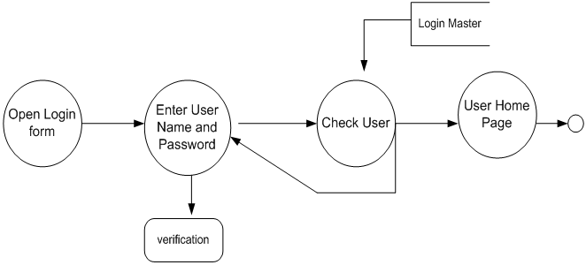

**Figure1:**Buyer and Seller Pro.

1. **RESULTS AND DISCUSSION**

Findings and analysis are similar to narrating a tale about the events during the vehicle tests. Within the automotive industry, testing real or virtual cars allows us to share the insights we've gained. We discuss items like their top speed, safety features, and fuel consumption. After that, we go over the significance of these findings and how they might improve automobiles. For instance, we might advocate using a particular design into cars going forward if we discover that it makes them safer in collisions. We also discuss any unexpected results or surprises we had while doing the exams. This makes it easier for everyone to comprehend what goes into creating cars and how to improve upon them.

1. **CONCLUSION**

In summary, a wide range of factors, including as consumer preferences, prevailing economic situations, technical breakthroughs, and regulatory frameworks, have molded the dynamic and ever-evolving landscape of the car market. It is clear from our investigation into the purchasing and selling of cars that consumers and industry players alike must comprehend these intricate dynamics. Car makers are better able to meet the changing expectations of consumers and navigate both economic and regulatory changes when they acknowledge the significance of elements like sustainability, safety, connectivity, and fuel efficiency.The automobile sector must continue to embrace innovation and adjust to the shifting needs of the market going forward. This entails making the most of technology developments like electric and self-driving cars, improving online shopping, and giving sustainability a higher priority in production procedures.

1. **REFERENCES**
2. Genesove, David. "Adverse selection in the wholesale used car market." Journal of Political Economy 101, no. 4 (1993): 644-665.
3. Verboven, F. (1996). International price discrimination in the European car market. The RAND Journal of Economics, 240-268.
4. Monga, Nikhil, Bhuvender Chaudhary, and Saurabh Tripathi. "Car market and buying behavior: A study of consumer perception." International Journal of Research in Management, Economics and Commerce 2.2 (2012): 44-63.
5. Jochem, P., Gómez Vilchez, J.J., Ensslen, A., Schäuble, J. and Fichtner, W., 2018. Methods for forecasting the market penetration of electric drivetrains in the passenger car market. Transport Reviews, 38(3), pp.322-348.
6. Li, Q., Li, Y., & Liang, H. (2019). The economic impacts of online service platforms: A two-sided market analysis. Electronic Commerce Research and Applications, 35, 100836.
7. Guo, Dong, et al. "Forecast of passenger car market structure and environmental impact analysis in China." Science of the Total Environment 772 (2021): 144950.