**EFFICIENT SOUND TRANSMITTING TOOTH-ANCHORED BONE CONDUCTION VIBRATING HEARING AID**

**Ms Bilna C1, Monika S2 , Kalaimathi T3 , Mythili B4 , Krishnavelavan A5**

1Assistant Professor, Biomedical Engineering, Agni College of Technology, Chennai, Tamil Nadu, India

2345Student, Biomedical Engineering, Agni College of Technology, Chennai, Tamil Nadu, India

**ABSTRACT**

BC hearing aids are the only non-surgical devices used for conductive hearing loss. We proposed a bone conduction hearing aid that is manufactured in the form of a dental implant type, and the excitation is directly transmitted to the bone by integrating it via bone conduction through the tooth. This doesn’t require any of your teeth to be altered, and the device can be inserted and removed easily. This hearing device is designed to use the natural amplification of your ear. Any sound coming from Modem is attenuated and it uses a digital processor (PIC16F877A) to transmit the signals to the soundbite module which needs very little power to generate the vibrations that travel through bone, which in turn sends those sound vibrations into your cochlea through your teeth. This way, the sound is transported from your impaired ear directly to your hearing ear.We measured the thresholds of bone conduction hearing (via the teeth) with the use of a bone conductive actuator. The findings indicated that our design was more acceptable for users with SSD due to its effectiveness, providing excellent concealment, which could increase user’s equity and confidence.

**Keywords :** Natural amplification, Bone Conduction, Modem, Digital Processor, Piezoelectric actuator, Dental Implants.

1. **INTRODUCTION**

Hearing is one of the five essential senses of our body that helps us communicate with one another and helps gain awareness of one's surroundings. When humans and other mammals perceive sound, the sound waves enter the external auditory canal and vibrate the tympanic membrane. This auditory stimulus is transmitted within the middle ear through three ossicles, the malleus, incus, and stapes, which relay the sound to the cochlea. Within the cochlea, the mechanical vibration of sound is transduced into an electrical signal, which activates the cochlear nerve. After passing through several nuclei in the central auditory pathway, the signal reaches the auditory cortex in the temporal lobe of the brain, resulting in hearing perception. Hearing loss can be classified into two categories based on the affected anatomical structure. If the external auditory canal, tympanic membrane, and ossicles are involved, it is called conductive hearing loss. In contrast, sensorineural hearing loss is caused by impairment of the cochlea, cochlear nerve, and more central auditory pathways. The perception of sound through the tympanic membrane and ossicles of the ear is called air conduction hearing and perception of skull vibrations directly entering the cochlea is called bone conduction hearing.

Profound unilateral sensorineural hearing loss, frequently referred to as single-sided deafness (SSD), characterizes a condition where one ear exhibits clinically-unaidable hearing impairment. This impairment is typified by severe-to-profound hearing thresholds coupled with poor word recognition ability. The incidence of SSD varies significantly, ranging from 3.2% to 19.4%. The causes of SSD are diverse, encompassing a wide array of pathologies including cochleovestibular abnormalities, temporal bone trauma, Meniere’s disease, vestibular schwannoma, vascular ischemia, autoimmune disorders, and infections. However, it is frequently of idiopathic origin.SSD often manifests suddenly, causing profound debilitation for the affected individual. Sensorineural hearing loss, the hallmark of SSD, is typically irreversible, and recovery through surgical intervention is not feasible. Consequently, compensatory measures such as air-conduction hearing aids or cochlear implants are employed to address the hearing deficit.In stark contrast, most cases of conductive hearing loss, characterized by disruptions in sound conduction through the outer or middle ear, are amenable to radical treatment through conventional ear surgeries. Procedures such as tympanoplasty, which repairs defects in the eardrum, and stapes surgery, which addresses abnormalities in the middle ear ossicles, offer effective solutions for mitigating conductive hearing loss. However, surgical treatment is not possible for some types of conductive hearing loss, such as severe chronic otitis. Individuals coping with single-sided deafness (SSD) encounter notable challenges in their daily lives, stemming from three primary difficulties:

1. Difficulty Localizing Sounds: One major hurdle is the struggle to perceive sounds originating from the deafened side, leading to spatial disorientation and compromised situational awareness. This deficit not only affects safety but also impacts social interactions and everyday tasks.

2. Difficulty Hearing in Noisy Environments: Another significant challenge is the diminished ability to filter out background noise and focus on desired sounds, particularly in bustling environments. This issue exacerbates communication barriers and contributes to feelings of frustration and isolation.

3. Inability to Predict Sound Direction: The inability to accurately discern the direction of sound sources further compounds the challenges faced by individuals with SSD, as it impairs their ability to react appropriately to auditory stimuli and navigate their surroundings effectively.

These functional disabilities often result in adverse psychosocial consequences, including withdrawal from social engagements, limitations in participation in various activities, and an increased reliance on others for communication support. As a consequence, individuals with SSD frequently experience a range of negative emotions, including denial, anger, depression, and feelings of isolation. In recent years, bone conduction hearing aids have emerged as a promising intervention for SSD due to their ability to bypass the damaged ear and directly stimulate the cochlea through bone conduction. However, traditional bone conduction devices that transmit sound vibrations through the skin encounter a significant challenge: the attenuation of the excitation signal by the skin. This attenuation diminishes the audibility of the transmitted sound, thereby limiting the efficacy of these devices in addressing the auditory needs of individuals with SSD. Meanwhile, the implantable bone conduction hearing aid (BAHA) has been developed in Sweden and sold commercially. This aid transmits excitation signals directly to the bone because it is fixed directly on the bone with a screw. The shortcomings associated with BAHA relate to the fact that it requires surgery and is visible from the outside because a titanium actuator is required to be surgically embedded in the skull so that the hearing aid can be attached to it. Therefore, we proposed an implantable hearing aid that is not visible from the outside. Instead, it is installed in the crown on the dental implants that could benefit the aging population. Unlike implantable bone conduction hearing aids, our device implantation requires no surgery. Rather, it is the type of removable and non-surgical hearing dental implant that uses the well-established principle of bone conduction to imperceptibly transmit sound via the teeth. Custom made for each person, Our device is simple, removable, and totally non-invasive.

1. **METHODOLOGY**

Our proposed system involves the development and effectiveness of a novel tooth-anchored bone conduction vibrating hearing aid designed to improve sound transmission in individuals with hearing impairments such as single sided deafness. Traditional bone conduction hearing aids face challenges in effectively transmitting sound due to issues such as skin attenuation and poor user satisfaction. In response, this innovative device utilizes a tooth-anchored approach to enhance sound transmission directly to the cochlea, bypassing traditional pathways. By vibrating the teeth, the device aims to improve audibility, speech perception, and user satisfaction.

**2.1) Objective**

Our objective is to design a selective auditory attention-sound detecting support system. We propose an implanted hearing aid that can be worn in the crown of the tooth (i.e, as a dental implant and operates in accordance with the bone conduction mechanism .The device in turn creates imperceptible vibrations using a piezoelectric actuator that are sent via the teeth, through the skull bones and ultimately to the cochlea. In our proposed system, individual target and anti-target sound sources in the environment can be selected, and the target sources in the facing direction are emphasized.

**2.2) Fabrication of a v3 voice module**

The production process of a commercially available conventional piezoelectric diaphragm (CPD) was modified to fabricate a novel piezoelectric transducer. Piezoelectric material with a thickness of 0.15 mm and a diameter of 15.0 mm was attached to a metal electrode plate with a thickness of 0.5 mm and a diameter of 25.0 mm. In SPT, the upper electrode was not attached to the top side of the exposed piezoelectric material. The flexible printed circuit was made of a polyimide base material and copper wiring and insulated by a parylene material to avoid chemical reactions and insulating paint to avoid a short circuit caused by the voltage application when the lower electrode contacts the skin. The voltage was applied by connecting the leads to the electrodes attached to the FPC and by attaching a ground electrode at a distant location from the soundbite application site.

**2.3) Physical Characteristics of Soundbite module**

The vibration motor present in the soundbite module produces mechanical vibrations in the frequency of around 6 Khz to 8 Khz which requires only a small amount of voltage supply of about 6V – 12V. The piezo electric material converts the electrical signals into mechanical vibrations which are ultimately attenuated to the cochlea directly through bone conduction. For insulation, parylene film is coated to protect the soundbite module which makes it resistant towards the chemicals present in the saliva and also water resistant. The life time period is for about 2 - 4 years.

1. **MODELING AND ANALYSIS**

**3.1) System Architecture**

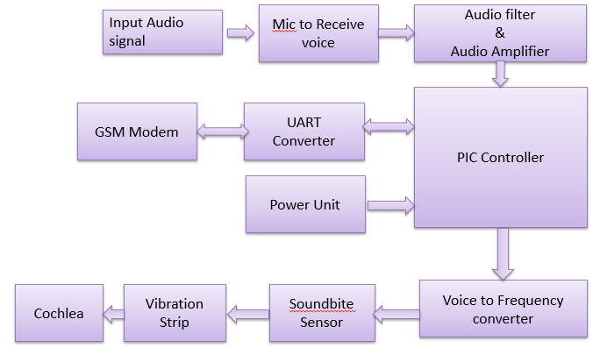

**Figure 1:** Proposed System

**3.2) Electronic Components**

* + 1. **Hardware Description :**

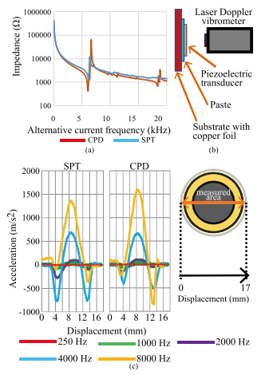

**PIC16F877A Microcontroller** - High-performance RISC CPU.Low-power, high-speed CMOS FLASH/EEPROM technology.In-Circuit Serial Programming (ICSP).Wide operating voltage range: 2.0V to 5.5V.Commercial and Industrial temperature ranges.Low-power consumption.

**SIM800A GSM Module** - This GSM Modem can accept any GSM network act as SIM card and just like a mobile phone with its own unique phone number.

Advantage of using this modem will be that you can use its RS232 port to communicate and develop embedded applications with low power consumption

**4G data Modem -** 4G LTE modem with SIM card socket, SMA antenna connector, DC power jack, and serial interface supports wireless communication modes of LTE-TDD/LTE-FDD/GSM/GPRS/EDGE. Suitable for LTE and GSM networks.Abundant software functions: USB. Powerful TCP/IP protocol stack for internet data transfer.

**Transformer -** Signal and audio transformers serve as intermediaries between different components in electronic systems, facilitating the seamless transfer of signals between them. They are utilized to connect different stages of amplifiers and ensure that devices like microphones and record players are compatible with the input requirements of amplifiers.

**Soundbite Module -** Consists of a vibration motor encapsulated with a rubber coating for insulation which transmits the signals received from the modem into mechanical vibrations with the help of the pic microcontroller for bone conduction.

* + 1. **Software Description :**

MPLAB IDE(MPLAB C Compiler) - Supports all 8-, 16- and 32- bit PIC MCUs and dsPIC® DSCs

Integrates with MPLAB X IDE to provide a full graphical front end .

1. **RESULTS AND DISCUSSION**

We developed a novel type of bone conduction device that efficiently transmits sound to the cochlea by skipping the tympanic membrane and middle ear ossicles. This novel device does not exert pressure on the jawline that can result in cavity damage when wearing conventional BCHAs. we have compared the threshold of hearing when teeth were vibrated in the horizontal (horizontal excitation) and vertical directions (vertical excitation) by hitting the surfaces where the teeth meshed. We also clarified the differences in the hearing sensitivity and frequency characteristics depending on the position of the tooth. It was observed that the sensitivity was higher in the case of vertical excitation up to approximately 4 kHz, and higher in the case of horizontal excitation above 6.5 kHz. In addition, it was clarified by the measurement experiments of the detection limit voltages that when the tooth was vibrated through the skin, the attenuation induced by the skin increased by approximately 10 dB for frequencies in the range of 0.25 to 10 kHz.

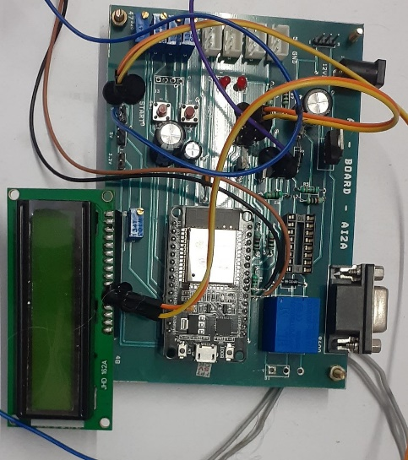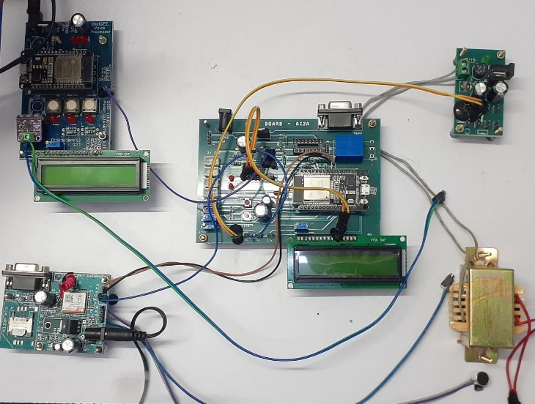

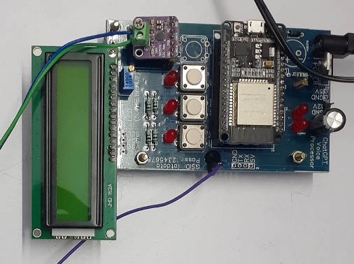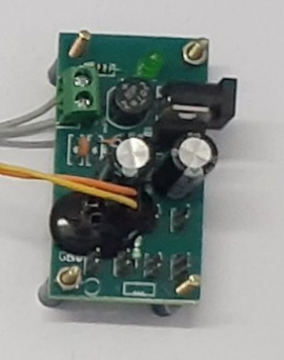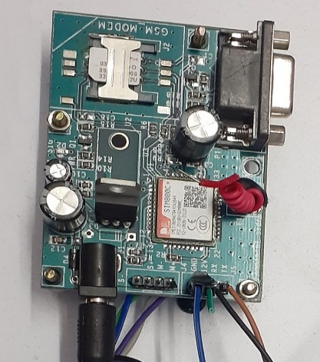

1. **CONCLUSION**

Bone-conduction devices (BCDs) that enables people with impaired hearing to gain the ability to hear sounds without the usage of their eardrums. The BAHA has both cosmetic and acoustic advantages over most conventional hearing aids. For complex listening conditions, in which the target speech is superposed at a rather low signal-to-noise ratio with other sounds and is corrupted by reverberation. Combination of hearing aids with smartphone-based mobile health technology may contribute to an integrated approach to hearing health care. This hearing device is designed to compensate the deafness of the inner drum and also outer drum problem solved. The PIC16F877A connected with GSM Modem when the call Receives then it automatically attends it. Then using the motor vibration signals have been produced then incoming voice signal is converted into low frequency vibration signal that fed through the teeth to cochlea. For Future advancements, New technologies such as machine learning based algorithms and multi-modal signal processing for improved speech processing and perception. Miniature False tooth dental implants for better compatibility and durability. Virtual reality and mobile health technology will improve speech enhancement, individual fitting and communication training for improving hearing health services.

**ACKNOWLEDGEMENTS (optional)**

WE WOULD LIKE TO EXPRESS OUR SINCERE GRATITUDE TO ALL INDIVIDUALS WHO HAVE CONTRIBUTED TO THE SUCCESSFUL COMPLETION OF THIS PROJECT. WE EXTEND OUR APPRECIATION TO THE RESEARCH MENTOR MS.BILNA .C WHO PROVIDED VALUABLE GUIDANCE AND SUPPORT THROUGHOUT THE PROJECT'S DEVELOPMENT.

We also acknowledge the contributions of the research team members who dedicated their time, expertise, and efforts to the implementation and testing of the proposed system. Their collaboration and teamwork were instrumental in achieving the project's objectives and outcomes.

1. **REFERENCES**
2. Qiong Luo , Ying Shen ,Ting Chen.,Effects of SoundBite Bone Conduction Hearing Aids on Speech Recognition and Quality of Life in Patients with Single-Sided Deafness. Hindawi Volume 2020, Article ID 4106949
3. Chin-Tuan Ta, Sara Akbarzadeh, Sungmin Lee ., The Spatial Selective Auditory Attention of Cochlear Implant Users in Different Conversational Sound Levels, University of Texas at Dallas, Richardson,2021, J. Clin. Med. 2021, 10(14), 3078
4. Wilhelm Wimmer, Michael Zbinden, Tom Gawliczek,. Performance with a new bone conduction implant audio processor in patients with single-sided deafness,2023, European Archives Of Oto-Rhino-Laryngology,280:3585-3591
5. Gomez, R., & Ferguson, M. (2020). Improving self-efficacy for hearing aid self-management: the early delivery of a multimedia-based education programme in first-time hearing aid users. International Journal of Audiology, 59(4), 272-281.
6. Gogate, M., Dashtipour, K., Adeel, A., & Hussain, A. (2020). CochleaNet: A robust language-independent audio-visual model for real-time speech enhancement. Information Fusion, 63, 273-285.
7. Tammen, M., & Doclo, S. (2022). Deep Multi-Frame MVDR Filtering for Binaural Noise Reduction. arXiv preprint arXiv:2205.08983. [pubMed]
8. Nustede, E. J., & Anemüller, J. (2021, August). Towards speech enhancement using a variational U-Net architecture. In 2021 29th European Signal Processing Conference (EUSIPCO) (pp. 481-485). IEEE
9. Pavlovic, C., Kassayan, R., Prakash, S. R., Kayser, H., Hohmann, V., & Atamaniuk, A. (2019). A high-fidelity multi-channel portable platform for development of novel algorithms for assistive listening wearables. The Journal of the Acoustical Society of America, 146(4), 2878-2878.
10. Tamás Ferenc Tóth, Adrienne Németh, Péter Bakó.,Matching the pitch perception of the cochlear implanted ear with the contralateral ear in patients with single-sided deafness: a novel approach,2023, SCImago Journal Rank - 0.849 eISSN - 1434-4726
11. Ichiro Furuta, Takayuki Okano, Kohei Yamahara,.Efficient Bone Conduction Hearing Device With a Novel Piezoelectric Transducer Using Skin as an Electrode,Shiga Medical Center Research Institute,Japan.,2022, VOL. 69, 0018-9294