Majestic Moments

Ayush kanade1, Prem Shroff2, Prof. Jinal Patel3

Department of Computer Science & Engineering.

Thakur ShivKumar Singh Memorial Engineering College, Burhanpur,

(Affiliated to RGPV Bhopal), India

***Abstract*-** Majestic Moments is your one- stop solution for creating unforgettable events, even when time is tight. We streamline the entire process, from planning to execution, ensuring your event is a resounding success. Tired of juggling bookings, packages, and customer details? Majestic Moments eliminates manual tasks, allowing you to effortlessly manage events, bookings, customers, and inquiries in one centralized platform. Our user-friendly system grants secure access exclusively to administrators, guaranteeing the privacy of your event data. Majestic Moments empowers you to manage your event anytime, anywhere. Our web-based platform is accessible from any internet- connected device, giving you complete control. Plan your event with ease, no matter where you or your guests are located. Our website is accessible from anywhere in the world with a single click. Experience the power of professional event management at a price that won't break the bank. Majestic Moments delivers exceptional value for every rupee spent. Maintain a comprehensive event database with ease. Our system simplifies data organization and retrieval, providing valuable insights for future events.

***Keywords:*** Majestic Moments

# INTRODUCTION

***Majestic Moments*** - Organizing successful events is an art form, and event management is the skilled practice behind it. This industry caters to specific audiences, bringing ideas to life through meticulous planning, financial stewardship, and flawless execution. From elegant weddings and electrifying concerts to informative corporate seminars and lively exhibitions, event management keeps the calendar packed.

While the economic impact of this ever- expanding industry remains surprisingly under-researched, its growth is undeniable.

Events of all shapes and sizes fuel this dynamism - from industry conferences and incentive trips (MICE) to trade shows, festivals, and the thrill of live sports and music.

On the professional side, event management offers a captivating blend of glamour and grit. While the fast-paced environment demands creativity and adaptability, the rewards are significant. It's important to note that compensation can vary depending on the area of focus. The logistics side, though crucial, tends to see lower compensation compared to sales and sponsorship roles.

Event planning, the heart of this process, involves meticulous tasks like budgeting, scheduling,venue,selection,permitting,transpor tation,entertainment, décor, security, vendor coordination, and even emergency preparedness. The scale can range from intimate business meetings to the grandeur of the Olympics!

Events themselves encompass a wide range of social experiences: from the infectious energy of music festivals to the solemnity of ceremonies (like weddings) and the joyful celebrations of parties (birthdays, for instance).

# OBJECTIVE OF PROJECT

This project aims to revolutionize event management by streamlining processes and fostering efficiency. Here's a detailed breakdown of our key objectives:

* Eradicating Manual Work: We intend to eliminate the tedious, time- consuming manual tasks associated with traditional event management. This will free up valuable resources for event planners, allowing them to focus on more strategic initiatives.
* Centralized Data Hub: The project envisions the creation of a unified database that serves as a central repository for all event-related information. This eliminates the need to juggle scattered spreadsheets, emails, and physical documents, fostering better organization and accessibility.
* Boosting Productivity: By automating repetitive tasks and centralizing data, this system will significantly enhance overall productivity. Event planners will experience a reduction in the time typically required for planning various aspects of the event, allowing them to dedicate more time to other important duties.
* Anytime, Anywhere Management: This user-friendly system grants event planners the flexibility to manage all aspects of the event remotely, at any time. They won't be constrained by geographical limitations or rigid office hours, ensuring timely and efficient event execution.
* Embracing Digital Transformation: In today's digital age, this comprehensive event management system aligns perfectly with the growing trend towards digitalization. It facilitates the digitalization of crucial elements like contracts, registrations, request forms, and reports. This not only saves time but also minimizes the stress associated with manual, paper-based processes.

In essence, this project offers a powerful solution that streamlines event management, enhances productivity, and empowers event planners with the tools they need to orchestrate successful events.

# APPLICATIONS AND SCOPE

1. APPLICATIONS-

* Effortless Event Creation and Management: An EMS acts as your central hub, allowing you to effortlessly create events, manage registration processes, track RSVPs, and maintain guest lists – all within a user-friendly interface.
* Global Accessibility: Imagine attendees from across the globe registering for your event with just a single click! An EMS transcends geographical boundaries, making your event accessible to a wider audience, fostering international participation, and boosting your event's reach.
* Cost Effective Planning: Streamlining workflows and automating tasks translates to significant cost savings. EMS functionalities can help you optimize budgets, negotiate better vendor deals, and identify cost-effective solutions, ensuring you stay within budget without compromising on quality.
* Data Management at Your Fingertips: Event data is a goldmine of insights. An EMS empowers you to maintain a centralized database of event information, attendee details, and registration records.

1. SCOPE-

Majestic Moments is a web-based platform designed to streamline the event planning process. It functions as a one-stop shop, allowing users to conveniently search for and procure a variety of services required to organize an event.

Ubiquitous Accessibility: A key advantage of Majestic Moments is its accessibility. The platform can be accessed from any internet-connected device, offering users the flexibility to plan their events anytime, anywhere and allows for on-the-go management.

Simplified Event Management: Majestic Moments leverages the power of event management systems, making the planning process for large events easier and more efficient. By facilitating the organization of various aspects under roof, the platform can potentially reduce costs associated with event planning.

Future Enhancements: The developers of Majestic Moments envision integrating an online payment gateway in the future. This would enable customers to seamlessly pay for services directly through the platform, further enhancing user convenience.

Data Security: To ensure user privacy, the information provided by users on Majestic Moments is solely accessible by authorized administrators. This safeguards sensitive data and fosters trust within the user base.

1. Flowchart

Flowcharts serve as a visual representation of a workflow, process, or algorithm. In essence, they are graphical maps that depict the sequential steps involved in accomplishing a task or solving a problem. Flowcharts are instrumental in various stages of process management, including analysis, design, documentation, and optimization.

**Flow Chart Diagram**

1. Advantages:
   * Access your event details anytime, anywhere with your phone, laptop, or tablet.
   * Get helpful tools to organize your event smoothly.
   * Attract attendees from anywhere in the world with a website.
   * Plan big events for less with an event management system.
   * Easily manage all your event information in one place.

# Disadvantages:

* + This website is mainly for Event Planners.
  + The range of organising event is limited .
  + Payment gateway is not used. So only cash payment is available.
  + Discount is available only for existing customers.

# Result

# Master Page

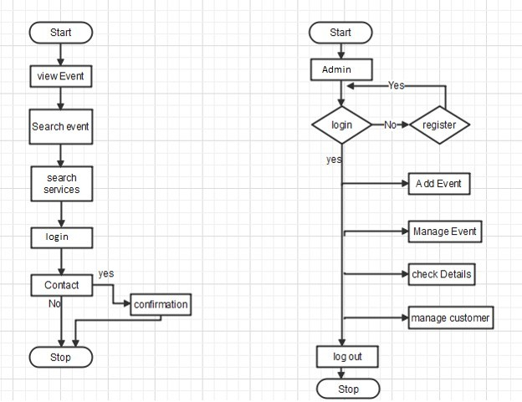

Welcome to our streamlined Registration Page! To simplify your future bookings, simply enter your details here during your first visit. This way, your information will be securely stored for faster checkout on any future bookings. Just provide your name and contact details, and your saved information will appear for confirmation. Need to update your address? No problem! You can easily make changes right on this page. Once you've reviewed your booking details, a confirmation prompt will appear. Just click "Confirm" to finalize your registration. Please note that currently, cash on delivery is the only payment option available.

# Home Page

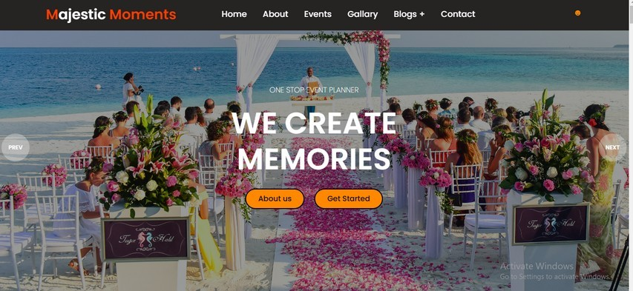

Welcome to your one-stop Event Planner! This landing page lets you browse a vast selection of categorize for easy navigation. Simply choose the section that piques your interest, and you'll be whisked away to a dedicated page brimming with options. Here, you can contact with us for booking an event or proceed straight to checkout our other Popular works. For your convenience, we showcase top-rated Events first, helping you make informed decisions. And the best part. You can even leave a review to share your experience with others!.

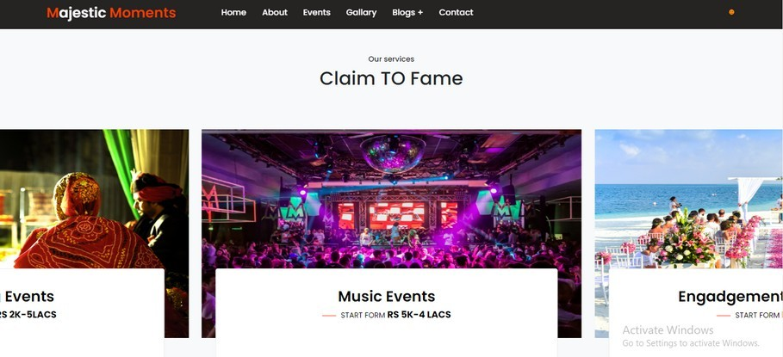

# Book Now Page

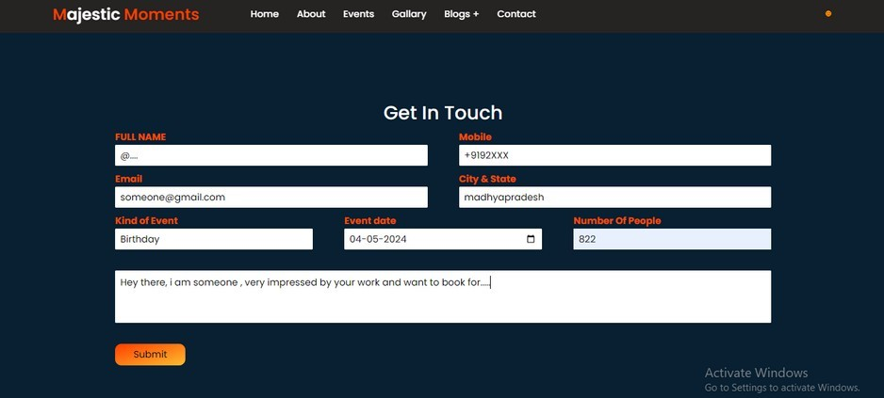

Majestic Moments Made Easy: Plan your perfect celebration from birthdays and weddings to unforgettable musical gatherings

- all in one place! Our user-friendly platform guides you through the process. Simply pick your event type, share some key details, and explore our network of trusted vendors.

We'll take care of the behind-the-scenes work, so you can focus on making memories that last!

# CONCLUSION

Majestic Moments is a user-friendly online platform that simplifies event planning. Search for a variety of services to cater to your specific event needs, from birthdays and weddings to corporate functions. Accessible anytime, anywhere on any internet-connected device, Indigo Events streamlines the planning process, allowing you to organize memorable events at affordable costs. For added convenience, online payment options are planned for the future. Furthermore, user information remains secure, accessible only by authorized personnel.

# REFERENCES

1. Official holidays and festivals. ([https://www.bankbazaar.com/indian-](https://www.bankbazaar.com/indian-holiday-calendar.html) [holiday-calendar.html](https://www.bankbazaar.com/indian-holiday-calendar.html) )
2. Provides access to event listings and ticketing information for events on the Eventbrite-platform.([https://www.event](https://www.eventbrite.com/platform/docs/introduction) [brite.com/platform/docs/introduction](https://www.eventbrite.com/platform/docs/introduction))
3. Reference reports on current web design trends to ensure a visually appealing and user-friendly interface. ([https://webflow.com/made-in-](https://webflow.com/made-in-webflow/2024) [webflow/2024](https://webflow.com/made-in-webflow/2024) )
4. Reference guides on usability testing to improve website navigation and user experience.(e.g. <https://www.nngroup.com/>)
5. Bootstrap v5.2.3 Documentation. Retrievedfrom(https://getbootstrap.com/docs/5.0/gettingtarted/introduction/ )
6. Use event blogging websites for content ideas and inspiration on promoting upcoming events.(e.g., <https://www.eventbrite.com/blog/category/event-planning-for-beginners/>)
7. W3Schools(<https://www.w3schools.com/css/> )