**IOT Based Dog Day Care System**

**Rutuja Nikam1, Riya Bhamare2, Kunal Kapdi3**

1Student, Department of E&TC, MVP’s KBT College of Engineering, Nashik, Maharashtra, India

2Student, Department of E&TC, MVP’s KBT College of Engineering, Nashik, Maharashtra, India

3Student, Department of E&TC, MVP’s KBT College of Engineering, Nashik, Maharashtra, India

**ABSTRACT**

Dog need special treatment and special care. Due to busy lifestyle, this task is not as easy as it used to be. The goal of this project is to design and implement a smart faves feeder. As more people interact with tangible gadgets and real world objects, this domain is attracting increasing interest. An organic and user friendly approach is necessary to facilitate these interactions. The current endeavor tackles enhancing the capability to assist through the application of a pet related system. This project addresses the improvement through the pet application of the ability to help dog owners raise their pet on the activity and eating control easily. Our study involves in the ideas of the internet of things, but also meets the demand of owners, who are the out for works without any trouble who even can feed their dog via Smartphone. The object is to allow the dog owners who automate feeding control. Implementing smart pet house will assure dog holders and increased warmth and peace of mind specially dog is unattended. The design method used in this project forwards the conversation around the involvement of dog in the design process while designing for dog computer interactions. Such design methods can also be used to understand what participatory design can mean where use groups cannot give direct verbal feedback to the designers such as younger children and others who are differently able. The product finds used both research related to canine has ability to smell and commercial applications.

**Keywords:** Dog-centric design, interspecies participatory design, olfactory enrichment device, canine robot.

1. **INTRODUCTION**

The system dispenses applicable quantum of food and water in feeding charger as instructed by stoner online and also slides open the feeding charger, also it calls out your canine to inform about feeding time. All of the movement of Canine can be covered online by the pet proprietor. This entire system is controlled by a ESP32 Microcontroller. The system is an IoT Grounded system that's able of taking care you your canine alone at home. The system is integrated with a camera that allows for live streaming over IoT platform to get on demand footage of home. The system takes covering far beyond a security camera as you can control the system online over internet and move through your house any time you want. This allows you to be with your faves no matter where you are. The system is also integrated with a speaker that speaks out to your canine’s allowing you to roar at them for any wrongdoings or call them when it's feeding time. The robot is a 4wheeled drive system with a feeding charger and 2 x sword lockers Bin1StoresDogFood caddy 2 Stores Water –based enrichment device for pet dogs. The device can also be used for training dogs professionally for smell related tasks such as medicine discovery, scent shadowing, and medical discovery. Scent Bot is a device ecosystem that consists of three corridors. First is a device called robot; second is the treat Dispenser and, third is a mobile application. The literature review of this Project highlights conversations from the field of Animal Computer Interaction (ACI) around centered design can be applied and understood from the perspective of a canine user. Incipiently, It discusses currently available enrichment devices for pet dogs.

1. **RELATED WORK**

“IoT Based Dog DAY- CARE ROBOT” this paper was published in IRJMETS in 2022. Dogs need special treatment and special care. Now a day’s thanks to busy life, this task isn't as simple because it won’t to be. The thing of this work is to introduce, design and apply a smart pet system. The commerce between mortal and physical bias within the globe is gaining further attention and it requires a natural and intuitive methodology to use. This study examines the inflexibility of calculation, communication and control technologies to enhance mortal commerce with faves by technology of the internet of effects. This work addresses the advance through the pet’s operation of the inflexibility of position- mindfulness, and to help pet possessors raise their pet on the exertion and eating control fluently. As people prefer to keep faves, faves also need special treatment and care. So, keeping faves is also not a straightforward task. We want to feed our pet timely. But, thanks to our busy schedule we’re unfit to try and do so. We’ve got designed a wise pet confluent system. This can help us feeding faves anytime. We're going to be ready to feed faves irrespective of where we are.[1]

“Robotic Day-care For Pets Using Sensors and Rasberry Pi”this paper was published in IEEE in 2023.The proposed Robotic Day-Care for Pets Using Sensors and Raspberry Pi is a unique and innovative solution that addresses the challenges of pet care in today's fast-paced lifestyle. By leveraging the power of the Internet of Things (IoT), sensors, and the Raspberry Pi, this project aims to provide a comprehensive and intelligent approach to pet care. The project recognizes the growing importance of intuitive and natural interactions between humans and technology. By incorporating sensors and the Raspberry Pi, the system can respond to the pet's needs and behavior in a seamless and intelligent manner, mimicking the attentiveness of a human caregiver. The system incorporates location awareness capabilities, allowing it to track the pet's movements and activities. This feature can be particularly useful for training pets and managing their behavior, especially when it comes to feeding and exercise routines. With the integration of IoT technology, pet owners can remotely monitor and control the system, ensuring their pets receive timely care and attention even when they are away from home. The smart pet feeder system is designed to provide pets with food at the appropriate times, even when the owners are unavailable due to busy schedules. This feature not only ensures the pet's well-being but also provides peace of mind to the owners.[2]

“IoT Based Automatic pet feeding and monitoring system” this paper was published in IJMDES in 2023 The proposed IoT-based Dog Day Care System with Live Streaming and Remote Control capabilities is a truly unique and innovative solution that addresses the challenges of pet care in today's fast-paced and technology-driven world. By seamlessly integrating cutting-edge technologies with a deep understanding of pet needs and human-pet bonding, this system offers a comprehensive and personalized approach to pet care. The integration of a Pi camera and live streaming capabilities over an IoT platform allows pet owners to maintain a real-time connection with their pets, even when they are away from home. This feature not only provides peace of mind but also fosters a sense of emotional attachment and reassurance. The system is designed with two separate containers, one for storing pet food and the other for water. These containers are equipped with automated dispensing mechanisms, ensuring that pets receive their meals and hydration at predetermined intervals, even in the absence of their owners. The use of a servo motor for opening and closing the food container, combined with a relay channel for pumping water, ensures precise and efficient dispensing of food and water. This level of automation and control helps maintain a consistent and reliable feeding routine for pets. The integration of a speaker system that calls out to pets during feeding times adds a personalized touch to the system. This feature not only helps attract the pet's attention but also simulates the familiar experience of being summoned by their owners for mealtime. The system's internet connectivity and remote control capabilities allow pet owners to monitor and manage their pets' care from anywhere in the world. This feature provides unparalleled flexibility and ensures that pet owners can remain connected to their beloved companions, even when physically separated. The system's internet connectivity and remote control capabilities allow pet owners to monitor and manage their pets' care from anywhere in the world. This feature provides unparalleled flexibility and ensures that pet owners can remain connected to their beloved companions, even when physically separated. The system's internet connectivity and remote control capabilities allow pet owners to monitor and manage their pets' care from anywhere in the world. This feature provides unparalleled flexibility and ensures that pet owners can remain connected to their beloved companions, even when physically separated.[3]

“IoT Based Pet Feeder System” this was published in IJARIIE in 2018. The proposed IoT-Based Pet Feeder System is a unique and innovative solution that addresses the limitations of traditional pet feeders and introduces a range of advanced features to enhance the overall pet care experience. By seamlessly integrating the power of the Internet of Things (IoT) with a robust hardware design, this system offers a comprehensive and user-friendly approach to pet feeding and monitoring. Unlike previous versions of pet feeders that relied on manual settings, this system incorporates an interactive remote controller, allowing pet owners to conveniently adjust various parameters such as feed times, intervals between consecutive feeds, and portion sizes from a distance. The system empowers pet owners to tailor the feeding schedule and portion sizes according to their pet's specific needs and preferences, ensuring optimal nutrition and care. The pet feeder is equipped with a unique "call for pet" feature that alerts the pet during feeding times, encouraging them to approach the feeder and promoting a more natural feeding routine. The system incorporates a refill alert mechanism that notifies pet owners when the food supply is running low, preventing any interruptions in the pet's feeding routine. Additionally, a safety lock feature secures the food container, preventing accidental spills or tampering. To ensure uninterrupted operation, the system is equipped with a dual power supply and a battery charger, allowing it to function even during power outages or when disconnected from the main power source. The pet feeder is designed with a sensor-based system that detects and serves any leftover food from the previous feeding session, minimizing waste and ensuring that the pet receives fresh and appropriate portions. The system offers a unique "priority feeder" feature that allows pet owners to choose between a multi-time feeding option or a single feeding option during the specified time gap, catering to the individual needs and preferences of both the pet and the owner.[4]

“Automatic Pet Food Dispenser Using IoT” this paper was published in IEEE in 2020. This project aims to create an automatic pet food dispenser controlled via the Internet of Things (IoT) technology. Develop an IoT-enabled device that can dispense dry pet food (for dogs, cats, etc.) automatically on a schedule or on-demand. Allow pet owners to remotely control and monitor the food dispensing from anywhere using an internet connection and associated mobile app/web interface. Prevent overfeeding and obesity in pets by controlling portion sizes and feeding schedules. Help train pets to eat meals on a routine schedule instead of free-feeding.[5]

1. **METHODOLOGY**

The project mainly consists of major components:

1. ESP32 Controller

2. ESP32CAM

3. Motor Driver

4. DC motor

5. Servo motor

The System Concept is canine day care system. This system grounded on ESP32 regulator. This system helps in feeding the canine. This system is easy to use, cost effective and secure. This system can use by non-technical people. It's controlled automatically by a phone; the software allows druggies to click the button to feed their tykes. The information will also be transmitted to the tackle where the motor will have one gyration by which the food and water will be dropped.

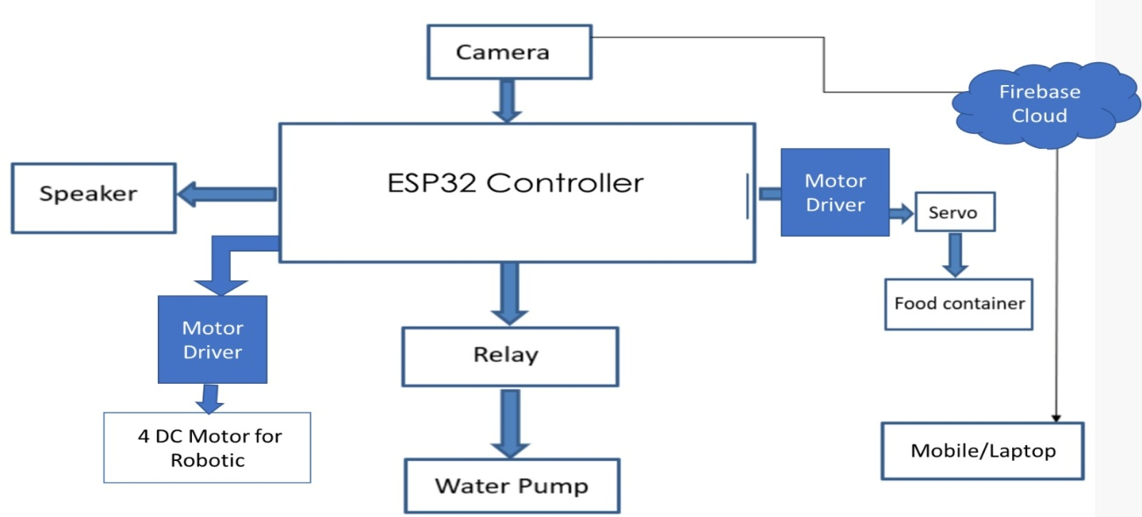

**Figure 1:** Block diagram of IoT Based Dog Day Care System

Firstly, we will use Brain of project ESP32 which will handle operations like Controlling Motors of Robot through its GPIO pins. Then use motor driver module to interface the motors with the ESP32, and used appropriate libraries can be utilized to control the motors. The ESP32 has capabilities, allowing it to connect to an IoT server for controlling and feeding. For Automatic feeder can use servo motors or stepper motors to control the food and water dispenser. The ESP32 controls the dispensers based on predefined schedules or user inputs from the IoT server. The system can be programmed to dispense food and water automatically based on schedules or user commands from the IoT Server. Camera or sensors can be integrated to monitor the pet’s activity and feed status and finally, we can feed our pet as well as can keep watch on them.

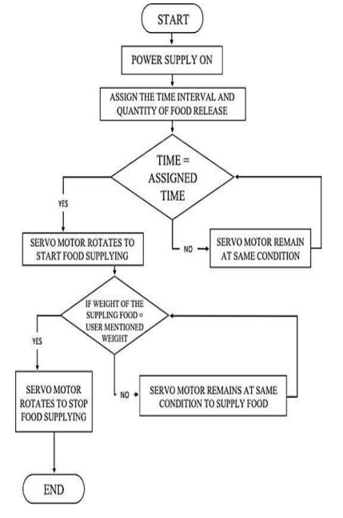

**Figure 2:** Flowchart of IoT based Dog Day Care System

1. **RESULTS AND DISCUSSION**

After completing and testing the project we have observed these following results. As shown below

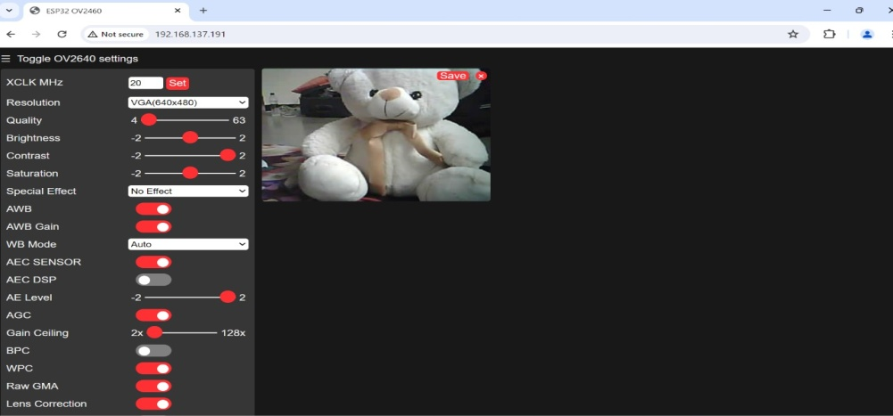

**Figure3:** Image captured by ESP32 cam

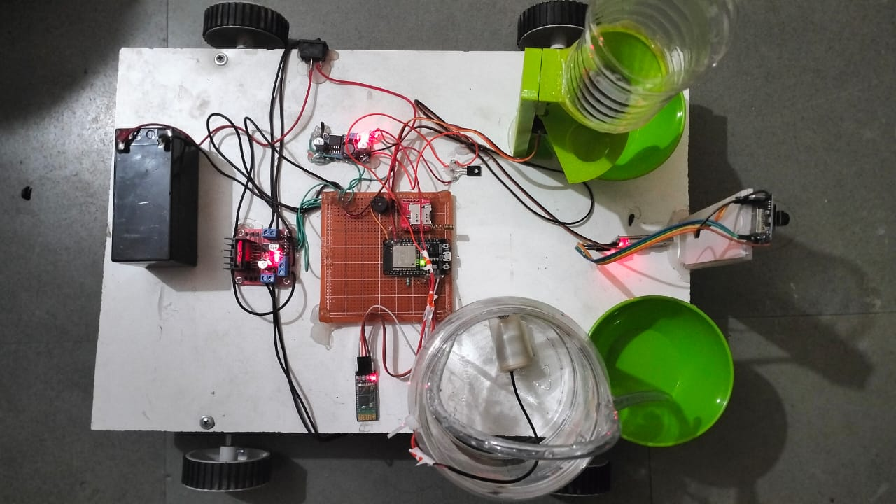

. **Figure4:** Image of dog day care system

1. **CONCLUSION**

In today's lifestyle reality, everything is changing into a smart framework and automation. Individuals need that the thing they purchased ought to be cost-productive and shouldn't make any kind of contamination. Our undertaking IOT Based Pet Care System likewise centers around that.It are very cost-proficient and doesn't make any kind of contamination. There are many projects like these in the market but the problems also stick to them. The problems people face are that the system is quite complex to use or it’s quite costly. But our project solves these things. It is quite cheap as compared to other systems and quite easy to use. Any non-tech person can understand how to use it as it is user-friendly.

1. **REFERENCES**
2. T. Sunil, K., et al. "IoT Based Dog Day-care Robot." International Research Journal of Modernization in Engineering Technology and Science 4.7 (2022): 2617-2620.
3. Bembde, Maya, et al. "Robotic Day-Care for Pets using Sensors and Raspberry Pi." 2023 International Conference on Sustainable Computing and Smart Systems (ICSCSS). IEEE, 2023.
4. Kulaikar, Jiten, et al. "IoT Based Automatic Pet Feeding and Monitoring System." International Journal of Modern Developments in Engineering and Science 2.4 (2023): 24-27.
5. Yadav, Saurabh A., et al. "loT Based Pet Feeder System." International Journal of Advance Research, Ideas and Innovations in Technology 2.4 (2018): 3656-3659.
6. Sangvanloy, Tannop, and Kingkarn Sookhanaphibarn. "Automatic pet food dispenser by using internet of things (IoT)." 2020 IEEE 2nd Global Conference on Life Sciences and Technologies (LifeTech). IEEE, 2020.