**Master’s Thesis On**

**“OPTIMIZING WORKFORCE PRODUCTIVITY: THE INTERPLAY OF COST AND EFFICIENCY AT AAJ ENTERPRISES"**

**UNDER THE GUIDANCE OF**

**Prof. Neha G Bhatia**

SUBMITTED BY

## HARSH CHAUHAN

(Admission Number:-22GSOB204007) .

MBA (LSCM) 2022-2024

Galgotias University



**School of Business Galgotias University**



**Certificate**

This is to certify that the Master’s Thesis **“OPTIMIZING WORKFORCE PRODUCTIVITY: THE INTERPLAY OF COST AND EFFECIENCY AT AAJ ENTERPRISES"** has been prepared by Mr. Harsh Chauhan. under my supervision and guidance. The project report is submitted towards the partial fulfillment of 2 year, Full time Master of Business Administration.

Name:- Prof. Neha G Bhatia

Signature of Faculty:-

Date:

**Declaration**

I, Harsh Chauhan, Roll No.22GSOB2040007, student of School of Business, Galgotias University, Greater Noida, hereby declare that the Master’s Thesis on **[OPTIMIZING WORKFORCE PRODUCTIVITY: THE INTERPLAY OF COST AND EFFICIENCYAT AAJ ENTERPRISES]** is an original and authenticated work done by me.

I further declare that it has not been submitted elsewhere by any other person in any of the institutes for the award of any degree or diploma.

Name:- Harsh Chauhan

Signature of the Student:-

Date:-

**DECLARATION BY THE STUDENT**

I hereby declare “OPTIMIZING WORKFORCE PRODUCTIVITY:-THE INTERPLAY OF COST AND EFFICIENCY AAT AAJ ENTERPRISES" that is the result of the project work carried out by me under the guidance of Mrs. Neha Bhatia in partial fulfilment for the award of MBA in Galgotias University, Greater Noida.

I also declare that this project is the outcome of my efforts and that it has not been submitted to any other university or institute for the award of any other degree Diploma or Certificate.

**Place:** Greater Noida **Name:** HARSH CHAUHAN

**Date: Roll No.:**22GSOB2040007

**CERTIFICATE OF ORIGINALITY**

Date: 21-04-2023

This is to certify that the dissertation titled “OPTIMIZING WORKFORCE PRODUCTIVITY: THE INTERPLAY OF COST AND EFFICIENCY AT AAJ ENTERPRISES” is an original work of Mr. Harsh Chauhan bearing Roll Number 22GSOB2040007 and is being submitted in partial fulfilment for the award of the MBA of Galgotias University, Greater Noida. The research work has not been submitted elsewhere for award of any degree. The material borrowed from other sources and incorporated in the research report has been duly acknowledged.

Name of Guide: Mr. Vinay Sabharwal

Signature of Guide:-

Date:-

**ACKNOWLEDGEMENT**

Theory is the first and important step which acts as a base, but practical knowledge is that aspect which bridges the gap between imagination and realities. Research is the part of the work situations and is closely related to the career and promotion structure. No dissertation is complete without a mention of all those who contributed is very existence. However an expression of thanks, no matter how extensive it is, never complete or adequate. This acknowledgement is no exception.

I wish to express my gratitude and sincere thanks to my guide Mr. Vinay Sabharwal, I Business Institute for her keen and guidance offered in an amicable and pleasant manner through this project work. I owe much too all faculty members of I Business Institute for their blessing and encouragement. At last, but not least, I would also like to thank all those people who spared time out of their busy schedules to provide me with relevant information and feedback.

**INDEX**

|  |  |  |
| --- | --- | --- |
| **CHAPTER NO** | **PARTICULAR** | **PAGE NO** |
| 1 | INTRODUCTION |  |
| 2 | PROFILE OF THE ORGANIZATION |  |
| 3 | DESIGN OF DISSERTATION |  |
| 4 | DATA ANALYSIS AND  INTERPRETATION |  |
| 5 | SUMMARY OF FINDING,  CONCLUSIONS & RECOMMANDATION |  |

# CHAPTER-1 INTRODUCTION

### INTRODUCTION

**AAJ ENTERPRISES PVT. LTD.**



**BACKGROUND OF THE ORGANIZATION**

AAJ is a supply chain service provider established and operating in India. The service portfolio includes 3PL, in plant warehouse operations management, last mile transportation and value added supply chain services. We are a new age and trusted supply chain working for several multinational and national companies across industries.

Had a humble beginning in 2010 and has since then gained the trust of our customers as their only third-party warehouse service provider with pan India presence handling over 70,000 SKU’s and more than 25 million units in stock. We dispatched slightly over 50 million units from all our facilities combined in year 2020.

We pioneer developing and operating large scale, shared warehouses for our customers with AAJ’s own investment in infrastructure of racking, technology, and material handling Equipment’s, resulting in zero capex costs for our clients. Our customized and in house WMS is our USP which allows for information transfer through EDI to all ERP’s and has advanced warehouse management functionalities.

The mission is to build an organization which can take India at the helm of global supply chain with its reliable, cost effective and innovative solutions.

AAJ Enterprises is one of the India’s leading 3PL and Warehousing Management Organization. The company’s service accuracy level of 99.9 percent, 7 lakh sq. ft. state of the art warehouse infrastructure backed with cutting-edge technological innovation, challenges the status quo. AAJ is a supply chain service provider established and operating in India and provide some value added service like printing, shrink wrapping etc. AAJ was established by Anil Kumar Jain in 2006 who is currently the chairman of AAJ Enterprises Pvt. Ltd.

With more than 500 employees, decade of experience, deep understanding of multiple industries & business functions; we bring expertise in managing Warehouse Infrastructure, Operations, Technology and Transportation ecosystem through solutions tailored to transform businesses and shape future.

Currently operational in:-

* Bangalore
* Kolkata
* Delhi NCR
* Mumbai
* Ghaziabad
* Greater Noida
* Sonipat
* Kundli 1
* Kundli 2

Over the last 10 years AAJ has achieved a CAGR of 26% in revenue and CAGR of 30% in warehouse space. AAJ aims to represent India globally and wants to become a global supply chain service provider in future

* GMV of INR 8 Billion
* 70,000 SKUs in Stock
* Yearly Dispatch of 40 million Units

Space 7 Lakh Square feet. Warehousing refers to the storage and preserving of goods until they are ready for distribution to the consumers. This is usually a very common practice that is associated with production. Produced goods are often required to be stored in a warehouse in order to make it readily available for consumers whenever they put forward demand for it.

Some warehouses are completely automated, and require only operators to work and handle all the task. Pallets and product move on a system of automated conveyors, cranes and automated storage and retrieval systems coordinated by programmable and computers running logistics automation software. These systems are often installed in refrigerated warehouses where temperatures are kept very cold to keep the product from spoiling.

In today's dynamic business landscape, where the relentless pursuit of operational excellence is the key to success, the realm of warehousing and supply chain management stands at the forefront of transformation. Warehouses, once seen as static storage facilities, have evolved into dynamic hubs of productivity and efficiency, thanks to the integration of cutting-edge technologies. Among these technologies, Artificial Intelligence (AI) and the Internet of Things (IoT) have emerged as game- changers, reshaping the way warehouses operate, manage inventory, and fulfill orders.

This project delves into the pivotal domain of warehousing, focusing on the imperative of enhancing operational efficiency. The warehouse under scrutiny is AAJ Enterprises, a distinguished Third-Party Logistics (3PL) warehousing company. AAJ Enterprises plays a pivotal role in the storage, management, and distribution of a wide array of products, catering to diverse industries. As a vital link in the supply chain, it is essential for AAJ Enterprises to optimize its operations, reduce errors, and meet the ever-increasing demands of modern commerce.

The primary objective of this project is twofold. First, it seeks to identify and rectify inefficiencies within AAJ Enterprises' warehouse operations. The project meticulously analyzes various facets of the warehouse, including picking, packing, inventory management, and communication channels, to pinpoint areas where improvements are most needed. These insights aim to streamline processes, reduce errors, and enhance overall efficiency.

Secondly, the project explores the transformative potential of AI and IoT in the context of warehousing. AI's cognitive capabilities, coupled with IoT's real-time data collection and connectivity, have paved the way for smart warehousing. This research endeavors to uncover how AI and IoT can be harnessed within the warehouse to augment decision-making, improve inventory accuracy, and enable predictive maintenance.

The significance of this project extends beyond the confines of AAJ Enterprises. It offers valuable insights for the broader logistics and warehousing industry, where competitiveness hinges on the ability to leverage cutting-edge technologies. By embracing AI and IoT-driven solutions, warehouses can not only boost efficiency but also adapt to the evolving demands of the Fourth Industrial Revolution.

In the following sections, we will delve deeper into the specific challenges faced by AAJ Enterprises, the methodologies employed to address them, and the potential applications of AI and IoT in reshaping the landscape of warehouse management. This project serves as a testament to the relentless pursuit of excellence and innovation within the realm of logistics, aiming to propel AAJ Enterprises and the industry at large toward unprecedented levels of efficiency and effectiveness.

A customized storage building, a warehouse enables a business to stockpile goods, e.g., to build up a full load prior to transport, or hold unloaded goods before further distribution,or store goods like wine and cheese that require maturation. As a place for storage, the warehouse has to be secure, convenient, and as spacious as possible, according to the owner's resources, the site and contemporary building technology. Before mechanized technology developed, warehouse functions relied on human labor, using mechanical lifting aids like pulley systems.

Warehousing is a vital component of virtually all businesses in general and the logistics business in particular. Warehouses have always been a part of large and complex distribution functions. Even small and medium-sized businesses are acknowledging the growing importance of warehouse management in today’s fast-paced scenario of integrated logistics, same-day delivery and e- commerce commitments. And why not, efficient warehousing provides vital economic benefits to businesses as well as their clients and customers.

Breaking it down, warehouse operations cover a number of important areas, from the receiving, organization, fulfillment, and distribution processes. These areas include:

* Receiving of goods
* Cross-docking of goods
* Organizing and storing inventory
* Attaching asset tracking solutions (like barcodes) to assets and inventory
* Integrating and maintaining a tracking software, like a warehouse management system
* Overseeing the integration of new technology
* Selecting picking routes
* Establishing sorting and packing practices
* Maintaining the warehouse facility
* Developing racking designs and warehouse infrastructure.

**Need of Project**

In the warehouse to be efficient is a big challenge in this compitive word so for that warehouse operations must be efficient.

Warehouse efficiency covers different aspects of warehouse operations, including anticipating demands, storage, and transportation needs. Here is the importance of warehouse efficiency:

* Uninterrupted management of warehouse processes ensures the safety of goods, quick order movement, and shipment of products. Efficient processes smoothen inventory flow and reduce errors.
* Warehouse equipment, policies, and software implementation contributes to increase efficiency in logistics and warehousing operations. With consistent improvement, you mitigate errors, such as stockouts and mispicks. It increases the annual revenue.
* By regularly checking the stock-keeping units (SKU), many companies can track their inventories better. Moreover, automated operations increase efficiency in warehouse management.
* Warehouse efficiency leads to better customer service. You can determine product availability more accurately by streamlining processes from order to delivery. It also provides customers with a more realistic shipping time that allow them to keep a regular track.

#### Objective

* To understand the picking and packing process, and achieve Turn around time (TAT) for daily tracker orders.
* Find out the errors in picking and packing methods. And provide a solution for it.
* Find out the loop holes in the current warehouse operations and give solutions to increase the efficiency.
* To see the applications of Artificial Intelligence (AI) and Internet of Things (IOT) in the warehouse operations.

#### Scope and Limitations of Project

* **Scope**
* The project's primary scope includes the analysis, optimization, and error reduction in the picking and packing processes within AAJ Enterprises' warehouse operations.
* It involves exploring and recommending AI applications, such as demand forecasting, predictive maintenance, and quality control, specifically tailored to warehouse operations.
* The project explores the integration of IoT technologies for real-time tracking, monitoring, and data-driven decision-making within the warehouse.
* The scope extends to formulating actionable recommendations for process improvements, error mitigation, and technology adoption.

#### Limitations

* It encompasses recommendations for staff training programs to enhance skills and reduce errors.
* The project's implementation may be limited by budgetary constraints for acquiring AI and IoT technologies and the availability of skilled personnel for their deployment.
* Integrating AI and IoT solutions can pose technical challenges, including compatibility issues, data security concerns, and the need for specialized expertise.The successful implementation of recommendations may require significant changes in processes and workflows, which could face resistance from existing staff and require careful change management.
* The effectiveness of AI and IoT applications heavily relies on the quality and availability of data. Poor data quality can limit the accuracy and reliability of these technologies.
* The project may require tailoring AI and IoT solutions to the specific needs of AAJ Enterprises, which could be time-consuming and resource-intensive.
* Implementing process changes and new technologies may temporarily disrupt warehouse operations and require downtime for training and transition.
* The return on investment for AI and IoT implementations may not be immediately evident, and measuring the long-term benefits can be challenging.
* External factors such as market fluctuations, supplier issues, or unforeseen disruptions can affect the project's success and timeline.
* The adoption of IoT and AI technologies may require compliance with industry-specific regulations and data privacy laws, adding complexity to the project.
* The organizational culture within AAJ Enterprises may need to adapt to embrace technological changes and new processes.

while the project holds significant potential for improving warehouse operations, it is essential to recognize and address these limitations to ensure a successful and smooth implementation of the proposed recommendations and technologies.

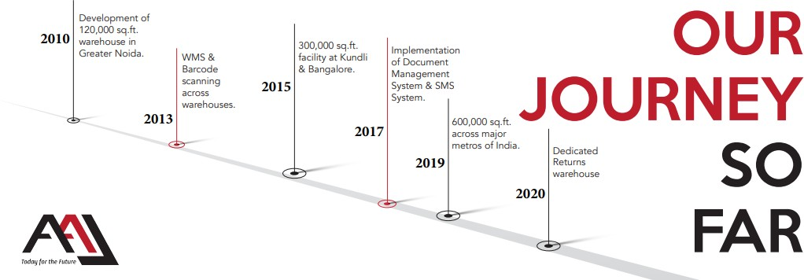

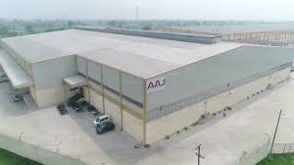



**CHAPTER 2**

## COMPANY’S OVERVIEW

#### Vision

What AAJ aims to become in the future Be a global supply chain service provider, taking India at the helm of supply chain in the world.

#### Mission

The Mission that AAJ aspires to fulfill in society Solving complex supply chain problems with reliable, cost effective and innovative solutions.

#### Slogan

Optimizing supply chain.

#### Values

* Uncovering possibilities.
* Integrity.
* Joyful place of work.
* Customer Delight.

#### History of company

AAJ is a supply chain service provider established and operating in India. The service portfolio includes 3PL, in plant warehouse operations management, last mile transportation and value-added supply chain services. They are a new age and trusted supply chain working for several multinationaland national companies across industries.

Had a humble beginning in 2010 and has since then gained the trust of their customers as their only third-party warehouse service provider with pan India presence handling over 70,000 SKU’s and more than 25 million units in stock. They dispatched slightly over 50 million units from all our facilities combined in year 2020.

They pioneer developing and operating large scale, shared warehouses for our customers with AAJ’s own investment in infrastructure of racking, technology, and material handling Equipment’s, resulting in zero capex costs for our clients. They are customized and in house WMS is our USP whichallows for information transfer through EDI to all ERP’s and has advanced warehouse management functionalities.

Over the last 10 years they have achieved a CAGR of 26% in revenue and CAGR of 30%in warehouse space. This has been possible with a value driven approach which delivers customer delight by exceeding the expectations on the agreed KPI’s as well continuous innovation of warehouse processes and technology. Today 100% their facilities usemobile barcode scanners for all operational activities.

The mission is to build an organization which can take India at the helm of global supply chain with its reliable, cost effective and innovative solutions.

AAJ Enterprises is India’s leading 3PL and Warehousing Organization. We have over 7 lakh sq. state of the art warehouse infrastructure backed with cutting-edge technology which challenges the status quo. With more than 500 employees, decade of experience, deep understanding of multiple industries & business functions; we bring expertise in managing Warehouse Infrastructure, Operations, Technology and Transportation ecosystem through solutions tailored to transform businesses and shape future.

#### Product And Service offered by AAJ Enterprises

These are the services offered at AAJ enterprises.

1. 3PL & Warehouse Management
2. Value Added Services
3. Consulting & Advisory
4. [E-commerce Fulfilment](https://www.aajenterprises.com/fulfillment/).
5. [Operations Management](https://www.aajenterprises.com/operations/).
6. [Transportation.](https://www.aajenterprises.com/transportation/)
7. [Returns Management.](https://www.aajenterprises.com/returns/)
8. [Value Added Services.](https://www.aajenterprises.com/vas/)

#### 3PL & Warehouse Management:

AAJ Enterprises provides third-party logistics (3PL) services, including the management of warehouses and distribution centers. They ensure efficient storage, inventory management, order fulfillment, and timely delivery of goods.

#### Value Added Services:

This service category includes additional services designed to enhance the value of logistics and supply chain operations. These services may include kitting, labeling, packaging customization, and quality control.

#### Consulting & Advisory:

AAJ Enterprises offers consulting and advisory services to help businesses optimize their logistics and supply chain strategies. They provide expert guidance on process improvement, cost reduction, and efficiency enhancement.

#### E-commerce Fulfilment:

E-commerce fulfillment services cater to online businesses. AAJ Enterprises manages order processing, pick and pack, and last-mile delivery to ensure a seamless shopping experience for online customers.

#### Operations Management:

AAJ Enterprises assists in optimizing overall operations within a supply chain. This includes inventory management, demand forecasting, process improvement, and cost control to achieve greater efficiency.

#### Transportation:

The transportation service involves managing the movement of goods from one location to another. AAJ Enterprises handles transportation logistics, route optimization, and carrier selection to ensure timely and cost-effective deliveries.

#### Returns Management:

Returns management focuses on handling product returns efficiently. AAJ Enterprises helps businesses establish processes for returns, inspections, restocking, and recycling or disposal, minimizing losses.

#### Value Added Services (Reiteration):

This category encompasses various additional services tailored to specific client needs. It may include customization, bundling, repackaging, or any value-enhancing services beyond basic logistics.

AAJ Enterprises offers a comprehensive range of services to support businesses in managing their supply chain and logistics operations effectively, allowing them to focus on their core competencies while achieving operational efficiency and cost savings.

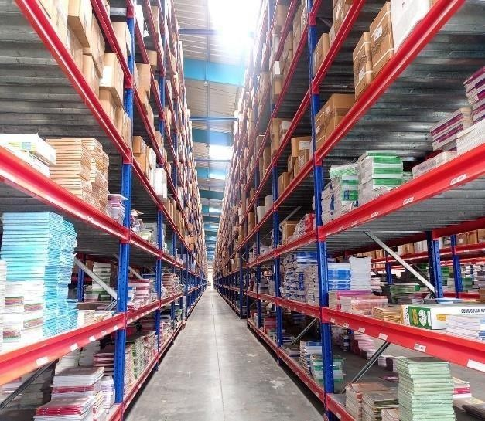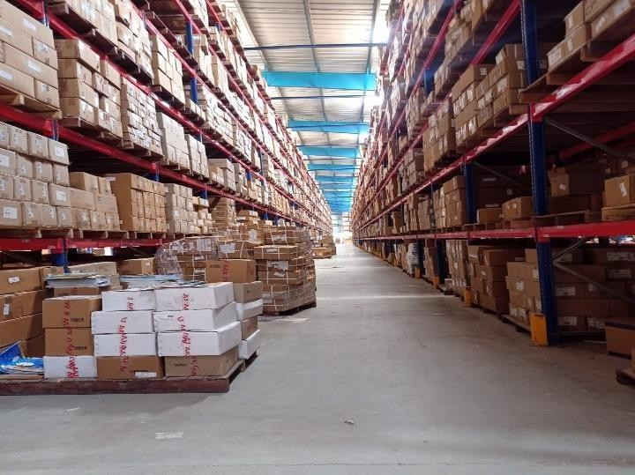

#### Different Operations in 3PL Warehouse at AAJ Enterprises.

1. Inward
2. Inventory
3. Picking and Packing
4. Dispatch
5. CS (Client success)

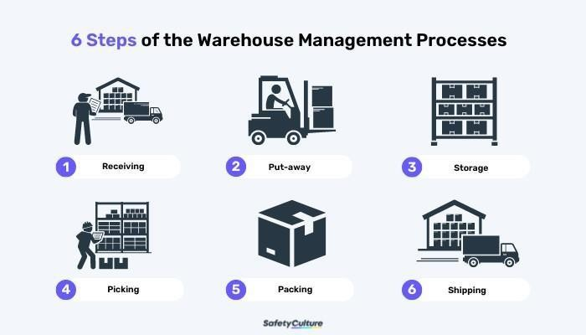

#### Why we need efficiency in warehouse operations

Efficiency in warehouse operations is crucial for several reasons, and it plays a vital role in the overall success of a business, particularly in supply chain management and logistics. Here are some key reasons why efficiency in warehouse operations matters:

**Cost Reduction**: Efficient warehouse operations can help reduce operational costs significantly. Streamlining processes, optimizing inventory management, and minimizingerrors can lead to lower labour, storage, and transportation costs.

**Improved Customer Service**: Efficient warehouses can fulfil customer orders faster and more accurately. This results in improved customer satisfaction, repeat business, and positive word- of-mouth recommendations.

**Inventory Management**: Effective warehouse management ensures that inventory levels are optimized. This reduces holding costs, prevents overstocking or understocking, and minimizes the risk of product obsolescence.

**Faster Order Fulfillment**: Efficient warehouses can pick, pack, and ship orders quickly, reducing lead times and ensuring that products reach customers faster. This is particularly important for meeting customer expectations in today's fast-paced market.

**Reduced Errors**: Efficient warehouse processes often result in fewer errors, such as picking mistakes or inventory discrepancies. This not only saves time and money but also enhances customer trust.

**Scalability:** An efficient warehouse can adapt to changes in demand and scale operations as needed without significant disruptions. This flexibility is essential for businesses looking to grow or adapt to market fluctuations.

**Safety**: Efficient warehouses are typically safer environments for workers. Properly organized and well-maintained facilities reduce the risk of accidents and injuries, improving employee morale and reducing workers' compensation costs.

**Sustainability:** Efficiency often goes hand in hand with sustainability initiatives. By optimizing processes and reducing waste, warehouses can minimize their environmental footprint, which is increasingly important to customers and regulators.

**Competitive Advantage**: In today's competitive business landscape, those with more efficient warehouse operations can respond quickly to market changes and gain a competitive edge over competitors with slower, less efficient logistics.

**Data Insights**: Efficient warehouses leverage data analytics and technology to gain valuable insights into their operations. This data-driven approach helps identify areas for improvement and make informed decisions.

**Compliance and Regulations**: Many industries have specific regulations and compliance requirements for inventory management and storage. Efficient warehouse operations ensure that businesses can meet these standards, avoiding legal and financial penalties.

**Supply Chain Optimization**: Efficient warehouses are a critical component of a well- functioning supply chain. They help ensure that products flow smoothly from suppliers to customers, reducing bottlenecks and disruptions.

The efficiency of warehouse operations matters because it directly impacts a company's bottom line, customer satisfaction, and overall competitiveness. By optimizing warehouse processes, businesses can reduce costs, improve service quality, and position themselves for long-term success in a dynamic and competitive marketplace.

#### Third Party Logistics (3PL) Market Analysis

The global third-party logistics market size was valued at USD 1,034.43 billion in 2022 and is expected to expand at a compound annual growth rate (CAGR) of 10.7% from 2023 to 2030.

The development of transport logistics infrastructure in the Asia and Middle East regions, the rapid growth of the [e-commerce](https://www.grandviewresearch.com/industry-analysis/e-commerce-market) sector, and the development of new technologies are expected to significantly contribute to the market growth. Shippers are focusing on outsourcing the transport activity to enhance their operations and cost-effectiveness. The increased working capital and globalization lead to the demand for efficient inventory management services. Moreover, the restructuring of the brick-and-mortar business model continues to provide dynamic growth to the industry.

The India 3PL market size is estimated at USD 37.31 billion in 2023, and is expected to reach USD

53.03 billion by 2028, growing at a CAGR of 7.28% during the forecast period (2023-2028).

The market is expected to be driven by the growth in manufacturing, FMCG, retail and e-commerce sectors. The Indian companies are demanding new logistics capabilities and complex solutions from the 3PL service providers to help them in the successful management of supply chain processes, bring down conventional logistics costs and handle more complicated tasks.

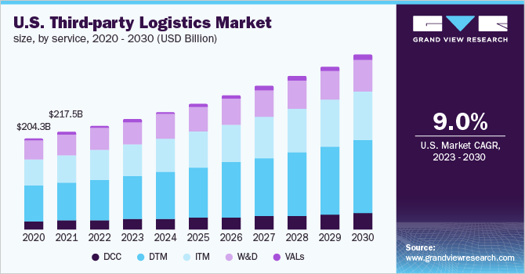

## CHAPTER - 3

**LITERATURE REVIEW**

Warehouses provide a proper place for arranging and controlling all products which help in boosting productivity and reduce the overall cost. It helps businesses in fulfilling the orders of customers on time. The warehousing process creates time utility by bridging the gap between the production and consumption time period. Apart from using the warehouse as the place of storage, it is also used for packaging and grading of products. Warehouses reduce the fluctuations in the price of the product by holding it when its supply exceeds in the market and by releasing it when its demand is more than its regular supply.

A literature review on increasing the efficiency of warehouse operations and the applications of AI and IoT (Internet of Things) in warehousing reveals a wealth of research and practical insights into these critical areas. Below is a summarized review of key literature in these domains:

"**Warehouse Design and Operations: A Comprehensive Review" (2018) by Balakrishnan et al**.: This paper provides a comprehensive review of warehouse design and operations, including layout optimization, inventory management, and order picking strategies to enhance efficiency.

**"Order Picking in Warehouses with Autonomous Robots: A Review" (2018) by Ghamlouche et al.:** The study explores the use of autonomous robots in warehouse order picking, emphasizing efficiency gains and improved accuracy.

"**Lean Warehousing: Principles, Practices, and Challenges" (2018) by Mello et al.:** This review discusses the principles of lean warehousing, focusing on minimizing waste, optimizing workflows, and enhancing efficiency.

**"Artificial Intelligence in Warehouse Management: A State-of-the-Art Review" (2020) by Rezaei et al.:** This review discusses AI-driven solutions for warehouse management tasks such as routing, scheduling, and predictive maintenance, highlighting their potential to enhance operational efficiency.

**"IoT-Based Smart Warehousing: A Comprehensive Review" (2019) by Gajananan et al**.: The study explores IoT-based smart warehousing solutions, including RFID, sensor networks, and data analytics, for real-time tracking, quality control, and energy management.

**"IoT and AI Integration for Warehouse Management: A Comprehensive Review" (2020) by Khin et al.:** The review highlights the complementary nature of IoT and AI in optimizing warehouse processes, enhancing decision-making, and reducing errors.

**"Internet of Things in Logistics and Supply Chain Management: A State-of-the-Art Literature Review" (2018) by Ivanov and Dolgui:** This review provides insights into how IoT can be integrated into supply chain and warehouse management systems, enhancing traceability, and reducing operational costs.

**"The Future of Warehousing: Past Lessons to Future Potential" (2016) by Mason-Jones et al.:** This paper explores the future of warehousing and discusses emerging trends like robotics, drone technology, and e-commerce's impact on warehouse design and operations.

"**Smart Warehousing: Trends, Drivers, and Implementation Challenges" (2019) by Schonberger and Blecker**: This study examines the concept of "smart warehousing" and the role of AI, IoT, and big data analytics in reshaping warehouse management practices.

### "A Literature Review on Models of Inventory Management under Uncertainty" (2016) by Babu and Reddy: This review focuses on inventory management models and techniques applicable to warehouse operations, particularly

### COMPETITION

There is a huge competition into the market and the competitors are from the core logistics background. The main reason of the competition is there network and availability in each zone and region. Some of the competitions are

* Aegis Logistics
* All cargo Logistics
* Gati
* Transport Corporation of India
* ABC India
* AFL Logistics
* AQUA Logistics
* DHL Express (India)
* Dynamic Logistics
* Geologistics (Pty)
* Mahindra Logistics
* Om Logistics
* Patel Logistics
* Reliance Logistics
* Safe Express
* Schenker India
* SembCorp Logistics
* SICAL Logistics
* Take Solutions
* Total Logistics (India)
* Transystem Logistics International
* TVS Logistics Services

One of the biggest competition is the local transportation which is been used for limited quantity by the small companies and organisations to save money.

CHAPTER-2

PROFILE OF AAJ ENTERPRISES

### TRANSPORTERS AND PUBLISHERS/CLIENTS

AAJ Enterprises is India’s leading 3PL and Warehousing organisation, with more than 500 employees, decade of experience, deep understanding of multiple industries & business functions.

### Transporters Selection

Each and every transporter have already given the specific terms In the agreement as docket charge and Volumetric weight charge for different hubs in different regions and the minimum charge for the shipment.

All the factors are been compared through WMS (Warehouse Management System) and the best transporter is selected for the process for every individual shipment.

After selecting the appropriate transportation the shipment is been traced till it gets delivered to the client.

Whole process has to completed within the given time i.e., TAT (Turn-Around Time)

AAJ itself do the transportation for some particular places but on a very low scale.

### TRANSPORTERS WITH AAJ ENTERPRISES PVT. LTD.

There are 8 main transporters working with the company:

* Bluedart
* FedEx
* Gati
* Safe Express
* Shri Maruthi
* Speed Post
* Spot-on
* TCI Express

Basically, The company has many others transporters also that do the delivery for the company but on the very low scale.

* Delhivery
* DTDC
* Amazon etc.

### PUBLISHERS WITH AAJ ENTERPRISES

**The main publishers are:**

1. HarperCollins Publishers India Ltd.
2. Hachette Publication
3. Golden Times
4. Next Education
5. RELX

### INDUSTRIES AAJ SERVE

**These are the Industries AAJ serve:**

1. Apparels
2. Health care
3. E-Commerce
4. FMCG
5. Energy
6. Publishing
7. Automobiles

### SERVICES PROVIDED BY AAJ ENTERPRISES

* **Transportation Management**

### Operations Management

* **E-Commerce Operations**

### Returns Management

* **Technology Management**

### Consultancy and Advisory Services

* **Value Added Services**

1. Online Portal Sale Management
2. Kitting/ Insertions
3. Digital as well as Offset printing
4. Customer Services
5. Credit Control

**INTRODUCTION OF THE STUDY**

Manpower affects everything in a business from production to client relationships. Without adequate and supportive manpower, a business will never be successful. And in Warehousing Management Organization efficiency of manpower matters the most. Basically, Cost and Efficiency are directly proportional to each other. If there is a person getting no money for his work will not do work efficiently. Everyone wants to be paid as per their work.

AAJ Enterprises Pvt. Ltd., like any Warehouse Management Organization (WMO), recognizes the paramount importance of manpower in achieving operational excellence. An adequately staffed and well-supported workforce directly impacts every facet of the organization, from efficient product handling to fostering positive client relationships. AAJ Enterprises' commitment to this principle is evident in their investment in over 950 employees and their potential through training and development initiatives. Furthermore, the company acknowledges the crucial link between cost and efficiency. By leveraging technology like their proprietary WMS and fostering a culture of fair compensation, AAJ Enterprises strives to optimize manpower utilization, ensuring cost-effectiveness and achieving its business objectives.

**The complete process is completely divided in two parts:-**

1. Warehousing
2. Logistics

### WAREHOUSING PROCESS (OPERATIONS)

**Warehousing process and working:**

This role plays a vital role in ensuring the smooth functioning of the warehousing operation by:

* Adhering to Standard Operating Procedures (SOPs): Guaranteeing all activities align with designated protocols, fostering consistency and quality.
* Optimizing Turnaround Time: Monitoring and minimizing the time taken to complete assigned tasks, leading to improved efficiency and responsiveness.
* Ensuring Accuracy: Maintaining meticulous attention to detail throughout all operations and associated documentation, minimizing errors and discrepancies.
* Workforce Management & Planning: Strategically planning daily tasks and efficiently managing the workforce, ensuring optimal resource utilization.
* Performance Monitoring: Maintaining and analyzing efficiency reports to identify areas for improvement and optimize workflows.
* Client Collaboration: Coordinating effectively with the customer service team to fulfill specific client requirements, fostering satisfaction and exceeding expectations.

By effectively fulfilling these responsibilities, this role contributes significantly to the success of the warehousing operation by ensuring efficiency, accuracy, and a client-centric approach.

### Locations in Warehouse:

1. Bulk Location
2. Shelf Location
3. Loose Location
4. Pulp Location

### The warehousing process consist of the factors

1. Inwards
2. Inventory
3. Outwards

**Inwards**

**Load Arrival**: Many companies in supply chain management leverage preliminary inbound planning to optimize and streamline their logistics services. This proactive approach minimizes errors and maximizes efficiency by:

* Automating Information Entry: Receipt information, including dock reservations, staging area allocation, and appointment scheduling, is automatically entered into the system within minutes, eliminating manual data entry and reducing the risk of human error.
* Enhanced Efficiency: This automation allows for faster processing, smoother execution, and better utilization of resources throughout the inbound logistics process.
* Error Reduction: Eliminating manual data entry minimizes the potential for errors in information like dock allocation, appointment scheduling, and staging areas, ensuring a smoother and more efficient operation.
* By implementing preliminary inbound planning, companies gain a significant advantage in terms of efficiency, accuracy, and overall logistics optimization.

**Bar Coded Information:** This approach utilizes barcodes to encode a combination of data points while maintaining confidentiality. Here's how it works:

* Data Concatenation: The barcode combines information like store ID, register ID, date, and a transaction number specific to that store and register.
* Hashing for Security: A hash function is then applied to this entire data string. A hash function produces a unique, fixed-length output value based on the input data. This means even minor changes to the original data will result in a completely different hash value.
* Pattern: The resulting hash value is displayed in the barcode following a consistent pattern. This ensures uniformity and facilitates scanning.

**Benefits of this Design:**

* Data Obfuscation: While the barcode reveals the overall structure, the actual content (store ID, register ID, date, transaction number) remains concealed due to the hash function.
* Error Detection: Any discrepancy in the original data will be detectable upon scanning, as the generated hash won't match the one encoded in the barcode.
* Overall, this barcoding strategy offers a balance between data integrity and information security.

**Tracking:** Incorporating truck license plate tracking for enhanced monitoring capabilities and data collection. This tracking is facilitated by Radio Frequency Identification (RFID) technology, specifically utilizing a solution known as "RFID Insider."

**Benefits of Truck License Plate Tracking:**

* Improves visibility and control over fleet movements.
* Facilitates automated gate access and tracking.
* Enables real-time location tracking for improved logistics planning.
* Provides valuable data for security and safety purposes.

RFID Technology: RFID utilizes radio waves to identify and track objects equipped with RFID tags. In this case, RFID tags would likely be attached to trucks, allowing for their automatic identification and data capture as they enter and exit designated areas.

Overall, this combination of truck license plate tracking and RFID technology empowers organizations with a sophisticated solution for improved logistics management, enhanced security, and streamlined data collection.

* **Put Away:** The putaway process signifies the final stage in a product's journey within a warehouse, where it's moved from the receiving area to its designated storage location. This crucial step involves:
* Precise placement: Goods are strategically positioned within the warehouse based on pre-defined storage rules, ensuring efficient retrieval and space optimization.
* capture: Serial numbers and lot numbers are meticulously recorded during the putaway process. This data is vital for inventory management, enabling accurate tracking and traceability of individual items or specific batches.

**By meticulously focusing on these aspects, the putaway process plays a critical role in:**

* Maintaining inventory accuracy: Recording serial and lot numbers ensures a clear understanding of which specific items are available in the warehouse.
* Facilitating efficient picking and fulfillment: Precise product placement based on a well-defined storage strategy streamlines order picking and expedites fulfillment processes.
* Enhancing traceability: Capturing and storing serial and lot number information enables tracing specific items throughout the supply chain, providing valuable insights for quality control and product recalls.

Therefore, the putaway process goes beyond simply storing goods; it lays the foundation for efficient inventory management, streamlined fulfillment operations, and enhanced traceability within the warehouse environment.

Inward Dock Standard Operating Process.

* Dock shutter will open only and only when the vehicles arrive at dock otherwise it will remain close all the time.
* Entry from operations main gate is only approved with safety belt for Unloaders and for driver / or the person who will take the receiving as well.
* No person is allowed to enter the Warehouse premises from Inward dock or by bypassing the SOP.
* Driver or the person with the driver have to come from operations gate after frisking process and after wearing Visitor belt to Inward department with document for dock opening process.
* Gate will be close immediately once the vehicle gets unloaded and the person who will take the receiving (driver / the person with the driver) from Inward will hand over the visitor belt to the security guard first and after that he will leave the premises.
* The dock supervisor will maintain the register for doing entry at consignment level for all type of inward
* The receiving of consignment should be given by authorized person only (On Roll Staff is allowed)
* The proper receiving should be given along with full name and signature of receiver and also both security and inward stamp should be mentioned on the receiving.

The receiving of boxes or qty should be given only after physical verification and in case not able to count/verified physical stock then receiving should be given with remark- Qty and Quality subject to physical verification.

## Inventory

Inventory management lies at the heart of effective supply chain management. It serves two critical functions:

**1. Maintaining Accurate Product Data:**

A comprehensive inventory management system records and maintains detailed information about every product present in the warehouse. This data includes:

* Product details (type, specifications, dimensions)
* Quantity on hand
* Location within the warehouse (storage section, bin number)
* Serial numbers and lot numbers (if applicable)
* Additional information relevant to specific products

**2. Facilitating Optimal Replenishment:**

By analyzing real-time inventory data, businesses can:

* Identify products nearing depletion.
* Trigger timely reorders based on pre-defined thresholds and lead times.
* Prevent stockouts that can disrupt production or customer fulfillment.
* Optimize storage space by avoiding overstocking of slow-moving items.

**Benefits of Effective Inventory Management:**

Improved customer satisfaction: Ensures products are readily available to meet customer demand, minimizing order delays and cancellations.

* **Reduced costs:** Minimizes storage, handling, and carrying costs associated with excess inventory.
* **Enhanced operational efficiency:** Streamlines order fulfillment processes and optimizes warehouse space utilization.
* **Increased accuracy and control:** Provides real-time data for better decision-making and risk management.

By effectively managing inventory, businesses can achieve greater efficiency, cost-effectiveness, and customer satisfaction throughout the supply chain.

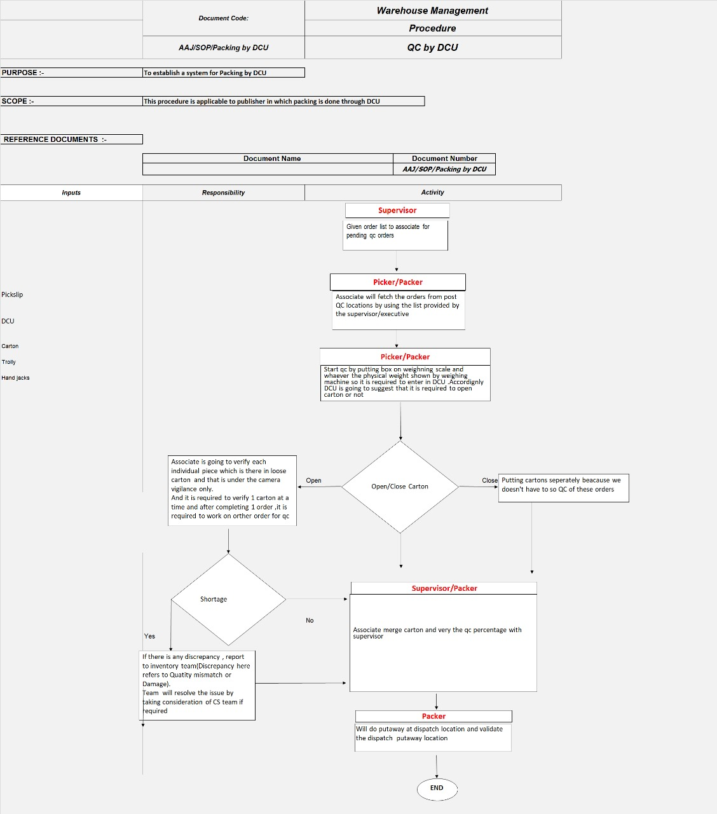

## Outbound

* **Quality Check**: Checking expiry dates is a crucial step in both inbound and outbound processes within the supply chain, especially for products with shelf-life limitations. This practice ensures:
* **Maintaining product quality:** By prioritizing the outbound shipment of Enhancing items with longer expiration dates, businesses can guarantee customers receive high-quality products with sufficient remaining shelf life.
* **Minimizing waste and losses:** Expired products become unusable and incur disposal costs. Strict expiry date management helps prevent unnecessary waste and associated financial losses.
* **Customer satisfaction:** Delivering products within their designated shelf life fosters customer trust and satisfaction, reducing the risk of receiving unusable or expired items.

Therefore, quality check is an essential practice for businesses to ensure they deliver products that meet quality standards and satisfy customer expectations. This practice is implemented during the inbound process to maintain proper stock rotation and prioritize the outbound shipment of items with longer expiration dates.

* **Sales Order**: A sales order serves as more than just an indication; it's a formal confirmation between a seller and a customer that the latter has agreed to purchase specific products at a set price and under defined terms. This document typically includes details like:
* **Product details:** Item descriptions, quantities, and pricing.
* **Customer information:** Billing and shipping addresses, contact details.
* **Delivery and payment terms:** Delivery window, payment method, and any applicable discounts or surcharges.

By issuing a sales order, the seller acknowledges the customer's intent to purchase and initiates the order fulfillment process. This document serves as a binding agreement that protects both parties and streamlines the transaction.

* **Pick and Pack**: The outbound process in a warehouse plays a crucial role in fulfilling customer orders efficiently and accurately. It involves a series of coordinated steps, including:
* **Order Management:**
* Download and Release: Orders are downloaded from the sales system and released for picking.
* **Picking**: This stage involves selecting the ordered items from the warehouse. There are various picking methods used to optimize efficiency, such as:
* **Discrete order picking:** Picking individual items for each order.
* **Batch picking**: Picking multiple orders simultaneously for similar items or destinations.
* **Wave picking:** Picking multiple orders in smaller batches throughout the day.
* **Zone picking:** Assigning specific picking zones to pickers based on item location.
* **Forward picking:** Picking items directly into shipping containers for specific destinations.
* **Cluster picking:** Grouping similar items from various orders for efficient picking.
* **Paper-based picking & pack:** Using paper pick lists and packing slips for manual order fulfillment.
* **Packing:**
* **Preparation:** Picked items are gathered and assembled for shipment. This may involve packing materials, labeling, and documentation preparation.
* **Shipping:**
* **Dispatch:** Prepared shipments are handed off to the designated carrier for delivery to the customer.

By employing various picking methods and efficient packing processes, warehouses can ensure timely order fulfillment while optimizing their resources and minimizing errors. This overall outbound process contributes significantly to customer satisfaction and overall business success.

# Document Scope

* This document provides an overview of the process.
* It explains the SOP to execute the process and also process flowchart.
* It defines the process risks and control measures.

**Terminology-:** Abbreviations used for special subject and activity –

* 1. **WMS *–*** Warehouse Management System is software which records all the warehousing transaction.
  2. **A.S.R**– Advance sale return.
  3. **G.R.N**- Goods Receipt Note is created to record the items send by supplier.
  4. **DCU *-*** Device Connected Unit is a type of electronic device which is use to generate gate pass.
  5. **D.M.S**- Document Management System is a type of software to save the receiving of shipments.
  6. **D.R.S-** Delivery Run Sheet is a document on which we receive the receiving of shipments.



Process of dispatch activity

Prepared By:

Responsibility Activity Special Attention Required

To control the short/excess discrepancies, 100% QC is done.

Once the picking and Packing Activity completed then the QC team after quality check of packed boxes will keep the boxes at Dispatch assigned

Locations.

QC supervisor

Dispatch Executive

Invoice supervisor

Dispatch executive

Dispatch executive

Dispatch executive

Security supervisor

It is done on the basis of orders reflecting in order pool, under picking, under dispatch and ready for gate pass.

Preparing of evening schedule around 11 am and preparing of next day morning schedule after 4 pm on daily basis.

Matching of quantity in PO and Invoice is cross checked by invoicing department.

Now invoices are downloaded from FTP and generated(only for duckbill) and then cross checked with PO to avoid the deviation in order qty & dispatch qty.

Types of orders

Local Orders

Out station orders

Cartons are checked in case of not found in the dispatch locations.

Schedule is given to dispatch floor boys to find the consignments in supervision of floor supervisor who update the live status in dispatch advice on Tab and take out the material to dispatch bay.

Schedule is given to floor boys to find the consignments in supervision of floo r supervisor and take out the material to dispatch bay.

The consignments are loaded by delivery boy in vehicles as per schedule in presence of security personnel who also make a note on register

The material is placed in dispatch bay as per assigned area for transporters and security personnel make a

transport-vise note on register for all

shipments placed in dispatch bay.

The security personnel monitors whether the paper activity is complete or not

Now, According to Schedule, Invoices are given to transporters to generate the GRN and consignor copy is received by floor supervisor against the material handover to them.

The Gate pass is generated according to updated schedule and accordingly, invoices and duly signed gate pass are given to security personnel after the verification by dispatch executive

The gate pass is signed and given to delivery boy after verification for loaded shipments in vehicle to make a exit of vehicle.

The Gate pass is generated according to updated dispatch status of consignments and cross checked with received consignor copy.

Security supervisor checks the exit pass from drivers

The duly signed gate pass is given to dispatch security personnel to cross check and sign the gate pass after verification for handover shipments to the transporter

Exit of vehicle

The signed gate pass is given to transporter to make a exit of vehicle.

What is Dispatch?

* Dispatch is a process for delivering the packed orders to the customers as per their demand. And it follows a systematic series of process to get the work done on time.

From where it Starts ?

* When the picking team packs the scheduled orders, then the dispatch activity starts.

How the packed orders are checked whether they have correct material with right weight or not in the carton?

* Here the QC (quality check) process starts which checks the weight of the orders by using the DCU.

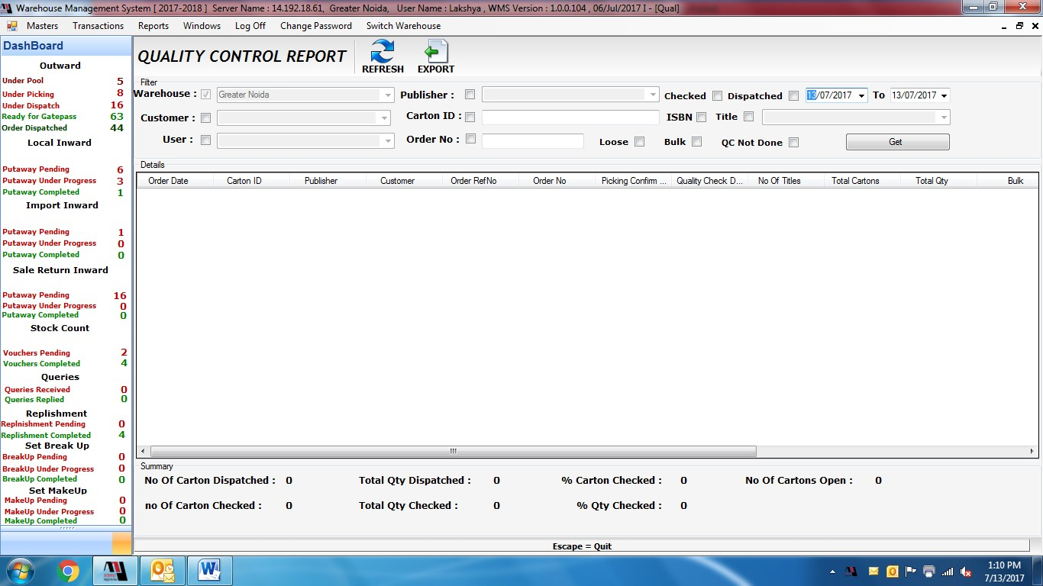

Now what is DCU ?

Basically, DCU (Device Connecting Unit) is a device which reads the printed bar code on the cartons and saves the information about the order in the WMS.



What is WMS and how it helps in working in the dispatch?

* It stands for WAREHOUSING MANAGEMENT SYSTEM. It is software specially programmed by the IT team for the AAJ Enterprise. It contains each and every detail about all the activities going on regarding orders for local and out station orders.

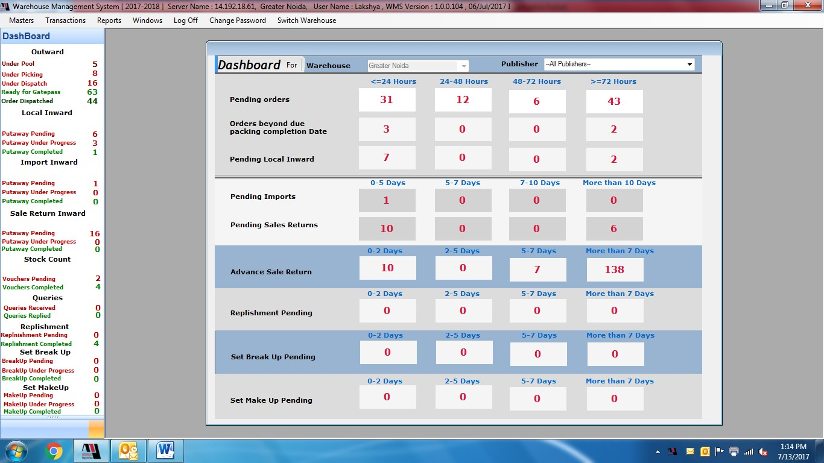

.

How it is decided that how many orders are ordered by the customer and to which customer they should be sent and when?

* Now by using the software WMS, the morning and evening schedule are prepared by the dispatch executive in the MS-Excel sheet. This sheet contains all the details about the publishers, customers, orders, address, quantity, and many more.

## How to prepare schedule

* Here, by clicking at **ADD**, dispatch advise will be open

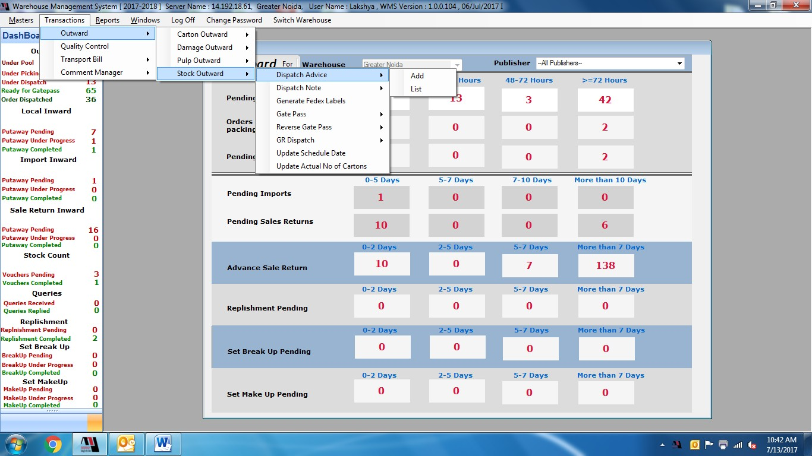

## What are LOCAL ORDERS?

* Orders which are ordered by the local customers.
* Local customers are those which are from Delhi/NCR region.
* On daily basis, schedule is prepared after 4pm to deliver the orders to next morning to the customers. And they should be delivered timely so that it does not cross TAT.
* Now in dispatch advise, for local orders, select the mentioned criteria in the screenshot and get the data and export it to an excel sheet.

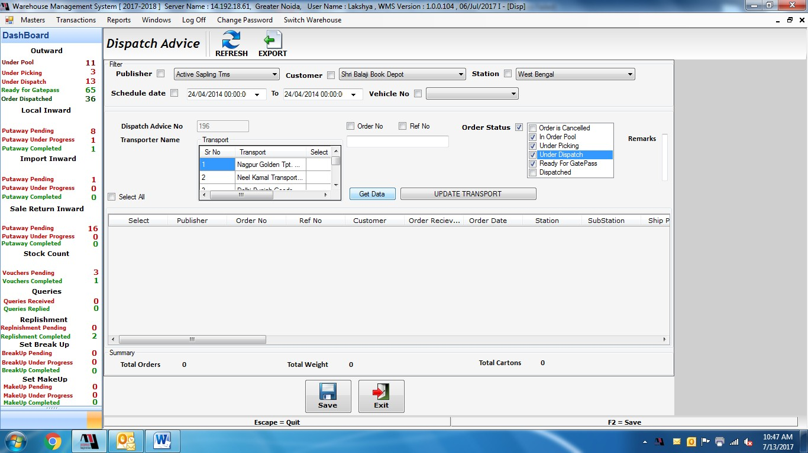

## What are OUT STATION ORDERS?

* + These are the orders from all over INDIA and others countries.
  + These are sent by the other transport services like FEDEX, RIVIGO, SPOT-ON.
  + **O**n daily basis, schedule is prepared after 11am and they all have to be sent on same day till evening so that it does not cross out TAT.
  + Here also, select the mentioned criteria in the screenshot and get the data and export it to an excel sheet.

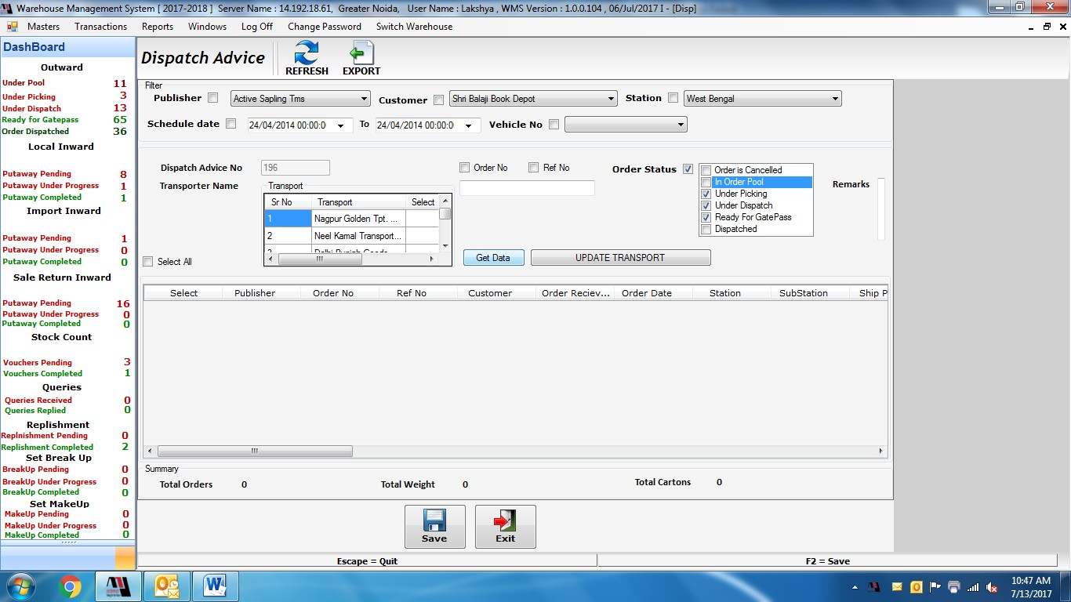

What is TAT?

* Ans. It is TURN AROUND TIME. Basically we are given a timeline of 24 hours for almost every publisher for local orders that orders should be delivered to the customers within 24 hrs. And in case of outstations orders, it 24 hrs as well as 48hrs.

## To check TAT for Dispatch Department

* Now, to check TAT for the dispatched orders.

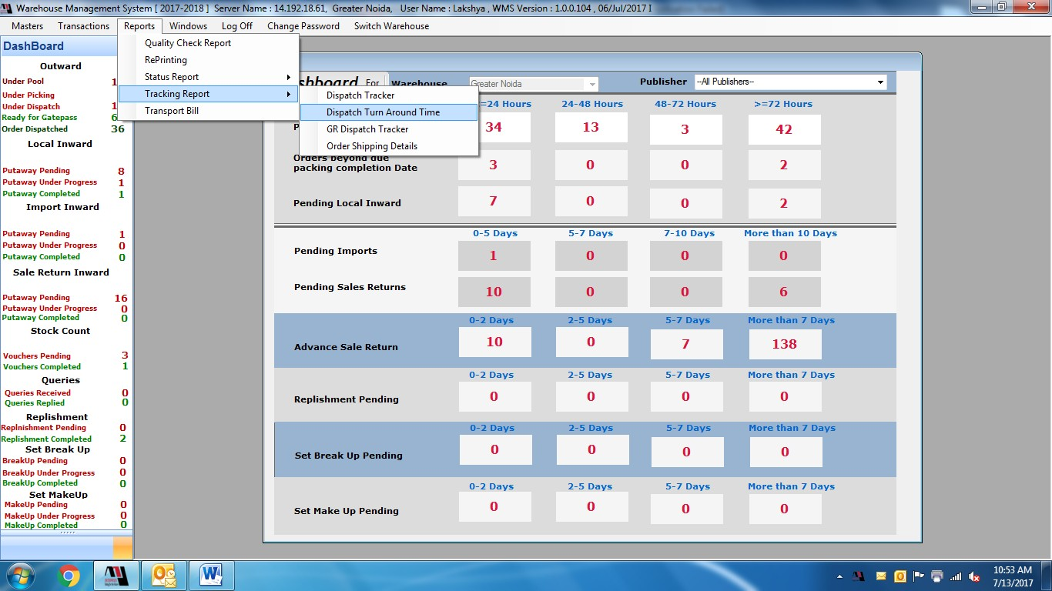

* Now, a list of orders will be shown and by analysing that data, we can easily track which orders are getting delayed and why?

**For Example**

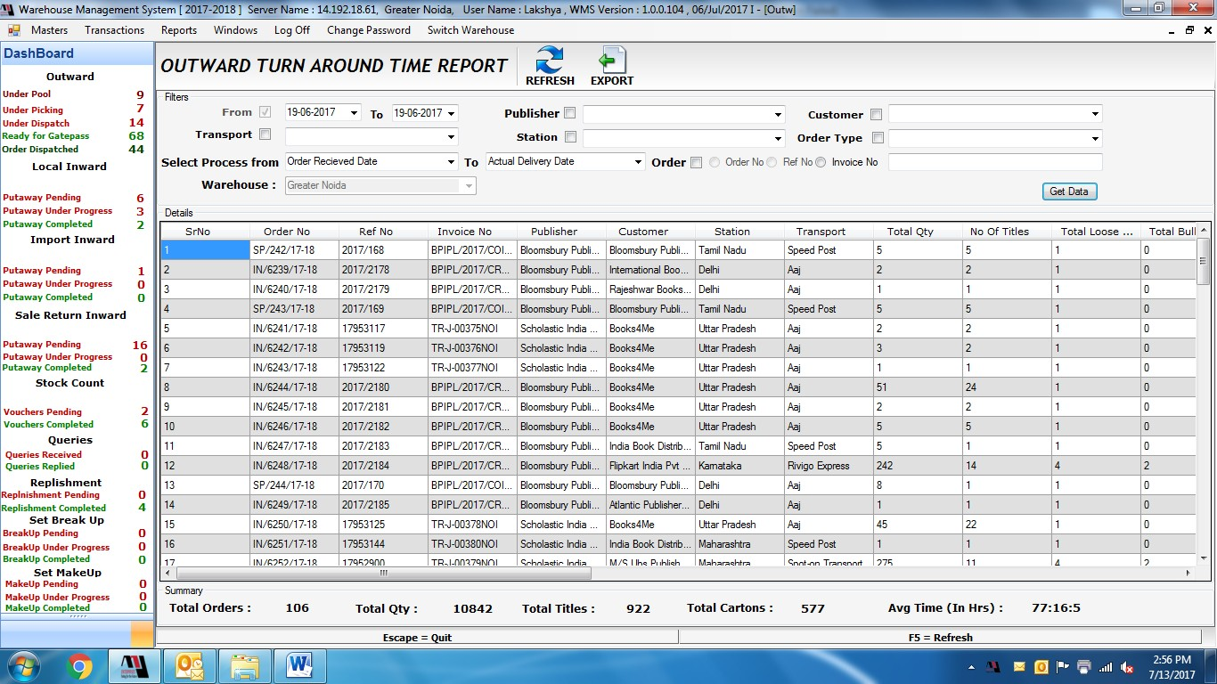

**Gate pass process**

* Now, after preparing the schedule for local and out station orders, invoices are generated by the invoice department and then the gate pass are generated.

# Exception-:

1. Failure of delivery due to traffic and communication gap.
2. Invoices should be cross-checked.
3. Filing should be done properly.
4. Bookings should be done from instructed accounts.

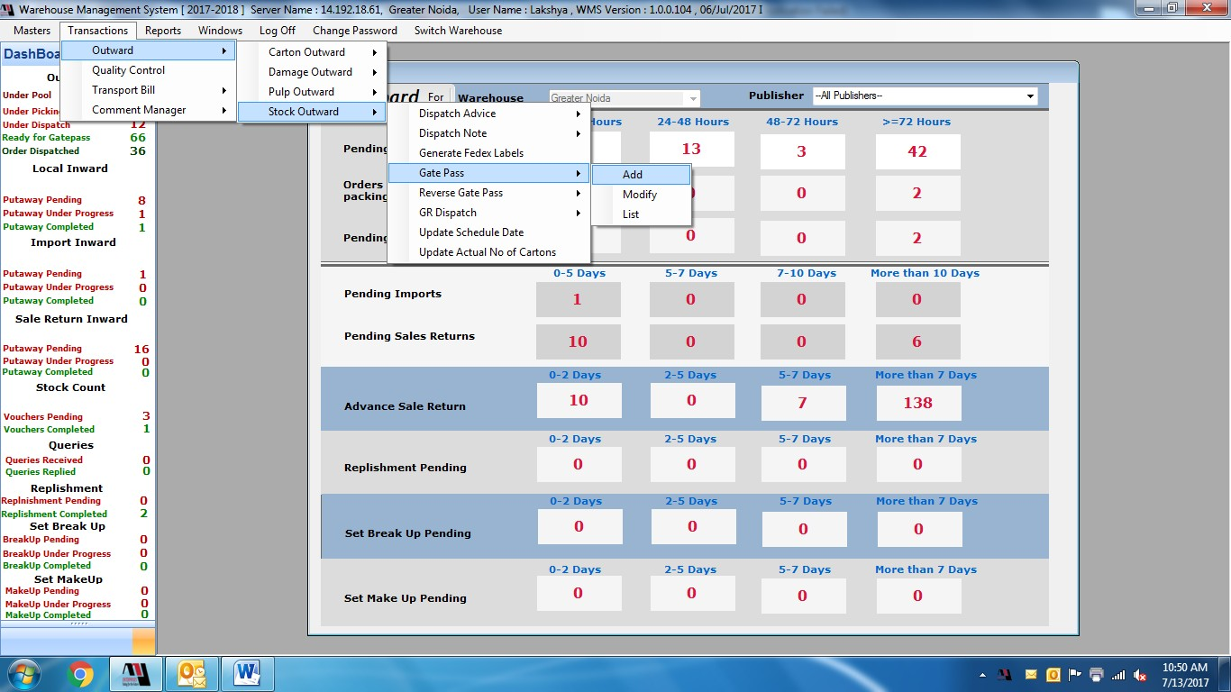

### LOGISTICS PROCESS

**Logistics Process and working:**

* Need assessment & vendor identification, on boarding and other related activities.
* Managing the turn-around time of assigned activities.
* Coordinating with internal & external stakeholders for fulfilment of specific requirements.
* Service level improvement in various aspects.
* Cost reduction & Process/Product improvements.

**The logistics process mainly uses hub and spoke model:-**

**The hub-and-spoke model creates numerous benefits, including:**

* **Continuous movement for loads** thanks to centralized handoffs.
* **Reduced lengths-of-haul**, which improve scheduling, reduce transit time and help drivers comply with hours-of-service regulations.
* **Consistent on-time performance**, which enhances service levels and ensures products arrive in the right place at the right time.
* **Improved driver recruiting and retention**. Drivers are able to return home each night, thus experiencing an improved quality of living. This produces additional benefits, including higher tenure, route consistency, increased transit dependability and performance, and improved safety.
* **Reduced costs and enhanced productivity** thanks to Penske’s economies of scale (larger loads reduce per-unit costs) and the elimination of the need for team drivers.
* **Lower carbon footprint**, because few empty miles driven reduces wasted fuel and emissions.
* **Consistent pricing** mitigates the risk of third-party carrier price fluctuations.

### LOGISTICS PROCESS

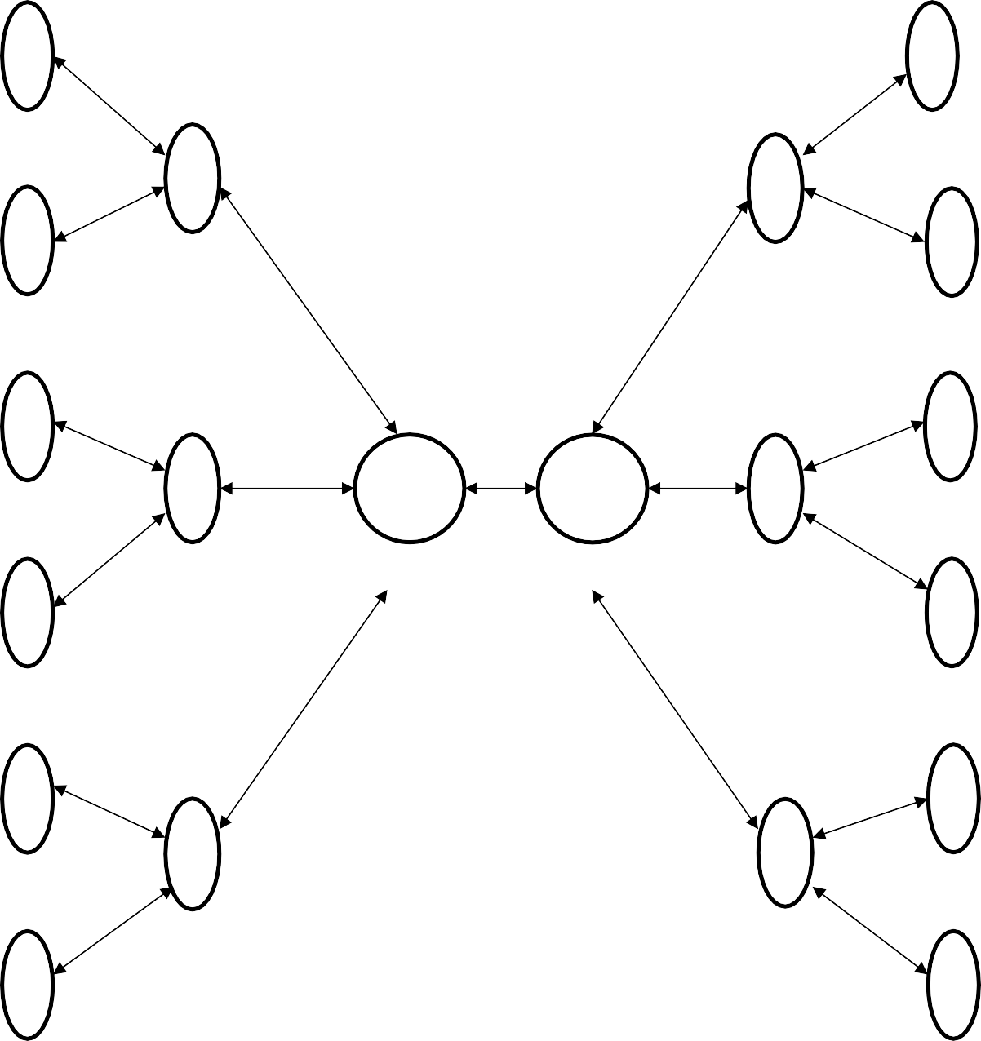

**W1 Consignee 1**

### Hub 1/Spoke Hub 1/Spoke

**W2 Consignee 2**

### W3 Consignee 3

**Hub 2/Spoke Mother Hub Mother Hub Hub 2/Spoke**

### W4

**SCOPE AND IMPORTANCE OF THE STUDY**

This project has been instrumental in providing me with valuable insights into the world of 3PL and warehousing, specifically through the lens of Aaj Enterprises' operations. It has offered me practical exposure to the company's environment, allowing me to understand the daily workings and dynamics involved. Additionally, the project has emphasized the importance of building relationships with various stakeholders, including customers, managers, clients, and transporters, a crucial skill set for any industrial setting. By delving into the complexities of warehousing and logistics processes at Aaj Enterprises, I have gained invaluable knowledge that prepares me for the demands of an industrial career. This knowledge encompasses a comprehensive understanding of both 3PL and warehousing processes, including inbound and outbound operations, inventory management, expiry date management, and the interconnected functions of various warehousing and logistics departments. Overall, this project has served as a stepping stone to industrial readiness, equipping me with the necessary knowledge and skills to navigate the complexities of the professional world.

### EXTENT

This project delves into several key aspects of warehousing and logistics, providing valuable insights that extend beyond theoretical knowledge:

**Cost-Efficiency and Manpower**: The project aims to analyze the relationship between cost and manpower efficiency within warehousing operations. This will shed light on how cost factors influence workforce productivity and identify strategies for optimizing both.

**Unlocking Operational Realities:** By delving into the actual warehousing and logistics processes, the project goes beyond textbook theory to reveal the practical day-to-day operations within a functioning organization. This practical understanding is crucial for navigating the realities of the industry.

1. **Optimizing Logistics:** The scope encompasses the analysis of transportation routes and finding the perfect transporter for specific shipments. This knowledge can be utilized to streamline logistics, minimize costs, and ensure timely deliveries.
2. **Financial Management Strategies:** The project aims to explore cost-cutting methods, cash management, and inventory management, equipping you with valuable financial strategies applicable to diverse organizational settings.
3. **Real-World Organizational Dynamics:** Through this project, you gain firsthand knowledge about how organizations function in real-world environments. This understanding provides valuable context for navigating professional settings and building your career path.

In essence, this project bridges the gap between theoretical knowledge and practical application, providing you with a comprehensive understanding of warehousing, logistics, and organizational dynamics within the field

### LIMITATIONS

This project strives to deliver objective and unbiased results by carefully considering potential limitations:

1. **Individual Variations in Responses:** Recognizing that employee expectations can differ, efforts were made to account for diverse perspectives and minimize bias in interpretation.
2. **Resource Constraints:** While detailed record-keeping is crucial, the project acknowledges the potential cost associated with additional clerical staff. Strategies were employed to optimize data collection and analysis within available resources.
3. **Challenges in Forecasting:** The project acknowledges the inherent difficulty in predicting future changes, particularly in technology and government policies. These uncertainties were considered during data analysis and interpretation to ensure realistic and adaptable findings.
4. **Uncertainty in Long-Term Manpower Planning:** The project recognizes the uncertainties associated with long-term manpower planning, especially in dynamic business environments. Despite these challenges, the project aimed to provide insights valuable for informed decision-making within plausible future scenarios.

By acknowledging these limitations, this project fosters transparency and strengthens the reliability of its findings, offering valuable insights applicable to real-world scenarios.

**IMPORTANCE OF STUDY**

**This research project aims to achieve the following objectives:**

**1. Understanding Aaj Enterprises' Operations:**

* **Analyze the role of 3PL and Warehouse Management:** This involves examining how Aaj Enterprises utilizes third-party logistics providers and manages its warehousing operations to deliver value to its clients.
* **Assess Aaj Enterprises' responsibilities towards clients**: This entails evaluating the services and commitments Aaj Enterprises offers to its clients in the context of 3PL and warehousing.
* **Evaluate the impact on Aaj Enterprises:** This involves examining how these 3PL and warehousing activities contribute to Aaj Enterprises' overall performance and success.

**2. Exploring the Cost-Efficiency and Manpower Relationship:**

* **Investigate the connection between cost and manpower efficiency:** This core objective delves into whether and how cost factors influence the productivity and effectiveness of Aaj Enterprises' workforce within their warehousing operations.

**3. Research Scope and Impact:**

* **Location of Study:** The research was conducted in the specific areas of Sonipat (Kundli 1 and Kundli 2) and Greater Noida.
* **Potential Benefits:** The findings of this study are intended to be valuable for both organizations and employees in the following ways:
* **Organizations:** Gain insights into optimizing manpower efficiency while managing costs related to 3PL and warehousing activities.
* **Employees:** Understand the potential for fair compensation based on performance and contribution within the context of the cost-efficiency relationship.

Overall, this research project focuses on understanding the interdependencies between 3PL, warehousing management, cost, and efficiency within Aaj Enterprises. By analyzing these factors, the study aims to provide valuable insights beneficial to both organizations and employees striving for sustainable growth.

### OBJECTIVES:

* To understand the efficiency of Manpower at AAJ enterprises
* To know the relationship of cost and efficiency of Manpower at AAJ Enterprises.
* To understand how to handle Manpower in warehouse.
* To understand the warehousing process at AAJ Enterprises
* To understand the Supply Chain Management.
* To understand the Logistics, its process and working.
* To know the Cash management, Route Management, Contract Management, Contract Negotiations.

**HYPOTHESIS**

**Ha:-**If manpower getting proper cost for their work, then their efficiency automatically increases.

Proper cost shows a positive impact on the efficiency of manpower, they took less time do the same work. Half of the manpower that are getting more cost looks more efficient than those are getting low cost.

**Ho:-** There is no relationship between cost and efficiency of manpower if they are getting more time and a specific task to do.

**NEED OF THE PROJECT**

The results of the study will be of great benefit to the following:

* **Organisation:** Given data will help the Organisation to know the basic necessities of the employees and will know the reason so that the organization can grow fast.
* **Employees:** It is very necessary to any person to be sufficiently paid for his work and most importantly in this current pandemic.

# CHAPTER -3 RESEARCH DESIGN

**RESEARCH DESIGN**

**Type of Research –Quantitative & Qualitative Research**

Quantitative research deals with numbers and statistics, while qualitative research deals with words and meanings. Quantitative methods allow you to test a hypothesis by systematically collecting and analysing data, while qualitative methods allow you to explore ideas and experiences in depth.

For the study during the project both qualitative and quantitative approaches were used to gather and study the important factors in warehousing and logistics which need to be developed for the smooth and effective process.

For the primary study both quantitative and qualitative approaches were employed in achieving its purpose.

A qualitative research technique was used to gain insights into the prevailing roles and functions of the people handling shipment from AAJ Enterprises. It provided insights into the setting of a problem, generating ideas and/or hypotheses for later quantitative research.

Quantitative research quantifies data and generalizes results from a sample to the population of interest. It measures the frequency of various views and opinions in that chosen sample.

### Scaling technique

Nominal scale is used for the measurement of variables as it is very simple and the most widely used when relationship between two variables is to be studied.

## CHAPTER- 4

RESEARCH METHODOLOGY

#### Objective:

* To understand the picking and packing process, and achieve Turn around time (TAT) for daily tracker orders.
* Find out the errors in picking and packing methods. And provide a solution for it.
* Find out the loop holes in the current warehouse operations and give solutions to increase the efficiency.
* To see the applications of Artificial Intelligence (AI) and Internet of Things (IOT) in the warehouse operations.

#### 

#### Methodology

* First to understand the working of every department and Their SOP (standard operating processes).
* To collect the data of previous months TAT report from picking and packing department. That is our secondary data.
* Primary data is collected though shop floor and by talking to associates. and observing the operations of warehouse.

#### Hypothesis

* **Hypothesis 1**: Cross-training warehouse staff to handle tracker orders in addition to regular orders will result in a more versatile workforce capable of fulfilling tracker orders promptly, reducing processing delays.
* **Hypothesis 2**: Worker training and skill development programs focused on proper picking and packing techniques will lead to a decrease in errors, as employees become more proficient in these tasks.
* **Hypothesis 3**: Conducting regular quality control checks and audits of randomly selected orders before shipment will help identify and rectify errors in both picking and packing operations, reducing the likelihood of shipping incorrect items.
* **Hypothesis 4**: Regularly reviewing and analyzing customer feedback and return data will provide insights into common picking and packing errors, allowing for targeted process improvements.
* **Hypothesis 5:** Implementing advanced technologies such as AI and IoT in warehouse operations will lead to a significant reduction in operational errors, resulting in improved overall efficiency. Collection of data.

To complete this project, we need two types of data

#### Primary Data

* Primary data was collected for understanding the efficiency of warehouse operations.
* Information for the qualitative research was obtained from:
* Strategic plan for AAJ Enterprises.
* Feedback taken by the Associates and Executives of AAJ Enterprises regarding their efficiency.
* Secondary research papers.

#### 

#### Secondary Data

Secondary data was collected to understand the picking and packing of orders and monthly Order data. For my quantitative research, I used

* Data from WMS (Warehouse Management System).
* Documents provided by AAJ Enterprises.
* Analysis of historical data and records related to inventory, picking, and packing.

#### Research Approach:

The project will adopt a mixed-method research approach, combining both quantitative and qualitative research methods to provide a comprehensive analysis.

#### Population Size:

The population size consists of all warehouse operations within AAJ Enterprises, including inventory management, picking and packing, communication channels, and overall workflow.

#### 

#### Sample Size:

The sample size will be determined based on the specific aspects of the warehouse operations under investigation. Each aspect may have a different sample size:

For inventory management, a random sample of 100 different SKUs (Stock Keeping Units) can be selected.

* For picking and packing, a sample of 50 order processing cycles can be observed.
* For communication channels, interviews and surveys can be conducted with a representative sample of 30 employees involved in the process.
* For the overall workflow, data from the entire warehouse population can be analyzed.

#### Sample Design:

The sample design will include both random sampling and purposive sampling:

Random sampling will be used for selecting SKUs and order processing cycles to ensure representativeness.

Purposive sampling will be employed for interviews and surveys to include individuals with relevant experience and expertise.

#### Statistical Tools:

To analyze and interpret the collected data, the following statistical tools and techniques can be employed:

* Descriptive statistics for summarizing and presenting data.
* Regression analysis to explore relationships between variables.
* Hypothesis testing to assess the impact of AI and IoT on efficiency.
* Data visualization tools for presenting findings effectively.
* Qualitative data analysis software (e.g., Power BI) for analyzing interview responses.

#### Limitations:

AAJ Enterprises is a lead 3PL Service provider but has very little data available as the technique used is same in all the warehouses so compression cannot be done.

At most attention was taken to eliminate any kind of biasness & mi-interpretation in the study to get optimum result. Even though the following limitations could have certain degree of impact on the findings.

1. Data is only taken from employees and thus the analysis could be biased and may not reflect the scenario across all other customers.
2. The response from every individual was different as the thinking capacity of every individual is different.
3. Data collected about Importance of warehousing and logistics form employee level may not represent the real picture.
4. Due to lots of work of company we had the limited time only.
5. As logistics is really a hectic job so many respondents were not interested to give the required time.
6. The response picture is different from employer end and employee end.

## CHAPTER- 5

**ANALYSIS AND INTERPRETATION**

#### Order Picking

**What is Order Picking?**

In warehousing, order picking is basically the picking out of individual or multiple products from the inventory of a warehouse or fulfillment center in order to complete the received customer orders. Maintaining efficiency in warehousing operations is a labor-intensive and tedious job. With the eCommerce boom and thus, an increase in demand for [e fulfillment services](https://aajenterprises.com/fulfillment/) in India, order picking strategies become growingly important for warehousing and eCommerce companies worldwide.

#### 

#### Importance of Order Picking

**Decreases Warehousing Costs and Optimizes Order Pickers’ Efforts:** The right order picking strategy can help you decrease your [warehousing and distribution](https://aajenterprises.com/warehousing/) costs by providing the order pickers with the most efficient route along for the product pick-ups thereby saving time and optimizing the pickers’ efforts for each item. This helps to reduce a substantial amount of operational costs.

**Improves Order Accuracy:** An order picking system can result in grouping similar orders, which along with saving time, improves order accuracy as there is less scope for human error and the picking list guides the efforts to make sure that the right item is picked through the right route. This reduces returns for e-commerce fulfillment orders as well.

**Enhances Customer Satisfaction:** Owing to fast and accurate deliveries, customer satisfaction is enhanced as the experience of buying products improves for the customer. Late deliveries and product mismatch are one of the main reasons businesses is lost in this customer-centric industry which an efficient picking system helps to solve.

Therefore, choosing the most suitable strategy for your e-commerce fulfillment and warehousing needs is a must.

#### Order Picking Strategies

**Single Order Picking (or Discrete Picking)** – This is the most basic order picking strategy where single orders are picked up one at a time by the order pickers for the complete order fulfilment. This is suitable when received operations/orders are simple in nature, warehouse space is smaller and involves limited SKUs, and the business is small-scale with a restricted investment towards warehouse management systems.

**Batch Order Picking** – This is suitable when multiple orders from similar SKUs are to be fulfilled at the same time. Similar orders from the same SKUs are batched together and picked up which saves time, and repetitive trips and improves order picking efficiency. It is advisable for a large volume of similar items.

**Cluster Order Picking** – This strategy is suitable for picking up multiple orders but unlike batch order picking, a variety of orders from different SKUs are fulfilled. They can be manual or automated, but commonly a cart is used with multiple compartments towards the picking zone and the picker is directed towards the next SKU. It is advisable for large volumes of dissimilar items.

**Zone Order Picking (or Pick & Pass)** – In this strategy, division of the warehouse into several physical zones as per similar SKUs is done and pickers are assigned to each zone who are responsible for orders from their respective zones in shifts. e fulfilment service is done by passing through several zones. It is suitable for multiple orders from the same or multiple SKUs involving complex orders in large warehouse spaces as it saves time, and effort, and pickers often get used to their zones.

**Wave Order Picking** – It is schedule-based order picking where planning is done taking into account pickers, delivery times, shipping dates, warehouse location of the products, and carrier pick-ups to determine an optimum wave of orders that can be grouped together and prioritized according to time and urgency. The scheduling windows help to maximize the pick-up and deliveries.

#### WMS (Warehouse management system)

WMS stands for Warehouse Management System, and it plays a crucial role in warehouse operations. A WMS is a software application or platform that is designed to optimize and streamline various aspects of warehouse management, with the primary goal of improving the efficiency and accuracy of warehouse operations. Here's an overview of its key roles and functions:

**Inventory Management**: WMS helps in tracking and managing inventory levels in real-time. It provides visibility into stock levels, locations, and movement within the warehouse. It enables efficient stock replenishment, ensuring that products are available when needed while minimizing overstock situations.

**Order Fulfillment**: WMS optimizes the order picking process by determining the most efficient picking routes, reducing travel time, and minimizing errors. It enables batch picking and wave picking to handle multiple orders simultaneously, improving order throughput.

**Space Utilization**: WMS assists in maximizing warehouse space utilization by optimizing storage locations and ensuring that items are stored in the most appropriate areas based on factors like demand and product characteristics.

**Accuracy and Quality Control**: It includes features for barcode scanning and RFID technology to improve accuracy during receiving, put-away, picking, and shipping. Quality control checks can be incorporated to identify damaged or incorrect items before they reach customers.

**Traceability and Visibility**: WMS provides end-to-end visibility into the movement of goods within the warehouse, helping to track and trace products, which is critical for recall management and compliance.

**Labour Management**: It aids in labour management by tracking employee performance, providing insights into productivity, and helping with workforce scheduling.

**Reporting and Analytics**: WMS generates reports and analytics that offer insights into warehouse performance, helping managers make informed decisions to improve efficiency.

**Integration with Other Systems**: WMS can integrate with other systems, such as Enterprise Resource Planning (ERP) software, transportation management systems (TMS), and e- commerce platforms, to ensure seamless data exchange and end-to-end supply chain visibility.

**Returns Management**: It supports the efficient processing of returned goods, helping to manage the reverse logistics process effectively.

**Compliance and Regulatory Requirements**: - WMS can assist in complying with industry- specific regulations, such as food safety standards or pharmaceutical requirements, by ensuring proper handling, storage, and documentation.

In sum a Warehouse Management System (WMS) plays a pivotal role in modern warehouse operations by optimizing inventory management, order fulfillment, space utilization, and overall efficiency. It helps warehouses run smoothly, reduces errors, and enhances customer satisfaction by ensuring that products are delivered accurately and on time.

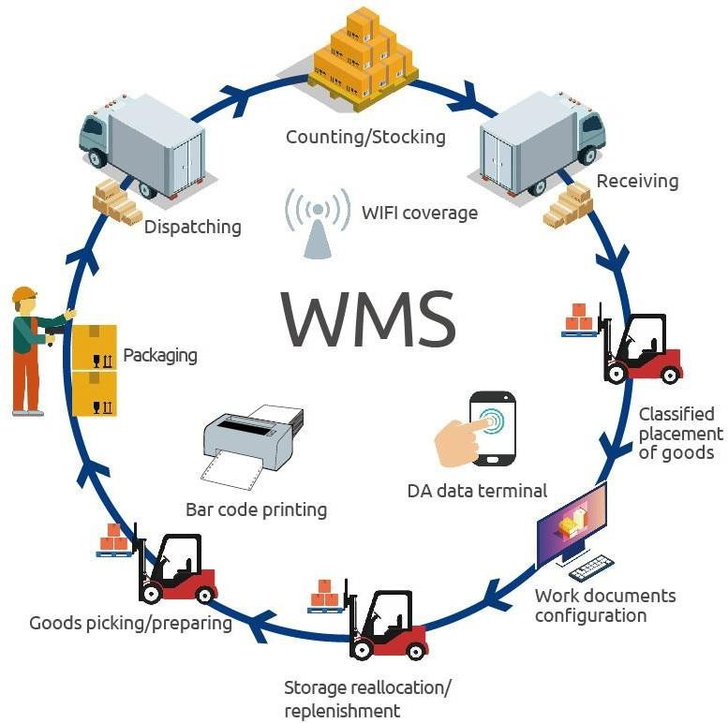

#### Data representation and analysis

The following data is collected during research period taken by me through WMS.

#### Clients in the warehouse

1. Harper Collins Publishers India Ltd.
2. Next Education India Pvt. Ltd.
3. Golden time Publishers Pvt. Ltd.
4. Hachette Book Publishing India Pvt. Ltd.
5. Relx (Elsevier)

#### TAT (Turn Around Time) of Publishers

Hachette Book Publishing India Pvt. Ltd.

|  |  |
| --- | --- |
| **No. of Titles** | **Turn Around Time (Hours)** |
| 1-199 | 24 |
| 200- 399 | 48 |
| 400+ | 72 |

Harper Collins Publishers India Ltd.

|  |  |
| --- | --- |
| **No. of Titles** | **Turn Around Time (Hours)** |
| 1-50 | 24 |
| 51-199 | 48 |
| 200+ | 72 |
| If quantity is 2500+ | 48 |

Next Education India Pvt. Ltd. And Golden time Publishers Pvt. Ltd.

For any order Turn Around time is 24 hours.

Relx Publisher

For any order turn around time is 2 hours.

|  |  |  |  |  |  |  |  |  |
| --- | --- | --- | --- | --- | --- | --- | --- | --- |
| **PICKING DEPARTMENT TAT REPORT March** | | | | | | | | |
| **PUBLISHER** | **Count of Order No** | **Sum of Total Titles** | **Sum of Dispatch Qty** | **Sum of Bulk Cartons** | **Sum of Loose Cartons** | **Count of IN TAT** | **Count of OUT OF TAT** | **PERCENTAGE** |
| Goldentime Publishers Pvt Ltd | 3 | 7 | 405 | 1 | 7 | 3 |  | 100 |
| Hachette Book Publishing India Pvt. Ltd. | 1088 | 9126 | 87997 | 964 | 2220 | 1069 | 19 | 98.25 |
| Harpercollins Publishers India Ltd. | 6920 | 78217 | 756069 | 13786 | 19308 | 6752 | 182 | 97.57 |
| Next Education India Pvt. Ltd. | 44 | 192 | 4954 | 83 | 154 | 44 |  | 100 |
| **Grand Total** | **8055** | **87542** | **849425** | **14834** | **21689** | **7868** | **201** | **98.96** |

#### Picking method used in warehouse.

**Single order picking** Single order picking, also known as discrete order picking or order-based picking, is a warehouse picking strategy where individual customer orders are picked one at a time. In this method, warehouse employees or automated systems focus on fulfilling a single customer's order before moving on to the next one. Single order picking is particularly suitable for businesses with a high volume of diverse and small-to-medium-sized orders.

#### 

#### Batch Order Picking Batch order picking, also known as multi-order picking or batch picking, is a warehouse picking strategy where warehouse employees or automated systems pick multiple customer orders at the same time. This approach is designed to improve efficiency and reduce travel time within the warehouse by consolidating the picking process for several orders.

#### Packing method used in warehouse.

**Pick Verification** Pick verification is a crucial step in warehouse operations, particularly during the order picking process. It involves confirming that the items picked by warehouse personnel or automated systems match the items listed on the customer's order, ensuring order accuracy and customer satisfaction. Pick verification can be done through various methods, depending on the technology and processes used in the warehouse.

#### 

#### Packing Utility Packing utility typically refers to the benefits and value that effective packing or packaging can provide in various contexts, such as product packaging, shipping, and logistics.

#### 

#### Findings of errors in picking and packing process

I found that method used are correct but there are some issues related to picking and packing done by associates.

* Picking is done from wrong place, if two location is assigned for same ISBN then they are sometimes picking from same location.
* Sometime extra picking is done. Then the book is not placed on the same location that leads to error in inventory and picking as well.
* There is a communication gap between associates and executives that leads delay in process. Also, clarity of instruction not be there that results into the errors.
* While packing there are several cases of SOP bypass. And which result into the error in packing and customer dissatisfaction.
* 5S (Sort, Set in order, Shine, Standardize, and Sustain) in not properly implemented which also effecting the picking and packing efficiency.
* In organization work management is not done according to scale of employs, which leads in delay in picking and packing.

#### factors that affecting the efficiency of warehouse operations

From observation and primary data collected on these bases these are the reason that effecting the efficiency of warehouse.

* Several Cases of SOP by bass in different departments.
* In inventory replenishment is a big concern, due to lack of a proper method and machine replenishment time is more that effecting the delivery time and efficiency of picking and dispatching team.
* Implementation of 5S is not properly done.
* Communication gap between CS team and other department. And also, between the associates and executives.
* Proper automation of warehouse is required and for those resources are required.

### Applications of Internet of Things in warehouse operations

In our rapidly evolving world, continuous technological innovations are reshaping various industries. The Internet of Things (IoT) has brought about significant transformations in supply chain management across sectors by enabling machines to connect and interact with products and end-users.

The impact of IoT on supply chain management is undeniable. According to Bain's research, B2B applications of IoT are projected to generate approximately $300 billion in revenues by 2022. McKinsey's analysis predicts even more substantial contributions from IoT to supply chain management, inventory control, and logistics, with potential revenues exceeding $560 billion by 2025. IoT is a constantly expanding network of interconnected devices, ranging from headphones, smartphones, wearables, to lamps.

With the advent of technologies like WIFI, beacons, BLE (Bluetooth Low Energy), and LWAN (Low Power Wide Area Network), warehouses are becoming "smarter" as they integrate IoT into their infrastructure.

The Impact of IoT on Smart Warehouses:

One of the significant challenges for warehouse managers in traditional setups is the lack of data to make informed decisions. Inaccurate operations can lead to additional labour costs and overall expenses. To address this, businesses are increasingly deploying IoT sensors within their warehouses to monitor product movements and the use of materials and assets in manufacturing units. Additionally, they are installing sensors on shelves to transmit real-time inventory data to their management systems, helping to eliminate costly and time-consuming mistakes.

A robust IoT network facilitates efficient monitoring and control of the entire warehouse, even remotely. This streamlines various tasks, including locating products within the warehouse, managing inventory, and monitoring stock movements, leading to cost and time savings.

Leveraging wireless internet connectivity, sensor networks, real-time data, and IoT platforms enhances overall warehouse management efficiency.

#### 

#### IoT Development Services in Warehouse Management:

IoT development services have played a significant role in optimizing warehouse management. Here are seven IoT development services that have proven effective in this field:

**Drones**: Drones offer an affordable and efficient way to track inventory in real-time. They can scan items without human interference, reducing the risk of accidents and errors. Drones can also assist in moving inventory, optimizing workload, and improving efficiency.

**Block chain Item Tracking**: Block chain technology provides instant visibility into product sales and real-time tracking of physical product locations. It helps detect theft, ensures compliance with chain-of-custody guidelines, and aids in forecasting demand.

**Vision Picking**: Smart glasses enable hands-free work, particularly in picking and transporting items within a warehouse. They accelerate work processes, reduce errors, and eliminate the need for manual documentation.

**Automated Tasking**: Automation through robotic assistants helps speed up monotonous picking and packing tasks, reducing human error and ensuring product quality.

**Data Analysis via RFID and IoT Devices:** RFID tags simplify inventory tracking and monitoring, reducing errors and preventing spoilage or theft. IoT technology aids in inventory level monitoring and demand prediction.

**Precise Location Monitoring:** IoT devices facilitate precise tracking of products from production to delivery. This data helps optimize delivery routes, improve efficiency, and ensure transparency across the supply chain.

**Enhanced Inventory Tracking**: IoT sensors installed throughout the warehouse track inventory movement and provide real-time data for data-backed decision-making. This reduces the need for manual intervention and enhances overall efficiency.

#### Benefits of IoT for Warehouse Managers:

Implementing IoT in warehouse management offers several advantages:

**Error Reduction**: IoT minimizes errors in warehouse operations, ensuring data accuracy and efficient inventory management.

**Predictive Analysis**: IoT data supports demand forecasting and informed decision- making, reducing costs and improving productivity.

**Streamlined Fleet Management**: IoT enables remote monitoring of vehicles, optimizing fleet performance, reducing costs, and improving delivery efficiency.

**Better Forecasting**: IoT, coupled with other forecasting methods, enhances the accuracy of demand forecasting, enabling optimal inventory management.

**Timely Regulatory Compliance**: IoT aids in traceability and compliance with industry replenishments for low- stock items, and suggest shorter walking routes.

**Natural Language Processing**: AI enables voice-picking, allowing warehouse workers to operate hands-free. It facilitates safer and more efficient operations. Additionally, smart glasses equipped with cameras use regulations, ensuring security and quality control.

IoT is revolutionizing warehouse management by providing real-time data, automation, and improved decision-making capabilities. Its adoption offers numerous benefits, from error reduction to efficient inventory management and enhanced supply chain visibility, making it an essential component of modern warehouse operations.

### Applications of Artificial Intelligence in warehouse operations

Artificial intelligence (AI) has transcended the realm of cinema and become an integral part of our daily lives, influencing our homes, transportation, mobile devices, and revolutionizing various industries, including the evolution of warehouse management and supply chain logistics. These advancements are reshaping the way we perceive the warehouse industry, with modern warehouses benefiting significantly from AI solutions. These tools enable businesses to meet the demands of constant eCommerce activity, efficiently manage a vast array of product SKUs with fewer errors, and respond faster to customer needs. Let's explore how AI has progressed in warehouses, its current impact, and its future potential.

AI's Role in Warehouses: AI in warehouses derives its value from various sub-technologies such as machine learning, natural language processing, robotics, and computer vision. Each of these components plays a unique role:

* **Machine Learning**: This technology employs algorithms to learn from past experiences and make practical decisions within the warehouse. It can detect patterns in sensor data, optimize inventory positioning, recommend computer vision to automatically recognize barcodes, and strategically placed cameras throughout the warehouse employ computer vision for end-to-end product tracking.
* **Robotics**: AI empowers physical robots with spatial awareness and real-world mobility. Robots can perform tasks like loading/unloading pallets, moving goods, and executing picking operations.

#### AI is Transforming Warehouse Management

AI is reshaping warehouse management in numerous ways, even though mentioning AI in some warehouses may still raise eyebrows. Many employees and managers may not realize that they are already benefiting from AI solutions. Here are eight key ways AI is transforming warehouse management:

* **Productivity:** AI streamlines pick-and-pack processes, optimizing efficiency and minimizing errors. Machine learning enables fully integrated, system-directed solutions, and slotting software incorporates AI algorithms for enhanced inventory management.
* **Communication:** Automated systems utilizing AI and machine learning communicate at a significantly faster pace than human operators, improving the speed and accuracy of warehouse-related activities.
* **Wages:** AI has the potential to reduce labor costs through automation, although this transformation will occur incrementally.
* **Warehouse Logistics:** AI enhances logistics optimization, enabling precise calculations of equipment and labour requirements based on detailed stock movement forecasting.
* **Robots:** AI guides robots in efficient picking, slotting, packaging, and distribution of goods, significantly reducing processing time compared to human labour.
* **Visibility**: AI, combined with advanced analytics, IoT sensors, and real-time monitoring, offers end-to-end visibility across supply chains, enhancing decision- making.
* **Data:** AI and machine learning uncover patterns in supply chain data, providing insights for improving supply chain management, logistics, and warehouse operations.
* **Inventory:** AI, particularly through Radio Frequency Identification (RFID), streamlines inventory control, offering precise and accurate tracking without the need for direct line-of-sight.

#### Companies Using AI in Warehousing

Several companies have successfully implemented AI in warehousing and logistics:

* **Amazon:** Utilizes AI and robotics in warehouses to enhance productivity, platform development, and customer experience.
* **Lineage Logistics**: Implements AI algorithms to optimize order flow, resulting in a 20% efficiency increase.
* **Data Art:** Provides custom AI software solutions for improved warehouse operations and market expansion.

#### Impact and Benefits of AI in Warehousing:

AI has already had a significant impact on warehouses worldwide, and it is predicted that by 2030, automated systems will replace humans in 30% of UK warehouse jobs. AI enhances productivity, safety, data accuracy, inventory management, cost savings, and contingency planning in warehouses. It simplifies communication, improves worker productivity, enhances data analysis, and fosters a safer work environment.AI is a transformative technology poised to revolutionize warehouse operations, improve efficiency, safety, and cost-effectiveness. It offers immediate and long-term benefits across industries, making it a crucial element in the evolution of modern warehouses. Companies must prepare for this digital transformation by evaluating their warehouse performance and embracing automation to remain competitive.

**DATA COLLECTION**

* **Primary data**

Primary data was collected for the calculation of relationship between cost and efficiency of manpower.

Information for the qualitative research was obtained from:

Strategic plan for AAJ Enterprises

* Feedback taken by the Associates and Executives of AAJ Enterprises regarding their efficiency
* Secondary research papers
* Job Descriptions:
* Mr. Vinay Sabarhwal (Warehouse manager, kundli-1 warehouse) (operations)
* Mr. Mayank Batham (Logistics head Manager).
* Mr. Prajwal Gupta(Assistant manager- kundli-1 warehouse)
* Mr. Mayank Shekhar (Team Lead,[Dispatch] kundli-1 warehouse) (operations)

### Secondary Data

Secondary data was collected to understand the Cost cutting, cash management and Route management.

For my quantitative research, I used

* Diagnostic data from shipments.
* Data from WMS & WMS Med (Warehouse Management System) i.e., Fixed charge, ODA charge, Volumetric weight, Docket charge, Fuel surcharge.
* Documents provided by AAJ Enterprises.

### Sampling Methodology

The sampling methodology used is Non-Probability

**Sampling Technique**: Purposive Sampling

Purposive sampling technique that often used in qualitative research, where the researcher wants to gain detailed knowledge about a specific phenomenon

### Sample Size: I had chosen 80 samples for the analysis.

### Questionnaire:

I formed the questions in such a manner that I acquired all the information that I required. Here I used the Nominal scale for the measurement of the relationship between two variables. I took the responses of most of the associates working in the co

### Sampling Design:

Selection of study area: Sonipat (Kundli 1, Kundli 2), Greater Noida. Selection of Sample size: 80

**LIMITATIONS OF THE STUDY**

At most attention was taken to eliminate any kind of biasness & mi- interpretation in the study to get optimum result. Even though the following limitations could have certain degree of impact on the findings.

1. The response from every individual was different as the expectation of every employee was different.
2. Data collected about satisfaction & awareness level may not represent the real picture.
3. Due to lots of work of company we had the limited time only.
4. As logistics is really a hectic job so many respondents were not interested to give the required time.
5. The response picture is different from employer end and employee end.



**CHAPTER - 4**

**DATA ANALYSIS AND INTERPRETATION**

**DATA ANALYSIS &INTERPRETATION**

The following data have been collected during the research period taken by me through the questionnaire method on 60 associates of three warehouses of the company i.e., Sonipat. (Kundli 1, Kundli 2), Greater Noida.

### Frequency Table

**Table 1: Frequency and Percentage of the Associates confirmed whether there is relationship between Cost and Efficiency.**



|  |  |  |
| --- | --- | --- |
| Have relationship b/w Cost & Efficiency | Frequency | Percentage |
| Yes | 49 | 81.6 |
| No | 11 | 18.3 |
| Total | 60 | 100 |

### Table 2: Frequency and Percentage of the Executives confirmed whether there is relationship between Cost and Efficiency.



|  |  |  |
| --- | --- | --- |
| Have relationship b/w Cost & Efficiency | Frequency | Percentage |
| Yes | 14 | 70 |
| No | 6 | 30 |
| Total | 20 | 100 |

**GRAPH**

### Cost and Efficiency Graph

**Fig 1: Frequency and Percentage of the Associates confirmed whether there is relationship between Cost and Efficiency.**

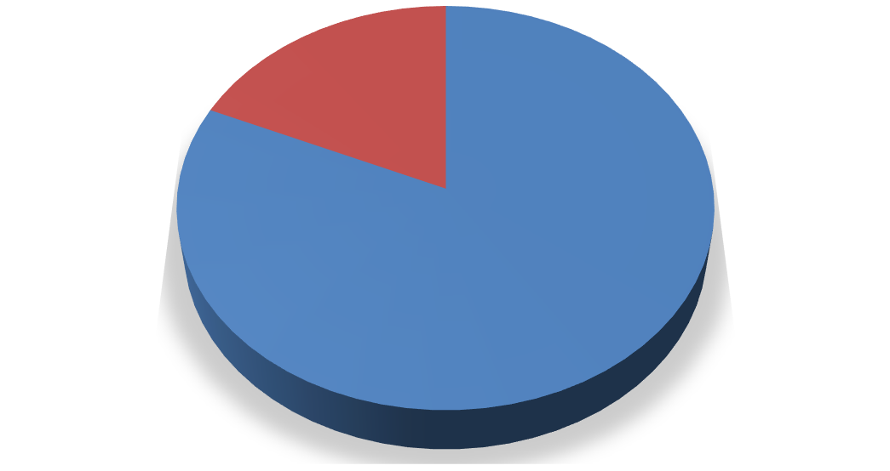

**Responses**

**No**

**18%**

**Yes**

**82%**

Yes

No

### Interpretation

The total no. of associates includes in the research is 60. Out of 60 associates, 81.6% (49) confirmed that there is relationship between cost and efficiency and 18.3% (11) said that there isn’t any relationship between cost and efficiency.

### Fig 2: Frequency and Percentage of the Executives confirmed whether there is relationship between Cost and Efficiency.

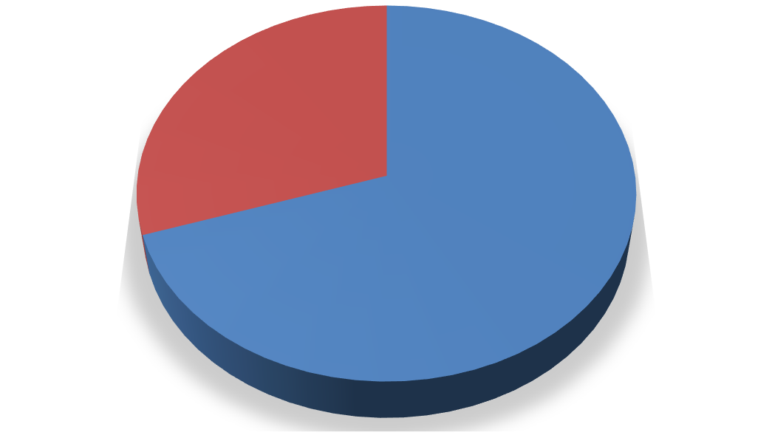

**Responses**

**No**

**30%**

**Yes**

**70%**

Yes

No

The total no. of executives includes in the research is 20. Out of 20 executives, 70% (14) confirmed that there is relationship between cost and efficiency and 30% (6) said that there isn’t any relationship between cost and efficiency.

### Table 3: Frequency and Percentage of the Executives confirmed whether they need Experienced & Costly staff or Freshers & In-budget staff.



|  |  |  |
| --- | --- | --- |
| Preference | Frequency | Percentage |
| Experienced & Costly | 22 | 73.3 |
| Freshers & In-budget | 8 | 26.6 |
| Total | 30 | 100 |

**Graph**

### Fig 3: Frequency and Percentage of the Executives confirmed whether they need Experienced & Costly staff or Freshers & In-budget staff.

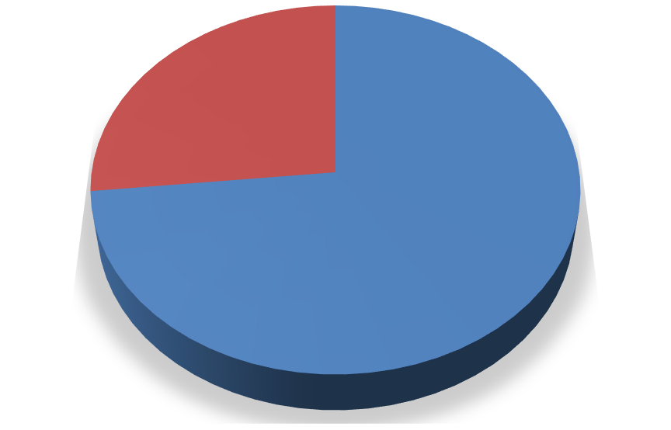

**Preferences**

**Freshers & In- budget 27%**

**Experienced & Costly 73%**

Experienced & Costly

Freshers & In-budget

**Interpretation**

The total no. of executives includes in the research is 30. Out of 30 executives, 73.3% (22) prefer experienced & costly staff as they are more efficient compared to freshers while 26.6% (8) prefer freshers & In-budget staff for smooth working of an organization thinking that they will train them due to which cost would also be saved.

**FINDINGS**

81.6% associates confirmed that in most of the cases, Cost is directly proportional to Efficiency of manpower while 18.3 % confirmed that there isn’t much relationship between these two variables.

Out of 20 Executives of AAJ, 14(70%) said that there is a relationship between cost and efficiency as all they had experienced while 6(30%) said “No” to this theory.

The respondents who confirmed the relationship between these two variables i.e., Cost and Efficiency, said that the manpower that got sufficient money do more work but the manpower that got less money lose their interest in work and show less activity or low efficiency because they all need to be paid as per their work.

Out of 30 executives, 73.3% (22) prefer experienced & costly staff as they are more efficient compared to freshers to run the business smoothly while on the other hand 26.6% (8) prefer freshers & In-budget staff for smooth working of an organization thinking that they will train them due to which cost would also be saved.

## CHAPTER- 6

### Findings and Suggestions

These are the finding and suggestions after studying the AAJ Enterprises operations and data available.

#### Location Management:

Implement a robust location management system to avoid the issue of picking from the wrong place. Ensure each ISBN has a unique and clearly marked location.

Regularly audit and update the location assignments to prevent duplication.

#### Inventory Accuracy:

#### Conduct regular cycle counts and reconcile inventory discrepancies promptly to prevent extra picking and inventory errors.

#### Implement barcode or RFID technology to improve inventory tracking accuracy.

#### Communication Improvement:

Foster open communication channels between associates and executives to address any delays or issues promptly.

Clearly define roles, responsibilities, and instructions to avoid misunderstandings and errors.

#### Standard Operating Procedures (SOPs):

Enforce strict adherence to SOPs during packing to eliminate bypass cases. Provide training and incentives for compliance.

Regularly review and update SOPs to ensure they reflect the most efficient and error- free processes.

#### 5S Implementation:

Develop a comprehensive plan to implement 5S principles in the warehouse.

Ensure regular audits and continuous improvement efforts to sustain the 5S framework.

#### Work Management Optimization:

Conduct workload analysis to align work distribution with the workforce's capacity. Adjust staffing levels as needed to prevent delays.

Implement task management software to prioritize and assign tasks efficiently.

#### Inventory Replenishment:

Develop a formal replenishment process that uses data analytics to determine optimal reorder points and quantities.

Invest in automation or technology solutions to streamline and expedite the replenishment process.

#### Automation Integration:

Assess the warehouse's automation needs and invest in technology solutions such as conveyor systems, automated picking, and packing robots to improve efficiency.

Explore the integration of warehouse management software (WMS) and Enterprise Resource Planning (ERP) systems for real-time data synchronization.

#### Cross-Departmental Communication:

Facilitate regular meetings and collaboration between the Customer Service (CS) team and other departments to address issues, share insights, and improve coordination.

Implement a centralized communication platform to enhance information flow.

#### Resource Allocation:

Allocate resources, including human resources and automation equipment, based on workload and demand fluctuations.

Conduct regular resource optimization reviews to ensure efficient resource allocation.

#### Continuous Improvement Culture:

Install a culture of continuous improvement within the warehouse team. Encourage employees to identify and report issues and propose solutions.

Reward and recognize employees for suggestions that lead to increased efficiency.

#### 

#### Training and Development:

Invest in ongoing training and development programs for warehouse staff to enhance their skills and knowledge.

Cross-train employees to perform various warehouse tasks, increasing versatility and flexibility.

Implementing these suggestions should help address the identified issues and lead to increased efficiency, reduced errors, and improved customer satisfaction in your warehouse operations

## CHAPTER- 7

**REFERENCES**

[**https://www.aajenterprises.com/blog/**](https://www.aajenterprises.com/blog/)[**https://www.alliedmarketresearch.com/3PL-market**](https://www.alliedmarketresearch.com/3PL-market)[**https://www.forbes.com/advisor/business/software/what-is-**](https://www.forbes.com/advisor/business/software/what-is-wms/)[**wms/**](https://www.forbes.com/advisor/business/software/what-is-wms/)

[**https://www.erpsoftwareblog.com/2023/06/the-impact-of-artificial-**](https://www.erpsoftwareblog.com/2023/06/the-impact-of-artificial-intelligence-%20%20%20%20%20%20%20%20%20%20%20%20%20ai-on-warehouse-management/)[**intelligence-**](https://www.erpsoftwareblog.com/2023/06/the-impact-of-artificial-intelligence-%20%20%20%20%20%20%20%20%20%20%20%20%20ai-on-warehouse-management/)[**ai-on-warehouse-management/**](https://www.erpsoftwareblog.com/2023/06/the-impact-of-artificial-intelligence-%20%20%20%20%20%20%20%20%20%20%20%20%20ai-on-warehouse-management/)

[**https://navigine.com/blog/smart-warehouse-system-how-to-ensure-the-**](https://navigine.com/blog/smart-warehouse-system-how-to-ensure-the-efficiency-of-the-company/)[**efficiency-**](https://navigine.com/blog/smart-warehouse-system-how-to-ensure-the-efficiency-of-the-company/)[**of-the-company/**](https://navigine.com/blog/smart-warehouse-system-how-to-ensure-the-efficiency-of-the-company/)

[**https://www.sciencedirect.com/science/article/pii/S2351978920301967**](https://www.sciencedirect.com/science/article/pii/S2351978920301967)

**CHAPTER 5**

**CONCLUSION AND RECOMMENDATIONS**

## CONCLUSION

I have concluded the survey for the associates and executives at AAJ Enterprises Pvt. Ltd. to check the relationship between the cost and efficiency of manpower.

I had chosen the cost and efficiency as it is the one of the most critical structures in warehousing and in any industry. The efficiency matters a lot in production as well as in any of the organization.

I was very lucky to join the company and formulating like the relationship between the manpower and efficiency, working style of intern, the effect of experience in the worth and the strategies of the company and the working style of the company. I had met different kind of people from different region and different work experience and profile they all have different views and mindsets.

After the survey I came to conclusion that there is the direct relationship between cost and efficiency, as the cost increases the efficiency also increases. Company has to understand the relation between cost and efficiency and should take the decisions accordingly to maintain the efficiency of the organization as well as to control the cost.

No doubt there is a relationship between cost and efficiency in every organization. Employees feel motivated when they paid more and work more efficiently.

**RECOMMENDATIONS**

**LABOUR:**

Company has to understand the no. of labor acquired to do any job. There should not be any shortage as well as excess of manpower.

### COSTING:

Understand the budget of the organization to control over costing, otherwise it can create a huge problem to the company.

The turnover should be kept less so that there is no extra cost of training of employees.

### . ENVIRONMENT:

The environment in the company should be kept good so that people feel motivated working there

**BIBLIOGRAPHY**

* [www.aajenterprises.com](http://www.aajenterprises.com/)
* Website
* Internet

**QUESTIONNAIRE**

1. Are you getting sufficient cost as per your work?
   * Yes ☐No
2. Will you work more if you are paid more?
   * Yes ☐No
3. Is there any relationship between cost and efficiency?
   * Yes ☐No

### If No, then jump to Question no. 5 (If yes, then proceed)

1. What is the relationship between cost and Efficiency?
   * Cost is directly proportional to Efficiency
   * Cost is indirectly proportional to Efficiency
2. Does the tea brake and refreshment brakes increase the efficiency of work?
   * Yes ☐No

### Question to Executives only:

1. What type of newly hired associates will you prefer?
   * **A.** Experienced and Costly associate
   * **B.** Freshers and In-Budget associate **Mention the reason for Question No. 6 Why?**