**Immune Thrombocytopenia**

SanjanaMokal, Sakshi Pachkudave , Ragini Salunkhe,

Diksha Kambale.

Navsahyadri Institute of Pharmacy, Naigaon, Pune Tal Bhor - 412213

[mokalsanjana65@gmail.com](mailto:mokalsanjana65@gmail.com) , [Sakshipachkudave@gmail.com](mailto:Sakshipachkudave@gmail.com) , [Salunkeragini95@gmail.com](mailto:Salunkeragini95@gmail.com),

[deekshakamble4@gmail.com](mailto:deekshakamble4@gmail.com)

**Abstract** **:**

Immune thrombocytopenia (ITP) is an acquired antibody-mediated disease for which splenectomy remains a curative treatment. The diagnosis and treatment of immune thrombocytopenic purpura (ITP) relies primarily on clinical knowledge and observation rather than documentation of scientifically high-quality clinical trials. One of the main obstacles to conducting such studies and conducting a reliable meta-analysis of available data is the lack of standardized critical definitions, outcome criteria, and uniformity of terminology. Additionally, the need for comparative clinical trials has surged due to the emergence of new therapeutic agents, such as receptor agonists for thrombopoietin, and innovative therapies, like the anti-CD 20 antibody.

**Keyword:** Immune Thrombocytopenia, Etiology, Pathophysiology, symptoms, causes,

Treatment .

**Introduction:**

Immune thrombocytopenia (ITP) is an autoimmune syndrome characterized by antibody- and cell-mediated platelet and cessation of platelet production, which can cause bleeding. The latest International Working Group Note recommends ITP for decision-making in all cases of immune-mediated thrombocytopenia, whether or not it occurs as part of another clinically apparent disorder or drug exposure (secondary ITP). with clear receptivity. etiology (primary ITP). The International Working Group also recommends a platelet count below 100 × ${10}^{9}$/l rather than 150 × ${10}^{9}$/l for diagnosis. This approach is based on the observation that less than 10% of otherwise healthy individuals with stable platelet counts between 100 and 150 × ${10}^{9}$/L develop more severe unexplained ITP within the next 10 years. This review focuses on primary ITP in adults of the population. , but covers certain aspects of secondary forms and pediatric ITP when appropriate. Management of ITP during pregnancy is discussed elsewhere in this issue (see "Thrombocytopenia during pregnancy")..

Designing prospective controlled clinical trials has been particularly challenging because patients with chronic disease represent less than 10% of all patients with ITP and have considerable clinical variability. Consequently, several problems related to the optimal treatment of these patients remained unsolved, and treatment principles were mainly based on expert opinions However, ongoing randomized trials with several new pharmacological agents promise to rapidly change this scenario. The purpose of this article is to provide an updated overview of ITP in adults, focusing on our current understanding of the mechanisms of thrombocytopenia and new treatments for chronic refractory ITP..

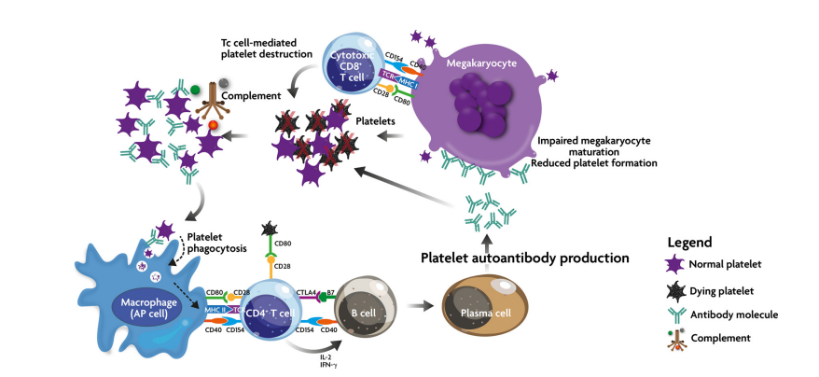

**Figure 1.**

**Figure 1.** Genetic mechanisms in ITP. Breakdown of self-tolerance causes APCs (including megakaryocytes) to process platelet autoantigens and present them to autoreactive T cells, initiating events that include stimulation of autoantibody production and activation of cytotoxic T cells. These two processes result in the destruction of peripheral platelets and the inhibition of megakaryocytes in the bone marrow. In addition, platelets neutralized by autoantibodies attack by the complement cascade.

ITP can be a primary condition or it can be caused by other conditions. The differential diagnosis of thrombocytopenia and possible secondary causes of ITP . In general, the incidence of ITP varies from 2 to 4 cases100,000 person-years, with two peaks: one in the 20-20 30s years \ n slight female predominance and higher in the 60s of the same gender distribution.5,6 Although some patients experience a single episode of ITP followed by immediate remission, chronic ITP develops up to 70 years of age. % of adults with this condition. Both spontaneous and treatment-induced remission can occur several years after diagnosis.

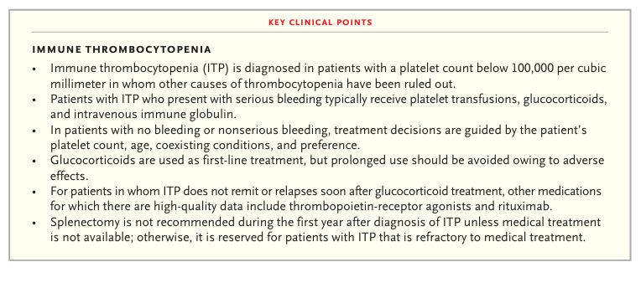

The pathophysiology of ITP is complex and remains incompletely understood (Figure 2). The traditional concept is that antibody-coated platelets are destroyed prematurely in the spleen, liver, or both due to interaction with Fcγ receptors.7Autoantibodies can also induce complement-mediated or desialylation-induced effects.. destruction of platelets and inhibition of megakaryocyte function.10 However, antiplatelet\antibodies are not detected in up to 50% of patients; this raises the possibility of alternative mechanisms for platelet destruction. Abnormalities have been described in T cells, including a shift of helper T cells (Th) to type 1helper T (Th1) and type 17 helper T (Th17) phenotype , and decreased number and function. regulatory T cells, which can control the autoimmune process. Limited studies suggest that CD8 cells are also involved..

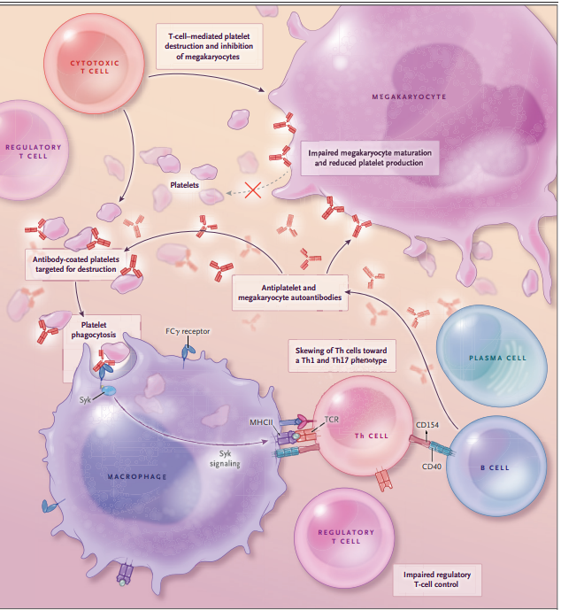

**Figure 2.**

**Figure 2. Pathophysiological Highlights of Safe Thrombocytopenia**.

 In spite of the fact that the pathophysiology of resistant thrombocytopenia (ITP) is not completely caught on, the key occasion is considered to be the production of antiplatelet autoantibodies. These autoantibodies target platelets for pulverization by macrophages within the spleen, liver, or both through actuation of Fcγ receptors; this prepare is controlled by spleen tyrosine kinase (Syk). Autoantibodies may too crush platelets through other instruments and hinder platelet generation by megakaryocytes. Antigens from phagocytosed platelets are thought to be displayed by the major histocompatibility complex course II (MHCII) to T-cell receptors (TCRs), fortifying autoreactive T cells. T-cell changes seen in ITP and hypothesized to be pathogenic incorporate skewing of T partner (Th) cells toward a sort 1 T aide (Th1) and sort n17 T partner (Th17) phenotype, lessening of administrative T-cell action, and an increment in cytotoxic T cells. Many thinks about propose that cytotoxic T cells can moreover specifically annihilate or repress the generation of platelets.

**Immune thrombocytopenia :**

The diagnosis of idiopathic thrombocytopenic purpura (ITP), sometimes referred to as immune thrombocytopenia or immunological thrombocytopenic purpura, is made when the platelet count is less than 100 × ${10}^{9}$/L.

**Etiology:**

A platelet count of fewer than 150 x ${10}^{9}$ is known as thrombocytopenia. Among neonates, especially premature ones, it is one of the most prevalent hemostatic disorders. It can result in a significant risk of bleeding and death and affects 18–35% of newborns admitted to neonatal intensive care units (NICUs). Many research showed that the degree of prematurity increases the likelihood of increasing thrombocytopenia and that immature newborns had a 2.52-fold higher risk of thrombocytopenia. It is generally described as an isolated thrombocytopenic autoimmune illness with no known underlying etiology. There may be indications of both maternal and neonatal variables in the complicated etiology of thrombocytopenia. in the process of creating it. Thrombocytopenia typically indicates the presence of another disease, such as necrotizing enterocolitis (NEC), sepsis, or intrauterine growth restriction (IUGR), however it may be the sole clinical manifestation of an autoimmune syndrome. Premature newborns with inflammatory bowel necrosis (NEC).

A typical clinical problem that gets worse with increasing prematurity is neonatal thrombocytopenia (NT). The fundamental reasons behind NT are now starting to diverge, and a lot of formerly held beliefs have been demonstrated to have little to no supporting data. We discussed the causes of newborn thrombocytopenia. The most frequent neonatal disorders associated with NT, according to earlier research, were hypoxia, sepsis, placental insufficiency, and preterm. If the infant appears healthy, the reason of thrombocytopenia in an otherwise healthy newborn is either placental insufficiency or an autoimmune or alloimmune immune response wherein the newborn's platelets are destroyed by maternal antibodies sent to it while it is still in utero.

Numerous investigations have assessed the frequency of thrombocytopenia during gestation, its cause, and the mother and result throughout pregnancy. Pregnancy thrombocytopenia is a common observation that happens about in 7–10% of foetal cases. Thrombocytopenia gestational (GT), hypertensive conditions (preeclampsia, eclampsia, HELLP   
the non-immune causes include vitamin B12 or folate insufficiency, acute fatty liver of pregnancy, disseminated intravascular coagulation (DIC), drug use, and vitamin B12.   
 As a whole, roughly 3-4% of pregnancies thrombocytopenia and immunological processes such as TTP and ITP are associated. Low platelet counts are the hallmark of immune thrombocytopenia (ITP), an autoimmune disease caused by autoantibodies from the mother that cross the placenta and target platelet membrane to destroy newborn platelets.

**Pathophysiology :**

The etiology of secondary immune thrombocytopenia is cause-dependent and more complex than that of primary immune thrombocytopenia. When a patient has a chronic Helicobacter pylori infection, their immune system produces antiplatelet autoantibodies in response to molecular mimicry of H. pylori antigens like CagA. These antibodies cause platelet aggregation and platelet extrusion of p-selectin and phosphatidylserine by some strains of H. pylori, which are linked to the patient's individual HLA variation, increased monocyte phagocytic activity, and decreased FcγRIIb. Human immunodeficiency virus (HIV) and hepatitis C virus (HCV) can induce autoantibodies against each other that cross-react with platelet glycoproteins to generate immunological complexes. 3 Severe

The immunological resistance of the patient's own platelets to autoantigens is one of the critical stages in the pathophysiology of ITP. Numerous studies show that a dysregulated T-cell response during ITP causes a skewed helper T cell balance (Th1/Th2) ratio, which in turn causes an increase in the quantity and hyperactivity of cytotoxic T cells. Consequently, increased platelet destruction and increased B cell survival are the outcomes of this increased cytotoxic T cell activity. Increased B cell survival therefore makes it easier to produce more autoantibodies, which speeds up the process of platelet elimination. Autoantibodies opsonize platelets, resulting in compromised thrombopoiesis, increased complement activation, phagocytosis, and apoptosis (Figure 3).

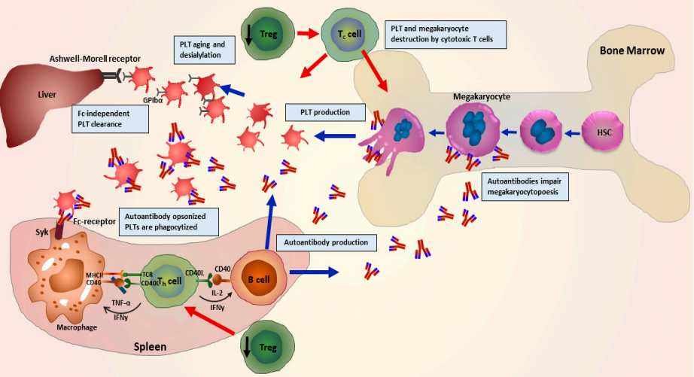

**Figure 3.**

**Figure 3 :**Pathophysiology of immune thrombocytopenia (ITP) illustrated graphically, showing various immune cells involved. The regulation of helper T cell-mediated B cell activation is disrupted when regulatory T cells are compromised. Autoantibodies are abundantly produced by B cells, which in turn cause opsonization, phagocytosis, complement activation, desialylation, and ultimately platelet death. Megakaryocyte maturation (megakaryocytopoiesis) is further impeded by autoantibodies, and megakaryocytes and platelets are destroyed by autoreactive cytotoxic T cells.

Several studies have shown new mechanisms independent of Fc-mediation, despite the fact that constant fragment (Fc)-dependent processes account for the majority of platelet destruction in the spleen. ITP-autoantibodies have been demonstrated in a study to cause glycosylation alterations on platelet surface glycoproteins (GPs). This GPs alteration accelerates platelet elimination in the liver upon additional identification by Ashwell–Morell receptors expressed on hepatocytes. Hepatocytes' platelet phagocytosis and desialylation are also induced by CD8+ T lymphocytes from ITP patients . This could elucidate a possible explanation for the ineffectiveness of splenectomy non certain ITP patients. A retrospective analysis of 61 ITP patients found that platelet desialylation led to reduced response to first-line therapies, regardless of any other factors.

Autoantibodies generated during ITP impact platelet survival as well as megakaryocyte-mediated formation . Research has demonstrated that autoantibodies bind to megakaryocytes and obstruct their maturation, which reduces the production of platelets . In vitro research has shown that autoantibodies impede megakaryopoiesis and maturation, which in turn suppresses platelet formation . Nonetheless, further research is necessary to determine how megakaryocyte apoptosis functions in the pathogenesis of ITP. Some indications and opposing statements have been found in the findings of previous and current studies. In fact, a study showed that treating megakaryocytes with ITP plasma actually reduces their apoptosis . When healthy umbilical cord blood was used to separate hematopoietic stem cells (HSCs), it was combined with ITP patients' plasma to create.

**Symptoms:**

There may be no symptoms associated with immune thrombocytopenia. When signs appear, they may consist of

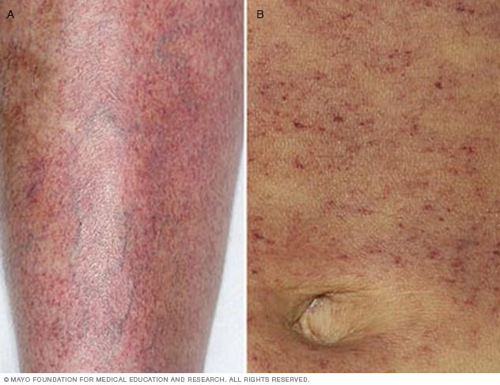

**Figure 4.**

* Bruising that is easily sustained.
* Petechiae, or tiny reddish-purple patches, that bleed into the skin. The lower legs are where the spots mostly appear. They resemble a rash.
* Bleeding into the skin greater than purpura, another name for petechiae.
* Flowing blood from the nose or gums.
* Hematochezia or dysuria.
* Extremely high monthly flow .

**Causes:**

In ITP, the immune system is stimulated to attack your body's own platelets. In most cases, this is due to the production of anti-platelet antibodies. In some cases, a type of white blood cell called T cells directly attack the platelets. This immune system error can be caused by one of the following:

* Medications (including over-the-counter medications) can cause allergies that cross-react with platelets.
* Infections, usually viral infections, including the viruses that cause chicken pox, hepatitis C, and AIDS, can elicit antibodies that cross-react. with platelets. react with platelets
* Pregnancy
* Immune system disorders such as rheumatoid arthritis and lupus
* Low-grade lymphomas and leukemias can produce abnormal antibodies against platelets.
* Sometimes the cause of immune thrombocytopenic purpura is unknown..

**Diagnosis :**

Primary ITP is diagnosed as an exclusion case. Infections, medications, systemic diseases, and primary hematologic abnormalities can all result in thrombocytopenia.10 It is important to take into account bleeding during dental work, trauma, and surgery when determining how long persistent thrombocytopenia or another bleeding disease might last. Patients can be divided into two categories using differential diagnosis. Patients with ITP, including those with systemic lupus erythematosus, are included in one category; patients with non-ITP, like those with leukemia and aplastic anemia, are included in the other. Aplastic anemia can first manifest as isolated thrombocytopenia, but anemia and leukopenia usually follow days, weeks, months, or even years later. Additionally, leukemia never manifests as thrombocytopenia on its own. References to international consensus publications and standards about the distinctions between primary ITP and the other conditions should be made.

**Table 1 : Diagnosis of ITP**

|  |
| --- |
| 1.Thrombocytopenia (<100× ${10}^{9}$/L) in the peripheral blood stream without morphologic indications of dysplasia. |
| 2. Any three or more of the following test results, including at least one of 3, 4, and 5 |
| 1. Normal leukocyte count |
| b)Increased platelate /associate anti-GPllb/llla antibody level |
| c)) A higher proportion of reticulate platelates |
| d) Plasma TPO level that is normal or slightly elevated (<300pg/mL) |
| 3. The following illnesses are not included: |
| TP aplastic anemia , MDS, PNH, SLE, leukemia, malignant lymphoma, DIC, TTP, setsis, sarcoidosis, viral infection, and others are drug- or radiation-induced conditions .Kasabach-Merritt syndrome, May-Hegllin abnormalities, Bernard-Soulier syndrome, and Wiskott-Aldrich syndrome |

**Abbreviations:** GP stands for glycoprotein; TPO stands for thrombopoietin; TP stands for thrombocytopenia; MDS stands for myelodisplastic syndrome; PNH stands for paroxysmal nocturnal hemoglobinemia; SLE stands for systemic lupus erythematosus; DIC stands for disseminated intravascular coagulation; and TTP stands for thrombotic thrombocytopenia.

**Table 2: Adjudication criteria for the diagnosis of thrombocytopenia** **:**

|  |  |
| --- | --- |
| Diagnosis | Adjudication criteria |
| Mild thrombocytopenia | * A reliable platelet count falls between 100 and 150 × ${10}^{9}$/L. Take into account gestational thrombocytopenia if a patient is expecting. Mild thrombocytopenia takes precedence over other diagnoses (such Hepatitis C or a family history of thrombocytopenia). |
| Primary ITP | * In patients with platelets <100 × 10^9/L with other diagnoses, the initial ITP diagnosis should be maintained if the platelet count increases to >100. |
| Secondary ITP   * Hepatatis C * HIV * Non-specific infection * Pregnancy associated ITP * Lymphoma * Sarcoidosis * Other autoimmune disease | * Even if the underlying illness is cured and the ITP persists, the diagnosis of secondary ITP should stand. * The diagnosis of primary ITP should be made if the ITP persists postpartum or precedes pregnancy, in which case the accompanying ITP platelets should improve with ITP treatment. |
| Drug-induced ITP | * With no additional medicines involved, thrombocytopenia usually develops 5–10 days after the first drug exposure and platelet count recovery usually happens after stopping the drug. To verify the information, either a drug test or the evidence of drug-induced antibodies in the platelets |
| Non-immune thrombocytopenia   * Alcohol related * Incidental thrombocytopenia in pregnancy (gestational thrombocytopenia) * Hypertensive disorders of pregnancy * Liver disease * Drug-induced bone marrow suppression * Thrombocytopenia associated with malignancy including aplastic anemia | * The platelet count is normally higher than 70 ${10}^{9}$/L during pregnancy for incidental thrombocytopenia of pregnancy (gestational thrombocytopenia), and normalization of  platelet count postdelivery, no history of thrombocytopenia (apart from during a previous pregnancy), and no thrombocytopenia in the fetus or infant. * Non-immune thrombocytopenia is usually not caused by fatty liver disease alone (without additional stigmas of chronic liver disease). |
| Other thrombocytopenia disorders  • Cyclical thrombocytopenia  • Heparin-induced thrombocytopenia  • Thrombotic microangiopathies | * Independent of therapy, there should be evidence of significant changes in platelet counts in cases of cyclical thrombocytopenia. If variations disappear but the platelet count remains low, ITP should be suspected. |

The method of making a clinical diagnosis of thrombocytopenic diseases is dependent on the provider and the region, is not standardized, and is subject to ascertainment bias. We created a diagnosis procedure that is more accurate for patients with thrombocytopenic diseases. Patients whose diagnosis changed from one visit to the next, those who experienced thrombocytopenia during pregnancy (due to overlap with other reasons), and those in which the origin of the thrombocytopenia remained unknown were all subject to the adjudication criteria .Hierarchical guidelines were used as adjudication criteria to determine when a patient should be classified as primary, secondary, or non-ITP, or when the diagnosis was deemed "unknown" due to uncertainty. According to our findings, 70.7% of patients who matched the criteria for adjudication had a change in diagnosis.

Adjudication standards (92/130), and that the five most frequent modifications were from unknown to primary ITP (n = 15); from primary ITP to secondary ITP (n = 10); and from unknown to non-ITP. (n¼10); distinct reason for non-ITP (n¼10); and key ITP for non-ITP (n¼9). The employment of an independent adjudicator, the range of thrombocytopenic illnesses included, and the application of a systematic approach to the identification of thrombocytopenic disorders were the study's strengths. The lengthy process's drawbacks were the requirement for further prospective validation studies and the possibility that it would be challenging to implement in abusive clinical settings.

**Treatment :**

**First**- **line treatment :**

Corticosteroids are the main treatment for ITP in adults. It has been demonstrated that dexamethasone and prednisone alter B-cell and dendritic cell activation, which reduces the immune system's ability to destroy platelets . Steroids can help up to 80% of patients, however many of them relapse after taking them. are progressively smaller. The cornerstone of treatment for a long time was prednisone, usually administered at a dose of 1 mg/kg/d for a period of two to four weeks. However, new research indicates that high-dose dexamethasone is much more efficacious. A Hong Kong trial including 125 patients whose baseline platelet counts were less than 20 x ${10}^{9}$/L showed that in 50% of responders, a single, brief course of dexamethasone (40 mg daily for four days) resulted in a stable platelet count higher than 50 × ${10}^{9}$/L.

For ITP patients who are pregnant and require treatment, corticosteroids are thought to be safe . It's evident that high-dose dexamethasone, or corticosteroids in general, work well as an initial treatment for ITP. The corticosteroid adverse effect profile, which includes diabetes, hypertension, and weight gain, can be an issue for certain patients, but corticosteroids are still a first-line medication that is suitable and typically safe to use . Intravenous immunoglobulin (IVIG) or Rhₒ(D) immune globulin (anti-RhD) can be added to treat steroid-resistant patients in order to improve the outcome. Furthermore, in cases when corticosteroids are prohibited, patients may benefit from these two treatments . Additionally, IVIG is recommended when platelet counts must be elevated quickly, as in situations involving severe and ongoing bleeding, and in certain patients, it may be used in combination with corticosteroids. The usual dosage is an infusion of 1 g/kg/day for a duration of one to two days; however, the doctor's preference may influence the regimen . In a trial of 19 individuals with chronic ITP, IVIG had a 75% response rate, stopping active bleeding within 12 hours of the onset of bleeding and increasing platelet counts.

Intravenous immunoglobulin (IVIG) or Rhₒ(D) immune globulin (anti-RhD) can be added to treat steroid-resistant patients in order to improve the outcome. Patients who cannot receive corticosteroids can also receive these two therapies . When platelet levels must be checked, IVIG is also indicated. elevated quickly, for example in situations involving severe and ongoing bleeding, and in some patients, it may be used in combination with corticosteroids. According to the physician's desire, regimens can differ from the standard one- to two-day infusion of 1 g/kg/day . Research conducted on 19 individuals suffering from chronic ITP revealed that 75% of them responded to IVIG, resulting in a stoppage of bleeding within 12 hours of the onset of bleeding and an elevation of platelets.

**Second line treatment:**

Thus, the choices for second-line treatment of adults with ITP are the main topic of discussion here. Since many individuals will not be able to take corticosteroids to produce a long-lasting remission and may experience severe and symptomatic thrombocytopenia; most patients will need second-line therapy since the long-term adverse effects of corticosteroids are intolerable [20, 21]. There are significant differences between the three main possibilities. Table II outlines the benefits and dangers associated with each of the three options: rituximab, splenectomy, and TPO-receptor agonists. First, there is a difference between therapies that alter the course of the disease (splenectomy, rituximab) in the hopes of achieving a long-lasting, total remission, and therapies that only offer symptomatic relief by keeping platelet counts elevated as long as the therapy is continued.

**Splenectomy.**

Therefore, the primary focus of this discussion is on options for adults with ITP's second-line treatment. Given that many people won't be able to use corticosteroids to achieve a permanent remission and may develop severe and symptomatic thrombocytopenia; the majority of patients will require second-line therapy since corticosteroids have unbearable long-term side effects [20, 21]. The three primary options differ greatly from one another. The advantages and risks of the three options—rituximab, splenectomy, and TPO-receptor agonists—are listed in Table II. First, there is a distinction between treatments that aim to achieve a complete and long-lasting remission by changing the course of the disease (rituximab, splenectomy) and those that merely provide symptomatic relief by maintaining elevated platelet counts as long as concluded that the data did not offer enough proof to back up the choice of whether to perform or postpone a splenectomy [24]. Surgical problems are becoming less frequent with the practice laparoscopic surgery, but they're still important. In 29 cases of laparoscopic splenectomy for ITP, the surgery-related mortality was 0.2% (3 of 1301 patients); complications necessitating further care happened in 9.6% of patients [3].

**Rituximab**

There are fewer statistics available for rituximab side effects and the likelihood of lasting remissions than there are for splenectomy. A comprehensive analysis found that 63% (95% CI, 53–73%) of patients had an overall response (platelet count greater than 50,000/lL) and 44% (95% CI, 30–58%) of patients had a full platelet count response (platelet count more than 150,000/lL) [8]. Just 10.5 months were the median response time [8]. Response rates of 31% [7] and 33% [9] have been recorded in other trials. The information about the dangers associated with rituximab treatment for ITP patients is inconclusive. According to the systematic evaluation, 9 (2.9%) of the 306 individuals had died and 10 (3.7%) experienced serious or potentially fatal toxicities.

**Treatment for patients with chronic refractory ITP:**

Since there is little prospect of bringing about a long-lasting remission in patients with chronic refractory ITP, achieving enough stable plate levels, while reducing unfavorable incidents. Generally speaking, corticosteroids are used in combination with other medications to treat individuals with refractory ITP. Selecting the best course of action for chronic refractory ITP presents a number of issues for clinicians. Even if a number of choices are employed in practice, the majority of the current therapy recommendations are not supported by evidence because they are based on expert opinion and uncontrolled cohort studies. The inconsistency in the criteria used to define platelet count outcomes among research poses a challenge to the assessment and comparison of published trials. Additionally, key clinical outcomes like bleeding and quality of life are not consistently measured. With these agents, responses rarely go over 30–35%, and with certain agents, such azathioprine, a response could not show up for several weeks.

**New treatment approaches :**

Thrombopoietic growth factors, such as Romiplostim and Eltrombopag, target the thrombopoietin (TPO) receptor and offer a unique therapeutic approach for the treatment of ITP . Romiplostim is an Fc-peptide fusion protein, while eltrombopag is a tiny, orally administered hydrazone chemical molecule. Both medications stimulate megakaryocyte development and maturation, which raises platelet production. They are agonists for the TPO receptor. The outcome of the The first phase III trials in individuals with and without splenectomies have been published. They are randomized, controlled, and issued for romiplostim . In both splenectomized and non-splenectomized patients, romiplostim elevated and maintained platelet levels; 83% of patients treated with romiplostim experienced an overall platelet response, compared with 7% of patients receiving a placebo (P < 0.0001; Cochran-Mantel-Haenszel test); Adrian Newland's article provides a more detailed description of these results. For the treatment of people with persistent ITP, romiplostim has now received approval in the USA and Australia. Published are the first phase III trials involving both splenectomized and non-splenectomized people.

They are managed, randomized, and romiplostim , a release. Romiplostim increased and maintained platelet levels in both splenectomized and non-splenectomized patients; 83% of patients treated with romiplostim had an overall platelet response, compared with 7% of patients receiving a placebo (P < 0.0001; Cochran-Mantel-Haenszel test); Adrian Newland's article goes into further detail about these findings. Romiplostim is currently approved in the USA and Australia for the treatment of individuals with chronic ITP.

**Conclusion:**

In conclusion, the existence of active bleeding, the patient's age, the platelet count, and their lifestyle all play a role in the decision of whether or not to treat an ITP patient. concerning the likelihood of bleeding, the existence of extra risk factors for bleeding, possible side effects from the available treatment, and the patient's personal preferences. In stable, asymptomatic patients, a vigilant observation strategy may be preferable to therapy because current treatment choices involve side effects that can be even more harmful than the disease itself. Although there are guidelines for treating individuals with ITP, they are still primarily based on There are established guidelines for the treatment of patients with ITP, but they still primarily rely on expert clinical judgment rather than empirical facts due to a dearth of data from studies and randomized, controlled trials. We require additional information from carefully planned, randomized, controlled trials looking into novel medications in the treatment of individuals with ITP. Based on the phase III findings, romiplostim appears to be a promising treatment choice for people with this chronic illness due to its good efficacy and tolerability.

**Referance :**

1. Adeline Furdol, MD, Etienne Riviere, MD, PhD, Adult primary immune thrombocytoenia, spleen histology finding and outcomes according to rituximab use based on analysis of 41 cases, Page no.1 to 2
2. Francesco Rodeghiero, Roberto Stasi, Blood journal, Standardization of terminology definition and outcomes criteria in immune thrombocytopenic purpura (ITP) of adults and children: report from an international working group 2008 ,Page no.3 to 5
3. Adam Cuker, Douglas B. Cines, Immune thrombocytopenia, Department of medicine of pathology and laboratory medicine university of Pennsylvania,Philadelphia PA , Page no.5 to 6
4. Roberto Stasi, Maria Laura Evangelista, Idiopathic thrombocytopenic purpura: current concept in pathophysiology and management 2008 Page no.245 to 256
5. Drew Proven, John W Semple, Recent advance in the mechanism and treatment of immune thrombocytopenia.Page no. 4 to 6
6. Nichola Cooper MD MBBS, Waleed Ghanima MB Ch.B Ph.D, Immune thrombocytopenia pg no. 945 to 946
7. Olsson B, Anderson PO, T-cell mediated cytotoxic towords platelets in chronic idiopathic thrombocytopenic purpura Nat med 2003
8. Anurag Singh, Primary immune thrombocytopenia novel insights into pathophysiogy and disease management, Journal of clinical medicine,Page no.2 to 3
9. Mihnea-Alexandu Caman, Pathophsiology diagnosis and treatment of immune thrombocytopenia, International journal of medical student, Page no.1 to 2
10. Siyu Sun, Rolf T. Urbanus , Platelets activation mechanism and consequences of immune thrombocytopenia, cells, Page no. 4
11. Shosaku Nomura, Advance in diagnosis and treatment for immune thrombocytopenia, Page no. 17-18
12. Mohamad Hosein Lookzadeh, Immune and Non-immune etiology of thrombocytopenia neonatal and maternal causes, World journal of peri and neonatology, Page no. 79
13. Margot samson, Treatment for primary immune thrombocytopenis : A review, Emergency medicine university of central florida college of medicine, page no.2 to 7
14. James N. George, Sequence of treatment for adult with primary immune thrombocytopenia, page no. 12 to 13
15. Roberto Stasi, immune thrombocytopenia purpura : the treatment paradigm, Department of medical sciences, page no. 13 to 17