**EXPERIMENTAL ANALYSIS ON PARTIAL REPLACEMENT OF CEMENT BY FLY ASH, COARSE AGGREGATE BY COCONUT SHELL AND FINE AGGREGATE BY SAW DUST IN CONCRETE**

**Yasam Yash1, Pawan Dubey2 , Rakesh Sakale3,Hirendra Pratap Singh4**

1Research Scholar Department of Civil Engineering, People's University, Bhopal (M.P.)

2Assistant Professor Department of Civil Engineering, People's University, Bhopal (M.P.)

3Associate Professor Department of Civil Engineering, People's University, Bhopal (M.P.)

4Assistant Professor Department of Civil Engineering, People's University, Bhopal (M.P.)

**1. ABSTRACT**

The contemporary world is heavily focused on green and ecological development. Concrete is the utmost widely used building material in the world. Cement, fine and coarse-aggregate, water, make up this composite material.

The replacement impacts that fly-ash, sawdust, and coconut-shell bring to concrete are the main topic of this thesis. Cement and usual fine-aggregates were moderately substituted with fly-ash and sawdust, individually. Here, the coarse aggregate in the solid is swapped out for coconut shell. Determining the compressive-strength, split-tensile strength, and slump value is how the experiment is conducted. Sawdust is added to concrete in percentages of 5.0%, 10.0%, 15.0%, 20.0%, and 25.0% in place of natural fine aggregates. Fly Ash is consistently added to the mix at a weight of 30.0% cement having strong pozzolonic qualities, sawdust has properties comparable to those of usual fine-aggregates, and coconut-shell gives the concrete strong split-tensile strengths. The outcomes are contrasted with the design mix M30 control mix. Testing is done on the specimens 7, 14, 21, and 28 days after they have cured. It has been found that, during 7, 14, 21, and 28 days of curing, concrete can have up to 20.0% of its natural fine-aggregate substituted by sawdust and 20.0% of its coarse-aggregate substituted by coconut shell, all without compromising its strength. Fly-Ash should remain at 30% of the mix. As the quantity of resources increases, slump's value diminishes. Additionally, the price of concrete decreased to the total price per cubic meter of concrete.

**Key Words:** coconut shell, saw dust, fly ash, sustainable concrete, pozzolonic.

**2. INTRODUCTION**

Every day, there is an enormous enhance in demand for concrete. In order to convene this requirement, a large amount of natural possessions must be used, which puts the ecosystem at serious risk. Thus, the goal of this study is to address environmental issues by falling the quantity of fly-ash, sawdust and, coconut that is dumped on landfills. This will undoubtedly help diminish the amount of carbon dioxide (CO2) that is released into the atmosphere, which otherwise contributes to global warming, one of the main issues facing the modern world. Therefore, fly ash, sawdust, and coconut shell are being used in this project to partially supernumerary cement, fine-aggregate and coarse-aggregate in concrete. Fly-ash is made up of silicon dioxide, aluminum oxide, and calcium oxide and is produced when coal is burned. Fly-ash can be used to partially swap cement in concrete since it has great pozolonic qualities and reacts with water quickly. Saw-dust is a waste product obtained from sawmills. Particularly in this area, using coconut-shells in place of coarse-aggregates in concrete is becoming more and more popular. The hard exterior of the coconut is called the shell. Since it worked, we can conclude that in many concrete applications, excess and by-product can be used in consign of natural materials.

**3. LITERATURE REVIEW**

**B. Vijay Kumar et al (2021),** invested that Fly ash a waste generated by thermal power plants is as such a significant environmental concern. The physical and chemical properties of fly ash are similar to cement, which is permitted to be used in concrete. The use of fly ash in concrete formulations as a supplementary cementitious material was tested as an alternative to traditional concrete. The replace of cement with fly ash includes 0% (without fly ash) 10%, 20%, 30% &40% by weight of cement. The high demand for concrete in the construction using normal-weight aggregates such as gravel and granite drastically reduces the natural stone deposits. India is the third-largest producer of coconut products in the world. Coconut trees are widely cultivated in the southern states of India, especially in Kerala. Coconut shells as a substitute for coarse aggregates in concrete are gaining importance, especially in this region. Coconut shells replaced coarse aggregate in three different percentages such as 10%, 20%, 30%. Workability of concrete increases with the addition of fly ash at all mixes while decreased with addition of coconut shells. The best combination in strength criteria is found at 30% fly ash and 20% of coconut shells as replacement of cement and coarse aggregate [3].

**Furqan Fayaz Khan et al (2020),** found out that requirement for natural aggregates has increased in the field of building and development of late which, of course, is realizing an enormous reduction of prices, taking off of costs and all the while, the developing countries are annoyed about the administration of the wood waste or sawdust. This paper presents the remarkable highlights of a test study dependent on Timbercrete blocks delivered by partial substitution of coarse and fine aggregates with sawdust. Different highlights like compressive strength, water absorption and density were learned at different substitution percentages. To evaluate the exhibition of timbercrete blocks at numerous substitution percentages an exploratory investigation was directed. Subsequently, blocks of measurements 150mm×150mm×150mm were tried, for the previously mentioned attributes, at different substitution rates of both coarse and fine aggregates. As a move, a solid collection of 1:2:4 was utilized where sawdust was used to supplant 5%, 10%, 15%, 20% and 25% of the aggregates step by step. Gunny bag curing was controlled as a strategy for decision for curing. After the examination was done, the compressive strength for 5%, 10%, 15%, 20% and 25% square blocks were recorded as 9.9N/mm2, 8.5N/mm2, 5.0N/mm2, 3.8N/mm2 and 2.7N/mm2 individually following 28 days.

**Aman Jatale et al (2019),** performed an experimental study on the effect of compressive strength when cement is partially replaced by fly ash. Here he take the replacement of cement with 20, 40 and 60 percent of sawdust. He studied upon the workability, setting time, density, air content, compressive strength and modulus of elasticity.The mix of M15, M20, M25 are used in this studied. Slump of 200+mm is maintain in all the mix so that to ensure that the mix can be placed at any time when there is congested. Based on the result obtained he conclude that for grade M15 and M25 give the optimum values at 20% replacement while for M20 it gives at 60% replacement. Fly ash concrete shows less bleeding and improves the characteristics like cohesiveness, pumping and surface finish. Slow gain of strength at early age as compared to later age

**Lavanya B.A et al (2018),** studied properties of concrete with partial replacement of coconut shell as coarse aggregate and fly ash as replacement of cement is studied. In this study M25 grade of concrete was made. Concrete mix of 10%, 20%, 30% and 40% replacement of coconut shell as coarse aggregate and constant replacement of 30% of fly ash were made. Water cement ratio of 0.45 was maintained for all the mix proportions. Properties like compressive strength, split tensile strength and flexural strength were studied at 7, 14, 28 days

**4. OBJECTIVE**

These are the following objectives of this work:-

1. The primary goals of this work are to determine the ideal saw-dust percentages to substitute for natural fine-aggregates, fly ash percentages to substitute for cement, and coconut-shell percentages to substitute for coarse-aggregate.

2. To determine and compare the slump values of regular concrete with modified concrete that has been treated with fly-ash, saw-dust, and coconut-shell.

3. To ascertain the changed concrete's hardened behavior, such as its compressive-strength.

4. To make the composite more inexpensive in association to regular O-P-C concrete.

5. To utilize these leftover elements to create lightweight concrete.

**5. MATERIALS & METHODS**

3.1 FLY-ASH: - They are the by-product remaining after the combustion of coal. It is of two types: Class-C and Class-F.

3.2 SAWDUST: - Sawdust is a by-product of a wood obtained after cutting, grinding or sanding with saw or other industrials tool.

3.3 COCONUT-SHELL: - The hardest portion of a coconut is its shell, which is situated on the side of the husk to protect the meat. Coconut-shell is a waste product from agriculture that is widely accessible in tropical nations across the globe.

3.4 COARSE & FINE AGGREGATES:- The aggregate classified as coarse aggregate is that which is retained on a 4.75mm IS screen and Fine aggregate is defined by IS:383-1963 as the aggregate that, when filtered over a 4.75mm IS-sieve and held on a 0.07mm IS-sieve

**FOR M30 GRADE CONCRETE**

Volume of Concrete = 1 cu.m

Total Volume of Cement = Cement/(S.G*1000)

= 422/(3.15*1000)

= 0.134 cu.m

Volume of Water = Water/(S.G*1000)

= 190/(1*1000)

= 0.190 cu.m

Total Aggregates

Requirement = A-(B+C)

= 1-(0.133+0.190) = 0.677 cu.m

Coarse-Aggregate (C.A) = D*C.A ratio*S.G*1000

= 1168.6 kg

Fine-Aggregate (F.A) = D*F.A ratio*S.G*1000

= 0.677*0.37*2.74 *1000

= 686.3KG

**Table 1 M30 Mix design of Concrete**

|  |  |  |  |  |  |  |
| --- | --- | --- | --- | --- | --- | --- |
| **Grade of Concrete** | | | | | **M30** | |
| **Cement** | | | | | **420 kg/m3** | |
| **Aggregates** | | **Fine aggregates** | | | **1855 kg/m3** | **685 kg/m3** |
| **Coarse-aggregates**   * **20mmaggregates** * **10mmaggregates** | | | | | **1170kg/m3**  **702kg/m3**  **468kg/m3** | |
| **Proportion of mix** | | | | | **1:1.63:2.8** | |
| **Water/Cement ratio** | | | | | **.45** | |
| **Replacement % of fly ash** | **Amount of fly-ash in Kg/ m3** | | **Replacement Percentage of saw-dust** | **Amount of saw dust in Kg/ m3** | **Replacement Percentage**  **Of coconut-shell** | **Amount of coconut shell in Kg/ m3** |
| **30%** | **126** | | **5%** | **34** | **5%** | **34** |
| **30%** | **126** | | **10%** | **68.5** | **10%** | **68.5** |
| **30%** | **126** | | **15%** | **102.75** | **15%** | **102.75** |
| **30%** | **126** | | **20%** | **137** | **20%** | **137** |
| **30%** | **126** | | **25%** | **171.25** | **25%** | **171.25** |

**5.1. EXPERIMENTAL ANALYSIS**

**Proportioning**- The design mix of preparation of 30 cubes of size 15cm x15cm x 15cm can be made.

**Mixing**- Raw materials i.e. fly-ash, coarse aggregate and sand was weighted manually according to the design mix. Then supplies were blend sequence in the pan and hand mixture was done. After the combination succeeded their homogeneity, the water was gradually assorted in the mix.

**Casting**- The fresh concrete is poured in moulds and compressed. Additional compaction was made by vibrating machine. The technique of intercourse and casting is similar to cement concrete cubes. Total 60 No. moulds of size 150mm X 150mm X 150mm is prepared.

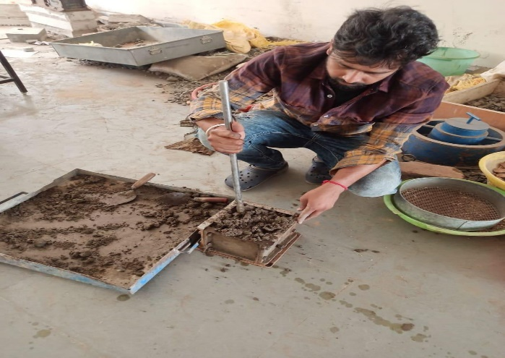

**Fig 1 Mixing of Materials Fig 2 Filling the Moulds**

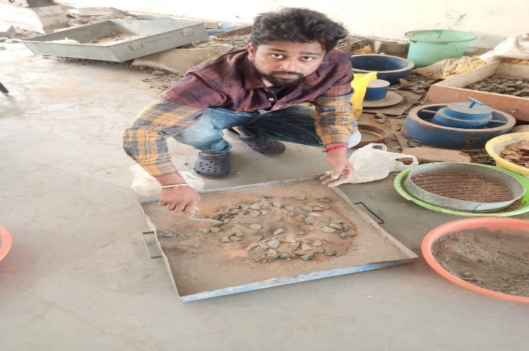

**Curing**- The test samples/specimen are cured in curative tank for desired period. After that the cubes are tested at the scheduled time.

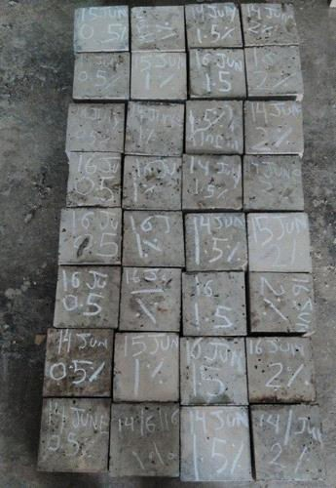

**Fig 3** **Concrete Cubes**

**Compressive Strength Test (IS-516, 1959)**

Lift the specimen from laboratory floor or outside after specified age and wipe out any dirt from the surface. Make sure the load is applied to the opposing sides of the cube cast by positioning the sample inside the machine in this manner. Position the specimen center wise on the machine's bottom plate.

Hand-rotate the variable section smoothly until it reaches the specimen's upper face. Until the specimen or cube fails, apply the load gradually, steadily, and without shock, at a rate of 140 kg/cm2/minute. Note the highest capacity and it should also be noted that any unusual structures in the sort of failure must not occur.

**Slump Cone Test (IS-1199-1959)**

In this test, a conical mold with an upper diameter of 10 cm, a lower diameter of 20 cm, and a altitude of 30 cm is used to measure the workability of the mix. The concrete is first prepared, then it is poured into the mold in four stages. 25 tamps were applied to each layer. Using a trowel, the surplus concrete was detached from the mold and the surface was leveled.Lift the mold using your hands, and then observe how the height of the specimen and the mold differ.

**Splitting-Tensile Test (IS-5816-1999)**

The cast specimen needs to be kept somewhere between 27° and 2°C for 24 hours, giving or taking 0.5 hours, after the water is added to the dry materials. Subsequently, the sample needs to be labeled, taken out of the mold, and immediately immersed in either renewed water that has been eviscerated or a elucidation of lime that has been soaked. Adjust the compression testing apparatus to the required range. After positioning the specimen, place the plywood stripe on the lower plate. Over the sample, position the second piece of plywood. Lower the top plate until it is in contact with the plywood strip. Apply the load continuously and shock-free at a rate between 0.7 and 1.4 MPa/min (1.2 and 2.4 MPa/min according to IS 5816: 1999). At the end, record the infringement load (P). Finally, three samples will be cast and evaluated for each analysis. Next, it will occupy the average tensile-strength.

**6. RESULT**

**Table 2 Average Compressive-Strength of Concrete after intercourse 30.0% fly ash, 5.0% saw-dust and 5.0% coconut-Shell.**

|  |  |  |  |  |  |
| --- | --- | --- | --- | --- | --- |
| **Days** | **Sample No.** | **Wt.** | **Load**  **in KN** | **Strength in MPa** | **Avg. strength** |
| **7 days** | **1** | **8.2** | **710** | **31.55** | **30.91** |
| **2** | **7.93** | **700** | **31.11** |
| **3** | **8.4** | **690** | **30.07** |
| **14 days** | **1** | **7.83** | **705** | **31.33** | **31.33** |
| **2** | **7.90** | **710** | **31.55** |
| **3** | **8.1** | **700** | **31.11** |
| **21 days** | **1** | **7.8** | **730** | **32.44** | **32.66** |
| **2** | **8.0** | **725** | **32.22** |
| **3** | **8.3** | **750** | **33.33** |
| **28 days** | **1** | **8.1** | **765** | **34.00** | **33.77** |
| **2** | **7.8** | **745** | **33.11** |
| **3** | **8.0** | **770** | **34.22** |

**Table 3 Average Compressive-Strength of Concrete after intercourse 30.0% fly ash, 10.0% saw-dust and 10.0% coconut-Shell.**

|  |  |  |  |  |  |
| --- | --- | --- | --- | --- | --- |
| **Days** | **S.No.** | **Wt.** | **Load**  **in KN** | **Strength in MPa** | **Avg. strgn.** |
| **7 days** | **1** | **7.75** | **715** | **31.78** | **32.15** |
| **2** | **7.68** | **730** | **32.44** |
| **3** | **7.80** | **725** | **32.22** |
| **14 days** | **1** | **7.75** | **735** | **32.66** | **32.73** |
| **2** | **7.74** | **730** | **32.44** |
| **3** | **7.84** | **745** | **33.11** |
| **21 days** | **1** | **7.78** | **785** | **34.89** | **33.93** |
| **2** | **7.80** | **735** | **32.67** |
| **3** | **7.85** | **770** | **34.22** |
| **28 days** | **1** | **7.80** | **780** | **34.67** | **34.74** |
| **2** | **7.85** | **785** | **34.88** |
| **3** | **7.85** | **780** | **34.67** |

**Table 4** **Average Compressive-Strength of Concrete after intercourse 30.0% fly ash, 15.0% saw-dust and 15.0% coconut-Shell.**

|  |  |  |  |  |  |
| --- | --- | --- | --- | --- | --- |
| **Days** | **Sample**  **No.** | **Wt.** | **Load**  **in KN** | **Strength in MPa** | **Avg. strgn.** |
| **7 days** | **1** | **7.55** | **770** | **34.22** | **34.07** |
| **2** | **7.60** | **760** | **33.77** |
| **3** | **7.60** | **770** | **34.22** |
| **14 days** | **1** | **7.58** | **815** | **36.22** | **35.93** |
| **2** | **7.62** | **810** | **36.00** |
| **3** | **7.64** | **800** | **35.55** |
| **21 days** | **1** | **7.60** | **820** | **36.44** | **36.52** |
| **2** | **7.64** | **820** | **36.44** |
| **3** | **7.65** | **825** | **36.67** |
| **28 days** | **1** | **7.60** | **830** | **36.88** | **36.96** |
| **2** | **7.65** | **835** | **37.11** |
| **3** | **7.67** | **830** | **36.88** |

**Table 5 Average Compressive-Strength of Concrete after intercourse 30.0% fly ash, 20.0% saw-dust and 20.0% coconut-Shell.**

|  |  |  |  |  |  |
| --- | --- | --- | --- | --- | --- |
| **Days** | **Sample**  **No.** | **Wt.** | **Load**  **in KN** | **Strength in MPa** | **Avg. strgn.** |
| **7 days** | **1** | **7.35** | **755** | **33.55** | **33.03** |
| **2** | **7.40** | **745** | **33.11** |
| **3** | **7.42** | **730** | **32.44** |
| **14 days** | **1** | **7.37** | **760** | **33.77** | **33.85** |
| **2** | **7.42** | **755** | **33.55** |
| **3** | **7.44** | **770** | **34.22** |
| **21 days** | **1** | **7.39** | **780** | **34.66** | **34.56** |
| **2** | **7.44** | **780** | **34.66** |
| **3** | **7.45** | **785** | **34.39** |
| **28 days** | **1** | **7.40** | **790** | **35.11** | **35.18** |
| **2** | **7.45** | **795** | **35.33** |
| **3** | **7.45** | **790** | **35.11** |

**Table 6 Average Compressive-Strength of Concrete after intercourse 30.0% fly ash, 25.0% saw-dust and 25.0% coconut-Shell.**

|  |  |  |  |  |  |
| --- | --- | --- | --- | --- | --- |
| **Days** | **Sample**  **No.** | **Wt.** | **Load**  **in KN** | **Strength in MPa** | **Avg. strgn.** |
| **7 days** | **1** | **7.30** | **640** | **28.45** | **29.18** |
| **2** | **7.25** | **680** | **30.22** |
| **3** | **7.22** | **650** | **28.88** |
| **14 days** | **1** | **7.30** | **690** | **30.67** | **29.92** |
| **2** | **7.28** | **680** | **30.22** |
| **3** | **7.25** | **650** | **28.88** |
| **21 days** | **1** | **7.32** | **725** | **32.22** | **32.15** |
| **2** | **7.30** | **730** | **32.44** |
| **3** | **7.27** | **715** | **31.78** |
| **28 days** | **1** | **7.33** | **745** | **33.11** | **33.48** |
| **2** | **7.32** | **750** | **33.33** |
| **3** | **7.30** | **765** | **34.00** |

**Table 7 Experimental Results of slump Cone Test**

|  |  |  |
| --- | --- | --- |
| **S.no.** | **Replacement Percentage of fly ash, Saw Dust & Coconut Shell** | **Slump** |
| **1** | **0%, 0%, 0%** | **92mm** |
| **2** | **30%, 5%, 5%** | **90mm** |
| **3** | **30%, 10%, 10%** | **89mm** |
| **4** | **30%, 15%, 15%** | **85mm** |
| **5** | **30%, 20%, 20%** | **80mm** |
| **6** | **30%, 25%, 25%** | **78mm** |

**Table 8** **Experimental Results of Split Tensile Test**

|  |  |  |  |
| --- | --- | --- | --- |
| **Days** | **Sample No.** | **% replacement** | **Avg. strgn.** |
| **7 days** | **1** | **5%** | **2.98** |
| **2** | **10%** | **3.08** |
| **3** | **15%** | **3.15** |
| **4** | **20%** | **3.21** |
| **5** | **25%** | **3.06** |
| **14 days** | **1** | **5%** | **3.08** |
| **2** | **10%** | **3.16** |
| **3** | **15%** | **3.19** |
| **4** | **20%** | **3.31** |
| **5** | **25%** | **3.07** |
| **21 days** | **1** | **5%** | **3.16** |
| **2** | **10%** | **3.23** |
| **3** | **15%** | **3.32** |
| **4** | **20%** | **3.41** |
| **5** | **25%** | **3.12** |
| **28 days** | **1** | **5%** | **3.33** |
| **2** | **10%** | **3.40** |
| **3** | **15%** | **3.47** |
| **4** | **20%** | **3.54** |
| **5** | **25%** | **3.18** |

**Chart 1 Cost Comparison for different types of sample used**

**6. CONCLUSIONS**

From this study, the following observations were made:

1. Based on the experimental work it can be concluded that for 7 and 28 days curing up to20 % of saw-dust and coconut-shell can be used in concrete because it provides good strength. For Compressive strengths up to 15 % sawdust and coconut Shell shows good increment in the results whereas for split tensile strength, up to 20.0% saw-dust, coconut-shell replacement can be made in concrete.

2. There is very minor decrement in the slump value of concrete which can be deliberated for the construction work.

3. The split tensile strength also increases up to 20% and its value decreases after that percentage.

4. The period of concrete has no consequence on the compressive-strength of concrete.

5. As we have done cost analysis of the modified composite which is associated with the normal OPC concrete in which the cost reduction is observed if we are using modified concrete which means that using this concrete is economical as related to normal OPC.

6. As the result shows that we can use 20% replacement as a material, so a cost saving of about Rs.1400 approximately is observed if we are constructing a 1m3work.

7. Sawdust exhibits strong strength because of its superior adhesion, which limits and absorbs breaks in the solid. Fly ash's good pozzolonic characteristic also helps this mechanism.

8. In addition, the concrete exhibits superior compaction ease as compared to the governor mix.

9. Furthermore, the introduction of sawdust in the concrete also helps to diminish the improper dumping of the hard excess into landfills and thereby making the concrete more biodegradable.

**REFERENCES**

[1] Ali M, Liu A, Sou H, Chouw N. Mechanical and dynamic properties of coconut fibre reinforced concrete. Construction and Building Materials. 2012 May 31;30:814-25.

[2] B.Damodhara Reddy1 , S.Aruna Jyothy2 , Fawaz Shaik3 Experimental Analysis of the Use of Coconut Shell as Coarse Aggregate IOSR Journal of Mechanical and Civil Engineering (IOSR-JMCE) e-ISSN: 2278-1684,p-ISSN: 2320-334X, Volume 10, Issue 6 (Jan. 2014), PP 06-13.

[3] Cook DJ, Pama RP, Weera single HL. Shellfibre reinforced cement as a low cost roofing material. Building and environment. 1978 Dec 31;13(3):193-8.

[4] Christy CF, Tensing D. Effect of Class-F fly ash as partial replacement with cement and fine aggregate in mortar.

[5] Dr .P. Sri Chandana, Ph.D, Shaik Ahamed Mynuddin Experimental Study on Strength of Concrete by Partial Replacement of Fine Aggregate with Sawdust and Robosand International Journal & Magazine of Engineering, Technology, Management and Research Volume No: 2 (2015), Issue No: 9 (September).

[6] FurqanFayaz Khan , Isha Chandra , Sajad Ahmad Bhat An Experimental Investigation on the Effect of Replacement of Fine and Coarse Aggregate by Sawdust in Solid Concrete Blocks for Different Mix Proportions ISSN 2321 3361 © July 2020 IJESC Volume 10 Issue No.7 .

[7] Gopinath K, Anuratha K, Harisundar R, Saravanan M. Utilization of Saw Dust in Cement Mortar& Cement Concrete. International journal of scientific& engineering research. 2015.

[8] Harsh K. Mistry, Kaushal D. Patel, Kunj B. Patel, Kahan P. Ramani and RakshaParolkar, A Review on The Study of Behaviour of Wastepaper Sludge Ash as a Partial Replacement, International Journal of Civil Engineering and Technology, 8(4), 2017, pp.107-110.

[9] IS 10262 2009 Guidelines for concrete mix design proportioning.

[10] IS-516, 1959Method of Tests for Strength of Concrete.

[11] IS-1199 1959Methods of sampling and analysis of concrete.

[12] Jatale A, Tiwari K, Khandelwal S. Effects on compressive strength when cement is partially replaced by fly-ash. IOSR Journal of Mechanical and Civil Engineering. 2013;5(4):34-43p.

[13] Joy AM, Jolly AK, Raju AM, Joseph BE. Partial replacement of fine aggregate with sawdust for concrete.

[14] Kiran TG, Ratnam MK. Fly ash as a partial replacement of cement in concrete and durability study of fly ash in acidic (H2So4) environment. International Journal of Engineering Research and Development. 2014 Dec;10(12):1-3.

[15] K Sampath Kumar, U M Praveen, A Prathyusha, V Akhila, P Sasidhar, A Comprehensive Study On Partial Replacement of Cement with Sugarcane Bagasse Ash, Rice Husk Ash & Stone Dust, International Journal of Civil Engineering and Technology, 7(3), 2016, pp. 163–172.

**BIOGRAPHIES**

|  |  |
| --- | --- |
|  | **Yasam Yash,**  Research Scholar, Department of Civil Engineering, People's University, Bhopal (M.P.) |