# Implementation Of Value Engineering In Construction Management

***Shinde Aniket Kailas1,Bibave Pravin Ranjedra2 ,Ghule Sagar Bharat3 ,Nawali Pradip Sunil4 ,Prof.Prakash Shinde5***

1,2,3,4 Student, Department of Civil Engineering, Vidya Niketan College Of Engineering,Bota.

5 HOD, Department of Civil Engineering, Vidya Niketan College Of Engineering, Bota.

**ABSTRACT**

Value Engineering is a proven management technique that can make valuable contributions to value enhancement and cost reduction in construction industry.Value Engineering is one of the most effective techniques known to identify and eliminate unnecessary costs in product design, testing, manufacturing, construction, operations, maintenance, data, procedures and practices. The methodology is composed of three main stages. The first stage is the Pre-Study of the Value Engineering. The purpose of this stage is to plan and organize the value study. Value Engineering is the systematic application of recognized techniques that identify the functions of the product or service, creatively establish the worth of those functions, and provide only the necessary functions to meet the required performance at the lowest overall cost. Value Engineering focuses on accomplishing the required functions at the lowest

overall cost. It helps in eliminating or minimizing wastage of material, time, and unnecessary cost, which improves value to the customer. The second stage is the Value Study which is the core of Value Engineering study and it is composed of five phases, the Information phase, Function Analysis Phase, l reative Phase, Evaluation Phase and the Presentation phase. All phases and steps perform sequentially. Such sequence of the methodology is expected to assist in logical and systematic flow of the process to achieve the targets of the VE study. The third stage is the Post Study. The objective during post-study activities is to assure the implementation of the approved value study change recommendations. In this study, how the principles of Value Engineering are applied in construction projects is explained, and by taking case study on residential building as the sample project, practices of Value Engineering in this project are described.

**Keywords**— Value Engineering, Functions Analysis, Cost, Quality aspects of a project, Value Analysis.

## INTRODUCTION

Value engineering is basically a team effort. It Aims at promotion of value awareness and raising the level Of professional competence and technological excellence In the organization. Value engineering not only aims at Cost reduction but also cost effectiveness which in turn Enhances the value and provides competitive advantage.Value engineering techniques can be applied wherever cost Is proposed or likely to be incurred in terms of money, Skills/expertise, energy or other resources. In other words, This will cover practically every area of human activity and Value engineering can be considered applicable to all of Them. Value engineering is applicable to hardware, building Or other construction projects and to soft areas, such as Manufacturing processes, administrative and management Systems, office procedures, books and forms and computer Software costs. In case of once through projects such as Civil engineering works for example, buildings, highways,Water/air/effluent treatment plants, etc and engineering Projects such as product design, greater benefits from the Application of Value Engineering can be obtained by Application of these techniques at the early design stages. Adequate data collection in such studies is essential Together with in depth involvement of the agencies dealing With the finance, design, construction and use of the Project. A project may require several teams to work Simultaneously on different aspects such as, structural Design, layout, subsystem services, etc.

## PROBLEM STATEMENT

The construction industry, despite its pivotal role in economic development, is frequently plagued by challenges such as cost overruns and delays in project timelines. The escalating costs and time extensions often associated with construction projects underscore a pressing need for effective methodologies to address these issues. The problem at hand revolves. around the prevalence of cost overruns in construction activities, adversely impacting project outcomes and economic feasibility. This study aims to address the problem by focusing on the implementation of value engineering in construction management. The overarching question is how value engineering principles can be strategically applied to identify and mitigate the factors contributing to cost overruns in construction projects. By understanding and resolving these challenges, the study seeks to contribute to the advancement of construction management practices,fostering improved project tracking and enhanced cost efficiency in the construction industry.

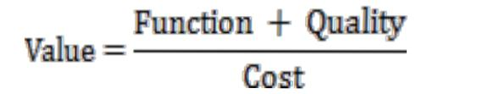

Where:

Function: The specific work that a design or item must Perform.

Quality: The owners or users need, desire and expectation.

Cost:Life cycle cost (LCC)

## LETRATURE REVIEW

In this paper we have discussed the concept of Value Engineering, its job plan and the effective implementation of it through a case study. Efforts have been put into the articulation of the paper to make it coherent which can be easily perceivable. A case study has been discussed in this paper involving a part used in the medical instruments. The material is chosen such that the cost is reduced without affecting the quality of the product. The best feasible solution from the available alternatives is chosen through the feasibility ranking table. Through the application of Value Engineering profits are maximized without hindering the reliability of the product. With the effective utilization of the technique the final outcomes comes out to be a successful showcase of value engineering.

The Value Engineering process and procedures are generally well defined and well-understood at all levels in the industry. Value Engineering is recognized as an effective tool to improve the performance of a product with reduction in cost without reducing in quality. . A proper decision matrix is prepared for choosing the appropriate alternative from the feasible choices available. The total saving which can be incurred per product by the implementation of above recommendations are 14.87 % for alternative-I and 27.44 % for alternative-II. Change in Technology and Globalization can rapidly increase which creates huge demand but not necessary for the same types product at the same price tags. These forcing companies think differently and look at their cost and create product to meet needs of market and trends.

## PROPOSED METHODOLOGY AND OPERATING PRINCIPLE

The value methodology use the disciplined Procedure for improving value and use procedure called Job plan. The job plan outlines specific techniques to Effectively analyze a product or service in order to develop The maximum number of alternatives to achieve the Products or services required functions. Adherence to the Job plan will better assure maximum benefits while Offering greater flexibility.

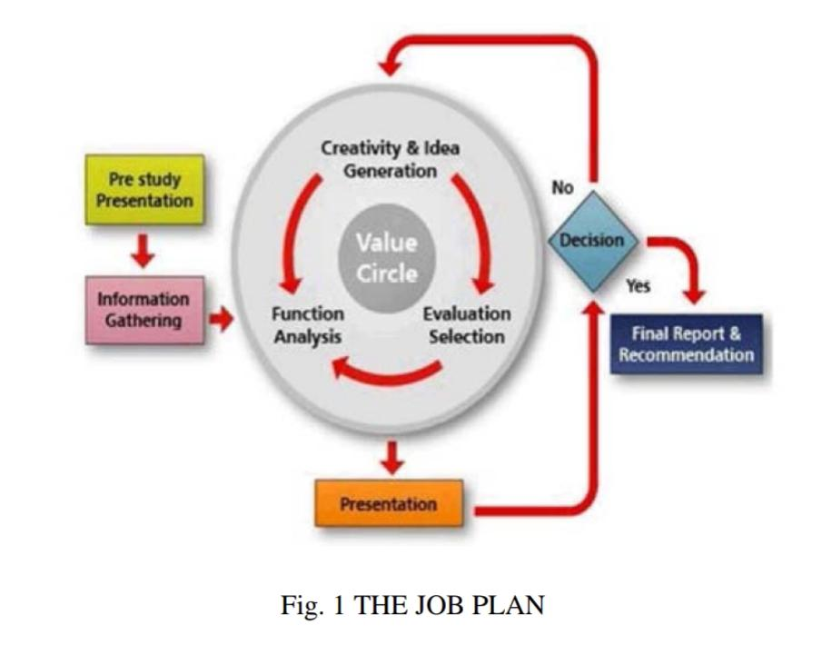

**Some alternative techniques**

1. CLC Bricks

2. 800 x 800 Granite Tile

3. Mivan Technology

STUDY AREA 1 – A proposed commercial building having 7 floor and102shops is taken for case study Location is in Punawale, Pune.

Total Area:2.8 acres

Built-up Area: 92000sq ft

STUDY AREA 2 – Shiv Sai Millenium is a commercial development in Punawale, Pune. 411033

Total Area:1.44 acres

Built-up Area:332.927 – 4632.029 Sq.ft.

**WORKING PRINCIPLE**

**Application of Value Engineering Can Be Done**

**In Following Stages**

1. Information Phase

2. Creative Phase

3. Evaluation Phase

4. Development Phase

5. Presentation Phase

## RESULT AND DISCUSSION

**STUDY AREA 1:**

**CLC Brick Work takes less duration than Conventional Brick Work.**

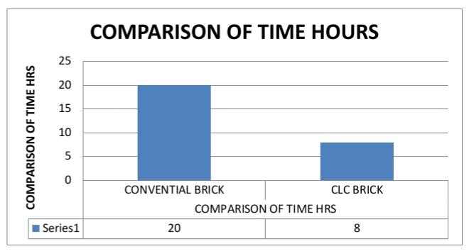

**STUDY AREA 2:**

**Construction with mivan takes less duration than Conventional technique.**

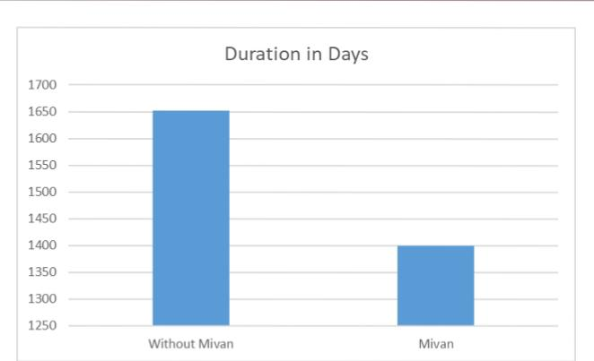

## CONCLUSION

It is not possible to apply VE on each project a Company produces. Much more successful value Engineering studies can be carried out on complex and big Projects which have high potential of restoring the Investment. Of course value engineering works have a Cost, therefore this project shall be big enough to meet this Cost and obtain profit. The purpose of value engineering is Not just reducing the costs, increasing the design standards, Making it easier to build the project and saving time and Money. VE must create a balance between all the needs of The project. Purpose of VE shall be determined in direction Of company purposes. Every person that joins for VE shall Be embraced. There should be no one in the team who Thinks in the opposite of project management, or who is Suspicious in the benefits of VE.The highest performance in VE is achieved Especially when the purpose is mainly increasing the value Rather than reducing the costs.The application of Pareto Law 20/80 states that around 20 % of the functions Constitute around 80% of the cost. These functions are the subject of value engineering. As a conclusion, the area of Value engineering analysis and study will be controlled by That functions. Further, we can do analysis of these Functions and suggest alternatives and calculate cost model After application of value engineering technique. For Getting a better output for value engineering.

## FUTURE SCOPE

1. Detailed Contract Documents.
2. Detailed Estimation of the items.
3. The action plan in place which consists of several sequential stages of a logical sequence.
4. Owner’s requirements for preparation of quality Model.
5. Ensure coordination between the relevant authorities in the project.
6. Collection and study of drawings.

### REFERANCE

1. Dr. S.V. Deodhar,(2010) “Construction Equipment and Planning,” Khanna Publishers Delhi. Fourth Edition.
2. Amit Sharma, R.M. Belokar, (2012) “ Achieving Success through Value Engineering:A Case Study”Proceedings of the World Congress on Engineering and Computer Science 2012 Vol II, ISSN: 2078-0966
3. <https://core.ac.uk/download/pdf/144786379.pdf>
4. <https://www.iaeng.org/publication/WCECS2012/WCECS2012_pp1330-1333.pdf>