SMART LEARN

Dhanesh Dalal1, Ashish Kumar Chouhan2, Pankaj Mahajan3, Prof. Kiran Tayade4

Department of Computer Science & Engineering.

Thakur ShivKumar Singh Memorial Engineering College, Burhanpur, (Affiliated to RGPV Bhopal), India

ABSTRACT

The Smart Learn project is an ambitious venture in the field of e-learning, seeking to redefine conventional educational approaches through the strategic integration of cutting-edge technologies. Rooted in a commitment to democratize education, this dynamic platform is meticulously designed to provide learners of diverse backgrounds and preferences with a tailored and accessible educational experience. The technological stack driving Smart Learn includes the Java programming language for robust development, a MySQL database for efficient data management, and the Apache Tomcat server for seamless deployment. The platform boasts an intuitive user interface and a rich array of interactive learning materials, ranging from comprehensive notes to engaging videos. What sets Smart Learn apart is its implementation of adaptive learning paths, allowing users to navigate educational content at their own pace and according to their unique learning styles. Collaborative features, discussion forums, and community-building elements further enhance the user experience, fostering a sense of belonging and shared knowledge. Global accessibility is a cornerstone of Smart Learn, ensuring that learners worldwide can access high-quality educational resources irrespective of geographical constraints. With a vision to empower individuals through education, Smart Learn aspires to cultivate a community of lifelong learners who are not only informed but also inspired to contribute meaningfully to the evolving landscape of knowledge acquisition

INTRODUCTION

Worldwide, In the dynamic landscape of education, the advent of technology has ushered in a new era of learning – one that transcends traditional boundaries and empowers individuals to acquire knowledge at their own pace and convenience. In this transformative journey, "Smart Learn," our innovative e-learning website, stands as a beacon of educational excellence and accessibility..

The motivation behind the "Smart Learn" project stems from a deep commitment to transforming the way individuals access and engage with education. Recognizing the evolving landscape of learning, we are driven by a passion to make education not only

accessible but also enjoyable and tailored to the unique needs of every learner.

The project is motivated by a desire to bridge the gaps in traditional learning methods, ensuring that education is not confined to the walls of a classroom. We believe that everyone, regardless of their background or circumstances, should have access to high-quality learning resources. "Smart Learn" is a response to the challenges faced by learners in finding personalized, engaging, and easy-to-understand educational content.

The goal is not just to impart knowledge but to inspire a love for learning. We believe that by integrating technology, user-friendly interfaces, and personalized content, we can ignite a passion for education and empower individuals to unlock their full potential.

RELATED WORK

The "Smart Learn" project has a broad range of applications and a vast scope, aiming to impact various aspects of education and learning. Some of the key applications and scope of the project include:

**Formal Education Augmentation**: "Smart Learn" can serve as a valuable supplement to formal education, providing additional resources, explanations, and interactive materials to enhance classroom learning.

**Distance Education**: The platform is well-suited for distance education, allowing learners to access educational content remotely. This is particularly beneficial for individuals who may not have easy access to traditional educational institutions.

**Language Learning**: The platform can include language learning modules, catering to individuals interested in acquiring proficiency in different languages.

**Exam Preparation**: "Smart Learn" can serve as a resource hub for exam preparation, offering comprehensive study materials, practice tests, and explanatory videos to help students excel in various examinations.

Global Accessibility: The project's online nature allows for global accessibility, enabling learners from diverse cultural backgrounds to benefit from the platform's educational offerings.

**Teacher Resources**: "Smart Learn" can provide resources for educators, including teaching aids, lesson plans, and multimedia content, facilitating effective teaching strategies in the classroom.

**Parental Involvement:** The platform can involve parents in their child's education by providing insights into the learning progress and suggesting ways for parents to support their child's educational journey.

SUMMARY

The implementation of Smart Learn, our dynamic e-learning platform, involved a meticulous process to bring the project from concept to reality. Leveraging Java as the primary programming language and JavaServer Faces (JSF) as the web framework, the development team crafted an intuitive and interactive user interface. The back-end was robustly supported by the MySQL database management system, ensuring efficient data storage and retrieval.

The implementation journey included the creation of comprehensive modules, such as user authentication and profile management, content management, personalization engines, interactive learning materials, assessment and progress tracking, community and collaboration features, and more. The incorporation of adaptive learning paths, gamification elements, and career guidance modules added depth and engagement to the platform.

Smart Learn's architecture is designed to accommodate diverse educational content, including notes, videos, quizzes, and assignments, offering users a holistic learning experience. The platform's adaptability to different learning styles, its global accessibility, and the emphasis on creating a sense of community among learners underscore its commitment to inclusivity and collaborative learning.

Throughout the implementation, the team followed industry best practices, conducted rigorous testing at each phase, and iteratively refined features based on user feedback. The result is a sophisticated e-learning ecosystem that aligns with the project's vision of democratizing education, making high-quality learning resources accessible to learners worldwide. Smart Learn stands as a testament to the successful implementation of innovative technologies in the pursuit of a smarter, more inclusive approach to education.

LIMITATION

While the "Smart Learn" project aims to revolutionize online education, it's important to acknowledge certain limitations that may impact its effectiveness:

Internet Dependency: The platform relies on internet connectivity, and users in areas with limited or no access to the internet may face challenges in fully utilizing the resources. This limitation may hinder the project's reach in remote or underserved regions.

TECHNOLOGICAL BARRIERS

Some potential users may lack access to devices like computers or smartphones, hindering their ability to engage with the platform. Technological barriers, including limited digital literacy, could limit the inclusivity of the project.

**Quality of Internet Connection**: Even in areas with internet access, the quality of the connection can vary. Slow or unreliable internet speeds may lead to difficulties in streaming videos or accessing interactive content, impacting the overall user experience.

**Language and Cultural Relevance**: The platform's content may not fully cater to diverse linguistic and cultural backgrounds. Adapting content to different languages and cultures is a complex challenge that may affect the inclusivity and effectiveness of the learning materials.

**Limited Interaction**: While "Smart Learn" offers interactive features, it may not fully replicate the collaborative and interactive aspects of traditional classroom settings. Some learners may miss the face-to-face interaction with teachers and peers, impacting their engagement.

**Overemphasis on Technology**: The project's reliance on technology may not align with the preferences of all learners. Some individuals may prefer traditional learning methods, and the digital focus of "Smart Learn" may not cater to their preferred style.

**RESULTS**

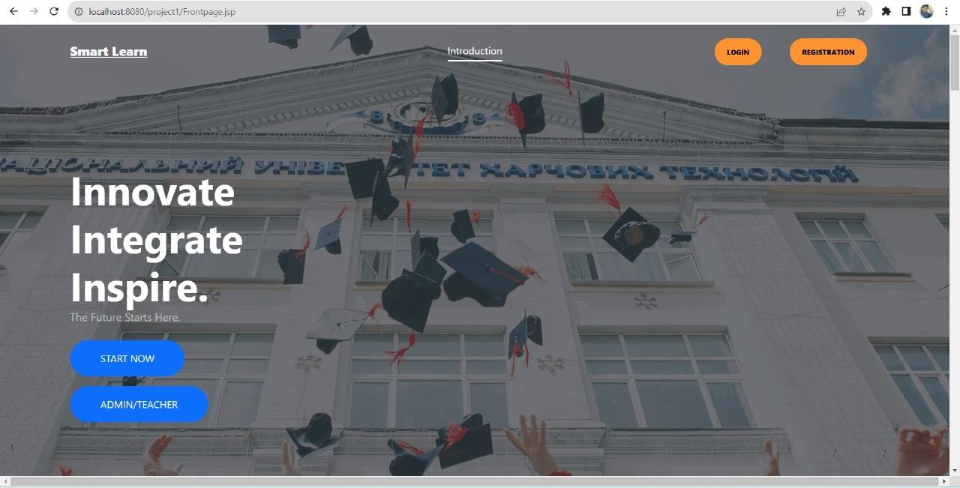

***Fig. 2****. Evaluation of Models On The Smart Learn*

CONCLUSION

"Smart Learn" project represents a significant stride towards transforming the landscape of online education. The methodology applied in its development, from needs assessment to strategic planning, content creation, and platform implementation, reflects a systematic and user-centric approach. By addressing gaps in existing e-learning platforms and incorporating personalized learning features, "Smart Learn" strives to make education accessible, engaging, and tailored to individual preferences. The iterative nature of development, informed by user feedback, ensures continuous improvement and adaptability. The project's emphasis on accessibility, security, and inclusivity aligns with the evolving needs of diverse learners. As "Smart Learn" enters the educational sphere, it carries the promise of providing a dynamic, high-quality, and user-friendly platform that fosters a love for learning and contributes to the democratization of education. The journey doesn't end here; it's a commitment to ongoing enhancements, staying attuned to user needs, and making learning an enriching experience for all.

FUTURE SCOPE

Looking ahead, the future scope of the "Smart Learn" project is brimming with opportunities for expansion and enrichment. To broaden its impact, the project could diversify its educational content, encompassing an even wider array of subjects and skill levels. Establishing global partnerships with educational institutions and experts worldwide could bring diverse perspectives and expertise to the platform. Advanced personalization algorithms could be developed to tailor the learning experience even more precisely to individual users, while the integration of emerging technologies like virtual reality and artificial intelligence could introduce immersive and intelligent learning features. Additionally, enhancing interactive assessments and fostering a sense of community among learners through forums and collaborative projects could deepen engagement. The project could also explore offline learning support for users with limited internet access, ensuring inclusivity. By incorporating career guidance modules and collaborating with industry experts, "Smart Learn" could become a go-to platform for skill development aligned with professional aspirations. Continuous user feedback mechanisms and participation in educational research initiatives would keep the platform dynamic and responsive to evolving needs. As "Smart Learn" evolves, it has the potential not only to be a transformative force in online education but also a hub of innovation and collaboration that empowers learners on a global scale.

**REFERENCE**

1. Java: The complete Reference by “Herbert Schildt”-Ninth Edition.
2. “A. A. Puntambekar” Software engineering and project management, 2013, Technical Publication.
3. Database Systems: The Complete Book, Hector Garcia-Molina, Jeff Ullman and Jennifer Widom, June 9, 2008-Second edition.
4. Java Performance: The Definite Guide by Scott Oaks. 1st Edition
5. Core Java Volume I -Fundamentals (11th Edition), 2020
6. Fundamentals of Database System, Seventh Edition, By Pearson Paperback – 2017 by Elmasri Ramez, Navathe Shamkant
7. Java: A Beginner's Guide, Eighth Edition, 8th Edition by Herbert Schildt Released November

2018, Publisher(s): McGraw-Hill

1. A Practical Guide to Database Design Hardcover -March 2018 by Rex Hogan
2. Database System Concepts, Sixth Edition by Avi Silberschatz, Henry F. Korth, S. Sudarshan
3. -McGraw-Hill
4. MySQL in a Nutshell, 2nd Edition by Russell J.T. Dyer, Released April 2008, Publisher(s): O'Reilly Media, Inc.
5. Learning MySQL: Get a Handle on Your Data 1st Edition, Kindle Edition by Hugh E. Williams (Author), Seyed M.M. Tahaghoghi (Author)
6. MySQL: The Complete Reference (Osborne Complete Reference Series), January 2004 by Vikram Vaswani
7. Expert MySQL (Expert's Voice in Databases) Paperback, December 2012 by Charles Bell
8. MySQL Explained: Your Step-by-step Guide to Database Design, November 2015 by Andrew Comeau
9. Java Projects by Kanetkar Yashavant P.
10. HTML and CSS: Design and Build Websites, November 2011 by Jon Duckett
11. Mastering HTML, CSS & Javascript Web Publishing Paperback –July 2016 by Laura Lemay (Author), Rafe Colburn (Author), Jennifer Kyrnin (Author)
12. Software Engineering: A Practitioner's Approach Paperback –April 2009 by Roger Pressman (Author).