Scholarship Access System For Diploma Students Through Cloud
Khokrale Tanuja#, Kabaddi Siddhi*, Kale Sakshi#, Tattu Anushka#
#Computer Department
Jaihind Polytechnic, Kuran
¹tanujakhokrale@gmail.com
²siddhikabaddi@gmail.com
³sakshikale07@gmail.com
⁴anushkatattu1@gmail.com

Abstract— The Scholarship Management System is used for managing the details of the students who are all applied for various scholarship in our college. This project helps to find the details of the eligible students to apply for the scholarship and also list the already applied students. The selection of eligible students is also possible by year wise. Eligible students are selected based on Caste such as SC/ST and Minority, CSSR and the department head, administrator also select the student to apply for scholarship based on their best performance in studies or sports activities. Administrator and department head only add the new records to the scholarship, update existing scholarship and also delete scholarship and also delete scholarship. This project also provides as the reports about scholarship and store details of eligible and non-eligible students. The scholarship details of the students are maintained by the head of the department. The renewal date of the respective scholarship also checked by both administrator and students.

Keywords— scholarship, manual , computerized, student, data.

- Introduction
The student scholarship is based on online system. The two algorithms are used that is collaborative Filtering, The student scholarship is based on online system. The two algorithms are used that is collaborative Filtering, Content Based Filtering. The scholarship is involved into three categories. That is caste wise, academic wise and poor student. The Admin is the main of the whole project. The scholarship is involved into three categories. That is caste wise, Academic wise (Rank older), poor status. The Admin are category add this student scholarship. The filtering process are involved many types of caste. They are OBC, MBC, SC, and OC. The apply status are invoked in this student scholarship. Paid or unpaid status are also viewed this student scholarship. The student is registering the student details and then login the homepage. The scholarship form is available in online. Register the scholarship apply form in online. The filtering process is two algorithm are used by solve the student caste wise allotment of scholarship. The alert message is also involved. Content based and collaborative technique is the result of a time-consuming process of scholarship and caste wise development. The scholarship students can pass on their query or their views or experiences on to portal password certain internship events are allocated. The scholarship student involvement is the most important part of a student institute or a foundation. It says a lot about the quality of student imparted in that scholarship student institute. Main of the status of scholarship student rests on its Alma Mater. After the scholarship students complete their education, they begin their voyage in the corporate world. Many types of scholarship student a lot to the kind of education, grooming, opportunities, co-curricular activities and events provide by their college. Many scholarship students like to come back to their college that has been a very important part of their memory. They like to give back to their college by giving their valuable time. They feel obliged to the scholarship student institute that opened new of jobs for them by building them academically strong. Most of the good colleges ensure an all-round development of the students. Such student scholarship events create wonderful memories for the students to cherish for a lifetime. The system for applying the scholarship is manual for the student in the existing system. To avoid the manual system this proposed system develops the application for scholarship on the basis of cast category, academic performance and social status. In this system student can apply scholarship using this portal where they can upload the proof and photo in this application.. Saves you from debt any students graduate from college with huge loan debts. The thought of repaying all the money limits their education. It also creates immense pressure on them for getting placed at good packages. This is the reason why most students can’t pursue careers, which don’t pay high salaries at entry level, even if they want to. On the other hand, a scholarship comes as free money and allows students like you to follow your dreams. It helps in empowering your academic and career goals by removing the financial barrier. Improves performance - Getting a scholarship takes away all your financial concerns. Thus, it gives you more time to study, gain knowledge and secure better grades. You get ample time to look for opportunities for skill development and knowledge enhancement. Gives you a career advantage - Earning a scholarship is prestigious. Since you get a scholarship on merit, getting one will leave a good impact on your future employers. Some competitive scholarships are so good that you can list them on your resume under accomplishments. Stand out from the rest during job search. Now all of you want to know why this scheme is so popular in all over the Country. We are going to tell you about all of this. Under this “Scholarship Management System” the State Government will give Rs.15000/- a year through cheque to the Mother and Guardian who will send their children to school. For this scheme family must be a native citizen of India. All mothers or recognised guardians who belong to the BPL family having white Ration Card send their children who are studying between class 1st to class 12th to any recognised institution included Government, private schools and junior colleges, residential schools and colleges in state which comes under this “Scholarship Management System”. Main motto of this scheme is to Promote the literacy rate in the state so that not a single child left illiterate. Mothers or guardians who are benefitting from this scheme should ensure that his /her children should maintain the 75% attendance. Officials under this scheme at district level started shortlisting beneficiaries who come under the scheme and most probably the first list of beneficiaries who comes under Scholarship Management System

- Literature Review
- Oxford Dictionary, “Oxford Dictionary Language matters”. Oxford: Oxford University Press, 2014. Tuition increases make education difficult for low-income families. Donated academic or accomplishment scholarships [1]. Many scholarships are merit-based. Financial need is considered. Scholarships are non refundable. To develop STEM leaders, the Niger State Scholarship Board requests candidates sponsor excellent undergraduate and postgraduate students. Niger State Scholarship Board automates paper scholarship analysis. Offices must receive applications in person. The reviewing committee and applicant will need more time to discuss issues while applications are processed. Therefore, more review paperwork may slow things down. Qualification screening, form evaluation, aptitude test, and oral interview are tedious. Web-based E-scholarships simplify applications.
- C.W. F. Anthony, S. Andrea, G. Kappel, R. Werner, E. Kimmerstor,etal,“Ubiquitous Web Application Development – A Framework for Understanding”, Hagenberg, Austria, Pp.1-7, 2000 The main aim of this paper is to analyze the existing software protection techniques and develop an efficient approach which would overcome the drawbacks of the existing techniques. This paper presented and discussed a survey on the protection of the software because of various attacks. Encryption techniques can be incorporated with the existing software protection techniques to improve the overall security of the software. Several software protection techniques available in literature are analyzed and examined.

- D. Ernst, “The Internet’s Effect on Business Organization: Bane or Boon for Developing Asia?” Asia pacific issues. No. 48, 2001
Anyone with internet connection can browse the web. This allows global information sharing. Internet speed, flexibility, and efficiency have made it the preferred method for performing more transactions [3]. Every company needs this technology to reach customers in this globalized world.

- S. Wen-Kai, “Development of E-Scholarship System”, M.Sc. Thesis, University of Wisconsin-La Crosse, La Crosse,011.Pp.20.
The use of the Internet has been extremely fast since it can now be accessed almost anywhere by numerous means. It has also introduced a new era of computing, providing the basis for promising application areas like e-banking, e-exams, e-ticketing [2]. In the late ‘90s came the introduction of the World Wide Web, and the implementation of the Web browser. This graphically oriented view of data quickly became popular for the Internet. Today we find much of our on-line interaction taking place through the browser. As the number of users on the World Wide Web increases every day, its use in different areas is also growing. One of the most powerful aspects of the web is that anybody who has
internet access can browse on the net. This enables sharing the information worldwide.

- PROPOSED METHODOLOGY
- Problem Statement
The problem statement for a scholarship access system through the cloud for diploma students could involve identifying challenges such as limited access to scholarship information, cumbersome application processes, and potential barriers for diploma students in accessing financial aid. The goal would be to develop a cloud-based system that streamlines the scholarship application process, improves information accessibility, and addresses the unique needs of diploma students, ultimately enhancing their opportunities for financial support in education.

- Motivation
Many Students loss scholarship scheme because of not having proper idea about the scholarship or not getting proper information on time.
Due to loss of scholarship there will be always a financial burden on the student’s parents.
On time information and easy process of scholarship can lead the student to study without much pressure of financial things This process can mine the real talent across the country
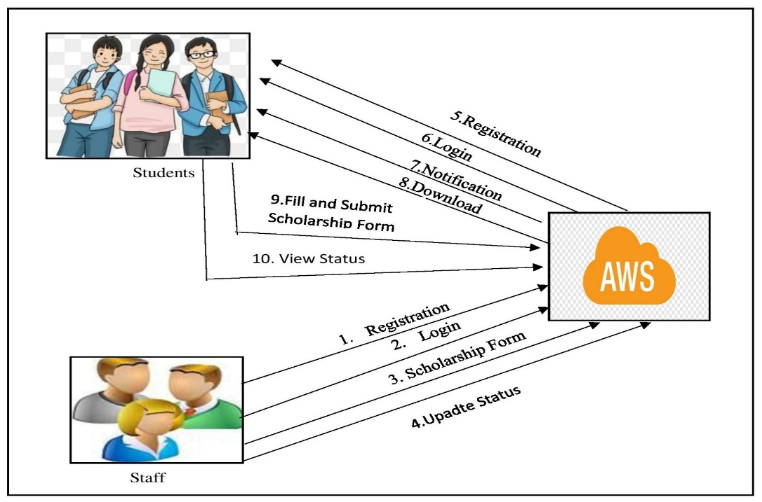
Fig. 1 System Overview Design
The proposed model for scholarship access management system can be elaborated with the following steps with the considered actors.
Step 1: Staff- The College staff gains an access to the scholarship access management system for which the valid credentials are generate d through the registration process. The staff can do the registration on their own, where the attribute so f the staff are provided and generate the login credentials for the staff by entering their respective details.
Using the generated credentials provided the staff gains access into the system after successful authentication. The staff can perform a number of different tasks after gaining the access as mentioned be low
1 .1 Profile Updation – Here staff can update his/ her profile data in the system to maintain the security and secrecy of the profile.
1 .2 New Scholarship form – Here staff will add the new scholarship details along.
with the form , that will be up loaded in the cloud and a notification email will be sent to all students.
1 .3 View admission details and edit – staff can view the added scholarship details and edit the same if he/ she required doing so.

Step 2: Student – Student is also an actor in this Scholarship access system . After providing the Student de tails he/ she will register in to the system successfully to perform the following tasks.
4.1 Profile Updation– Here students can update his/ her profile data in the system to
maintain the security and secrecy of the profile
4 .2 View notification – Here student can view the scholarship notification details
4 .3 Fill the and upload – Here student can fill the scholarship form and upload to the cloud.
4 .4 View status – Here student can view the scholarship status.

- Module Description
Module A: Staff
- Staff Register
- Staff Login
- Upload Scholarship forms

Module B: Student
- Student Registration
- Student Login
- View Scholarship forms
- Download forms
- Fill the forms and upload
- Get notifications

- System Related Diagrams
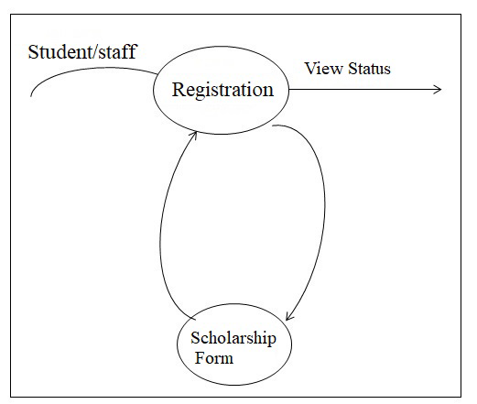
Fig. 2 DFD Level 0
The DFD 0 diagram for the data flow diagrams describes the flow of the approach. The DFD diagram provides the simplest flow where in the staff/student registers on the system and scholarship form and get view the status.

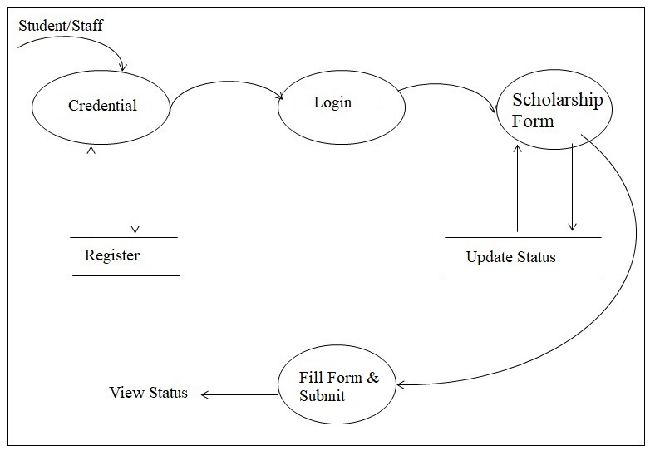
Fig 3 DFD level 1
The DFD 1 diagram provides even more details wherein the staff/student provides the credentials for registration. After successful registration the staff/student can login into the system to upload the scholarship form and update the status, then student fill the form and submit the same which leads view status.


Fig 4 Activity Diagram
The activity diagram lists the various activities that are performed in the proposed methodology. The start state is initiated and the staff/student, scholarship form, fill and submit the form and view status which leads to the stop state.

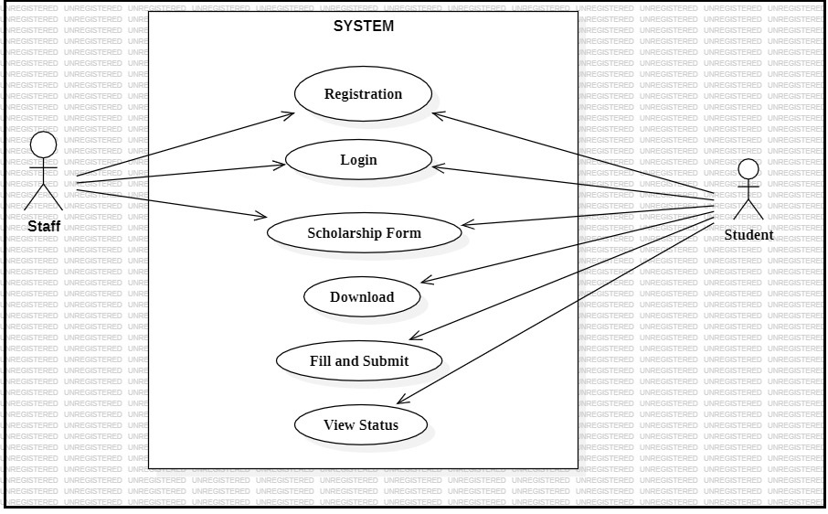
Fig. 4 Use case Diagram
The Use case Diagram depicts the various use cases that are performed by the staff and the student in the proposed model. The use cases for the staff include feeding the registration, login, upload the scholarship form. The use cases for the student includes registration, login, and download the form, fill the same and submit it, then view status.
IV.RESULT
We have successfully developed a project on Scholarship Access System for diploma Student Through Cloud.
V. Conclusions
The project “Scholarship Access System Through Cloud for Diploma Student” is developed by using Framework Swing as a front end and SQL Server as a back end. This project is used to reduce the manual work by using computerized work to maintain the scholarship related information related to students. It is accessed by admin using their login credentials. The student can check the renewal date. This project will be useful for both the admin and customer because of time consumption.

References
[1 ] Oxford Dictionary, “ Oxford Dictionary Language matters” . Oxford : Oxford University Press, 2 01 4. [Online ].
Available:http://www.oxforddictionaries.com/definition/english/scholarship.
[2 ] C.W . F. Anthony, S. Andrea, G . Kappel, R. Werner, E . Kimmerstor,et al,“ Ubiquitous Web Application Development – A Framework for Understanding ” , Hagenberg , Austria, Pp .1-7, 2 00 0. Available: http ://www 0.cs.uc l.ac.uk/staff/A. Finkelstein/papers/uwa.pdf.
[3 ] D. Ernst, “ The Internet’ s Effect on Business Organization: Bane or Boon for Developing Asia?” Asia pacific issues. No. 48, 2001 ,
pp.1-8.Available:http://www.eastwestcenter.org/file admin/stored /pdfs/api0 48 .pdf.
[4 ] K. Peterson, “ Financial Aid Glossary” , A Nelnet Network, 2 01 3. [Online ].
Available At: http://www.fastweb.com /financialaid/ article s/financial-aid-glossary.
[5 ] A. Exforsy, “ Difference between Scholarship and Grant”
Blog,28November,2014; http://www.exfosys.com/careercenter/ scholarships/difference-between-scholarship-and -grant.html.
[6 ] B .Sanothimi, “ A Study on Scholarship Management and its Effectiveness in terms of Enrolment and Retention Final Report”
Kuleswar, Kathmandu, 2010. Pp 3 -5.[7 ] M. Brumbaugh, “ Increasing Efficiency in a Community College Scholarship
Program ” , M .Sc. Thesis, Concordia University, Portland , 2011 .
[8 ] R. H . Michael, “ The Impact of Financial Aid on Postsecondary Persistence: A Review of the Literature ” , Nasfaa Journal of Student Financial Aid, Vol. 37 , No. 3, 2008 . pp 30 -34 .
[9 ] S. Wen-Kai, “ An Online Scholarship Application System ” , M .Sc. The sis, University of Wisconsin-La Crosse, La
Crosse,0 11 .Pp.2 0.Available :http://www.google .com.ng/url?url=http://minds.Wisconsin.edu/bitstream /handle/17 93 /5 24 84
[1 0] M.Z. Rashad , M . S. Kandil, A. E. Hassan, and M. A. Zaher, “An Arabic
Web-Base d Exam Management System” ,International Journal of Electrical & Computer
Sciences (IJECS-IJEN S) vol.10 no.1 . 2010 . pp 48-55.
[1 1] C. K. Ayo, I. O . Akinyemi, A.A. Adebiyi, and U.O . Ekong, “The Prospects of E-Examination implementation in Nigeria” ,Turkish Online Journal Of Distance Education (TOJDE),vol.8,no.10.2007.pp.125-135.

