**Review On Polyherbal Dusting Powder**

chaudhari sumeet santosh, Ms katkar vaishnavi, Dr. Garje S. Y., Dr.sayyed G.A.

**Abstract:**

Polyherbal dusting powders are topical formulations comprised of a blend of medicinal herbs finely powdered for application onto the skin. These powders serve various purposes in skincare, including soothing irritation, absorbing excess moisture, providing fragrance, or aiding in wound healing. The selection of herbs in polyherbal dusting powders is based on their traditional medicinal uses and therapeutic properties, encompassing anti-inflammatory, antimicrobial, antifungal, and soothing effects. This abstract provides a brief overview of the concept of polyherbal dusting powders, highlighting their natural composition and versatility in addressing diverse skin concerns.

. **Keywords**: Antimicrobial, staphylococcus aureus, diffusion, bacterial culture, polyherbal backfill, microbes

**Introduction:**

Polyherbal dusting powders represent a traditional yet versatile approach to skincare, harnessing the therapeutic potential of multiple medicinal herbs. These powders have been utilized across various cultures for centuries, offering a natural alternative to conventional skincare products. Composed of finely powdered herbs, polyherbal dusting powders are applied topically onto the skin to address a range of dermatological concerns, including irritation, moisture absorption, fragrance, and wound healing.

The formulation of polyherbal dusting powders typically involves a careful selection of medicinal herbs known for their specific properties and synergistic effects. These herbs may include well-known botanicals such as neem, turmeric, aloe vera, chamomile, lavender, and many others, each chosen for its distinct therapeutic benefits. The blending of multiple herbs allows for a holistic approach to skincare, offering a comprehensive solution that targets various skin conditions.

The popularity of polyherbal dusting powders stems from their perceived safety and efficacy, rooted in the rich tradition of herbal medicine. Unlike synthetic skincare products that may contain harsh chemicals, polyherbal dusting powders often boast natural ingredients that are gentle on the skin and less likely to cause adverse reactions. Additionally, the versatility of these powders allows for customization based on individual needs and preferences, catering to a wide range of skin types and concerns.

In recent years, there has been a resurgence of interest in natural and herbal skincare solutions, driven by growing consumer awareness of the potential risks associated with synthetic ingredients. Polyherbal dusting powders offer an appealing option for those seeking to enhance their skincare routine with products derived from nature's bounty. However, despite their long history of use and anecdotal evidence of efficacy, scientific research on the specific benefits and mechanisms of action of polyherbal dusting powders remains limited.

This paper aims to explore the preparation, evaluation, and potential applications of polyherbal dusting powders, shedding light on their traditional uses, modern formulations, and emerging scientific evidence. By delving into the world of polyherbal skincare, we can gain a deeper understanding of these time-honored remedies and their role in contemporary dermatology.

Top of Form

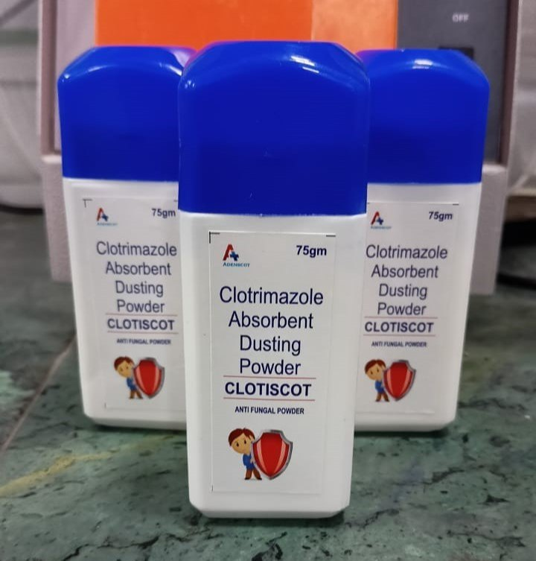

Fig. Dusting powder

**Definition:**

Polyherbal dusting powders are topical formulations composed of a combination of multiple medicinal herbs in powdered form. These powders are typically applied to the skin for various purposes, such as soothing irritation, absorbing excess moisture, providing fragrance, or promoting healing. The selection of herbs in polyherbal dusting powders is often based on their traditional medicinal uses and therapeutic properties, including anti-inflammatory, antimicrobial, antifungal, and soothing effects. Polyherbal dusting powders offer a natural alternative to conventional skincare products and are often preferred for their perceived safety and gentleness on the skin.

**Type of polyherbal dusting powder:**

1. **Antifungal Dusting Powder:**
   * Contains herbs with antifungal properties such as neem, turmeric, and tea tree oil.
   * Used to treat fungal infections like athlete's foot or jock itch.
2. **Anti-itch Dusting Powder:**
   * Formulated with herbs like chamomile, calendula, and lavender.
   * Provides relief from itching associated with skin irritations, insect bites, or rashes.
3. **Anti-inflammatory Dusting Powder:**
   * Contains herbs with anti-inflammatory properties such as aloe vera, turmeric, and licorice root.
   * Helps reduce redness, swelling, and discomfort associated with inflammatory skin conditions like eczema or psoriasis.
4. **Cooling Dusting Powder:**
   * Formulated with cooling herbs like mint, sandalwood, and rose petals.
   * Provides a refreshing sensation and helps soothe hot, irritated skin.
5. **Moisture-absorbing Dusting Powder:**
   * Contains ingredients like cornstarch, arrowroot powder, and oat flour.
   * Absorbs excess moisture, keeping the skin dry and preventing chafing or discomfort.
6. **Wound Healing Dusting Powder:**
   * Formulated with herbs known for their wound healing properties, such as turmeric, aloe vera, and comfrey.
   * Helps promote faster healing and prevent infection in minor cuts, abrasions, or burns.
7. **Anti-odor Dusting Powder:**
   * Contains herbs with antimicrobial properties like neem, tea tree oil, and thyme.
   * Helps control odor-causing bacteria and keeps the skin feeling fresh.
8. **General Skincare Dusting Powder:**
   * Combines a variety of herbs with different skincare benefits, such as neem, tulsi, turmeric, and rose.
   * Offers overall skin nourishment, protection, and maintenance.

These are just a few examples, and there can be numerous other formulations tailored to specific needs or preferences. The choice of herbs and other ingredients depends on factors such as the desired therapeutic effects, skin type, and any existing skin conditions.

Top of Form

**Materials and Methods:**

1. **Selection of Herbs**: Describe the selection criteria and the chosen herbs, including their medicinal properties.
2. **Herb Procurement and Processing**: Detail the process of sourcing, cleaning, drying, and grinding the herbs.
3. **Formulation Development**: Explain how the proportions of each herb were determined and the method used for mixing.
4. **Addition of Base Ingredients**: Specify the base ingredients used and their purpose in the formulation.
5. **Optional Additives**: If applicable, describe any fragrance oils, essential oils, or antimicrobial agents added.
6. **Packaging**: Discuss the packaging materials used and the labeling of the product.

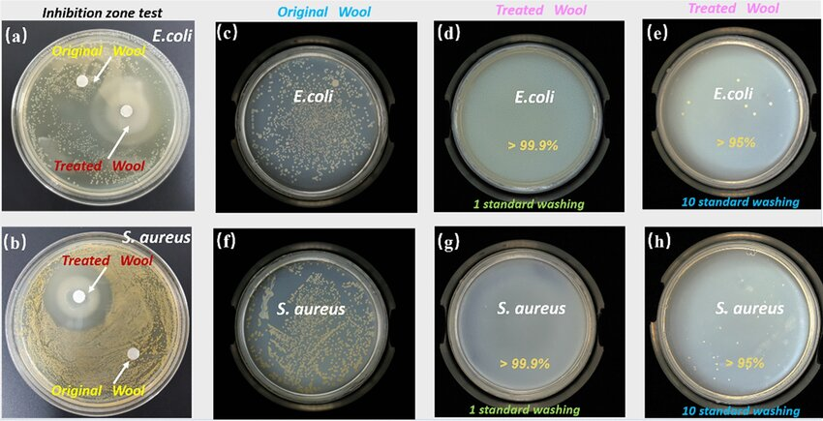

**Ealuation Methods:**

1. **Physicochemical Evaluation**: Detail the tests conducted for particle size distribution, moisture content, pH, and bulk density.
2. **Microbiological Analysis**: Explain the microbial load testing methods used.
3. **Skin Compatibility Testing**: Describe the patch testing procedure and any adverse reactions observed.
4. **Efficacy Testing**: Outline the efficacy studies performed to evaluate the powder's effectiveness in managing skin conditions.
5. **Stability Testing**: Explain the stability testing protocol and the storage conditions tested.

**Advantages:**

1. **Natural Ingredients:** Polyherbal dusting powders typically contain a blend of natural herbs, which are often considered safer and gentler on the skin compared to synthetic ingredients.
2. **Versatility:** They can be formulated for various skin conditions and purposes, such as soothing irritation, absorbing moisture, providing fragrance, or promoting healing.
3. **Customization:** Herbal formulations allow for customization based on individual needs and preferences, with the flexibility to adjust the combination and proportions of herbs.
4. **Therapeutic Properties:** Many herbs used in polyherbal dusting powders possess therapeutic properties such as anti-inflammatory, antimicrobial, antifungal, and soothing effects, offering multi-dimensional benefits for the skin.
5. **Minimal Side Effects:** Due to their natural composition, polyherbal dusting powders generally have fewer side effects and are less likely to cause allergic reactions or skin sensitivities compared to products containing synthetic chemicals.
6. **Non-greasy Feel:** Unlike some creams or ointments, dusting powders typically leave the skin feeling dry and non-greasy, making them suitable for use in hot and humid climates.

**Disadvantages:**

1. **Variable Efficacy:** The effectiveness of polyherbal dusting powders can vary depending on factors such as the quality of ingredients, formulation consistency, and individual skin responses, which may lead to inconsistent results.
2. **Messy Application:** Dusting powders can be messy to apply, especially if not dispensed carefully or if the packaging is not user-friendly, leading to waste and inconvenience.
3. **Limited Targeting:** While polyherbal formulations offer a broad spectrum of benefits, they may not be as targeted or potent as single-ingredient medications or treatments specifically formulated for certain skin conditions.
4. **Storage and Shelf Life:** Herbal products may have shorter shelf lives compared to products with synthetic preservatives, and they may require special storage conditions to maintain their efficacy over time.
5. **Sensitivity Concerns:** Although rare, some individuals may be allergic or sensitive to certain herbal ingredients, leading to adverse reactions such as skin irritation or contact dermatitis.
6. **Regulatory Challenges:** Depending on the jurisdiction, herbal products may face regulatory challenges related to labeling requirements, safety standards, and claims substantiation, which can impact their availability and marketing.

Overall, while polyherbal dusting powders offer many potential benefits, it's essential to consider individual preferences, skin sensitivities, and the quality of the product when choosing and using them. Consulting with a healthcare professional or dermatologist can also provide personalized guidance on skincare products.

**Application of Polyherbal dusting powders:**

1. **Soothing Irritation:** Polyherbal dusting powders containing herbs with anti-inflammatory and soothing properties, such as chamomile, calendula, and aloe vera, can be applied to irritated or inflamed skin to reduce redness, itching, and discomfort. They are often used to alleviate symptoms associated with conditions like eczema, psoriasis, allergic reactions, and sunburn.
2. **Absorbing Excess Moisture:** Dusting powders formulated with absorbent ingredients like cornstarch, arrowroot powder, or oat flour are applied to areas of the body prone to moisture accumulation, such as the underarms, groin, and feet. These powders help absorb sweat and excess moisture, keeping the skin dry, comfortable, and less susceptible to chafing, odors, and fungal infections like athlete's foot or jock itch.
3. **Providing Fragrance:** Some polyherbal dusting powders incorporate fragrant herbs or essential oils to provide a natural, pleasant scent. These powders can be dusted onto the body as a natural alternative to perfumes or scented body powders, imparting a subtle fragrance that lingers throughout the day.
4. **Promoting Healing:** Polyherbal dusting powders containing herbs known for their wound healing properties, such as turmeric, comfrey, and myrrh, can be applied to minor cuts, scrapes, and abrasions to promote faster healing and prevent infection. These powders create a protective barrier over the wound while delivering beneficial compounds that support the skin's natural healing processes.
5. **Controlling Odor:** Dusting powders containing antimicrobial herbs like neem, tea tree oil, or thyme can help control odor-causing bacteria on the skin, particularly in areas prone to perspiration. These powders are often used as a natural deodorant alternative, helping to keep body odor at bay while maintaining skin health.
6. **Nourishing and Conditioning:** Some polyherbal dusting powders incorporate herbs rich in vitamins, minerals, and antioxidants that nourish and condition the skin. These powders can be applied to dry or rough areas of the body, such as elbows, knees, and heels, to moisturize, soften, and improve skin texture over time.

Top of Form

**References :**

1. Textbook of professional pharmacy- N. K. Jain& S. N. Sharma, Vallabh Prakashan, Page no.286- 287

2. Modern dispensing pharmacy by N. K. Jain &G. D. Gupta, IV Edition, page no. 180-196.

3. A Textbook of Pharmaceutical Formulation byB. M. Mittal, page no. 180.

4. Introduction to dosage form by Sukhbir Kaur,Page no. 10-11.

5. Handbook of Pharmaceutical Microbiology,Experiments and Techniques, IIIrd Edition by Chandrakant Kokare. 2.17-2.24

6. Textbook of Pharmaceutics- I as per PCIRegulations by A. A. Hajare and Dr. D. A.Bhagwat, page no. 6.1- 6.14.

7. Systemic approach to practical pharmaceuticsBy Dr. A. K. Seth, page no. 4/231- 4/235.

8. Pharmaceutics I, R.M. Mehta (2015) VallabhPrakashan 6th edition pg. no 3-4

9. https://patents.google.com/patent/EP0182296A2

10. https://en.wikipedia.org/wiki/Talc

11. https://en.wikipedia.org/wiki/Kaolinite

12. https://pubchem.ncbi.nlm.nih.gov/compound/11178

13. https://www.science.gov/topicpages/t/tested+essential+oils

14. https://en.wikipedia.org/wiki/Rose_oil

15. https://en.wikipedia.org/wiki/Almond#Oils

16. https://en.wikipedia.org/wiki/Oil_of_clove

17. Fu, Y., Zu, Y., Chen, L., Shi, X., Wang, Z.,Sun, S., & Efferth, T. (2007).Antimicrobial activity of clove and rosemary essential oils alone and in combination. Phytotherapy research, 21(10), 989-994.

18. Bhattacharya S, Mishra RK. Pressure ulcers: Current understanding and newer modalities of treatment. Indian J Plast Surg. 2015 Jan;48(01):004-16.

19. Edsberg LE, Black JM, Goldberg M, McNichol L, Moore L, Sieggreen M. Revised National Pressure Ulcer Advisory Panel Pressu re Injury Staging System: Revised Pressu re Injury Stagi ng System. J Wound Ostomy Continence Nurs. 2016;43(6):585-97.

20. Benbow M. Pressu re sore guidelines: patient/ca rer involvement and education. Br J Nurs. 1996; Feb 8-21;5(3):182, 184-7.

21. Mehta RM. Dispensing Pharmacy. Edn 1, Vallabh Prakashan, Delhi, 2000, 108.

22. Singh C, Gupta S, Pal Jain A. Phytochemical Screening of Solanum xanthocarpum and Alpinia officinarum Ind ian Medicinal pla nts. Inter national Journal of Emerging Technologies and Innovative Research 2019; 6(6):664-671.

23. Wani MS, Parakh, SR, Dehghan MH, Polshettiwar SA. Herbal medicine and its standardization. Pharmaceutical Reviews 2007; 5(6).

24. Kokate CK, Purohit AP, Gokhale SB. Pharmacognosy. Edn 16, Nirali Prakashan, Pune, 2001, 242-253

25. Chauhan P, Keni K, Patel R. Investigation of phytochemical screening and antimicrobial activity of Curcuma longa. Int J Adv Res Biol Sci. 2017 May 13;4(4):153-63.

26. Akbik D, Gha diri M, Chrzanowski W, Rohaniza deh R. Curcumi n as a wound healing agent. Life Sci. 2014 Oct 22;116(1):1-7

27. Fa d hil AA, Ha m eed NM, Ri d h a ZH, Mah d i OA, Sead FF, Ha m a d DA, Adhab AH. Study on Essential Oils having Antimicrobial Activity Against Staphylococcus aureus and Staphylococcus epidermidis Isolated f rom Oral Cavity Infection. Inter national Journal of Pharmaceutical Quality Assurance. 2022;13(2):178-181.

28. Chundran NK, Husen IR, Rubianti I. Eect of Neem Leaves Extract (Azadirachta indica) on Wound Healing. Amj. 2015;2(2):199 -203.

29. Ikpe V, Eze C, Mbaoji P, Joshua P. Phytochemical analysis and antifungal activity of aloe vera leaves. Bio-Research. 2019 Jul 19;15(1): 974.

30. Saniasiay J, Salim R, Mohamad I, Harun A. Antifungal Eect of Malaysian Aloe vera Leaf Extract on Selected Fungal Species of Pathogenic Otomycosis Species in In-vitro Culture Medium. Oman Med J. 2017 Jan 4;32(1):41-6.

31. Singh Y, Gupta A, Kannojia P. Tagetes erecta (Marigold) – A review on its phytochemical and medicinal proper ties. CMDR. 2020 Aug 20;4(01):1-6

32. Shetty LJ, Sakr FM, Obaidy KA, Patel MJ, Shareef H. A brief review on medicinal plant Tagetes erecta Linn. J App Pharm Sci, 2015; 5 (3): 091-095. Available online at htt p://www.japsonline.com DOI: 10.7324/JAPS.

33. Khandelwal.K. Practical Phar macognosy. Pragati Books Pvt. Ltd.,2008.

34. Harborne JB. Textbook of Phytochemical Methods. A Guide to Modern Techniques of Plant Analysis. London: Chapman and Hall Ltd; 1998.

35. Aulton ME, Taylor K. Aulton’s pharmaceutics: the design and manufact ure of medicines. Elsevier Health Sciences; 2013.

36. Lachman L , Lieberman HA, Kanig JL. The Theory and Practice of Industrial Phar macy, Varghese publishing house. Vol. 67. Bombay; 1991.

37. Patel AM, Kurbetti SM, Savadi RV, Raje V N, Takale VV. Formulation and Evaluation of New Polyherbal Formulat ions for Their Wound Healing Activity in Rat. International Journal of Pharmaceutical Research & Allied Sciences. 2(2):66–9.

38. Dash GK, Murthy PN. Studies on Wound Healing Activity of Heliotropium indicum Linn. Leaves on Rats. ISRN Pharmacology. 2011 Apr 12;2011:1-8.

39. Dorsett-Martin WA. Rat models of skin wound healing: a review. Wound Repair Regen. 2004;12(6):591-9.

40. Nasir MA, Mahammed NL, Roshan S, Ahmed MW. Wound healing activity of polyherbal formulation in albino rats using excision wound model, incision wound model, dead space wound model and burn wound model. International Journal of Research and Development in Pharmacy & Life Sciences. 2016;5(2):2080–7.

41. Orešč a n I n V. Treat m e nt of press u r e ulce r s with Bi oap I t® wo u nd healing herbal ointment-a preliminary study. IJRDO-Journal of biological science. 2016 Oct.31; 2(10):1–15. Available from: <https://www.ijrdo.org/index.php/bs/article/view/166325>. Talekar YP, Apte KG, Paygude SV, Tondare PR, Parab PB. Studies on wound healing potential of polyherbal formulation using in vitro and in-vivo assays. J Ayurveda Integr Med. 2017;8(2):73-81.

42. Noori, HJ, Jasim, SY, Abbass, WAK. Evaluation of Curcumin Eect on Wound Healing in Rat Model. International Journal of Drug Delivery Technology. 2022;12(3):1208-1218

Wound Healing Potential of Polyherbal Dusting PowderIJDDT, Volume 13 Issue 4, October – December 2023 Page 133516. Khandelwal.K. Practical Phar macognosy. Pragati Books Pvt. Ltd.,200orne JB. Textbook of Phytochemical Methods. A Guide to Modern Techniques of Plant Analysis. London: Chapman and Hall Ltd; 1998.18. Aulton ME, Taylor K. Aulton’s pharmaceutics: the design and manufact ure of medicines. Elsevier Health Sciences; 2013.19. Lachman L , Lieberman HA, Kanig JL. The Theory and Practice of Industrial Phar macy, Varghese publishing house. Vol. 67. Bombay; 1991.20. Patel AM, Kurbetti SM, Savadi RV, Raje V N, Takale VV. Formulation and Evaluation of New Polyherbal Formulat ions for Their Wound Healing Activity in Rat. International Journal of Pharmaceutical Research & Allied Sciences. 2(2):66–9.21. Dash GK, Murthy PN. Studies on Wound Healing Activity of Heliotropium indicum Linn. Leaves on Rats. ISRN Pharmacology. 2011 Apr 12;2011:1-8.22. Dorsett-Martin WA. Rat models of skin wound healing: a review. Wound Repair Regen. 2004;12(6):591-9.23. Nasir MA, Mahammed NL, Roshan S, Ahmed MW. Wound healing activity of polyherbal formulation in albino rats using excision wound model, incision wound model, dead space wound model and burn wound model. International Journal of Research and Development in Pharmacy & Life Sciences. 2016;5(2):2080–7.24. Orešč a n I n V. Treat m e nt of press u r e ulce r s with Bi oap I t® wo u nd healing herbal ointment-a preliminary study. IJRDO-Journal of biological science. 2016bedsores.

REFERENCES

1. Bhattacharya S, Mishra RK. Pressure ulcers: Current

understanding and newer modalities of treatment. Indian J Plast

Surg. 2015 Jan;48(01):004-16.

2. Edsberg LE, Black JM, Goldberg M, McNichol L, Moore L,

Sieggreen M. Revised National Pressure Ulcer Advisory Panel

Pressu re Injury Staging System: Revised Pressu re Injury Stagi ng

System. J Wound Ostomy Continence Nurs. 2016;43(6):585-97.

3. Benbow M. Pressu re sore guidelines: patient/ca rer involvement

and education. Br J Nurs. 1996; Feb 8-21;5(3):182, 184-7.

4. Mehta RM. Dispensing Pharmacy. Edn 1, Vallabh Prakashan,

Delhi, 2000, 108.

5. Singh C, Gupta S, Pal Jain A. Phytochemical Screening

of Solanum xanthocarpum and Alpinia officinarum Ind ian

Medicinal pla nts. Inter national Journal of Emerging Technologies

and Innovative Research 2019; 6(6):664-671.

6. Wani MS, Parakh, SR, Dehghan MH, Polshettiwar SA. Herbal

medicine and its standardization. Pharmaceutical Reviews

2007; 5(6).

7. Kokate CK, Purohit AP, Gokhale SB. Pharmacognosy. Edn 16,

Nirali Prakashan, Pune, 2001, 242-253

8. Chauhan P, Keni K, Patel R. Investigation of phytochemical

screening and antimicrobial activity of Curcuma longa. Int J

Adv Res Biol Sci. 2017 May 13;4(4):153-63.

9. Akbik D, Gha diri M, Chrzanowski W, Rohaniza deh R. Curcumi n

as a wound healing agent. Life Sci. 2014 Oct 22;116(1):1-7

10. Fa d hil AA, Ha m eed NM, Ri d h a ZH, Mah d i OA, Sead FF, Ha m a d

DA, Adhab AH. Study on Essential Oils having Antimicrobial

Activity Against Staphylococcus aureus and Staphylococcus

epidermidis Isolated f rom Oral Cavity Infection. Inter national

Journal of Pharmaceutical Quality Assurance. 2022;13(2):178-

181.

11. Chundran NK, Husen IR, Rubianti I. Eect of Neem Leaves

Extract (Azadirachta indica) on Wound Healing. amj.

2015;2(2):199 -203.

12. Ikpe V, Eze C, Mbaoji P, Joshua P. Phytochemical analysis and

antifungal activity of aloe vera leaves. Bio-Research. 2019 Jul

19;15(1): 974.

13. Saniasiay J, Salim R, Mohamad I, Harun A. Antifungal Eect

of Malaysian Aloe vera Leaf Extract on Selected Fungal Species

of Pathogenic Otomycosis Species in In-vitro Culture Medium.

Oman Med J. 2017 Jan 4;32(1):41-6.

14. Singh Y, Gupta A, Kannojia P. Tagetes erecta (Marigold) - A

review on its phytochemical and medicinal proper ties. CMDR.

2020 Aug 20;4(01):1-6

15. Shetty LJ, Sakr FM, Obaidy KA, Patel MJ, Shareef H. A brief

review on medicinal plant Tagetes erecta Linn. J App Pharm Sci,

2015; 5 (3): 091-095. Available online at htt p://www.japsonline.

com DOI: 10.