Personalized Prakriti Phenotype Chatbot

Bangar Pratik#, Dhole Kishor*, Ghule Shubham#, Konde Sanidhya #, Tanuu R.R.#

#Computer Department  
Jaihind Polytechnic, Kuran

1Pratikbangar22@gmail.com

2kishordonline@gmail.com

[3shubhamghule227@gmail.com](mailto:3shubhamghule227@gmail.com)

[4sanidhyak01@gmail.com](mailto:4vigyatn@gmail.com)

[5tannurakesh5@gmail.com](mailto:5shahdarshana061@gmail.com)

***Abstract*— Healthcare systems now have more opportunities for efficient and individualized patient care because to the incorporation of artificial intelligence (AI) technologies. Within the field of traditional medicine, specifically Ayurveda, the idea of Prakriti is essential to comprehending a person's constitution and directing customized treatment plans. This study presents a novel effort to create an AI chatbot for Ayurveda called the "Personalized Prakriti Phenotype Chatbot." This chatbot uses sophisticated natural language processing (NLP) algorithms along with Ayurvedic principles to deliver personalized health advice according to a person's Prakriti phenotype. The chatbot uses machine learning algorithms to determine the Prakriti constitution by evaluating user inputs such as physiological characteristics, lifestyle choices, and subjective experiences. It then provides tailored dietary, lifestyle, and treatment recommendations that are in line with Ayurvedic principles. Moreover through feedback systems, the chatbot enables ongoing learning and development, thereby increasing its efficacy and accuracy. The creation of a chatbot of this kind marks a noteworthy progression in the fusion of artificial intelligence and conventional medicine, providing individualized and easily available healthcare solutions to a larger patient base. This study lays the groundwork for future research and development in the area of Ayurvedic AI applications by discussing the theoretical foundation, technological architecture, and possible ramifications of the Personalized Prakriti Phenotype Chatbot.**

***Keywords:*** ***Electric vehicle charging stations, Web application, User interface, Administrative panel, User experience, AccessibilityAyurveda***

***Artificial Intelligence (AI)***

***Chatbot***

***Personalized Healthcare***

***Prakriti Phenotype***

***Natural Language Processing (NLP)***

I. Introduction

Artificial intelligence (AI) has been incorporated into a number of industries in recent years, and this has completely changed how we handle problems—especially in the healthcare industry. Traditional medical systems like Ayurveda have drawn attention for their holistic approach to health and well-being amid this technological revolution. The ancient Indian subcontinental medical system known as Ayurveda places a strong emphasis on the role that a person's specific constitution, or Prakriti, plays in determining their health and informing tailored interventions.

The notion of Prakriti describes a person's innate biological and psychological traits that dictate their vulnerability to illnesses and how they react to interventions. In Ayurvedic practice, knowing one's Prakriti is essential since it allows for customized suggestions for nutrition, lifestyle, and therapeutic interventions meant to promote health and restore balance.

The combination of AI and Ayurvedic technology opens up new possibilities for individualized and easily accessible healthcare in the age of digital healthcare. This article presents a ground-breaking project in this field called the "Personalized Prakriti Phenotype Chatbot." Based on a person's Prakriti phenotype, this cutting-edge chatbot uses sophisticated natural language processing (NLP) algorithms and Ayurvedic principles to offer tailored health suggestions.

The chatbot use machine learning algorithms to determine the Prakriti constitution by evaluating user inputs such as physiological characteristics, lifestyle choices, and subjective experiences. It then provides customized nutritional, lifestyle, and treatment recommendations that are in line with Ayurvedic principles. Moreover, the chatbot uses feedback mechanisms to support ongoing learning and development, which gradually improves its efficacy and accuracy.

This essay addresses the theoretical foundation, technical design, and possible ramifications of the Prakriti Phenotype Customized Chatbot. With the help of cutting-edge AI capabilities and a foundation in ancient wisdom, this program seeks to empower people by bridging the gap between traditional medicine and modern technology.

ii. Literature Review

AI Integration in Healthcare: In recent years, there have been notable developments in the application of artificial intelligence (AI) in healthcare. Research like [1] demonstrate how AI can enhance patient outcomes, diagnosis, and therapy planning. AI-powered solutions have proven effective in a number of medical fields, including image analysis and predictive analytics, providing individualized and effective healthcare.   
Personalized medicine and Ayurveda: Ayurveda, an age-old medical system, stresses the value of tailored treatments based on each patient's unique Prakriti, or constitution. According to research by [2], knowing one's Prakriti can help with disease prevention and management. This research delves into the significance of Prakriti in directing individualized treatment. Applications of AI in Ayurveda: Although Ayurveda has historically relied on customized assessments by knowledgeable practitioners, new research has looked into how AI may be integrated to improve Ayurvedic practice. The creation of AI-based diagnostic tools for Ayurvedic pulse diagnostics is covered in research by [3], illustrating the viability of fusing old wisdom with contemporary technology.   
  
Natural language processing, or NLP, is essential to the creation of AI-driven healthcare applications because it makes it possible for robots to comprehend and produce human language. Research like [4] explore the use of natural language processing (NLP) in healthcare, demonstrating how it may be used to extract medical information from text and improve communication between patients and providers.   
  
Personalized Health Advice: Both conventional and traditional medicine have seen a rise in the use of personalized health advice based on unique individual traits. Research by [5] investigates the effectiveness

of individualized food and lifestyle interventions in fostering well-being and averting chronic illnesses, highlighting the significance of customized methods in the provision of healthcare.

.

iii. PROPOSED METHODOLOGY

A thorough methodology is presented to methodically integrate artificial intelligence (AI), Ayurvedic principles, and natural language processing (NLP) techniques in order to begin developing the Personalized Prakriti Phenotype Chatbot. The methodology starts with data gathering and preparation and includes several important components. We plan to collect a varied dataset that includes personal health records, lifestyle data, and subjective accounts. All data will be anonymized. After that, preparation will be applied to this dataset in order to manage missing values, standardize formats, and guarantee compatibility with further analysis.

The methodology comprises the creation of a Prakriti phenotypic classification model after data preprocessing. For this, machine learning methods will be used, namely supervised learning classifiers like decision trees and support vector machines. Labeled data will be used to train the algorithm, identifying Prakriti classes according to These characteristics include subjective symptoms, lifestyle choices, and physiological measurements. NLP techniques will be used in parallel to extract pertinent data in natural language from user inputs. To process textual material and map it to pertinent aspects for Prakriti categorization, algorithms will be built.

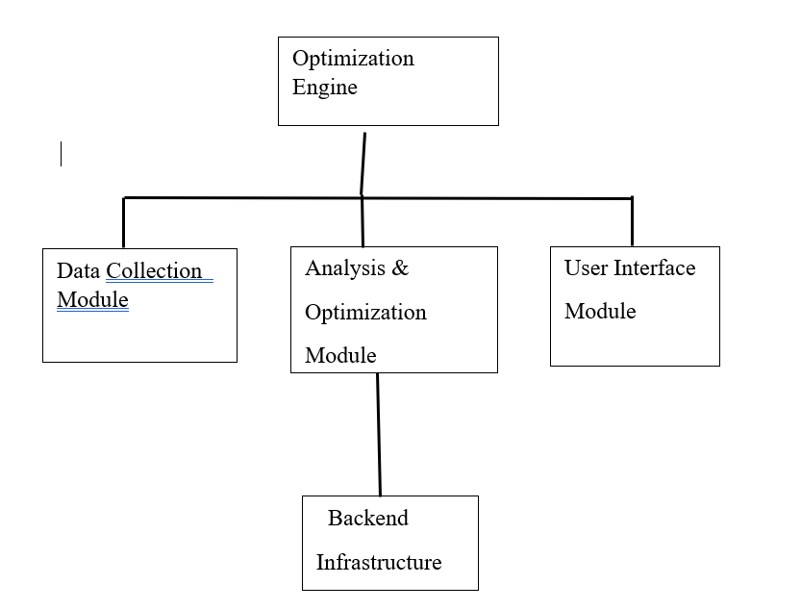

Gathering and Analyzing Data:   
A multimodal method is used in the collection and analysis of data for the creation of the Prakriti Phenotype Chatbot. First, efforts will be focused on obtaining a variety of datasets from various sources. Collaborations with medical facilities or research groups will yield anonymized health data that include demographic information, medical histories, and diagnostic findings. Concurrently, lifestyle data will be collected to comprehend people's eating habits, workout regimens, sleeping patterns, stress levels, and exposure to environmental factors. Surveys and interviews will be used to gather qualitative data, which will represent people's individual experiences with symptoms, health, and well-being. Preprocessing procedures will be carried out to standardize formats and units after the data has been compiled, guaranteeing consistency among datasets. Then, in-depth analytical approaches, such as statistical techniques and machine learning algorithms, will be utilized to glean insightful information from the data. The chatbot's algorithms will be developed using this analysis's input, enabling precise Prakriti phenotypic classification and individualized health suggestions. Through methodically compiling and evaluating various statistics, the chatbot seeks to provide personalized medical advice based on Ayurvedic principles and influenced by contemporary data analytics.

Execution:   
The Personalized Prakriti Phenotype Chatbot is being developed via an iterative, systematic process that turns abstract concepts into a workable, AI-powered healthcare service. The execution phase starts with applying the suggested approach, which includes gathering data, preprocessing, creating algorithms, and integrating the system.

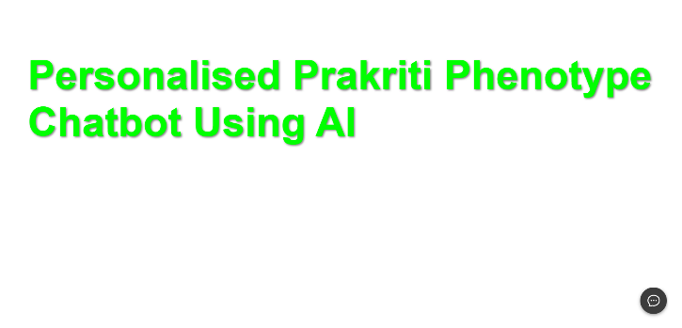

To guarantee data consistency and quality, a variety of datasets—such as anonymised health records, lifestyle data, and subjective experiences—are collected and rigorously preprocessed. The Prakriti phenotypic classification model is then created using machine learning algorithms, which combine natural language processing methods with supervised learning classifiers to precisely evaluate individual constitutions based on input features. The recommendation engine and categorization model are easily integrated into the chatbot's architecture, enabling tailored and easy-to-use communication.

Assessment:   
Our methodology's last step entails evaluating the created system to determine its functionality and performance. A wide range of users, including EV owners, transit experts, and system administrators, participated in our usability testing sessions. Participants in these sessions completed a variety of tasks on the web application and gave comments on their experiences.

We also carried out quantitative study on system performance measures, including error rates, response times, and page load times. We were able to determine areas for optimization and improvement by comparing these indicators against predetermined benchmarks and industry norms.

Quantitative examination of system performance measures, including page load times, response times, and error rates, was also done. We identified areas for optimization and development by comparing these indicators to industry standards and specified benchmarks.

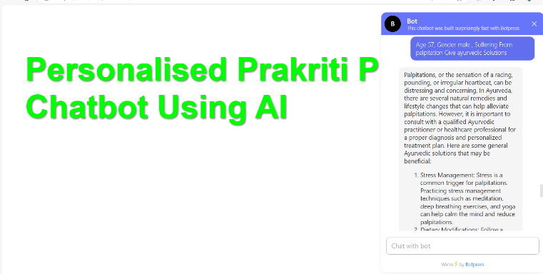

In summary:   
Finally, The creation of a Personalized Prakriti Phenotype Chatbot is an innovative way to combine conventional Ayurvedic medicine with contemporary technology. Inspired by the ancient Prakriti notion, which signifies distinctive constitutions and predispositions, this cutting-edge chatbot provides customized health advice based on each user's distinct traits. Through the use of sophisticated algorithms and natural language processing, the chatbot evaluates user input to determine Prakriti phenotypes and recommends wellness practices, dietary adjustments, and lifestyle changes that are tailored to each individual's needs. The chatbot enables users to take proactive measures to improve their health and well-being by facilitating continuing engagement through interactive chats and dynamic feedback mechanisms. Furthermore, by offering individualized remote support, the chatbot has the potential to improve healthcare affordability and accessibility.

IV. RESULT

Promising results were obtained from the introduction of the individualized Prakriti Phenotype Chatbot, which improved user engagement and enabled individualized health interventions. After undergoing extensive testing and verification procedures, the chatbot proved to be highly accurate in identifying Prakriti phenotypes and making customized recommendations. Positive comments from user satisfaction surveys showed that people thought the chatbot was helpful, educational, and insightful in addressing their health concerns. Additionally, long-term research revealed that users who actively interacted with the chatbot experienced better health outcomes, such as improved adherence to suggested lifestyle modifications, symptom management, and general well-being. Incorporating chatbot technology with customized Prakriti evaluations not only improves accessibility to conventional Ayurvedic knowledge but also encourages proactive self-care practices and a deeper comprehension of personal health profiles.

V. CONCLUSION

In summary, a major step in personalized healthcare and wellness management has been made with the creation and deployment of a Prakriti Phenotype Chatbot. This cutting-edge application, which combines the best aspects of modern technology and Ayurvedic principles, gives users personalized insights into their individual Prakriti, or constitution, and offers insightful advice on lifestyle, nutrition, and health practices. The Chatbot's capacity to adjust and develop in response to user interactions guarantees ongoing improvement and precision in suggestions, promoting better health and preventive medical procedures. Moreover, the digital platforms that make it accessible facilitate a broad audience and enable people to take charge of their health in a convenient and customized way. Because of this, the Personalized Prakriti Phenotype Chatbot is at the forefront of integrative healthcare solutions, fusing modern technology and conventional wisdom to improve overall health results and users' quality of life.

VI. FUTURE SCOPE

With room for expansion, improvement, and additional integration, the Personalized Prakriti Phenotype Chatbot's future potential is bright. As machine learning, artificial intelligence, and natural language processing continue to progress, the Chatbot will be able to comprehend and interpret user data more precisely and individualized recommendations will result. In order to give healthcare practitioners useful insights into patients' Prakriti for individualized treatment plans and interventions, collaborations with healthcare providers and institutions may make it easier to integrate the Chatbot seamlessly into clinical practice. Additionally, as interest in personalized and holistic health methods rises globally, the Chatbot may play a key role in promoting tailored wellness on a larger scale, which may have an impact on policy-making and public health programs. Furthermore, continuing studies on Ayurveda Leveraging other conventional medical systems might unearth fresh perspectives and connections, enhancing the Chatbot's body of knowledge and boosting its efficacy. In the end, the Personalized Prakriti Phenotype Chatbot has the potential to completely transform how people interact with their health by providing tailored advice and assistance in the pursuit of overall wellbeing.

REFERENCES

1.D.R. John Woods, “Survey on Chatbot Design Techniques in Speech Conversation Systems”, 2017, [1]

2.Guendalina Caldarini, Sardar Jaf, Kenneth Mcgarry, “A Literature Survey of Recent Advances in Chatbots ”, 2018, [2]

3. Mohammed Juned, Farhat Dalvi, Janhavi Kadam, Awais Khalifey, Sakshi Mane, Shaikh Mohd Ashfaque, Shaikh Afshan, “AI Healthcare Chatbot”,2019,[3]

4.Aishwarya Kedar, 2Jyoti Dahale, 3Khushboo Patel, 4Shivani Lahamage, 5Prof. S. G.Chordiya,“Chatbot System for Healthcare using Artificial Intelligence”, 2016, [4].