HARMONY AS AN AESTHETIC APPROACH FOR MEDITATION CENTERS

1Gaurav mishra, 2Ar. Arjun Sharma

1Undergraduate student,

12School of Architecture,

12IPS Academy, 452012, Indore, Madhya Pradesh

Abstract: In recent years, meditation centres have become increasingly popular among individuals seeking solace, tranquillity, and respite from the pressures of contemporary life. This research paper seeks to explore the significance of harmony as an aesthetic approach in designing and organizing meditation centres, with the aim of enhancing the overall meditative experience for practitioners. By conducting an interdisciplinary examination of architecture, interior design, and psychological well-being, this study aims to investigate the role of harmonious aesthetics in facilitating a more effective and fulfilling meditation experience.

The study emphasizes the importance of harmonious aesthetics in shaping the design of meditation centres. The pursuit of visual appeal extends beyond mere aesthetics to encompass a multisensory experience that evokes a sense of calmness and promotes mindfulness. The interplay of colours, textures, and spatial arrangements come together to create a serene atmosphere that guides practitioners on a journey inward. The paper underscores the significance of interior design in fostering harmony in meditation centres. Interior spaces that incorporate calming colour palettes, natural materials, and minimalist aesthetics create an environment that is conducive to meditation. Researchers examine the psychological impact of these design choices on practitioners, exploring how a harmonious interior can facilitate a deeper sense of mindfulness and focus during meditation sessions.

Furthermore, the study analyses case studies of existing meditation centres that are renowned for their aesthetic excellence. By identifying commonalities in their design philosophies and best practices, the paper aims to inform architects, designers, and meditation practitioners alike. The goal is to foster a deeper understanding of the role of intentional aesthetics in enhancing the meditative journey and contributing to holistic well-being.

In conclusion, this research paper emphasizes the significance of harmony as a key aesthetic principle in meditation centre design. By focusing on harmonious aesthetics, architects, designers, and meditation practitioners can create an environment that promotes inner peace, mindfulness, and overall well-being. The findings of this study contribute to the evolving discourse on meditation centre design and have practical implications for those involved in the design and construction of such spaces.

Keywords- harmonious aesthetics, design of meditation centres, multisensory experience, harmony principle

1. INTRODUCTION

In today's fast-paced and often chaotic world, many individuals are seeking inner peace and well-being through mindfulness practices, with meditation being one of the most powerful means to achieve serenity and balance. However, the design and ambiance of meditation centers play a pivotal role in shaping the meditative experience, influencing the depth of contemplation and the ability to disconnect from the external tumult. This has led to an exploration of the aesthetic dimension within the context of meditation centers, with a specific focus on the concept of harmony.

As the demand for purposefully designed meditation spaces grows, it becomes imperative to understand the holistic impact of aesthetics on the meditative process. Drawing insights from diverse disciplines such as architecture, psychology, and philosophy, this research aims to shed light on the nuanced relationship between the physical environment and the psychological well-being of meditation practitioners. Through an analysis of existing meditation centers celebrated for their aesthetic excellence and a consideration of psychological implications, this study endeavors to provide a comprehensive understanding of how harmony in design enhances the meditative journey.

Harmony, as an aesthetic approach, transcends mere visual appeal and extends into the realm of creating an environment that resonates with the principles of balance, proportion, and unity. This paper seeks to unravel the intricate interplay between harmonious aesthetics and the efficacy of meditation, examining how intentional design choices contribute to a conducive atmosphere for introspection and mindfulness. The notion of harmony goes beyond the superficial; it becomes a guiding principle that influences the spatial configuration, architectural elements, and sensory experiences within meditation centers.

The principle of harmony in architecture plays a crucial role in the design and functionality of a meditation center. By incorporating harmony into the architectural elements, the space can enhance the overall meditative experience for practitioners.

Firstly, the use of balanced and symmetrical design elements in a meditation center can promote a sense of tranquility and balance. Symmetry in the layout and placement of features such as doors, windows, and meditation spaces creates a harmonious visual experience. This balanced arrangement helps to minimize distractions, allowing individuals to focus their attention inward during their practice.

Additionally, the choice of materials and colors is fundamental in creating a harmonious atmosphere. Natural materials, soft colors, and a minimalist approach contribute to a serene and calming environment. These elements are carefully selected to evoke a sense of connection with nature and simplicity, fostering a peaceful and harmonious ambiance conducive to meditation. Incorporating the principles of harmony also extends to the spatial layout. Well-thought-out circulation paths, the strategic placement of meditation areas, and the integration of green spaces can enhance the flow and coherence of the center. This facilitates a smooth transition between various spaces and activities within the meditation center, creating a seamless and unified experience for practitioners. Furthermore, the acoustics of a meditation center play a pivotal role in promoting harmony. Carefully designed soundscapes, such as the use of natural sounds or soothing music, can enhance the meditative experience. Attention to acoustics helps create a peaceful environment that minimizes external disturbances, allowing individuals to immerse themselves fully in their meditation practice. In addressing this intersection of aesthetics and meditation, the research aspires to contribute valuable insights to architects, designers, and the broader community interested in fostering environments that facilitate not only meditation but also holistic well-being in an increasingly frenetic world. Through a focused exploration of harmony as an aesthetic approach, this paper sets the stage for an in-depth investigation into the transformative potential of intentional design in the realm of meditation centers, thereby providing a foundation for future research and practice.

In conclusion, the application of the harmony architecture principle in a meditation center is essential for creating an environment that supports and enhances the meditative experience. From balanced and symmetrical design elements to the careful selection of materials and colors, every aspect of the architecture contributes to a harmonious and tranquil atmosphere. These considerations collectively create a space that encourages mindfulness, introspection, and inner peace for those seeking solace in their meditation practice.

1. Need for meditation centres

Meditation is losing focus and bringing it back to a point again and again. It is about re-centring and bringing them back to a starting point. It is a flow of wandering, and each time coming home to where you started.

The benefits of this are many, like learning to observe thoughts with a detached approach, slowing the pace of our inside chattering, and stretching the mind-muscle to translate this practice into our daily lives, to mention a few. Ultimately this practise of Meditation helps us beat stress, build willpower and have a stronger focus.

Meditation has many approaches and India as a country has seen many Masters share its beauty and depth. In recent years, with a growing interest in Mental Health, there is a bigger need than ever to heal our internal environment through meditation so that it can benefit our external life too.

n our fast-paced, modern world, finding moments of tranquility and mindfulness has become increasingly essential for our overall well-being. This article explores the profound impact that meditation can have on our lives and how meditation centers serve as sanctuaries of serenity and self-discovery. We will delve into the significance of meditation in contemporary society and provide a glimpse of the numerous benefits that await those who embark on the path of meditation within the nurturing embrace of a meditation center.

Meditation centers are sacred spaces designed to facilitate and elevate the practice of meditation. They offer an environment where individuals can learn, explore, and deepen their meditation practice. Throughout this article, we will provide a glimpse of thebenefits that await those who practice in a dedicated a meditation center. From enhanced mental clarity to improved physical health and a sense of community, meditation centers hold the promise of a more balanced and harmonious life. Join us on this journey to discover how meditation centers can be your path to mindfulness and relaxation in the modern age.

1. Harmonious environment in meditation centres

2.1 Harmony of the Built-up Structures with the Natural environment:

This principle proposes that a therapeutic rehabilitation center project aims to blend with its surroundings to create a sense of peace and relaxation. Nature is a strong aspect to the master plan, and the design should attempt to bring the natural environment inside the patients that occupy the healthcare facility as manifested in the design of Rehabilitation Centre.

2.2 Environmental harmony:

Beautiful and harmonious works of art gives us pleasure and makes us feel good with their appearance. Similarly, beautiful and harmonious musical compositions give us a feeling of relaxation and make us feel good. In visual art, the harmony between colours is important because it indicates in an impression of harmony. What does harmony mean in context of space? To understand the harmony in space context first we must understand the visual structure of it. Although we use vision as a main sense of perceiving the environment, the other senses also contribute to gain the information.

2.2.1 Visual elements of the place:

The simplest way of presenting the complexity of our real world is through Euclidian geometry. We should use the elements or the combination of them, as separated ones or as part of other elements. For analyse purposes we should understand the attribute of each basic element before we know how they interact and effect different variables and their spatial organization that has produced that particular pattern. In summary, basic elements are the basic mass space elements of visual expression. Basic elements can be seen in relation to light, colour, time and movement. We see them in many ways. There are however, a limited but fundamental number of ways of varying them. Variables such as: number, position, direction, orientation, size, shape, interval, texture, density, colour, time, light, visual force, visual inertia, determine the overall visual effect, whether it is harmonious or not.

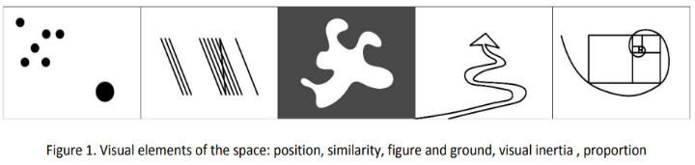

Figure 1. visual elements of space: position, similarity, figure and ground, visual inertia, proportion

2.1.2 Perception:

Perception as interpretation of sensory information is composed from knowledge, learning, memory, expectations and attention of the observer that is why the interpretation is very personal and it depends from the sense of perception (Figure 2).

Perception sometimes referred as ‘cognition’ concerns more than just seeing or sensing the urban environment. According to Ittelson “it refers to more complex processing or understanding of stimuli”

Figure 2. perception

2.1.3 Emotion and experience:

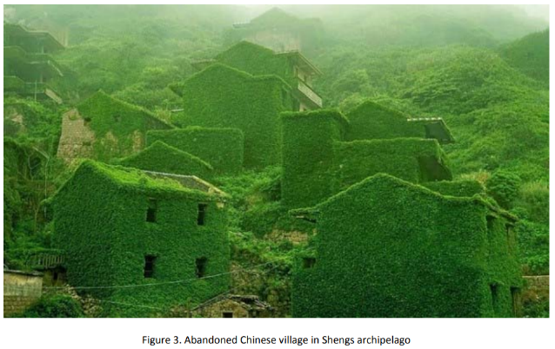Since the human being is genetically programed to live in a natural habitat it is obvious that the presence of elements of nature makes the environment harmonious. The more nature presence in sites or buildings the more harmonious environment. But what can we say about an environment when natural and human experiences are interlocked in such way that gives an interfering (mixed) feeling.

Figure 3. Abandoned Chinese village in Shengs Archipelago

A fishing village on Gouqi (Figure 3) is a case of this impression. It is an example that shows us how man is used to develop the natural world into settlements, but in this case we see how nature decides to take it back. This case gives an impression of something between sublime and morbid

1. Empathy and transcendental meditation as analogy of harmony:

“A human being is a part of a whole, called by us ‘universe’, a part limited in time and space. We experience ourselves, our thoughts and feelings as something separated from the rest…a kind of optical delusion of our consciousness. This delusion is a kind of prison for us, restricting us to our personal desires and to affection for the few persons nearest to us. Our task is to be free ourselves from this prison by widening our circle of compassion to embrace all living creatures and the whole of nature in its beauty.”

-Albert Einstein.

Einstein discussed empathy, describing it as a process that creates a connection between people and involves perceiving without bias. Empathy involves understanding a person's emotional state and responding in a way that provides complete support and develops mutual trust. Similarly, when dealing with a building or site, we should intuitively perceive its inner state and give it our full attention and expertise.

The practice of transcendental meditation involves the use of sound (mantra) in order to create vibrations that align the individual with nature and the way of life. By collaborating with the universal mind, as per the concepts of transcendental meditation, it is believed that universal harmony can be achieved. This is accomplished through a combination of spirituality and physics, absolute and relative, meditation and physical activities. As a result, a sense of perception is developed that leads to complete harmony. The objectives of transcendental meditation, as both a science of being and an art of life, can be used as an analogy to understand and experience environmental harmony.

4. Role of Harmony in building aesthetics:

Harmonious aesthetics play a crucial part in creating tranquil, balanced, and spiritually nurturing environments in architecture. This is particularly evident in the design and construction of meditation centers, where the integration of harmonious aesthetics goes beyond the visual appeal and deeply influences the mental and emotional states of individuals seeking solace and introspection.

Meditation centers provide spaces that are dedicated to offering individuals with a peaceful and conducive environment for contemplation, mindfulness, and spiritual growth. The use of harmonious aesthetics in these spaces helps to enhance the overall experience and effectiveness of meditation practices. One vital aspect is the consideration of architectural elements such as form, proportion, and materials, which collectively contribute to a sense of balance and unity.

4.1 Development of form and shape

In meditation centers, the form guided by harmonious aesthetics often embraces simplicity and symmetry. Clean lines, uncluttered spaces, and a sense of openness are prevalent to eliminate distractions and create a calm atmosphere. The architectural layout is meticulously planned to guide the flow of energy within the space, allowing individuals to navigate through mediation sessions with ease.

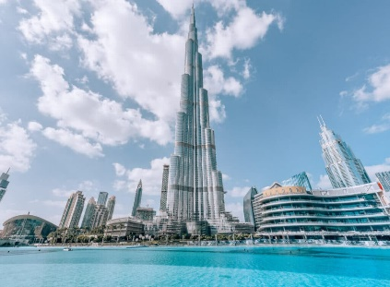 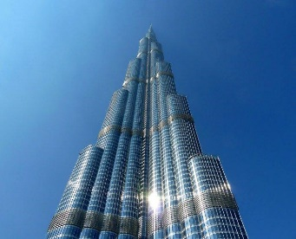

Figure 4; 5 Symmetry in elevation; simplicity in façade

4.2 Play with proportions

Proportion plays a crucial role in harmonious aesthetics as it governs the relationships between different elements in the design. Well-proportioned spaces and structures promote a sense of equilibrium and coherence in meditation centers. The careful arrangement of meditation halls, courtyards, and ancillary spaces reflects an understanding of the human scale, ensuring that the architecture harmonizes with the natural proportions of the human body and psyche.

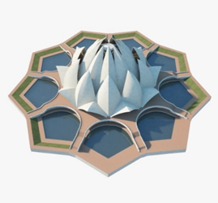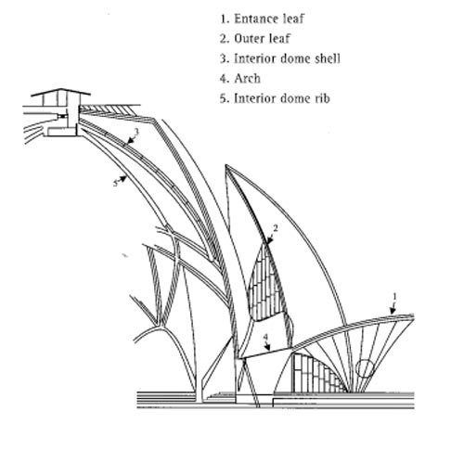

Figure 6; 7 lotus temple complex ; dome structure

4.3 Selection of materials

Materials selected for construction also contribute significantly to the harmonious aesthetics of meditation centers. Natural and sustainable materials such as wood, stone, and bamboo are often preferred for their organic textures and calming qualities. These materials not only create a visually pleasing environment but also establish a connection with nature, fostering a sense of groundedness and tranquility.

4.4 Colour coordination

The color palette choices in harmonious aesthetics are purposefully subdued in meditation centers. Soft, earthy tones and neutrals dominate the color scheme, evoking a sense of serenity and simplicity. The careful use of color extends to interior spaces, where muted hues on walls and furnishings contribute to a soothing ambiance conducive to deep introspection.

5.5 Acoustically harmonious

Beyond the visual aspects, the integration of harmonious aesthetics extends to the acoustic environment of meditation centers. Thoughtful design considerations, such as the strategic placement of sound-absorbing materials and the incorporation of natural elements like water features or wind chimes, contribute to a tranquil soundscape. This acoustic harmony enhances the meditative experience, minimizing external disturbances and allowing individuals to immerse themselves fully in their practice.

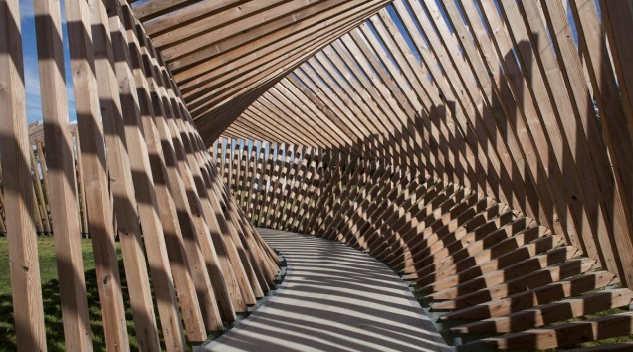

Figure 8. integration of harmonious aesthetics

6. Harmony in landscape architecture

The landscape surrounding meditation centers is not overlooked in the application of harmonious aesthetics. Outdoor spaces are often designed with contemplative gardens, walking paths, and reflective ponds. The natural elements, including carefully chosen vegetation and hardscape materials, contribute to a seamless integration with the architectural design, creating a holistic and harmonious environment that encourages a connection with surrounding nature.

In conclusion, the application of harmonious aesthetics in architecture significantly affects the design and functionality of meditation centers. Architects create spaces that go beyond the visual realm by focusing on simplicity, proportion, materials, color, and sound, influencing the mental and emotional well-being of individuals engaged in meditative practices. These harmonious environments serve not only as physical structures but also as integral components in the spiritual journey of those seeking solace and inner peace.

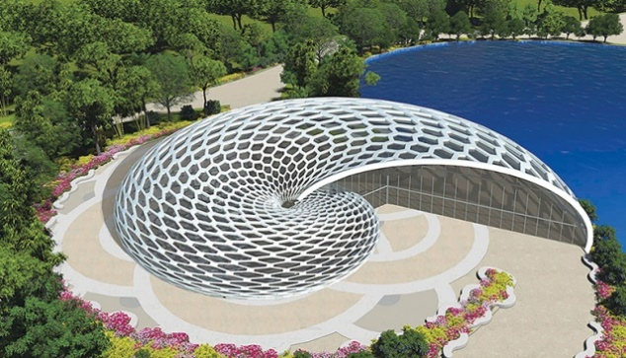

Figure 9: connection with surrounding nature

1. RESEARCH METHODOLOGY

The study was thoughtfully designed to follow the case study research design, utilizing a qualitative approach for data collection and analysis. It involved gathering vital information through observation, sketches, and photographs from several locations, which were selected based on their availability in the study area. The chosen locations included the Rehabilitation Center Groot Klimmendaal in the Netherlands, Matri Mandir in Auroville, the Global Vipassana Pagoda, the Isha Yoga Foundation, and the Mughal gardens in the Taj Mahal in Agra. These locations were purposely selected for international case study due to their exceptional standard and relevance to the study.

The primary objective of the research was to identify the different techniques employed in the design and construction of the selected well-being centers. During the observation, photographs, and sketches were taken to capture the critical aspects of creating harmony through aesthetics. The gathered data was then analyzed to draw conclusions regarding the aspects of creating harmony through aesthetics.

Overall, the study was insightful and involved an in-depth analysis of the selected well-being centers. The findings from the study provide valuable insights into the techniques used in designing and constructing well-being centers to create a harmonious and aesthetically pleasing environment. These insights can be used to improve the design and construction of future well-being centers, ensuring that they are not only functional but also visually appealing and harmonious.

1. RESULT AND DISCUSSIONS

Harmonious aesthetics in meditation center architecture fosters serene environments conducive to introspection and spiritual growth. Employing principles like balance, simplicity, and natural elements, these designs enhance the meditative experience. Thoughtfully arranged spaces, calming color schemes, and fluid lines promote tranquility, aligning with meditators' quest for inner peace. Integrating sustainable materials and eco-friendly features not only aligns with the serene ambiance but also respects nature. Harmonious architecture in meditation centers cultivates a holistic atmosphere, encouraging mindfulness and promoting a sense of unity between the physical and spiritual realms. Such spaces become sanctuaries, fostering mental clarity and profound connections with one's inner self. The applications of such aspects are observed and discussed in the following case studies of well-being centers.

1. Rehabilitation Center Groot Klimmendaal, Netherlands:

The building's impressive size is not intimidating but instead harmonizes with its natural surroundings. This is made possible by the clever use of brown composite aluminum on the facades that perfectly matches the shades of the trees in the forest, and the incorporation of transparent glasses that seamlessly invite the beauty of the forest into the building. The rehabilitation facility's design is thoughtfully planned to integrate the natural elements that exist on the site, such as green plants, shrubs, trees, and the water body, among others.

The layout of the program is clearly defined, with offices located below, clinical areas above, and a separate Ronald McDonald House on the roof that stands out with its unique identity. The double-height ground floor, located at the entrance, provides ample space to accommodate special elements of the program, such as a sports facility, fitness center, swimming pool, restaurant, and theatre. These facilities are not only for patients but also for family members and members of the local community, such as schools and theater groups, who can use them regularly. As a result, the building and its patients are at the heart of the community, making it a perfect blend of functionality and aesthetics.

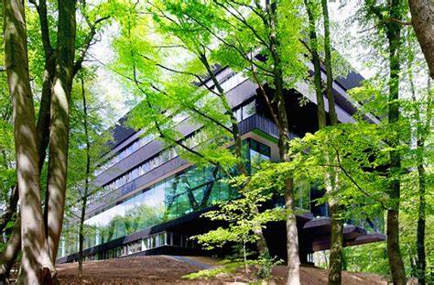 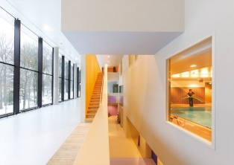

Figure 10; 11 exterior view; interior view

2. Matri Mandir in Auroville:

The Matrimandir is an awe-inspiring structure that appears to be emerging out of the ground, symbolizing the birth of a new consciousness. This magnificent building has been under construction for over 50 years, and its progress has been closely followed by many. The Matrimandir Gardens are a delightful experience, with twelve individually named parks such as "Harmony," "Bliss," "Perfection," "Progress," and "Consciousness," each boasting a unique variety of flowers, shrubs, and trees. The Matrimandir is the center of attention, and it is considered the "symbol of the Divine's answer to man's aspiration for perfection" and the "central cohesive force" for the growth of Auroville. The triangular fabric structure on the building's exterior allows for a gentle and calming flow of natural light to enter the meditation hall, providing a soothing atmosphere within the space. The Matrimandir inspires visitors to aspire to greatness and reminds them of the power of human will and determination.

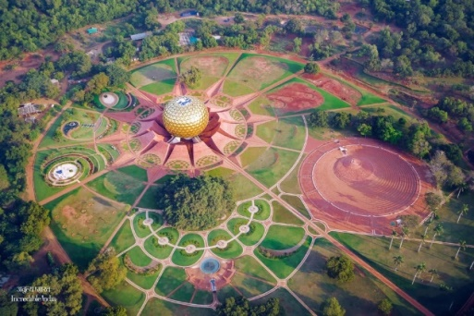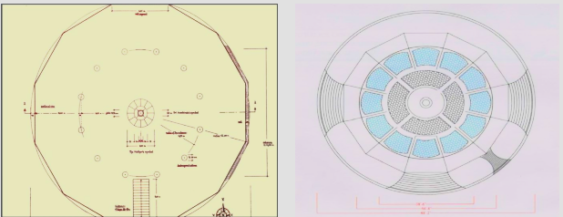

Figure 12; 13 matrimandir complex; planning and division of zones

3. The Global Vipassana, Pagoda:

The Global Vipassana Pagoda complex is a magnificent structure built to express gratitude to Gautama Buddha for His teachings, which aim to eradicate suffering. The complex serves as a place to learn about the life of Buddha and His teachings, and to practice Vipassana meditation. The meditation center located in the complex offers free Vipassana meditation courses, providing an opportunity for people to learn and practice this ancient meditation technique.

The construction of the Global Vipassana Pagoda began in 1997, and after years of hard work, it was completed in 2008. The pagoda comprises three sub-domes, with the first and largest dome being the most remarkable. This dome was completed in 2006, and it now holds bone relics of Gautama Buddha, making it the world's largest hollow stone masonry structure containing such relics. The relics were discovered in Bhattiprolu, Guntur district, Andhra Pradesh, South India, and have been donated by the Mahabodhi Society of India and the Prime Minister of Sri Lanka to be kept at the Global Vipassana Pagoda. The second and third domes, along with an auxiliary dome adjoining the second dome, sit atop the first dome, completing the structure.

 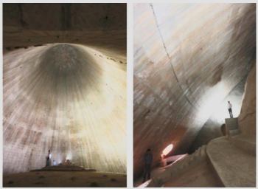

Figure 14, 15 the global vipassana complex; structure of second and third dome

4. The Isha Yoga Foundation:

The Isha Yoga Center, located at the foothills of Velliangiri on the outskirts of Coimbatore, is a sanctuary for those seeking self-improvement. The center offers a wide range of paths to spiritual growth, including kriya (energy), gnana (knowledge), karma (action), and bhakti (devotion). People from all over the world come to the center to find inner peace and transformation.

The center is committed to nurturing inner growth and creating a stable state of well-being in individuals. The expansive residential facility houses a vibrant international community of brahmacharis, full-time volunteers, and visitors. The Isha Yoga Center provides a supportive environment for individuals to adopt healthier lifestyles, pursue greater self-fulfillment, and unleash their full potential.

In addition, the center boasts the largest non-supporting dome pagoda in the world, constructed using a unique technique that balances three sub-domes. This remarkable structure is a testament to the center's commitment to innovation and excellence.

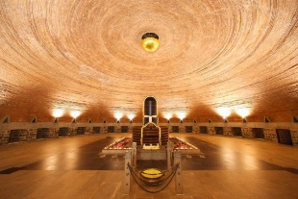 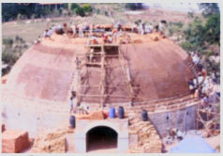

Figure 16; 17 interior view; non supporting dome construction

5. The Mughal gardens of taj mahal, agra:

The Taj Mahal is a stunning ivory-white marble mausoleum located in Agra, Uttar Pradesh, India. Commissioned in 1631 by the fifth Mughal emperor, Shah Jahan, the mausoleum was built to house the tomb of his beloved wife, Mumtaz Mahal, and also serves as the final resting place of Shah Jahan himself. The complex spans over 17 hectares and features a beautiful mosque and guest house, surrounded by formal gardens that are enclosed by a crenellated wall.

During the Mughal Empire, landscapes were characterized by subdivision, with the four-square form, also known as the paradise geometry, creating interesting patterns and modulation of space. Mughal art was influenced by Islamic and Hindu cultures, as well as aspects of Buddhist aesthetics that were based on organic patterns of sculptural ornamentation, combined with the Islamic sense of mathematical order and geometry.

The Mughal garden is a distinctive combination of landscape and architecture, achieving harmony through the combination of the Islamic paradise garden with the Asian tradition of garden burial. The Taj Mahal is a perfect example of this, presenting four-square patterns created by tree-lined divisions. The center of the site features water, which not only marks the garden but also reflects the dome, creating a unique and beautiful atmosphere. What makes the Taj Mahal even more special is that the tomb is located at the end of the garden, adding to its overall charm and beauty.

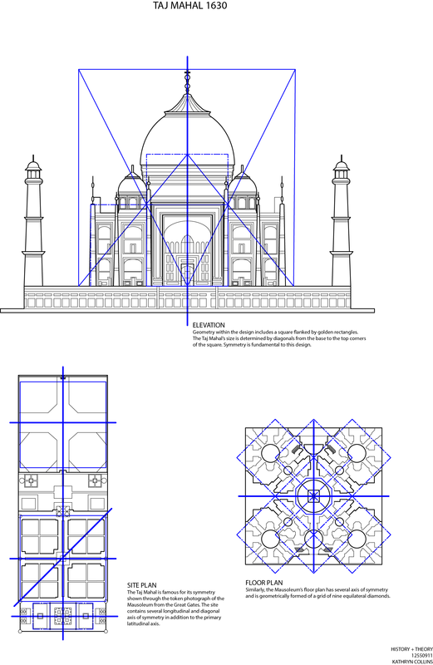 

Figure 18 . Elevation site plan and floor plan (use of proportions)

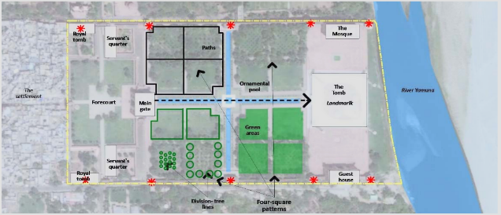

Figure 19 . Taj Mahal site plan. Four–square patterns (landscape harmony)

1. CONCLUSION

This text explores the significance of creating a peaceful and harmonious atmosphere in meditation center architecture, which encourages introspection and spiritual development. The implementation of this concept is illustrated through a variety of case studies of well-being centers, such as the Rehabilitation Center Groot Klimmendaal in the Netherlands, Matri Mandir in Auroville, the Global Vipassana Pagoda, and the Isha Yoga Foundation. Each center is thoughtfully designed to incorporate natural elements and sustainable materials, promoting serenity, mindfulness, and a connection between the physical and spiritual worlds.

In today's fast-paced world, meditation centers have become a necessity for individuals seeking peace and relaxation. Meditation has been proven to provide numerous benefits, such as stress relief, improved focus, and willpower. To make the most of these benefits, it is important to have a harmonious environment in meditation centers. The natural environment and visual elements create a sense of peace and relaxation, which can help individuals to attain a deeper state of meditation. By joining a meditation center, individuals can find a sanctuary of serenity and self-discovery, leading to a more balanced and harmonious life.

Harmonious aesthetics are crucial in designing meditation centers. Architectural elements such as form, proportion, materials, color, and acoustics create a spiritually nurturing environment. Simplicity, symmetry, natural, and sustainable materials such as wood, stone, and bamboo promote groundedness and tranquility. Subdued color palettes and a well-designed acoustic environment minimize disruptions. Contemplative gardens and natural elements provide a holistic and harmonious experience.

In conclusion, the creation of a peaceful and harmonious atmosphere in meditation centers is essential for individuals seeking to improve their wellbeing through meditation and introspection. Through the use of natural elements, sustainable materials, and thoughtful design, meditation centers can provide a sanctuary for individuals to explore and deepen their spiritual practice. By promoting a connection between the physical and spiritual worlds through architecture, meditation centers encourage individuals to live more balanced and harmonious lives, even amidst the chaos of the modern world.

1. ACKNOWLEDGEMENT

I would like to express my heartfelt gratitude to all the individuals and organizations who have contributed to the successful completion of my research paper. I feel indebted to my supervisor, Ar. Arjun Sharma, for his invaluable guidance, motivation, and support throughout the research process. His insights and suggestions have been instrumental in shaping my ideas and refining my work. I also extend my sincere appreciation to my research guides, whose cooperation, expertise, and feedback were crucial in steering me in the right direction.

I would be remiss if I didn't acknowledge the support of my colleagues and friends. Their unwavering encouragement, suggestions, and assistance have been a source of strength and motivation throughout this journey. Their constructive criticism and valuable inputs have helped me to overcome obstacles and refine my ideas. Without their support and encouragement, this work would not have been possible, and for that, I am truly grateful.

1. REFERENCES

* Allbritton, Marcel & Heeter, Carrie. (2018). Meditation as an Intervention for Health: A Framework for Understanding Meditation Research. 3. 025. 10.21926/obm.icm.1804025.
* Schlechta Portella, Caio Fábio et al. “Meditation: Evidence Map of Systematic Reviews.” Frontiers in public health vol. 9 742715. 2 Dec. 2021, doi:10.3389/fpubh.2021.742715
* Wang, Yuzheng et al. “A Bibliometric and Visualization Analysis of Mindfulness and Meditation Research from 1900 to 2021.” International journal of environmental research and public health vol. 18,24 13150. 13 Dec. 2021, doi:10.3390/ijerph182413150
* Dhamma Ganga Vipassana Meditation Centre; Reorient Your Spirit & Find Peace At These 7 Most Calming Meditation Centres In Kolkata; [Best Meditation Centres In Kolkata | WhatsHot Kolkata](https://www.whatshot.in/kolkata/reorient-your-spirit--find-peace-at-these-7-most-harmonious-meditation-centres-in-kolkata-c-26147)
* Harmony of Design and Landscape; [Harmony of Design and Landscape | illustrarch](https://illustrarch.com/landscape-architecture/16407-harmony-of-design-and-landscape.html)
* The Key Architectural Elements Required to Design Yoga and Meditation Spaces; [The Key Architectural Elements Required to Design Yoga and Meditation Spaces | ArchDaily](https://www.archdaily.com/797259/the-key-architectural-elements-required-to-design-yoga-and-mediation-spaces)

Paper id: IJCRT_254968 – **Acceptance Notification and Review Result of paper** TITLE - Harmony As An Aesthetic Approach For Meditation Centers. - Your Paper Accepted Complete Below Process and Publish it. Your Email id:  gaurav.j.mishra2020@gmail.com [Track your paper : https://ijcrt.org/track.php?r_id=254968](https://ijcrt.org/track.php?r_id=254968)

|  |
| --- |
| image**Your Paper Acceptance details as per below Complete Step 1 and Step 2 and publish within 1 to 2 days.** |

|  |  |  |  |  |  |  |  |  |  |  |  |  |  |  |  |  |  |  |  |  |  |  |  |  |  |  |  |  |  |  |  |  |  |  |  |  |  |  |  |  |  |  |  |  |  |  |  |  |  |  |  |  |  |  |  |  |
| --- | --- | --- | --- | --- | --- | --- | --- | --- | --- | --- | --- | --- | --- | --- | --- | --- | --- | --- | --- | --- | --- | --- | --- | --- | --- | --- | --- | --- | --- | --- | --- | --- | --- | --- | --- | --- | --- | --- | --- | --- | --- | --- | --- | --- | --- | --- | --- | --- | --- | --- | --- | --- | --- | --- | --- | --- |
| **Dear Author, Congratulation!!!**  Your manuscript with Registration ID:**IJCRT_** **254968**has been **accepted** for publication in the **International Journal of Creative Research Thoughts (IJCRT) |**[**www.ijcrt.org**](http://www.ijcrt.org/) | **ISSN: 2320-2882 | International Peer Reviewed & Refereed Journals, Open Access Journal. IJCRT is Peer Review Journal, Refereed Journal, Peer Reviewed Journal Referred Journal and Indexed Journal Open Access Journal Online and Print Journal**    **IJCRT Impact Factor: 7.97 | UGC Approved Journal No: 49023 (18)**   Check your paper status: [**https://ijcrt.org/track.php**](https://ijcrt.org/track.php?r_id=254968)**or**[**http://ijcrt.org/Authorhome/alogin.php**](http://ijcrt.org/Authorhome/alogin.php)  **Online Payment Link for Indian author:**[**http://ijcrt.org/pay_form_2.php**](http://ijcrt.org/pay_form_2.php)  **Online Payment Link for Foreign/international author:**[**https://ijcrt.org/pay_form_international.php**](https://ijcrt.org/pay_form_international.php)     |  |  |  | | --- | --- | --- | | Your Paper Review Report : | | | | Registration ID: | IJCRT – 254968 | | | Title of the Paper: | **Harmony As An Aesthetic Approach For Meditation Centers** | | | Accepted or Not: | **Accepted** | | | **Criteria** | **Points out of 100%** | |  |  | | --- | --- | | **Track Your Paper Details:** | | | **Paper Track Link 1:** | [**https://ijcrt.org/track.php**](https://ijcrt.org/track.php?r_id=254968) | | **Paper Track Link 2:** | [**http://ijcrt.org/Authorhome/alogin.php**](http://ijcrt.org/Authorhome/alogin.php) | | **Online Payment link Details:** | | | **Indian author:** | [**http://ijcrt.org/pay_form_2.php**](http://ijcrt.org/pay_form_2.php) | | **Foreign/international author:** | [**https://ijcrt.org/pay_form_international.php**](https://ijcrt.org/pay_form_international.php) | | | **Continuity** | **90%** | | **Text structure** | **93%** | | **References** | **84%** | | **Understanding and Illustrations** | **96%** | | **Explanatory power** | **87%** | | **Detailing** | **86%** | | **Relevance and practical advice** | **94%** | | **Overall Assessment (Comments.)      Paper Accepted: YES** | | | | **Unique Contents:  88%    Paper Accepted** | | | | Reviewer comment store in online RMS system. Paper Accepted complete below Step1 and Step2 process and publish your paper within 1 to 2 day. | | | |  | | | | **Publication of Paper** | **Within 01-02 Days after Submitting documents. Please complete payment and send payment proof along with below documents.** | | |

|  |  |
| --- | --- |
| **Publication of Paper** | **Within 01-05 Days after Submitting documents.** |
| **REQUEST FORM FOR HARD COPY OF CERTIFICATE** | [**http://ijcrt.org/paymentInfo.php**](http://ijcrt.org/paymentInfo.php) |

**Thank you very much for submitting your article to the IJCRT.**

Copy Text