NutriChef – ML and CNN based nutrient analysis and culinary exploration

Mr. Jeet Agrawal¹, Mr. Raj Shekokar², Mr. Aniket Kale³, Miss. Ritika Arya⁴
¹Department Of Information Technology, Tulsiramji Gaikwad Patil College of Engineering and Technology, Nagpur, India
²Department Of Information Technology, Tulsiramji Gaikwad Patil College of Engineering and Technology, Nagpur, India
³Department Of Information Technology, Tulsiramji Gaikwad Patil College of Engineering and Technology, Nagpur, India
⁴Department Of Information Technology, Tulsiramji Gaikwad Patil College of Engineering and Technology, Nagpur, India

Under the Supervision of,
Prof. Pooja Patle
Department of Information Technology,
Tulsiramji Gaikwad Patil College of Engineering and Technology, Nagpur, India

Abstract — NutriChef stands as an innovative web platform, meticulously crafted on the potent MERN (MongoDB, Express.js, React.js, Node.js) stack, seamlessly blending state-of-the-art machine learning technologies, including TensorFlow.js, Keras, and scikit-learn. This dynamic amalgamation empowers users to embark on an immersive culinary exploration and nutrient analysis journey. The platform offers diverse search options, enabling users to explore recipes by name, ingredients, or through image recognition.
Keywords — Machine Learning, CNN, Nutrient Analysis, Culinary Exploration, Chatbot Integration, MERN development.

Introduction
The primary objective of "NutriChef" is to empower travelers and food enthusiasts by offering a solution that effortlessly identifies any dish through image recognition technology. Whether one is exploring a bustling market in Jaipur, savoring street food in Mumbai, or delving into the culinary mysteries of the North-East, "NutriChef" becomes their reliable companion. The key features of the platform include image-based food recognition, nutrient analysis, recipe generation, and health-related information. Users can capture or upload images of unknown dishes, and the system provides not only the name of the dish but also an in-depth analysis of its nutritional components, presented in a clear and understandable percentage form. It acts as an advisor, guiding travelers to make informed and healthy food choices during their tours.
India's culinary heritage is celebrated for its complexity, diversity, and mouth-watering flavors. "NutriChef" preserves this celebration by making it accessible to all, from seasoned food connoisseurs to newcomers to Indian cuisine. As a beacon of innovation and technology in the culinary world, "NutriChef" aims to enhance the gastronomic experience while promoting healthier eating habits. It's a project that harmonizes tradition and technology, and its implications reach beyond India's borders. In the age of digitalization and AI, "NutriChef" stands as a testament to the power of ML and CNN to enhance our daily lives. It not only simplifies the culinary journey but also encourages a healthier way of exploring cultures through their cuisines. "NutriChef" is poised to be a significant contribution to the realms of technology, health, and cultural exploration, providing users with a unique way to connect with the culinary tapestry of India.

Ease of Use
In the realm of technology, the ease of use is a paramount aspect that significantly influences user adoption and satisfaction. Nutrichef, a revolutionary project in the culinary and nutrition space, has been meticulously designed with a user-centric approach to ensure seamless interaction and accessibility.
The user interface of Nutrichef is intuitively crafted, providing a straightforward and visually appealing experience. The landing page offers clear navigation, presenting users with four main functionalities: searching by name, ingredients, uploading photos, and using the camera to capture dishes. This simplistic design allows users, even those with minimal technical expertise, to effortlessly explore and utilize the diverse features offered by Nutrichef.
One of the prominent ease-of-use features is the search functionality. Users can input the name of a dish or select ingredients to obtain comprehensive information about the dish's nutritional content and culinary details. The straightforwardness of this process empowers users to swiftly access the information they seek, making Nutrichef a user-friendly platform for individuals of varying technological proficiencies.
The integration of image recognition technology adds an innovative layer to Nutrichef's user experience. Users can upload photos of dishes or use the camera to capture them, initiating the system's analysis to provide detailed insights. This feature not only enhances ease of use but also caters to users who prefer a more visual and interactive approach to obtain information about the foods they consume.
Nutrichef also prioritizes adaptability, ensuring that users can access the platform seamlessly across different devices. The responsive design allows individuals to use Nutrichef on laptops, tablets, or smartphones, promoting a versatile and accommodating user experience.

CONVOLUTIONAL NEURAL NETWORKS
Convolutional Neural Networks (CNNs) offer a robust model architecture for image classification and recognition. They comprise a sequence of filters applied to the raw input image to effectively extract and learn image features. These features play a pivotal role in the model's classification process. Typically, CNNs consist of three main types of layers.
The first type is the Convolutional layers, where a set of convolution filters, often 3x3 in size, is applied to different sections of the input image. These filters perform mathematical operations, producing a single value in the output. Activation functions, such as Rectified Linear Units (ReLU), are then applied to introduce nonlinearities into the model.
Pooling layers form the second type and are responsible for downsampling the resulting image from the convolutional layers. This downsampling reduces the size of the feature map, aiding in faster processing. Max pooling is a commonly used algorithm in which sub-sections of the feature map (e.g., 2x2 pixels) are extracted, and only the maximum value is retained.
The third type is Fully Connected layers, which conduct classification on the features extracted after downsampling. In these layers, every node is connected to every node in the previous layer.
CNNs automatically perform feature extraction through a stack of convolutional modules, each consisting of a convolutional layer followed by a pooling layer. The final layers involve one or more fully connected layers for classification. The last fully connected layer incorporates a softmax activation function, assigning a value between 0 and 1 for every class. The sum of all class values equals 1, representing the likelihood of the image belonging to each target class.
The strength of CNNs lies in their automated feature extraction process, utilizing convolutional and pooling layers. A conventional CNN contains multiple convolution and pooling layers, culminating in a fully connected layer to deliver the final classification. Each unit in the final layer signifies the probability of the corresponding class in image classification.
For effective CNN design, adjustments to hyperparameters are crucial, including the number of hidden layers, kernel size, and activation functions. In this paper, we propose both a basic and an optimized version of these parameters, aiming to enhance the overall performance of the CNN model.

PROPOSED CNN ARCHITECTURE
All input images were resized uniformly to dimensions of 224x224x3 before being fed into the Convolutional Neural Network (CNN) model. The CNN inherently performs automated feature extraction, transitioning from larger pixel amounts to finer details such as color and edges.
The first and second convolutional layers consist of 64 feature kernel filters with a filter size of 3×3. Upon passing the RGB input image (with a depth of 3) through these layers, the dimensions change to 224x224x64. Subsequently, the output undergoes a max-pooling layer with a stride of 2.
The third and fourth convolutional layers feature 124 kernel filters with a size of 3×3. Following these layers is another max-pooling layer with a stride of 2, resulting in a reduced output size of 56x56x128.
Layers five through seven are convolutional layers with a kernel size of 3×3, each utilizing 256 feature maps. These layers are succeeded by max-pooling layer with stride of 2.
Layers eight to thirteen consist of two sets of convolutional layers, each with a kernel size of 3×3 and 512 kernel filters. These sets are followed by a max-pooling layer with a stride of 1.
The fourteenth and fifteenth layers are fully connected hidden layers, each comprising 4096 units. Finally, a softmax output layer (sixteenth layer) with 1000 units concludes the network architecture.
This architecture allows the model to progressively extract intricate features from the input images, starting with larger patterns and gradually delving into finer details. The convolutional and pooling layers play a pivotal role in this automated feature extraction, contributing to the model's ability to discern patterns and nuances in the input data.

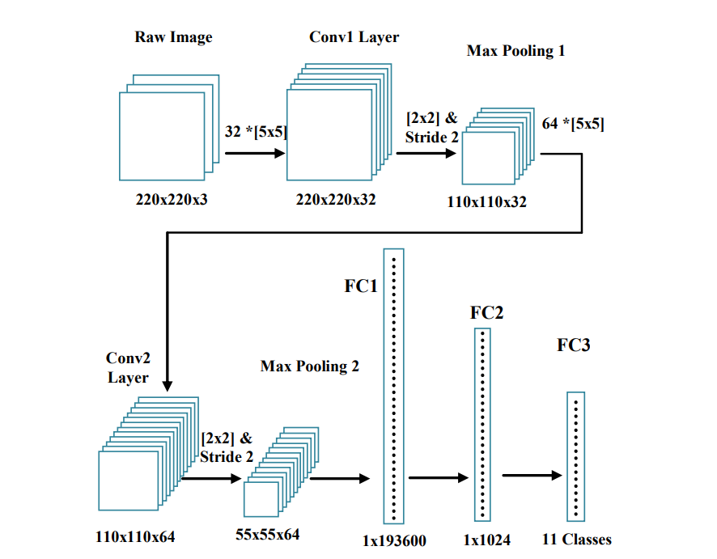
Fig. 1. Basic CNN layer structure

For enhanced model accuracy, we advocate the utilization of a more intricate architecture featuring multiple convolutional layer blocks before reaching the final fully connected layer. Achieving greater accuracy in classification demands a deeper network. However, there exists a tradeoff, as increased depth influences both performance and the time required for results. In our approach, we have implemented a 24-layer model, incorporating 21 convolutional layers and 3 fully connected layers, as depicted in Fig. 2.
In each convolutional layer, the stride is consistently set to 1 pixel, and spatial padding of the convolutional layer input is meticulously performed to preserve dimensions post-convolution. Specifically, the padding for 3 × 3 convolutional layers is set to 1, while for 5 × 5 layers, the padding is adjusted to 2. Spatial pooling is strategically applied through five max-pooling layers, interspersed among some of the convolutional layers but not universally, employing a 2 × 2-pixel window and a stride of 2.
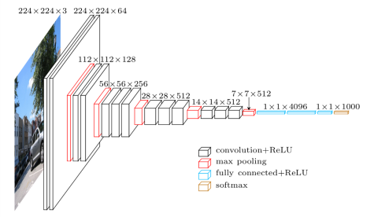

Fig. 2. VGG 16 layers

Given the intricacies of food classification, encompassing various details like shape, color, and texture, employing a larger kernel size at the initial layers is pivotal. This choice ensures the preservation of shape-related features throughout the learning process. Simultaneously, smaller kernel sizes are employed to capture and retain the finer details of food objects, contributing to a more comprehensive and nuanced understanding of the images in the classification process.
The VGG16 model, developed by K. Simonyan and A. Zisserman, is a deep learning architecture comprising a total of 41 layers. This includes 13 convolutional layers, 5 maximum pooling layers, 2 dropout layers, 3 fully connected layers, 15 ReLu layers, 1 softmax layer, 1 input layer, and 1 classification layer. The deep features crucial for classification are extracted from the fc6 and fc7 layers. Both the fc6 and fc7 layers generate 4096-dimensional feature vectors, as illustrated in Fig. 3.

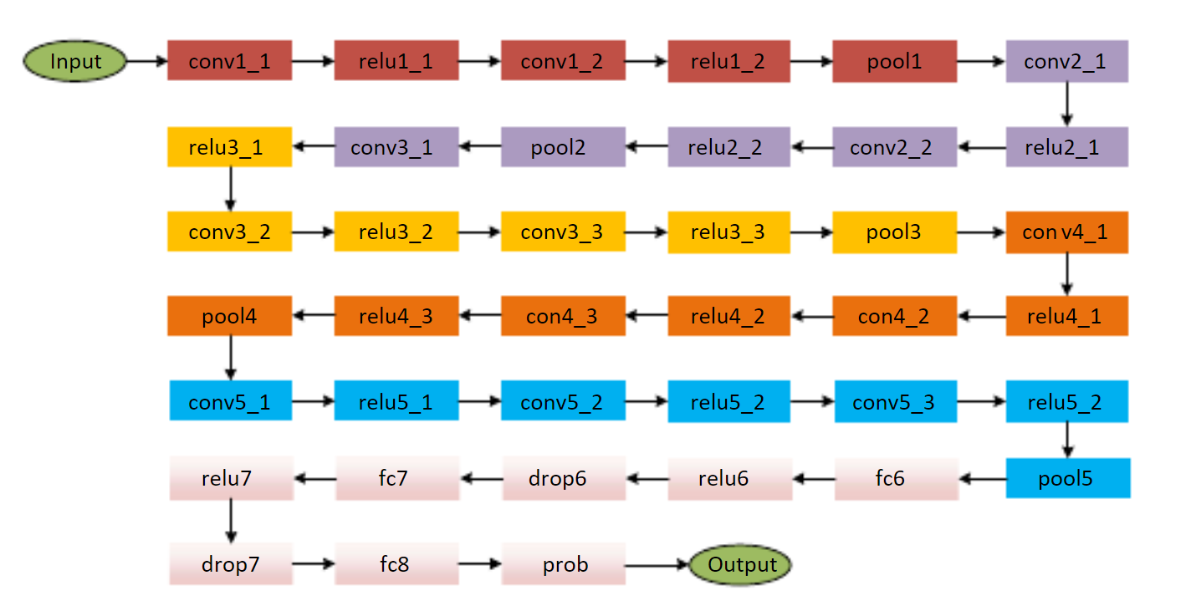
Fig. 3. The illustration of the VGG16 model.

Food dataset
We propose a new dataset that includes local Indian food items/ dishes. 12400 food images are distributed over 124 with 100 images for each category. The images were collected from publicly available Internet sources including but not limited to, image search engines. Food image were collected with respect to variations to pose, rotation, color and shape complexity to improve the identification accuracy when more than single food item is included in the image.

Acknowledgment
In the exciting journey of bringing Nutrichef to life, we, the Nutrichef team, express our deepest gratitude to everyone who contributed their skills, passion, and dedication to make this project a reality. Each team member played a pivotal role in shaping Nutrichef into the innovative and user-friendly platform it is today.
We also want to express our thanks to our mentors, advisors, and everyone who offered guidance and support throughout this endeavor. Your wisdom and encouragement fueled our determination and inspired us to push the boundaries of innovation.

References

[1] Dorian Raboy, Sabrina Lu,” Image to Recipe/Nutritional Information Generator”, 2020
[2] Moolya, Sakshi Pansare, Anushree Kshirsagar, Sonali Bodekar-Kale, “Recipe Generator Using Deep Learning.” International Journal for Research in Applied Science and Engineering Technology, (IJRASET), vol. 10, no. 5,May 2022, pp. 846–51.
[3] Amaia Salvador, Michal Drozdzal, Xavier Giro-i-Nieto, Adriana Romero,” Inverse Cooking: Recipe Generation from Food Images”, 2019
[4] Javier Marin1 , Aritro Biswas, Ferda Ofli , Nicholas Hynes , Amaia Salvador , Yusuf Aytar , Ingmar Weber , Antonio Torralba,” Recipe1M+: A Dataset for Learning Cross-Modal Embeddings for Cooking Recipes and Food Images”, IEEE TRANSACTIONS ON PATTERN ANALYSIS AND MACHINE INTELLIGENCE, June 2019(Chinese food).
[5] Ekta Belwal, M Sujatha,” Development of foxtail millet incorporated breakfast recipes and their comparison with traditional recipes made of cereals”, Int J Home Sci 2021, vol.7, no.3, pp.147-151.
[6] Srinivasamoorthy.P, Preeti Savant,”RECIPE GENERATION FROM FOOD IMAGES USING DEEP LEARNING”,International Research Journal of Engineering and Technology (IRJET) ,Volume: 09, Issue 03 ,Mar 2022
[7] Garcia-Garcia, A., Orts-Escolano, S., Oprea, S., Villena-Martinez, V.,& Garcia-Rodriguez, J. (2017) “A Review on Deep Learning Techniques Applied to Semantic Segmentation.”
[8] Srinivas, S., Sarvadevabhatla, R. K., Mopuri, K. R., Prabhu, N., Kruthiventi, S. S., &Babu, R. V. (2016) “A taxonomy of deep convolutional neural nets for computer vision.”

