**Well Bin (Smart City solutions for clean living and health monitoring)**

**Sankalp Sharma1, Shashwat Singh2, Srinath Chepuri3**

1Dept of Electronics And Communication Engineering, SRM Institute of Science and Technology, Kattankulathur Chennai, Tamil Nadu–603203, India

2 Dept of Electronics And Communication Engineering, SRM Institute of Science and Technology, Kattankulathur Chennai, Tamil Nadu–603203, India

3 Dept of Electronics And Communication Engineering, SRM Institute of Science and Technology, Kattankulathur Chennai, Tamil Nadu–603203, India

**ABSTRACT**

Every day, several lives in India are impacted when patients receive care that is not prompt and appropriate. Moreover, real-time parameter values are not efficiently measured in clinics or hospitals. It could be difficult for hospitals to often check on the health of their patients. It is also not feasible to observe ICU patients continuously. Our method is useful in managing situations such as these. Our system is intended to be utilised in hospitals for the purpose of measuring and keeping track of several characteristics, such as heart rate and temperature. The Arduino Uno R3 can be used to record the results, which will be shown on an LCD display. Additionally, the findings can be sent to the server using a Wi-Fi module. Physicians who log onto a website can access the results. The primary goal of this large-scale initiative is to create Smart City Solutions that effectively monitor public health and encourage clean living in metropolitan settings. There are two main components to the initiative: Health Monitoring and Clean Living. The project incorporates air quality monitoring and intelligent waste management solutions within the context of Clean Living. Sensor-equipped smart trash cans optimise rubbish collection routes, cutting expenses and their negative effects on the environment. Real-time data on contaminants is provided by air quality monitoring stations, allowing for timely responses. Furthermore, energy-saving innovations like intelligent street lighting help to lessen carbon emissions. In terms of health monitoring, the project makes use of wearable technology and sensors to gather health data in real-time, enabling proactive health management and early problem identification. Machine learning algorithms analyse data trends, offering personalized recommendations. Smart clinics with telemedicine facilities enhance healthcare accessibility. Emphasizing privacy and data security, this project envisions a future where technology creates cleaner, healthier, and more liveable urban spaces, promoting a high quality of life for residents while adhering to ethical guidelines.

**Keywords— Arduino Mega 2560, Monitoring system, Wi-Fi module sensors, Real time data collection**

1. **INTRODUCTION**

Every day, several lives in India are impacted when patients receive care that is not prompt and appropriate. Moreover, real-time parameter values are not efficiently measured in clinics or hospitals. It could be difficult for hospitals to often check on the health of their patients. It is also not feasible to observe ICU patients continuously. Our method is useful in managing situations such as these. Our system is intended to be utilised in hospitals for the purpose of measuring and keeping track of several characteristics, such as heart rate and temperature. The Arduino Uno R3 can be used to record the results and view them on an LCD display. Additionally, the findings can be sent to the server using a wifi module. By logging onto a website, doctors can view the results. This major project focuses on developing Smart City Solutions that address the pressing challenges of promoting clean living and efficient health monitoring within urban environments. The initiative encompasses two primary facets: Clean Living and Health Monitoring. In the realm of Clean Living, the project integrates smart waste management systems and air quality monitoring. Sensor-equipped smart trash cans optimise rubbish collection routes, cutting expenses and their negative effects on the environment. Real-time data on contaminants is provided by air quality monitoring stations, allowing for timely responses. Furthermore, energy-saving innovations like intelligent street lighting help to lessen carbon emissions. In terms of health monitoring, the project makes use of wearable technology and sensors to gather health data in real-time, enabling proactive health management and early problem identification. Algorithms for machine learning examine patterns in data and provide tailored suggestions. Access to healthcare is improved by smart clinics that have telemedicine capabilities.

1. **METHODOLOGY**

*We will require a variety of hardware and software components to build a scalable system that combines smart garbage alerts with healthcare management. IoT sensors for healthcare, such as heart rate and temperature monitors, will provide data to microcontrollers, which will then send it over WiFi to a server. The web-based dashboard and LCD displays' user-friendly interfaces will enable both local and distant monitoring. In the meantime, sensors will be used by the smart waste system to determine the level of each bin, and microcontrollers will use GSM/GPRS to deliver notifications. rubbish management authorities will be assisted via a user interface as algorithms optimize rubbish pickup routes. MQTT and HTTP/HTTPS are two communication protocols that will guarantee smooth data flow. The efficient management of garbage and urban health are the goals of this integrated strategy*

* 1. **Block Diagram**

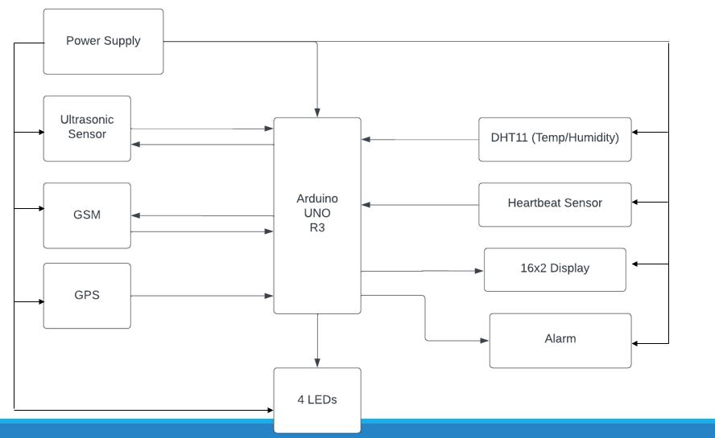

**Fig 1** : Block Diagram

**2.2 *Main Objective***

*The following is a concise summary of “WellBin (Smart City solutions for clean living and health monitoring)” main goals:*

*● Designing and implementing a robust healthcare management system that can monitor vital parameters such as temperature, heart rate, and other relevant metrics in real-time is the primary objective. This system intends to tackle the widespread problem of delayed and insufficient medical interventions, specifically within Indian healthcare facilities.*

*● Another crucial objective: leveraging IoT technology to integrate various sensors, microcontrollers, and communication modules seamlessly. Our aim--by accomplishing this task--is to enable efficient data collection; transmission; analysis – all with the end goal of facilitating prompt decision-making by healthcare professionals.*

*● The project actively pursues the development of intuitive user interfaces: locally through LCD displays; and remotely—utilizing a web-based dashboard. These interfaces facilitate healthcare practitioners' access to patient data, thereby empowering timely interventions and enhancing patient care.*

*● Privacy and Data Security Emphasis: We prioritize the privacy and security of patient data profoundly; it is our paramount objective. To ward off unauthorized access or breaches, we will implement robust encryption techniques–as well as access controls–with an unyielding focus on safeguarding sensitive health information*

***2.3* DATASET COLLECTION**

*Our website collects real time data from the device and processes the data and sends it to the allocated devices which serves as both updates and alert notifications that the user can easily access. Our data is collected overtime and reflects the past states of the monitored persons health and vitals while also holding the dataset for garbage alert systems.*

*The Smart City Insights Platform is an integrated solution that harnesses sensor data from health monitoring and smart garbage systems to provide comprehensive analytics for informed decision-making in a smart city environment. This platform converges health and environmental data, fostering a holistic approach to urban well-being.*

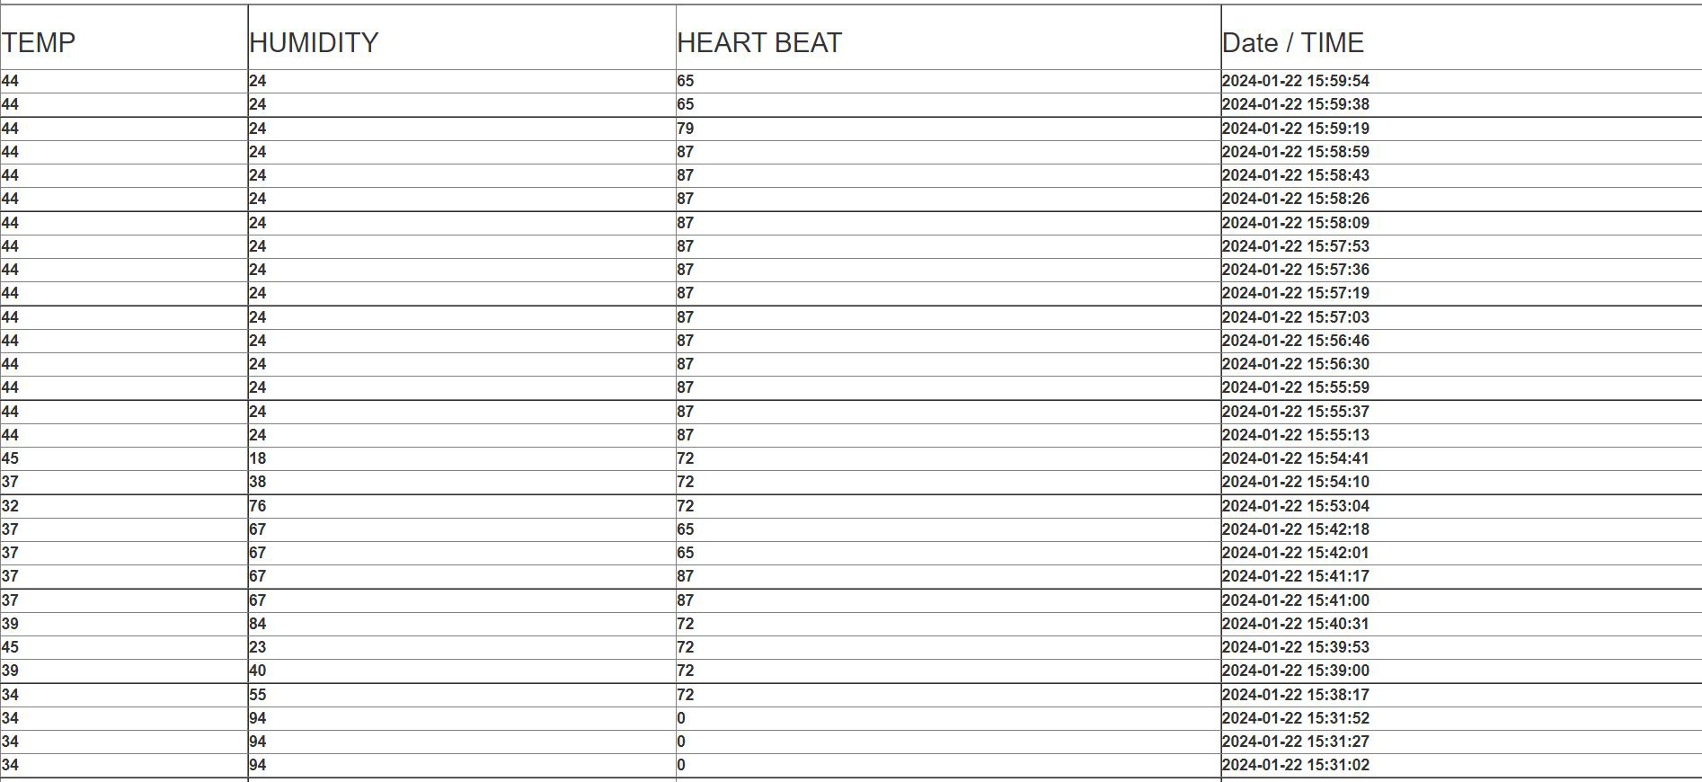

**Fig 2:** Sensors Data

1. **MODELLING AND COMPILING**

Arduino sketches (programs) are typically written in a subset of C++ known as the Arduino programming language. This language simplifies some aspects to make it more accessible for beginners while still allowing for powerful and flexible programming.

Arduino Integrated Development Environment (IDE):

The Arduino IDE is the software used to write, compile, and upload code to Arduino boards. It provides a user-friendly interface, a code editor, and tools to compile and upload code to the Arduino hardware.

Compilation Process:

When you write an Arduino sketch, the code is compiled into machine code that the Arduino microcontroller can understand. The compilation process involves translating the human-readable code into a binary format that the hardware can execute.

Compilation Errors and Debugging:

The Arduino IDE helps identify and highlight compilation errors, making it easier for users to debug their code. The IDE also provides a serial monitor for debugging and viewing output from the Arduino board.

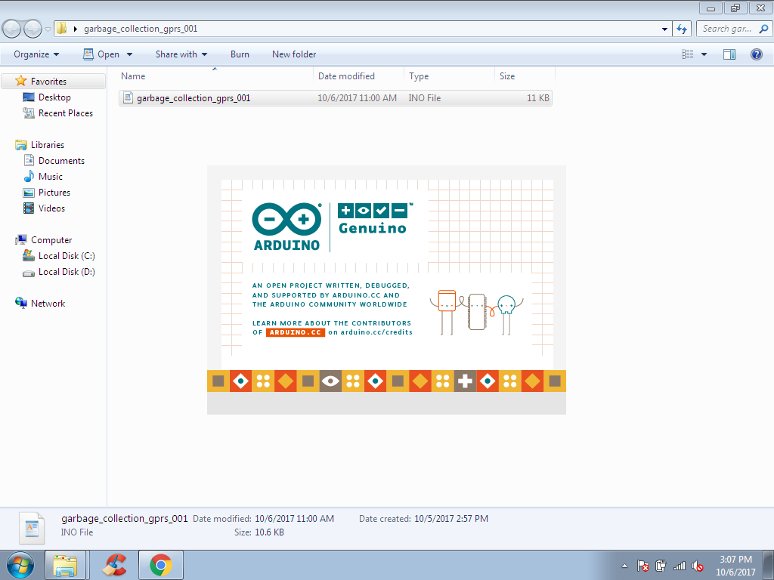

**Fig 3 :** Software Startup (Arduino IDE).

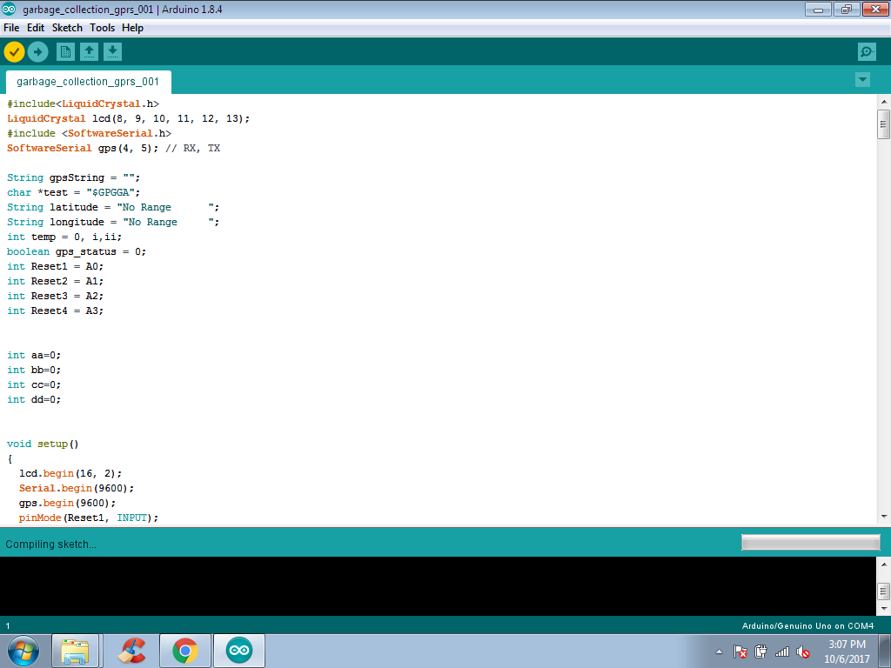

**Fig 4 : Arduino IDE**

***3.1 SMART CITY INSIGHTS PLATFORM (WEBSITE INTEGRATION)***

**User Authentication**: Secure user authentication ensures that only authorized individuals can access sensitive health and environmental data.

**Dashboard Overview**: Upon logging in, users are presented with an intuitive dashboard providing an overview of the latest health metrics and garbage status.

**Health Monitoring Section**:

3.1.1 Real-time Vital Signs: Visual representation of real-time health data including temperature and heart rate.

3.1.2 Historical Data: Access to historical health data for trend analysis and monitoring changes over time.

3.1.3. **Smart Garbage Monitoring Section:**

Bin Status: Live status updates on garbage bin fill levels.

Geographical Tracking: Visual representation of bin locations on a map for efficient waste management

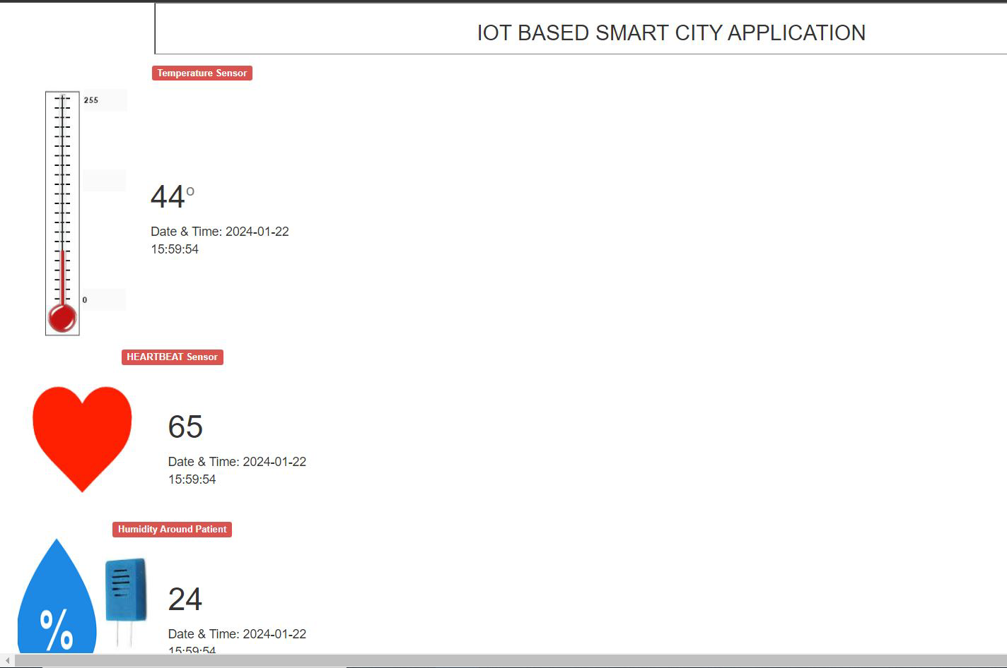

**Fig 5** : SmartCity Insights Platform

**3.2 PRE-PROCESSING ALGORITM**

For an IoT-based garbage alert system with temperature, humidity, and health monitoring, the preprocessing algorithm would typically involve several steps:

Data Acquisition: Collect data from various sensors including temperature, humidity, and health monitoring sensors attached to garbage bins or wearable devices.

Data Cleaning: Remove or filter out any noisy or erroneous data points that may be present due to sensor errors or environmental interference. This ensures that only reliable data is used for further analysis.

Data Fusion: Combine data from multiple sensors to create a unified dataset. This step involves aligning timestamps and merging data from different sources into a single dataset for analysis.

Feature Extraction: Extract relevant features from the combined dataset that can be used for analysis and decision-making. For example, calculate average temperature and humidity levels over a certain time period, or extract key health metrics such as heart rate or activity level.

Normalization: Scale the extracted features to a standard range to ensure that they are comparable and do not bias the analysis due to differences in measurement scales.

Missing Data Handling: Address any missing data points by imputing them using techniques such as mean or median imputation, or by interpolating values based on neighboring data points.

Data Aggregation: Aggregate the preprocessed data over specific time intervals or geographical regions to reduce data volume and facilitate real-time analysis.

Data Formatting: Format the preprocessed data in a suitable structure for storage or transmission, such as JSON or CSV format, depending on the requirements of the application.

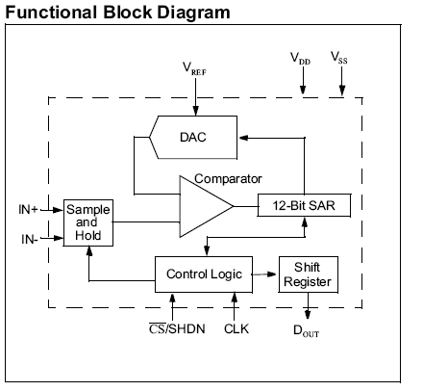

**Fig 6** : Functional Block Diagram

1. **RESULTS AND DISCUSSION**

1. Modularity and Upgradability: Forecast: The project design will prioritize modularity, allowing for easy replacement or upgrading of components, ensuring adaptability to future technological advancements.

2 Compliance with Standards: Forecast: Adherence to engineering standards, regulatory requirements, and safety norms will contribute to the project's credibility, reliability, and acceptance within the relevant industries.

3. User Acceptance: Forecast: A user-friendly interface, coupled with reliable performance, is anticipated to lead to high user acceptance and satisfaction, promoting the widespread adoption of the health monitoring and smart garbage systems.

4. Positive Impact on Urban Living: Forecast: The successful implementation of both systems is expected to contribute positively to the overall quality of urban living, promoting health and environmental well-being.

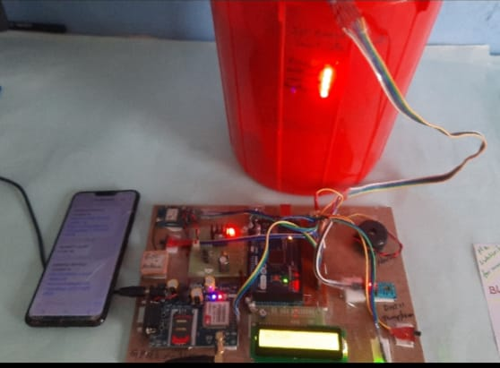

**Fig 7:** Complete Hardware Setup

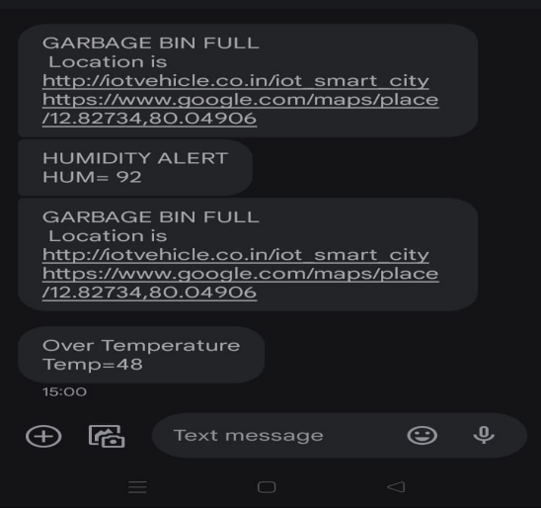

**Fig 8** : Messages received on Phone

.

1. **CONCLUSION**

The creation of "WellBin: Smart City Solutions for Clean Living and Health Monitoring" is a major step in the right direction towards resolving the complex issues that urban environments face, especially in India, where effective waste management and prompt healthcare interventions are critical. Our all-encompassing strategy combines cutting-edge technology with an outlook for a more sustainable and healthful future.

By incorporating IoT-based solutions, we have developed a strong healthcare management system that can monitor critical indicators in real time, reducing the consequences of postponing medical operations. Our solution improves the quality of healthcare services in urban environments by utilising wearable devices, sensors, and machine learning algorithms to enable proactive healthcare management and early issue detection.

Our project simultaneously addresses the urgent problem of waste management by putting in place smart trash cans and air quality monitoring equipment. By streamlining waste collection routes, lessening their negative effects on the environment, and offering real-time data on contaminants, these advances enable timely actions to maintain cleaner and healthier urban settings.

Our focus on user-friendly interfaces gives waste management authorities and healthcare professionals quick access to vital information for well-informed decision-making, both locally through LCD displays and remotely through web-based dashboards. In addition, we uphold legal and ethical requirements while guaranteeing the integrity and confidentiality of sensitive data through our commitment to privacy and data security.

The "WellBin" concept sees a time when technology is essential to creating cleaner, healthier, and more habitable urban environments. Our goal is to develop sustainable solutions that enhance the standard of living for locals while encouraging social justice and environmental stewardship. To do this, we want to leverage the power of innovation, cooperation, and responsible governance. As a team, we set out to create smarter, healthier cities that will last for future generations

1. **REFERENCES**

*[1] S. Misra, S. Pal, N. Pathak, "i-AVR: IoT-Based Ambulatory Vitals Monitoring and Recommender System," IEEE Internet of Things Journal, vol. 10, no. 12, pp. 1-1, Jun. 15, 2023.*

*[2] Sosunova, I., & Porras, J. (2022). IoT-enabled smart waste management systems for smart cities: A systematic review. IEEE Access, 10, 73326-73363.*

*[3] Abdalzaher, M. S., Fouda, M. M., Elsayed, H. A., & Salim, M. M. (2023). Toward secured IoT-based smart systems using machine learning. IEEE Access, 11, 20827-20841.*

*[4] Rajab, H., & Cinkelj, T. (2018). IoT based smart cities. In 2018 International Symposium on Networks, Computers and Communications (ISNCC) (pp. 1-6). IEEE.*

*[5] Siam, A. I., El-Affendi, M. A., Abou Elazm, A., El-Banby, G. M., & El-Bahnasawy, N. A. (2023). Portable and real-time IoT-based healthcare monitoring system for daily medical applications. In 2023 IEEE 11th International Conference on Cloud Computing (CLOUD) (pp. 1-8). IEEE.*

*[6] E. Likotiko, Y. Matsuda, K. Yasumoto, "Garbage Content Estimation Using Internet of Things and Machine Learning," IEEE Access, vol. 11, pp. 1-1, Feb. 3, 2023.*

*[7] N. Taimoor and S. Rehman, "Reliable and Resilient AI and IoT-Based Personalised Healthcare Services: A Survey," IEEE Access, vol. 10, pp. 535-563, Dec. 22, 2021.*

*[8] W. A. N. A. Al-Nbhany, A. T. Zahary, A. A. Al-Shargabi, "Blockchain-IoT Healthcare Applications and Trends: A Review," IEEE Access, vol. 12, pp. 4178-4212, Jan. 2, 2024.*

*[9] A. Subrahmannian and S. K. Behera, "Chipless RFID Sensors for IoT-Based Healthcare Applications: A Review of State of the Art," IEEE Transactions on Instrumentation and Measurement, vol. 71, article sequence number 8003920, Jun. 6, 2022.*

*[10] C. Nwibor, S. Haxha, M. M. Ali, M. Sakel, A. R. Haxha, K. Saunders, "Remote Health Monitoring System for the Estimation of Blood Pressure, Heart Rate, and Blood Oxygen Saturation Level," IEEE Sensors Journal, vol. 23, no. 5, pp. 5401-5411, Mar. 1, 2023 .*

.