**HOME AUTOMATION SYSTEM USING “ARDUINO UNO” AND “ARDUINO IDE 2.1.1”**

**Akash D Girhe[1],Tanshri M Wanjari [2],Khushboo B Kewat[3],Pravin S Lokhande[4] ,**

**Rohan R. Bhandopiya[5],Nutan Dhande[6], Abhishek Singh[7]**

1,2,3,4Student, Department of Computer Engineering, Agnihotri College of Engineering, Wardha, India 5,6,7Assistant Professor, Dept. of Computer Engineering, Agnihotri College of Engg., Wardha, India

# Abstract

The rapid advancement of technology has brought forth innovative solutions to enhance the comfort, convenience, and security of modern homes. This paper introduces a novel Home Automation System (HAS) that leverages cutting-edge technologies to create an intelligent and interconnected environment within a household. The primary objective of this system is to simplify daily tasks, optimize energy consumption, and increase overall safety. This paper introduces a Home Automation System (HAS) that leverages the capabilities of “GSM” (Global System for Mobile Communications) and “IoT” technologies to create a smart and interconnected environment within a household. The primary objective of this system is to enhance user convenience, improve energy efficiency, and bolster security through seamless remote control and monitoring.

**Keywords:-** Arduino uno , MCU node , GSM, IOT

# 

# INTRODUCTION

In an era defined by the rapid convergence of technology and daily life, the concept of a "smart home" has become increasingly prevalent. The integration of Global System for Mobile Communications (GSM) and the Internet of Things (IoT) technologies has propelled home automation systems into the forefront of modern living. These systems have redefined the way we interact with and manage our homes, ushering in a new era of convenience, energy efficiency, and security.

The fusion of GSM and IoT technologies has given birth to a Home Automation System (HAS) that is both intelligent and interconnected. This system leverages the power of mobile communication and the vast network of IoT devices to create a dynamic and responsive living environment within the confines of our homes. By seamlessly integrating GSM and IoT, it empowers homeowners with unprecedented control,

accessibility, and insights into their living spaces.

This paper explores the exciting world of home automation systems, with a particular focus on those based on GSM and IoT technologies. We delve into the fundamental concepts, components, and capabilities of this innovative system, shedding light on its transformative potential in reshaping the way we experience and manage our homes. The advent of GSM-based home automation systems has introduced a remarkable level of convenience by enabling remote control and monitoring. Homeowners can now effortlessly manage their homes, whether they are on the premises or miles away, through simple text messages or dedicated mobile applications. The integration of IoT devices further enhances this experience by collecting real-time data from sensors strategically positioned throughout the home.Moreover, the integration of voice assistants and user-friendly mobile applications simplifies control and access to the system's features, making it accessible to users of all technical backgrounds. Customization is a key aspect, allowing homeowners to tailor their home automation experience to their unique preferences and lifestyle.

In this paper, we will explore the various components and functionalities of GSM and IoT-based home automation systems, examine their applications in real-life scenarios, and highlight the potential for scalability and expandability. Additionally, we will discuss the role of data analytics and machine learning in optimizing the system's performance and user experience.As we embark on this journey through the world of GSM and IoT-based home automation, we will discover a realm where our homes become not just places of shelter, but intelligent, adaptable, and responsive spaces that cater to our every need, enhance our daily lives, and secure our future.

# Objective

Following are the objective of the project:

* Home automation simplifies daily tasks by allowing remote control and automation of various functions, such as lighting, heating, and entertainment systems.
* Energy Efficiency: Smart thermostats, lighting controls, and energy monitoring help reduce energy consumption, leading to cost savings and reduced environmental impact.
* Integrated security features, like surveillance cameras, doorbell cameras, and smart locks, enhance home security and provide peace of mind.
* Homeowners can personalize their automation settings to match their lifestyle and preferences.
* Automation can make a home more accessible for individuals with disabilities, improving their quality of life.
* A well-implemented home automation system can increase the resale value of a property.

# LITERATURE SURVEY

* A smart home automation system implement by using Global System for Mobile Communication (GSM). In GSM based home automation systems, communication between main module and appliances is done through text messages [3].
* The wireless communication between the smartphone and Arduino UNO is done through Bluetooth technology. This will be more helpful for handicapped and aged people who wants to control appliances by speaking voice command [3].
* The home automation system is a mobile web-based application. This paper can be customized a lot as it has multiple GPIO port that can be programmed and they can give the user control over various things from his smart phone like security, surveillance, lighting, energy management, access control, entertainment [4].
* Home automation system should also provide a user-friendly interface on the host side, so that devices can be easily setup, monitored and controlled [4].
* Yekhande, et. al. [4], proposed the architecture for smart home control and monitoring systems using Arduino is proposed and implemented.
* Water and air quality control and checking[7].
* Brilliant locks and security and switches[7].
* Controlled brilliant home machines[7].

|  |  |  |  |
| --- | --- | --- | --- |
| Sri  No | References | Strong points | Week points |
| [1] | Sudha Kousalya, G Reddi, Priya Vasanthi, B Venkatesh, IOT Based Smart Security and Smart Home Automation presented at International Journal of Engineering Research & Technology 04, April-2018. | A smart home automation system implement by using Global System for Mobile Communication (GSM). In GSM based home automation systems, communication between main module and appliances is done through text messages . | The main drawback of GSM based home automation system is that there is no guarantee text message deliver to the system every time. |
| [2] | K Eswari, DeviK Shravani, M Kalyani, Mr. Abbas Hussain, Mrs. N Gayathri “Real-Time Implementation of Light and Fan Automation using Arduino” presented at International Journal for Research in Applied Science & Engineering Technology (IJRASET), 06, June-2020 | Smart home devices often communicate wirelessly to connect with each other and with a central hub or gateway. Popular wireless protocols used in IoT-based smart home systems include Wi-Fi, Zigbee, Z-Wave, Bluetooth, and Thread. | One of the biggest challenges is interoperability among devices using different wireless protocols. Not all smart home devices are compatible with each other, which can lead to a fragmented ecosystem where certain devices cannot communicate or work together seamlessly. |
| [3] | Shreya Bhuguna, karan karmyal “IOT in home automation” presented at International Journal for Research in applied science and Engineering Technology (IJRASET) 10|May 2022 | Spending optimization in IOT and smart phone your family with transparency , subsequently , you will have the option to decrease your utility expenses altogether, furthermore , smart appliances are typically built to maximize resource efficiency | Smart appliances and IoT devices often come with a higher upfront cost compared to traditional alternatives. This initial investment can be a barrier for some families, especially those on a tight budget. |

# 3. METHODOLOGY

The development and implementation of a Home Automation System (HAS) based on GSM and IoT technologies require a systematic and well-structured approach. This methodology outlines the steps and considerations involved in creating a robust and efficient home automation system**.**

**Project Planning and Requirements Analysis:**

* Begin by defining the scope of the project and understanding the specific requirements and goals of the home automation system.
* Identify the areas and functions within the home that will be automated, such as lighting, climate control, security, and energy management.
* Determine the communication protocols, hardware components, and sensors required to achieve the desired automation tasks.

**System Architecture Design:**

* Create a high-level system architecture that outlines the main components of the GSM and IoT-based home automation system.
* Specify the roles and responsibilities of each component, such as sensors, actuators, central control hub, and user interfaces.
* Define the communication pathways between these components and the central control hub.

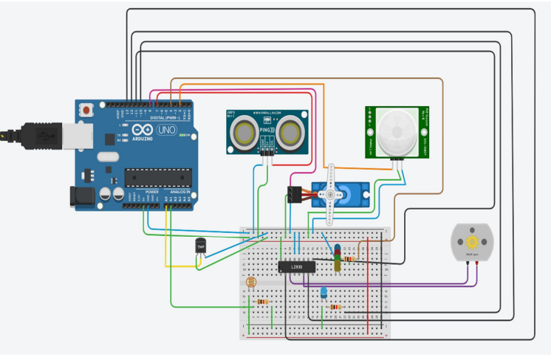

**Fig. Circuit Diagram**

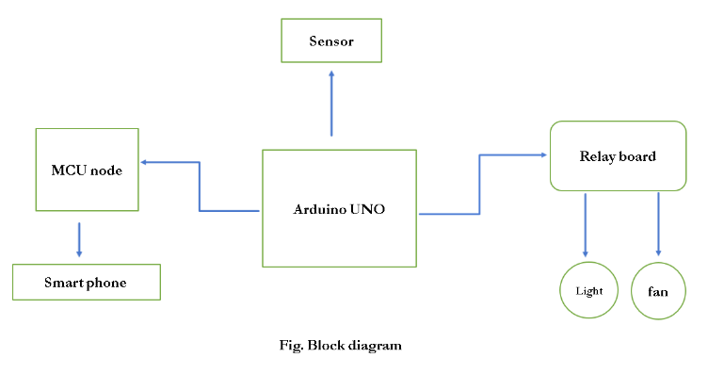

We need some software and hardware to finish our project.

**1. Required Software:**

1) ARDUINO IDE

**2. Required Hardware:**

1) Arduino Nano

2) Node MCU

3) Relay model

4) LED light

5) Jumper Wires (male to female and male to male)

6)LED Diodes

**Arduino UNO -** The Arduino UNO is a standard board of Arduino. Here UNO means 'one' in Italian. It was named as UNO to label the first release of Arduino Software. It was also the first USB board released by Arduino. It is considered as the powerful board used in various projects. Arduino.cc developed the Arduino UNO board.

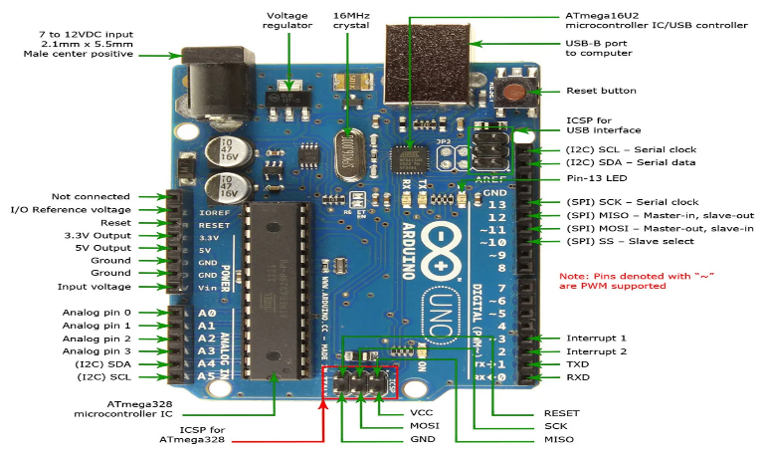

Fig. Arduino uno

Arduino Uno is the central control unit of the home automation system. It's a microcontroller board based on the ATmega328P chip, which can be programmed to interact with various sensors and actuators. Arduino offers a user-friendly development environment for writing and uploading code.

Arduino UNO is based on an ATmega328P [microcontroller](https://www.javatpoint.com/microcontroller). It is easy to use compared to other boards, such as the Arduino Mega board, etc. The board consists of digital and analog Input/Output pins (I/O), shields, and other circuits.

The Arduino UNO includes 6 analog pin inputs, 14 digital pins, a [USB](https://www.javatpoint.com/usb-full-form) connector, a power jack, and an ICSP (In-Circuit Serial Programming) header. It is programmed based on IDE, which stands for Integrated Development Environment. It can run on both online and offline platforms.

**Sensors:-** Advanced sensors are a crucial part of home automation. Some common sensors include:

* **Motion Sensors:-** These detect motion and can be used for security, lighting control, and occupancy detection.
* **Temperature and Humidity Sensors:-** Monitor environmental conditions and can be used for climate control.
* **Light Sensors:-** Measure ambient light levels for automatic lighting control.
* **Gas and Smoke Sensors:-** Ensure safety by detecting gas leaks or smoke.
* **Ultrasonic Sensors:-** Measure distance and can be used for object detection and obstacle avoidance.

**Actuators:-** Actuators enable you to control physical devices in your home. Examples include:

* **Relays:-** Used to control high-voltage appliances like lights, fans, and heating systems.
* **Servo Motors:-** Precisely control the position of objects or devices.
* **Smart Plugs:-** Control and automate standard electrical outlets.

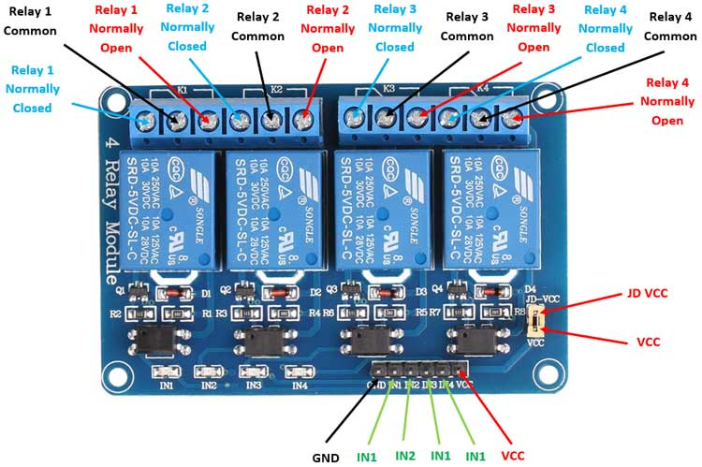

Fig. Relay model

**Communication Modules:-** To connect your Arduino-based system to the Internet or other devices, you can use:

* **Wi-Fi Modules (e.g., ESP8266 or ESP32):-** Enable IoT connectivity and remote control.
* **Bluetooth Modules:-** Useful for local communication with smartphones or other Bluetooth-enabled devices.
* **Node MCU :-** Node MCU is an open-source development board that is based on the ESP8266 system-on-a-chip (SoC). It provides an easy way to prototype and develop IoT (Internet of Things) projects by offering built-in Wi-Fi connectivity and a programmable microcontroller.

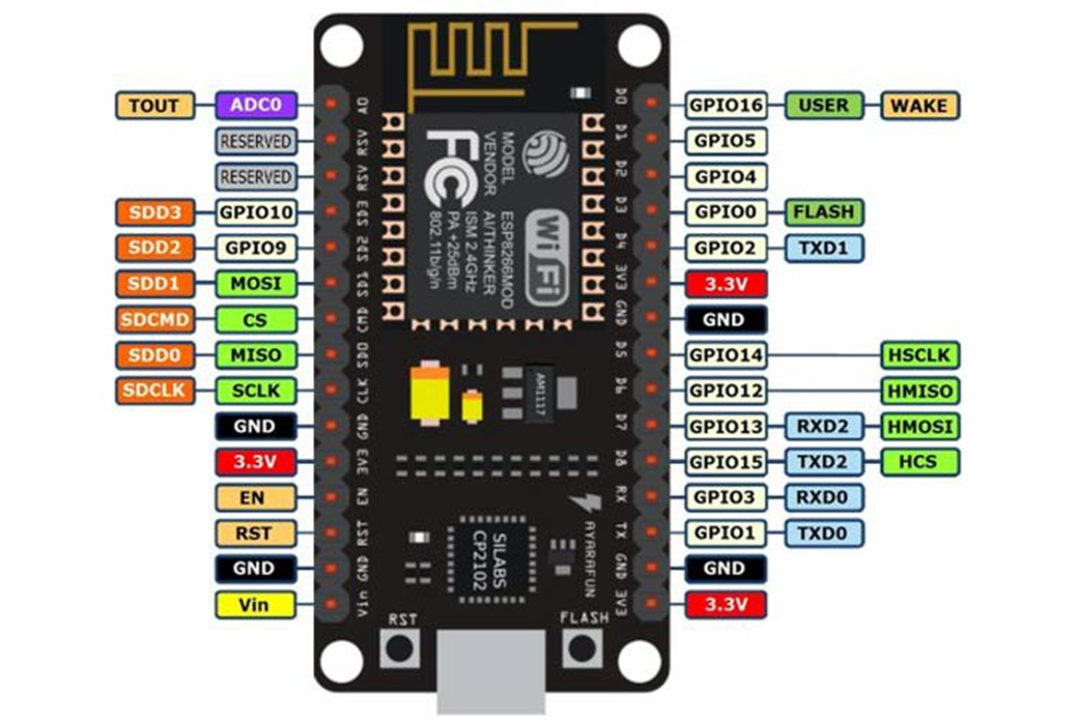

Fig. Node MCU

**User Interface:-** You can create a user-friendly interface using:

* **LCD Displays:-** Provide visual feedback and status information.
* **LEDs:-** Indicate device states or act as status indicators.
* **Touchscreens:-** Implement touch-based control interfaces.
* **Mobile Apps:-** Develop custom mobile apps to control and monitor your home automation system.

**Programming:-** Arduino Uno is programmed using the Arduino IDE (Integrated Development Environment). You write code to read sensor data, control actuators, and implement automation logic. Libraries and online resources are available to simplify coding tasks.

**Power Supply:-** Depending on the components and power requirements, you may need a suitable power supply to ensure reliable operation.

# PROPOSED SYSTEM

**Flow chat :-**

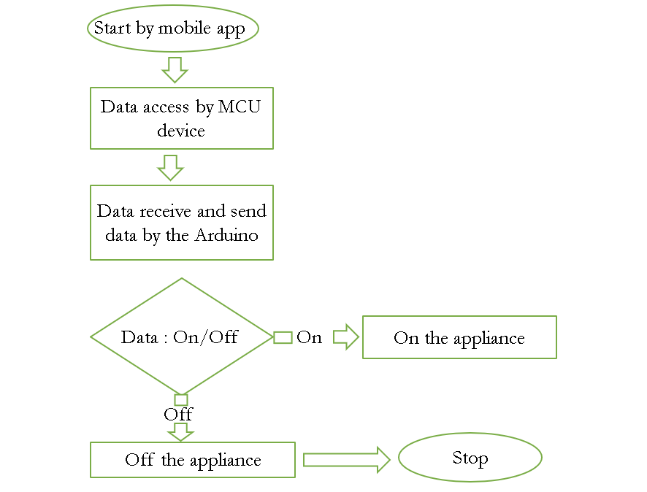

Fig . flow chat

The working of a Home Automation System (HAS) based on GSM and IoT technologies involves a seamless integration of hardware, software, and communication protocols to create an intelligent and interconnected living space. Here's a step-by-step breakdown of how such a system operates:.

The working of a Home Automation System (HAS) based on GSM and IoT technologies involves a seamless integration of hardware, software, and communication protocols to create an intelligent and interconnected living space. Here's a step-by-step breakdown of how such a system operates:

**Data Sensing and Collection:-** The core of the system lies in various IoT sensors strategically placed throughout the home. These sensors can include motion detectors, temperature sensors, humidity sensors, light sensors, door/window sensors, and more.These sensors continuously collect data related to environmental conditions (e.g., temperature, humidity, light levels), occupancy (e.g., motion), and security (e.g., door/window status).

**Data Transmission:-** The collected data from these sensors is transmitted to a central control hub, often via wireless communication protocols like Zigbee, Wi-Fi, or Bluetooth. .In the case of GSM-based systems, some data may be sent directly to cloud servers via the GSM network, ensuring that homeowners can access the data remotely.

**Central Control Hub:-** The central control hub acts as the brain of the system. It receives data from sensors, processes it, and makes decisions based on pre-defined rules and user preferences. It can be a dedicated hardware device or a software application running on a computer or server.

**Automation Rules and Logic: -** Automation rules are defined by the homeowner or system administrator. These rules specify conditions and actions to be taken based on sensor data. For example, if motion is detected in a room, the system can automatically turn on the lights in that room. If the temperature exceeds a certain threshold, it can adjust the thermostat settings accordingly.

**User Interface:-** Homeowners interact with the system through a user-friendly interface. This can be a mobile application, a web dashboard, or voice commands via integrated voice assistants like Amazon Alexa or Google Assistant .Users can monitor sensor data, set preferences, create automation rules, and control devices remotely through this interface.

**Device Control and Actuation:-** Based on the automation rules and user commands, the central control hub sends control signals to various actuators and smart devices. These can include smart lights, thermostats, locks, and appliances. For example, if a user commands the system to "turn off all lights," the central hub sends signals to all connected lights to switch them off.

**Security and Alerts:-** The system incorporates security features such as IoT-based surveillance cameras, door/window sensors, and smart locks. .In the event of a security breach or an unusual occurrence detected by sensors, the system can send instant alerts, notifications, or even trigger alarms to alert homeowners or authorities.

**Data Storage and Analysis:-** Sensor data, user preferences, and system performance data are often stored securely in the cloud or on local servers.

- Data analytics and machine learning algorithms may be applied to this data to derive insights, optimize energy consumption, and improve system performance over time.

**Scalability and Future Expansion:-**The system is designed to be scalable, allowing homeowners to add new IoT devices and functionalities as needed, ensuring future readiness and adaptability to emerging technologies.

In summary, a GSM and IoT-based Home Automation System transforms a traditional home into an intelligent, responsive, and connected living space. It relies on sensor data, automation rules, and user interfaces to provide convenience, energy efficiency, and security while enabling remote access and control, making daily life more efficient and comfortable for homeowners.

**5. RESULT**

Implementing home automation using an MCU node and MCU node IDE can result in a sophisticated system offering a range of functionalities. Through this setup, users can remotely control various home appliances and devices, such as lights, fans, or thermostats, using a smartphone or web interface. By integrating sensors like motion sensors or temperature sensors, the system can automate actions based on environmental conditions, promoting energy efficiency by adjusting settings accordingly. Additionally, incorporating security measures such as door/window sensors or surveillance cameras enhances home security, with the ability to receive notifications in case of any intrusion. Integration with voice assistants enables hands-free control of devices through voice commands. The system can also log and analyze sensor data, providing insights into occupancy patterns, energy usage, and environmental conditions over time. With expandability and customization options, users can tailor the system to their specific needs and preferences, creating a personalized and efficient home automation solution.

**5.1 Result of Application**

**5.2 Running the Application**

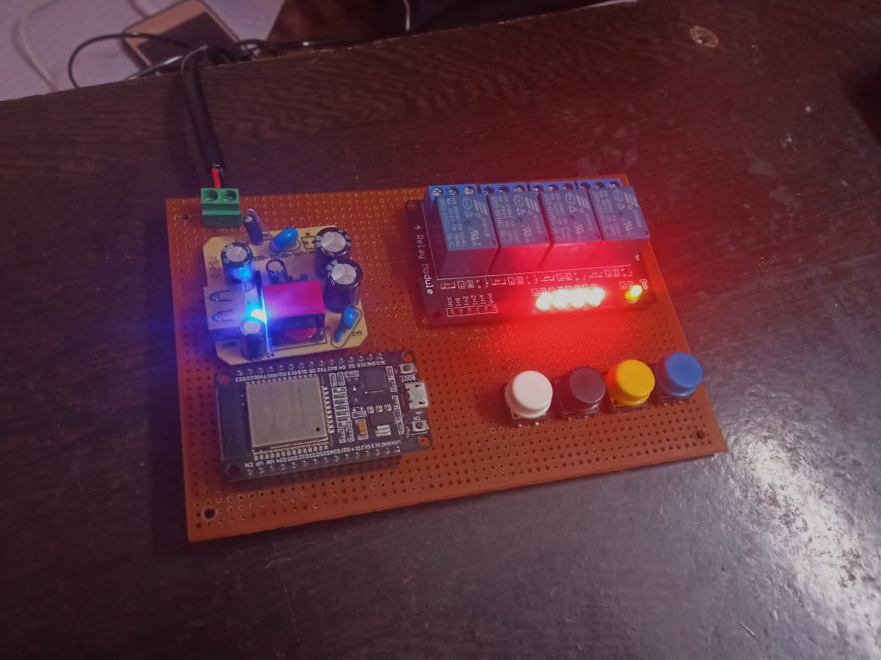

After the first installation, you meet setting screen. It has the two fields:

The first field used to enter IP address and port number as a link.

* Main screen
* Side menu
* Control by internet screen

This page used to enter to the control page, which has buttons to control hardware.

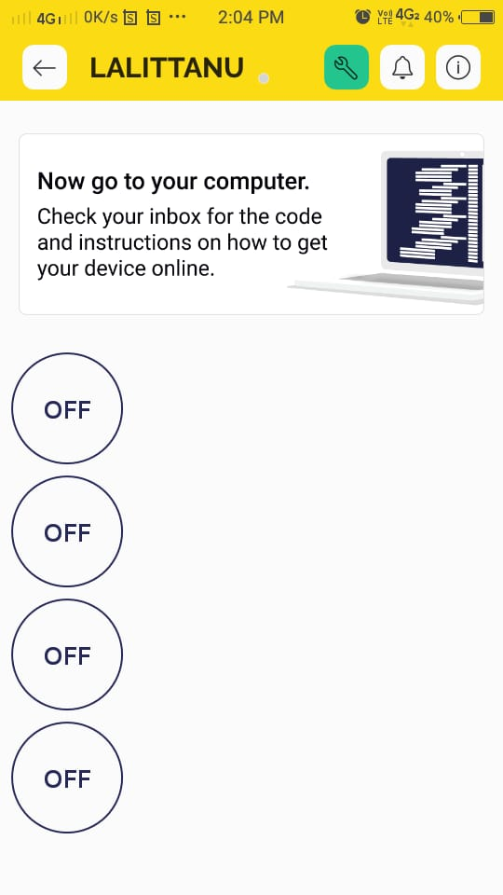 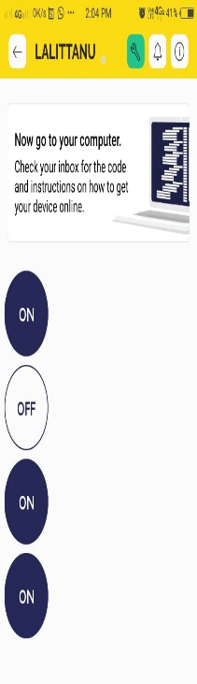

Fig.26: Pictures of Application

## 5.3 Control Buttons and Working

Control buttons used to control hardware part via the internet. The buttons are (open door, close door, open window, close window, open pump, close pump, open light, close light, open fan, close fan, open air-condition and close air-condition).

Open door: When the user presses open door button then the application will send a request as a link (<http://192.168.254.110:8080/?OPENDOOR>) that communicates with Arduino. Then MCU node will execute open door commands.

Fig.26: Pictures of Application

Close door: the user presses close door button so the application sends a request as a URL (<http://192.168.254.110:8080/?CLOSECDOOR>) which communicates with Arduino. Furthermore, MCU node executes close door commands.

Open window: When the user presses open window button then the application will send a request as a link (<http://192.168.254.110:8080/?OPENWINDOW>) that communicates with Arduino. Then MCU node will execute open window commands.

Close window: the user presses close window button so the application sends a request as a URL (<http://192.168.254.110:8080/?CLOSECWINDOW>) which communicates with Arduino. Furthermore, MCU node executes close window commands.

On pump: When the user presses open pump button then the application will send a request as a link (<http://192.168.254.110:8080/?OPENPUMP>) that communicates with Arduino. Then MCU node will execute open pump commands.

Off pump: the user presses close pump button so the application sends a request as a URL (<http://192.168.254.110:8080/?CLOSECPUMP>) which communicates with Arduino. Furthermore, MCU node executes close pump commands.

ON light: When the user presses open light button then the application will send a request as a link (<http://192.168.254.110:8080/?OPENLIGHT>) that communicates with Arduino. Then MCU node will execute open light commands.

Off light: the user presses close light button so the application sends a request as a URL (<http://192.168.254.110:8080/?CLOSECLIGHT>) which communicates with Arduino. Furthermore, MCU node executes close light commands.

On fan: When the user presses open fan button then the application will send a request as a link (<http://192.168.254.110:8080/?OPENFAN>) that communicates with Arduino. Then MCU node will execute open fan commands.

Off fan: the user presses close fan button so the application sends a request as a URL (<http://192.168.254.110:8080/?CLOSECFAN>) which communicates with Arduino. Furthermore, MCU node executes close fan commands. · Open air-condition: When the user presses open air-condition button then the application will send a request as a link (<http://192.168.254.110:8080/?OPENAIR>) that communicates with Arduino. Then MCU node will execute open air-condition commands.

## 5.4 The Working on Gas Sensor

The MQ2 sensor senses the gas leaking in the home then send the gas level value over MCU node and Ethernet shield or SIM900. When the gas level raises greater than natural level then MCU node will send notification via Ethernet shield or SIM900. For example, there is a gas leaking inside the home. Therefore, MCU node will open the fan and the window to expel the leaking gas. Simultaneously, MCU node will send the notification to the mobile.

**5.5 The temperature**

The LM35 sensor senses the temperature inside the home then send the temperature value through AR and Ethernet shield or SIM900. If the temperature increases, more than normal level then MCU node will send notification via Ethernet shield or SIM900. For example, there is a fire inside the home then MCU node will open the door, the window and water pump for firefighting. At the same time, MCU node will send the notification to the mobile.

**5. CONCLUSION**

The fusion of GSM and IoT technologies in the context of Home Automation Systems (HAS) represents a significant leap forward in the evolution of modern living. As we conclude our exploration of this innovative realm, it becomes abundantly clear that GSM and IoT-based home automation systems have the potential to redefine the way we interact with our living spaces. They offer unprecedented levels of convenience, energy efficiency, and security, shaping homes into intelligent, responsive environments.

**6. REFERENCES**

1. Arpita Yekhande, Prof. Kapil Misal, “HOME AUTOMATION SYSTEM USING RASPBERRY PI. “presented at International Research Journal of Engineering and Technology (IRJET) ,10 | Oct -2017). AUTOMATION SYSTEM USING RASPBERRY PI. “presented at International Research Journal of Engineering and Technology (IRJET) ,10 | Oct -2017).
2. Abhijit Shejal, Amit Pethkar, Akash Zende, Pratyusha Awate, Prof.Sudhir.G.Mane, AUTOMATION.” Presented at International Research Journal of Engineering and Technology (IRJET) 05 | May 2019.
3. Sudha Kousalya, G Reddi, Priya Vasanthi, B Venkatesh, IOT Based Smart Security and Smart q1`Home Automation presented at International Journal of Engineering Research & Technology 04, April-2018
4. K Eswari, DeviK Shravani, M Kalyani, Mr. Abbas Hussain, Mrs. N Gayathri “Real-Time Implementation of Light and Fan Automation using Arduino” presented at International Journal for Research in Applied Science & Engineering Technology (IJRASET), 06, June-2020
5. Bouzid Mohamed Amine , Chaib Fatima Zohra , Hamani Ilyes , Aid Lahcen, Allaoui Tayeb, “SMART HOME AUTOMATION SYSTEM.” Presented at
6. International Journal of Robotics and Automation (IJRA) ,4 | Dec. 2018
7. Ayush Gajjar, Deepak Mishra, Shubham Ingale, Aniket Kore, “SMART HOME SYSTEM.” Presented at International Research Journal of Engineering and Technology (IRJET) , 01 | Jan 2019
8. Shreya Bhuguna, karan karmyal “IOT in home automation” presented at International Journal for Research in applied science and Engineering Technology (IJRASET) 10|May 2022S