Blockchain in Supply Chain Management: A Review

Prachi D. Patil, Prachi J. Patil, Shweta Patil, Anjali Panchal, Prof. Sayali Karmode UG Students, IT Dept, MGM’s College of Engineering Kamothe, Navi Mumbai, India

Assistant Professor, IT Dept, MGM’s College of Engineering Kamothe, Navi Mumbai, India [pdp1479@gmail.com,](mailto:pdp1479@gmail.com) [pp1601034@gmail.com,](mailto:pp1601034@gmail.com) [shweta3819@gmail.com,](mailto:shweta3819@gmail.com) [anjalipanchal782@gmail.c](mailto:anjalipanchal782@gmail.c)om, [sayalis.karmode@gmail.c](mailto:sayalis.karmode@gmail.c)om

# Abstract—The market has seen significant change over the last few years, becoming more demanding and dynamic, which has created a competitive atmosphere. Because the supply chain depends so heavily on flexibility, collaboration, and integration, it is essential to the business's ability to react to the changing environment. Numerous business owners are interested in supply chain apps, and numerous specialized applications are being adopted to enhance the supply chain's flow control. Due to its ability to be swiftly adjusted to changing market conditions and business environments, blockchain technology is one of the most significant new technical applications in the supply chain and has attracted the interest of many business owners. After reading this, one will have a better understanding of how blockchain technology is being applied in this industry. The research paper's findings advise businesses to invest in blockchain technology to improve the supply chain's transparency, adaptability, and security. Without a doubt, building trust with supply chain stakeholders is facilitated by the use of blockchain technology. At the conclusion, the research article has also discussed some positive aspects and the blockchain's potential for integration and collaboration.

**Keywords — Blockchain, Supply Chain Management, Industry 4.0, Smart Contracts, Transparency, Trust, Traceability, Flexibility.**

# I.INTRODUCTION

Supply chain management has always been difficult for the majority of multinational corporations. The business has consistently invested a significant amount of resources, which results in a number of inefficiencies and cost reduction strategies. As blockchain technology approaches, businesses are considering the future. This technology may contribute to the supply chain's progress. Analysts claim that by improving supply chain efficiency, trust, and transparency, blockchain technology can improve the modern supply chain structure. [1]. Furthermore, many supply chain executives believe that blockchain technologies will be the supply chain's future. According to a 2019 PwC poll, almost 24% of the industrial manufacturing sector is considering using blockchain technology for supply chain management [2]. Over 55% of senior executives and practitioners viewed blockchain as their top priority, according to the 2020 Deloitte global blockchain study [3]. Because of its distributed safe technology, blockchain technology plays a critical role in the industry of the 4.0 era, as illustrated in Figs. 1, 2, and 3. The technology has attracted interest from the business and academic communities [4]. Blockchain is a distributed ledger technology that provides users with inexpensive, safe transaction and transfer settlement [5]. Furthermore, although blockchain is relatively new in the realm of supply chain networks that offer the future of business, it is not a new internet infrastructure.

# Definition of blockchain

It is understood to consist of a series of encrypted data blocks containing information that is locked to prevent access by anyone without the necessary key [6]. The chain is made up of numerous files that are connected to one another. Each file has historical data about the blocks in the blockchain as well as a timestamp that indicates when the data was created [7]. The blockchain is the collective name for all of the blocks.

# Blockchain infrastructure

Blockchain can only be accessed via an internet- connected PC, laptop, or server. When connected, all devices are referred to as blockchain nodes. The study of blockchain in the supply chain will cover how permission is granted to specific users and how blockchain is stored by nodes [8]. When data is saved and exchanged across different sites, countries, or institutions, it is known as a blockchain, and this process creates a ledger across the nodes [6]. Blockchain uses distributed ledgers, where each node stores identical data, in contrast totraditional databases, which encapsulate digital data in a centralized location.

# Adding to the blockchain

A node must send out a transition request containing the data it wants to contribute to other nodes in the blockchain network in order for the block to be created in order to add data to the blockchain block [7]. Before the new block can be added to the blockchain, it must beapproved for inclusion. When a new block is being validated, the node mist verifies that it is structured correctly and contains no duplicate transactions [9]. An encrypted block is added to the blockchain and the blockchain network once the block is validated, and the other nodes store it.

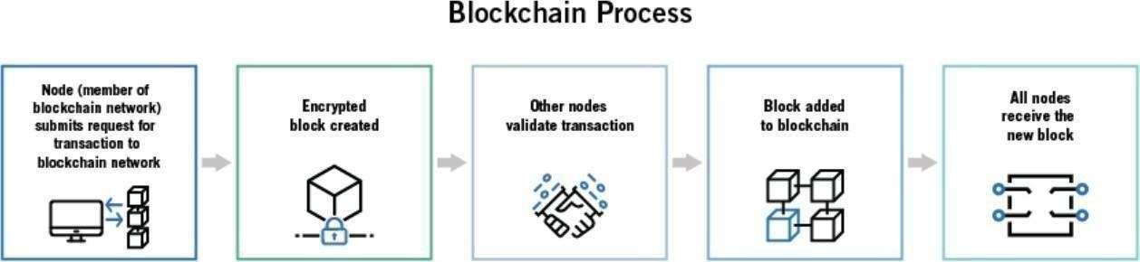

Fig. 1. Blockchain Infrastructure [6].

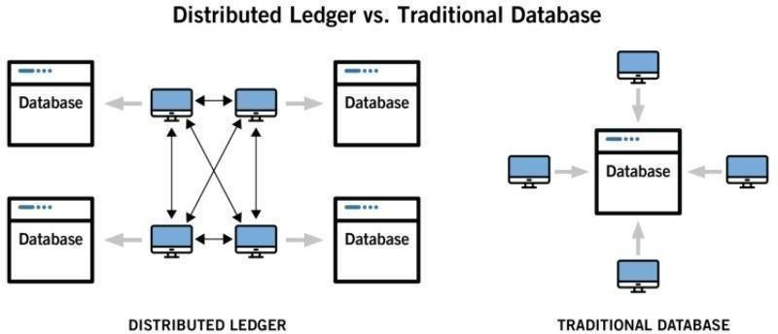

Fig. 2. Blockchain Process [7].

# RESEARCH OBJECTIVE

The study aims to explore blockchain technology and its potential benefits for logistics organizations. Although blockchain technology is a recent development and is not well known to most people, this paper has assisted readers in learning about its introduction and its applications in supply chain management.

# Research Question

How can technology be used to address some of the issues facing the supply chain?

# Research Motivation

Many products that are delivered to customers in the supply chain field are made up of independent farms. These factors make it difficult for the company to compete as stand-alone entities, even though they are a part of the vast supply chain network [11]. In addition, businesses are facing issues related to uncertainty as a result of globalization and elevated customer expectations. Additionally, there is intense market rivalry and a convoluted supply chain that necessitates collaboration amongst supply networks. Due to insufficient information exchange and internal competition, supply chains are fragmented. In addition, these limitations have a significant impact on how well a corporation performs and create problems, high operating expenses, and capacity storage that are easily fixed by blockchain technology.

# Research Gap

Although blockchain technology has many advantages, it is not a complete answer for supply chain management. Blockchain technology and associated technologies are not without their challenges. The project must acknowledge the difficulties in the supply chain system and the realm of supply changes, where a blockchain-based system necessitates numerous legislative regulations. Furthermore, the supply chain system's high transaction throughput requirements are not met by the current blockchain platform. There are many different players in the supply chain. To increase liquidity and data security, it is therefore essential to offer incentives like efficiency gains in order to keep participants highly motivated. Security and privacy are two more key concerns with blockchain technology [13]. The current IoT system is built on a central paradigm where the IoT devices are configured, connected, and validated. There are issues with IoT data. Thus, in order to discover blockchain technology, one must consider transformation.

# LITERATURE REVIEW

Literature on supply chain management in blockchain technology has grown significantly as the potential of blockchain to revolutionize supply chain operations becomes more apparent. Below is a brief literature survey outlining key research papers, articles, and reports in this domain:

"Blockchain Technology for Supply Chain Transparency: Potential Use Cases and Challenges" by Ivanov, D. (2019). This paper explores various potential applications of blockchain in improving transparency and traceability in supply chains. It discusses challenges such as scalability, interoperability, and data privacy.

"Blockchain Technology in Supply Chain Management: A Comprehensive Literature Review" by Laicity, M., & Khan, S. U. (2020). This review provides an extensive analysis of existing literature on blockchain technology in supply chain management. It covers topics such as benefits, challenges, adoption factors, and future research directions.

"Blockchain in supply chain and logistics: Progress and future directions" by Li, S., & Qiu, L. (2021). This paper discusses the progress made in implementing blockchain technology in supply chain and logistics contexts. It examines the benefits, challenges, and potential future directions for research and application.

"A Blockchain-Based Approach for Enhancing Transparency and Traceability in Supply Chains" by Zheng, Z., Xie, S., Dai, H., et al. (2019). The authors propose a blockchain-based approach to enhance transparency and traceability in supply chains. They present a framework and discuss its potential benefits and challenges.

"Blockchain Technology in Supply Chain Management: A Case Study of Coase a Supply Chains**"** by Cheng, M., Nie, T., & Lai, K. K. (2020). This paper presents a case study of applying blockchain technology in supply chain management using the Coase a supply chain framework. It discusses the implications of blockchain for transaction costs, information asymmetry, and governance structures.

# METHODOLOGY

* 1. **Traditional Research Methodology**

Traditional supply chain also includes a supplier, manufacturer, wholesaler, retailer and customer. But the main objective of extending the traditional supply chain is to consider the in between and eventual environmental effects of all products and processes known as stewardship. The stewardship concept is shown in figure 3 below. After the life cycle of the product gets over, the product is finally collected from customer and after the collection, if some components are found to be good enough to use, it is directly sent to the retailer and those are not further forwarded for dismantling. In final dismantling of the product, if some parts are found to be used are forwarded directly in manufacturing process and finally those, which are not of any use are disposed off or recycled such that it is used as raw material.

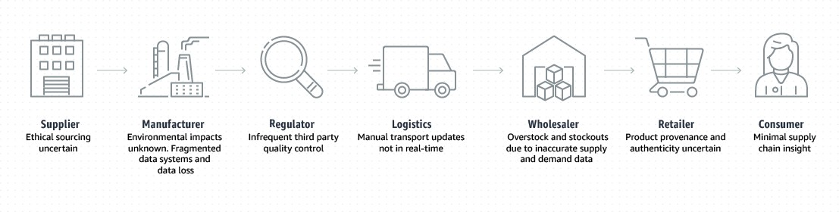

Fig.3 Traditional supply chain

# Supply chain in blockchain

Supply chain management (SCM) involves the coordination of activities and resources involved in the production and distribution of goods or services. Blockchain technology offers several potential benefits to traditional supply chain processes, including transparency, traceability, security, and efficiency. Here's how supply chains can leverage blockchain:

* + 1. **Transparency and Traceability**: Blockchain provides an immutable and transparent ledger where all transactions and data are recorded. Each participant in the supply chain can access and verify this information in real-time. This transparency enhances trust among stakeholders and allows for better traceability of products throughout the supply chain journey, from raw material sourcing to delivery to end customers. For example, in the food industry, blockchain can be used to trace the origin of contaminated products quickly, minimizing the impact of foodborne illness outbreaks.
    2. **Smart Contracts:** Smart contracts are self-executing contracts with the terms of the agreement directly written into code. In supply chain management, smart contracts can automate and enforce contractual agreements between parties. For instance, payment terms can be automatically executed upon the successful delivery of goods, eliminating the need for intermediaries and reducing transaction costs and delays.
    3. **Supply Chain Finance:** Blockchain can facilitate supply chain finance by providing a secure and transparent platform for trade financing, invoice factoring, and inventory financing. By digitizing trade documents and assets on the blockchain, financial institutions can mitigate risks and offer faster and more accessible financing options to suppliers and buyers.
    4. **Authentication and Counterfeit Prevention:** Blockchain enables the creation of digital certificates or unique identifiers for products, which can be recorded on the blockchain at each stage of the supply chain. This ensures the authenticity of products and helps prevent counterfeiting. Consumers can verify the authenticity of products using blockchain-enabled apps or scanning QR codes, thereby enhancing brand trust and consumer confidence.
    5. **Data Management and Interoperability:** Supply chains often involve multiple parties with different systems and data formats. Blockchain can serve as a distributed data layer that facilitates seamless data exchange and interoperability among disparate systems. This reduces data silos, improves data integrity, and streamlines information sharing across the supply chain network.
    6. **Regulatory Compliance:** Blockchain can help companies comply with regulatory requirements by providing an immutable audit trail of activities and transactions. This is particularly relevant in industries with stringent regulations, such as pharmaceuticals, where companies must track and verify the authenticity of drugs throughout the supply chain to comply with regulations like the Drug Supply Chain Security Act (DSCSA) in the United States.

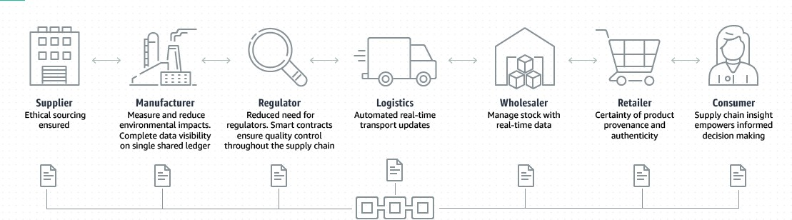

Fig 4. Supply chain in blockchain

# RESULT AND DISCUSSION

* 1. **Results**

There is no doubt in the fact that the modern supply chain has benefited from the advancement in technology but there are still significantchallenges the modern supply chain management encounters in functioning which are discussed below:

* + - Complex ecosystem: there is an intricate web of suppliers as well as registered channels of the global enterprise that operates atregional, national, and international levels [16]
    - Lack of traceability: it becomes difficult for the supply network to pinpoint providence
    - Improper response: there can be delay experienced if the process mismatch in between the individual country and the operatingcompany
    - Poor visibility: when the process is dispatched, [17] the company cannot keep track of the goods with the help of barcodes in thetransit
    - Data reconciliation: there can be problems with data reconciliation because there is a different process that is likely to log data invarious ways
    - Lack of trust: there can be a lack of trust in the system and the function when they are not transparent

The research paper has highlighted that complexity is the main factor of all these challenges. Previously companies had a limited number of suppliers and thus they know what to expect and whom to communicate with at the time of problems. But with time, the business ecosystem has changed, and the participants are not aware of one another and don't have visibility into the multi-layered supply structure. The business is also not aware of each other stated activities which increase the possibility of risk.

There is no way that the business can go back to the old practices because the market has become very wide and complicated as of now. But the complexity can be solved by finding a new way that would help in transparency and building trust between the companies. One of the major problems of supply chain companies is end-to-end monitoring. This has led to difficulty in figuring out the location as well as the condition of inventory in forecasting customer demand and properly tracking the share of the capacity of the transport [7]. Moreover, this also gives rise to improper end-to-end visibility, when global supply chains with geopolitical unrest are considered and it can put the organization at potential risk of disruption. If the company does not have a transparent supply chain, they can experience heavy losses as they have very improper information to figure out t response to disruption.

Blockchain in the supply chain process assures secure online transactions and this technology is the most suitable technology that can be adopted by supply chain management companies [18]. Apart from this, the technology is also helpful in providing the customer proper service by making it easier to access all the information of the product. The technology is also well valued for transparency, honesty as well as openness in the relationship of the various fields of the supply chain. Blockchain technology also offers faster transportation of goods and to figure out the weakness in the chain.

There is no doubt in the fact the technology would offer potential security and transparency comprehensively. The companies using blockchain technology can monitor the changes as well as record everything that was changed and who and why they have changed [14]. The reason why they can track the changes is that the items in the chain have a particular version of the registry and they will not experience any disagreement about transactions in the supply chain which makes the transaction process efficient. When the productsin the organization are shipped and the smart contract is signed the data gets reflected in the ledger. The data is then stored with proper information that as who created it and when it was created as well as the information on whether it was difficult to fake. Moreover, the companies who have access to this ledger can read the items and look at who is having the items currently. The paper has also discussed how blockchain can be treated with the internet of things and mobile technology to prepare a real-time delivery monitoring system [6].

There is no need to track the products manually rather one can use digital sensors to track goods in the entire supply chain from beginningto finish. The combination of blockchain and the internet of things in logistic companies can help in reducing delivery as well as with the logistic process to transfer it to closely track deliverables [17].

With the help of this, the organization can have an accurate and updated inventory by attaching small sensors to the products [1]. The smart inventory can provide useful data about the items that talk about past location and on-site storage times and many more.

There are also important attributes that are offered by digital ledgers that the supply chain can adopt. A study by [19] has indicated that blockchain assures transparency, security, authenticity as well as visibility. However, have explored the various attributes of the blockchain like decentralization, security, visibility as well as trust in the supply chain.

# Discussion

It has been discussed above that blockchain development is still a beginning and Technology such as robotic Technology, 5G, IoT, 3D printing, and big data can be integrated with blockchain technology in the 4.0 era . Talking about the IoT system, can be used in conjunction with blockchain technology for enhancing traceability by collecting census offering consumers as well as retailers to trace the total process of the supply chain. Other applications suggest monitoring delivery process and machine landing models can be usedin predicting potential risk and tracing the origin of the raw material. their system can be used to its full potential by installing different types of sensors that can help in generating various traceability reports. Moreover, by integrating the above Technology with blockchain, many features can be benefited by arranging the resources of the logistics by the IoT system availability [10]. Hence the client can figure out the delivery status as soon as possible without any hassle.

# CONCLUSION

There are a group of companies that make supply chain systems, and it also consists of various types of flow such as information, finance, and goods. It Is important to collaborate with the various forms of the business and integrate the flows to enhance the total performance and come up with a competitive advantage for the various organizations. The literature review of the blockchain explored the powerful features that can be used in various fields. Moreover, the paper has also highlighted blockchain technology and how it would facilitate supply chain collaboration and integration.

This paper converges the main themes of compliance, immutability, disability as well as transparency. It also agreed to the fact that the main themes are there in the blockchain and how it can help in bringing advantages of the supply chain management. The reason has also shown that the blockchain is one of the emerging technologies and the pandit must be given the chance to prove that it can bring a changein the supply chain.

The people have also explored smart contracts and how in reality they can be helpful by implementing them in today's traditional

system. Analysis has also been done on smart contracts about how one can input data into the blockchain. On the other hand, a few of the researchers did not agree with the fact about blockchain implementation is a standalone software that plays a pivotal role in reducing the cost of traditional software. But most of the researchers have agreed to more than one point that blockchain implementation in IOT devices reduces cost.

# Future Work

Blockchain is an emerging technology and can help in the upliftment of the supply chain business; it alone cannot make any disrupted changes in the business ecosystem. But the research paper has highlighted that the technology would provide direction and ideas for future research and a couple of directions have been suggested. The primary objective is to monitor the business needs that are defined at the high level which consists of capability needs. The second factor is the Technology exploration research that will develop innovative services by taking into account new information and communication technologies.

Lastly, the authors suggested that it is very crucial to integrate blockchain with other technologies like the IoT, smart contract 3D printing, etc., and welcome the end user to give ideas on the various services. All the studies would help government managers as well as researchers to understand blockchain technology and implement it in business and supply chain management.

# Open Research Questions

Currently, the organizations have no clue about blockchain-enabled solutions and a seeking networking

with the corresponding groups on this concept. The progress of blockchain technology in the supply chain field has been slow inenterprises because of several reasons that are discussed below.

* + - The organizations are still arguing for finding a solution that can offer the best integration, security, privacy, customerexperience and scalability.
    - The organizations are not sure of the regulatory as well as compliance application of the deployment
    - The potential use cases have not been identified and how the use cases can be comprehensive is also not judged
    - The organization fails to identify when to initiate in making a consortium or to join with the existing one
    - Metal hurdles because of the extensive complication interaction as well as change in the management ahead
    - The rising tactical and technological issues that are required to be addressed include performance and scalability, data governance, enterprise architecture as well as business process design

# REFERENCES

* + - 1. S. Gore, S. Hamsa, S. Roychowdhury, G. Patil, S. Gore and S. Karmode, *"Augmented Intelligence in Machine Learning for Cybersecurity: Enhancing Threat Detection and Human-Machine Collaboration,"* 2023 Second International Conference on Augmented Intelligence and Sustainable Systems (ICAISS), Trichy, India, 2023, pp. 638-644,Doi: 10.1109/ICAISS58487.2023.10250514.
      2. Layth Almahadeen, Renzon Daniel Cosme Pecho, Murugananth Gopal Raj, Nichenametla Rajesh, Zainab Mohammed Imneef, Sayali Karmode Yelpale, *“Digital Investigation Forensic Model with P2P Timestamp Blockchain for Monitoring and Analysis”* , Journal of Electrical System, Vol. 1, No 1, (2024): 09-17 ( DOI : <https://doi.org/10.52783/jes.656>)
      3. Sayali Karmode, *Security Challenges for IoT Based Applications & Solutions Using Fog Computing: A Survey,* Journal of Journal of Cybersecurity and Information Management, Vol. 3 , No. 1 , (2020) : 21-28 (Doi : <https://doi.org/10.54216/JCIM.030103>)
      4. M. S. K. Yelpale, “Security and privacy challenges in cloud computing: a review,” *Journal of Cybersecurity and Information Management*, vol. 4, no. 1, pp. 36–45, 2020.

View at: [Google Scholar](https://scholar.google.com/scholar_lookup?title=Security%20and%20privacy%20challenges%20in%20cloud%20computing%3A%20a%20review&author=M.%20S.%20K.%20Yelpale&publication_year=2020)

* + - 1. Sayali Karmode Yelpale, *“IOT Technology for Pandemic Situation”, NJITM*, vol. 4, no. 2, pp. 25–27, Jan. 2022 [https://mbajournals.in/index.php/JoITM/article/view/806.](https://mbajournals.in/index.php/JoITM/article/view/806)
      2. Karmode, S. S., & Bhagat, V. B. (2017). *DETECTION AND BLOCKING SOCIAL MEDIA MALICIOUS POSTS. International journal of modern trends in engineering and research*, *4*(5).
      3. Kermode, S. S., & Bhagat, V. B. (2016). A Review: Detection and Blocking Social Media Malicious Posts. *Int. J. Mod. Trends Eng. Res*, *3*(11), 130-136. doi: [10.21884/IJMTER.2016.3133.Q4M8O .](https://doi.org/10.21884/IJMTER.2016.3133.Q4M8O)
      4. Prof. Bhushan B. Thakare, Prof. Sayali Karmode Yelpale, “Smart Home with Edge Computing”, International Journal of Interdisciplinary Innovative Research & Development (IJIIRD), Vol 6, 2021 [https://ijiird.com/wp-](https://ijiird.com/wp-content/uploads/CSE016-1.pdf) [content/uploads/CSE016-1.pdf](https://ijiird.com/wp-content/uploads/CSE016-1.pdf)
      5. Sayali Karmode, “Blockchain Technology Security Issues and Concerns : A Review”, International Research Journal of Modernization in Engineering Technology and Science, Vol 6, Issue 03, March 2024 DOI : https:/[/w](http://www.doi.org/10.56726/IRJMETS50249)w[w.doi.org/10.56726/IRJMETS50249](http://www.doi.org/10.56726/IRJMETS50249)
      6. Wang Y, Singgih M, Wang J, Rit M. Making sense of blockchain technology: How will it transform supply chains? Int. J. Prod. Econ., 2019; 211: 221-236.
      7. Huddiniah ER, Er M. Product Variety, Supply Chain Complexity and the Needs for Information Technology: A Framework Based on Literature Review, Operations and Supply Chain Management: An International Journal, 2019; 12(4): 245-255
      8. [Zibin Zheng,](https://www.researchgate.net/profile/Zibin-Zheng-2?_tp=eyJjb250ZXh0Ijp7ImZpcnN0UGFnZSI6InB1YmxpY2F0aW9uIiwicGFnZSI6InB1YmxpY2F0aW9uIn19) [Shaoan Xie,](https://www.researchgate.net/profile/Shaoan-Xie?_tp=eyJjb250ZXh0Ijp7ImZpcnN0UGFnZSI6InB1YmxpY2F0aW9uIiwicGFnZSI6InB1YmxpY2F0aW9uIn19) [Hong-Ning Dai](https://www.researchgate.net/profile/Hong-Ning-Dai?_tp=eyJjb250ZXh0Ijp7ImZpcnN0UGFnZSI6InB1YmxpY2F0aW9uIiwicGFnZSI6InB1YmxpY2F0aW9uIn19)An Overview of Blockchain Technology: Architecture, Consensus, and Future Trends, DOI[:10.1109/BigDataCongress.2017.85](http://dx.doi.org/10.1109/BigDataCongress.2017.85)
      9. Wang Z, Wang T, Hu H, Gong J, Ren X, Xiao Q. Blockchain-based framework for improving supply chain traceability and information sharing in precast construction. Autom. Constr., 2020; 111: 103063.
      10. Huddiniah ER, Er M. Product Variety, Supply Chain Complexity and the Needs for Information Technology: A Framework Based on Literature Review, Operations and Supply Chain Management: An International Journal, 2019; 12(4): 245-255.
      11. Xu P, Lee J, Barth J, Richey R. Blockchain as supply chain technology: Considering transparency and security. Int. J. Phys. Distrib. Logist. Manag., 2021; 51: 305–324.
      12. [Rizwan Manzoor**,**](https://link.springer.com/article/10.1007/s10479-022-05069-5#auth-Rizwan-Manzoor-Aff1)[B. S. Sahay](https://link.springer.com/article/10.1007/s10479-022-05069-5#auth-B__S_-Sahay-Aff1) **&** [Sujeet Kumar Singh,](https://link.springer.com/article/10.1007/s10479-022-05069-5#auth-Sujeet_Kumar-Singh-Aff1)Blockchain technology in supply chain management: an

organizational theoretic overview and research agenda, Original Research**,** Published: 24 November 2022

* + - 1. Blockchain and Supply Chain Management Arman Jabbari | Philip Kaminsky Department of Industrial Engineering and Operations Research University of California, Berkeley January 2018
      2. Martha Herndon, Sydney Verge, Sharon Halley, Stephine Holloway, Blockchain Technology in Supply Chain Management MGMT 6260
      3. Pranav Chavan, Harshraj Deshmukh, Aakash Dhotre, Aditya Gharat, Sayali Karmode, “Blockchain Democracy : Evaluating a Secure Voting System”, International Research Journal of Modernization in Engineering Technology and Science, Vol 6, Issue 03, March 2024 DOI : <https://www.doi.org/10.56726/IRJMETS50478>