**IoT-Based Baby Monitoring System for Smart Cradle: A Comprehensive Solution for Infant Care**

**E. Sasikala Reddy1, Y Niharika2, A Rajesh2, Ch Ramya2, M Deepika2, S Shiva2**

1Assistant Professor, Dept. of ECE, Gokula Krishna College of Engineering, Sullurpet, India

2UG Scholar, Dept. of ECE, Gokula Krishna College of Engineering, Sullurpet, India

**ABSTRACT**

In the contemporary era, where dual-income households are increasingly common, the challenge of balancing professional commitments with infant care responsibilities is ubiquitous. To address this challenge, an innovative solution is proposed: the IoT-based Baby Monitoring System for Smart Cradle. This system integrates cutting-edge technologies such as Internet of Things (IoT), sensor modules, and microcontrollers to offer real-time monitoring and automated functionalities for infant care. Key features include alert notifications for crying, automatic swinging to soothe the baby, detection of bodily functions like potty, and monitoring of body temperature. Leveraging GSM modules for communication, the system ensures seamless connectivity and instant alerts to caregivers. A comprehensive literature review reveals shortcomings in existing methods, such as manual intervention, limited data insights, and incomplete monitoring capabilities. In contrast, the proposed system addresses these limitations by providing continuous monitoring, automated controls, remote accessibility, and data analytics. Through a detailed methodology, the components and functionalities of the system are described, highlighting its potential to revolutionize modern parenting and caregiving practices. The findings underscore the significance of technological advancements in enhancing infant care efficiency and parental peace of mind.

**Keywords:** Automated Alerts, Infant Care, IoT-based Baby Monitoring System, Real-time Monitoring, Smart Cradle

1. **INTRODUCTION**

In the contemporary landscape of modern living, the dynamics of family structures and societal norms have undergone significant transformations. With the rise of dual-income households and busy professional schedules, parents often find themselves juggling multiple responsibilities, including the care of their infants. However, the demands of work and domestic life can present challenges in effectively monitoring and attending to the needs of their babies, particularly during crucial developmental stages. Recognizing these challenges, there arises a pressing need for innovative solutions that can provide efficient and reliable infant care while accommodating the demands of modern lifestyles [1].

In response to this need, the IoT-based Baby Monitoring System for Smart Cradle is introduced, a pioneering approach to infant care that leverages the power of technology to enhance parental peace of mind and ensure the well-being of infants. This system represents a convergence of cutting-edge technologies, including the Internet of Things (IoT), sensor modules, and microcontrollers, to create a comprehensive solution for real-time monitoring and automated caregiving [2].

The rationale behind the development of this system stems from the inherent difficulties faced by working parents in simultaneously managing their professional commitments and attending to the needs of their infants. Traditional approaches to infant care, such as manual monitoring and standalone devices, often prove inadequate in providing the level of attention and support required for optimal infant development. Moreover, the limitations of existing methods, including the need for constant human intervention, lack of real-time monitoring capabilities, and incomplete insights into infant well-being, underscore the necessity for a more sophisticated and integrated approach to infant care [3].

The IoT-based Baby Monitoring System for Smart Cradle offers a multifaceted solution to address these challenges comprehensively. By integrating sensor modules capable of detecting vital parameters such as ambient sound, room conditions, body temperature, and infant weight, the system provides caregivers with real-time data insights into the well-being of their infants. Furthermore, automation features such as adaptive rocking, environmental control, and instant alerts for exceptional conditions ensure prompt and efficient responses to the needs of the infant, even in the absence of direct human supervision [4].

A critical aspect of the proposed system is its connectivity and accessibility. Leveraging GSM modules for communication, the system enables seamless interaction between caregivers and the smart cradle, facilitating remote monitoring and instant notifications of critical events. This functionality not only enhances convenience for caregivers but also ensures timely interventions in case of emergencies or unusual occurrences.

Through a thorough literature review, the limitations of existing methods and solutions in infant care, ranging from manual intervention to incomplete monitoring capabilities, have been identified. By addressing these shortcomings and offering a comprehensive and technologically advanced solution, the IoT-based Baby Monitoring System for Smart Cradle seeks to redefine the paradigm of infant care in the digital age.

In the subsequent sections of this paper, a deeper delve into the methodology, implementation, and evaluation of the proposed system will be presented, highlighting its potential to revolutionize modern parenting practices and contribute to the well-being of infants and caregivers alike.

1. **LITERATURE SURVEY**

The landscape of infant care has seen various attempts to innovate and improve existing methods, with researchers exploring different approaches to address the challenges faced by parents and caregivers. A review of existing literature reveals a range of studies and research papers focused on infant monitoring systems, smart cradles, and related technologies.

One notable study by Shahadi et al. (2020) presented an Automatic Monitoring and Swing the Baby Cradle for Infant Care [5]. The authors introduced a system equipped with a swing mechanism and facial expression analysis for ensuring infant safety. However, the use of artificial intelligence led to increased system costs, highlighting the need for cost-effective solutions.

Similarly, Shasna et al. (2019) proposed an Infant Cradle Monitoring System using IoT [6]. Their system integrated IoT technology to monitor various parameters such as temperature and humidity, providing caregivers with real-time data for enhanced infant care. This study emphasized the importance of IoT connectivity in modern infant monitoring solutions.

In contrast, Goyal and Kumar (2013) introduced an Automatic e-baby Cradle Swing based on Baby Cry [7]. Their system utilized sound recognition technology to detect infant cries and initiate automatic swinging of the cradle. While effective in addressing certain aspects of infant care, this approach focused primarily on cry detection without comprehensive monitoring capabilities.

Furthermore, Patil and Mhetre (2014) presented an Intelligent Baby Monitoring System, which offered continuous monitoring of infant activities and vital signs [8]. The system aimed to provide caregivers with insights into the well-being of infants through real-time data analysis. However, the study highlighted the need for further research to improve the accuracy and reliability of monitoring systems.

Additionally, Palaskar et al. (2015) proposed an Automatic Monitoring and Swing the Baby Cradle for Infant Care [9]. Their system incorporated automatic swing functionality and monitoring capabilities to ensure infant safety and comfort. This study underscored the importance of automation in modern infant care solutions.

These studies collectively demonstrate the ongoing efforts to innovate and improve infant monitoring systems, with a focus on enhancing convenience, safety, and efficiency for parents and caregivers. However, existing approaches often suffer from limitations such as high costs, limited functionalities, or lack of comprehensive monitoring capabilities. Addressing these challenges requires the development of cost-effective, technologically advanced solutions that integrate IoT connectivity, sensor technologies, and automation features to provide seamless and reliable infant care [10]-[12].

1. **METHODOLOGY**

The Smart Cradle System proposed herein integrates a diverse array of components, incorporating IoT connectivity via GSM, alongside various sensors including soil moisture, sound, and the DHT11 sensor. Additionally, microcontrollers such as ArduinoUno are utilized to establish a comprehensive solution for infant care.

This sophisticated system enables continuous real-time monitoring of crucial parameters such as environmental conditions and infant well-being. Furthermore, automation features such as adaptive rocking, environmental control, and instant alerts serve to enhance the comfort and safety of the infant.

Caregivers are afforded remote access via a mobile application or web interface, thereby ensuring convenience and peace of mind. Robust security measures, encompassing restricted camera access and data encryption, are implemented to safeguard the privacy of users and the sensitive nature of infant health monitoring.

The proposed methodology marks a significant advancement in modern parenting and caregiving practices. When monitored values exceed predefined thresholds, audible alerts are emitted through the speaker, and notifications are promptly dispatched to the user. Additionally, temperature regulation functionality is facilitated through the activation of a fan in response to temperature fluctuations.

The system's architecture encompasses various components, including but not limited to:

* Power Supply
* Soil Moisture Sensor
* Sound Sensor
* DHT11 Sensor
* Arduino Uno Microcontroller
* APR9600 Chip
* LCD Display
* Relay Module
* L293d Motor Driver
* GSM Module
* Speaker
* Fan
* Motor
* IP Camera

1. Power Supply: Provides electrical power to the entire system, ensuring its continuous operation.
2. Soil Moisture Sensor: Measures the moisture content of the soil in the cradle, aiding in the monitoring of environmental conditions.
3. Sound Sensor: Detects sound levels within the vicinity of the cradle, contributing to the assessment of the infant's auditory environment.
4. DHT11 Sensor: Monitors temperature and humidity levels in the cradle, crucial for maintaining optimal comfort conditions for the infant.
5. Arduino Uno Microcontroller: Serves as the central processing unit, coordinating the functioning of various components and executing programmed tasks.
6. APR9600 Chip: Used for audio playback, emitting audible alerts and messages when predefined thresholds are exceeded.
7. LCD Display: Provides visual feedback and status information to caregivers, enhancing user interaction and feedback.
8. Relay Module: Controls the activation of other devices, such as fans or motors, based on input conditions or commands.
9. L293d Motor Driver: Facilitates the operation of motors, enabling functionalities such as adaptive rocking of the cradle.
10. GSM Module: Enables communication with caregivers via mobile networks, providing real-time alerts and notifications.
11. Speaker: Emits audible alerts and messages to caregivers when abnormal conditions are detected or user intervention is required.
12. Fan: Regulates temperature within the cradle by activating in response to temperature fluctuations, ensuring the infant's comfort.
13. Motor: Drives mechanical components such as rocking mechanisms, contributing to the cradle's automation features.
14. IP Camera: Provides visual monitoring of the infant, enhancing caregiver oversight and enabling remote viewing via the Internet.

The IoT-based Baby Monitoring System for Smart Cradles operates via an interconnected network of devices. Embedded sensors within the cradle detect the baby's movements, temperature variations, and sound levels. Subsequently, these data streams are transmitted in real-time to a centralized hub utilizing Internet of Things (IoT) protocols, thereby enabling parents to remotely monitor their infant's status.

Advanced algorithms are employed within the system to analyze sleep patterns and environmental conditions, providing valuable insights into the baby's well-being. Alerts and notifications are automatically triggered in response to irregularities, ensuring timely intervention and appropriate action. The integration of IoT technologies culminates in a smart, responsive, and user-friendly solution for enhanced baby monitoring and care. The block diagram, swing cradle flowchart, and messaging systems are given in Fig. 1 to 3.

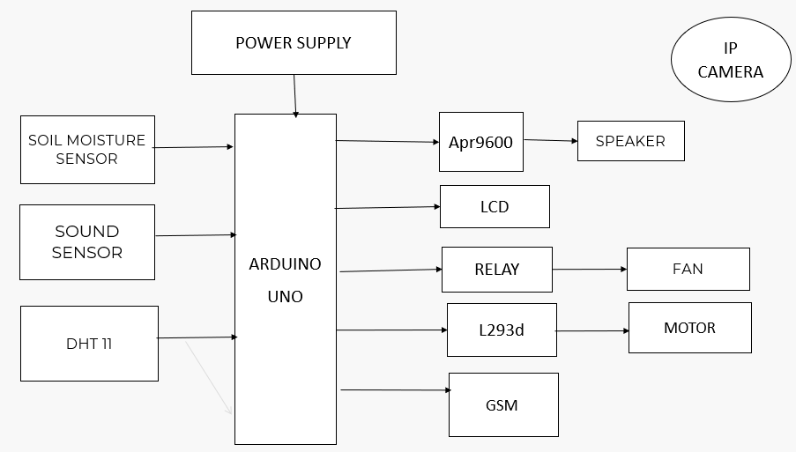

**Figure 1:** Block Diagram.

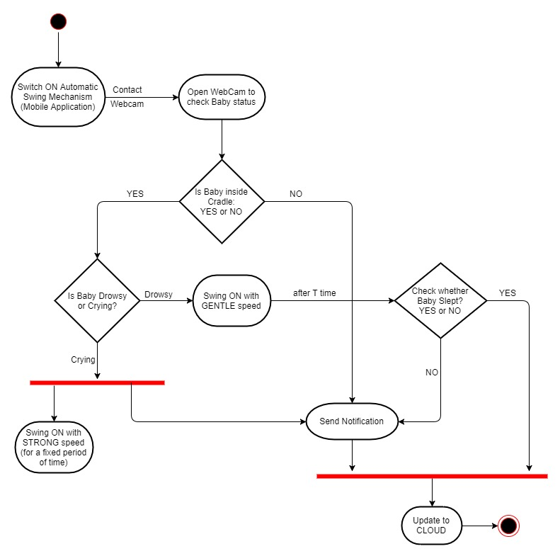

**Figure 2:** Automatic Swing Cradle Flowchart.

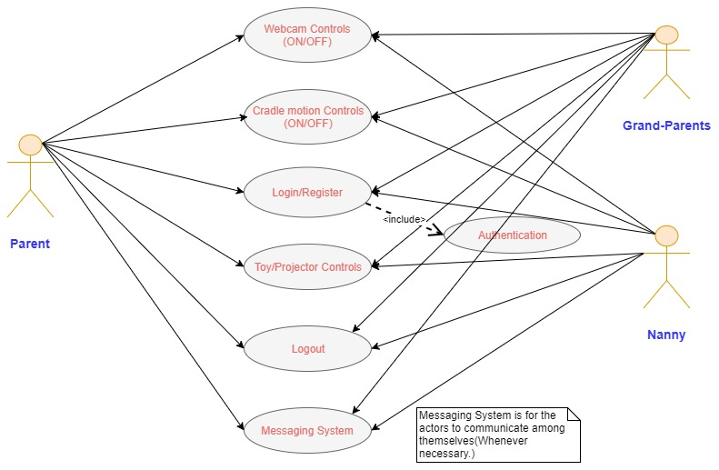

**Figure 3:** Messaging System.

1. **CONCLUSIONS**

The development and implementation of the IoT-based Baby Monitoring System for Smart Cradle represent a significant advancement in modern infant care solutions. Through the integration of cutting-edge technologies such as the Internet of Things (IoT), sensor modules, microcontrollers, and automation features, the system offers a comprehensive and reliable solution for addressing the challenges faced by parents and caregivers in monitoring and attending to the needs of infants. The system's ability to provide real-time monitoring of vital parameters such as ambient sound, temperature, humidity, and soil moisture, coupled with automation features such as adaptive rocking and alert notifications, enhances parental peace of mind and ensures the well-being of infants even in the absence of direct human supervision. Moreover, the system's connectivity options, including GSM modules for communication and remote access through mobile apps or web interfaces, enable caregivers to monitor and control the smart cradle system conveniently from anywhere.

1. **REFERENCES**
2. M. Jayamma, N. Ramanjaneyulu, A. Sathish, and Y. M. Rao, “Crosstalk Analysis of On-chip VLSI Interconnects,” International Journal of Emerging Research in Engineering, Science, and Management, vol. 1, no. 4. JPM Publishers, 2022. doi: 10.58482/ijeresm.v1i4.2.
3. C. Venkataiah, D. R. Setty, N. Ramanjaneyulu, and Y. M. Rao, “Crosstalk Peak Overshoot Analysis of VLSI Interconnects,” International Journal of Emerging Research in Engineering, Science, and Management, vol. 2, no. 1. JPM Publishers, 2023. doi: 10.58482/ijeresm.v2i1.2.
4. V. Talakayala, P. Dahiwale, and S. Mate, “General Voting System for Democratic Countries Using Blockchain and Computer Technology,” International Journal of Emerging Research in Engineering, Science, and Management, vol. 2, no. 1. JPM Publishers, 2023. doi: 10.58482/ijeresm.v2i1.3.
5. E. S. Reddy and T. Sathyanarayana, “Design and Implementation of New Biorthogonal Wavelets and its Application to Image Processing,” International Journal of Emerging Research in Engineering, Science, and Management, no. 1. JPM Publishers, 2022. doi: 10.58482/ijeresm.v1i1.2.
6. Shahadi, H. I., Muhsen, D. H., Haider, H. T., & Taherinia, A. H. (2020). An Automatic Monitoring and Swing the Baby Cradle for Infant Care. IOP Conference Series: Materials Science and Engineering, 671(1), 012050.
7. Shasna, M., Mathilakam, K., Kabeer, M. M., Navami Krishna, U. A., Nazar, N. N., & Ashok, N. (2019). Infant cradle monitoring system using IoT. International Journal of Advanced Research in Computer and Communication Engineering, 8(4).
8. Goyal, M., & Kumar, D. (2013). Automatic e-baby cradle swing based on baby cry. International Journal of Computers and Applications, 975, 8887.
9. Patil, S. P., & Mhetre, M. R. (2014). Intelligent baby monitoring system. ITSI Transactions on Electrical and Electronics Engineering, 2(1), 11-16.
10. Palaskar, R., Pandey, S., Telang, A., Wagh, A., & Kagalkar, R. R. (2015). An automatic monitoring and swing the baby cradle for infant care. International Journal of Advanced Research in Computer and Communication Engineering, 4(12), 187-189.
11. K. Subramanyam and T. Ramasri, “Design of Biorthogonal Wavelets based on Spline and Spline-like Functions for Image Compression,” International Journal of Emerging Research in Engineering, Science, and Management, no. 1. JPM Publishers, 2022. doi: 10.58482/ijeresm.v1i1.3.
12. K. Hemalatha and E. S. Reddy, “An Image Processing-Driven System for Fake Currency Detection,” International Journal of Emerging Research in Engineering, Science, and Management, vol. 2, no. 2. JPM Publishers, 2023. doi: 10.58482/ijeresm.v2i2.2.
13. C. Keerthipriya and M. N. Shaik, “Machine Learning-Based Approach for Cardiovascular Disease Detection and Classification,” International Journal of Emerging Research in Engineering, Science, and Management, vol. 2, no. 2. JPM Publishers, 2023. doi: 10.58482/ijeresm.v2i2.3.