**A STUDY ON EMPLOY RETENTION IN MN AUTO PRODUCTS PRIVATE LIMITED, COIMBATORE**

**KARTHIKEYAN T1, Mr.K.MANOJKUMAR2**

1Final Year MBA, Excel Engineering College(Autonomous), Komarapalaym

2Assistant Professor, Department of Management Studies, Excel Engineering College(Autonomous), Komarapalaym

**ABSTRACT**

**Hiring knowledge people for the job is essential for an employer. But retention is even more important than hiring. The employees are the valuable assets to the organization so it is the responsibility of an organization to develop the strategies in order to retain the employees. The researcher study conducted is descriptive in nature. Both primary and secondary data collected to meet the require for the collective data a stipulated questionnaires method is used as an instrument the questionnaires consists of multi choice, five scale and ranking questions and convenience sampling using the study and the sample size is 150. Percentage analysis, Weighted average method, Chi-square test, Correlation analysis, Regression analysis and ANOVA analysis was used for research purpose. The findings shows that most of the Employees need some changes in the working environment.**

**Keywords:** Employer, Employee, Hiring,Retain…

1. **INTRODUCTION**

Effective employee retention is a systematic effort by employers to create and foster an environment that encourages current employees to remain employed, by having policies and practices in place that address their diverse needs. A strong retention strategy, therefore, becomes a powerful recruitment tool. Retention of key employees is critical to the long-term health and success of any organization. It is a known fact that retaining the best employees ensures customer satisfaction, increased product sales, satisfied colleagues and reporting staff, effective succession planning, and deeply embedded organizational knowledge and learning. Employee retention is important to team building and cohesion in the workplace so workers can come to trust and depend on each other. Diminished productivity and competitive advantage are among the biggest losses when talented employees leave an organization high employee turnover rate can harm an organization's ability to carry out its mission due to impairments to continuity, loss of institutional knowledge, and high costs of replacing departing workers and training new replacements.

1. **OBJECTIVES OF THE STUDY**

* To study the employee retention in M N Auto Products Private Limited, Coimbatore.
* To identify the current retention strategies being used by the organization, such as employee recognition programs, training and development opportunities, and work-life balance initiatives.
* To find out employer and employee relationship in the company.
* To know the compensation, motivational techniques, welfare facilities and Job satisfaction of employees in the Organization

1. **LIMITATIONS OF THE STUDY**

* This study can provide the employer and employee relationship in the company.
* This study can define the compensation, motivational techniques, welfare facilities and Job satisfaction of employees in the Organization.
* This study will help to make the implementation decision in the future period.
* This study will analysis the reason for employee attrition in the organization.
* This study can help to identify the underlying reasons for employee productivity and develop effective strategies to improve retention.

1. **METHODOLOGY**

**Research Design**

In here in order to meet the research objectives, descriptive research design is used.

**Sample Frame:** M N Auto Products Private Limited.

**Sample Unit:** All the 3 levels of employees like top level, middle level and lower level.

**Sample Size :**150 respondents

**Project Area**: Human Resource Department

**Sample Size**

Sample size refers to the number of participants are included from the total population in a study. The sample size of 150 was taken for the study.

**Sampling Technique**

In this study probability sampling technique is used. In probability sampling method, Simple Random Sampling technique is employed.

1. **RESULTS AND DISCUSSION**

**REASON FOR LEAVING THE JOB OF EMPLOYEES IN THE ORGANIZATION**

|  |  |  |  |
| --- | --- | --- | --- |
| **S.NO** | **PARTICULARS** | **NO.OF.RESPONDENTS** | **PERCENTAGE** |
| 1 | Personal reasons | 21 | 14% |
| 2 | Team fitment | 50 | 33.33% |
| 3 | Career Opportunity | 56 | 37.33% |
| 4 | Work imbalance | 20 | 13.33% |
| 5 | Others | 3 | 2% |
|  | **TOTAL** | **150** | **100** |

**INFERENCE:**

Through the above table and graph, it is clear that 37.33% of the respondents were said career opportunity, 33.33% were team fitment, 14% of the respondents are personal reason, 13.33% of work imbalance and 2% were others.

: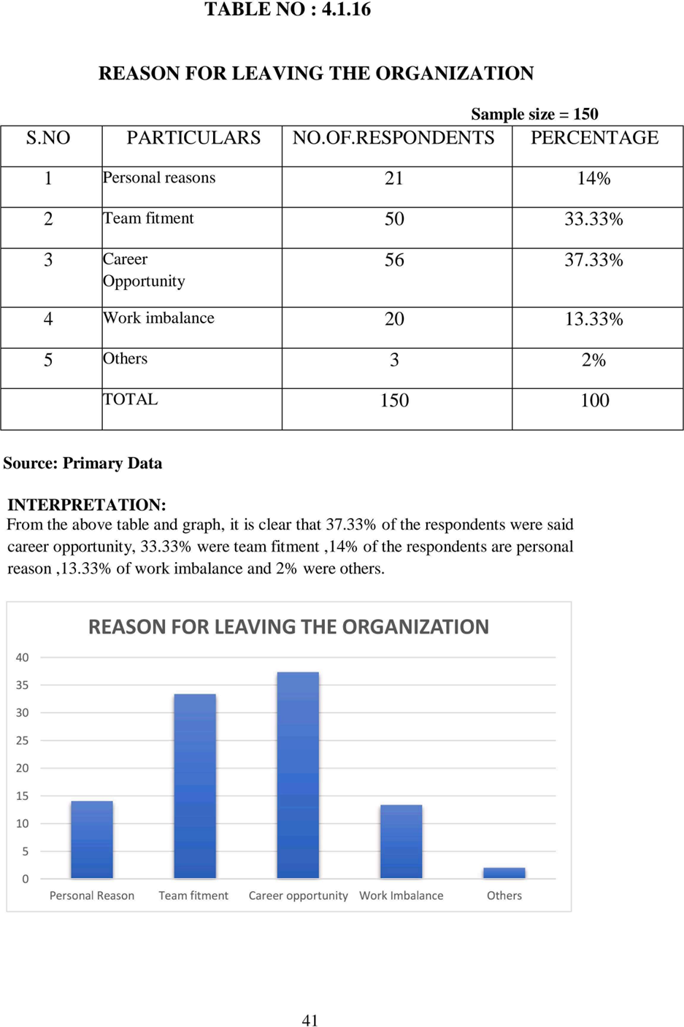

**ANOVA ANALYSIS**

**EMPLOYEES ARE TREATED FAIRLY AND THE SUPERIOR MAINTAINS A GOOD RELATIONSHIP:**

**AIM:**

To know the difference between employees treated fairly and the superior maintains a good relationship

**NULL HYPOTHESIS HO**: There is no difference between employees treated fairly and the superior maintains a good relationship

**ALTERNATIVE HYPOTHESIS HI**: There is a difference between employees treated fairly and the superior maintains a good relationship.

**EMPLOYEES ARE TREATED FAIRLY AND** **THE SUPERIOR MAINTAINS A GOOD RELATIONSHIP:**

|  |  |  |  |  |  |
| --- | --- | --- | --- | --- | --- |
| **Model** | **Sum of**  **Squares** | **df** | **Mean square** | **F** | **Sig** |
| **Between rows** | 228.491 | 9 | 25.388 | 6.742 | .005 |
| **Within groups** | 527.169 | 149 | 3.765 |  |  |
| **Total** | 755.660 | 150 |  |  |  |

**INTERPRETATION:**

Therefore, Ho is rejected and the alternative hypothesis HI is accepted. Hence there is a difference between employees treated fairly and the superior maintains a good relationship.

1. **RECOMMENDATIONS**

* The management is recommended to come forward to look over every employee to support them till the end.
* They can also advise the employees to attend every training program that is being conducted in the company. So that it will help the employees to know more about the new training programs.
* The company can also give proper respect to the employees working with them. If they are not treated properly, it may be the reason to be dissatisfied as most of the respondent has ranked highest ranking.
* The company is suggested to improve the working condition, since some of the employees are not satisfied with that.
* Some of their decisions are not clarified and there is no proper team fitment. If proper guidance and counselling is provided to the employees they can retain.
* From the study, the management can increase their salary, can have a proper communication between subordinates, maintaining a friendly environment will help the company to retain them.

1. **CONCLUSION**

An organization faces many challenges in their day-to-day activities, one of which impact is difficulty in retaining the employees. From the study it is concluded that employees like to feel that there is someone to whom they can turn for advice, if they need it. The workplace environment can have a culture where employees working as a team. The management can try to understand the needs of the employees. By conducting employee satisfaction surveys, you won't know what's wrong or what's right unless the management ask. Encouragement, participation and sharing of ideas will also attract their employees to retain. Only if employees are valued at work, they will have the interest to work and that will not lead to employee dissatisfaction. If the suggestions are taken into consideration the company will benefit in the future.

##### 

##### **BIBLIOGRAPHY**

* Bruce H. Kemelgor and William R. Meek (2008), Employees Attraction and Retention in Growth-Oriented Entrepreneurial Firms: an Exploratory Study, journal of small business, Volume-19, issue-1, 45-52.
* Claire Crutchley and Yost (2008), Key Employees Attraction and Retention Plans in Bankruptcy, HRDJournal, Volume 3, Issue-1, 86-99.
* Eva Kyndt, Fillip Dochy, Maya Michielsen and Bastiaan Moeyaert (2009), Employees Attraction and Retention: Organisational and Personal Perspectives, African Journal of Business Management, Volume-5, Issue-1, 106-110.
* John E. Sheridan (1992), Organizational Culture and Employees Attraction and Retention, Academy of Management Journal, Volume-35, Issue-5, 45-49.
* John P. Hausknecht, Julianne M. Rodda and Michael J. Howard (2008), Targeted Employees Attraction and Retention: Performance-Based and Job-Related Differences in Reported Reasons for Staying, African Journal of Business Management, Volume-2, Issue-3, 78-89.