**Designing and development of lapping machine**

**Mr. T. C. Jagtap1, Mr. Vaibhav Sunil Morankar2, Ms. Rutuja Nandkumar Surywanashi3,**

**Mr. Pranav Deelip Savkare4, Mr. Rohan Samadhan Gavali5**

2,3,4,5student, Mechanical Engineering, Sandip Foundation's Sandip Polytechnic, Nashik, Maharashtra, India.

1Professor, Mechanical Engineering, Sandip Foundation's Sandip Polytechnic, Nashik, Maharashtra, India.

India.

# ABSTRACT

Always a designer focuses on the challenges of bringing perfect ideas and products to life. So there must be sophisticated machinery and quite modern methods They continued to develop and introduced for provident manufacturing of products. At the same time, we must maintain that there is no permissibility of quality and sweet taste. In this age of robots comes a significant phase of creature mortality. Prove to yourself that it provides superior results by using a robotic device quantity of product than the quantity of domestic production. Everyone in the contest request wants to scale their product & make their device multipurpose. There is someone who makes up his mind It coincided with the challenges of bringing theories and policies into reality. New technologies and processes are constantly being developed Affordable and quality colourful products.

# INTRODUCTION

In ancient times, during the Stone Age, people used a technique called imbrication to create tools. By rubbing a stick against a surface covered with sand, our ancestors were able to drill holes, which was essentially the first form of machining ever invented. A depiction from the German Museum in Munich, based on archaeological research, illustrates how these primitive imbrication machines might have appeared. This illustration demonstrates the process of drilling through the use of rotational movement, speed, weight, and the presence of sand grains and liquid. It also suggests that various factors, whether intentional or accidental, influenced the outcome of the drilling process.

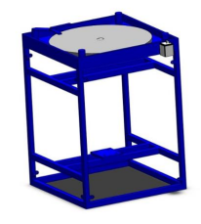

Gradually, by adjusting the weight of the monuments, the rate of material waste could be effectively managed. This phenomenon has recently been fully understood. It is now apparent that for imbrication to yield the most stylish results, all relevant factors must be carefully considered and optimized. The discovery of essence, along with processes such as casting, forging, and subsequent operations like stropping (using sturdy patches), became significantly important. As a result, lapping fell out of use. The introduction of hand blocks (Johansson) and a growing demand for higher quality products played a key role in reigniting interest in the art of imbrication.

1. **LITERATURE REVIEW**

Bhaskar Chandra Kandpal published a paper in March 2012 on the fabrication of a wet grinding machine and measured the essence junking rate using different grades of emery paper. The paper discusses the mechanical medication needed during polishing and concludes that a methodical medication system is the best way to achieve the desired results. The material junking rate (MRR) of different grades is detailed in the paper, along with descriptions of the grinding and polishing systems. The research also includes instructions for the fabrication of the wet grinding machine. It was found that using a motor and belt drive system helped reduce the mechanical stress on the equipment. Another paper by Gohil in 2014 focused on the design of a lead screw medium for vertical door belting. Machine says about leadscrew selection in design of leadscrew selection criteria are proposed and gives design for leadscrew. They also give criteria of screw periphery for colorful length selection of leadscrew. In this paper they also explained design medium of leadscrew. LeonardE. Samuels,( 2003) published paper on the metallographic polishing by mechanical styles. He's presumably best known for his abecedarian studies of the mechanisms of grinding and polishing using abrasives and the part of these processes in producing structural changes in face of essence. In this book they give all the information about polishing with abrasives and their principles. colorful goods of abrasives with their fortitude size changes are mentioned in the book. Dillinger,( 1985) published paper on the Polishing says about polished face parcels and related goods on pristine sword after polish. He also examine cargo extension wind before face was polished and after the polish of face. He took trial on the 304 pristine sword at different cargo conditions. Hosned,( 2014) published paper on a construction of polishing machine cooperating with robot was illustrate the construction of polishing machine. He makes the polishing machineco-operating with robot. This machine was created for mortal health.

1. **METHODOLOGY**

﻿**Research**:-Conduct a comprehensive study of existing lapping machines and their operation.

**Design**:-Create intricate CAD models and engineering drawings for the lapping machine components.

**Manufacturing**:-Precisely fabricate and assemble the components following industry standards and guidelines.

**Testing & Refinement**:-Conduct rigorous testing to ensure the efficiency and effectiveness of the lapping machine, and refine the design if necessary.

# CONSTRUCTION

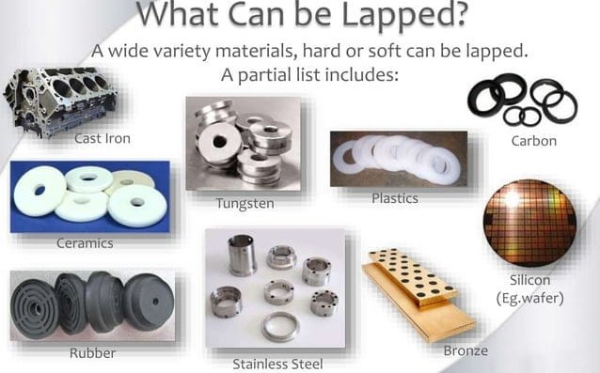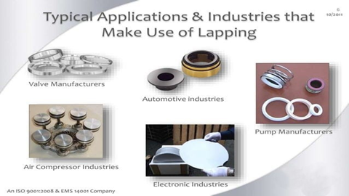

1. **Gather Necessary Materials and Components:**

Create a list of materials and components you'll need, such as a motor, worktable, lapping plate, abrasive material, control system, and supporting structures. Ensure that the materials are suitable for the intended purpose.

1. **Design the Lapping Machine:**

Create detailed CAD (Computer-Aided Design) drawings and plans for your lapping machine. Consider factors like the type of lapping motion (rotary or reciprocating), the size and shape of the lapping plate, and the motor's specifications. Ensure the design meets safety and ergonomic standards.

1. **Fabricate the Machine:**

Use the CAD designs as a guide to fabricate the various components of the lapping machine. This may involve machining, welding, and assembly work

1. **Assemble the Machine:**

Assemble all the fabricated components, ensuring proper alignment and fit. Pay special attention to the bearings and the lapping plate's attachment to minimize vibrations.

1. **Install the Motor and Power System:**

Install the electric motor and power transmission system to drive the lapping plate. Ensure that the motor is securely mounted and aligned with the lapping plate.

1. **Build the Control System:**

Develop or purchase a control system to manage the machine's operation. Depending on your design, this may involve speed control, timer settings, and safety interlocks. Incorporate an emergency stop mechanism for safety.

1. **Add Safety Features:**

Implement safety features such as guards, emergency stop buttons, and safety interlocks to protect users from potential hazards during operation.

1. **Test and Calibrate:**

Before using the lapping machine for its intended purpose, conduct thorough testing and calibration to ensure it operates as expected. Check for any vibrations, uneven lapping, or other issues that may affect performance.

1. **Operate and Maintain:**

Once the lapping machine is operational, provide training to the operators. Establish a maintenance schedule to keep the machine in good working condition. Regularly inspect and lubricate moving parts, and replace abrasive materials as needed.

1. **AVAILABEL RESOURCES**

# Mild Steel: Mild steel is a cost-effective choice for the frame and structural components of the lapping machine. It provides good strength and durability.

# Aluminum: Aluminum can be used for non-structural components like covers, guards, and some smaller parts due to its lightweight nature and ease of machining.

# Plywood: Plywood is a suitable material for creating templates, patterns, or non-structural parts of the lapping machine. It's cost-effective and easy to work with.

# Plastic: Utilize plastic materials like PVC, HDPE, or ABS for covers, guards, and other non-structural parts. These materials are lightweight and resistant to corrosion.

# Bearing Materials: For bearings, consider materials like bronze or oil-impregnated sintered bronze bushings, which are readily available and cost-effective for smaller machines.

# Electric Motor: Choose an off-the-shelf electric motor with the necessary power and speed ratings for your lapping machine. Ensure it's compatible with your power supply.

# Fasteners: Use standard screws, nuts, bolts, and washers made from materials like carbon steel or stainless steel, which are readily available at hardware stores.

# Abrasive Material: Depending on your lapping needs, you can source abrasive compounds or abrasive paper from local suppliers for use on the lapping plate.

# Rubber: If a softer lapping surface is required, you can source rubber sheets or rubber-coated materials locally to use as a lapping plate.

# Control Components: For the control system, you can source basic switches, buttons, and simple electrical components from local electronics suppliers.

Lubricants and Coolants: Depending on your machine's design, you may need lubricants or coolants. These can be obtained from local industrial suppliers.

# RESULTS AND OUTCOMES

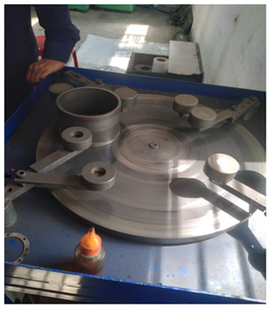 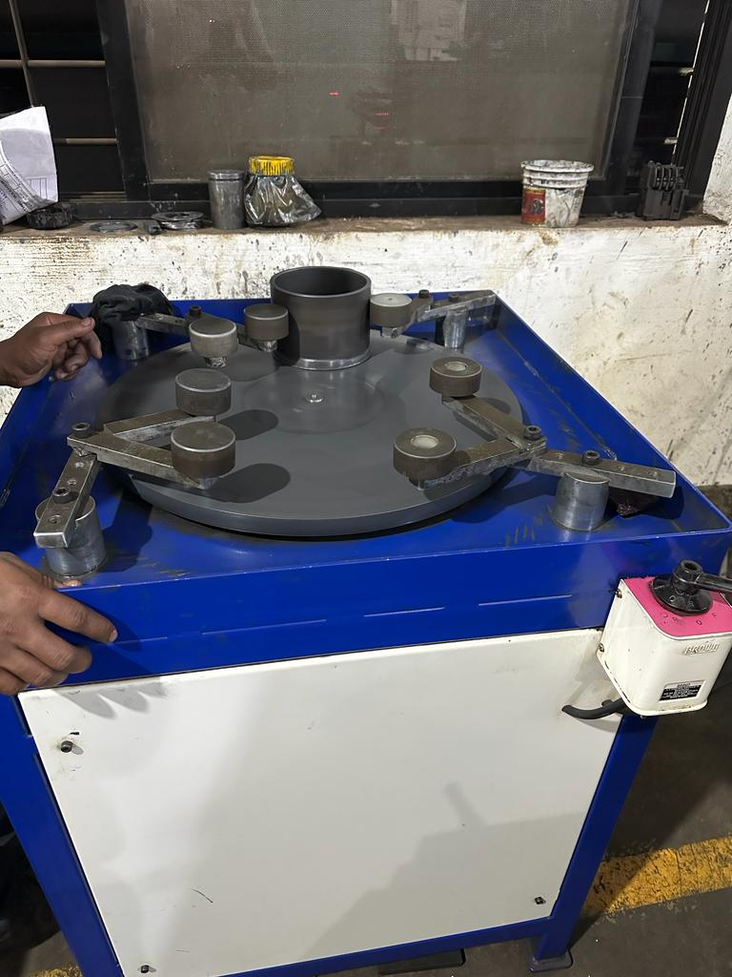

**Abrasive Action:**- A harsh or rough way of doing something. Two surfaces are rubbed together with an abrasive and a lubricant in a process called lapping. This process eliminates material and smooths the surface. Lapping machines commonly employ a cast iron lap or a flat surface coated with abrasive particles to perform their function. The tool and the workpiece are moved back and forth or rotated in relation to each other, with the workpiece positioned against the tool. The workpiece is pressed against the lap with a controlled force to remove the desired amount of material. The force is regulated meticulously to prevent warping or harming the object being worked on.

**Functional Lapping Machine**: The primary outcome is the successful construction of a functional lapping machine that can perform the intended lapping operations.

**Precision and Accuracy**: A well-constructed lapping machine should deliver the expected precision and accuracy in terms of surface finish, flatness, and dimensional tolerances.

**Customization**: Depending on the design and features incorporated into the machine, the outcome may include a customized lapping machine tailored to specific work piece requirements or industry standards.

**Cost-Efficiency**: Efficient construction practices and material choices can lead to the outcome of a cost-effective lapping machine that meets the desired performance criteria without unnecessary expenses.

**Safety Compliance**: If designed and constructed with safety in mind, the lapping machine should comply with relevant safety standards and regulations, ensuring a safe working environment.

**Operational Reliability**: A well-made lapping machine should demonstrate reliability in its operation, minimizing downtime and maintenance requirements.

**Material Compatibility**: The outcome includes ensuring that the materials and components used in the machine are compatible with the lapping process and the work pieces to be processed.

**Performance Consistency**: The lapping machine's outcome should be consistent performance, where it consistently produces work pieces with the desired surface finish and dimensional characteristics.

**Ease of Operation**: The machine should be user-friendly, with clear controls and interfaces, making it easy for operators to set up and operate.

# CONCLUSION

﻿ As we conclude this file, we feel a sense of satisfaction in successfully completing the mission on time. We also had a good amount of fun celebrating the success of the production schedules for the working model. Consequently, we are pleased to declare that the calculation of mechanical skill was an entirely beneficial factor. Despite the challenging design criteria, we were able to overcome them by utilizing suitable reference books. By choosing raw materials that were not yet processed, we were able to accurately machine the additives, resulting in a very close tolerance and reducing the need for balancing. It is unnecessary to emphasize that we did not leave any stone unturned in our efforts during machining, fabrication, and meeting the task version to our satisfaction. The model is created with our assistance to meet the desired objectives.

# REFERENCES

1. Khurmi and Gupta “ proposition of Machine ” Edition Reprint 2007. Page no. 106- 107
2. Khurmi and Gupta “ Machine Design ” Edition 2005. runnerno. 261- 280 and 558- 570
3. “ Information Search Report on an electro- glamorous machines ” Om diligence, C- 25, MIDCSatpur.2012- 13.
4. Design of machine rudimentsProf.V.B. Bhandari, Tata Mc. Grew Hill Publishing Co. New Delhi.
5. Workshop Technology, HajaraChaudhari.
6. Production Technology,R.K. Jain.
7. PSG Design Data Book.
8. Production Engineering,P.C. Sharma.
9. Production Technology,O.P. Khanna.
10. Tribological Research and Design for Engineering Systems, edited byD. Dowson,M. Priest,G. Dalmaz, AA. PageNo. 545.
11. International Research Journal of Engineering and Technology( IRJET) e-ISSN 2395-0056, ShrikantB. Pawar, SwapnilK. Kol