“IMPACT OF PROPOSED METRO RAIL ON TRAFFIC ENVIRONMENT : A CASE STUDY AT INDORE (M.P.)”

PALLAV GOYAL¹, PROF. RAKESH SAKALE², PROF. HIRENDRA PRATAP SINGH³

PG SCHOLAR¹, ASSOCIATE PROFESSOR², ASSISTANT PROFESSOR³
School of Research and Technology, People's University, Bhopal (M.P.)

ABSTRACT

Indore is one of the fastest growing cities in India with an urbanization rate of 20.81%. This will lead to an increase in the number of vehicles registered in the city. The significant increase in personal vehicles such as two-wheelers and cars is the cause of increased traffic congestion, accidents, insufficient parking spaces and air pollution. A previous study only looked at private vehicles instead of using public and private vehicles simultaneously. The main objective of this study is to know the number of passengers who will use metro train services in Indore city leaving private vehicles and public transport modes. Data were collected and grouped into three main studies: socioeconomic studies, tourism studies, and fashion change studies. SPSS software is used to analyze survey data, Logit model is used to find probabilities. Data were obtained from questionnaires distributed along the study area of ​​Indore city. An impact analysis was also done by increasing gas prices and another by increasing the speed of the subway.
Keywords: Logit Model, Model Shift, Private Vehicles, Public Transport
CHAPTER-I
INTRODUCTION

GENERAL

Transportation is the lifeblood of the city, promoting the city's urbanization. Indore is one of India's major growing cities with the highest urbanization rate in Madhya Pradesh. According to a report by the Indore Regional Transport Office, the city has about 10.98 lacs of registered vehicles, of which 89% are private vehicles such as two-wheelers (77%), cars (12%), etc. and the remaining 11% are public vehicles such as minivans, buses, cars, etc. Vehicles increase by 8% each year and with this number of vehicles, the city becomes congested and polluted, causing difficulties for people.

BACKGROUND

Public transport is in high demand in Indian cities because relatively few people own private vehicles. Except for a few large cities, most people mainly use public transportation because they own a small car. Low-income people give up comfort for cheaper transportation services, while middle- and high-income people and car owners value comfort and quality service.

Indore City (A Brief Outlook)

Indore, a historic city located on the banks of the Khan and Saraswati rivers, is the largest city in the 'Indore Agro-Industrial Area' of Madhya Pradesh. It is located almost in the center of the fertile Malwa plateau, at 220° 43' North latitude and 760° 42' East longitude and is the nerve center of the state's economic activities. The exact origin of the city is unknown. The earliest records of Indore date back to 1791, when it was a small village called Indrapur, named after the Indreshwar temple. Indrapur was then in the Ujjain kingdom. In the first quarter of the 18th century, the Holkars made Indore their capital and ruled the Indore region until independence. Since then, the city of Indore has become an important urban center of the state of Madhya Pradesh.

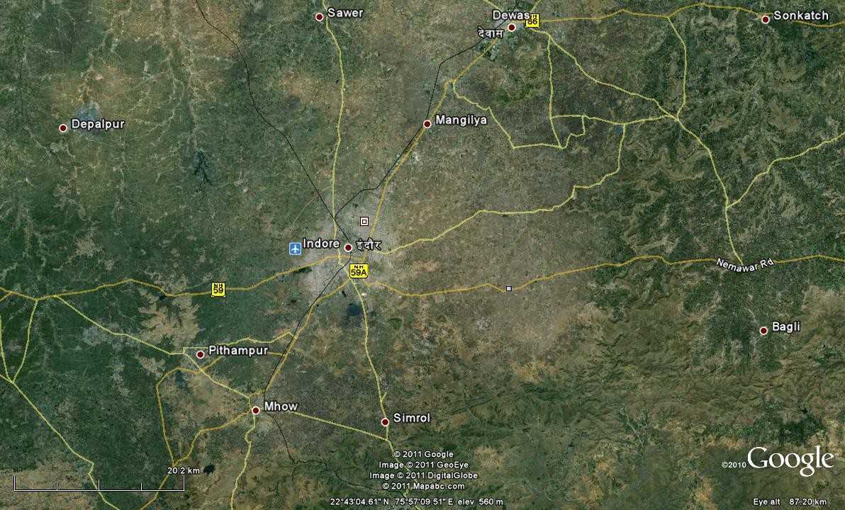
Indore is quickly becoming a center of commerce and trade serving the state in general and the region in particular. Rapid industrial and commercial development, coupled with recent population growth, has contributed to a large-scale increase in traffic on the city's roads. This increasing traffic intensity has resulted in the manifestation of several problems such as traffic jams, delays, accidents, pollution, etc. constitutes a potential threat to the city's economic vitality and productive efficiency.
Fig 1 Overview of Indore and Surrounding Towns

Since Indore city is a metropolitan city of the state, it is administered by a municipal corporation under the Indore Metropolitan Area. According to the Indian Census, the population of Indore city in 2011 was 1,964,086; in which men and women are 10,20,057 and 9,44,029 respectively. Additionally, the urban/metropolitan population of Indore is 21,70,295. A large number of people come to Indore in search of livelihood. These people are estimated to number up to 1,00,000 and are not from Indore city but reside there to earn their livelihood. In the period 2001 - 2011, the growth rate was 32.7%, of which urban areas were 40.1% and rural areas were 15.3%. In most developing and developed countries, as soon as the city population exceeds 1 to 1.5 million, the necessary arrangements for implementing MRTS will be put in place and with the growing population, the steps Network deployment and expansion will be implemented.
Major cities like Indore have seen significant growth due to global expansion and urbanization, exacerbated by a sudden increase in tourism demand. On the other hand, the supply of transport and services is clearly lagging behind demand. Because public sector budgets are generally very tight, funding for transport improvements is unfortunately insufficient. Most transportation services exceed their capabilities in terms of style.
Hence, Indore launched the i-Bus public transport system, also known as Indore BRTS. This has placed additional pressure on the city's road public transport system. In addition to creating frequent bottlenecks on both sides of the corridor, construction also raises significant safety concerns.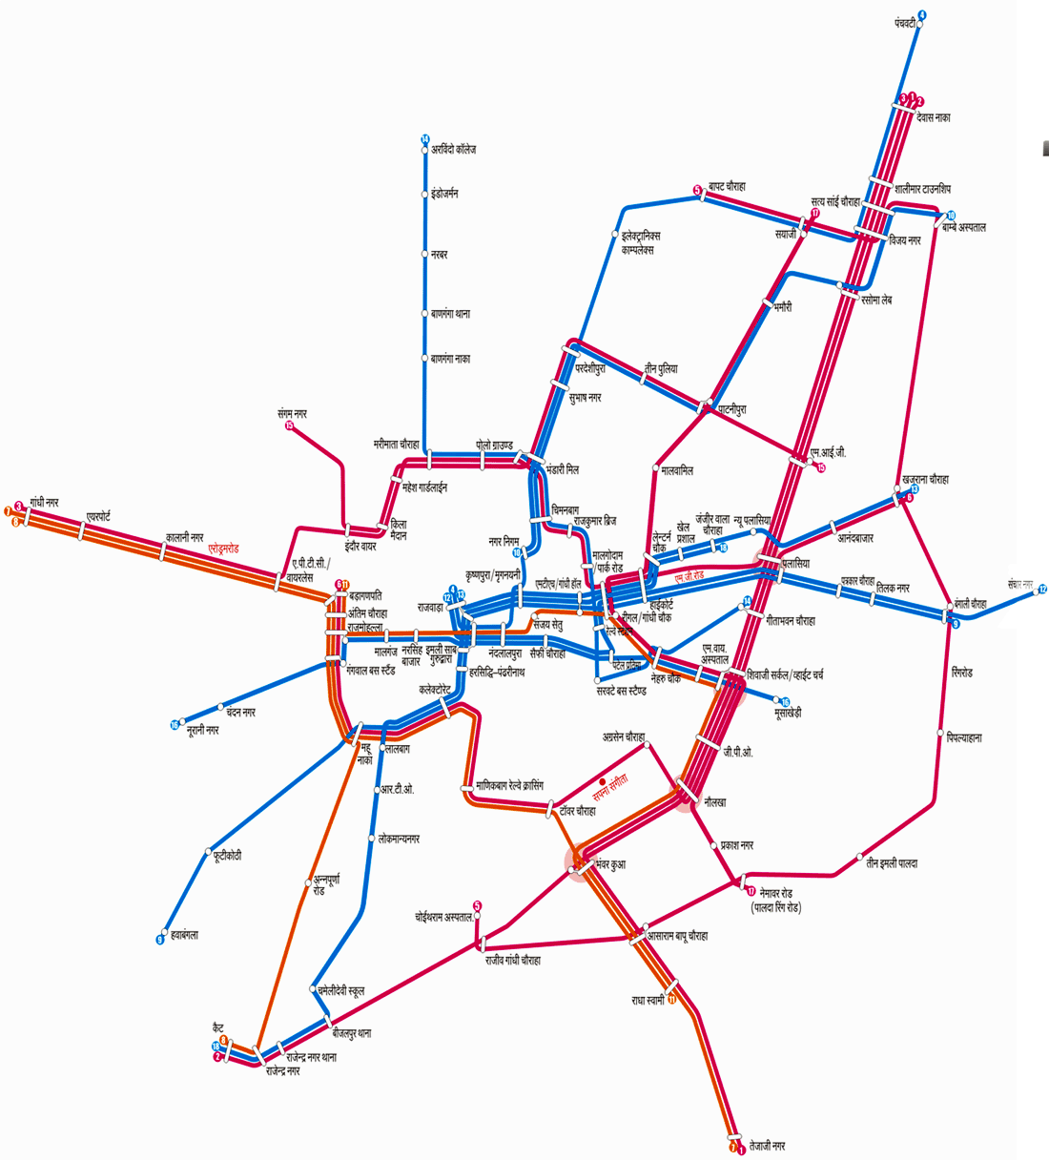
Fig 2 Indore City Transport System
Currently, even representatives of an unidentified city have been asked to stop the project and demolish the built structures. BCLL was established by the Indore Municipal Corporation (IMC) as a Special Purpose Vehicle (SPV) to integrate the alliance into the public transport system of Indore. Most city roads are only 60 meters wide. The basic design to create the corridor was flawed in this case.

Table 1 Showing population of Indore city in NOS

City | Indore
State | Madhya Pradesh
District | Indore
Total Population | 3,276,697
Total Male | 1,699,627
Total Female | 1,577,070
Total Male (0-6 Age Group) | 421380
Total Female (0-6Age Group) | 221612
Total Literates | 80.87%
Total Male Literates | 87.25%
Total Female Literates | 74.02%
Source: Indian Census Department (2011)

CHAPTER-II

REVIEW OF LITERATURE
This chapter will introduce the concept of customer satisfaction and perceived service quality by public transport users. To understand the parameters which influencing the mode choice, previous studies in the field of study of mode choice behaviour analysis and identified to method to develop the model for change in ridership. For this purpose review of relevant literature and research works are necessary to be performed. In this section, concept and different methods of modal split techniques can be examined and also to understand that which the different parameters are which help in improving the transport facilities and making those facilities an asset for the passengers travelling in it. In this literature review of previous case studies and research works are included which demonstrate the different methods of evaluation of mode choice analysis. These references proved to be a great advantage for us to effectively undergo our survey and give a factual result and up to the mark achievement.

2.1 BRIEF VIEW OF RESEARCH PAPERS

Hong et al. 2016, investigate on used panel data the before-and-after impact of a new light rail transit line on active travel behavior. Participants were divided into a treatment group and a control group (residing <½ mile and >½ mile from a new light rail transit station, respectively). Self-reported walking (n = 204) and accelerometer-measured physical activity (n = 73) were obtained for both groups before and after the new light rail transit opened. This is the first application of an experimental-control group study design around light rail in California, and one of the first in the U.S. Our panel design provides an opportunity for stronger causal inference than is possible in the much more common study designs that use cross-sectional data. It also provides an opportunity to examine how an individual’s previous activity behavior influences the role that new light rail transit access plays in promoting active travel behavior. The results show that, when not controlling for subject’s before- opening walking or physical activity, there was no significant relationship between treatment group status and after-opening walking or physical activity. However, when controlling for an interaction between baseline walking/physical activity and treatment group membership, we found that living within a half-mile of a transit station was associated with an increase in walking and physical activity for participants who previously had low walking and physical activity levels. The results were opposite for participants with previously high walking and physical activity levels. Future policy and research should consider the possibility that sedentary populations may be more responsive to new transit investments, and more targeted “soft” approaches in transit service would be needed to encourage people to make healthy travel choices [1].

B. Y. Chen and Y. Wang 2018, studies ignore human mobility due to the lack of large- scale human mobility data. This study investigates the impacts of human mobility on accessibility using massive mobile phone tracking data collected in Shenzhen, China. In this study, human mobility information is extracted from mobile phone tracking data using a time-geographic approach. The accessibility of each phone user is evaluated using fine spatial resolution across the entire city. The impacts of human mobility on accessibility are quantified by using relative accessibility ratios between phone users and a virtual stationary user in the same residential location. Results of this study enrich understandings of how land use influences relationships between human mobility and accessibility. For resource-poor regions with sparse service facilities, human mobility can greatly enhance individual accessibility. In contrast, for resource-rich regions with dense service facilities, human mobility can even reduce individual accessibility. Overall, human mobility can reduce spatial inequity of accessibility for people living in different regions of the city. The results of this study also have several important methodological implications for including human mobility and time dimension in accessibility evaluations [2].

B. Y. Chen and H. Yuan 2017, study travel time uncertainty has significant impacts on individual activity-travel scheduling, but at present these impacts have not been considered in most accessibility studies. In this paper, an accessibility evaluation framework is proposed for urban areas with uncertain travel times. A reliable space-time service region (RSTR) model is introduced to represent the space-time service region of a facility under travel time uncertainty. Based on the RSTR model, four reliable place-based accessibility measures are proposed to evaluate accessibility to urban services by incorporating the effects of travel time reliability. To demonstrate the applicability of the proposed framework, a case study using large-scale taxi tracking data is carried out. The results of the case study indicate that the proposed accessibility measures can evaluate large-scale place-based accessibility well in urban areas with uncertain travel times. Conventional place-based accessibility indicators ignoring travel time reliability can significantly overestimate the accessibility to urban services [3].
Beirao and Sarsfield Cabral 2007, presents the results of a qualitative study of publictransport users and car users in order to obtain a deeper understanding of travellers attitudes towards transport and to explore perceptions of public transport service quality. The key findings indicate that in order to increase public transport usage, the service should be designed in a way that accommodates the levels of service required by customers and by doing so, attract potential users. Furthermore, the choice of transport is influenced by several factors, such as individual characteristics and lifestyle, the type of journey, the perceived service performanceof each transport mode and situational variables. This suggests the need for segmentation taking into account travel attitudes and behaviours. Policies which aim to influence car usage should be targeted at the market segments that are most motivated to change and willing to reduce frequency of car use [4].

C. Chriqui and P. Robillard describe a model for the transit assignment problem with a fixed set of transit lines. The traveler chooses the strategy that allows him or her to reach his or her destination at minimum expected cost. First we consider the case in which no congestion effects occur. For the special case in which the waiting time at a stop depends only on the combined frequency, the problem is formulated as a linear programming problem of a size that increases linearly with the network size. A label-setting algorithm is developed that solves the latter problem in polynomial time. Nonlinear cost extensions of the model are considered as well [5].

C. Morency et al. 2007, explained the potential of smart-card data for measuring the variability of urban public transit network use is the focus of this paper. Data collected during 277 consecutive days of travel on a Canadian transit network are processed for this purpose. The organization of data using an object-oriented approach is discussed. Then, measures of spatial and temporal variability of transit use for various types of card are defined and estimated using the data sets presented. Data mining techniques are also used to identify transit use cycles and homogenous days and weeks of travel among card segments and at various times of the year [6].

Eboli, L., and G. Mazzulla described the Relationships between Rail Passengers’ Satisfaction and 18 Service Quality. In there work A Framework for Identifying Key Service Factors. Increasing the use of public transport is one of the most convenient strategies for alleviating the problems resulting from the excessive use of the private car in most
metropolitan areas (congestion, pollution, noise, etc.). In order to improve public transport, developing appropriate tools for measuring and monitoring service quality is necessary. Among the various methods for measuring transit service quality the authors choose to adopt a method based on customer perspective because they retain that customers have the right elements for appropriately judging the used service [7]

F. Le Clercq 1972, describe a model for the transit assignment problem with a fixed set of transit lines. The traveler chooses the strategy that allows him or her to reach his or her destination at minimum expected cost. First we consider the case in which no congestion effects occur. For the special case in which the waiting time at a stop depends only on the combined frequency, the problem is formulated as a linear programming problem of a size that increases linearly with the network size. A label-setting algorithm is developed that solves the latter problem in polynomial time. Nonlinear cost extensions of the model are considered as well [8].

- Zhou and R.-H. Xu 2012, study on urban rail transit (URT) system is operated according to relatively punctual schedule, which is one of the most important constraints for a URT passenger's travel. Thus, it is the key to estimate passengers' train choices based on which passenger route choices as well as flow distribution on the URT network can be deduced. In this paper we propose a methodology that can estimate individual passenger's train choices with real timetable and automatic fare collection (AFC) data. First, we formulate the addressed problem using Manski's paradigm on modelling choice. Then, an integrated framework for estimating individual passenger's train choices is developed through a data- driven approach. The approach links each passenger trip to the most feasible train itinerary. Initial case study on Shanghai metro shows that the proposed approach works well and can be further used for deducing other important operational indicators like route choices, passenger flows on section, load factor of train, and so forth [9].

- David 1995, explained the strategic significance of community transport, identifies and analyses the key issues which face community transport, and presents an analytical and evaluative account of the role, status and future of community transport [10].

- Faroqi et al. 2017, described for the increasing availability of public transit smart card data has enabled several studies to focus on identifying passengers with similar spatial and/or temporal trip characteristics. However, this paper goes one step further by investigating the
relationship between passengers’ spatial and temporal characteristics. For the first time, this paper investigates the correlation of the spatial similarity with the temporal similarity between public transit passengers by developing spatial similarity and temporal similarity measures for the public transit network with a novel passenger-based perspective. The perspective considers the passengers as agents who can make multiple trips in the network. The spatial similarity measure takes into account direction as well as the distance between the trips of the passengers. The temporal similarity measure considers both the boarding and alighting time in a continuous linear space. The spatial-temporal similarity correlation between passengers is analyzed using histograms, Pearson correlation coefficients, and hexagonal binning. Also, relations between the spatial and temporal similarity values with the trip time and length are examined. The proposed methodology is implemented for four-day smart card data including 80,000 passengers in Brisbane, Australia. The results show a nonlinear spatial-temporal similarity correlation among the passengers [11].

J. Gadziński and A. Radzimski explained the opening of the Poznan Rapid Tram (pol. Poznański Szybki Tramwaj, PST) in the year 1997 symbolically marked the beginning of a new era in the development of urban transportation systems in Poland. In this paper we would like to address the following question: more than one decade after the opening of the PST, what are its effects in terms of travel behaviors, housing choices and satisfaction, and apartment prices? In order to answer this question, we combined data on travel behaviors and housing choices from a survey based on a sample of nearly 300 households with data on housing prices from over 1400 real estate transaction records from the period between 2010 and 2013. Our results show that the proximity to PST affects travel behaviors, as respondents living close to PST stops confirmed that they use this form of transportation more often. There also seems to be some effect on housing choices; in locations close to PST stops we found many households living in rental housing, particularly university students. Also, about 20% of interviewees declared that they would pay more for apartments located closer to the rapid tram. However, that effect was only partly confirmed through the analysis of transaction prices. Using standard and spatial econometric regressions including variables like apartment size, floor number, amenities, and type of building we found a weak correlation between the proximity to PST and apartment prices. In conclusion, we argue that treating property price effects as the main justification for public transportation projects might be a doubtful choice, because in some cases the principal impacts of such projects might be visible in terms of residents' satisfaction and travel behaviors [12].

CHAPTER-III

METHODOLGY

MODEL CONSTRUCTION

Initially, a stated preference questionnaire was designed and included items to collect data on commuters' socioeconomic and travel characteristics. The questions were prepared taking into account the selected part of the survey area, including the proposed stations for Metro Line 3 under construction. The questionnaire was also prepared in digital form to solicit online survey responses. So, the linguistic and technical aspects have been carefully covered for easy understanding by the users. Socio-economic parameters such as age, gender, income group, vehicle ownership are used to model the probability of transferring to the subway along with travel parameters such as travel purpose, mode of travel, discomfort encountered and possible reasons for switching to using the subway etc. It is also necessary to check the possibility of people switching to using the subway. A pilot survey was also conducted in both online and offline modes to evaluate the effectiveness of the designed questionnaire.

PROBABILITY SAMPLING

Income certainly affects the use of transportation, research shows that 40.2% of people belong to the LIG group, followed by 38.8% of the MIG group and the remaining 21.1% of the HIG group. For the number of trips in certain modes, it is necessary to find active and inactive and we find that 54.7% are active and the remaining 45.3% are inactive. The household structure also leads to the average number of people in the household being 2.52 people, of which 1.90 people are working on average and 2.42 people are not working on average. Vehicle ownership is also a deciding factor in choosing a mode of transport. A study shows that 44.5% of people use 2-wheelers for daily work, 20.1% use cars and 3.9% use bicycles. There are also 31.5% of respondents who use public transportation and regularly use bus services.
The 11 proposed stations on the line are considered nodes and the area is divided into zones.

The units “tpew” and “tpcx” are used to describe firing rate. We see that there are 29.33 tpew and 3.32 tpcx. During the journey, it was observed that 44.29% of commuters traveled between 5 and 10 km, 35.82% traveled more than 10 km and the remaining 19.88% traveled less than 5 km.

The survey was conducted in two parts: inventory survey and field survey. Modal Shift Study conducted for Delhi Metro at DMRC, RITES Comprehensive Mobility Plan, New Delhi during the years 2011 and 2012. Vehicle Growth Model is a study of Indore Regional Transport Office (MP). The field survey was conducted using three methods: home interviews, travel interviews, and destination interviews.
A total of 508 commuters' responses were recorded along the selected study route by filling out the questionnaire form. The questionnaire form is divided into three sections describing socio-economic status, travel habits and mode switching behavior. This data is accumulated in SPSS data table for further regression analysis.
The interview questionnaire is designed to collect as much information as possible to analyze public transport needs and mode conversion behavior to urban railways of people in the study area in the context of public transport.

QUESTIONNAIRE

From the characteristics of the study area, it seems that terms of time, fare and comfort will be the main research factors and these four factors, waiting time, walking time, price , comfort and convenience, will become the deciding factor for the study. The travel probabilities are found for 2-wheeler to metro and car to metro, as these two vehicle types are the major contributors to the ridership in the area.

The proposed Logit models are developed for the two model components to identify the regime change from one to the other. The models developed aim to estimate the possible modal shift from two-wheelers to urban rail and train public transport services towards urban rail. Therefore, the models are binary in nature and are called BLogit models.

The proposed models are based on the concept of relative utility. The relative utility function measures the relative utility of one mode compared to another by comparing the values ​​of a set of travel attributes for the two modes. The importance of the relative utility of buses is demonstrated by respondents' preference for the current mode over the proposed metro service as well as the ratio of travel attributes. Mode-specific relative utility functions are individually calibrated for the specific modes that combine the most influential travel attributes. The relative utility function of mode “M” is determined by:

λm = f (P1,P2,P3,P4) (1)

Where,

P1 is the Ratio of walking time by Metro Rail to walking time by mode M

P2 is the Ratio of waiting time by Metro Rail to waiting time by mdoe M

P3 is the Ratio of travel cost for Metro Rail to travel cost for mode M

P4 is the Ratio of comfort by Metro rail to comfort by mode M

Proposed BLogit models for estimating shift from 2W to city bus as under

e^{λMT}
=

Pb e^{λMT}+e^{λ2W}

Where, Pb is Mode Shift proportion from 2W to Metro Rail

λMT is Relative Utility of Metro Rail λ2W is Relative Utility of 2 Wheeler

From the formula, probability of Commuters shift is found out with respect to another mode.

The study is divided into 3x3 groups; Level A shows the best parameter ever opt. Level B shows the moderate parameter and Level C shows the worst parameter opt by the commuters.

Table 2 Level of Convenience
 | X1 (Min) | X2 (Min) | X3 (Min) | X4 (Min)
Level A | 5 | 5-10 | 1.0 | Opt-1
Level B | 10 | 10-15 | 1.5 | Opt-2
Level C | 15 | 15-20 | 2.0 | Opt-3

MODEL INPUT

A utility function is formed for each mode. The equation is formed as a function of the relative ratios of each parameter considered. Depending on the groups discussed above, different relative ratio values ​​are determined depending on the condition. Form the utility function probabilities found for each group.

Table 3 Input Parameter Categorize

Parameter | Option  1 | Option  2 | Option  3 | Option  4
Walking Time  (X1) | 5 min | 10 min | 15 min | 20 min
Waiting Time  (X2) | 5-10  Min | 10-15  Min | 15-20  Min | 20-25  Min
Fare (X3) | Rs 2.0  /km | Rs 3.0  /km | Rs 4.5  /km | Rs 6.0  /km
Comfort and Convenience  (X4) | Option 1 | Option 2 | NA | NA

CHAPTER-IV

RESULT AND CONCLUSION

MODE SHIFT FROM TWO WHEELER TO METRO RAIL

There are average 33 % of people are ready to change its mode from 2 Wheeler to Metro Rail.

Table 4 MIG Categories, Percentage of Mode Shift is 35%
Level of  Convenience | Stage 1  (<5km) | Stage 2 (5-  10 km) | Stage 3  (>10 km)
Level A | 39.25 | 51.12 | 62.23
Level B | 19.48 | 25.34 | 29.48
Level C | 10.25 | 12.15 | 12.56

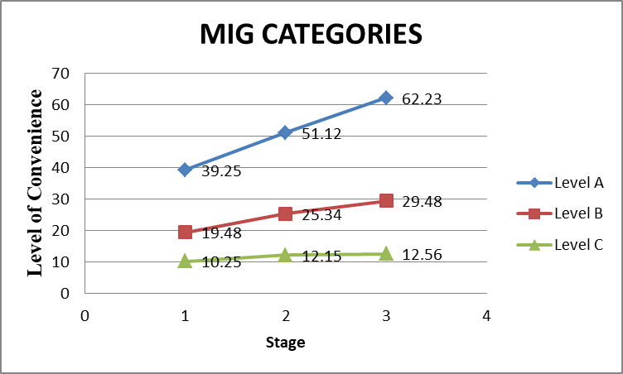

Figure 1 MIG Categories, Percentage of Mode Shift is 35%

The impact of the income structure is analyzed on the regime change and it is observed that for the LIG portfolio the value increased by 40% and for the HIG portfolio it decreased by 10%, which is reasonable. The reason behind the change is that People in the LIG category are more sensitive to comfort and convenience at a reasonable cost. But HIG people care more about comfort and convenience, they care less about money, and they use the subway less.
Table 5 LIG Categories, Percentage of Mode Shift is 40%
Level of Convenience | Stage 1 | Stage 2 | Stage 3
Level A | 48.55 | 65.50 | 64.85
Level B | 31.25 | 35.43 | 40.42
Level C | 14.35 | 20.27 | 14.45

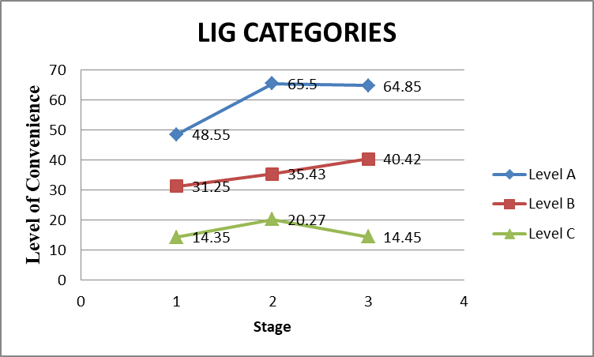

Figure 2 LIG Categories, Percentage of Mode Shift is 40%

Table 6 HIG Categories, Percentage of Mode Shift is 10 %
Level of Convenience | Stage 1 | Stage 2 | Stage 3
Level A | 9.15 | 13.25 | 18.55
Level B | 3.86 | 4.56 | 6.85
Level C | 2.74 | 2.42 | 3.28

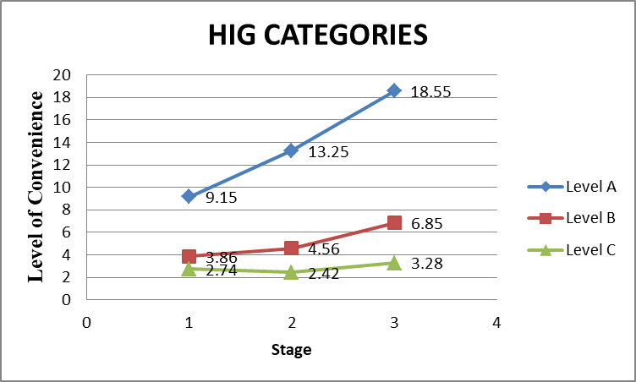
Figure 3 HIG Categories, Percentage of Mode Shift is 10 %

It is observed that by introducing better facility and improving condition the value of utility function for using Metro get increases and Probability of Shift also get increases.

IMPACT ANALYSIS

Impact Analysis is done by Increasing the Petrol Price and by increasing the speed of Metro.

Increasing the petol price ;

On increasing the Petro Price 50 % by 2021. It is observed that people give favorable response for the shift. Value given below shows the increase in probability.

Table 7 Increase in Probability of Mode Shift on Increasing the Petrol Price

λ(Utility  Function) | Pb (%)  Metro/2W | Pb(%) Metro/  Bus
0.00 | 0.023 | 0.13
1.00 | 0.052 | 0.33
2.00 | 0.16 | 0.59
3.00 | 0.32 | 0.81
4.00 | 0.57 | 0.91
5.00 | 0.83 | 0.97
6.00 | 0.94 | 1.02

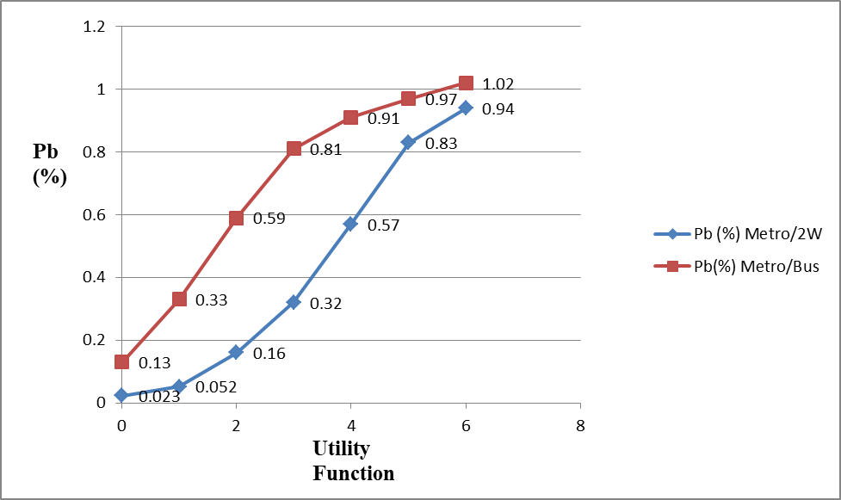
Figure 4 Increase in Probability of Mode Shift on Increasing the Petrol Price

CONCLUSION
By analyzing the data following conclusion are made:
- It is found that, in the present situation there will be around 35% mode shift. Considering the income factor, for LIG it is 40% and for HIG it will fallen down to around 10%.
- For present population metro is running in 2016 then around 2.65 lacs trips per day will prefer to travel by it. For the year 2021 it will increases to 4.34 lacs trips per day
- By impact analysis for increase in Petrol price, it shows the positive response towards the mode shift.
- By impact analysis for increase in Metro Rail speed, it also shows the positive response towards the mode shift.
- It is observed that there will be around 71% of people will shift for the metro rail. Considering the income factor for LIG it will be 54% and for HIG it decreases to 17%.
- For present population metro is running in 2016 then around 6.85 lacs trips per day will prefer to travel by it. For the year 2021 it will increase to 9.5 lacs trips per day.
- By impact analysis for increase in petrol price, it shows the positive response towards the mode shift.
- By impact analysis for increase in Metro Rail speed, it shows the positive response towards the mode shift.

Indore is surrounded by residential buildings, colonies, major working areas, bus stands and railway stations. The range of services of the rail transport system will not only bring convenience to residents but also to those who have just moved to the city. For this purpose, a customer satisfaction study was conducted to identify important qualities that would be in high demand among bus passengers, thereby increasing supply and demand. Thanks to that, the research results are reviewed in depth, creating conditions for more convenient transportation and improving the living standards of city residents, which is what urban planners are constantly striving for.

FUTURE ANALYSIS

The results of this study firmly demonstrate that there are a number of factors that influence the quality of client treatment. It is necessary to consider such diverse factors in a deeper analysis. In-depth interviews and brainstorming with multiple respondents can facilitate the creation of more meaningful customer satisfaction metrics. Car owners can be persuaded to use public transportation by bus. Future research should focus on finding strategies to persuade people to change their preferred mode of transportation by examining the types of public transportation that best meet their preferences. These matters are managed or resolved solely for convenience and through customary inquiries.
REFERENCES
- A. Hong, M. G. Boarnet, and D. Houston, “New light rail transit and active travel: A longitudinal study,” Transportation Research Part A: Policy and Practice, vol. 92, pp. 131-144, 2016.
- B. Y. Chen, Y. Wang, D. Wang, Q. Li, W. H. K. Lam, and S. L. Shaw, “Understanding the impacts of human mobility on accessibility using massive mobile phone tracking data,” Annals of the American Association of Geographers, vol. 108, pp. 1115-1133, 2018.
- B. Y. Chen, H. Yuan, Q. Li et al., “Measuring place-based accessibility under travel time uncertainty,” International Journal of Geographical Information Science, vol. 31, no. 4, pp. 783-804, 2017.
- Beirão & Sarsfield Cabral 2007, 2.1: p18 “Understanding and private car: A qualitative study- Transport Policy 14: 478-489”.
- C. Chriqui and P. Robillard, “Common bus lines,” Transportation Science, vol. 9, no. 2, pp. 115-121, 1975.
- C. Morency, M. Trépanier, and B. Agard, “Measuring transit use variability with smart- card data,” Transport Policy, vol. 14, no. 3, pp. 193-203, 2007.
- Eboli, L., and G. Mazzulla. Relationships between Rail Passengers’ Satisfaction and
18 Service Quality: A Framework for Identifying Key Service Factors.
- F. Le Clercq, “A Public transport assignment method,” Traffic Engineering and Control, vol. 14, no. 2, pp. 91-96, 1972.
- F. Zhou and R.-H. Xu, “Model of passenger flow assignment for Urban rail transit based on entryand exit time constraints,” Transportation Research Record, no. 2284, pp. 57-61, 2012.
- G. David, Community Transport: Policy, Planning, Practice, Gordon and Breach Press, Amsterdam, The Netherlands, 1995.
- H. Faroqi, M. Mesbah, and J. Kim, “Spatial-temporal similarity correlation between public transit passengers using smart card data,” Journal of Advanced Transportation, vol. 4, pp. 1-15, 2017.
- J. Gadziński and A. Radzimski, “The first rapid tram line in Poland: How has it affected travel behaviours, housing choices and satisfaction, and apartment prices?” Journal of Transport Geography, vol. 54, pp. 451–463, 2016.
- J. Kim, J. Corcoran, and M. Papamanolis, “Route choice stickiness of public transport passengers: Measuring habitual bus ridership behaviour using smart card
data,” Transportation Research Part C: Emerging Technologies, vol. 83, pp. 146-164, 2017.
- K. M. N. Habib, L. Kattan, and T. Islam, “Model of personal attitudes towards transit service quality,” Journal of Advanced Transportation, vol. 45, no. 4, pp. 271-285, 2011.
- M. Bagchi and P. R. White, “The potential of public transport smart card data,” Transport Policy, vol. 12, no. 5, pp. 464-474, 2005.
- M. D. Hickman and D. H. Bernstein, “Transit service and path choice models in stochastic and time-dependent networks,” Transportation Science, vol. 31, no. 2, pp. 129-146, 1997.
- R. B. Dial, “Transit pathfinder algorithm,” Highway Research Record, vol. 205, pp. 67- 85, 1967.
- S. Nguyen and S. Pallottino, “Equilibrium traffic assignment for large scale transit networks,” European Journal of Operational Research, vol. 37, no. 2, pp. 176-186, 1988.

