Implementation Of Value Engineering In Construction Management

***Shinde Aniket Kailas1,Bibave Pravin Ranjedra2 ,Ghule Sagar Bharat3 ,Nawali Pradip Sunil4***

***,Prof.Prakash Shinde5***

1,2,3,4 Student, Department of Civil Engineering, Vidya Niketan College Of Engineering,Bota.

5 HOD, Department of Civil Engineering, Vidya Niketan College Of Engineering, Bota.

**ABSTRACT**

In this paper we have discussed the concept of Value Engineering, its job plan and the effective implementation of it through study. Efforts have been put into the articulation of the paper to make it coherent which can be easily perceivable. A case study has been discussed in this paper involving a part used in the medical instruments. The material is chosen such that the cost is reduced without affecting the quality of the product. The best feasible solution from the available alternatives is chosen through the feasibility ranking table. Through th the application of Value Engineering profits are maximized without hindering the reliability of the product. With the effective utilization of the technique the final outcomes comes out to be a successful showcase of value engineering.

**Key Words:** Value Engineering, Time Reduction, Quality, Construction.

# INTRODUCTION

Value Engineering is an organized systematic approach Directed at analyzing the function of systems, equipment, facilities, services, and supplies for the purpose of achieving their essential functions at the lowest life-cycle cost consistent with required performance, reliability, quality, and safety[1]. Society of Japanese Value Engineering defines VE as: “A systematic approach to analyzing functional requirements of products services for the purposes of achieving the essential functions at the lowest total cost” [2]. Value Engineering is an effective problem solving technique. Value engineering is essentially a process which uses function analysis, team- work and creativity to improve value (3). Value Engineering is not just “good engineering.” It is not a suggestion program and it is not routine project or plan review. It is not typical cost reduction in that it doesn’t “cheapen” the product or service, nor does it “cut corners.” Value Engineering simply answers the question “what else will accomplish the purpose of the product, service, or process we are studying?” [4]. VE technique is applicable to all type of sectors. Initially, VE technique was introduced in Manufacturing industries. This technique is then expanded to All type of business economic sector, which includes construction, service, government, agriculture, education and healthcare [5].

# PROBLEM STATEMENT

The construction industry, despite its pivotal role in economic development, is frequently plagued by challenges such as cost overruns and delays in project timelines. The escalating costs and time extensions often associated with construction projects underscore a pressing need for effective methodologies to address these issues. The problem at hand revolves. around the prevalence of cost overruns in construction activities, adversely impacting project outcomes and economic feasibility. This study aims to address the problem by focusing on the implementation of value engineering in construction management. The overarching question is how value engineering principles can be strategically applied to identify and mitigate the factors contributing to cost overruns in construction projects. By understanding and resolving these challenges, the study seeks to contribute to the advancement of construction management practices,fostering improved project tracking and enhanced cost efficiency in the construction industry.

In this paper we have discussed the concept of Value Engineering, its job plan and the effective implementation of it through a case study. Efforts have been put into the articulation of the paper to make it coherent which can be easily perceivable. A case study has been discussed in this paper involving a part used in the medical instruments. The material is chosen such that the cost is reduced without affecting the quality of the product. The best feasible solution from the available alternatives is chosen through the feasibility ranking table. Through the application of Value Engineering profits are maximized without hindering the reliability of the product. With the effective utilization of the technique the final outcomes comes out to be a successful showcase of value engineering.

The Value Engineering process and procedures are generally well defined and well-understood at all levels in the industry. Value Engineering is recognized as an effective tool to improve the performance of a product with reduction in cost without reducing in quality. . A proper decision matrix is prepared for choosing the appropriate alternative from the feasible choices available. The total saving which can be incurred per product by the implementation of above recommendations are 14.87 % for alternative-I and 27.44 % for alternative-II. Change in Technology and Globalization can rapidly increase which creates huge demand but not necessary for the same types product at the same price tags. These forcing companies think differently and look at their cost and create product to meet needs of market and trends.

# PROPOSED METHODOLOGY AND OPERATING PRINCIPLE

The value methodology is a systematic process which is Applied by a multidisciplinary team to improve the value of a Project through the analysis of functions. We are using some Alternative parameter in our case study instead of traditional One in our case study. Now-a-days we saw some (2 or 3) of These parameters were implementing in construction Industry but we are going to implement these all parameters In one building, So that we would know how these going to be Beneficial to construction industry.

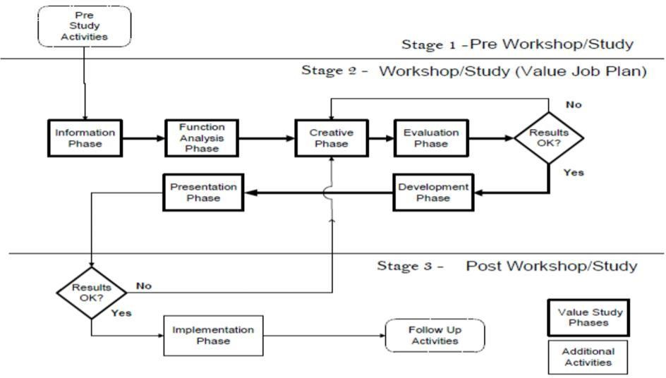

**Some alternative techniques**

1. CLC Bricks
2. 800 x 800 Granite Tile
3. Mivan Technology

STUDY AREA 1 – A proposed commercial building having 7 floor and102shops is taken for case study Location is in Punawale, Pune. Total Area:2.8 acres

Built-up Area: 92000sq ft

STUDY AREA 2 – Shiv Sai Millenium is a commercial development in Punawale, Pune. 411033 Total Area:1.44 acres

Built-up Area:332.927 – 4632.029 Sq.ft.

## Application of Value Engineering Can Be Done In Following Stages

1. Information Phase
2. Creative Phase
3. Evaluation Phase
4. Development Phase
5. Presentation Phase

# RESULT AND DISCUSSION

**STUDY AREA 1:**

**CLC Brick Work takes less duration than Conventional Brick Work.**

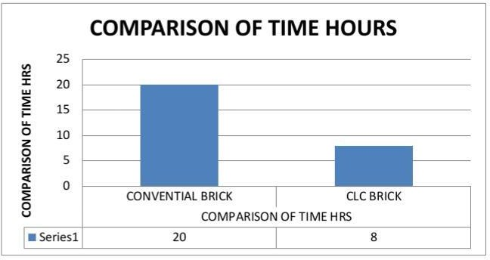

**STUDY AREA 2:**

**Construction with mivan takes less duration than Conventional technique.**

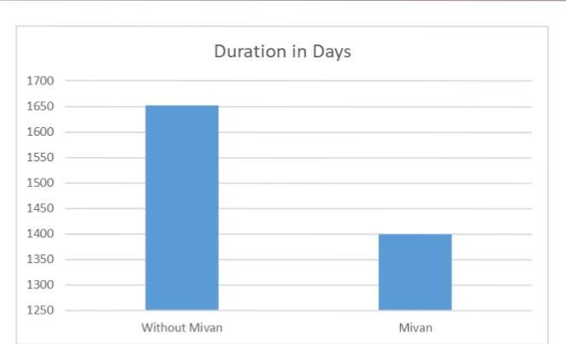

It was discussed that using value engineering by Multidisciplinary team, value and economy are improved Through study of alternative design concepts, material and Construction methods without compromising functional Requirement and quality. In this paper the various methods Of formwork and materials are used for implementation of Value engineering. Hence value engineering techniques can Help in reducing the duration and increase the speed of Construction project.

# FUTURE SCOPE

* 1. Job analysis distinctive way (function analysis).
  2. Get appointed a large amount of good ideas that are applicable.
  3. The action plan in place which consists of several sequential stages of a logical sequence.
  4. Multi-disciplinary team working in the studies of col¬lective values.
  5. Ensure coordination between the relevant authorities in the project.
  6. Quality is not compromise.

## REFERANCE

1. Amit Sharma, R.M. Belokar ―Achieving Success through Value Engineering: A Case Study‖ Member, IAENG Proceedings of the World Congress on Engineering and Computer Science 2012 Vol II
2. K. Ilayaraja and MD. ZafarEqyaaba ―Value Engineering in Construction‖ Department Of Civil Engineering, Bharath University, Chennai Indian Journal of Science and Technology, Vol 8
3. <http://www.iaeng.org/publication/WCECS2012/WCECS2012_pp1330-1333.pdf>
4. lfile:///C:/Users/File/Downloads/87285-154763-2-PB.pdf