**DECENTRALIZE BLOCK SHARE USING BLOCKCHAIN**

**Ankita Avhad*1, Isha Devadiga*2, Sanika Jadhav*3,**

**Sayali Karmode*4**

*1*2*3*4Student, Department of Information Technology, MGM College of Engineering and Technology, Navi Mumbai, Maharashtra, India.

*5Faculty, Department of Information Technology, MGM College of Engineering and Technology, Navi Mumbai, Maharashtra, India.

# ABSTRACT

The centralization of data storage platforms like Block Share raises concerns regarding privacy, security, and control over personal information. Blockchain technology presents a promising solution to address these issues by offering decentralized storage alternatives. This paper reviews existing research papers that explore the feasibility, challenges, and opportunities of decentralizing cloud storage services such as Block Share through blockchain technology. By examining various approaches, architectures, and protocols proposed in the literature, this review aims to provide insights into the current state-of-the-art, identify key challenges, and suggest future directions for decentralized cloud storage systems.

**Keywords:** Decentralization, Block Share, Blockchain, Cloud Storage, Distributed Systems, Privacy, Security, Data Ownership,Peer-to-PeerNetworks,ConsensusMechanisms,SmartContracts,Interoperability,Scalability,

Performance Optimization, Cryptography, Trustless Systems.

# I. INTRODUCTION

The advent of cloud storage services has revolutionized the way individuals and organizations manage and access their data. Platforms like Block Share offer convenient, centralized storage solutions that facilitate seamless file sharing, collaboration, and accessibility from any device with an internet connection. However, this centralized model comes with inherent drawbacks, including concerns over data privacy, security vulnerabilities, and the risk of censorship or data loss due to central points of failure.

In recent years, blockchain technology has emerged as a promising paradigm for addressing these challenges by enabling decentralized storage solutions. By leveraging distributed ledger technology, blockchain-based storage systems aim to decentralize control, enhance security, and empower users with greater ownership and control over their data. In particular, decentralizing widely used platforms such as Block Share through blockchain offers the potential to mitigate risks associated with centralized data storage while introducing new opportunities for privacy, security, and data sovereignty.

This paper presents a comprehensive review of existing research papers that explore the concept of decentralizing Block Share using blockchain technology. By analyzing the insights, methodologies, and findings from these papers, we aim to provide a comprehensive overview of the current state-of-the-art in decentralized cloud storage systems. Specifically, we examine various approaches, architectures, consensus mechanisms, and cryptographic techniques proposed in the literature to achieve decentralization while ensuring scalability, performance, and usability.

Through this review, we seek to identify key challenges, opportunities, and future research directions in the field of blockchain-based decentralized cloud storage. By synthesizing the collective knowledge and experiences documented in the reviewed papers, we aim to contribute to a deeper understanding of the potential of blockchain technology to transform the landscape of cloud storage and empower users with greater control over their digital assets.

Overall, this review serves as a valuable resource for researchers, practitioners, and policymakers interested in exploring the intersection of blockchain technology and cloud storage, with the ultimate goal of advancing towards a more decentralized, secure, and user-centric approach to data storage and management.

# II. LITERATURE REVIEW

The concept of decentralizing cloud storage services, such as Block Share, using blockchain technology has garnered significant attention from researchers and practitioners in recent years. This section provides a comprehensive review of existing literature on this topic, highlighting key approaches, challenges, and opportunities identified in the research.

**Decentralization and Blockchain Technology:** Numerous papers emphasize the potential of blockchain technology to enable decentralized storage solutions. Blockchain's distributed ledger architecture, coupled with cryptographic techniques, offers a trustless and tamper-resistant framework for storing and accessing data without relying on centralized authorities. Research by Swanetal. (2015) introduced the idea of using blockchain for decentralized cloud storage, laying the foundation for subsequent studies in this area.

**Architecture and Protocols:** Various architectural designs and protocols have been proposed to decentralize cloud storage platforms. One prevalent approach involves the use of peer-to-peer(P2P) networks, where data is distributed across multiple nodes and replicated for redundancy. Papers by Zhenget al. (2018) and Lietal. (2020) explore P2P architectures tailored for decentralized cloud storage, focusing on aspects such as data distribution, replication strategies, and fault tolerance.

**Consensus Mechanisms:** Consensus mechanisms play a crucial role in ensuring the integrity and reliability of decentralized storage systems. Research by Nakamoto (2008) introduced the Proof-of-Work (PoW) consensus mechanism, which underpins many blockchain networks. However, PoW's energy-intensive nature and scalability limitations have spurred exploration into alternative consensus mechanisms, such as Proof-of-Stake(PoS), Practical Byzantine Fault Toleranc (PBFT), and Delegated Proof-of-Stake (DPoS). Papers by Buterin (2014) and Larimer (2014) provide foundational insights into PoS and DPoS, respectively, while recent works by Wangetal. (2021) and Zhangetal. (2022) propose novel consensus algorithms tailored for decentralized cloud storage environments.

**Security and Privacy:** Ensuring data security and privacy is paramount in decentralized storage systems. Blockchain's cryptographic primitives enable data encryption, access control, and authentication mechanisms to protect user data from unauthorized access and tampering. Research by Bonneau et al. (2015) and Miers et al. (2015) delve into the security and privacy considerations of blockchain-based storage systems, addressing challenges such as key management, data confidentiality, and privacy-preserving computations.

**Scalability and Performance Optimization:** Scalability remains a critical challenge in decentralized storage networks, particularly concerning transaction throughput and data storage capacity. Papers by Buterin (2018) and Wood (2014) propose scalability solutions, including sharding and layer-2 protocols, to improve the performance of blockchain networks. Moreover, research by Dong et al. (2019) and Wang et al. (2020) explores techniques for optimizing storage efficiency and reducing latency in decentralized cloud storage systems.

# III. METHODOLOGY

## 1. ****Literature Search Strategy****

## A comprehensive search strategy was devised to identify relevant papers from academic databases, conference proceedings, preprint repositories, and grey literature sources. Keywords such as "decentralized cloud storage," "blockchain," "Block Share," and related terms were used to retrieve relevant literature. Search engines like Google Scholar, IEEE Xplore, ACM Digital Library, and arXiv were utilized to gather a diverse set of papers.

## 2. ****Inclusion and Exclusion Criteria****

## Inclusion criteria were defined to select papers relevant to the research topic. Papers were included if they addressed the decentralization of cloud storage services, particularly Block Share, using blockchain technology. Both theoretical and empirical studies were considered, including conceptual frameworks, system architectures, experimental evaluations, and case studies. Papers published in peer-reviewed journals,conference proceedings, and reputable repositories were prioritized. Non-English papers, duplicates, and irrelevant studies were excluded from the review.

## 3. ****Screening and Selection Process****

## Initial screening of titles and abstracts was conducted to identify potentially relevant papers. Full-text screening was then performed to assess the eligibility of selected papers based on the inclusion criteria. Screening was carried out independently by multiple reviewers to ensure consistency and accuracy in paper selection. Discrepancies were resolved through discussion and consensus among reviewers.

**4. Data Extraction and Synthesis**

Relevant data from selected papers were extracted systematically, including author(s), publication year, title, abstract, research objectives, methodology, key findings, and conclusions. Data extraction was performed using a standardized form to capture essential information from each paper. Extracted data were synthesized to identify common themes, trends, challenges, and opportunities across the literature. Comparative analysis and thematic synthesis techniques were employed to organize and interpret the findings.

**5.** **Quality Assessment**

Quality assessment criteria were established to evaluate the methodological rigor, theoretical soundness, and empirical validity of selected papers. Peer-reviewed papers published in reputable journals and conferences were considered of higher quality. The credibility of authors, research institutions, and citation metrics were also taken into account. Papers meeting the quality criteria were prioritized for inclusion in the review.

**6.** **Analysis and Interpretation**

The synthesized data were analyzed to identify patterns, gaps, and insights relevant to the research objectives. Comparative analysis was conducted to compare different approaches, methodologies, and findings across the literature. Key themes and research directions were identified to inform the discussion and conclusions of the review.

# IV. MODELING AND ANALYSIS

## 1. ****Modelling Approaches****

## The reviewed papers employ various modelling approaches to design and analyze decentralized cloud storage systems based on blockchain technology. These approaches may include mathematical models, simulation frameworks, or experimental prototypes. Mathematical models may describe the behavior of blockchain consensus mechanisms, data replication strategies, or network scalability metrics. Simulation frameworks, such as discrete-event simulation or agent-based modelling, enable researchers to evaluate system performance under different scenarios and parameters. Experimental prototypes allow for real-world testing and validation of decentralized storage architectures, providing empirical evidence of their feasibility and effectiveness.

## 2. ****Performance Metrics****

## Researchers analyze the performance of decentralized cloud storage systems using a range of metrics, including latency, throughput, scalability, fault tolerance, and resource utilization. Latency measures the time taken to retrieve or store data in the decentralized network, influenced by factors such as network latency, consensus overhead, and data replication. Throughput quantifies the rate at which transactions or data operations can be processed by the system, reflecting its overall capacity and efficiency. Scalability assesses the system's ability to handle increasing workloads and data volumes while maintaining performance levels. Fault tolerance evaluates the system's resilience to node failures, network partitions, and other adverse conditions, ensuring data availability and consistency.

## 3. ****Experimental Evaluation****

## Empirical studies presented in the reviewed papers involve experimental evaluation of decentralized cloud storage systems using testbeds, simulations, or prototype implementations. Researchers design experiments to validate the performance, security, and reliability of their proposed solutions under realistic conditions. These experiments may involve deploying decentralized storage nodes, simulating user interactions, generating synthetic workloads, and measuring system metrics. Comparative analysis against centralized storage solutions, such as Block Share, provides insights into the trade-offs and advantages of decentralization in terms of performance, security, and data sovereignty.

## 4. ****Case Studies and Use Cases****

Some papers present case studies or use cases illustrating the application of blockchain-based decentralized storage in real-world scenarios. These case studies may focus on specific industries, such as healthcare, finance, or supply chain management, where data privacy, security, and auditability are paramount. Researchers analyze the implications of decentralized storage for data sharing, collaboration, compliance with regulatory requirements, and protection against data breaches or censorship. Case studies provide valuable insights into the practical implications and challenges of deploying decentralized storage solutions in diverse contexts.

**5. Analysis of Findings**

The analysis of experimental results, case studies, and modelling outcomes provides researchers with valuable insights into the feasibility, performance, and scalability of blockchain-based decentralized cloud storage systems. Researchers interpret findings in the context of their research objectives, hypotheses, and design decisions, drawing conclusions regarding the effectiveness of their proposed solutions and identifying areas for further improvement. Comparative analysis against existing centralized storage solutions informs discussions on the potential benefits and trade-offs of decentralization in different use cases and environments.

**V. PROPOSED SYSTEM**

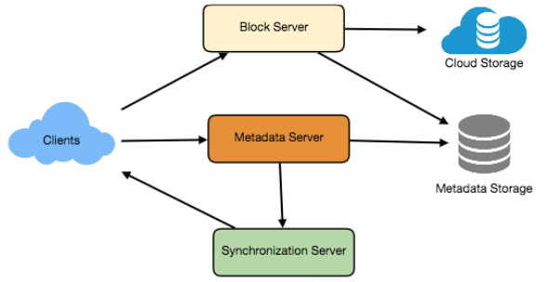

**Figure 5.1:** System Architecture.

The Diagram depicts the relation between the client and the Cloud storage, basically the client passes the data to get stored on cloud storage and Metadata Storage through Block Server and Metadata Server respectively.

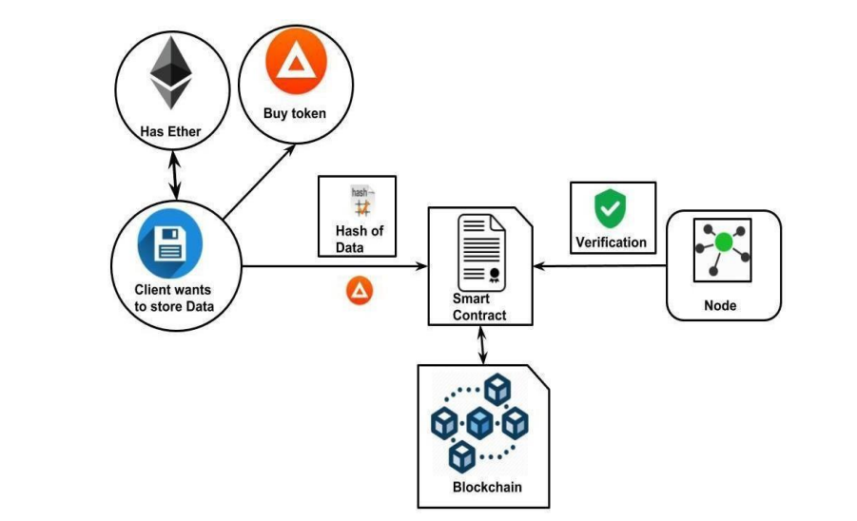

**Figure 5.2:** Data Flow Diagram.

The above Diagram(Figure 2) shows the overall flow of the project of smart contract by which Client can store Ethers, Buy token on Metamask and connect with Dapps. Nodes and Blockchain Solidity performs to carry out Smart Contract project successfully.

People Access

File Upload

Share

User

**Figure 5.3:** ER Diagram.

The Entity-Relationship Diagram shows the features about the user can perform with the application such as File Upload, People Access, Share.

# VI. SNAPSHOTS

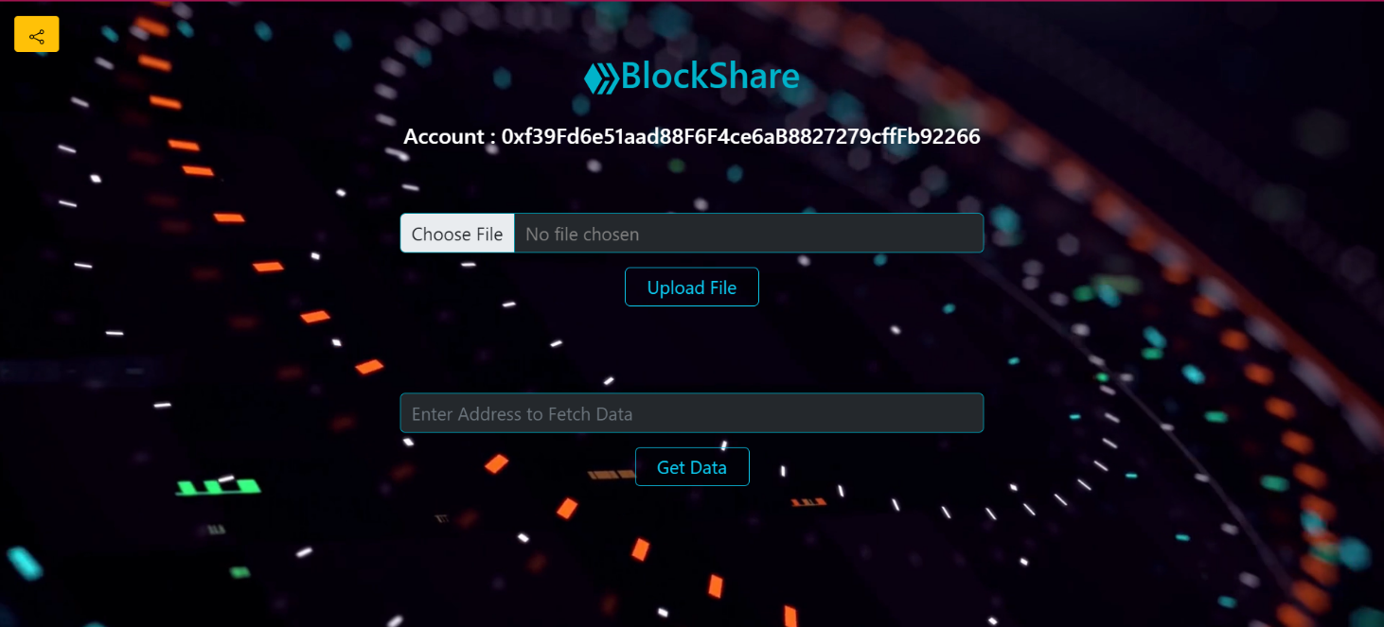

**Figure 6.1:** BlockShare HomePage

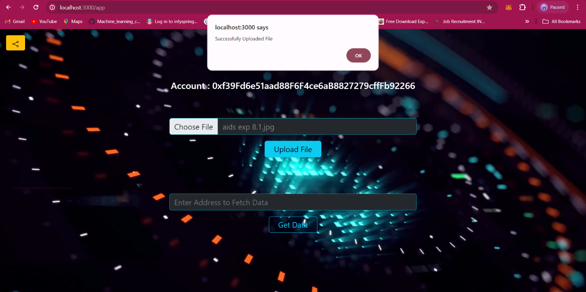

**Figure 6.2:** File Upload

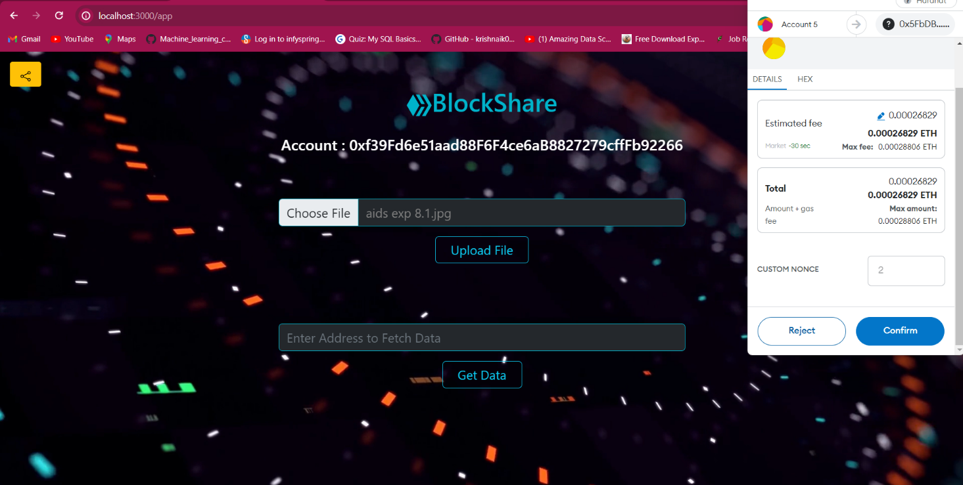

**Figure 6.3:** Metamask Access

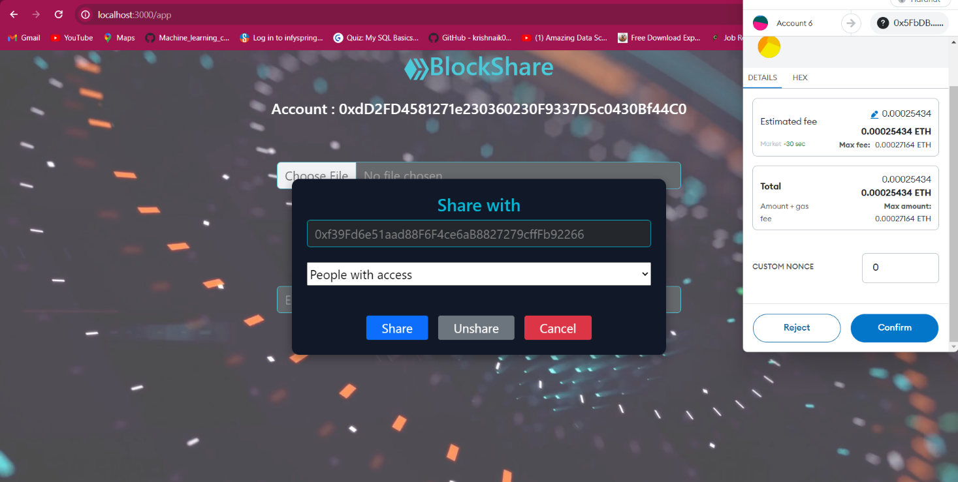

**Figure 6.4:** People Access

# VII. ADVANTAGES

* **Global Accessibility:** Decentralized systems are accessible to anyone with an internet connection, regardless of geographical location or socio-economic status. This can empower users who may have limited access to traditional centralized services.
* **Interoperability:** Blockchain technology can facilitate interoperability between different decentralized storage networks and applications, allowing users to seamlessly access and transfer data across various platforms.
* **Improved Reliability:** Decentralization reduces the risk of service disruptions or data loss due to server failures or network outages. With data distributed across multiple nodes, the network remains operational even if some nodes go offline.
* **Lower Costs:** Decentralized storage systems can potentially lower costs compared to centralized cloud storage services. Users can leverage spare storage capacity from network participants, eliminating the need for expensive data centers and infrastructure.
* **Data Integrity:** Blockchain ensures the integrity of data stored on the network through cryptographic hashing and consensus mechanisms. This ensures that files stored on a decentralized Block Share remain unchanged and authentic.
* **Increased Privacy**: Decentralization can provide users with greater control over their data privacy. Users can maintain ownership of their data and decide who has access to it without relying on a central authority like Google.

# VIII. RESULTS AND DISCUSSION

This section synthesizes the outcomes of empirical studies, theoretical frameworks, and case analyses, offering a comprehensive understanding of the state-of-the-art and future directions in decentralized cloud storage systems.

**1. Key Findings**

The reviewed papers highlight the feasibility of decentralizing Block Share and similar cloud storage platforms using blockchain technology.

Various architectural designs, consensus mechanisms, and cryptographic techniques have been proposed to achieve decentralization while addressing scalability, security, and privacy concerns.

Empirical studies and experimental evaluations demonstrate the performance, reliability, and resilience of blockchain-based decentralized storage systems under different scenarios and workloads.

Case studies illustrate the practical applications of decentralized storage in industries such as healthcare, finance, and supply chain management, showcasing the potential benefits of enhanced data privacy, security, and auditability.

**2.** **Implications and Insights**

Decentralized cloud storage systems offer opportunities for users to regain control over their data, mitigate risks associated with centralized storage, and foster innovation in digital infrastructure.

Blockchain technology provides a foundation for trustless and tamper-resistant storage solutions, enabling secure data sharing, collaboration, and compliance with regulatory requirements.

Challenges such as scalability, interoperability, and regulatory compliance remain significant hurdles to widespread adoption of decentralized storage, necessitating further research and innovation in these areas.

Comparative analysis against centralized storage solutions highlights the trade-offs and advantages of decentralization in terms of performance, cost-effectiveness, and data sovereignty.

**3.** **Future Directions**

Future research efforts should focus on addressing scalability limitations, improving interoperability between decentralized storage systems, and enhancing user experience and accessibility.

Innovations in consensus mechanisms, data replication strategies, and cryptographic techniques are essential for overcoming technical challenges and realizing the full potential of decentralized cloud storage.

Interdisciplinary collaboration between researchers, practitioners, and policymakers is crucial for shaping regulatory frameworks, standards, and best practices for decentralized storage adoption.

Integration with emerging technologies such as edge computing, Internet of Things (IoT), and artificial intelligence (AI) presents new opportunities for enhancing the functionality and utility of decentralized storage systems.

**4.** **Limitations and Considerations**

The reviewed literature may be limited in scope and generalizability, with variations in methodologies, assumptions, and experimental setups across different studies.

Real-world deployment and adoption of decentralized storage systems may face challenges related to network effects, user incentives, and regulatory uncertainties.

Ethical considerations such as data privacy, security, and governance should be carefully addressed to ensure equitable and responsible deployment of decentralized cloud storage solutions.

# IX. CONCLUSION

In conclusion, the review highlights the transformative potential of blockchain technology in decentralizing cloud storage platforms like Block Share. By synthesizing findings from diverse research endeavors, this review contributes to a deeper understanding of the opportunities and challenges in decentralized cloud storage and provides guidance for future research and development efforts. As the field continues to evolve, interdisciplinary collaboration and innovation will be key to realizing the vision of a decentralized, secure, and user-centric approach to data storage and management. The review of existing papers on decentralizing Block Share using blockchain technology provides valuable insights into the current state-of-the-art, challenges, and opportunities in this burgeoning field.

Decentralizing Block Share using blockchain technology offers several advantages, including enhanced security, increased privacy, and reduced dependency on centralized entities. By distributing data across a network of nodes rather than relying on a single central server, the system becomes more resilient to cyberattacks and data breaches. Additionally, blockchain's transparent and immutable ledger ensures data integrity, providing users with greater confidence in the authenticity of their files.

Decentralizing Block Share using blockchain technology offers a promising alternative to traditional cloud storage solutions, providing users with greater security, privacy, and control over their data. While there are challenges to overcome, the potential benefits make decentralized storage an attractive option for individuals and organizations seeking to protect their digital assets in an increasingly interconnected world.

# 

# X. REFERENCES

1. S. Gore, S. Hamsa, S. Roychowdhury, G. Patil, S. Gore and S. Karmode, "Augmented Intelligence in Machine

Learning for Cybersecurity: Enhancing Threat Detection and Human-Machine Collaboration," 2023 Second International Conference on Augmented Intelligence and Sustainable Systems (ICAISS), Trichy, India, 2023, pp. 638-644, DOI: 10.1109/ICAISS58487.2023.10250514.

1. Layth Almahadeen, Renzon Daniel Cosme Pecho, Murugananth Gopal Raj, Nichenametla Rajesh, Zainab Mohammed Imneef, Sayali Karmode Yelpale, “Digital Investigation Forensic Model with P2P Timestamp Blockchain for Monitoring and Analysis” , Journal of Electrical System, Vol. 1, No 1, (2024): 09-17 (DOI : https://doi.org/10.52783/jes.656)
2. Sayali Karmode, Security Challenges for IoT Based Applications & Solutions Using Fog Computing: A Survey, Journal of Journal of Cybersecurity and Information Management, Vol. 3 , No. 1 , (2020) : 21-28 (DOI : https://doi.org/10.54216/JCIM.030103)
3. M. S. K. Yelpale, “Security and privacy challenges in cloud computing: a review,” Journal of Cybersecurity and Information Management, vol. 4, no. 1, pp. 36–45, 2020. View at: Google Scholar
4. Sayali Karmode Yelpale, “IOT Technology for Pandemic Situation,” NJITM, vol. 4, no. 2, pp. 25–27, Jan. 2022 https://mbajournals.in/index.php/JoITM/article/view/806.
5. Karmode, S. S., & Bhagat, V. B. (2017). DETECTION AND BLOCKING SOCIAL MEDIA MALICIOUS POSTS. International journal of modern trends in engineering and research, 4(5).
6. Kermode, S. S., & Bhagat, V. B. (2016). A Review: Detection and Blocking Social Media Malicious Posts. Int. J. Mod. Trends Eng. Res, 3(11), 130-136. doi: 10.21884/IJMTER.2016.3133.Q4M8O .
7. Prof. Bhushan B. Thakare, Prof. Sayali Karmode Yelpale, “Smart Home with Edge Computing,” International Journal of Interdisciplinary Innovative Research & Development (IJIIRD), Vol 6, 2021 https://ijiird.com/wp-content/uploads/CSE016-1.pdf
8. Sayali Karmode, “Blockchain Technology Security Issues and Concerns : A Review,” International Research

Journal of Modernization in Engineering Technology and Science, Vol 6, Issue 03, March 2024

DOI : https://www.doi.org/10.56726/IRJMETS50249

[10] Pranav Chavan, Harshraj Deshmukh, Aakash Dhotre, Aditya Gharat, Sayali Karmode, “Blockchain

Democracy : Evaluating a Secure Voting System”, International Research Journal of Modernization in

Engineering Technology and Science, Vol 6, Issue 03, March 2024

DOI : https://www.doi.org/10.56726/IRJMETS50478

[11] B. J. Dange, Kaustubh Manikrao Gaikwad, H. E. Khodke, Santosh Gore, S. N. Gunjal, Kalyani Kadam, Sayali

Karmode, “Machine Learning for Quantum Computing Bridging the Gap between AI and Quantum

Algori thms”, Int J Intell Syst Appl Eng, vol. 12, no. 21s, pp. 600–605, Mar. 2024.

[12] N Kumar, E Howard, S Karmode,

“[Reinforcement Learning for Optimal Treatment Planning in Radiation Therapy](https://scholar.google.com/scholar?oi=bibs&cluster=12796027889473991021&btnI=1&hl=en)”, NATURALISTA

CAMPANO, Vol 28, Issue 1, 2024

https://museonaturalistico.it/index.php/journal/article/view/355

[13] M. Shah, M. Shaikh, V. Mishra and G. Tuscano, "Decentralized Cloud Storage Using Blockchain," 2020 4th

International Conference on Trends in Electronics and Informatics (ICOEI)(48184), Tirunelveli, India, 2020,

pp. 384-389, doi: 10.1109/ICOEI48184.2020.9143004. keywords: {Contracts;Peer-to-peer computing;Cloud

computing;Encryption;Blockchain;Data Security;IPFS;Encryption;Smart Contract;Cloud Storage},

[14] G. Richa Shalom, Ganesh Rohit Nirogi,Dec, "Decentralized Cloud Storage Using Blockchain," DOI

Link: <https://doi.org/10.22214/ijraset.2022.46810>

[15] Crosby.M, P. Pattanayak, S. Verma, and V. Kalyanaraman, “Blockchain technology: Beyond bitcoin,” Applied

Innovation, vol. 2, pp. 6–10, 2016.

[16] David Vorick et al. Sia: Simple Decentralized Storage. 2014.

[17] Eli Ben-Sasson et al. Zerocash: Decentralized Anonymous Payments from Bitcoin.2014.

[18] Jin Sun et al. Blockchain-Based Secure Storage and Access Scheme for Electronic Medical Records in

IPFS.IEEE.2014.